About AncientWells.org.au
The Ancient Wells ministry began in Adelaide, South Australia, in April 2007, under Ramoth Gilead Ministries, Inc. Ramoth Gilead is based in Middleton, South Australia, and headed up by Raf Shaw, who ministers internationally, teaching mostly about hearing God being the key to just about everything. Details of all meetings are on the website: Mondays at Middleton, Wednesdays in Adelaide, Fridays in Belvidere, and the Sunday One Accord Fellowship in Middleton.
Raf began ministering as a new Christian on the building sites where he was working. He was taught early on in his faith that “My sheep hear My voice”, and was determined to press in to God until he could hear clearly. The fruit of this began to manifest, and fellow workers got saved as they witnessed God’s miraculous power in action. He is now in full-time ministry, mostly because the phone never stops, and because the Lord told him to meet the need. In, the early ‘90s, God told him to move to Middleton, south of Adelaide, and establish a “Place of Refuge” for His people. Raf and his wife Denise still live there, and minister all over the world as the Lord them. He has learned that God is the provider of every need, financial, spiritual and physical, and ministers effectively to every kind of sickness and disease.
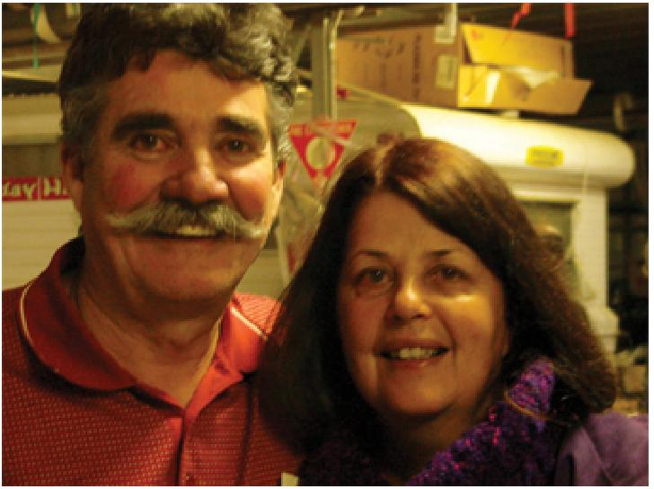
God put on Raf’s heart the great need for healing meetings in Adelaide, after so many sick Christians were seeking him out for effective prayer ministry, and driving to Middleton for meetings. The first Well of Healing meetings began on Wednesdays in Term 2, 2007, and have continued since. Healing rooms run during the day for those who want private, focused ministry, and the open meetings are every Wednesday night. Details and maps are on the website.
The AncientWells.org.au website is managed by Paul Davies, a high school teacher by training, and “Raf’s shadow” according to his wife. It is full of useful teaching from Raf, both as audio and video files. These are free for download or streaming online, and can be accessed through our iTunes podcast.  We also have an archive of the original “Voice of Healing” magazines from the 1950s Healing revival, free to download or read online as PDF files. Teaching, testimonies and news articles about some of the most amazing healings from that Move of God. There are also useful and encouraging clips and messages from other ministries. | 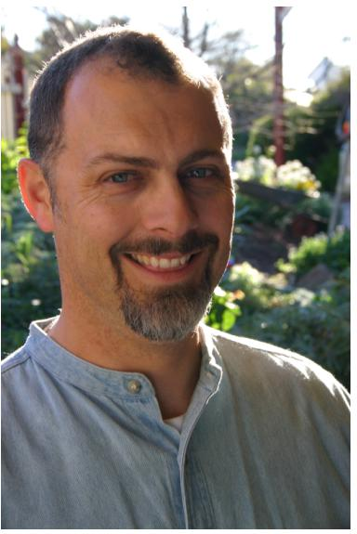

We try to post testimonies of what God has done in meetings, but we are in the midst of training Christians to email them in, or write them down, rather than just tell us verbally. So, we don’t have as many online as we see God doing each week. In the last year, we have seen several cancers healed, and a host of other major and minor diseases and disabilities. We have also had a Psychiatrist send us several of his patients for prayer ministry.
We are NOT trying to establish a church, or steal sheep (we don’t want them). We simply want to assist Christians in accessing their inheritance of health from their Father. We want to teach them so they can help others in the churches they come from, because unless we move forward as a body, we end up working against each other.
All our stuff is free, because God told Raf clearly that “Selling product undermines your spiritual authority,” and denies faith in the Father to provide. God put this project on Paul’s heart after reading some of the magazine articles, and noticing the depth of relevant teaching inside.
If you’re ever Down Under, come to Adelaide and visit! Please email testimonies and comments to: testimonies@ancientwells.org.au.

Foreword
Growing up the son of a Sydney Anglican minister I inherited a very rich understanding of the scriptures, and I was always keen for more of the Lord and wondering why we didn’t see the miracles I read about. I remember asking my Dad when I was 12 about healing, and he explained about Charismatics and their beliefs. I discovered that he had been taught at Theological College that God didn’t do that anymore – it wasn’t necessary now we have the Bible. When I asked him what he thought he answered: “I’m waiting to see...” I remember walking out of his study thinking: “That’s ridiculous. Of Course God is still doing the same things.”
Little did I know the extent to which the Church had suppressed the knowledge of the ministry of divine healing. To this day the majority of Western Christians have no idea that in the 1950s a massive healing revival took place. Over 100 ministers travelled around the U.S.A. and the world holding Tent Meetings – people getting out of wheelchairs was everyday, people having surgically removed parts restored was common!
The magazine which documented the revival was the Voice of Healing. For 50 years since the Lord “took it away” (1957), the little known about the Revival was mired in controversy, slander, misunderstanding and the like. Of the 100 ministers involved, many ended in disgrace – “Girls, Gold or Glory” ruined many lives and ministries. The religious establishment ensured that the survivors faced opposition in all things, and few are still alive today. Some, like Paul Cain, disappeared from public life for many years, until the Lord began to call them forth. Little by little more and more people began to hear about the 50’s, though it was very hard (especially if one was not US-based) to find information about it. Roberts Liardon’s book: “God’s Generals” broke down many barriers, and gave many Christians their first look at men such as William Branham, Jack Coe, and A.A. Allen. But everything began to change in 2007.
In February 2007, Todd Bentley (www.freshfire.ca) had a prophetic experience where he was standing on the platform of a William Branham meeting in 1952. He believed it was a dream, and was watching Branham call people out and tell them the secrets of their hearts. Branham would experience a vibration in his left hand when the Angel was near him. Suddenly he stopped, looked at his hand, and turned to look directly at Todd. Todd started to wonder if maybe he was actually THERE. Branham walked across the stage to Todd and placed his left hand on his chest. The vibration went right through his body and he fell out under the power of God. When he awoke the next day he rang Bob Jones, who had “seen it all” during the night. Todd asked him; “Why 1952?” Bob replied: “That was the last year it was pure. It got corrupted in ’53, and the Lord took it away in February ’57.” Exactly 50 years before. The Lord told Todd this was a Jubilee season for the restoration of the Healing Ministry.
Many other events confirmed this. Bill Johnson’s Bethel Church (www.iBethel.org) bought Roberts Liardon’s God’s Generals museum outright to honour the history of what the Lord has done and help make it available. One of the men involved in slandering A.A. Allen in the 60’s publicly confessed and repented of false witness at the end of 2007. Conferences began to be organised to honour the Father’s of the faith from the last century and inform Christians of what had occurred.
When I discovered an archive of the original “Voice of Healing” Magazine several pages down in a foreign website, I couldn’t believe the blessing. I had been hoping for one or two issues, and here was several years’ worth of the mag – already scanned into PDF files.
So I snaffled the Lot! I figured if I had that much trouble finding them others would too, so we made them available free on our website: www.ancientwells.org.au. Since then we’ve had emails from all over the Western Church exclaiming: “What an amazing treasure!” and the like.
They were not wrong! As I read more and more of the incredible healing testimonies and the articles that had been lost for over 50 years I was increasingly challenged by the Lord to tell people. I was stunned that

many of the issues that Christians are struggling with in the Healing Ministry were dealt with in the ‘50s and teaching had been published answering these same issues.
So we’re making this available, free. Please be blessed and challenged by what you read and email us with your testimonies: testimonies@ancientwells.org.au. If you have any issues of the magazine stashed away that we haven’t got on the Web please scan them and send them so we can share it around.
Spread the word to your friends: Jesus Christ IS the same, yesterday, today and forever. When He is lifted up on the earth He will draw all men to himself.
I pray that the teachings in this collection will encourage you and build you up, and that you will be challenged to keep seeking intimacy with the Father, and you will press in to hear His voice and receive all that He has for you.
Let’s lift Him higher.
Paul Davies B.Sc. Dip. Ed.

THE VOICE OF HEALING April 1948 Page 3
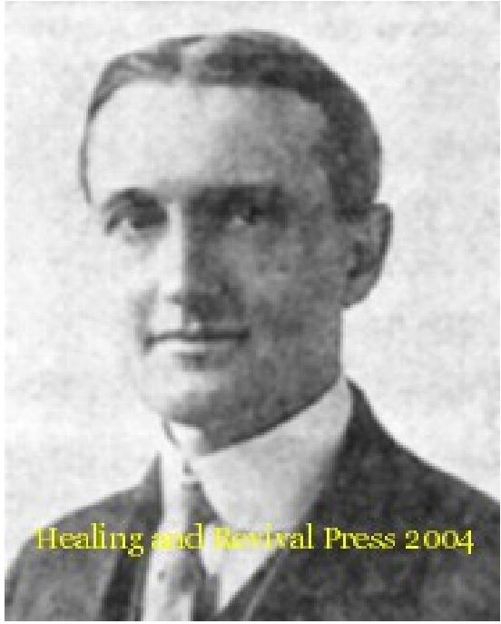
WHY ALL ARE NOT HEALED
By REV. F. F. BOSWORTH
PART ONE
Since it is so clearly revealed everywhere throughout the Scriptures that our Heavenly Father wills our healing why do some in our day who seek healing, fail to receive it? This is the question in the minds of many honest inquirers. There are many answers to this question, which we will briefly mention since by these answers, many who had failed to receive healing, have been enabled to locate themselves after which they have been gloriously healed.
First: Ignorance of this - physical healing is part of the Gospel. Faith cometh by hearing... the word of God. Many in our day seek healing before they have heard or read enough of the Word of God to produce real faith. The early church was united and unanimous on the subject of healing and praying for the sick. They lifted up their voice to God with one accord in prayer for signs and wonders of healing; and it was not the faith of the evangelist but of the whole company of believers that brought healing to "everyone in the streets of Jerusalem” after Christ's ascension (Acts 514 - 16). A large part of the present church, through ignorance and tradition, are opposed to healing for which the early church unitedly prevailed in prayer; the present church as a whole has not accepted our Lord's attitude towards sickness as fully revealed in the Gospels. In this day opposition often takes the place of united prayer; unbelief takes the place of united faith; lukewarmness the place of being spirit-filled, as all were, in the early church. So I will ask the question. May not the blame for the failure of some to be healed be largely due to the unbelieving part of the church herself since we are members one of another? I believe you will say yes. Suppose it was generally believed now that the day of regeneration was past. How this would hinder the success of the ministry in that part of the Gospel! On the other hand, suppose that from infancy we had all been taught the healing part of the Gospel as definitely as any other part? I believe very few would have any difficulty in evidencing faith for healing. Second: Community unbelief. Although Jesus worked miracles and healed all that were sick in other places, when He came to Nazareth where He was brought up, we read, He could do no miracle there... because of their unbelief. Think of it! Christ Himself under the full
anointing of the Holy Ghost was hindered by community unbelief. Since this is true, is it strange that some in any city should fail to receive healing? God would not allow the gift of miracles to operate in Christ where, by their unbelief, they were making Him a liar.
Did the fact that Christ could do no miracle there prove anything but the unbelief of the people? By withholding the Gospel of healing and preaching in its place the traditions of men, many of our present day teachers have turned almost the whole world into a Nazareth of unbelief so that we have to labour in Nazareth nearly all the time. If it is right to account for the failure of some to receive healing by calling into question Christ's willingness to heal, then why not call into question His willingness to save all men to justify the unsanctified condition around us? Considering the fact that in the minor or healing part of our ministry

THE VOICE OF HEALING April 1948 Page 3
we are compelled to labour in the face of almost universal unbelief, and that those who preach only the soul salvation part of the Gospel are labouring in the midst of almost universal faith in the matter of salvation, I think that God is giving proofs of Divine Healing as bright and convincing as the proofs of regeneration, and that with not nearly so much teaching to produce faith. When I consider the lack of teaching, the opposition, the unscriptural condition and the general attitude of the present-day church toward this part of the Gospel, instead of wondering why some are not healed, I marvel at the success that God is giving to those who pray for the sick. I think you will agree with me when I say that the proofs of Divine Healing among those now attending the meetings who say they have been healed are as bright and convincing as the proofs of regeneration are among the same number in any church who profess to be regenerated. Are not the hundreds who now testify that they have been healed in as good health physically as a like number of professing Christians in any church are spiritually?
Would not the physical health of those who have been healed compare favourably with the spiritual health of even the average minister of today, and yet the latter has heard a hundred times more on the subject of salvation to produce faith than the sick have heard to produce faith for healing. I think that the average professing Christian of today is a poorer proof of the doctrine of regeneration and consecration than those who testify to being healed are of the doctrine of healing. Many who have been deaf and dumb mutes from birth, whom Christ has healed perfectly in our revivals, can now hear better physically than the average church member can hear spiritually and that, without nearly so much teaching to produce faith. I have seen many who could not walk a step from birth, who since being prayed for are walking better physically than the average church member is walking spiritually. Many who have had totally blind eyes can now see better physically than the average church member can spiritually.
Are all who have been baptized washed from all their sins? No, but those who have faith are; and what water is in the ordinance of Christian baptism, oil is in the ordinance of anointing the sick for healing. You say, "So-and-so was anointed and was not healed." I answer, "So-and-so was baptized and is not saved." Some say, "I know a man who was prayed for and was not healed" and I ask you, "Did you ever pray for a man who did not get saved? If so, yours was the bigger failure because it is a thousand times more important to be saved than to be healed.” Would you reject the doctrine of consecration because some church member or even some minister is not consecrated? Let us be consistent. I, for one, will preach all the Gospel if I never see another man saved or healed as long as I live. I am determined to base my doctrines, not upon phenomena, but upon the immutable word of God.
Third: The healing part of the Gospel is hindered, and even made void by traditions of men. Jesus said to the Jewish teachers in His day, "Ye have made void the law by your traditions." In our day we have done worse and made void some of the Gospel by our traditions. One tradition is that God is the author of disease and wills the sickness of some of His worshippers. It is a mystery to me how anyone can hold this view in the face of the Scriptures and the ministry of Christ during which, for three years He healed all that were

THE VOICE OF HEALING April 1948 Page 3
oppressed of the devil, that came to Him. If sickness is the will of God for His worshippers then every physician is a law-breaker, every trained nurse is defying the Almighty and every hospital is a house of rebellion instead of a house of mercy. If God wants you sick it is a sin for you to even want to he well because you are to love the will of God.
Another tradition which is responsible for thousands dying a premature death after years of bodily agony, is the teaching that we can glorify God more by remaining sick and expecting patience. An honest but unenlightened minister will often kneel at the bedside of one suffering with arthritis or cancer and pray, "Lord, since in thy loving providence thou hast seen fit to lay thy afflicting hand upon our dear sister, give her fortitude and patience to bear this affliction. This is done in place of obeying the plain command to anoint any sick in the church and to pray the prayer of faith for their healing, which John Wesley says was the only process of healing in the Church until it was lost through unbelief. Now if it is true, as many are taught, that they can glorify God more by remaining sick than by being healed, then Jesus hesitated not to rob the Father of all the glory He possibly could by healing everyone that appealed to Him for help during His entire earthly ministry. And His successor, the Holy Spirit, who was sent down to augment what Christ had begun to do and to teach, hesitated not to rob God of all the glory He could by healing in the streets of Jerusalem (Acts 5:15, 16), and Paul did not hesitate to rob Him of all the glory he could by healing all the other sick on the Island of Melita.
Then the most common and threadbare tradition is the worn-out statement that the age of miracles is past. Of all traditions, this is the most foolish, illogical and unscriptural of any that I have ever known. The Holy Spirit in whose age we now live, is God's only miracle Worker, the only Administrator of the Father's will; the One who healed all the sick multitudes who came to Christ for healing during the days of His flesh. All the miracles ever wrought until the Day of Pentecost were accomplished by the Spirit, the miracle Worker, before He had entered the world officially for His own dispensation. The age in which we live was intended by our heavenly Father to he the most miraculous of all because it is the miracle Worker's, the Holy Spirit's age or dispensation. During this age the great promise is that God will pour out the Holy Spirit, the miracle Worker, upon all flesh; this is the only age when the Miracle Worker would incarnate Himself.
This is the only age when the nine gifts of the Spirit, including the gifts of faith, healing and miracles, were to be distributed to every man severally as He will. Jesus promised that the works which He was doing, and greater works would be continued and augmented by the Holy Spirit, the miracle worker, after He entered office during Christ's exaltation, which is the Spirit's dispensation. How absurd and ridiculous for any Bible teacher to pick out this, the miracle Worker's age, as the only age when miracles are done away with, how absurd to teach that the Holy Spirit will work miracles in every Age but His own, which is a better dispensation with a better priest and better covenant, better promises and better everything. (To be continued in the next issue)

THE VOICE OF HEALING Dec 1950, Page 12
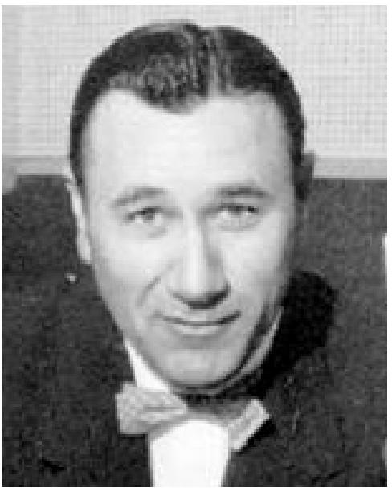
How to Receive Deliverance – Oral Roberts
- Know that God's Will to Heal You
Practically everyone recognizes the fact of God's healing power. Mental acceptance is not enough. We must have personal, active faith in God for our own healing.
It is my sincere belief that Christ's death on the cross includes all people everywhere and in all generations. The apostle Peter writes of Jesus, "Who his own self bare our sins in his own body on the tree, that we, being dead to sins, should live unto righteousness, by whose "stripes ye were healed." ( 1 Peter 2:24).
The prophet Isaiah had known that Christ would be the Saviour and healer over seven hundred years before the crucifixion. Said he, "But he was wounded for our transgressions, he was bruised for our iniquities: the chastisement of our peace was upon him; and with his stripes we are healed" (Isaiah 53:5).
Both Isaiah and Peter declare that there is healing in His stripes. Someone recently pointed out to me that in Pilate's Hall of Judgment the Roman scourger of Jesus inflicted thirty-eight stripes on His back. Also the medical world says there are thirty-eight major diseases. If this is true then for every disease there is a healing stripe on the flesh of Jesus' back.
The apostle Matthew tells the story of Jesus as the Great Physician and at the end of the day's labour of deliverance he says that Jesus' healing power is a fulfilment of scripture. Matthew writes, “... they brought unto Him many that were possessed with devils; and He cast out the spirits with His word, and healed all that were sick, that it might be fulfilled which was spoken by Esias the prophet saying, Himself took our infirmities, and bare our sicknesses" (Matthew 8:16, 17 is referring to Isaiah 53:4).
- Remember that Healing Begins Within
You reach God and He reaches you through your soul. When God breathed the breath of life into man he became a living soul. Jesus declares that: "God is a spirit; and they that worship Him must worship Him in spirit and in truth." (John 4:14).
Why is a man dominated by fear? Because he is not using his faith. Why is he not using his faith? Because he is out of tune and harmony with his God. There is only one thing that can separate a man from God, "... your iniquities have separated between you and your God, and your sins have hid his face from you, that he will not hear" (Isaiah 59:2).
Man's most severe struggle is within himself for be is condemned by his own sins. As long as this is true, faith will not work. "If our heart condemn us not, then we have confidence (faith) toward God" (I John 8:21).

THE VOICE OF HEALING Dec 1950, Page 12
I imagine this question presents itself, "Does a Person have faith whether he is right with God or not?" The answer is, "Yes, he does." Everybody has faith for God gives a measure of faith to every man. The difference is that faith will not work as long as there is sin in the person's life.
Sin is a dominating thing and it produces a division in the soul. Faith lies dormant and inactive (James 2:17). Without the power of active faith the soul is no match for the grueling grind of life. The body and mind, keenly responsible to the soul, feel the impact of the soul's fears and weaknesses and are easy prey for mental and physical ills.
It adds up to this; You cannot serve the devil with your life without losing out in the battle of life.
"Ye must be born again," says Jesus (John 3:3). The now birth is a transforming spiritual experience (2 Corinthians 5:17). Condemnation is lifted. "There is therefore now no condemnation to them who are in Christ Jesus, who walk not after the flesh but after the spirit" (Romans 8.1).
3. Use a Point of Contact for the Release of Your Faith.
God is the only healer. Doctors perform a good work but they only assist nature while God can actually bring deliverance. The authority of Satan's oppression over human life is in God and in His children. But God is a spirit and sometimes we are confused because He is not directly before us in a human body. He does not come into your room as your family physician with medical potions and instruments, you cannot see Him with the human eye, nor can you take a trip to heaven and present your case as you would go to your doctor's office. How then can we reach Him? By establishing a point of contact. Faith is the meeting ground between your limited self and your limitless God. A point of contact is given as a means of steadying and helping you to release your faith. Establishing a point of contact is like stepping on the starter of your car - you expect something to happen. The Roman centurion said. "I am not worthy for you to come under my roof, but speak the word only and my servant shall be healed.” Speak the word! He went on to say, "For I (also) am a man under authority, having soldiers under me, and I say to this man, go, and he goeth; and to another, come, and he cometh; and to my servant, Do this and he doeth it." (Matthew 8:513).
Remember that the woman with the issue of blood used a point of contact which helped her set the time for healing. She said, "If I may touch but His clothes I shall be whole." There was no healing in His clothes, but touching the clothes helped her release her faith and her faith made her whole. That's why God gives us a point of contact. The book of Acts tells how that handkerchiefs or aprons were sent from the body of the apostle Paul to the sick and demon-possessed and how that through these little faith-cloths deliverance was wrought. These cloths became points of contact and when placed upon the body of the sick and afflicted, the captives turned their faith loose and were set free. I, too, have been impressed and directed of the Lord to carry on the ministry of healing through cloths so that we are sending out over 10,000 a month.

THE VOICE OF HEALING Dec 1950, Page 12
- Turn your faith loose Now!
So many times I have seen the need of saying, "Believe now and you may have deliverance." On the other hand, many captives, when asked when they expect to get healed, will reply, "Oh, when God gets ready, I am." God has been ready all the time. It's your move next. Others reply, "I'm expecting God to heal me anytime." On the face of that statement is a certain amount of reasonable value, but I remind you that it in not scriptural. There is a definite time when faith works and unless you set a time, it in doubtful if you will ever be delivered. God says, "Today is the day of salvation" (deliverance).
When you expect healing at no certain time, you are putting it into the dim, vague and distant future. God wants to heal you now. The best time is when God is ready; He is ready now!
The woman with the issue of blood set a time: when she touched His garment. The centurion set a time for deliverance; when Jesus spoke the word. The ruler of the synagogue set a time: Come and Lay hands on my child. They expected deliverance at the moment the Lord did what they asked Him to do. God will respond and work in our behalf when we believe and set a time. This is a glorious privilege and matchless opportunity. "This very hour" is what the Lord is saying. The longer you wait to believe, the weaker your faith will grow; the more quickly you believe, the stronger your faith will develop. Strike a blow for deliverance this very minute. If faith has risen in your heart, turn it loose, don't finish reading this even, Believe God now! The time for deliverance is when you can believe. The secret of deliverance is in instant obedience.
- Close the case for victory.
When Bible conditions have been met and you feel the power of healing surging through your body in answer to the faith prayer, then close the case: take up the old road you have been travelling and believe God every step of the way. Burn every bridge between you and the old affliction. Don't talk about the affliction except when God especially impresses you to give your testimony, then dwell more on His mighty power of deliverance than on what the devil afflicted you with and how you suffered. Change your outlook and live on the sunny side of life.
- Join yourself to companions of faith.
I know how important it is to have encouragement and an atmosphere of faith to live in after being healed.
A few days after I had been healed I was feeling extremely weak in my body. My mother, a devout woman of faith, sensed my discouragement and said, "Son, you were sick a long time and you were bedfast when God healed you. You will have to exercise and do some work to get your strength back." She saved my healing.

THE VOICE OF HEALING Dec 1950, Page 12
I have often wondered what would have happened to me had not my mother and father provided an atmosphere of faith for me during those early stressful days of my healing.
I have asked myself this question: What if I had been a member of a church whose minister and people were unfriendly toward healing and to people who had been healed? What would I have done in a moment of weakness and despondency if these people failed to encourage me or if they ridiculed me? How can I who have been healed by a miracle receive help from a church that denies the possibility and reality of the miracle of healing wrought in me by faith in God? How would I feel if the minister ridiculed the people who had prayed the "prayer of faith" for my healing."
There is only one answer to this problem: those receiving deliverance by faith in God should by all means, join themselves with the church that believes in Bible deliverance and that will provide for them an abundance of faith and hope.

The Voice of Healing April-May 1951
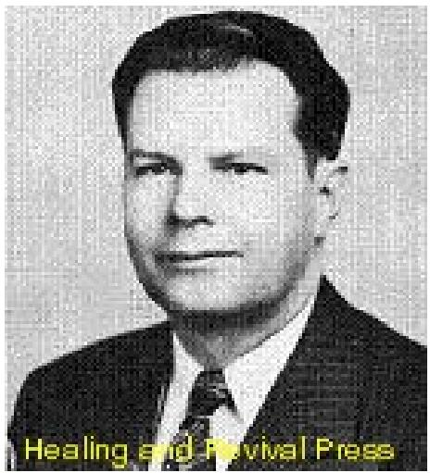
MY MOST IMPORTANT MESSAGE ON DIVINE HEALING
Gordon Lindsay
Perhaps the most prevalent error made by people seeking healing, including those who are fully convinced of this truth, is the confusing of hope with faith. Sick people, when prayed for, naturally hope that they will be better, but hope is by no means faith Hope is only passive, quite different from faith, which is active, creative. Hope has the element of uncertainty; it looks forward to possibility, while faith looks backward to accomplished fact. Faith rests with confident assurance on God's word, though it receives no encouragement at all by what the eye may see. By faith God created the worlds, when there existed nothing but the eternal emptiness of space.
The natural man is a creature of his senses. If he still sees or feels the symptoms of an affliction he insists on believing what his senses tell him, rather than what God's word has said. Faith, by contrast, is not influenced by what the eye sees, and indeed is indifferent to it. It is not a creature of the senses but draws its strength from the immutability of God's word. If this were not the nature of faith, no such thing as faith would be necessary. Why should faith be needed for that which already exists, and the eye sees it and the hand feels it?
THE PARALLEL BETWEEN SALVATION AND HEALING
It is this misconception of what faith is that makes it difficult for some to understand and to appropriate physical healing. Yet really there should be no reason for this ignorance. The Bible teaching concerning healing is quite as simple as that of salvation. The truth is that the healing of the body and the salvation of the soul involves a similar work of the Spirit - and are governed by very nearly, it riot exactly, identical laws. The key to the understanding of the whole subject of Divine Healing lies in a recognition of the almost exact parallel between the faith necessary for healing and that necessary for salvation. Therefore, if we have a knowledge of the faith by which salvation comes, then by simple comparison we may understand the principles of faith for healing.
Let us note the similarity between the problem of securing deliverance for the soul from its sinfulness, and that of the deliverance of the body from its sickness. Most sinners, except perhaps the rashest of fools, entertain at least a secret hope of being eventually saved. But though the sinner recognizes the value of heaven, and may agree that the prospect of being eternally lost is infinitely more tragic than merely being sick, yet this powerful incentive to repentance is not sufficient in many cases to result in the sinner's conversion. Moreover, even after the sinner has some appreciation of the awfulness of the disease of sin, and expresses a willingness to forsake it, yet he will not be saved until lie believes the good news that Christ died for him. Only when lie accepts the Finished Work of Calvary can he be saved! If the sinner will not believe, until lie feels saved--he will never be saved! Have not most (if us witnessed people who have made this very mistake? It is only in the act of believing the Finished Work of Calvary that the sinner's conversion takes place.

The Voice of Healing April-May 1951
THE FINISHED WORK OF CHRIST
This belief in the Finished Work of Christ did not become the inheritance of the Christian church without a struggle, which indeed shook the church to its foundations. The truth came as a fruit of the Great Reformation. Luther and others discovered that prayers, penances, fastings, tears, and great strugglings of the soul, did not bring them to an enjoyment of peace with God. It was only when they boldly accepted the promise of the Finished Work of Christ, that heaven's peace came. Nor was it easy in those days, to take such a stand. All the traditions of men, the myriad dogmas of the Medieval Church, all the instincts of the natural, unconverted man, clashed and revolted against such a truth. Nevertheless, men of daring boldness fought the battle through and won It! The truth that "the just shall live by faith," once scarcely believed by anyone, eventually came to be the foundation stone of the faith of countless millions!
This truth, born of the Great Reformation, is understood by every successful soul-winner; and in helping the sinner he carefully instructs the candidate what he must do to be saved. He knows that it is a mistake to attempt to bring the sinner to a decision until the Spirit has deepened his convictions, and until he has a clear knowledge of God's promise concerning salvation. The Christian worker realizes that it a man's mind is confused, or it he has not fully taken hold of the promise, he is apt to succumb to the first strong temptation that comes his way. For this reason a wise minister does not press action upon a sinner the first moment he enters a service. There is a preliminary work of the Spirit that needs to take place in his heart. There are instructions for his mind to receive. The Spirit must not be asked to do His office work of the New Birth before He has first done His work of conviction.
A PRELIMINARY WORK OF THE SPIRIT NECESSARY TO HEALING
The tragedy is that many Christian workers who clearly realize these things throw this wisdom to the winds when it comes to the matter of Divine Healing. Often they are anxious to have the sick person they are interested in, ministered to immediately, and if results are riot forthcoming in the way that they anticipate, they may even be indignant. People travel thousands of miles to clinics, they may spend a fortune to obtain the best of medical skill, and will accept the failure of physicians philosophically. But when they come for Divine Healing, they want to lay down the rules. To them such Scriptures as "faith cometh by hearing and hearing by the Word of God," and, "lay hands suddenly on no man," have little significance. Some, in ignorance of God's Word, suppose that one with the gifts of healing should go from hospital to hospital, healing all that are sick. The often seem unaware of the Biblical account of Jesus at the Pool of Bethesda where He healed one and left the other cripples and the infirm sitting there. Or that Jesus, while at Nazareth, could not (not would not) do mighty works there because of their unbelief. They overlook the fact that Christ's teaching on healing anticipated a willingness on the part of the individual to submit his life completely to God, or, that when the Lord replied to a Gentile woman's request to heal her daughter He declared that healing was the "children's bread." It we are to understand Divine Healing we must realize that it is the same power that heals the soul and forgives sin, that also heals the body. (James 5:14-16).

The Voice of Healing April-May 1951
THE FINISHED WORK OF HEALING
It requires no long time for the sinner to be saved, once his heart is prepared to receive Christ, although sometimes it may take years for a person to get into a place that he is willing to yield to God. But once that moment arrives, salvation comes almost instantly. This is possible because of the Finished Work - salvation accomplished once and for all at Calvary. As long as the sinner does not believe, or postpones his salvation to the future, he will not be saved. Once he believes that God does it now, the work is done.
Christians do not reproach the work for encouraging the penitent to believe at once. There is no way for the sinner to be saved until he believes. No one accuses a worker of using deceit (except railers against the Gospel) if he urges the repentant soul to take God at His Word and to believe that salvation is an accomplished fact. Yet in the matter of Divine Healing, just such a charge is made, and that by Christians.
TWO FATEFUL ERRORS
We are now in a position to note two fateful errors that the Church makes in the matter of Divine Healing. First: Although it is generally accepted that a God-anointed teaching of the Word is required before ordinarily a true work of conversion may take place, often the same persons will not concede the Spirit of God the same opportunity in the matter of healing. Too often they will encourage the sick person to be prayed for without teaching and may resent it if the minister advises the sick person first to prepare his heart. Second, although they will encourage a penitent sinner, to believe in the FINISHED WORK of salvation, some with fine inconsistency will reproach those who deal the same way in securing the healing of the sick. Some mischievously will point to some sick person who was supposed to have thought he was healed and who is still sick. This is criminal unbelief. It is similar to the act of one who would discourage a sinner from getting saved, by pointing to some backslider, who once thought he was saved but is now backslidden. Let God be true and every man a liar! According to God's Word they were saved if they truly believed. So the sick person is healed if he believes. Both salvation and healing are a Finished Work of Calvary.
THE INTERRUPTED MIRACLE
Of course, if the new convert allows doubts to take refuge in his heart, the work of salvation becomes a miscarriage. The sick person who has received healing, may likewise lose it if he allows doubts to secure a foothold in his heart. Did not Peter walk on the water? Yes, and it was truly a miracle. But the miracle miscarried when a doubt crept into his heart - which, we may add, was caused by Peter looking at the waves instead of Christ. Healing is a Finished Work, as far as God is concerned. But we have to appropriate it, and not allow the enemy to challenge our right to it. Peter declares, "by whose stripes ye were healed." (Read also Isa. 53 and Matt. 8:14-17). We do not pray healing down from heaven or persuade God to do what was fulfilled at Calvary. What we do is to appropriate healing in identically the same way that the sinner appropriates salvation.

The Voice of Healing April-May 1951
THOSE WHO RECEIVE WITH JOY AND FALL AWAY
Jesus told of some who hear the gospel and "receive the word with joy and “...for a while believe, and in time temptation fall away." Others, said he, "are choked with cares and riches and pleasures of this life and bring no fruit to perfection." (Luke 8:13-14). There was nothing wrong with the word that was sown in their hearts. There was nothing amiss with the encouragement it gave these people to believe, nor with the joy that came to them as a result of believing. The trouble was that they allowed something to disturb their believing, which "choked" or interrupted the work of the Spirit. This circumstance is also true of those who believe for healing. The moment a man believes for his physical deliverance, he receives it as far as God is concerned. "Whatsoever ye desire when ye pray, believe ye receive and ye shall have." (Mark 11:24). Therefore if temptation comes, and one yields to the symptoms, he does the very thing the devil wants him to do. He does exactly as an erring new convert who, under temptation gives way to the enemy's suggestion that he never was really saved. So is the man who believes for healing, then doubts and afterward declares he didn't get his healing.
The truth is that the majority of people who come for healing are healed so far as God is concerned. The real problem is to keep these people from unbelief and from scepticism, and all those who are slaves to their sense knowledge. At this time as at no other it is important to keep these people under the word of God and from association with unbelievers. The problem is identically the same as a pastor experiences when a large group of converts accept Christ. How he labours with these people, giving them loving attention, and feeding them with the sincere milk of the word. It he did not, in many cases they would fall by the wayside. Satan tempted Christ and said, "It thou be the son of God ..." He tempts the sinner who has been truly saved. He will tempt every person who has been healed. But while the young convert is encouraged to resist temptation and the devil, and to look away to Christ, the person who is healed will all too often be given suggestions by friend or foe, by the weak and the well, by the preacher and the pew, to not be too sure of his healing, and to be on the alert for the return of his old affliction.
SIN OF UNBELIEF
We might as well face the truth. Unbelief is sin. It is condemned by the Lord, even worse than obscenity. Unbelief is war against the very law of being. It is a slavish loyalty to sense-knowledge and a disloyalty to the word of God.
A true pastor encourages his new converts to stand steady in the faith, even though they go through the fires of temptation as many must. He warns them to hold fast and not give way to the wiles of the enemy. Even so, the person who has been healed should be taught that it is God's plan that sickness should be taken from his midst, (Exod. 23:25) and that God's will for him is that he "should prosper and be in health even as (his) soul prospereth." This is the promise and it will be fulfilled in the lives of all who are bold to believe.

The Voice of Healing – September 1951
F. F. Bosworth's message to the sick – Word from the man who has received over 200,000 testimonials of healing during his ministry.
The Opening Of The Prison
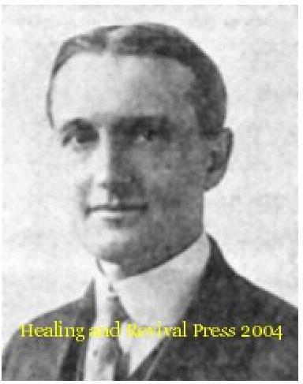
By F.F. Bosworth
Please read Isa. 61:1-2 and Luke 4:18
"The opening of the Prison" is God’s own figurative illustration of our release or imprisonment to sin, and sickness and everything else that reached us through the Fall. It covers every phase of our redemption and salvation. What I have to say applies equally to every bondage known to man. If you are physically well, and your problem is one of the many others covered by redemption, then think of your problem as in open prison, and follow these instructions. You can thus keep God busy fulfilling his promises to you, and you can live in the experience and enjoyment of your freedom.
What is meant by opening of the prison? It means that the prisoners are free. Accordingly Moffat so translates the text, "To tell the prisoners they are free, to tell the captives they are released." Jesus opened the prison for us by bearing our punishment. "Jehovah hath caused to meet on him the punishment of us all." (Isa. 53:6; Dr. Young's translation.) In Deuteronomy 28, all sickness is listed among the punishments which Galatians 3:13 tells us Christ redeemed us from. He, Himself, took our infirmities and bore our sickness (Matt. 8:17.) Jesus paid our debt, and since it does not have to be paid twice, we are free.
HOW ARE THE SICK TO GET OUT OF PRISON?
First, they must know that the prison is open. Faith must have a Divine fact to rest upon. Accordingly, Jesus said, "The Lord hath sent me to proclaim the good tidings . . . to announce release to the prisoners ... to proclaim the opening of prison to them that are bound." Jesus used the word "bound" when he said, "Ought not this woman whom Satan hath bound be loosed . . .?" Sickness is a bondage from which we have been redeemed. Jesus also said, "He hath sent me to free the oppressed." (Moffatt) All sickness is called the oppression of the devil." (Acts 10:38.) The sick must have the "word of faith in their mouth and in their heart" before it can produce results.
Connected with "the word of faith" (each of God's promises) is the provison "if thou shalt confess with thy mouth Jesus as Lord," (Romans 10:9-10). The condition of our salvation is our confession and acceptance of His Lordship over us. Christ does not save those whom he cannot govern. “For to this end Christ both died and rose, and revived, that He might be Lord both of the dead and the living." (Romans 14:9.) Until we gladly acknowledge His Lordship over us our priorities are wrong. We are not to seek our redemptive blessings selfishly that we may waste them on our pleasures. Because of this selfish motive James says to some, "Ye ask, and receive not, because ye ask amiss."

The Voice of Healing – September 1951
RIGHT THINKING AND RIGHT BELIEVING ARE NECESSARY
After knowing that the prison is open, the first thing God requires of man is that he forsake his way and thoughts and accept God's way and thoughts. (Isa. 55:7.) Since the Fall the natural man is bound and imprisoned by his physical senses. These keep him looking to his symptoms instead of being occupied with the Word of God. The opening of the prison frees him from this bondage, making it possible to see and know beyond what the natural senses register. Man's way is to judge by the walls of the prison instead of by the open door. True the walls are there, but the door is open.
Faith requires no evidence but the Word- it is blind to all but the Word of God. Paul says, "We look not at the things that are seen." When we rely upon physical evidence we repudiate the Word, and faith his no opportunity to exercise itself.
"Let him forsake his thoughts." Man's thoughts have been that the prison is locked and that, therefore, he is not free. He must forsake such thoughts and think the truth - the truth that the prison is open and that therefore he is free to walk our. One man thinks that his disease will kill him, while the enlightened man knows that he can be healed. Both of these men have faith, but one has faith that the disease will kill him, while the other has faith in God's promise to heal him. The sick man must "forsake" his way of judging according to the walls of the prison - by his symptoms - and he must accept God's way of reckoning according to the open door.
As soon as the good news is believed it produces joy. Jesus said in his text, "He hath sent me to preach . . . the acceptable year of the Lord." The Gospel Age was typified by the Old Testament year of Jubilee (Heb. A time of shouting). It was a happy year because God said on the day of the Atonement (in this 50th year) "Ye shall return every man to his possessions." just so the Gospel age is a “time of rejoicing" over the restoration of all our lost possessions in the fall: Health for soul and body and every other blessing included in our redemption.
God's promises, when truly believed, become the rejoicing of our heart before they are fulfilled to us. (Jer. 15.16.) A pardon from the governor read to a man sitting in an electric chair to be electrocuted would make him happier before he gets out of the chair than he will be a month later. Believing and rejoicing that we are free precedes our first stage out of prison or bondage so sickness. The absence of rejoicing would prove that you do not really believe the proclamation that you are free.
The sick person must forsake the Thought that his freedom is a future act. It is not a future act, it is a past act. Your use of your freedom may be a future act, but it should not be. The door to your prison has been open a long time. "By his stripes ye were healed." Calvary was your "emancipation proclamation" from everything outside the will of God. The "Emancipation Proclamation" by Abraham Lincoln made the slaves of the South free before they knew it. But they did not use their freedom until they were informed of it. Then they did not judge according to their surrounding, but by the proclamation.

The Voice of Healing – September 1951
YOUR PART IN RECEIVING HEALING
The sick person must believe he is free because of the open prison door, and then act accordingly. Unless faith his corresponding actions, God's word says that it is as dead as a body without a spirit is dead. The opening of the prison" has made you free but you will be in prison until you rejoice and walk out. No one else can do your part for you. I cannot pray you out of prison without your cooperation. Jesus required action on the part of the sick to be healed. He commanded the palsied man himself, not the four that brought him in, to take up his bed and go home. He commanded the ten lepers to go and show themselves to the priest before their healing was manifested. Jesus commanded the blind man with the withered hand to stretch it forth, etc., etc.
Even in the Old Testament times Jonah sacrificed with the voice of thanksgiving calling his prison walls “lying vanities," not after, but before he got out. Naaman was required to dip in the Jordan seven times before his leprosy was cleansed. Even Christ, after preaching the message of our text, "could do no miracle in Nazareth because of their unbelief. Though Divine, He could not do their part.
If you were in prison, longing to get out, and the warden, pointing to the open door, should say to you, "Look," "that door is open for you," would you rejoice? Would you ask your friends to pray you out after they had already prayed for the court for your pardon and release? Your friends could come in and walk out with you, but not for you. Fix your eyes on the open door and keep on, rejoicing and walking and the walls of your prison will soon be behind you - the manifestation of your healing will become history.

Voice of Healing, November, 1951 page 4
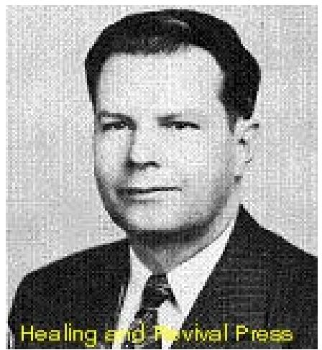
WHAT TO DO WHEN DEATH STRIKES
By GORDON LINDSAY
In relating this experience, which came to me recently, I do so, trusting that it will give help and encouragement to others who may have a desperate encounter with the enemy. For a quarter of a century, I have enjoyed almost uninterrupted health, and on several occasions when sickness has attempted to secure a foothold in our home, God miraculously intervened and delivered us from all the works of Satan. I say this not boastfully, but as one who is humbly grateful for God's grace and mercy, which He has always seen fit to extend to us.
A few weeks ago, I was engaged in some important business in the East. It required my being up 'till very late hours, and on some nights, I secured very little sleep. This was nothing new to me, since ordinarily, two o'clock in the morning his been the time I usually retire.
THE DEVIL STRIKES UNAWARES
About a day or two after I began this business trip. I became aware that a boil of some kind was forming on the back of my neck. Boils are usually inconsequential incidents, and I hardly gave the matter a passing thought. The next day, however, I noticed that the swelling was not the same as that of an ordinary boil. Had I been at home, I certainly would have followed my usual pattern of action when any kind of sickness has seemed to threaten. I mean by this that at such times I always wait upon God until I feel that I have dominion over what may seem to be portending trouble. But I was at the busiest part of my journey and matters I was dealing with were of such nature they were occupying all my attention and time. My mistake was a common one - people usually do not get in earnest when an affliction threatens, until the thing becomes securely entrenched.
Concluding my business on Friday, I found myself at the great Washington, D. C. airport, a little after midnight, standing by for possible space on an airliner headed west. It was at this time that I realized something was seriously wrong. The boil now extended over a space of several inches in width and was quite painful.
I was fortunate to get a plane that took me as far as Memphis But arriving at the city, I was too weak to proceed further, and so remained overnight in a hotel. By morning, I found that the infection had spread across my entire neck, and was extremely hard and painful when touched.
I LEARN THE SERIOUSNESS OF MY CONDITION
While waiting for a plane, I determined to find out just what the trouble was, and made an inquiry of a local physician. He took just a brief glance and his face paled. Looking at me earnestly, he said, "Sir, 1 am sorry to tell you this, but this is a most serious infection - it is a carbuncle, and has developed to the point where it is going to give you great trouble; such

Voice of Healing, November, 1951 page 4
things often result in - - - " his voice trailed off, and then continued, "the infection is near your spinal cord, and can result in spinal meningitis." He spoke decisively, "You must have medical treatment at once."
1 was weak and exhausted and in no condition to argue. So I said, "Doctor. I thank you for this information, but 1 will do nothing until 1 reach Shreveport. My plane leaves shortly." The physician was a kindly man, and he was convinced I did not realize the gravity of the situation, He admonished, he urged, he cajoled, he begged, he almost threatened. But I was adamant. If this was a matter of life and death, then I must throw myself on the mercy of Jehovah Rapha, the Lord our Healer; and weak as I was, I did not feel that I could convince him. He looked at me again and, almost with tears in his eyes, said, "If you do not have the money, don't worry over that. Your life is more important than money." Of course, the money was not the object, and I could not but appreciate the kindly solicitude of the physician.
When the doctor saw that I would not undergo medical treatment in Memphis, he turned to me and said, "I'll let you go on one condition - that you will call your physician as soon as, you reach Shreveport." I replied, "Doctor, I promise you that the moment I get to Shreveport I'll call on my Physician." I kept that promise, even before I got to Shreveport. I most earnestly called on my Physician - the Great Physician, the Sympathizing Jesus.
THE BATTLE BEGINS
In Shreveport, the battle began. I believe that an answer from heaven came the first day, but due to an organized attack of the powers of hell, the result was not manifest immediately. Because of the peculiar part TVH plays in these great salvation-healing revivals the devil evidently believed he could effect a damaging blow, if he could get its editor out of the way. No man is indispensable, yet each of us is given a task that is peculiarly our own.
Having great confidence in the prayers of others, I sent out telegrams to several of my brethren containing the following words:
"The devil has struck me with a serious infection. I am convinced as with Daniel, the answer has already been sent. Undoubtedly this attack is tied up with the devil's attempt to frustrate the rapidly growing work of TVH. Please hold on to God with me for the manifestation of complete deliverance." Gordon Lindsay
At this point, I wish to express my deep appreciation for all those who held faith with me, and some who visited and prayed with me. We are members of one Body, and the prayers and faith of others are of great significance and importance.
I asked my wife to bring me a medical dictionary from the office. 1 wanted to find out just how bad a carbuncle was. Although she has a good memory, each day she "forgot" to bring it. Later, when 1 was back at the office, I read what it had to say. It was as follows: CARBUNCLE: A name applied to a very painful-and dangerous affection – the skin gives way at several places, and through these openings, the core of the carbuncle is seen as a

Voice of Healing, November, 1951 page 4
grayish-white slough - it is accompanied by severe general disturbance, due to the absorption of poisons produced by the microbes in the carbuncle --- the process causes great exhaustion to the patient, and from this exhaustion, or more actual poisoning, death often follows. It is customary to open the carbuncle with a cross-shaped incision..."
After 1 read this doleful obituary, I had a suspicion that my wife "forgot" to bring the book on purpose.
THE BATTLE RAGES
For three days the battle raged. I could feel the terrific impact of spiritual forces in action, in which the carbuncle seemed to be the nerve center of the battle arena. In the natural, the issue seemed in doubt, But in the spiritual realm, God gave me peace, and I could feel that the Spirit of God was raising up a standard against this menacing power that was searching for my life. The struggle went on for hours---sometimes in the middle of the night. After I had prayed for healing I ceased begging or crying. I have often seen this method used and it is worse than useless. I just kept praising God for the victory that I knew was surely mine.
One other thing I did. 1 searched my life carefully, and asked the Spirit of God to turn the searchlight on anything that was displeasing to Him. An attack by the enemy should always be a means of drawing us closer to God. A great mistake, and one alas made too often, is that when Satan strikes, people begin to whine and say, "I don't know why this had to come on me." An attack by the enemy, may not indicate any outbroken sin, but it often indicates that we have let the devil break down the hedge of Divine protection somewhere, if only that we have failed to obey the laws of rest, diet, health, etc.
When one is in severe pain, the greatest battle is to reject the false sense knowledge that denies the promise of God. If not properly taught, one is almost certain to accept theverdict of the pain, rather than to praise God for this sure promise of healing and deliverance.
A PREMATURE VICTORY
On Tuesday afternoon, I felt that victory had come. Simultaneously the great swelling opened and the poison began to drain out. Every hour or so, my wife would put a fresh hot pack on the place of infection, and the draining continued without cessation. The pain had ceased, and at last I could fully relax. God had graciously prevented the affliction from passing to any other part of my body - a remarkable exception to the normal and usual course of a carbuncle.
A DIABOLICAL TRICK OF THE ENEMY
I will admit that I was not prepared for the next development. Apparently Satan considered that there was much at stake in the outcome of the battle and had no intention of retiring from the field until he had played his last card. My father and mother were visiting us at the time. Father, who is seventy-eight years of age, had never been really sick once in his life. He has led a very temperate life, and has hardly known what sickness is.

Voice of Healing, November, 1951 page 4
At one o'clock on Wednesday morning, my wife was applying cloths, for the poison was flowing out very rapidly, and every couple of hours, she would apply the cloths. I had completely relaxed, and was enjoying the rest that was stealing over my body. At that moment my father came into the room. I thought perhaps he had come to see how I was, but one look at him and I knew something definitely was wrong. His face grimaced with pain. He informed us that his kidneys had locked, and I could see that he was in great agony. I also perceived that he was suffering so much that he would not be able to get victory himself. Satan, frustrated, had apparently lashed out against him.
I was distressed. There was my poor old father, whose hands had soothed my brow many a time. When, as a child, I was in need, he had waited on me more times than I can remember. Now there he was in pain and suffering, begging me to pray for him. It was almost more than I could bear. I arose from my bed, and with all my strength began rebuking the enemy. But soon my strength was exhausted, and I had to fall back on my bed. Five or six times, I arose to rebuke the enemy, but at last I fell back utterly exhausted. (Father recovered, for which we are thankful - Praise God!)
HAD I LOST MY HEALING?
As for me, I fell into a fitful sleep of exhaustion. I would see hallucinations and time-after-time I would wake with a sudden start. At length in the afternoon my wife came and looked at the carbuncle. It was red and angry, had increased in size, and worse - it had completely closed up. She had little to say. Her face was solemn, and the thought came to me, “Had I, through this overexertion, lost my healing?" Temptations, which are nothing at all in normal times, loom large when one's strength is completely exhausted. Yet, in my extremity, God helped me. I grimly determined to refuse to accept anything but that God had healed me. That was my decision, live or die, sink or swim.
Having no strength to pray, I picked up the Bible and read the story of Hezekiah's sickness unto death. He too had been afflicted with a terrible boil or carbuncle, and when he had inquired of the Lord, the prophet had brought him word, "Set thy house in order, for thou shalt die and not live." I read on. I saw how Hezekiah had turned his face to the wall, and had plead with God to spare him and give him additional years of life. As a result of his prayers. God sent him a message that he should recover, and have fifteen additional years.
I read further. Though Hezekiah had been told of his healing, yet apparently the symptoms were still there -the hideous, terrible, death-dealing carbuncle was still on his body.
The pain was there, and nothing apparently had changed. To stimulate his faith, he asked God for a sign. He was given his choice of whether the shadow would go forwards or backwards ten degrees on the sundial of Ahaz. Looking objectively at Hezekiah we would probably think that the miracle of the shadow moving on the sundial would be far beyond the mere healing of a carbuncle. But as I lay there in bed, I could understand how that terrible, painful, nervewracking boil, loomed larger to Hezekiah than anything else. He asked that the shadow go backward ten degrees, in order to give him faith for healing of his affliction, of which as Yet he saw no signs of abatement.

Voice of Healing, November, 1951 page 4
Not in a moment, but gradually, I realized that God had given me a greater sign than He gave to Hezekiah - the sign of the Son of Man, "by Whose stripes we were healed." And "Who took our infirmities and bore our sicknesses." And when He did this on Calvary, the sun did not just retreat ten degrees, but it withdrew its shining altogether! When Jesus died, darkness came upon the face of the entire land! Calvary is a sign to every sick person that Jesus has borne his sickness.
As I lay in bed, praising God for the healing, it seemed that a new strength came tome, and a voice seemed to say, "Do not doubt your healing." I fell asleep believing that victory had come, and Satan was defeated. When I awoke in the morning, I found that the swelling was going down rapidly, and the poison was again flowing from it. That was Thursday. By Monday, I was back at the office working, and. that evening I attended a church service. Hallelujah! Praise the Lord! Hezekiah went up to the house of the Lord on the third day. I believe that I could have gone on the third day also, but friends told me I had better wait another day.
After Isaiah pronounced the healing, be also recommended that a special poultice should be placed on the boil. (II Kings 20:7) The poultice had nothing to do with the miracle of healing, but its use demonstrates the fact that the Bible teaches that sympathetic care of the sick is in harmony with and not opposed to Divine healing. The external application of it fig poultice was applied to the swelling to draw the poison out. We didn't have any figs, but we obtained qualified advice as to what kind of poultice should be applied (Isa. 38:21).
My testimony is that of Hezekiah after he had been healed. "The Lord was ready to save me, therefore we will sing my songs to the stringed instruments all the days of our life in the house of the Lord." Isa. 38:20.

THE VOICE OF HEALING April 1952 page 19  Common Objections To Divine Healing  by Rev. P. C. Nelson  "Wherefore the Lord said, Forasmuch as this people draw near me with their mouth, and with their lips do honour me, bus have removed their heart far from me, and their fear toward me is taught by the precepts of men: therefore, behold I will proceed to do a marvellous work among this people, even a marvellous work and a wonder... And in that day shall the deaf hear the words of the book and the eyes of the blind shall see out of obscurity, and out of darkness." | 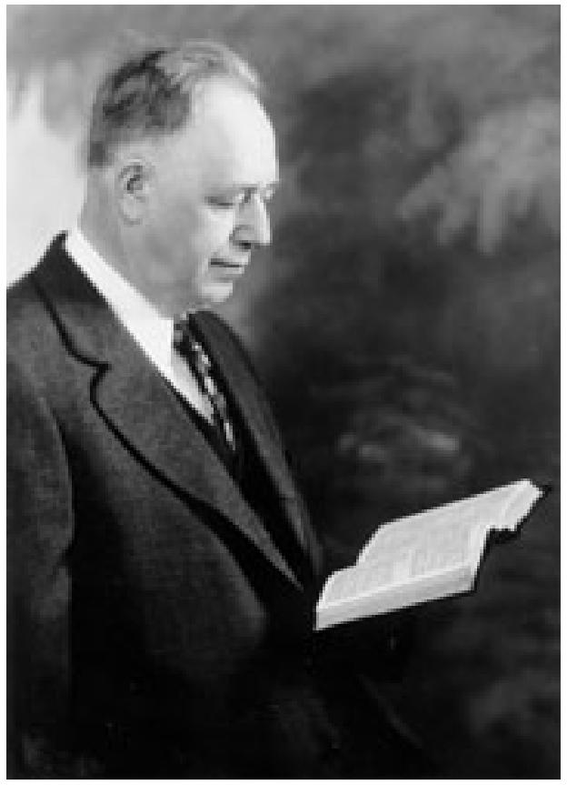

My text, taken from Isaiah, 29th chapter, 13 to 18 in part, is very applicable to our times:
Time For The Lord To Work
We are living in just such a time as the prophet describes. Thousands make a profession who have no possession. Much churchianity - little Christianity. Beautiful forms of religion, but denying the power of God. Laxity in morals, selfishness, greed, and hypocrisy in the high-seats in the synagogues. We preachers have failed to stem the tide of worldliness which has swept into the churches and threatens to sink them.
We cannot do it by the ordinary means employed. The people who most need the message of warning from the faithful pastor seldom hear it, and if they do, and he speaks out against their pet sins and their secret faults with directness, he is soon seen packing his goods to take a journey. In just such a time, the Lord asks us to step back and let Him take the work in hand, and by marvellous miracles of power demonstrate His presence and awaken the people out of their lethargy, indifference, and unbelief. For this reason He asked me to scrap all of my old sermons and methods and the learning acquired by many years of patient study, including twelve years in several of our best schools and seminaries, let Him give me it new message of power and life, and "confirm the Word with signs following.”
So many say, “If this is the work of God, why do not all ministers recognize it, and cooperate in it?" I do not wish to cast any aspersions on my Brethren, but I suspect it is for the same reasons that the religious leaders of the Jews, with rare exceptions, failed to recognize the work of God in the time our Lord was on earth, and He said of some, "Neither will they be persuaded though one rose from the dead."
Christ, The Only Divine Healer
Divine Healing is the work of God, just as much as the creation of the world and the saving work of Christ our Lord. Healing not wrought by Divine power is not Divine Healing. How strange that anyone should dare in our times to raise objections against

THE VOICE OF HEALING April 1952 page 19
the work of Jesus Christ in opening the eyes of the blind, the cars of the deaf, and making paralytics walk!
Papers over the country dub me as a Divine Healer, or worse yet - THE Divine Healer. I am no healer, and am as human as anybody. I never claimed I could heal anybody, never thought I could. There is one Divine Healer, His Name is Jesus Christ! He commanded His followers to heal the sick, but it was in HIS name and by His power. As a man of wealth might say to his secretary, "Write this man a check and pay him.” The secretary "pays" him, but out of the funds of his employer. In the same way I heal the sick - by the command of Jesus Christ and by His power.
A Warning to Opposers
Those who oppose this work are not opposing P. C Nelson, but the Lord Jesus Christ; who is saving scores of souls daily and is healing all manner of sickness and disease among the people, exactly as He did in ancient times. It is His way of reviving His work and building up His cause and it cannot be done in the churches with the backing of the religious leaders, thank God, it can be done without them. 1 would rather have my right arm severed from my body than to oppose what Christ Himself is doing, lest haply 1 "should be found fighting against God." (Acts 5.39).
Let us now take up some of the objections commonly heard against Divine Healing.
Has The Devil Been Converted?
Some have said it is the work of the devil. If that is so, the devil has been soundly converted and is now working to build up the cause of Christ, for hundreds have been wonderfully converted in these meetings. Some have made restitutions, some have been delivered from vices and bad habits, some have paid up bad debts, some have quit the dances, the card tables and the show houses, and some have given up old grudges, and many who cursed and swore have learned to pray and to praise the Lord. One brother answered the objection by saying that if it was the work of the devil, the devil failed to get the praise, for all that are healed give the glory to God. 1 never knew that the devil could be converted, but if this is his work, he is more effective in building up the cause of Christ than many pastors in this city together. I would not venture such a statement if I had not constantly disclaimed any credit for the work myself. It is not the devil's work, not man's work - it is the work of God. If it is the devil's work, how is it that the devil and all his dupes are fighting it so hard? Jesus said, when they made the some objection in ancient times, "A house divided against itself cannot stand!"
Not Hypnotism, Mesmerism, or Magnetism
Many say it is hypnotism or mesmerism or magnetism. I have never been hypnotized and have never hypnotized anyone, and could not do it if my life depended on it. If this is hypnotism, I certainly ought to he decorated with all the orders and medals the kings and potentates of earth can give, for not one of the professional hypnotists can make the deaf hear, the blind see, or the lame walk, and none of these miracles which you have seen in this tabernacle can be done by them.

THE VOICE OF HEALING April 1952 page 19
Hypnotism can make fools out of those who become its victims, but it cannot restore to reason or to health, as you have seen the Lord doing in these meetings. It is over a year since the Lord healed me, after a painful, serious automobile accident in Detroit. If this is hypnotism, I too was "hypnotized" and thereby enabled to rise and walk, and I have been on my feet ever since. This "hypnotism" has good lasting qualities. I have known some who were "hypnotized" many years ago, and escaped death; some from cancer, some from tuberculosis, and some from other deadly diseases, and they are still "hypnotized."
Not Spiritualism but Spirituality
Some say it is spiritualism. No, it is not spiritualism; it is spirituality. It is so spiritual that the carnal "Christian" cannot understand it. But it has nothing in common with spiritualism or spiritism, which is everywhere condemned in the Bible as a work of demoniac delusion. The increasing interest in spiritism is one of the signs that Christ will soon appear and that we are now living "in the latter times," for Paul says in First Timothy 4:1, "Now the Spirit speaketh expressly, that in the latter times some shall depart from the faith, giving heed to seducing spirits and doctrines of devils, speaking lies in hypocrisy; having their conscience seared with a hot iron." With God, the Father, and Christ, the Son, and the Holy Spirit, our Comforter, abiding in us, as Jesus taught in the fourteenth chapter of John's Gospel, and with the light of God's Holy Word on our Pathway, we need no witch or medium to bring us into communication with the dead. Spiritualism denies the soul-saving doctrines of the Word of God, denies the inspiration of the Scriptures. This abominable delusion of the Devil has never made anybody better, but has wrecked many a good life. People who have been healed in our meetings have lost their healings when they have gone to spiritualistic seances. Some of the most pitiable people I have ever met were dupes of spiritism and were demon-possessed or account of dabbling in these things so fearfully denounced in the Word of God.
Not Christian Science, But Christian Sense
Some call this Christian Science. That shows a deplorable ignorance. It is not Christian Science, but, as a local physician said to one of his patients who was healed in these meetings: “It is not Christian Science, but Christian sense!" We do not deny the reality of matter or of pain. We do not say we do not suffer when we do. We do not deny the personality of God, or the death of Christ, or His resurrection, or His coming again. We do not set aside the ordinances of the Gospel, and we lay hands on the sick and anoint them with oil, exactly as He commanded. We put all our faith for salvation from sin and healing from disease in the atonement made by Jesus Christ on the cross (Matt. 8:17), and in the power of the convicting, regenerating, healing Spirit of God.
Why All Are Not Healed
Some ask why all who come to us for prayer are not healed. I answer, because the Lord's requirements have not been fully met. Many come forward for salvation in revival meetings and some in the regular church services, who are not saved. If you pray for the salvation of a soul and fail to get him saved, you have made a more serious failure than I have if I pray for a thousand to be healed and they die without healing, for

THE VOICE OF HEALING April 1952 page 19
the salvation of the soul is infinitely more important than the healing of the sick. However, the quickest and surest way, and in many cases, the only way, to get people saved is by the use of the key of Divine Healing, which the Lord put into the hands of the church. The church lost it, and now that it has been found, refuses to take it back.
Healing May Be Gradual
Some ask why all who are helped are not perfectly and instantly and permanently healed. I answer that the Lord frequently begins a healing work to encourage the person to go deeper into His love and grace, and to acquire a greater faith, and get a spiritual blessing, and then complete healing from all bodily afflictions. Partial or gradual healing may prove a greater blessing than instantaneous, complete healing. The Lord wants you to learn to walk with Him. If He healed you instantly and completely, you might forsake Him, run away from Him. Many do not have faith to take complete instantaneous healing. Many remark to me, "This trouble was long in coming on, and I have had it for many years. I cannot expect it to leave me at once."
Spiritual Preparation Necessary
All who come up in the healing line should be in the services several days to hear the Word of God, see people healed before their eyes, and bear the joyful testimonies of those who have been healed. They should have time for private confession of hidden sins and for the reading of God's sweet promises. When you have a promise to stand on, and real faith, you are not disturbed by symptoms - you are staking all on the Word of God, and ask for no other evidence. So many have been soaked in unbelief so long it takes a long time to get it all out of their systems. Ministers who should be "examples of faith" as well as piety, sometimes are so full of prejudice and unbelief that they took with pity, if not with contempt, on people who believe that God will fulfil His gracious promise with reference to prayer. You must have faith enough to take healing from the Lord, and enough to stand in the midst of a cold, unbelieving, cynical world. And what is worse, too often the churches that bear the holy name of Christ discount, discredit, disclaim, and disown the Work of the Lord Jesus Christ. If the apostles should arise from the dead and want to preach here and heal the sick, exactly as they used to do, there is more than one church in this city that would not welcome them.
A Final Word
In conclusion, let me say that Divine Healing is being revived in our times, not by the churches as such, but by the Lord Himself through humble servants who are not afraid of the sneers of their fellows, and are not seeking popularity, or pleasure or ease, and are not afraid to stand alone with the Lord, who Himself was despised and rejected by the very people He died to save. It is spreading over the whole earth. God is using this ministry to awaken a cold, worldly church, and prepare a people for His soon coming. It is the master-key to the human heart. It is the method of Christ and of the apostles and of all the early preachers of the Christian church. It is the key which the Lord is using today to unlock the hearts of men, and to bring in the greatest revival ever known in this world. Those who oppose it are not opposing a doctrine or a person like myself. They are fighting against God, and standing in their own light. In all humility and love we

THE VOICE OF HEALING April 1952 page 19
would warn them who oppose this work of God, in the words of Paul in the synagogue at Antioch of Pisidia:
"Beware, therefore, lest that come upon you, which is spoken in the prophets; Behold, ye despisers, and wonder, and perish, for I work a work in your days, a work which ye shall in no wise believe, if one declare it unto you!” (Acts 13:40,41, cf. Hebrews 1:5).

THE VOICE OF HEALING January 1952 Page 16
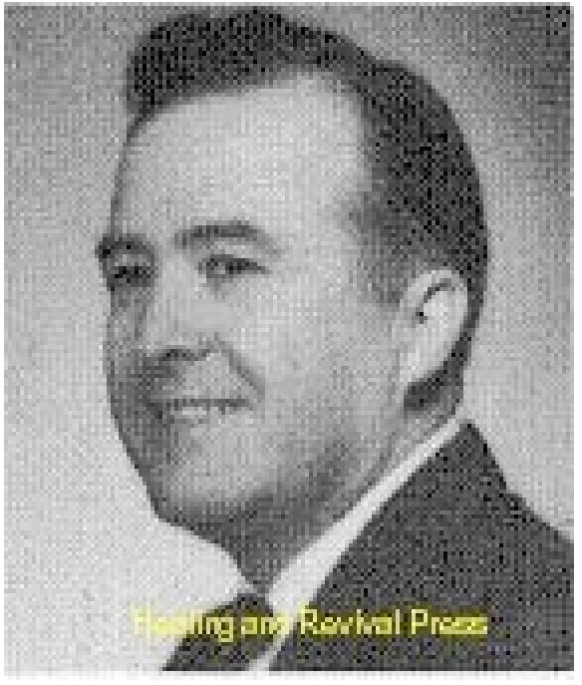
Don't Accept Failure
By W. V. GRANT
One of the most pitiful things is a person who has all his faith pinned on the success, or failure, of someone else. The faith that receives things from God is the faith that cometh by hearing the Word of God, instead of seeing a failure someone makes.
Here is a question that is asked often - "I know a dear saint of God who has been afflicted for many years. She has faith. She has prayed earnestly for her deliverance. So many of God's best men have prayed earnestly for her, but there is no change in her condition. She lives so close to God. It looks like she would receive her healing, if healing is right. What is the matter that she doe's not have her healing?"
SAME RULE FOR OTHER THINGS
I know of a pastor of a certain church who wrote against Divine Healing. He phoned a number of people trying to find one case who did not receive healing. He finally found one about two thousand miles from his home. This man was on the West Coast. He says the man told him he had his healing, but lost it. This well-meaning pastor tried to use this one failure to prove that there was nothing to the thousands of healings which God has performed.
At the same time, we can find a man out of a thousand that this pastor prayed for to receive salvation, who was not saved. Does that prove there is nothing to salvation?
I prayed for hundreds of people to receive the Holy Ghost. Hundreds have received the Holy Ghost, but some I pray for do not receive. Does that prove that we don't have the Holy Ghost? Does that prove there is nothing to the Holy Ghost? Does that prove that God does not fulfil His promises anymore? Certainly not.
The promises of salvation are sure, even if no one ever takes advantage of them. The same is true of the promises of healing. The promises of the Holy Ghost are true if not one ever takes advantage of them. The same is true of the promises of healing.
Just because one person fails to get saved, would you say there is nothing to anyone's salvation? After God has healed thousands, would it be consistent to say, "Unless He heals some extreme case, He lied about it all?" After God saves thousands, would it sound logical to say, "Unless He saves a certain bootlegger down on the edge of town He does not save anyone, and that He fails to keep His word?"

THE VOICE OF HEALING January 1952 Page 16
CAUSE FOR EVERY AFFLICTION
You say that the woman in question is a saint, and she has done all she can do and there is no cause for her to be sick? You are taking her word before you take God's Word. God says if she has faith, she will be healed. Be careful lest you make God a liar.
The Bible says there is a. cause for every affliction. When the cause is removed, then the affliction will cease. For every affliction, there is a cause.
If a doctor tells you not to eat green peaches, then you should remove the cause before you get cured. If you don't take the doctor's medicine and advice, then you may not be cured. Remove the cause. Look into the Word of God. Find out the cause. Move the cause of the affliction and the healing will come.
Sin is not the cause of all sickness. Some refuse to lay hold on the promises of God. It seems that there are some good people who trust neither doctors nor the Lord. Some simply suffer things out. Some are stubborn; they will not obey the Lord. They will not obey the doctor! Yet they will whine around and blame both. They say they have done all they can do.
Just because you fail to collect your $10,000 insurance, which was promised you, is no good reason that I should not collect my insurance. How would it sound if I say, "Well, I will not try to collect my $10,000 because this man failed to collect his?" If it was promised to me I could collect it. Healing is promised to you. Come and get it, even if others don't.
DON'T RELY ON PEOPLE
Some receive healing when others do. When the person they are watching fails, they also give up, and will not trust the Lord because their friend failed.
If you were travelling across the bridge of some great river and you saw someone jump off and kill himself, would you do the same thing? Yet, you are doing something much more dangerous when you give up the Lord because someone else did. Don't go back on your promises. God will not go back on His!
If a man kills himself, will you kill yourself? Would you fail to be saved because there is a hypocrite here and there? Therefore, when the other fellow fails to receive healing, you come and receive yours anyway. If the other fellow says he has done everything required and still didn't receive healing, be sure and don't believe him rather than the Lord.
For someone to say, "I know a person who has sought healing for years and really lives holy, and believes, but has not been healed," is just the same as saying, "I know a person who has kept his part of the agreement, but God has not kept His Word." That is a very serious charge against your Master. That is making Him out a liar. It is bad enough to think that, much less to say it!

THE VOICE OF HEALING January 1952 Page 16
MAGNIFY HEALINGS INSTEAD OF FAILURES
For every backslider you find you cart also find a true Christian. Why don't you look at him? For every hypocrite you find, you can also find a true saint. Why not watch him awhile? For everyone you see who fails to receive his healing, I can show you someone who receives his healing. Why not get your eyes on him awhile?
A person can generally find just what he is searching for. If you have an evil eye, and look for faults, you find them. If you have an eye that is single to the glory of God, and look for some true child of God, you will also find him.
Some birds find rotten meat because that is just what they started out to find. Other birds find good meat because that is what their nature calls for.
Be occupied with the promises of God and let your faith increase. Why be occupied with certain cases and entertain unbelief?
God always keeps His covenants, and whenever the fulfilment of any promise is not realized, that is no sign that there is something wrong in heaven. Regardless of what you think someone is; if you think someone is a good saint and deserves his healing, the trouble is not with God or His Word.
DEPEND ON GOD"S WORD
When Peter was walking on the waters, why did he sink? It was because be got his eyes on something else. That will be the reason you sink. Jesus said, "Oh, ye of little faith." If you want to have faith, keep your eyes off the failure of others. One thing about Peter; he did try again. He walked! You can too!
We must base our faith on the Word of God alone, instead of what someone tells us.
Does He say, "I am the Lord that healeth thee, if everyone else receives his healing?" "They shall lay hands on the sick and they shall recover, if no one ever makes a failure?" If Jesus makes promises like these, then keep such excuses. If He promises to heal us all, in every disease, then lay down such an excuse, and come on and get right. Believe God instead of others.

The Voice of Healing – February 1952 pg 15
STEPS IN VICTORIOUS FAITH - PART IV
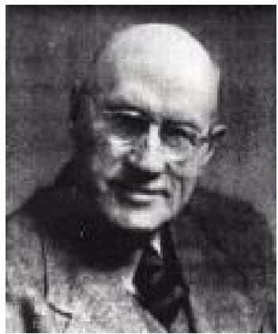
FAITH BELIEVES in the face of RETURNING ATTACKS By Harold Horton
Counter attacks are an established procedure in warfare. Everybody acknowledges this. Yet many who have been healed by the Lord are shocked and sometimes shattered when the spiritual foe counter attacks their bodies with the old ailment. When the United Nations forces have gained some ground by determined attacks, the enemy organizes a fierce counter attack in his endeavour to recover lost ground. So it is in spiritual warfare. When we are healed by the Lord, we must not suppose that this is the end of the conflict. The enemy may still bitterly seek to sweep us back into the old defeat and despair. His wiles are subtle and his methods treacherous. Have you been healed magnificently by the living Jesus, through the prayers of the saints and the gifts of the Spirit? This is glorious victory.
But have you been fiercely counter-attacked since, and has the old disease seemed once more to have fastened itself upon you with merciless hold? All is well if you will keep your Faith operative. The same faith through which you were delivered will keep you delivered, or repeat your deliverance if you have fallen before the strategy of the enemy. ONLY BELIEVE - is still the unfailing principle of glorious victory. Cheer yourself in every attack, by the Word of God.
Enemy counter attacks are a prominent part of revelation in God's Word. Though David in his youth valiantly overcame Goliath, the boastful Gittite of Gath and all his mighty horde, he fought this same malignant foe all through his long life; but he was triumphant in every fierce conflict. Never was he defeated while he was faithfully serving the Lord and believing His Word. In 1 Sam. 47:50,51 we read that "David prevailed over the Philistine . . . and smote the Philistine and slew him." "And when the Philistines saw their champion was dead, they fled." Victory through Faith! Yet later in David's history we read that "moreover the Philistines had yet war again with Israel." And "there was yet a battle with the Philistines at Gob." "And there was again a battle in Gob with the Philistines." "And there was yet a battle in Gath. But in all these bitter attacks David was mightily victorious! He was a man of Faith - and continued Faith.
THE PHILISTINES WILL DEFEAT YOU IF YOU WILL LET THEM.
But they and their boastful leader are already defeated if you will determine by grace to stand in that victory. The battleground is often your body. But all the enemies of your body are defeated long ago and their captain overcome by one greater than David, on the cross of Calvary. There He won, for us a permanent victory. The enemy will again impudently lift his defeated head if you will give him any leeway. But the Word assures you that Christ has given you "power over all the power of the enemy." "Nothing shall by any means hurt you” if you will stand in Calvary's victory. Resist the devil and he will flee from you. Do not parley with him when he meets you. Do not fence with him. He will disarm you with a swift stroke and leave you defeated. Resist him, and he will give up the fight and leave you

The Voice of Healing – February 1952 pg 15
victorious on the field. In later life David learned a new way to deal with his enemies. He no longer fought them – he ran through troops. He ignored them. He would not even recognise their presence. When he came to a seemingly insurmountable barrier, a towering wall of opposition, he did not seek for human means to overcome it. He leapt over walls - and ran through troops. The fight is won long ago at Calvary. The counter attacks are also all won long ago by the same Mighty Victor. Stand in victory. Not the subtlest foe nor the bitterest attack can withstand FAITH in that finished work.
The land of Canaan belonged to the people of the Lord before they entered it. Enter now your Promised Land of deliverance and health and victory. The' enemy in Canaan was defeated before the people of the Lord encountered them. They had not even to fight them. They were to sweep them out triumphantly before them. If the enemy failed to withdraw before the triumphant tread of the Israelites, it was either through fear or sin. The Land was theirs. All they had to do was to claim it and set their feet on it. The land of Health and Victory is yours NOW. All you have to do is to claim it in the face of every challenge. Set your feet on it and make it yours. It is yours in any case. Why not MAKE it yours by FAITH NOW! This Minute! Faith is the Victory. Faith goes on believing in spite of every returning attack. Your sins are gone at Calvary's cross. They do not come back on you, though you may be strongly tempted to accept them once more, Resist them. Your sicknesses are also gone at Calvary. "By His stripes you were healed." Your sicknesses do not come back any more than your sins. But the enemy will tempt you to believe they are back again. Stand in victorious FAITH. The enemy cannot withstand that. He will have to flee before your triumphant Faith and leave you victor on the field. Resist NOW, though the fight may be fierce. You are confronting a defeated foe. His power is stripped by the Victor - Jesus. But he will terrorize you still if you will submit to him.
Once more consider the inspired analogy of David's victory over all the power of the Philistines. David entered his public ministry by overcoming one mighty giant - in the Name of Jehovah. Of him we read that "the staff of his spear was like a weaver's beam." 1 Sam. 17:7. At the end of his life David was confronted with four terrifying giants (1 Chron. 20:48). As one of these terrible monsters advanced towards him, David must have shaken with fear (2 Sam. 21:15-17). "Goliath!" his heart exclaimed. "Goliath again! The same towering frame. The same boastful imprecations. The same gritted teeth. The same roaring threats. The same resounding strides - Yes - the same terrible spear" – for we read of him - "Whose spear staff was like a weaver’s beam.” 1 Chron. 20:5. No wonder David was filled with fear. Did a doubt fill his heart as to whether Goliath was really dead? "Surely (David might have inwardly reasoned) - surely I slew him many years ago by Faith in Jehovah! I severed his head with his own helpless sword and carried it in triumph to King Saul. Yet There he stands; before me in all his terrifying arrogance. Tbe same glaring eyes. The same poised weapon. Was I deceived when I thought I slew him? Has be risen by satanic miracle from the dead?" No wonder fear gripped his heart at this terrifying apparition. But now read in the Word: "And there was war again with the Philistines; and Elhanan ... slew Lahmi The brother of Goliath the Gittite, whose spear staff was like a weaver's beam!" Not Goliath - but his brother! The same family likeness! The same diabolic resemblance; the same satanic grimaces and gesticulations. But not Goliath. Lahmi! "He fell by the hand of David

The Voice of Healing – February 1952 pg 15
and by the hands of his servants." Thank God there are still pebbles in the brook. The same promises that slew Goliath long ago slay his brother now.
Are you threatened by the same affliction that the Lord healed long ago. The same swellings, the same pains, the identical symptoms? Fear not. It is not Goliath. He is dead long ago. It is Lahmi, his evil brother. Hurl the victorious pebble now - the Name of Jesus. The same Faith that slew Goliath will slay all his evil brood. This counter attack is not the former disease come back. It is a simulated sham to terrify you into defeat. Do not accept it. Stand in victory. Resist the devil and he will flee from you. Take no notice of the attacks. Run through troops. Leap over walls. Place a promise in the sling of FAITH now, and bury it deep the head of the giant that confronts you. You are the victor in the fight.
Faith must be tested. BUT THE TEST IS NOT DEFEAT. It is designed to lead to triumphant victory. I prayed once for a broken man - dying of "disseminated sclerosis of the spine" (horrifying words!). He was dying of a creeping paralysis. He was in mortal agony. He was already dead from his feet to his bowels, He had spent thousands of dollars on doctors and specialists, but was worse than ever in spite of all ... His legs and feet now were so dead that you could push hat pins into them and he would feel nothing. The death had reached his bowels and bladder, and be could not relieve himself either way. As he tried to do so his agonizing screams were heard a block away. I instructed him in faith. I prayed for him. I took his hand, and with brave but shaky faith he arose at my invitation. He started off by himself, the first time in many months - walking - unsteadily, but walking. He uttered the Name of Jesus at every step. His wife came weeping up to assist him. I said "No. Leave him to Jesus." He went, unaided up and down the stairs, on Jesus at every step. He went into the garden, and before the terrified neighbours stumbled in his unsteady gait, shouting "Jesus” at every step. I left him walking - improving all the time. In a week or so I went to see him again. He was back in bed, The doctors told him he was mad to try to walk. He was dying. His relatives agreed. He succumbed to friends suggestions and went to bed - to die. I prayed for him again. The brave man got up once more shouting "Jesus" at every step. In a few - weeks he was perfectly healed. Strong legs, new internal organs, operating normally.
Are you suffering new attacks of the enemy? It is not Goliath. It Lahmi! It is not the old disease. It is an imitated one with a family likeness. Resist it. The Promise hurled in faith will defeat every returning attack of the bitter foe. Rise NOW in victory. The same Jesus who healed you long ago heals you now in this new and heavy attack. NOW! Faith goes on believing in the face of every returning attack. Faith is the victory!

THE VOICE OF HEALING November 1952 Page 16
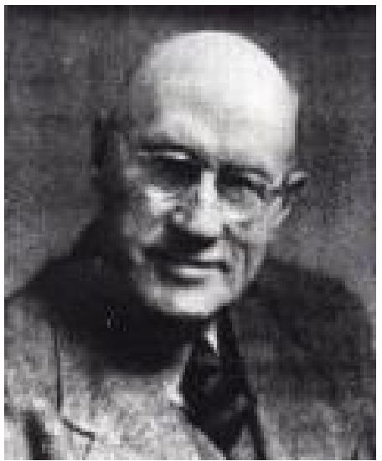
STEPS IN VICTORIOUS FAITH -Part VI
Faith Ignores Symptoms
By Harold Horton
Many sick people, when they have been prayed for, almost unconsciously examine their symptoms, their feelings and appearances, to see if they are healed. It is very evident that that is not faith. That is "putting the cart before the horse," the effect before the cause. It is an attempt to measure the Word of God, not by God's faithfulness, but by what we have understood and proved of it. We must not come to God to see IF He heals us. We must come with full assurance of faith that He will and does heal us. God never tries to heal us. God never half or partially heals us. If we do not seem to be healed it is because we have not yet assuredly believed. If we seem to be only partially healed it is because we have only partially believed. Healing does not at all depend on what we see or feel, but on what we BELIEVE.
DON'T EXPECT RETURN
Only recently a good brother came to me to be prayed for an obstinate hernia. He said he had been healed long ago but that the swelling kept coming back again. I told him as graciously as I could that it kept coming back because he really expected it to come back. The fact that he was still wearing a truss proved the accuracy of my words, Now, I am not here considering the legitimacy or otherwise of "means" - that is another subject.
I am discussing the reason why this hernia kept showing up again. Obviously he was expecting it to come back. He was even making provision for its reappearance. The sure way to discover signs of returning symptoms is to look for them and prepare for them. The enemy will help you to find them almost any time you like. Faith ignores symptoms, and relies absolutely on the Word of God - let me not be misunderstood. We are of course to expect manifestations of perfect healing. There is no healing without health. But the manifestation always follows the faith.
The kind of manifestation accords with the degree of faith. But faith must always go first. I reminded you in a former study that David had so many enemies (so have you, dear friend and I) that he came to the position in God where he determined not to acknowledge them. He "ran through troops" - which is better than fighting them. He ignored what he saw. All the "armies of the aliens" are really defeated and "turned to flight" for us the moment when in real faith and understanding we set foot in the Kingdom of God. We can, if we understand this, ignore them.
FEAR OF DEFEAT
Fear of defeat is a fruitful source of enemy manifestations. If you fear them and look for them, symptoms will appear and follow you like a pack of hungry wolves. Recognition and examination of them emboldens them. Bold courage and living faith intimidate them; they will slink away defeated. Resist them and they will flee from you. If you look to see IF you

THE VOICE OF HEALING November 1952 Page 16
are healed you may easily find that you are not. Fearsome symptoms dog your steps in fear and unbelief. If you BELIEVE, evil symptoms leave you victorious and inviolate, and health symptoms catch you up and accompany you to your infinite delight.
Consider the incident from which we have taken our text. Jesus was hungry. He came to a fig tree, expecting to find fruit. There was no fruit. He thereupon withered it with a word of faith. In the morning, "Peter calling to remembrance said unto him, Master, the fig tree which thou cursedst is withered away." Why did Peter wait until "the morning" to say "The fig tree is withered away?" No doubt because the evening before, when Jesus actually spoke to the tree, Peter did not think it was withered away for to him and the other disciples It did not look as if it were withered away. Perhaps, like thousands since their day, they were looking at symptoms instead of God and His eternal unbreakable Word.
As Jesus spoke, the evening before, they might have been thinking: "The Master has spoken His destructive Word, but so far as we can see, there is no immediate result. There is the tree exactly as it stood - the same root, the same stem, the same branch, the same twig, the same leaf. No change. The Master has worked many wonderful miracles in our sight, but this time He seems to have failed." But - "in the morning, as they passed by" their verdict was reversed. They saw the fig tree dried up from the roots. They needed to see to believe. Last evening they were looking at the tree instead of the Word of the Master. But last evening Jesus was not looking at the tree but at the Omnipotent Word of His unfailing Father. They were looking at symptoms and seeing failure.
Christ was looking at His Word of Faith and seeing victory. They were considering the look of things and missing the reality. Christ was considering the reality of the situation and ignoring appearances. "Master, behold, the fig tree which thou cursedst is withered away!" Of course it was! It was withered away last night when Jesus spoke to it, but they did not believe it because they did not see it! Jesus knew it was withered away because He BELIEVED IT, ignoring symptoms. It was when they realized the actuality of Faith's product that Jesus said to them: "Have faith in God." They had been having faith in appearances; in physical manifestations, in miracles and fig leaves - that is, in symptoms - instead of in God and God's Word spoken by God's mighty Son. Sight may deceive us. Appearances may mislead. Miracles may seem to fall, Leaves may appear to persist. Symptoms may lie. But God's Word cannot fail, and God's love cannot deceive.
Beloved sufferer, if you have been prayed for. Jesus has already spoken the withering Word to that unprofitable growth or development in your body. It is dead and will do you no more harm. Believe it until you even SEE that it will do no harm. Appearances will align with faith.
The evening before, as Jesus spoke the withering Word, the tree immediately became lifeless and harmless. So with your disease, even though appearances do not seem to have changed. But the next day the tree became, not only lifeless and harmless, but leafless and fruitless, that is symptomless. The next day, in a word, the tree looked what it actually was in Jesus' mind the day before - checked and rotted and defunct. No unprofitable growth can withstand

THE VOICE OF HEALING November 1952 Page 16
the Word of the Lord of Life and Health. Jesus has spoken the Word of power now to your disease. Believe it.
Do not look to see if the condition has changed. Look to the unfailing Word and believe it has changed. Ignore symptoms and rejoice in faith. The work is done the moment the Word is spoken. The change has come the instant the heart has accepted it by faith. The dreaded disease is gone by faith - Keep hold of faith until it has gone in fact. Do not look at leaves and twigs and branches and bark-swellings and sores and pains.
Look at the promise, and the Word, and the Lord - and believe! Symptoms will tell you the tree is the same. Faith will assure you the thing is dead. Jesus believed His Word. You do the same. The same result will accrue for you as for Him. Following this incident, in a word that has blessed and encouraged and delivered thousands of real believers down the centuries, Jesus announced, "Have faith in God . . . What things soever ye desire, when ye pray, believe that ye have taken them (Greek), and ye shall have them."
Consider again that devil's hateful trinity mentioned above - swellings and sores and pains.... How dreadful and threatening they are! They are like the three "sons of Anak, Sheshai, and Ahiman, and Talmai," (Josh. 15:14), fearsome giants, who terrorized the people of God for years, and challenged their entry into the Land of Promise. Of them the terrified spies said (the unbelieving spies, who went into the Land to see IF God's promise was true - instead of believing it), "There we saw the giants, the sons of Anak: and we were in our own sight as grasshoppers, and so were we in their sight." But had not God already said, "Thou shalt not be afraid of them," though they were "a people great and tall, whom thou knowest, and of whom thou hast heard say, Who can stand before the children of Anak! Understand therefore this day, that the Lord thy God is he which goeth over before thee; as a consuming fire he shall destroy them, and he shall bring them down before thy face: so shalt thou drive them out, and destroy them quickly, as the Lord thy God hath said unto thee!" (Deut. 9:2, 3). Is not that wonderful encouragement! Therefore courageous Caleb ("whose faith follow" ) prayed: "If so be the Lord will be with me, then I shall be able to drive them cut, as the Lord hath said." Thus, testifying to his faith and the faithfulness of God, we triumphantly read that "Caleb drove thence the three sons of Anak, Sheshai, and Ahiman, and Talmai," (Josh. 15: 14).
So, beloved child of God, if you too are molested by those modern sons of Anak," Pains and Swellings and Sores; if after prayer they have persistently plagued you and challenged your entry into the Promised Land of Health; now - in the Name of the Lord, take victory over them, and, like Caleb, drive them off your territory. Or rather, accept the fact that they are driven off long ago by one Mightier than Caleb. They are beaten at Calvary, and you are free from their power as you stand in faith. Arise in victory now. Slip past the beaten bullies. Do not bow to them. Do not recognize them. Do not see them. Ignore them.
Jesus has dealt with them and driven them out of your pathway and life. Ignore their power and their very presence. Stand in Christ's victory, and rejoice. The manifestation of victory will follow the Faith.

THE VOICE OF HEALING November 1952 Page 16
It is perfectly natural to look for symptoms. But divine healing is perfectly supernatural. It is not a physical thing. It is, like salvation, a thing of grace. Both are by faith and not by sight or feeling. If you look for symptoms you are limited by what you see. Faith leaps far beyond sight and lives in a realm of perfect heaven-centered liberty and victory. Faith has X-ray eyes that see the invisible through the visible, the reality beyond the seeming. The invisible is always in Christ, that serene peace and health and harmony in spirit, soul and body that Jesus died to purchase for all who believe. Symptoms will mislead you. Mistrust them. God will deliver you. Trust Him. Arise - come to Him in the scriptural way - and claim His perfect redeeming work for your body - NOW. In spite of everything- trust Him. Faith ignores symptoms. Because Faith trusts God.

THE VOICE OF HEALING May 1952 Page 17
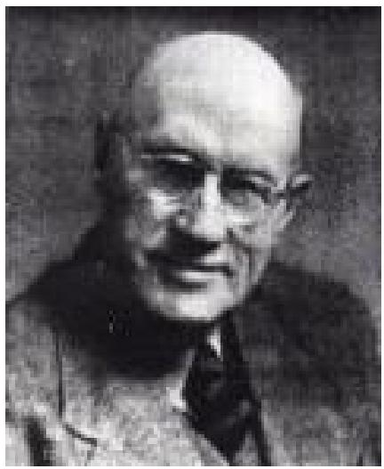
Steps in Victorious Faith No. V
Faith Shows Itself in Action
By Harold Horton
"Faith without works is dead." James 2:20
One of the most important, and yet apparently one of the most
difficult lessons to learn, is that faith is not a doctrine or a theological notion or a religious emotion or a healing principle, but an ACTION.
One of Brother Wigglesworth’s most often repeated axioms was that "faith is an act." There is no evidence of the existence of faith except in our action. Faith has neither proof nor fruit apart from action. James 2 says "though a man say he hath faith and have not works, can that faith save him?” or (since the word for "save" and "heal" is the same in the original) "can that faith heal him?" "Faith, if it hath not works, is dead, being alone... Shew me thy faith with- out thy works, and I will shew thee my faith by my works." "Faith without works is dead." Of Abraham, James says that "faith wrought with his works, and by works was made perfect." The "works" here, in all these scriptures, are of course, not the works of the law, but the works of faith. That is, the works by which alone the existence of personal faith is manifested and operated and enjoyed.
Real, genuine, actual faith cannot be hid. It must inevitably be seen in action. Boiling water issues in steam, and steam issues in mechanical motion. Faith that does not act is not faith. It is, at the best, hope. Hope must progress far beyond its own territory if it is to receive from from God the blessed things He so graciously promises us. The just shall live by faith - not by theology nor desire nor profession - but by living, operative faith. So often our precious sick saints say (when they are instructed to believe): "But I do believe!" Of course, in the secret chambers of the heart they trust they are believing. They hope they are believing. Therefore they say they are believing. But when vital faith is really present it will show itself in immediate action. Faith does not merely proclaim its presence - it shows its presence in fearless action. "I will show thee my faith by my works." "Believe only, and thou shalt be made whole."
On the simple promise and the naked Word, faith obeys immediately, however impossible the promise or absurd the command. The faith that does not act is still secretly arguing with the Word instead of believing and obeying it. To look "at the promise and to begin to weigh its practicability. To compare is not faith; it is doubt the seriousness of our case with the simplicity of the divine provision is not faith; it is doubt. To look at symptoms and the promise and stagger at the seeming lack of connection between the two is not faith; it is doubt. All hesitation is doubt. Faith does not hesitate. It acts, works, launches forth, flings itself with utter abandon on the promise, and seizes its desired object,
How difficult it is to tell sufferers the truth without seeming to hurt them! Even if it appears harsh we must say that if we do not receive when we ask it is more than likely because we

THE VOICE OF HEALING May 1952 Page 17
have not believed. If we ask a second time we certainly do no wrong, but it is a sign that we did not succeed in believing the first time we asked. Ask again. As soon as we really believe we realty receive. Every one that asketh receiveth. Everyone that seeketh findeth. If we are waiting for anything after we have prayed it is because we have not believed we have received. If we wait, it is not really healing we are waiting for, but faith. If we have not faith, let us frankly admit it and wait on the Lord until we receive it. Do not say "There! I have asked the Lord and believed Him, and He has not healed me!" That is putting the onus of failure on God. God puts it on us. If you are not healed, rather say - "Lord, 1 cannot yet have believed. Help Thou mine unbelief." Let God be true and every man a liar where there is seeming failure.
You must believe if you are to receive. If we have believed we must have received, in spite of appearances or feelings. I repeat, faith shows itself in action. It obeys immediately without looking at the likelihood of success. "Go, wash in the pool of Siloam," Jesus once commanded a man who stood before Him in need. If he had been disposed to argue, he might quite logically have answered: "But, Lord, it is not 'washing' I am in need of, but eyesight!" A mind that confronts God and His Word with arguments is choked with unbelief. This man did not argue. He did not hesitate. He did not stay to estimate the virtue of Siloam's water or the reasonableness of the instruction. He immediately went in
obedience to the strange command - and came seeing. HIS going proved his confidence. His works testified to his faith. By his works, his faith was made perfect.
"Stretch forth thy hand," said the Lord to another man, this time in the synagogue. The man might with perfect reason have said, "But, Lord, that is just what I cannot do. Perhaps you are not aware of the symptoms, Sir. My hand is withered from birth. I have never moved it. It is atrophied. It is dead. I cannot stretch it forth." If he had argued like that, no one could have charged him with unreason. It is perfectly true that humanly speaking he could not stretch forth his hand. If he had employed this justifiable logic there would have been an end to all hope of healing. But he did the impossible at the Lord's command. His faith showed itself in action. His works indicated the reality of his faith. He acted his faith, proving its mighty presence. Faith accomplishes the impossible at the Word of the Master
A brother in Worcester, Massachusetts, had suffered from chronic colitis for 14 years, always in pain - eating hardly anything. He had spent hundreds of dollars on doctors and surgeons and psychiatrists. As he went to each new specialist, without exception they all, when they examined him, shook their heads solemnly, giving him no shadow of hope of recovery. I prayed for him in the Name of the Lord and told him to go home and eat something that in his condition he could not eat! He went and did so. He came the next day, fully delivered. I saw him months later, perfectly whole, eating everything he desired with no uneasy effects, and 'working full-time with normal strength. He did not stay to wonder if he could do the impossible. He did it in the Name of the Lord because he was told to. His works proved and implemented his faith.
"Arise, take up thy bed, and walk," said Jesus to another man, in Capernaum. "But, Sir," he might have replied, "that is impossible. Did you not notice that these four friends tore the

THE VOICE OF HEALING May 1952 Page 17
shingles off the roof and let me down at Thy feet helpless and motionless? I am paralyzed, Lord. I cannot arise. I have no life in my limbs, and no nerves in my frame." All that would have been perfectly true and logical. But it would have been an unmistakable proof of unbelief. Unbelief gets nothing from God. Faith moves in consonance with the plan of God. Faith does the impossible at the Word of the Lord. When the Lord commands, He enables - always. He cannot aid the unbeliever. He can and will aid the believer every time. So the man, without contrary word, arose and took up his bed and walked, finding that the command, on obedience, empowered by the creative Word, immediaely performed the miracle of deliverance. Faith is not professed credence. It is not ostentatiously nodding assent to the Word. It is obeying the Word at once without question or fear. "The obedience of faith."
A godly woman, Peter's wife's mother, was suffering from malaria, deadly eastern fever, with no hope of recovery in the natural. Jesus touched her hand, and immediately she arose and ministered to those who had so patiently ministered to her. Her utter confidence in the Lord, and His Word and His touch, displayed itself in immediate faith; faith displayed itself in immediate healing. Now, her friends might with reason have said to her "But Sister, take care! Do nothing foolish. You know the temperature you have been running. You know how weakened you are with long sickness. You know how bitter the weather is today. Be wise, Sister. We know how courageous you are. BUT better rest a few weeks until the weather improves and your strength returns. Your eyes are puffy through lack of sleep. Your pulse is feeble. Your cheek is pallid, and your heart weak." All of which would have been perfectly reasonable in the natural. But faith bounds beyond the natural. Faith does not consider symptoms or circumstances or possibilities. Faith arises at the touch of the Lord. "She arose and ministered unto them." This is where so many fail to get their healing. They do not arise. There are many living like invalids who were healed long ago. They have not yet acted their faith, proving that faith is really not present.
A woman in Detroit called me to pray for her. She had long been house-bound suffering from heart trouble and nervous prostration. She began complaining that nobody had prayed the prayer of faith for her." I spoke to her seriously for in this case it was necessary. I said, "Why do you wear that invalid's house-coat all day long?" I dared to command her in the Name of the Lord. I asked her to go at once and dress in reasonable and normal attire. Then I told her I expected her to come to the meeting that night. She did what I said in spite of my seeming harshness, and she came to the meeting, well and happy. She testified at once that she had been for years seeking sympathy from others, but that now she had learned the lesson of personal faith. She at last acted her faith. She obeyed the command. She arose and ministered to her people, a whole woman. How she enjoyed the new victorious activity in place of the old helpless lassitude!
To sit in a chair all day in a house-coat or dressing-jacket is to look like an invalid. To look like an invalid is feel like an invalid. To feel like an invalid is to act like an invalid. Arise no, beloved sufferer. Do not allow the enemy longer to have dominion over you. Release faith and act according to its dictates. Lie down no longer. Arise and minister. “The spirit of a

THE VOICE OF HEALING May 1952 Page 17
man will sustain his infirmity.” Resist the devil and he will flee from you. Welcome him and he will live with you.
This, I repeat, is where so many fail to get their healing, or lose it when they have it. They fail to rise and minister. (Ministering, of course, means doing normal duties.) They lie down, expecting others to wait on them till they are unable to lift themselves above their circumstances. Do not feel defeated like that! If you have been prayed for, arise now violently in the Name of the Lord and walk and begin to work. Cease to eat invalid food and drink invalid drinks; eat and drink normally in the Name of the Lord Jesus. Faith is the victory. Faith shows itself in action. Faith takes hold. Faith holds on. Faith arises. Faith steps out. Faith is an act. “Faith wrought with works, and by works was faith made perfect.”

THE VOICE OF HEALING December 1952 Page 15
Donald Gee Column
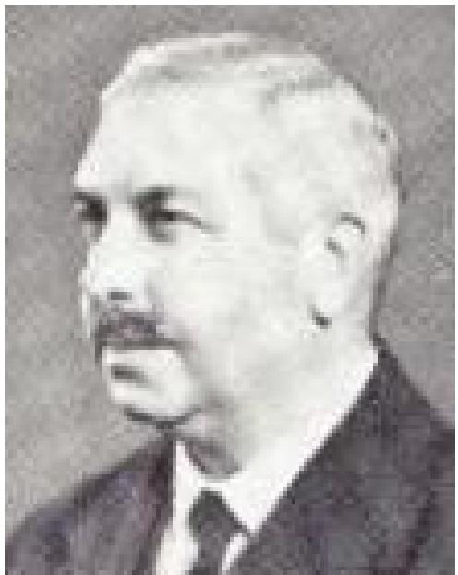
That Grand Word "Health "
The word: "Health" occurs only twice in our New Testament (Acts 27:34 and 3 John 2) where it represents two different Greek words. The second reference surely expresses one of the loveliest birthday wishes we can imagine - "Beloved, I pray above all things that thou mayest prosper and be in health, even as thy soul prospereth." The same word, meaning to be sound, healthy, well, is translated "whole" in Luke 5:31 and 7:10, where the idea of physical health is clear. The other reference takes us into the vivid description by Luke of the disastrous voyage to Rome in which he accompanied Paul. Amid howling winds, driving rain, leaden skies, on a doomed ship, and surrounded by despairing men, God's servant says "Take some meat: for this is for your health" - and then proceeds to eat some bread, after he had given God thanks, before them all . . . "Then were they all of good cheer." In this case the word is that important word "soteria" that keeps on recurring throughout the New Testament. In 40 instances it is translated "Salvation." The verb "sozo" is translated "save" no less than 92 times. So we might think of Paul saying, "Take some food, for this is for your salvation." And so, physically, it proved to be.
I am indebted to J. A. C. Murray in the BRITISH WEEKLY for a refreshing reminder that "soteria" can be translated "health," and "sozo" to heal or to save. Furthermore, he points out the very interesting and suggestive fact that John Wycliffe (1320-1384) who gave us the very first translation of the New Testament into the English tongue, ALWAYS renders the word "health" instead of "salvation." Some of the passages shine with new significance by this translation as, for instance, the story of Zacchaeus (Luke 19:9) "This day is health come to this house." Or Paul's great testimony in Romans 1:16 "1 am not ashamed of the Gospel of Christ; for it is the virtue of God unto health for believers." Working in the opposite direction we can render Luke 8:36 - "By what means he that was possessed of the devils was saved," or Acts 14:9 where Paul perceived that the cripple had faith to be saved.
This enriching bit of Bible study all adds up to the one important truth that when we speak of "salvation" we ought not limit it to the soul, but should understand that it includes a gracious place for the present needs of the body too; and when we speak of "healing" in evangelism we rightly include it as a part of full salvation. When we announce an "evangelistic AND healing campaign" we are making an almost unnecessary distinction from the point of view of scriptural terminology, although it may wisely avoid confusion in popular thinking if we keep them separate. But from a literal standpoint on New Testament language a divine healing meeting is very richly a "salvation" meeting; and a healing meeting means that my whole spirit and soul and body can be graciously saved and sanctified.
The same rich truth is affirmed when our Bibles speak of us being "made whole." To be healthy is just to be whole. "Whole" comes from the Old English root "Halig," from whence

THE VOICE OF HEALING December 1952 Page 15
"Haelth" which is just our modern word "Health" with a transposition of vowels. We still speak of healthy people, particularly old people, as being "hale,” that is – robust and vigorous. Of very helpful significance is the fact that from the same root-word "Halig" we get our word "HOLY" (German ' "Heilig"). Rightly understood to be “holy" is just to be in robust and vigorous health of soul and spirit. Scriptural holiness is not that rather sickly, ascetic, white-faced, negative quality that so often it is wrongly imagined to be. To be holy in God's sense is to be living a full life, red-blooded, active, strong and healthy in perfect obedience to the law of the Spirit of life in Christ Jesus.
(Donald GEE is Editor of a quarterly, magazine PENTECOST which gives a review of world-wide missionary and revival news.)

THE VOICE OF HEALING August 1952 Page 13
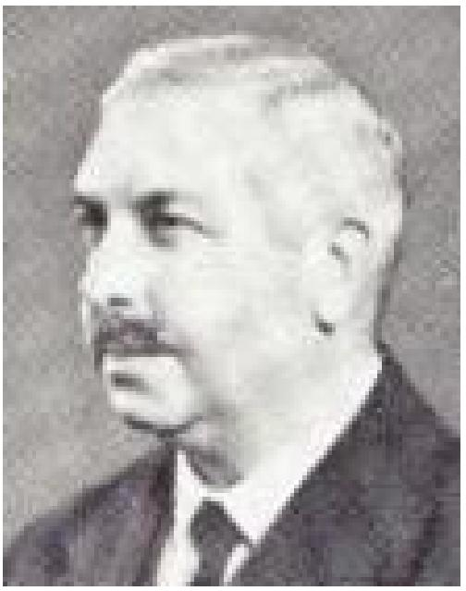
The Donald Gee Column
Unnecessary Discouragement
The purpose of publishing reports of the great Divine healing campaigns and their accompanying miracles in answer to prayer for the sick in the Name of Jesus is primarily to glorify God Who is visiting His people. After that it is with a desire to encourage faith throughout the Church. It is good and helpful for people every-where to know that these things are happening today, and that by means of "signs following" the preaching of the Word, huge crowds, running sometimes into tens of thousands, are being attracted to the Word of Life and thereby many are confessing faith in Christ as their Saviour.
But although all this should be a cause for pure joy we never can tell how some people will react. One of the unexpected and undesired results of the publication of these reports of the great healing campaigns is a reprehensible wave in some local assemblies of complaint against the pastor that, "These things are not happening here!" In some cases it is the pastor himself who is oppressed by discouragement as he compares his own limited ministry with the spectacular reports published in various magazines.
Now if a preacher takes the line of definite repression of the Spirit, and if he goes so far as to actively promulgate unbelief in out Lord working today, as at the beginning of the Christian era, then we shall have every sympathy with the lawful complainers. The scriptural command to "Quench not the Spirit" stands unaltered, and that with special reference to the manifestation of His gifts, as the context and any good commentary as a spur to draw us nearer to God. Let us cultivate it while it is healthy. Happy are they who "hunger and thirst." They do as all good.
But it is a very different matter where a local pastor is faithfully preaching the full gospel and prays continually for the sick in the course of his ministry. Such a man ought to command the loyal support of all his people, even though his efforts way not appear to be meeting with spectacular success. As a matter of fact, and I speak from personal knowledge, there is a vast amount of quiet healing ministry going on in thousands of Pentecostal Assemblies all over the world. The big efforts and the mammoth campaigns get the limelight. Indeed they almost HAVE to as part of the technique of modern methods of evangelism. We need not grudge it to them. But it is a very big mistake to think that the Spirit of God is only using the prominent preachers, and only working in the big campaigns, Thank God that He is using the little ones too.
The discouragement of some faithful local pastors and some humbler evangelists and missionaries because they are not seeing in their ministries the same results as those of the widely advertised campaigns is to be sincerely deplored. It touched a tragic depth in the too-long fasting of one preacher who rashly vowed that he would not eat until God showed him why "signs" were not following his ministry. We admire his zeal and his devotion even unto

THE VOICE OF HEALING August 1952 Page 13
death in his sincerity, but it all seems to have been so unnecessary and misguided. Surely the right thing is for us all to go ahead with such faith as we possess, by the grace of God, and then trust Him to confirm His Word.
We use a mistaken measuring rod, and because unnecessarily discouraged over our own ministry, if the measure we use is the apparent success of some outstanding evangelists whom we have placed before our eyes us models. The measure of each man's faith lies within the grace of God (Rom. 12:3) and the distribution of gifts "as He will.” No amount of fasting will force us beyond the talents entrusted to out care, though it may greatly help us in doing our utmost with them. Our true concern is faithfulness with what the Lord HAS bestowed, and none need complain of lack of scope in which to win the Master's approval. To ACT in His Name, and then leave the results with Him is the way of truth and wisdom. The supernatural so many long to see is not the reward for morbid strain and stress, but rather it is the manifestation of the Spirit working through different members of the body of Christ according to the will of God. Our part is faith and obedience - the rest belongs to the Almighty.
Unnecessary discouragement caused by unwise comparisons is to be restricted. Our duty is to rejoice in all that the Lord IS doing anywhere and everywhere, and then serve Him with joy in our own sphere in confidence that He is faithful. Intense longing for revival to the point of real travail in intercession is a vital part of the Divine method, but with the burden of the Lord there should come a deep inward peace and freedom from personal anxiety. Let the reports we read of signs and wonders elsewhere no longer cloud not joy with local or personal discouragement. Let them, rather, stimulate us to be on the tip-toe of expectation while we carry on with a song in our hearts and praise on our lips to the Giver of all good.
(DONALD GEE is Editor of a quarterly magazine PENTECOST which gives a review of world-wide missionary and revival news.)

THE VOICE OF HEALING January 1952 Page 14  Steps in Victorious Faith No. III  Faith Believes Before it Receives  By HAROLD HORTON  "Have faith in God (Have the faith of God. R.V.) ... What things soever ye desire, when ye pray, believe that ye receive them, and ye shall have them." Mark 11:22, 24. | 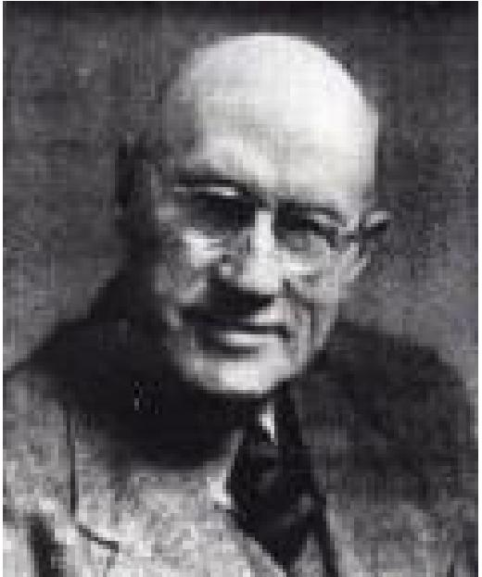
Faith is the opposite principle of sight. One of the most difficult lessons to learn (it ought to be the simplest) is that what we see has nothing at all to do with what we believe. It is only difficult because we have an idea faith is profound. It is not. Faith is simple. If our faith were but more simple, we would take Him at His Word. My old intimate friend, Wigglesworth, often said in my hearing, that "Faith has nothing whatever to do with symptoms."
What we see may not be what we believe, but what we believe is bound to come to pass as soon as we believe it. What we see, even after prayer; may often give the lie to what we believe, but the liar is not faith but sight. What we believe already exists, though for the time being we may not see it. When there are clashing evidences like that, one of them must be wrong. Which is the culprit? What we believe or what we see? Which is the liar, faith or sight? There ought to be no doubt in our minds about the matter when we view it in the light of God. If we receive the Word as the voice of God, then it must be true. That being so, the opposite evidence must be the lie. God says, "everyone that asketh receiveth." (Matt. 7:8.) If when we ask we do not seem to receive, then the seeming must be wrong. But how often this seeming is the only thing that people see and believe when they pray. In the natural order we always want to see to believe. In God's order we must "believe to see.” Psalm 27:13. Believing always precedes seeing. But just as truly, seeing always follows believing, that is if believing is true, founded, unshakable, solid faith. When, therefore, we ask God for a thing like healing, we must not look or feel to see whether or not we have it. "He that cometh to God must believe THAT He is." We must not consult looks or feelings or symptoms. We must consult the Word of God which says we already have the thing we ask for when we believe. We must not, I repeat, look around to see if we have the thing we ask for. We must believe and know that we certainly have it as we ask in faith. Asking is receiveing. Believing is having. Faith is more than desiring... It is more than asking...It is possessing.
The promised land belonged to the people of God before they actually set foot on it. "Every place that the sole of your foot shall tread upon, that have I given you." Joshua 1:2, 3. God here was not promising to give them the promised land. He was stating that He had already given it to them. It was theirs! All they had to do was to believe and possess it.
So God has already "blessed us with all spiritual blessings in heavenly places in Christ." (Eph. 1:3). All the heritage Jesus died to purchase for us is ours, now, at this moment. It is not that God promises to give it to us. He has done that already. It is ours. All we have to do is to set foot on it . . . To believe and possess it by faith.

THE VOICE OF HEALING January 1952 Page 14
Now healing for the body is part of that blessed inheritance represented by the land of promise. It is therefore before us now, ready for our possession. God completed the work of healing nearly 2,000 years ago when He placed all our diseases on the precious, flawless Lamb of God, our Substitute. That heritage - healing - is now yours and mine. It is the purchased possession, our Lover's legacy to us. We are the legitimate legatees, the heirs to all the estate. We are not only right to go in and claim our very own inheritance; we are well able to go in and possess it, as Caleb said, the people were well able to possess all the land of Canaan. (Num. 13:30). Thousands missed that lovely land through common unbelief. God grant we may not in the some way miss our inheritance of healing for our sickness through the very same common, almost universal unbelief.
Look at the passage we are considering again, and divide it for clearness. "What things soever ye desire." Soever means anything, Ye means everybody. What things means your healing, beloved sufferer. It is perfectly natural and legitimate for the sick to desire healing. God has budgeted for that very thing in the gospel of deliverance. Most people have been taught so little or so poorly in the churches that they are afraid even to desire healing from God, though they are strangely not afraid to desire healing from the human professionals. Are you deathly sick, brother, sister? You are in divine order in desiring to be healed. One of the names of your Saviour is Jehovah Rapha, "the Lord that healeth thee." Then begin there, with absolute confidence that you are in the will of God. Desire strongly now your perfect healing. Then add that the Lord has promised to give you even the desires of your heart. But the next word is, Pray - "when ye pray." Here again many who do not know the Lord very well (He loves them all the same) are afraid to pray lest they pray wrong. Do not try to invent fine sentences. The Lord hears a broken cry, as He heard the cry of the young lad, Ishmael, in his grief. (Gen. 21:17). Prayer is not talk, nor oratory. Some people think it is. They thought so in Jesus' day. (Matt. 6:7). No. Prayer is need finding expression. Three words will do, if you mean them and believe God takes you seriously. Pray now - "Lord heal me." Again, to quote my dear old friend Wigglesworth, I have heard him more than once declare that he could get more out of God "by believing Him for one minute than by talking to Him all night." Do you get the truth of that? It is important. God never promises to answer prayer in the abstract. There is a skyful of abstract prayer rising to God every day. He only promises to answer BELIEVING prayer. Prayer that does not believe is not prayer in any scriptural sense. When ye pray, BELIEVE. That is the next thing. Do it now. Put your hand on your sick part, and ask God now in those three simple words in real faith: "Lord heal me." Believe He does it NOW.
The next move is to "receive." When? Just now, the moment we pray. Now the text in the King James version is "believe that ye receive them." But the text both in the American and the English revision is “believe that you have received them.”... Which is mightier still. Do not believe as you pray that God is going to give you what you ask for. Do not even believe He is giving it to you. Believe that you have it - now. Indeed F. B. Meyer tells us that the word in the original is much stronger even than "have received." He says it is a physical word, violently active. He translates the verse this way: "What things soever you desire when you pray, believe that you have taken them." We must believe, that is, before we receive. Do that now with your healing. Take it - grasp it - seize it. Lay depredatory hands

THE VOICE OF HEALING January 1952 Page 14
on it. Snatch it. Make it yours. Hold it fast. Do not wait to see if it is coming. Do not look to see if it is there. Take God's Word concerning it as the actual thing you are desiring. It is yours, not for the asking, but for the taking. Assuredly know what God has assuredly promised. Not because you can see it or feel it, but because you have taken it in the vice-like grip of living faith, When you pray in faith of that sort, the faith of God, you already have the thing you pray for. You have it because God says so. Believe that, and you have it actually, visibly, sensibly, rejoicingly.
A good sister, wife of a Pentecostal pastor friend, in middle life suffered, like many sisters, from internal prolapse. The Lord healed her and the healing stood for some years. But one day, as she was ironing clothes in her kitchen, her inner organs once more slipped from their moorings, She grew wrathful with the enemy, slapped down her iron, put up her hands and cried. "Lord Jesus, I will not have this! You have healed me. I claim that healing now!" She felt warm divine hands knit together her organs. She was healed. At that moment her husband came into the house from a pastoral visit. 'As he saw his wife he said, "Mary, you are rosy with the glory!" "Yes," she said - and told him what I have just written. "Ah, Mary," he said, "I am learning in my advanced years. I see there is something more than believing. There is something more than receiving. It is TAKING ."
Take your healing now, sister, brother. Count on it - and God ... and rejoice.

THE VOICE OF HEALING September 1952 Page 17
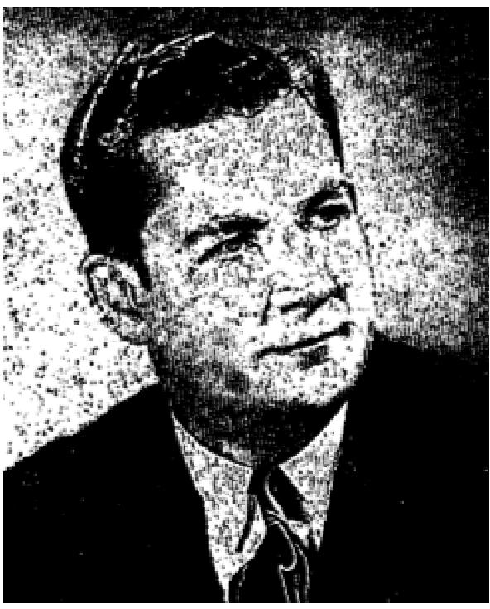
WHAT IS FAITH?"
By GAYLE JACKSON
"Faith is the substance of things hoped for. The evidence of things not seen." (Heb. 11:1)
Literally hundreds of men and women from night to night and day today, through the channels of mail, telephone and personal contact, continue to ask the vital questions: "how can I get healed? How can I be saved? How can I be free from the habits and the sins that bind me? How can I find the peace that you preach about from night to night?" Multitudes are in the valley of decision. Multitudes are searching for the light of a better day. There are hundreds under the sound of my voice tonight that need help - along the line of knowing how to receive from Almighty God, and that is what I want to help you with at this time. I want to teach you how to receive from God. THERE IS A WAY THAT YOU CAN HAVE ANYTHING THAT YOU WANT, THAT IS PLEASING IN THE SIGHT OF GOD. God has promised His children that if they live good -and obedient they shall eat the good of the land. He promised again that He wouldn't withhold anything good from them that walk uprightly. Isn't that right?
God Has Promised US All Things
All things are in Him, and everything that is good and perfect and noble and sweet and virtuous belongs to the people of God in this day. Thousands yea millions are living beneath their privileges in Christ tonight. If only they knew how to reach God and approach Him, how much sweeter their Christian experiences could be. How much more beneficial they could be to their fellow man, and how much brighter rays of sunshine would radiate from Christian lives to bring conviction upon the sinner and cause him to yearn for the kind of experience enjoyed by the child of God.
You Do Not Have to Live in the Gloom
You do not have to live in the night. You do not have to live in a world of fear and doubt and misunderstanding. Jesus Christ has provided a way whereby you can have the sweet, good things that God his given to the Human Family. He has provided a way of happiness and joy, but there is only one way by which we may obtain these blessings and that is by THE AVENUE OF FAITH. You must lay aside everything else. If you receive anything from God, it must come through the avenue of faith. There is no other way. Blessings from God do not come through the realm of the five senses, but through the sense of Faith. Do not forget that. You do not receive from God because you are good. You do not receive from God because you have been a church member for a long time. Neither do you bargain with God. Some people come to these meetings and say, "If God will heal my little child I will live right." Others say, "If I see someone else healed of the same disease that I have, I'll go up and let the minister pray for me." THAT IS NOT FAITH, my friend. Oh, that displeases God when we cling to that attitude. God is pleased when we believe Him and stand on His Word alone.

THE VOICE OF HEALING September 1952 Page 17
Faith
You say, "What is Faith, anyway?" The Bible says that FAITH IS THE SUBSTANCE OF THINGS HOPED FOR, THE EVIDENCE OF THINGS NOT SEEN. I want you to know tonight that when YOUR HEALING BECOMES VISIBLE, IT IS NO LONGER FAITH. When your salvation comes to the place where you KNOW that you are saved, it is no longer Faith, it is knowledge. You believe before you are converted. You BELIEVE before you RECEIVE the Baptism of the Holy Ghost.
Faith Without Works Is Dead
You do not get anything until you BELIEVE. You just search for yourself and see. God knows there isn't a preacher in the land that believes in FEELING any more than I do. Right now I feel just about like David felt that day when he danced and shouted so at seeing the Ark coming up the road. His wife despised him in her heart and God cursed her in a manner to prevent her bringing forth children. That is exactly the condition that exists today. Much of the church has become FROSTED OVER, PETRIFIED, PUTRIFIED, APOSTACISED, WORLDLY, COLD, and has denied the power of God, DENIED THE VIRGIN BIRTH, DENIED THE DIVINITY OF OUR LORD, TURNED AWAY FROM THE POWER OF GOD AND ACCEPTED A FORM OF GODLINESS AND DENIED THE POWER THEREOF - AND THEY NO LONGER BRING FORTH CHILDREN INTO THE KINGDOM OF GOD.
Faith Is Like A Title Deed
It is the thing that you desire that you cannot see. Praise His name forevermore. Faith is like the deed to your house. You do not have to see your house to know that you have a house. You see a deed. It is not necessary that you see your bank account to know that you have got money. You have a cheque book. You can be in Germany or in any state in America and walk up to your kinfolk and friends and say, "You may be poor but your old bud here is rich." They look at you and say, "You are?" You reach down in your pocket and pull out a little check book, telling them that you own an estate, and produce from your brief case abstracts, deeds, etc., to prove your statement. Just a few sheets of paper, but on those little pieces of paper there is a description of thousands of dollars worth of land and real estate, and it is listed in your name, with no mortgage on it. It is a clear title deed and NO ONE, according to the law of the land, can take it from you. It is yours, wherever you go. Whether or not you SEE it or SMELL it or TASTE it or FEEL it, it is yours, because you have the title deed to it.
The Sixth Sense
The sixth sense is the sense of Faith. It is our title deed to the things that God has given to us. Our Saviour made us a will one time. He left us His will and Testament. The testament is of no value until the death of the testator. One day our Testator died and He left us a will. In that will and Testament is the salvation of every man and woman under the sound of my voice tonight, and in that will and Testament is contained the healing for every sick man here tonight. Some people ask the question, "Brother Jackson, is healing for everybody?" Yes, HEALING IS FOR EVERYBODY THAT WILL BELIEVE IN ALMIGHTY GOD.

THE VOICE OF HEALING September 1952 Page 17
Some Say, "I think that it is the will of God for me to be sick; well, if you think that it is the will of the Lord for you to be sick, quite rubbing yourself. Let the medicine alone! Don't ask anybody to have sympathy for you. Don't call the preacher to pray for you because you would not want to do anything to hinder the will of God. It is the will of God that all men be FREE.
A God of Love
'The way you approach God is exactly the way in which you approach anyone that you have confidence in, on a straightforward business basis. God has laid down in His book certain laws. God said: "He that believeth and is baptised shall be saved." He also said that if we confess with our mouth and believe with our heart that Jesus Christ is the Son of God . . . we shall be saved. Confess and believe and that brings salvation. It makes no difference how you feel. I'll tell you, that if there is anything that makes me tired, is for someone to get down to get saved, and after having worked and prayed with them for quite a while, they look up drying their tears, and upon your inquiry of how they feel, they half-heartedly confess that they do not feel much different, This is a repeated happening over and over in the churches across the land and it is a disgrace in the eyes of Almighty God. We should have more confidence in God than that. God give us courage! You say you don't feel any different? Did God say anything about your having certain feelings when you got saved?
God Honors Faith
This is a thought worth more than gold, if you can open your hearts to receive it tonight. ANYTHING that you believe God for, you have. I don't care whether you see it or not. You have it. Isn't that wonderful? If I believe I am saved ... I AM SAVED. If I believe that I am healed . . . I AM HEALED. If I believe for the Baptism of the Holy Ghost, I receive it, if I ask God for it and believe. I have it. REMEMBER THAT!

THE VOICE OF HEALING January 1952 Page 6  Why Some Are Healed Quickly, Others Slowly  By Gordon Lindsay  It is a well-known fact that in ministering to the sick, many are healed instantly, some gradually, others not at all. This fact causes many people to stumble, and conclude that there is an element of mystery, inscrutable and imponderable, about the work of healing - that God heals rapidly in some cases, and slowly in others, as He for some mysterious reason, may choose. | 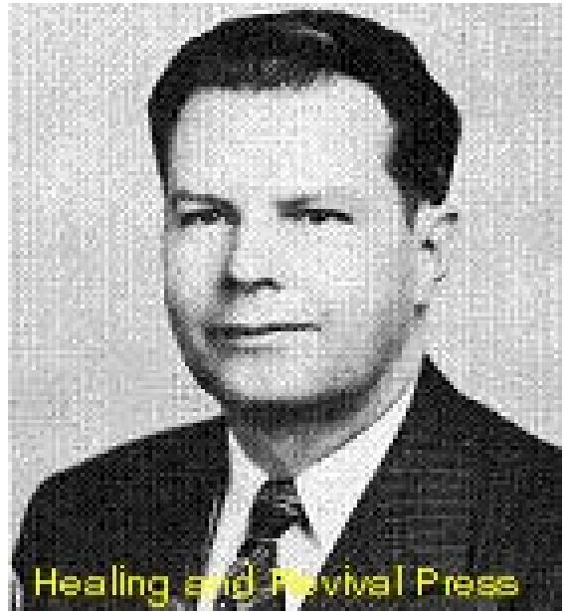

'This however, is a great mistake, and leads to wrong views on the subject of healing. The fact is that the Spirit of God, in a certain sense, is passive - though a thousand people cry for healing, they will not be healed unless the means that God has provided for the release of the healing power of the Spirit be appropriated. There are a number of factors which govern the intensity and rapidity of the flow of healing power. It is important that we consider these if we are to have an intelligent apprehension of the working of the ministry of Divine Healing.
The Minister
The First factor on the rapidity of Healing involves the one who ministers to the sick. The Scriptures declare that "to another is given gifts of healing." It is reasonable to believe that an individual to whom this special ministry has been given will have more success in ministering to the sick than one who has not, though it is also true that there are instances where a simple child of God will pray the prayer of faith and have success in the healing of a stubborn case, where others, perhaps with noted ministries, have failed. This is because there are other factors involved in the matter of the manifestation of the healing of the sick beside gifts of healing, and these also determine the issue. Nevertheless, it is to be expected, that those who have specially entered into this ministry will have greater success than others who may not have entered into the same realm of faith. An instance of this is the case where Jesus brought healing to the demon-possessed boy, after the disciples had failed (Matt. 17). Their ministry had not achieved the same degree of power that Jesus' had, for, reasons that He later explained.
The Anointing of the Minister
The Second Factor in the Rapidity of Healing involves the anointing upon the minister at the
Time he prays.
Every minister who has had success in praying for the sick, knows that he ministers with greater power on certain occasions, than at other times, Generally speaking, he will have a greater anointing during a service, than when he is accosted at a time when his mind is on other things. The human spirit cannot be at the same degree of intensity the whole 24 hours of the day. Extreme weariness often lowers the effectiveness of a man's anointing. After a man ministers to a large number of the sick, he begins to feel weak, and he finds it advantageous not to pray longer, until he has had time to rest. So Jesus recreated at times, from the multitude, even though there were many sick to whom He had not ministered

THE VOICE OF HEALING January 1952 Page 6
(Mark 6;31). It is to be noted that after a time of rest, he returned to minister in great power. (Verses 55 and 56).
The Degree of the Power of The Lord Present
The Third Factor in the Rapidity of Healing involves the degree of Faith in the
"Atmosphere" where prayer for the sick is made.
A hostile or unbelieving audience can definitely retard the power of healing. Thus in some very serious cases recorded in the Scriptures, we find that before ministration was made, unbelievers were excluded from the room. This happened when Jesus raised Jairus' daughter (Matt. 9:24-25). Peter also put forth everyone from the room when he prayed for Tabitha to be raised from the dead. (Acts 9:40).
In John 5:4, it is very evident that there was a marked difference in the manifestation of healing power at one time than at another. In this case, it was the presence of an angel that determined the difference. However, since “all power is of God," it comes back to the same thing that there is a difference in the power manifested in healing at one time and another.
Prayer and the teaching of the Word of God, determine, to a great extent, the Divine healing power present. In this respect, Luke 5.16-17 is an extremely significant passage of Scripture. We are told that Christ withdrew himself into the wilderness and prayed, and then returned and taught the people. As a result, "the power of the Lord was present to heal." On the other hand, in Mark 6.1-6, His attempt to teach the people of Nazareth met with a rebuff. We are told that "he could do there no mighty work, save he laid hands upon a few sick folk and healed them." (Verse 5). Prayer determined the degree of the healing power present; the amount of faith present determines the release of that power.
The Faith of the Sick Person
The Fourth Factor in the Power of Healing is the degree of faith that the sick person possesses. The need of personal faith, if one is to receive any thing from God is so widely taught in the Scriptures, that we hardly need to dwell upon this matter here. Jesus said, "According to your faith, so be it unto you," or "Your faith has made you whole," Many factors determine the faith that an individual has. Generally speaking, when an individual desires healing, he needs to have his faith quickened for that particular healing. Christians of long standing, who call for prayer at a moment's notice without any heart preparation, often find it difficult to receive their healing. "Faith cometh by hearing, and hearing by the Word of God."
The Individual’s care of his Body
The Fifth factor in the Effecting of Healing involves the individual's care of his body. It is true that a person, when ministered to, must act his faith. He should begin doing what he could not do before. However, he should not be negligent in the care of his body. A person healed from a serious sickness, should not overdo, or attempt foolish and unprofitable ventures just to show how strong he is. We have known those who have had remarkable deliverances, and who foolishly dissipated their strength by long working hours, eating

THE VOICE OF HEALING January 1952 Page 6
carelessly, plunging violently into business, without thought that they might go beyond their strength. Healed people should not baby themselves, yet nature itself teaches us that proper care of the body is essential, and people who are careless in this way, have been known to have had relapses. which can be charged to the fault of no one but their own.
The Degree of Damage to the Physical Body
The Sixth Factor Involved in the Power of Healing, is the fact that there is a vast difference between a sickness which may be healed, and a wasting disease that has already destroyed vital parts of the body, and where complete healing involves creative action, As an illustration: a man who has an injured arm may be healed. But if his arm has been destroyed, it may well be that he does not have faith for it to grow back again. Now, let us take a parallel illustration in which two individuals have cancer, of the stomach. Both arc prayed for and in both cases, the cancer is killed and passes from the body. One person fully recovers, but the other never becomes fully well. In the first case no vital organ was destroyed and the person recovers. In the other case, vital parts of the organ were already destroyed by the cancer. Healing is not sufficient. Because of the advanced stage of the cancer, a creative miracle is required to restore parts vital to life. Where faith is high, such a miracle may, and often does, take place, however, where faith is weak, it is quite possible that the death of the cancer may take place, without the necessary recreation of destroyed organs. Moral: A sick person should seek the Lord for his healing before he is almost dead and not as a last resort. Such delay is parallel to that of a sinner, who waits till he is dying, before he makes an effort to get his soul saved. There are, of course, death bed conversions, and there are also remarkable healings that take place on apparent "death beds."
The Determination to Stand on the Word
The Seventh factor in the Power and Rapidity of a Healing involves the individual's determination to stand on God's Word and his refusal to be influenced by symptoms. The new convert who gives way to feelings or temptation, may, all the balance of his life be a spiritually sick Christian. Being dominated by his senses, instead of God's promises, he is continually up and down. In contrast, other Christians who learn to stand on the Word regardless of feelings or the devil's lies, develop into sturdy believers, and enjoy an experience of victory.
So it is with those who come to God for healing. There are those who are entirely influenced by the way they feel rather than by God's Word. Consequently, they often lose what they already have. On the other hand, there are those who are determined to believe the promise, and as they do the symptoms vanish, and their healing becomes a ringing testimony of God's healing power.
Some have faith for a miracle, but not all. However, all have enough faith for a healing, if they will only use the faith that they have. Jesus said, if a man had faith as small as a grain of mustard seed, he could speak to a mountain, and it would be removed. But you cannot dig up the mustard seed the next day, or the third day, to see if it has become a tree. But, if left alone, that bit of faith that God had created in the mustard seed, will cause action, and

THE VOICE OF HEALING January 1952 Page 6
though this at first is imperceptible, yet finally it will result in the seed growing until it becomes a great herb.
The lesson to be learned then, is that we should not become discouraged because of difficulties, or because deliverance does not become fully manifest immediately. The thing to remember is that in every case, the difficulties will eventually be resolved, and overcome, if we refuse to accept defeat.

THE VOICE OF HEALING May 1953 Page 22
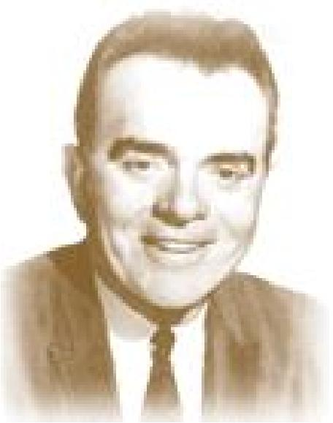
Demon Possession Today
(A Chapter from the book of the above title)
By A. A. Allen Chapter II
Are Demons Real?
Are they real? How could any person who has ever read the Bible ask such a question?
Let us slip back into the eighth chapter of Luke, and there in verse 27, have a look at a man who dwelt in the tombs. There we see him with not a stitch of clothes on his thin, cold, naked frame. Night and day he wanders through the mountains, continually crying and cutting himself with stones. (See also Mark 5: 1-15) Thousands of devils had driven this man there, for "Many devils were entered into him.” (Luke 8:30)
Just ask that man if devils are real! Watch him there as with stones he cuts himself... again and again, blood spouting from the wounds! You say demon possession isn't real? Yes, it is real! That man's nakedness is real. His insane crying day and night is real. And the demons that torment him are real! Sure proof of their reality is found the method of his deliverance. Watch as Christ casts out the devils. Listen as the man (or more accurately the demons within him, speaking through his lips) cries out "Torment me not!" Hear Jesus, ask him "What is, thy name?" The answer comes, "my name is Legion, for WE are Many." (Note the plural WE. Not the man speaking, the demons within!) Hear the demons plead to be sent, not to wander through dry places, seeking rest (Matt. 12:45), but into the great herd of two thousand swine across on yonder hill slope (see Mark 5:13).
As Jesus cast out the devils, He gave them permission to go into the swine. Tell me demon-influence isn't real, those two thousand swine run violently down a steep place and into the sea! Yes it is real! I can see the swine as the breakers wash them up onto the beach, every one dead. KILLED BY DEMONS! A grim reality!
But the man out of whom the demons were cast, where is he? At the feet of Jesus! He is wearing clothes now, and in his right mind. Yes, demons are real, but thank God, the deliverance from demons that Jesus gives is real too!
Not far from where you live is what society calls a "Psychopathic Hospital" or in other words, an insane asylum. As you walk down the long corridors, is that large ring of keys hanging at the nurse's belt real? The many doors she unlocks before you and locks again behind you, you know they are real! The hardwood lined cells with great niches worn in the hardwood - could it be true that bare human fingers have worn those deep furrows in hardwood, as a dog scratches in the earth?
As we watch in amazement, a dozen husky men guards overpower a single man, and place him in a straight jacket. Is the strength of that man real? What is the source of this sudden super-human strength? Could it come from a natural physical force, or does it come from

THE VOICE OF HEALING May 1953 Page 22
demons? After the brute of a man is hauled off to his cell, we inquire of the guards. We find to our surprise that this man at one time was one of the most learned men in America, a professor at Yale. We are informed that he has these spells only about once a month. They last only a few days, and then the man is perfectly normal again.
In one of our great tent campaign services, one of the ushers rushed to the platform where I was seated, and quickly informed me that, far to the rear of the tent, someone was "having a fit." Before I could get back to the person, excitement had grown. A group had already gathered round, some praying, some plainly not knowing what to do. A couple of strong Men were keeping his tense body on the chair upon which he was stretched. What a pitiful sight! Was that real blood that ran down from his mouth as he chewed his tongue? Did I just imagine that I saw this young man stretched out and writhing on the chair? Those uncanny animal-like noises that came from, the man - could a human make such a noise? Surely that couldn't be real! But it was! You say of course it was real.
You have seen such cases - you know they are real! Only a few moments before, this same young man had sat there with his revival song book in his hand, singing, seemingly enjoying the service, when suddenly he began to stiffen, lose control of himself, as a spirit more powerful than his own took over. The demon which had taken control of him is just as real as the blood, the foaming lips, the chewed tongue, the writhing, agonized body, the uncanny sounds. There can be no effect without a cause!
If you are still in doubt as to the reality of demon power in this case, here stands the boy's father, ask him. His story is very similar to the one told in Mark 9:17-27, "Wheresoever he (the demon) taketh him, he teareth him: and he foameth, and gnasheth his teeth and pineth away: and ofttimes it hath cast him into the fire, and into the waters to destroy him." (Note: There was a definite time when this spirit or demon came upon him, or took him." It did "tear him." It was real enough to cast him into the fire and water to destroy him.) When Christ rebuked the demon, it cried and rent him sore, and came out of him. If spirits are not real, they cannot enter into people, they cannot tear and rend them, they cannot cry and moan and groan. They cannot come out. Only a real demon could make a lunatic out of a normal boy (see Matt. 17:5-18). "Jesus rebuked the devil; and he departed out of him: and the child was cured from that hour.”
DEMONS ARE REAL!
Demons were real nineteen hundred years ago, and they are just as real today!
Into one of our recent healing lines came a man, who couldn't talk. From the card the man had filled out, I learned he had been unable to talk eight years. His wife volunteered the information that he had spoken perfectly until eight years before when suddenly, something seemed to get hold of him and paralyze his speech organs. In obedience to Mark 16:17, I laid hands upon the man and commanded IN THE NAME OF JESUS the dumb spirit to leave him. Immediately, a smile came to the man's face. He opened his mouth and for the first time in eight years, began to speak perfectly, shouting the praises of God, crying, "It is gone. It is gone! I am free!"

THE VOICE OF HEALING May 1953 Page 22
Was this man's condition real' Could it be attributed to a demon, or a devil? Let us go to the Bible for the answer. From Matthew 9:32, 38: "They brought to him a dumb man possessed with a devil. And when the devil was cast out the dumb spake."
Note that the scripture plainly declares that this man's condition was because the man was possessed of a devil, and, that when the devil was cast out the condition was relieved: How could any one who believes the Bible say that demons no longer exist? It is time people got back to the Bible and began to learn the truth!
Was the deliverance Jesus gave real? Yes! And your deliverance can be just as real! "You shall know the truth and the truth shall make you free" (John 8:32).
In one of our tent campaigns in the deep south recently, a young man brought his deaf mute friend for deliverance. Upon examination, the young man, 21 years of age, Was found to be totally deaf from birth, and utterly unable to speak. Laying hands upon the young man, I rebuked the deaf spirit, charging it to leave in Jesus name. Immediately, the young man was not only able to hear the faintest sound but, in a few moments, was taught to say a few words, such as Mama, Papa, and Brother Allen. A few nights later, he was able to speak even in sentences, in a clear language.
This young man who had been delivered had a little brother eight years old, who was in the same condition, having never, from birth, been able to hear nor speak. The last night of this campaign, the lad's father brought him to me. According to the scripture, we laid hands upon this young boy, commanding the foul spirit to leave in the name of Jesus. In a split second it was gone! The little lad, even as his older brother, in a few moments time, was taught to speak simple words, and proved beyond a doubt be could hear the faintest sound.
Was the condition of these two brothers real? I asked the lad's father. He declared that neither of his two sons had been able to hear sound, nor to speak a word until the night they attended the great healing campaign and were set free by the power of God from these afflicting demons.
Ask that young man if the demon was real - that demon that had, him bound tied and fettered, rendered speechless and unable to hear. He will tell you that the moment I laid hands upon him not only was he able to speak, but, thank God, to hear also.
From the V0ICE OF HEALING magazine, Dec., 1951, I quote:
ONCE TOTALLY BLIND - SEES AGAIN
"In March of 1951, I had a stroke. I was unconscious four days, after which I was totally blind. My son drove me to Tyler, Texas, to A.A.Allen's revival, and led me to Rev. Allen, who placed his hands upon me and prayed, saying, "Thou Spirit of Infirmity who makes this man blind, I bind and rebuke you NOW in the name of Jesus! I command you, in Jesus name

THE VOICE OF HEALING May 1953 Page 22
to go now!" Then he took his thumbs from my eyes, commanding me to see. God had instantly healed me. I saw many people. I saw their faces. I saw the evangelist clearly, even the colour of his tie and suit. Praise God! Once I was blind, but now I see!"
(Signed) J. 0. Bryan Chatham, La.
Ask this man if demons are real! Ask him if deliverance is real! In his case, all that I had done was to rebuke the spirit that had blinded the man. As I removed my fingers from over the man's eyes, he immediately began to shout, "I can see! I can see! I can His deliverance was REAL!
Recently, a woman came into the prayer line, who had been deaf in one ear many years. Placing a finger in that ear, I commanded. "In the name of Jesus, thou deaf spirit, I charge thee, come out!" A smile of joy came over her face. She began to clap her hands and shout, "I can hear, I can hear!" While the great crowd rejoiced with the woman, suddenly her expression changed. The smile left her face, and she showed great distress. Pointing to the ear which had been normal, she cried, "I'm deaf in this ear now!" When I had commanded the deaf spirit to leave one ear, at my command it came out, but had entered immediately into the other ear. As soon as I had commanded the spirit to come out of her and enter no more into her, she again shouted the victory over the deaf spirit, hearing perfectly with both ears.
Suddenly a woman, sitting in the fourth row from the front, leaped to her feet and ran down the aisle to where I was standing on the ramp, a look of fright an her face and fingers in her ears, screaming, "My God, my God, I'm deaf! I can't hear a thing!" The deaf spirit cast out of the first woman's cars had entered into hers - and she was totally deaf! "I can't even hear myself talk!" she declared. Her hearing had been normal up until this moment, but suddenly IN A MOMENT'S TIME she was totally deaf. This proved to me that not only this case, but many cases of deafness are a result of deaf spirits. I laid my hands upon the woman and commanded the deaf spirit to come out. Immediately this woman, too, rejoiced shouting, "'It's gone! It's gone! Thank God. I am delivered!"
Was this real? Yes, my friend, this was real. All the people who saw that woman come running knew that it was real. They knew it was real when the demon came out and the woman rejoiced, shouting, "Now I am free!"
My Friend, demons are real! Imaginary things cannot make sounds. They cannot cry with loud voices. Look with me at Acts 8. Philip here is in a great revival campaign in the city of Samaria. Many people are being healed by the mighty power of God, loosed from the power of demons, and set free. It is a great city-wide deliverance meeting. Multitudes are rejoicing and following the Lord in water baptism. The Bible declares plainly that the reason why the people gave heed to the things which Philip spake was because they HEARD AND SAW THE MIRACLES WHICH HE DID!

THE VOICE OF HEALING May 1953 Page 22
"And the people with one accord gave heed unto those things which Philip spake, hearing and seeing the miracles which he did. For UNCLEAN SPIRITS, CRYING WITH LOUD VOICE, CAME OUT OF MANY THAT WERE POSSESSED WITH THEM; and many taken with palsies, and that were lame were healed." (Acts 9:6, 7)
The demons that came out of those people were real! They had to be real, inasmuch as they were able to cry with loud voices as they came out of those who were possessed of them. Listen, my friend, demons in Philip's day were real! They were real enough to bind, afflict, and possess people. They were real enough to cry with loud voices when they came out of those whom they had possessed! They are just as real today! Demons today can talk, just as they talked in Philip's day. They have no voice of their own, but they can take control of human vocal organs, and speak through People as they yield to the demons that possess them.
On the West Coast some time ago, after I had preached a message on deliverance, a lady came In the altar call. It was "Liberation Night," a special night when I lay hands on all who are oppressed, vexed, bound, or possessed by unclean spirits or demon powers, in a special prayer line. When this woman came before me in the prayer line, I discerned immediately that she was possessed, and would cause trouble in the prayer line. Therefore, I asked her to go into the big prayer room in the rear where I would pray for her later.
After the prayer line had been attended to, accompanied by a number of ministers who had been with me on the platform and in the prayer line, I went into the prayer, room, where the lady and a number of others were waiting. When I had made the call in the main auditorium, the lady apparently had been anxious to be delivered, but now as we entered the prayer room she backed away against the wall. I could see that she was gripped by fear.
As I looked into that woman's eyes, it seemed that I actually looked into the eyes of the devil, she was so possessed by evil powers and demon spirits. As I came near where the woman was standing, she said in a voice which was not her own, "I am not coming out!" I said to the ministers who were praying with me, "This is not the woman speaking. It is the demons inside! Back me up in prayer. This thing must come out!" As I laid hands upon the woman, black, beady, snake-like eyes looked into mine, as she repeated, "I'm not coming out!" Looking steadily back into her eyes, I said, "Satan, you are a liar! You ARE coming. out!" Immediately, I felt the demon leave. Yet I knew there were other demons present, for in my spirit I was not free. I could feel the presence of other demons within this woman. Again I prayed, commanding the evil spirits to come out, One at a time, they began to come out of the woman, naming themselves as they came.
We had glorious victory that night. The preachers stood around me and together we rejoiced as the demons, subject to us though the name of Jesus, loosed the woman and came out, one after another, until nine in all had gone from her. Then the woman began to talk again, She said. "There are not any more. They have all come out. They are all gone." But in my spirit, I knew they were not all gone. Once again, we commanded the demons to come out. Immediately, another demon came out and named himself; saying, "I am a lying demon. I

THE VOICE OF HEALING May 1953 Page 22
am the one who said, 'There are no more, they are all gone!'" Then the last one came out, naming himself as a demon of lust.
These demons were real, with real personalities. Thank God deliverance today is just as real as the, deliverance that was wrought in the name of Jesus through Philip, in the eighth chapter of Acts!

THE VOICE OF HEALING September 1953 Page 2
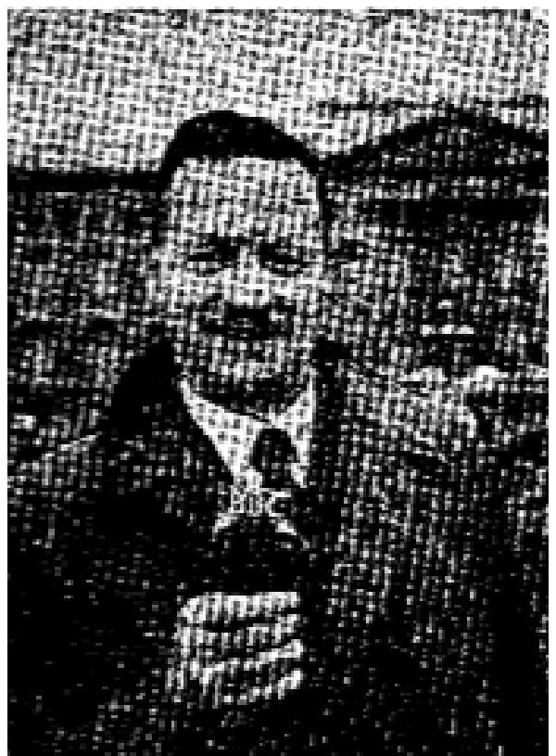
Divine Deliverance in the Local Churches
By Thomas N. Foster
Pastor, National Revival Crusade,
Melbourne, Australia
The present world-wide ministry of deliverance is not only for the sick and the sinner; it is also for the saint, the pastor and Assembly. During the past six months I have visited a number of countries throughout the world, including Egypt, Palestine, Italy, Britain, Sweden, Denmark, Germany, Canada, and the U. S. A. In these lands I have met many pastors, laymen and members of all types of Holy Ghost Assemblies. All of them agree that Christians, and even Spirit-filled believers, can be severely oppressed by evil spirits. Many have told me of their experiences in deliverance.
POSSESSION AND OPPRESSION
There is a vital distinction between being possessed by evil spirits and oppressed by them. When a person is "possessed," it means that he loses control of himself and the evil spirit has full or partial control.
Have we not met Christians who habitually lose their temper? This can be the work of an evil spirit. Thank God, they can be set free by deliverance!
Have we not seen Christians who are "bound" by the smoking habit? Some of these have been filled with the Holy Spirit and lost the victory. Praise God, they can be set free. Christians can also be bound by fear, jealousy, envy, hate, unforgiveness, resentment, and a hundred other things, but none of these can resist the ministry of deliverance in the power of the Spirit.
SISTER FREE FROM LYING
Last year in Australia I saw a sister set free from a lying spirit. This woman had received the gift of the Holy Spirit several years before, but was backsliding because of a defeated life. When she confessed to lying, she was prayed for and completely set free. Her body convulsed during deliverance and she seemed almost to choke as the evil spirit left her body. Jesus said, in Mark 16:17 - "And these signs shall follow them that believe; in my name shall they cast out devils.
SISTER SET FREE FROM FEAR
In Melbourne I saw a sister set free from a spirit of fear. She felt this thing come upon her in her unsaved days when attending a cinema. Even after receiving the Gift of the Holy Spirit she was still plagued by this spirit of fear. Her life was blighted and her nerves shattered. One day during a healing wave, she knelt down and cried aloud, "Go, you evil spirit of fear." She kept this up for some minutes, then her body stiffened, her head went back and she gave a tremendous gasp. This sister then shouted, "Thank you, Jesus. It is gone." She broke forth into speaking in tongues, laughed in the spirit, and was set completely free.

THE VOICE OF HEALING September 1953 Page 2
How many Spirit-filled Christians are there today who need a similar deliverance from fear! Thank God, the ministry of deliverance is not only for the sinner. It is also for the saint. It is a ministry for the local church.
DELIVERANCE FROM OPPRESSION
Oppression is different from possession inasmuch is the sufferer is not controlled in this
case, but is vexed and disturbed,
When Spirit-filled believers allow their health to run down, or are weak after a big battle with the enemy, they are prone to severe attacks of oppression. This leaves them defeated, gloomy, despondent, downcast, discouraged and weak. Pastors and evangelists ate well acquainted with this experience! Sometimes this condition can last for weeks or months. The longer it lasts, the harder is the battle for deliverance and healing. However, there is victory for all! Here it is, from Acts: "God anointed Jesus of Nazareth with the Holy Ghost and with power: who went about doing good, and healing all that were oppressed of the devil; for God was with him."
How many pastors, evangelists, teachers, and ministers are there today who need deliverance from oppression!
I had a remarkable experience along these lines myself last year. I had been through severe times of testing, ill-health, and was seeking God for a deeper experience in holiness and sanctification. Scores of things in my life which had oppressed me were brought to my mind and then I was completely released. I had a marvelous physical experience of release and was able to name many of them. They oppress me no more!
God brought to light and set me free from some sins of which I was not conscious. Among these was spiritual pride. It was one of the few times in my life when God spoke to me and I heard HIS Blessed Voice.
How many spiritual leaders today need to be clean-sed from spiritual pride!
Thank God the ministry of deliverance today is not for only the sinner, it is for the spirit-filled believer: the pastor, the evangelist, the elder, the deacon, and all who are "oppressed of the devil." Many who oppose this message are the ones who need deliverance most of all!
DELIVERANCE FOR THE ASSEMBLY
In my travels I have seen many Assemblies that need a ministry of deliverance themselves before launching out to others. When you go into the building there is no revival power present. The faith is low, the fire on the altar is almost out. Thank God, this ministry can change an entire assembly. In England a pastor was burdened with this message and preached deliverance. Many were filled with the Spirit and revival fires burned brightly. Everyone knew it. Outstanding healings took place.
How many Assemblies today need the preaching of deliverance to revive them once more!

THE VOICE OF HEALING September 1953 Page 2
DELIVERANCE AND SANCTIFICATION
There is a close link between these two. While it is not claimed that deliverance is sanctification, nevertheless it is one of the channels which God is using today. The believer who has been possessed or oppressed in the past can now live a life of victory rather than defeat. He has been set free from things which bound him or oppressed him.
In some quarters the impression has been given that once you received the Gift of the Holy Spirit, it was the end of the road and you were now qualified for heaven. However, in many cases it has been found that it is the beginning of the road.
Many spirit-filled believers have had a difficult childhood. Parents were cruel, conditions were hard, handicaps became real and complexes crept in. The psychologist and psychiatrist know these conditions and do their utmost to remedy them. However, they have their limitations because their ministry is not necessarily in the name of Jesus.
The ministry of deliverance meets the need as no other can. Where such needs are apparent, there are several steps, which have been found very helpful.
- Confess the fault, sin, oppression, weakness, or whatever it may be that hinders.
- Plead the blood of Jesus and the power of His Name.
- Tell it to go from you in the Name of Jesus and oppress you no more.
- Stay there until it is gone.
In some cases there is a physical manifestation. If the person is fully surrendered, there may be none, but there will be a great sense of release and relief. Very often when the spirit is set free, there is immediately -joy in the spirit, holy laughter, and tongues of praise, worship and adoration.
How Many Christians today are battling over something in their lives for sanctification when the ministry of deliverance would give them victory!
There is no hindrance, weakness, sin, fault, oppression, complex, or setback, which can resist the ministry of deliverance today. Praise God for this mighty weapon, which can be in the hands of every spirit-filled believer. Hallelujah.
This may well be the last revival before Jesus comes. Let Satan be overthrown, every evil spirit cast out, and obtain full victory in the Name of Jesus.
"And the very God of peace sanctify you wholly; and I pray God your whole spirit and soul and body be preserved blameless unto the coming of our Lord Jesus Christ." (I Thess. 5:23)

THE VOICE OF HEALING October 1953 Page 12  Len Jones Column  Down the Years  It is 25 miles from Jerusalem to Jericho. It is all downhill, which is why the Scriptures say, "A certain man went DOWN to Jericho, "for if you go from Jerusalem to Jericho you certainly go DOWN – you descend 3,000 feet in 25 miles. You can almost travel the whole distance on a free engine. The road curves a great deal and is among hills, because of which, even these days, it lends itself to highway robbery. It is quite easy to understand many being beaten and robbed on this road, not only in the year 53 but also the year 1953. | 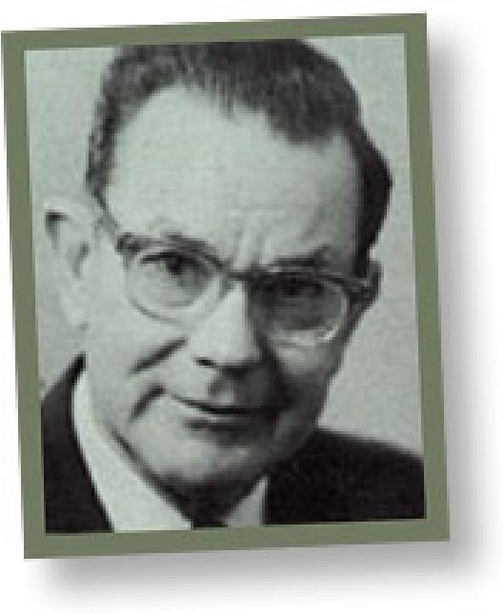

The only building you pass on the way is the Good Samaritan's Inn, on the left-hand side of
the road. The Dead Set is 1200 feet below sea level, and you see a sign in three languages at sea level. The Dead Sea is 26 per cent salt compared with ordinary sea water, which is about 41/2 per cent salt, That means it is about a quarter solid. It is impossible to sink in the Dead Sea. A non-swimmer would never drown there - you just can't go under.
THE CHILDREN OF ISRAEL VIEWED THE PROMISED LAND - BEFORE THEY ENTERED IT
As you look across the Dead Sea, you can see the Mountains of Moab. You can see the place where Sodom and Gomorrah once stood and where Lot's wife was turned into a pillar of salt. You can see Mount Pisgah where Moses stood and viewed the Promised Land.
God showed the Children of Israel the Promised Land before He took them into it. He does the same today. The Promised Land speaks in type of all the spiritual experiences God has for us these days. God promised them the Land - He also has given us "exceeding great and precious promises." There were Giants that sought to hinder them - there are giants that would seek to hinder us. It was faith that took them in - it is faith that will take us in. It was not the strength of their own right arm, but the promises of God that gave them the victory.
We have come quite a distance. Many giants have been fought and victories have been won. Ammonites, Amorites and Moabites have fallen before us and we are glad. We can look back at victories won and experiences enjoyed – we can look forward to victories yet to win. Perhaps a few personal past experiences as well as future hopes and ambitions might help.
THE PROMISED LAND LOOKED WONDERFUL BUT THE G1ANTS LOOKED TOO "BIG"
Thirty years ago the writer read John 3.16. He caught a glimpse of truth and hope sprang tip in his breast, when he read of the possibility of "having everlasting life" and never perishing." The promised land looked- wonderful, but the giants in the way looked too big and formidable - all seemed too good to be true, and he wondered if such an experience was for him. It all seemed far beyond him, and, he wondered.

THE VOICE OF HEALING October 1953 Page 12
And yet, believe it or not, that land was possessed and that victory was won, and, today without a doubt, the writer stands on the other side of the battleground, and knows of a very surety that he "has everlasting life and will never perish." That is wonderful and he is glad.
CITIES OF THE PROMISED LAND WERE TAKEN ONE BY ONE
Two years later the writer came across another experience, which also seemed far beyond him and too good to be true. He read in Acts 2:4 of what happened on the Day of Pentecost. He was told that this experience was for today, and wondered. He was told it was for him and he wondered still more, It seemed far too wonderful to think that he would ever receive an experience like the "Early Disciples" received on the Day of Pentecost, and that he would speak in a language that he had never learned.
Well on May 1, 1925, the seeming impossible happened, and today he is also on the other side of that battleground. Like the Children of Israel of old, he saw both experiences, including the giants, before he entered into them.
More recently, while in New Zealand the writer read another Scripture and saw further land to be possessed. He read Galatians 5:24 - "And they that are Christ's have crucified the flesh with the affections and lusts."
"Why," he thought, "the flesh, with its affections and lusts is where all the trouble is, and victory here is victory indeed." It was possible to have other experiences and still be in need of this one - possible to have conquered Ammonites, Moabites and still need victory over Jebusites.
VICTORY COMES BY BELIEVING – NOT THROUGH STRUGGLING OR FIGHTING Victory today comes exactly as it came of old. It was not by struggling or fighting but believing. He remembered the message of Hebrews 4, where we are encouraged to rest after a perfect work of redemption, as God rested after a perfect work of creation.
He remembered how he had fought. He remembered how he had struggled. He remembered how he had prayed. He remembered how he had fasted and how he had confessed. He remembered how he had wept over his inward wrongness, longing for inward purity, and yet after years of Christian experience he was no nearer inward cleanness and soundness and he wondered. Had he been seeking victory the wrong way.
Absolute cleanness, perfection in the truest sense, inward moral soundness and all that goes with it, complete victory over the “flesh with its affections and lusts" in actual day by day experience, were all promised in this verse. It was a sight of the promised land, before entering in, and was no more seemingly hopeless and impossible than the other two experiences.
GOD"S WORD IS MORE RELIABLE THAN FEELINGS
And then he remembered that the Scripture was positive: "They that are Christ's HAVE
crucified the flesh with its affections and lusts." It does not say that they SHOULD, they

THE VOICE OF HEALING October 1953 Page 12
COULD, or they OUGHT TO, but believe it or not IT says "THEY HAVE." And hope sprang into his heart as he remembered that God's Word was ALWAYS TRUE. If God says "HAVE" well "HAVE” it IS. How wonderful are the "HAVES" the "HATHS" and the "HAVE NOTS" OF GOD'S WORD.
God's word is more reliable than what we feel. It is more reliable that what we see, and more dependable than what we know or understand. What we feel may be wrong. What we think may be wrong and what we understand may be wrong, but God's Word is NEVER wrong. Man's word may be right, but God's Word is ALWAYS right.
And so he was faced with the alternative of whether he would believe what God said, or whether he would believe what he thought, felt and understood. He eventually decided to believe God's Word regardless of everything else, and what a victory this brought and what a panorama of truth opened up before him.
"ALL THINGS ARE YOURS" - THROUGH CHRIST!
This brought such a flood of Scriptures before him. He read Romans 8:2. "For the law of the spirit of life in Christ Jesus HATH made me free from the law of sin and death," and he decided that this was truly so and "HATH" means "HATH." He read Ephesians 1:3,
"Blessed be the God and Father of our Lord Jesus Christ, who HATH blessed its with ALL blessings in Heavenly Places."
He had known these Scriptures by heart for years, but had never really believed them. He decided that we pray about many things that God says are ours already! His joy knew no bounds as he read, "All things are yours, and ye are Christs and Christ is God's," and he right then and there, decided that all things were his and he was Christ's and Christ was God's, and he acted upon it.
He decided that we were GIANTS ASLEEP, and were going around like paupers with signed checks in our pockets. He decided that God knew who we were, and the Devil knew who we were, but WE DIDN'T KNOW WHO WE WERE. He decided that the only place to find out who we were was in God's Word. He then looked to see what the Word of God said about us, and remembered that we could not go by what others thought of us, for the Apostle Paul said: "It is a small matter to be judged of you or of man's judgment," and neither could we go by what we thought of ourselves, for the same Apostle said, "I judge not myself." Therefore, he had learned that the only place to find out who and what we are was in God's Word, and that He said some truly amazing things. It is time we believe it, for failure to realize our standing in Christ is the true cause of all Christian's weakness today.
"YE ARE COMPLETE IN HIM"
When he read: "Ye are complete in Him,” he could not express the joy that filled his heart, and when he read, "And if children, then heirs; HEIRS OF GOD AND JOINT HEIRS WITH CHRIST" the joy of it was an experience like the Baptism of the Holy Spirit all over again, and well could he understand why the Disciples looked and acted like drunken men on the Day of Pentecost. He was ashamed to think that he had gone so long in his weakness and

THE VOICE OF HEALING October 1953 Page 12
insufficiency and had failed to see what the Scriptures speak of as the "inheritance of the saints in light" (Colossians 1:12). Surely, Christ's riches were "unsearchable" and it was time that we knew "the things that are freely given to us of God" (1 Cor. -2:12).
Our greatest need today is for “revelation" and “illumination" and the answer to the Apostle Paul's prayer. "that the God of our Lord Jesus Christ, the Father of qlory, may give unto you the Spirit of wisdom and revelation in the knowledge of him." (Ephesians 1:17).
YOU CAN HAVE A LIFE OF COMPLETE VICTORY
Yes, that which was impossible had come to pass. By the grace and power of God, this giant also had been laid low and this tribe vanquished. Another battle had been fought and another victory had been won. We have a different message now, a positive message - we know where we are and what we have, and have been lifted above a life that is always "walking on egg shells."
Maybe this is still a future experience for you dear reader, or maybe you have come through this also and have possessed the land.
THERE IS HEALING FOR YOU!
Maybe "With His stripes ye are healed" is another giant that is still in front of you. Maybe it seems very wonderful, but so very impossible, as there are so many giants. Well, all the writer needs to say is that it is no more impossible than the three above experiences were to him. Maybe there is something else he should say, and that is that God's Word is true - it is truer than your ache; it is truer than your pain; it is truer than your cancer; it is truer than your growth – and it is truer than your symptoms. Your ache could be wrong; your pain could be wrong: your tumour could be wrong: your growth could be wrong and your symptoms could be wrong. BUT LISTEN WHILE HE SUGGESTS TO YOU, QUIETLY, POSITIVELY AND SO VERY DEFINITELY, GOD'S WORD IS NEVER WRONG, AND IS MUCH MORE WORTHY OF OUR TRUST AND CONFIDENCE than the other things that we so often so readily believe.
The last tribe beaten in Canaan, was the tribe of the Jebusites. One by one the others fell before the Children of Israel and one by one spiritual giants are also falling before children today. The Jebusites were encamped around Jerusalem and fought valiantly and courageously and would just not give in, but at last they were routed and put to confusion.
"GREATER WORKS SHALL YE DO" - WAS ONE OF CHRIST'S LAST PROMISES
In closing let the writer say that there is one more spiritual experience that he hopes doesn't frighten you "because the giants of that land are big." It doesn't frighten him, and he has to confess that as he looks at it, it is no more impossible of fulfilment than John 3:16, Acts 2:4 and Galatians 5:24 were in the years gone by. When you have seen other giants laid low and victories won, and land possessed, that have been shown you before you entered in you have confidence that the God who has brought you thus far will take you right on.

THE VOICE OF HEALING October 1953 Page 12
Here it is - John 14:12: "Verily, Verily I say unto you, He that believeth on me, the works that I do shall he do also; and greater works than these shall he do; because I go unto my Father.”
THOSE WHO BELIEVE - ENTER IN!
It means exactly what it says. The whole promise hinges on our "believing in Him." Nothing is promised to unbelief, but everything to faith. A man told a congregation how God healed his sick horse just like John Wesley also testified. Perhaps you don't believe God heals sick horses - well if your horse gets sick, it will have to die, that's all. We get what we believe for. God is as big as we make Him. Out of a thousand Christians who believe that God can, only one out of that thousand believes God “can and will through me." They are the Joshuas and the Calebs. THEY ARE THE ONES WHO ENTER IN - WHAT WILL OUR CHOICE BE?

THE VOICE OF HEALING May 1953 Page 10  Raymond T. Richey Column  Fellow Labourers With Him  For the past decade a new "wave" of healing revivals has been sweeping the earth – mighty miracles, signs and wonders have been and are being seen, heard and felt. | 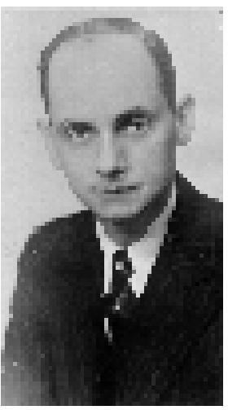

Everywhere men and women are saying, "We have never seen it on this fashion." People are slain under the mighty power of God's Spirit - Sinners are being swept into the Kingdom of God; believers are being filled with the Spirit, lukewarm Christians are fired again with the glow and thrill of their, "first love"; backsliders are coming back to the Father's house and the Revival for which we have longed and hoped and prayed is ON!
The varied gifts of the Spirit are being manifested by God's ministers and hearts are made to rejoice as we watch the moving of the Spirit and we sing with joy "God is moving by His Spirit, Moving oer all the earth; Signs and wonders, where God moveth. Move, oh Lord, in ME!"
It is the last sentence of that chorus that I want to talk with you about very briefly - Move, oh God, IN ME!"
As the many thousands of Spirit filled believers sit in the audiences in these great revivals and see and hear and feel the moving of the Spirit of God in the evangelists there is born a new, deeper hunger to be used by the Spirit of God in a greater way than before. The Child of God wants to know where be, where she fits into this new thing that God is doing, or rather into this old thing that God is doing in a greater way, on a larger-scale than ever before. It is to you that I want to speak -
Paul, the greatest evangelist of the ages, spoke often of "fellow-helpers" and "fellow labourers" and it is there that you will find your place - just as the Director, of the great hand, or the great orchestra, must have each individual musician in his or her place before the concert can be what he desires and what the listening audience must enjoy, so the evangelist who is before the public eye must have his many “helpers" and "labourers" before the Revival will be what God wants and what the people need.
Paul, in his letter to the Philippians, speaks of "yoke fellow." This refers, no doubt, to one who was also a "minister" or "preacher," but he refers also to "those women who laboured with me in the Gospel, and other - my fellow labourers."
The ministers who assist the Evangelist, the musical director, etc. - the members of the evangelistic party, perhaps all these may properly come under the title of “yoke-fellow," but oh the thousands who have the joy and privilege of being “fellow-labourers."

THE VOICE OF HEALING May 1953 Page 10
Your attendance, your interest, your singing, your giving, and, most important of all, your believing prayers - all these things make you "fellow-labourers." Without you, God could not; (and how reverently we say that, "could not") do the things He wants done - could not reach the souls He wants reached, could not heal the bodies He wants healed, could not Baptize the believers with His Spirit, could not bestow His gifts on waiting servants.
We mentioned above just four of the many ways in which you may be a "fellow-labourer" - You can so easily see how you may fit into each of these ways. I will refer to only the really "paramount one."
PRAYER! As the meeting is opened with prayer or with singing, you, can pray; as testimonies are given, you can pray; as God's minister preaches, you can pray; when opportunity is given for people to give, you can not only give, you can pray; when the altar call is given, you can pray - when the healing service is in progress you can an pray - as each individual one comes to be ministered to, you can join in "believing prayer!" You can be a "fellow-labourer."
The dictionary gives this definition of "fellow": "A companion or associate - one of the same kind - one of a pair - associated or joined with." Does this not give a new importance, a new dignity, a new worth to your labour - a companion, an associate of that one whom God is so gloriously using - far better a companion of our LORD in whose Name it is all being done - not less important is your work than that of the one who stands behind the sacred desk, you are: "fellow-labourers."
It has been well said: "Generals plan the battles, but G.I.'s win the battles. " We realize that both. Generals and privates are necessary in every army - even so it is in God's great army.
David that great warrior-King said, "As his part is that goeth down to battle, so shall part be that tarrieth by the stuff - they shall part (or share) alike." And so it shall be in that day when the Great King of all the earth gives His rewards.

THE VOICE OF HEALING December 1953 Page 6  Len Jones Column  GIANTS Asleep!  Paupers With Signed Cheques In Our Pockets!  Recently when I was at Edmonton in Alberta, I read the of a man during the last war who came to his commanding officer and said, “I have taken a prisoner,” to which the commanding officer replied, "Bring him along." The man went back and when he returned said, "The prisoner won't come," to which the commanding officer replied, “Come yourself.” And the man replied, “The prisoner won't let me." | 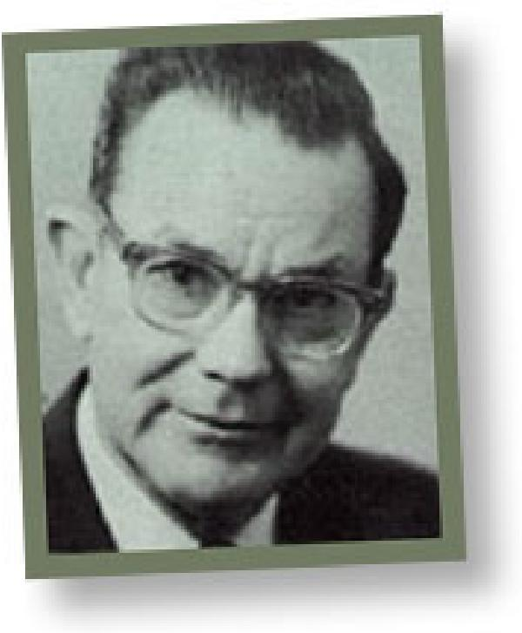

Unfortunately that is the kind of victory many of God's children experience, in the face of so many Scriptures, Christ’s death on the Cross provided salvation, and, Thank God, it also did a lot more. He died not only that we might be “legally safe," but that we might be “morally sound."
Giants asleep! Paupers with signed cheques in our pockets! That is exactly what we are! Few of us realize our standing in Christ! Few understand and appreciate the merest fraction of what God for us on the Cross! Failure to understand and appreciate our standing in Christ, is the cause of all weakness and impotence.
The one great burden of the epistles is just this! The heart throb of all the Apostle Paul's prayers is that God will give unto us the spirit of wisdom and revelation in the knowledge of Christ; that the eyes of our understanding might be enlightened; and that we might know the hope of His calling, the riches of the glory of his inheritance, and the exceeding greatness of His power towards us who believe.
Strange but true, the epistles are taken up not so much with evangelism, but the perfecting of the saints, the edifying of the body of Christ, till we all come to the unity of the faith and the measure of the stature of the fullness of Christ, no longer children, no longer tossed about, but having attained growth into full stature, and hearts and minds that understand and appreciate all that God has done for in Christ (Ephesians 4).
When we read of the power of the Old Testament prophets and the disciples in the days of Christ, how humbled we should be at our impotence, when we realize we have much more light than they had.
Living in the full blaze of the revelation given the Apostle Paul, after Christ's triumphant crucifixion and resurrection, what manner of men ought we to be? Shame on us! The charge at the Judgment Seat of Christ, before which we must all appear, will not be what colour stockings we wore, for "holiness is more than wearing black stockings," but why were we so impotent, when we knew these promises. It is not what we are "not doing" but what are "we doing?”

THE VOICE OF HEALING December 1953 Page 6
Yes, we are giants asleep! We don’t realize who we are or what we are! God knows who we are, and is trying to tell us in His Word and by His Spirit! The Devil also knows who we are, and is scared that we might wake up! HOW CAN WE FIND OUT WHO WE ARE? There is only one place to answer that and that is God's Word, for you cannot go by what you FEEL, nor by what you THINK about yourself, BUT YOU CAN GO BY WHAT GOD’S WORD SAYS! Man's word might be true, but God’s Word is ALWAYS true; There are two tragedies among Christians:
- We don't read God's Word enough.
- We don't believe what we do read.
If we fed our souls like we feed our bodies what a different story it would be.
Listen to what God says about you:
"Ye are complete in Him," "Sin shall not have dominion over you," "All things are yours and ye are Christ’s and Christ is God's," “Greater is He that is in you than He that is in the world,” “We are more than conquerors through Him that loved us and gave Himself for us,” “Heirs of God and joint heirs with Jesus Christ," “He that spared not His own Son but delivered Him up for us all, how much more shall He not also freely give us all things!"
It is time we believed what God says, more than what we think or feel! These exceeding great and precious promises have been given unto is that we might become partakers of the divine nature! It is only the Word of God that can change us! WE GET WHAT WE BELIEVE FOR!
We put off to the future the things that God tells us are for us right now! We pray for things that God says are ours already. "Blessed be the God and Father of our Lord Jesus Christ, who HATH blessed us with all spiritual blessings in heavenly places.” "For the law of the spirit of life in Christ Jesus HATH MADE ME FREE from the law of sin and death."
Some time ago I heard a story! It well illustrates our point. A passenger on one of the large Atlantic steamers did not know that meals were provided with his ticket - he ate soda crackers until the last day, when he was told. He got to England allright, but he missed such a lot! It is not only a matter of getting to Heaven; through the death of His Son God made such a wonderful provision for us all!

THE VOICE OF HEALING May 1953 Page 8
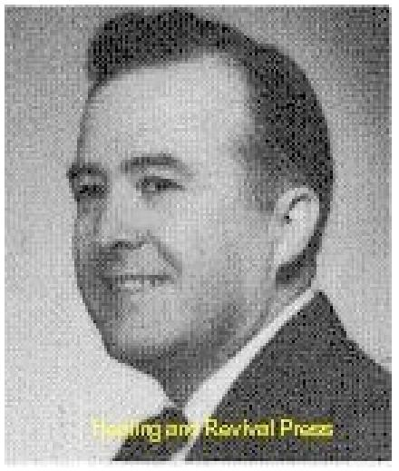
The Gift of "DISCERNING OF SPIRITS"
By W.G.Grant
The Spiritual gift of discerning of spirits is the supernatural manifestation of the Spirit of God revealing, to one what spirit is in operation.
WHAT IT IS NOT
Discerning of spirits is not suspicion, as many seem to practice. A person who has never had the Spirit can have the gift of suspicion.
This gift is not Christian Science, for they deny the existence of a devil or spirits.
Many people have a keen sense of imagination; but it comes after they lose the Spirit of God (Rom. 1:21). God hates the gifts of (unsanctified Ed.) imagination (Prov. 6:16-18). That is why God destroyed people in the flood (Gen. 6.5). We can have victory over it (II Cor. 10:5)! It is not reading someone's mind or thoughts. If God should see fit to reveal to you someone's mind or thoughts, that would be "a word of knowledge" (I Sam. 9:19) and would have nothing to do with spirits, if no Spirit is involved.
One does not need a supernatural gift to know about the human spirit, which can be studied by people who are sinners (I Cor. 2:11). This gift cannot be fortune-telling. This “gift of discerning of spirits" can show fortune telling, is of the devil (Acts 16). The devil copied fortune telling from God's "word of knowledge."
This gift is not discerning of faults, but of spirits. It is the spirit of the devil that makes a person a fault-finder. It is not "the gift of discernment," but "discerning of spirits." Most anyone can discern people, but it takes a supernatural insight to discern spirits.
This gift is not to be confused with spiritism, which is condemned by the Bible. The spirits of our dead relatives are not floating around in the air, but they are with Jesus (Eccl. 12:7). As spiritism and demon-possessed people increase in number, we need discerning of spirits so much the more.
WHAT IT IS
Discerning of spirits is God's Spirit enabling one to know what spirit is being manifested. It
is a supernatural look into the world of spirits. It is the one thing that keeps the Church safe.
This gift can show the kind of spirits in people today, such as spirits of disobedience, pride, contention, self-pity, lust, nagging, murmuring, stubbornness uncleanliness, back-biting, complaining, filthiness, deafness, blindness, dumbness, infirmity, lying, stealing, hatred, joking, talkativeness, laziness, tormenting, and thousands of others spoken of in the Bible.
In these last days, as the devil is sending a revival of demon forces, God is using Spiritual gifts.

THE VOICE OF HEALING May 1953 Page 8
The discerning of spirits shows what gift is in manifestation in a service and how God is working. Many people make the mistake of following their programs and running the service right, against the leading of God's Spirit, because they do not discern what gift is in manifestation. If we work with the Spirit, and the Spirit works with is us, the psychologists and the, chiropractors will be confused and confounded, as the people were at Pentecost.
BIBLE EXAMPLES
A certain damsel, possessed with a spirit of divination followed Paul and Silas, saying that they were "servants of the most high God." Instead of making her one of the charter members of the Church, Paul cast the devil out of her. Before he cast the devil out, he first discerned the devil was there.
Bar-Jesus (Elymus) sought to turn away Sergius Paulus from the faith (Acts 13:6): "Then Paul, FILLED WITH THE HOLY GHOST, set his eyes on him and said, 0 full of all subtlety and all mischief, thou child of the devil, thou enemy of all righteousness, wilt thou not cease to pervert the right ways of the Lord?" (Acts 16: 9, 10).
But Paul first discerned that spirit was there. And, just before the gift of healing was manifested through Paul, he first discerned the good spirit in a man. "Steadfastly beholding him, and perceiving he had faith to be healed" (Acts 14:9).
Philip let one man be baptized without discerning the evil spirit which was still in him. But when Peter started to pray for him he discerned it and said, "For I perceive that thou are in the gall of bitterness, and the bond of iniquity" (Acts 8:23).
Simon had believed with his mind, was baptized, became Philip's convert, but his heart was not right with God. If more of us had "discerning of spirits" manifested in our churches today, the churches would not be filled with people with perverse spirits and hearts full of sin. They would have a change of heart as well as a change of mind.
By this gift, Jesus discerned over 2,000 in one man (Mark 5). He discerned seven spirits in Mary, the spirit of covetousness in Judas, and the spirit of pride in Peter. He said we could do the same thing (John 14:12).
With this gift, the prophets can judge the gifts of tongues, interpretation, and prophecy (1 Cor. 11:29) to see if the gifts are genuine. This particular task certainly should not be left to an unbeliever, who fights God's power and gifts (I Cor. 2:15). "But he that is spiritual judgeth all things, yet he himself is judged of no man.”
EXPERIENCES
In a Dallas revival while I was giving the altar invitation one night, I told the people, if anyone left the house right then, the spirit of bondage was waiting for him at the door. A lady deliberately walked out. The next day she came back for prayer, saying a hand grabbed her as she walked out the door. After praying for some time in Vain she left never to return.

THE VOICE OF HEALING May 1953 Page 8
In one revival, I told the people the demons of death were waiting at the door for someone who rejected God. A girl rejected the Spirit and. walked out. She never returned. Within two days she was in her grave.
In a Breckenridge, Texas, auditorium I told the people a lady was in the audience with a suicide spirit (demon). However, she would not come for deliverance, but left the auditorium and blew her brains out with a shotgun.
A CRITICAL SPIRIT
In the same revival one night I said, "There is a person near me with a critical spirit who, is opposed to, this meeting. You will cause souls to be lost. Stop it, or I will turn you over to Satan for the destruction of the flesh." He came forward, confessed, and was restored and filled with the Holy Ghost. The discerning of spirits was in operation, even before I mentioned it to him.
In the same revival, just as a man, totally blind in one eye from birth, was restored to normal, I felt the spirit of opposition until I could go no further. I stopped and pointed to a man, ordered him out of the auditorium, and was then able to continue praying with more results.
One night I had a man nearly through to the Holy Ghost when I felt a perverse spirit near, which was hindering me. I looked up and saw a man close by looking at me. I went over and prayed for him. After he left the house, the boy received the Holy Ghost. That was discerning the spirit, before I prayed for the man.
DEMONS ARE DISCERNED
I walked into the hospital in Hot Springs, to pray for a lady who was dying with a cancer. I cried out, "You demons of death, come out." SHE AROSE AND WALKED! She was discharged and sent home. I would not have known to cast out such a spirit, if I had not first discerned the spirit.
I could not have learned that any way, except by the Spirit of God. Since the Spirit gave it to me, it was a Spiritual gift in operation. I told a man in Malvern, Arkansas, who was seeking for the Holy Ghost, that he would never be filled until he confessed he was a dirty, low down sinner on his road to hell, that he must get saved first. He became very angry, and wanted to fight. 1 held him down until he confessed and was delivered.
In one altar service, near Malvern, Arkansas, a lady arose and began to do a waltz or dance. God showed me it was a false spirit. After 1 dealt with her, she confessed she was a sinner. She was saved, filled, and delivered.

THE VOICE OF HEALING May 1953 Page 8
DIFFERENT ANOINTINGS DISCERNED
I started to preach, the other night, and discerned that the anointing to preach was not there. I stopped preaching, stood silent, and waited on God for a while. It looked like the service was a failure. Then I discerned the Spirit was anointing to heal. Many were healed, saved, and filled with the Spirit. That was one of our best services.
I have gone many times like that, for a whole week without getting to preach. Had I tried to preach, the services would have been killed. God knows how to lead for people's deliverance!
Hundreds of times God, has shown me a spirit of blindness, deafness, arthritis, cancer, or some other disease. I would tell the people, and they would come forward and receive deliverance.
How many people have missed deliverance because the minister did not discern the spirit which was hindering, or the Spirit which was helping?

THE VOICE OF HEALING April 1953 Page 15  The Real Reason  Why Christians are Sick!  Gordon Lindsay  The apostle said that many were weak and sickly because they discern not the Body of Christ. He declared, in 1Cor. 12:27 - "Now ye are the body of Christ, and members in particular." We are members of the Body of Christ. We are flesh of His flesh and bone of His bone. Should the members of the Body of Christ be sick? God forbid! | 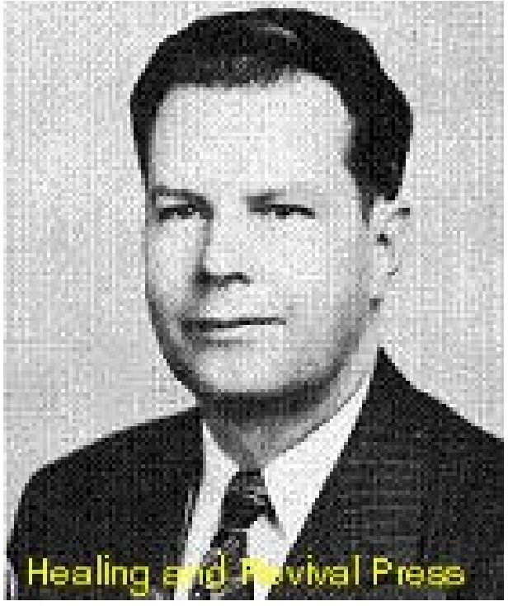

There are those who seem to think that it is the will of God that the members of Christ's Body be subjected to sickness. Their strongest claim to this belief seems be Paul's "thorn in the flesh." Paul had a "thorn in the flesh" and they say that this thorn was sickness. Carrying their argument on, they point out that if so great an apostle as Paul was sick, certainly sickness must in some cases be the will of God for His people. Now if it could be proved that Paul's "thorn in the flesh" was sickness, we might concede that there was some argument in the favour of this contention. But was Paul's "thorn in the flesh" sickness? We propose to show that this assumption is entirely false and without a shred of evidence in the Scriptures.
In the first place, leading Bible expositors who are not known as exponents of the doctrine of Divine healing, admit that there is no evidence that this figure of speech relates to sickness.
The Scofield Bible says about the theory of Paul's supposed sickness. "This cannot be positively known, and the reserve of Scripture is as sure mark of inspiration as its, revelations. Paul's particular 'thorn' is not described that his consolations may avail for all to whom any thorn is given."
Some have argued, without any proof whatever, that Paul's thorn was ophthalmia, a serious eye affliction inducing bodily weakness, and producing a condition of near blindness. If any proof was needed that Paul was not blind, it is the fact that the Lord healed him of blindness! The Lord directed Ananias to the place where Paul was praying, that he should lay hands upon him that he might receive his sight (Acts 9:17). This was confirmed in a vision (vs. 12.) And the Scripture records that he did receive his sight (vs. 18.) Surely this plain statement of the Scripture should end forever further false surmises about Paul's blindness.
It is true that Paul did have “a thorn in the flesh.” What was it? On this matter we ought to allow the Scriptures to explain themselves. What does the Bible say that a “thorn in the flesh” is? All agree that the term is a figure of speech and not a literal thorn. We shall see that the Scriptures use the term “Thorn in the Flesh” to indicate personalities and not disease. In Numbers 33:55, Moses said:

THE VOICE OF HEALING April 1953 Page 15
" If ye will not drive out the inhabitants of the land from before you; then it shall come to pass that those that ye let remain of them shall be pricks in your eyes, and thorns in your sides, and shall vex you in the land wherein ye dwell.”
Joshua, speaking sometime later, “They shall be scourges in your sides, and thorns in your eyes.” (Joshua 23.13. Again in Judges 2:3, the Lord speaks of the Caananites as “thorns in your sides.” We see, therefore, that according to the Scripture, “a thorn in the flesh” is not a disease but a personality, whom the devil uses to annoy, to persecute or trouble the children of God.
Paul's “thorn in the flesh” must have been something similar. Many times the apostle had triumphed over his opposers. On one occasion a man who would hinder him was stricken with blindness. At another time a girl with a familiar spirit who was used of Satan to intrude upon the ministry of the apostle, was silenced when Paul with authority cast out the evil spirit. When the apostle was cast in prison, an earthquake shook the foundations and opened the doors. But there came a time when Paul no longer experienced such deliverance. Cast into prison, he languished there a long period of time, and it appeared that evil men triumphed over him. Just as the Canaanites were a “thorn in the flesh” to the Children of Israel, so these persecutors were to Paul. Yet there was a Divine purpose in it all. During the time Paul was imprisoned, he wrote a number of wonderful epistles. Had he been free to evangelize at that time, it is possible that they would never been written.
There is something else for those to note who suppose Paul's “thorn in the flesh” was sickness. Just before Paul tells us about that “thorn,” he lists his labours and sufferings for Christ. He said he was “in labours more abundant, in stripes above measure, in prisons more frequent, in deaths oft” (2 Cor. 11:23-33). It is a long list and does not sound like the story of a sick man. If a sick person could do as much as Paul did, and suffer all those things, we might wish that kind of sickness upon all the children of God!
The fact is that Paul had infirmities and sufferings, but not one place in the list is there mentioned anything, about sickness. And why is the omission? Because Christians are the members of the Body of Christ. It is not the will of God that the Body of the Lord should be sick. Yea, Christ's body while on earth, suffered infirmities. It became tired and weary. Christ hungered; He thirsted. He suffered in agony for a lost world. Yea, His body died on the cross. But He was never sick.
So we, who are members of the Body of Christ, will suffer weariness as He suffered. We shall be subject to infirmities as He was subject. If His Coming tarries, we shall die as His body died. But since His body was never sick, then it is not the will of God that we become sick, for we are members of His Body. If we discern that our body is the Body of Christ, then we shall not be weak and sickly nor die before our time!

THE VOICE OF HEALING September 1953 Page 5
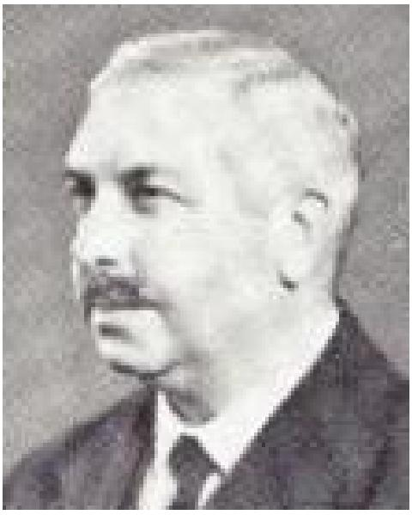
Donald Gee Column
The Root of Bitterness
A correspondent has given me permission to publish the following - "You will no doubt be surprised at the contents of this letter. I am enclosing a small gift of thirty shillings (about $5.00) to the Bible School, and am sending it through you personally because I have harboured ill-feeling against you since July, 1952. A remark you made in the course of one of your addresses seemed a disparaging remark about the people from ... , or so the enemy of souls made it appear. At the time it went like a stab to my heart, but it has grown, I'm ashamed to say, into a root of bitterness. So much so that I could not think a kindly thought of you. Now during prayer this morning I was inquiring of the Lord regarding Revival in this place, and He seemed to say to me “Put right what's wrong first.” Of course, as I honestly searched my heart I had to confess THIS towards you was anything but right, and so I am making a clean breast. Please forgive me, brother, and pray for me and for .... Your sister in repentance."
One cannot but be deeply moved on receiving such letters. I am certain that already the writer has been richly blessed by the God of all grace, and who can tell how far this may extend? Incidents like this commence Revivals. It blessed and humbled me also as I wrote and asked for forgiveness for an offence committed all unwittingly. One can be sincerely sorry for the most unintentional wound given to others.
"In many things we offend all!” or, "We all make many a slip" as Moffatt translates James 3:2. We preachers are of all men most to be pitied in this matter. It is battle enough for our souls that we have to contend with our common human weakness that so readily injects personal prejudice into our ministry; but the double burden of us preachers is that "often our hearers misunderstand us and clothe our words with an offensive significance we never intended. For us it comes with special force that "If any man offend not in word the same is a perfect man." Can such ever be a preacher?
The receiving of such a frank confession, either written or spoken, always arouses in my mind an uncomfortable query as to how many more people there are walking around whom I have offended, and they have NOT told me about the matter. One fears that if our ministry has been at all wide it may be more than we care to imagine. Where they have genuinely forgiven the slip the matter can profitably be forgotten, but so often personal attitude and relationship will always remain impaired unless there has been frank speaking. In many cases the animosity lingers and sinks ever deeper until, to quote my correspondent's words, it has "grown into a root of bitterness." Whether the original matter of offense was justified or not, the resultant bitterness of feeling becomes a defiling thing to an increasing circle, and cannot but grieve the Spirit of God and hinder the freedom of His working. It is a universal fact of all true Revival that this kind of thing is among the first to be dealt with by the Holy Spirit when time is given to importunate prayer.

THE VOICE OF HEALING September 1953 Page 5
The matter seemed to me specially suitable for reference in this column because of James 5:16: "Confess your faults one to another, and pray one for another, that ye may be healed." It would be very mistaken to attribute all failure among Christians in receiving. Divine Healing to neglect of the mutual confession of faults. But it is equally mistaken to think that the plain word in this matter ter can be ignored with impunity. J. B. Phillips' translation is particularly pungent: "You should get into the habit of admitting your sins to each other and praying for each other so that if sickness comes to you may be healed."
After considerable experience of these things I think I am prepared to affirm that more harm has come to us from reluctance to confess than from too much aptitude in that direction. Few spiritual factors are more likely to hinder health and happiness of body and soul so much as a sullen, smouldering resentment against another.
Donald Gee.

THE VOICE OF HEALING October 1953 Page 24  The Word of Knowledge - What Is It?  By W. V. Grant  THE WORD OF KNOWLEDGE is not education, which is mere natural knowledge. Education can be acquired by a man who has never had the Spirit. This gift has no mixture with the natural. This gift is not teaching, which is a ministerial gift, and requires study (11 Tim. 2:15). A man can be anointed to teach what he has already acquired by mental ability. | 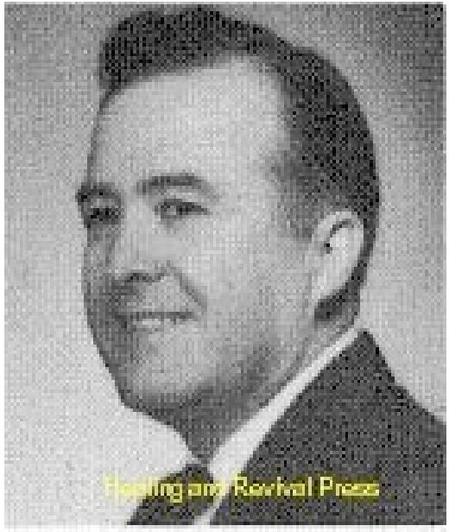

It is not psychology, which is a science of the mind. Natural sinners can teach psychology. It cannot be fortune telling. God's Word condemns fortune telling, which is of the devil. The devil counterfeits God's gift. If a fortune teller knows anything supernaturally about a man, you can be sure it is not the supernatural Spirit of God that gives him the knowledge.
THE WORD OF KNOWLEDGE ENLIGHTENS
I would not serve a God who is not as powerful as the devil. The devil is not more powerful than GOD. The devil, through fortune-tellers, is seeking to tell you something that will worry you to death and break up your home, heart, purse, and future; but God, by the word of knowledge, is trying to build all these things for you.
It is not very often an audible voice, but it was, such when God spoke to Samuel (1 Sam. 3:4). It is God who speaks to man and not man to man. God speaks to us by the Spirit very often in a still, small voice (1 Kings 19:12). It is no more a spoken word than discerning of spirits is a spoken word. The difference is, one deals with spirits and the other does not.
If man speaks the word of knowledge after the Spirit gives it to him, that part would come under the ministerial gift of teaching, exhortation, or such-like (Eph. 4).
IT IS NOT THE GIFT OF KNOWLEDGE
This gift is not the “gift of knowledge,” but the “gift of the word of knowledge” given by the Spirit. God does not, give us all His knowledge, but just a word (part) occasionally; although, the part will be changed into the whole during the perfect age (1 Cor. 13:9-10) when we will know as we are now known.
This gift is not guessing, imagination, or the working of the mind. It does not work through your mind any more than does speaking with tongues. God speaks to your spirit without the help of your natural mind or ears. You simply know it, that's all,
IT IS NOT A KNOWLEDGE OF GOD'S WORD
It is not a knowledge of God or of God's Word, that comes by learning, by study, or long experience. For instance, Eli, the priest, had long knowledge of God and His Word through experience; but the child Samuel, who had neither, was given a “Word” direct by the Spirit. Eli had gotten to the place where he had no open vision (1 Sam. 3:7, 11-14).

THE VOICE OF HEALING October 1953 Page 24
WHAT IT IS
The Spiritual gift of the word of knowledge is certain facts in the mind of God, which He sees fit to reveal to a servant supernaturally by His Spirit. It is only a “word,” or a portion of God's great storehouse of knowledge.
God speaks in divers manners, such as dreams, visions, revelation, or in audible voice. It is always conveyed supernaturally as any other gift. This gift can tell the whereabouts, conditions, nature, or thoughts of a person, animal, place, or thing even when it is impossible to learn it in the natural.
It is different from the Spiritual gift of faith in that it lets you know things even when you did not pray for them. The Spiritual gift of faith deals with things “not yet come to pass,” else it would not be faith. It is not a vocal gift, as it makes you to know and not to speak. It is not discerning of spirits, as it has nothing to do with a supernatural spirit.
It helps one, to look into the heart, mind, or nature of a man and to know his secrets and intentions. It has helped people find lost articles, but its main purpose is to find lost souls.
BIBLE EXAMPLES
While Peter was lying flat on his back on the house top, the Spirit of God told him three men were seeking him (Acts 10:19). Had Peter gone to school one hundred years he could not have gained such knowledge, The all-knowing God gave part of His knowledge to Peter by the Spirit.
The Spirit of God told Samuel that Saul's asses had already been found, and let him know all that was in Saul's heart (1 Sam. 9.19-20). A voice from God told Elijah that God had seven thousand who had not bowed their knees to Baal (1 Kings 19:18). A spiritual revelation!
THE WORD OF KNOWLEDGE COMES AFTER ALL NATURAL KNOWLEDGE HAS FAILED
The Lord told Samuel that Saul had hid himself behind the stuff (1 Sam. 10:22). This was after all natural knowledge failed. The Spirit made John to know the condition of the churches. (Revelation, chapters one, two, and three).
The Spirit told Elisha the location of the Syrian Camp (11 Kings 9:6), something the Intelligence Division of the army did not know. By a word of knowledge God told Ananias that Saul was at a certain place praying (Acts 9:11).
God made Paul to know, even when the captain did not know, that the voyage was very dangerous and would be of much hurt and damage (Acts 27:10).
The Spirit made Paul to know that he must go to Rome (Acts 23:11). He needed another gift to let him know when and how he must go. We will study that gift in the next chapter.

THE VOICE OF HEALING October 1953 Page 24
IT IS A SUPERNATURAL REVELATION OF GOD
Jesus knew that a certain woman was then living with a man without being married to him, and had had five husbands before she “took up” with him (John 4:18). He also knew the condition of Nathanel's heart and life, and what he had been doing (John 1:47-48).
In a night vision the Spirit gave unto Daniel what the king had dreamed (Dan. 2:19); but he yet needed the manifestation of another gift to know the meaning of the dream and what the king should do, and how he should do it.
“Eye hath not seen, nor ear heard, neither have entered into the heart of man, the things which God hath prepared for them that love Him, BUT GOD HATH REVEALED THEM TO US BY HIS SPIRIT.” (1 Cor. 2:8-10).
Marvellous revelation gifts!
IT IS GIVEN TO GOD'S SERVANTS TO ASSIST OTHERTS
God is concerned about every detail of our lives; even the hairs of our heads are numbered. If we cannot be in connection with the Spirit in the little things, we cannot be in connection in the larger things (Luke 16:10-11).
God showed me in a dream that three preachers in another state were in danger. I wrote all three of them. Two of them told me in letters of appreciation that the warning was just in time to keep them from serious trouble. The third preacher was soon taken to a nervous hospital in a straight jacket. When he was released he apologized to me for ignoring my letter of warning.
One night the Lord showed me that a preacher in another state was in trouble with his church. I wrote and told him. He wrote back saying that everything was going fine and his church was all right. A few weeks later I noticed in the paper that he suddenly resigned and moved to a church in another state. When I saw him he confessed that the church split. If he had listened and believed, he could have been saved the embarrassment.
WARNS GOD'S SERVANTS AND SAINTS OF IMPENDING DISASTER
Many times, while pastoring churches, the Spirit would make me to know in dreams, visions, or otherwise, that certain members were in trouble or going through severe trials. I would get to them just in time to help them. An ounce of prevention is better than a pound of cure. A stitch in time saves nine. I would root out the weeds in time to save the crop.
In Goldonna, Louisiana, while in the parsonage, the Spirit made me to know that Brother and Sister. B. were in trouble. Running to my room, falling across the bed, I prayed through until I touched God. Then I got into my car, and drove to their place. The same time God had warned me to pray, their house was on fire, Brother B. being gone. (They had already had one burn-out before then, losing all they had). Sister B. had stopped the fire just in time.
That was a word of knowledge before I went to my bed to pray about it.

THE VOICE OF HEALING October 1953 Page 24
REVEALS TO GOD'S SERVANTS THOSE NEEDING SPIRITUAL HELP
In a vision one night the Spirit of God showed me a man who had been delivered from cigarettes and had later gone back to smoking. The next night I started a revival in Nashville, Arkansas. During, the services I arose and said. "There is a man here who was prayed for and delivered from a habit. He has gone back to using it; the craving has returned. He is bound again. If he will come forward, God will deliver him again." He immediately arose and came to the front, telling how he had gone to a revival many miles away, was delivered and, after several months, tried a cigarette to see how it would taste. He had been bound since. That night he was delivered again, filled with the Holy Ghost, and is still going on with God, working in the church.
Of course, that was a word of knowledge given to me before I went to Nashville. Being delivered was another gift in manifestation, which we will study later.
In a dream one night I saw a woman who had been afflicted for many years crying for help, I started the next night in a revival several miles away. There I met this same woman. It was a word of knowledge, given by the Spirit. Her deliverance is another story.
SUPER-NATURALLY DIRECTS AND GUIDES GOD'S SERVANTS AND SAINTS Many times after a revival has gone on for five or six weeks, the Spirit has spoken to my spirit, "The revival is over." Other people could not understand why I was closing the meeting, as scores were being filled with the Holy Ghost in a single day. I still needed another gift manifested to show me how to close and deal gracefully, leaving a good taste. We will study it in the next chapter.
While I was in Tyler, Texas, the Spirit made me to know that my son, who was with his mother in Ardmore, Oklahoma was in danger. I wrote my wife giving her advice what to do before I received the long distance call telling me the news.
REVEALS THOUGHTS AND INTENTS OF PEOPLE FOR THEIR BENEFIT
I walked back into the audience, as I was giving an invitation for people to come to the altar, looked a lady in the eyes and said, "You used to have the Holy Ghost; come sit on the front seat and you will have it again in five minutes." It happened as I said. She made a good worker.
I found out later that she was a singer in a nightclub, in a backslidden state, at that time. God only showed me she used to have the Holy Ghost and she had faith to be delivered in five minutes. He did not show me where she worked. He gave me, by His Spirit, a word of His all knowledge.
Another night God spoke to my spirit in a still voice and made me to know that a man was on a high cliff ready to fall, to be forever lost. I sent him word. He was saved, filled with the Holy Ghost and is now a deacon and superintendent.

THE VOICE OF HEALING October 1953 Page 24
(Note: Please notice that I lay no claim to these gifts above any other member of Christ's body; but I relate just a few of my experiences, when God saw fit to manifest the gifts, which He has given to the Church (1 Cor. 12:28), through one of his least of all servants. I do it as an illustration showing you the working of each gift, and not of myself.)
Oh, that every pastor evangelist, teacher mother, dad, and every Christian would realize the need of such a gift being manifested through their lives.

THE VOICE OF HEALING September 1953 Page 10
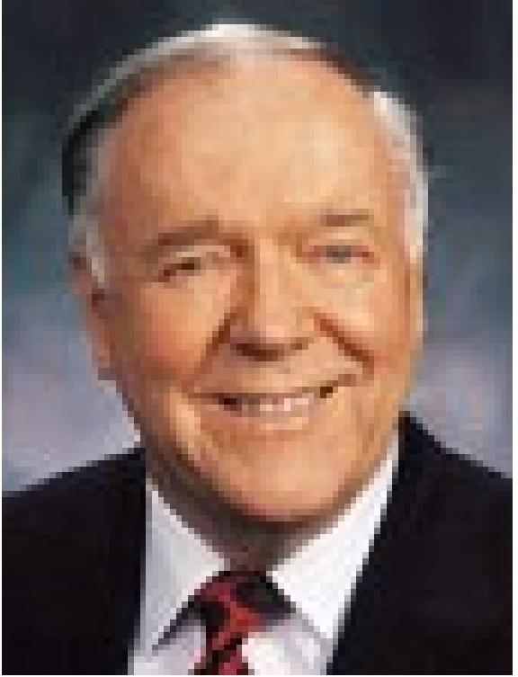
A Vision of the End
And God's Message to Me
By Kenneth A. Hagin
A REMARKABLE VISION in which an evangelist was caught away and shown scenes of both heaven and hell, and in which an Angelic Messenger gave him a special message concerning events which are to transpire in the end-time.
While I was conducting a revival in Rockwall, Texas, during the latter part of August and the first part of September, 1950. I called the people around the altar for prayer at 10 PM, September 2. As I was praying the Spirit of the Lord came upon me in a wonderful way, and I began to pray in other tongues. In a few minutes I heard a voice saying unto me "Come up hither." I looked up and saw Jesus standing with a crown in His hands. He said, "This is a soul-winner's crown." The crown was most beautiful and human language could never describe it. He said to me, "My people are so careless and indifferent. This crown is for every one of my children. I speak and say, 'Go speak to this one' or 'pray for that one,' but my people are too busy. They put it off, and souls are lost because they will not obey me." I wept before Him and repented of my failures. Jesus then said to me, "Come up hither," and it seemed I went with Him through the air till I saw a beautiful City.
We did not go into the City, but beheld it at close range. How beautiful and indescribable it was. Jesus said, "My people are so selfish; they say they are ready and talk about their mansion and the glories of Heaven while many all around them are in darkness and have no hope. Share your hope with them invite them to come with you."
VISION OF HELL
Then He took me down to Hell and as I beheld it, I said, "Lord, it looks just like it did when I saw it on April 21, 1933 at 7:30 PM when I died and my soul went to this place and You spoke and my soul came back into my body. I then prayed through and You saved me. Only now I'm not afraid nor horrified as I was then. I saw what seemed to be human bodies wrapped in flames. Jesus said to me, "Warn men and women about this place," and I cried out with tears that I would. Then He brought me back to earth and as He stood by my side, He talked to me about my ministry and told me some things in general that He later explained in detail in another vision. Jesus disappeared and I realized 1 was still kneeling on the platform. I heard people crying and praying around me.
THE MESSAGE OF THE HORSEMAN
About that time, the Holy Spirit came upon me again and I fell flat on face on the platform. As I lay under the power, I saw a horseman riding at full speed toward me. He held a scroll of paper high in his left hand. I was not conscious of my earthly surroundings, but seemingly was my in space somewhere. When the horseman came to me, he stopped; passed the scroll from his left hand to his right the handed it to me saying, "Take and read I opened or unrolled it and saw at the top of the page in big, bold, black print these words: "WAR-

THE VOICE OF HEALING September 1953 Page 10
DESTRUCTION." I was struck dumb and unable to speak. He laid his right hand on my head and said, "Read in the Name of Jesus Christ," and I began to read what followed on the paper; then I looked as the words instructed, and saw what I had read about. I saw thousands and thousands of men in uniform marching to war. I saw many women, old, white haired, middle aged and even young women with babies in their arms bowed together in sorrow and weeping profusely. I saw the skyline of a large city and when I looked again the skyscrapers were burned out hulls, the city in ruins There was written that not just one city would be thus destroyed, but many. I continued to read the scroll. It was written in the first person and was just like Jesus Himself speaking. He said, "America is receiving her last call. Some nations have already received their last call and will never receive another. THE TIME OF THE END OF ALL THINGS IS AT HAND," was repeated at least four or five times. He said also that this was the last great revival.
GIFTS TO BE RESTORED TO THE CHURCH
All of the Gifts of the Spirit will be in operation in the last days and the Church will do greater things than even the early Church did, and have greater power, signs and wonders than were written in the Acts of the Apostles. He said we had seen and experienced many healings, but would now behold amazing miracles such as had not been seen before. More and more miracles will be performed in the last days which are just ahead, for He said, "It is time for the Gift of Working of Miracles to be more in prominence. We now have entered into the era of the miraculous. Many of my own people will not accept the moving of my Spirit and will turn back and will not be ready to meet Me at my coming. Many will be deceived by false prophets and miracles of Satanic origin. But follow the Word of God and the Spirit of God, and follow Me and you will not be deceived. I am gathering my own together and preparing them, for the time is short." There were several exhortations to watchfulness, to awake, to pray and not be deceived.
THE 7 DAYS BEFORE THE FLOOD
Then He said, "As it was in the days of Noah, so shall also the coming of the Son of Man be. As I finally spoke to Noah and said yet seven days and I will cause it to rain upon the earth forty days and forty nights, and every living substance that I have made will I destroy from off the face of the earth, so today I am speaking and giving America her last warning and call to repentance and the time that is left is comparable to the last seven days of Noah's time.
"Warn this generation as did Noah his generation for judgment is about to fall, and these things shall be fulfilled shortly, for I am coming soon." He said again, "This is the last revival and I am preparing my people for My coming. Judgment is coming but I will call my people away even unto myself before the worst shall come. But be thou faithful; watch and pray," were the concluding remarks, “For the Time of the End of all things is at hand."
VISION OF THE THRONE
Those who were present at the time of my vision said I read the scroll aloud for about thirty minutes. I cannot recall all of it at the present time, I handed the scroll back to the rider and he rode away in the same direction from which he had come. Then I was conscious of the

THE VOICE OF HEALING September 1953 Page 10
fact that I still lay on the floor flat on my face. I lay there in the glory for a few minutes and then heard a voice saying, "Come up to the throne of God." Looking up, I saw Jesus again and went to Him, it seemed, right through the air. We came to the throne of, God and I beheld It with all its splendour. I was not, able to look upon the face of God but only beheld His form. I saw the rainbow around about the throne. I saw the winged creatures on either side of the throne. They are peculiar looking creatures and have eyes of fire that look in all directions. I stood with Jesus in the midst and He talked with me for nearly an hour. I saw Him as plainly as I ever saw anyone in this life and heard Him speak. I will not go into detail as to what He said to me for it concerns only me, and my ministry. The following account, however, covers the main points.
PERSONAL MESSAGE
He said that He had called me to a special ministry and had kept me through the years. Though Satan had tried to destroy my life many times, His angels had watched over me and cared for me. He talked to me about some things that the Holy Spirit had said to me almost two years before. He showed me where I had missed Him and doubted His dealings with me. I fell at His feet and repented with tears. Then He spoke about speaking to me again, this time by prophecy and also by that still small voice in my heart. He said that I had been faithful and believed and obeyed this second time and at that time entered into the second phase of my ministry. He said that I was now to enter into the third phase of my ministry. And If 1 would be faithful to what He had said to me; believe and obey Him, He would appear to me again and talk to me; then I would enter in to the fourth and final stage or phase of my ministry. He laid His finger in the palm of each of my hands and then laid His hand on my head and said, "Go, for I have called thee, sent thee and given thee, a special anointing to pray for the sick." My hands burned like I had fire in them. He said, "When you lay your hands on the sick, lay one hand on each side of their body. If you feel the fire jump from hand to hand, there is an evil spirit or demon in the body causing the affliction or trouble. Call him out In My Name. The demon or demons will have to go in My Name. If the fire does not jump from hand to hand it is a case of healing only. Pray for them in My Name; if they will believe and accept it, the fire will leave your hands and go into their bodies and drive out the affliction or sickness. When the fire leaves your hands and. goes into the body, you know they are healed." I fell at His feet and cried out in tears, "Lord don't send me; send somebody else. Please, don't send me. Just give me a little church to pastor, but don't send me; I'd rather not go, Lord, I've heard so many of our own ministers and folks criticize those who pray for the sick. Lord, just give me a common-place ministry."
THE LORD'S REBUKE
Jesus rebuked me and said, "I'll go with you and stand by your side as you pray for the sick; and many times you will see Me. Occasionally I will open the eyes of someone in the audience and they will say, “Why I saw Jesus standing by that man as He prayed for the sick."' I said, "All right, Lord, I'll go if You'll go with me: I'll do my best and be as faithful as I know how." There came a love that I had never known into my heart for those who criticize this type of ministry. I said, "Lord, I'll pray for them, for they don't know, or they would not say the things they do. Lord, I've said similar things, but I didn't realize nor see as I do now, and neither do they. Forgive them Lord."

THE VOICE OF HEALING September 1953 Page 10
Then He said, "Go thy way, My son; fulfill they ministry and be thou faithful for the time is short." As I walked away from the throne of God, Jesus said just another word or so "Be sure to give Me all the praise and glory for all that is done, and be careful about money, Many of My servants whom I have anointed for this type of ministry have become money-minded and, have lost the anointing and ministry I gave them. There are many who would pay much to be delivered. Many parents in the world have children whose little bodies are twisted and they would give thousands of dollars for their healings. Many of them shall be delivered as you lay your hands on them, but you must not accept a charge for your ministry. Accept offerings as you have been doing. You must go your way; be faithful, for the time is short," Jesus then journeyed with me back to the earth, and I realized that I still lay on my face on the floor, He talked with me there a moment and then disappeared.
My hands burned for three days just like I had a coal of fire in them. Now, when I wait upon Him in prayer and fasting, the same anointing comes upon me again.

THE VOICE OF HEALING June 1954 Page 7  Donald Gee Column  Anointing With Oil  WHY do we anoint the sick with oil for divine healing? A very simple answer might he "Because it is in the Bible," and we would point to the two passages where the practice is referred to and enjoyed - Mark 6:13 and James 5:14-16. But it will strengthen our intelligent approach to the matter, if we seek to understand something of what lies behind it. | 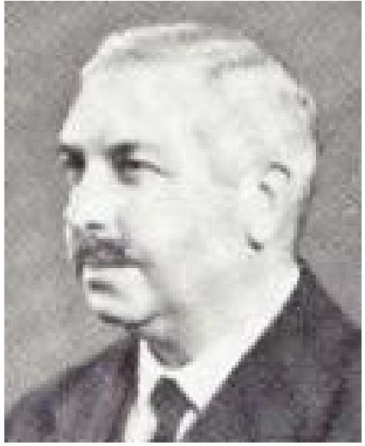

In the first place scriptural anointing with oil is not extreme unction" as practiced by the Roman Catholics for those at the point of death. Scriptural anointing with oil is for LIFE, not death, "the Lord shall raise him UP." Secondly, it is not medicinal. The apostles and the elders of the church who performed this rite were not medical practitioners. They acted as men with purely spiritual qualifications, notably faith, and they operated by prayer. No sensible person will suppose that oil applied medicinally, as in the parable of the Good Samaritan (Luke10:34) would equally serve for all manner of sickness and disease. The healing factor is spiritual, not natural, as certainly was the case when our Lord used the strangest of ointments when He spat on the ground, and made clay of the spittle, and anointed the eyes of the blind man with the clay (John 9;6).
But, if the power that heals by prayer is spiritual, why anoint with oil at all? As a matter of fact, divine healing is often received apart from anointing. Probably in the majority of cases, especially in evangelism, the Lord blesses the simple laying on of hands. There is no recorded case in the Book of Acts of anointing with oil in connection with miracles of healing. The Lord may heal in answer to simple prayer, as perhaps in the instance of Epaphroditus (Phi 2,27). The decisive element on our side is "the prayer of faith" (James 5:15), and it appears that the chief use of anointing with oil when praying for the sick is to provide an aid to believing. This is consistent with the divine purpose in other sacraments in the Church where that which can be seen and handled by our natural senses helps us to grasp the potent unseen and intangible spiritual factors of truth.
For such purposes the Holy Spirit takes and sanctifies some of the common things and usages of life. The ordinance of believer's baptism is the ordinary bath lifted to a sacramental level ("Arise, and be baptized, and wash away thy sins," Acts 22:16): the breaking of bread service is the ordinary meal, equally lifted to a sacrament ("as they did eat, Jesus took bread,” Mark 14:22). Anointing with oil is a personal habit of the East ("when thou fastest, anoint thy head," Matt. 6:17). Anointing the body was usually, except for burial, connected with health and joy and well-being (Thou anointest my head with oil," Psalms 23:5), and readers will recall classic instances in the Odyssey. To anoint the body would have healthful suggestions and association for the early Christians more easily than for ourselves.
Deeper still, anointing with oil is typical of the spiritual grace of the Holy Spirit of God. Throughout the Old Testament anointing with oil carried a long and sacred tradition connected with the priesthood and with kingship (eg. Aaron and David), The New

THE VOICE OF HEALING June 1954 Page 7
Testament makes "anointing" definitely typical of the Holy Spirit - "God anointed Jesus of Nazareth with the Holy Ghost and power" and "We have an unction from the Holy One," etc. All this taken together means that anointing with oil is intended to help us realize the presence and power of the Holy Spirit. It is superstitious to suppose that the oil in itself carries any miraculous power. C. T. Studd was miraculously healed after being anointed with kerosene! It is GOD, not the oil. "The LORD shall raise him up." The prayer of faith recognizes the unseen Lord with power present to heal, but that faith is truly assisted by the outward ordinance of anointing.
It is a prevalent mistake to cheapen this sacred ordinance by using it for all kinds of trivial complaints. The Bible is clear that it is reserved for those seriously ill. The word for "sick" in James 5:14 is literally "exhausted." That is to say they are so weak that they are compelled to "call" for the elders to come to them in their grave necessity. This is far removed from a preacher almost pleading with members of a church to come out to be anointed for some minor indisposition in order to comply with a local "testimony." Anointing with oil ought never become commonplace. To preserve its gravity is a signal service to faith. The mutual confession of faults also adds to the depth of the spiritual exercise properly involved in its observance. Its exercise makes an exacting demand upon the spiritual life of the elder, called upon, for they must be men who can offer the "prayer of faith." Fuller consideration of these factors would carry us beyond the scope of this column. It is a matter for gladness that more and more ministers of the Gospel in many sections of the Church are prepared to exercise this ministry in humble dependence upon the Living Christ.

THE VOICE OF HEALING March 1954 Page 6

The Binding and Loosing Ministry
By Evangelist Louise Nankivell
MATTHEW 18:18 we have a scripture verse of striking import which is perhaps not quite as familiar to Christian believers as a lot of others. It is those words of the Lord Jesus Christ, where He says -
"Verily I say unto you, whatsoever ye shall bind on earth shall be bound in heaven: and whatsoever ye shall loose on earth shall be loosed in heaven." This is one of those portions which has been a little difficult for us to understand. And possibly Jesus knew it would even be hard for us to believe; so He emphasized His statement by a prefix - "VERILY I SAY UNTO YOU."
"YE MUST BE BORN AGAIN"
There are not too many verses in the Bible beginning with the words "Verily I say unto you." In fact, the number is limited. Therefore, when you do find these words introducing a statement, you can count on it that a truth of tremendous significance is about to follow.
For instance, can you think of any matter more vital than that of the new birth? When Jesus wanted to press home the absolute necessity of regeneration, He declared - "Verily, verily, I say unto thee, except a man be born again, he cannot see the kingdom of God,"
Notice how the Lord Jesus accentuates this great truth with the predicatory phrase, "Verily, verily - it is true! It is true! I tell you it is true - ye must be born again."
And in Matthew the 18th chapter and the third verse, Jesus, in bespeaking the indispensability of conversion, stresses this declaration by adding these same words - "Verily I say unto you – ( I tell you it is true) - except ye be converted, and become as little children, ye shall not enter into the kingdom of heaven."
"GREATER WORKS SHALL YE DO"
Another verse with this arresting prefix is that breath-taking passage in the 14th chapter of John - "Verily, verily I say unto you, he that believeth on me, the works that I do shall He do also; and greater works than these shall lie do because I go unto my Father."
The power and the authority of the believer are so far-reaching, that, even after Christ tells us it is true, that believers will do His work and greater, we are still gasping for breath over it. Well, this very same emphatic phrase of affirmation, which Jesus used concerning the new birth, conversion, the promise to the believer of the greater works, He has used concerning the binding and loosing ministry. Yet we have failed to comprehend its importance and have too lightly passed it by. But we dare not be remiss with His assertion, for these words are our investment of authority by the Great Conqueror, the One who would have His people "more than conquerors through Him that loved us."

THE VOICE OF HEALING March 1954 Page 6
"WHATSOEVER YE BIND ON EARTH IS BOUND IN HEAVEN"
Let us look again at these words in Matthew 18:18. Jesus said - "Verily I say unto you, whatsoever ye shall bind on earth shall be bound in heaven; and whatsoever ye shall loose on earth shall be loosed in heaven."
"But sister, to whom was the Lord Jesus Christ speaking? Wasn't He speaking to Peter? Yes, of course He was. But He was not speaking to Peter only, He was speaking to all of His disciples; and He is speaking these words today to every Peter, to every disciple right down to the very end of time - to the end of the world.
"Whatsoever ye shall bind on earth” - "Whatsoever!" Think of it! A pretty big order! But the Lord has some big words in His book. This one is so big - we sometimes stumble over it.
It makes me think of another one of the Lord's big words. "Whosoever!" Big as the world, isn't it! Whosoever is so big it takes in everybody, and whatsoever is so big it takes in everything. And the best part about it is, the "Whatsoever" is for the "whosoever!"
"Whatsoever!" Read it again and take note that it doesn't say "whomsoever." Sometimes we'd like to read it that way.
There's Brother X! He's such a trial to us! He's always on the "off-side" of things and he's so often causing trouble. My wouldn't we like to bind him!
And Sister Y! Her tongue is so long and seems to be loose at both ends. She criticizes and condemns: and is always stirring up conflict. Wouldn't we like to bind her tongue! We'd tie it up so tight.
We'd bind her up good. And we sometimes try it and get into a peck of trouble in the doing. But, dear ones, we're going at it in the wrong way. Jesus didn't say, "Whomsoever" ye bind, but "whatsoever."
If we want to see victory for Brother X and Sister Y, beloved, let us strike at the source of the disturbance. Let us bind the unseen forces of darkness that are inciting our brother, our sister to do those things which are unbecoming to the Gospel of our Lord and Saviour Jesus Christ.
WE BATTLE AGAINST PRINCIPALITIES, POWERS, RULERS OF DARKNESS Let us not forget that our warfare is not against flesh and blood, but "against principalities, against powers, against the rulers of the darkness of this world, against spiritual wickedness in high places." Our authority is not over men but over the powers of the air. Our part is to bind the forces of darkness – the powers of sin, evil, disease, hindrances to the Gospel, every spirit of doubt, anxiety, fear. And His promise is "WHATSOEVER ye bind on earth shall be bound in heaven." Our part is to liberate the prisoners and set the captives free. And His promise is, "WHATSOEVER ye shall loose on earth shall be loosed in heaven."

THE VOICE OF HEALING March 1954 Page 6
Whatsoever "YE" shall bind... YE! My disciples! O holy place of privilege and power!
O disciples of Christ! O church of the living God! Why have we all too often failed to comprehend the power and authority, which are ours through our glorious Lord!
Hath He not declared, "All power is given unto me in heaven and in earth?" And should not the same power in the living Head flow down through the body?
"I GIVE UNTO YOU POWER OVER ALL THE POWER OF THE ENEMY!"
Hath He not spoken, "Behold, I give unto you power (or authority) to tread on serpents and
scorpions, and over all the power of the enemy?" (Luke 10:19).
Never shall I forget how the Lord one day revealed the significance of these words to my heart. I could hear Him say to me, "Behold, I GIVE you power."
And I answered, "Yes, Lord, I take it - this Power. This authority you are giving me."
"And Lord. Because I 'TAKE' it. I have it - I HAVE power ever not 'some' but 'all' the power of the enemy." Even the devils are subject unto us through His name.
UNSEEN FORCES ARE WARRING AGAINST GOD'S PEOPLE
A great and real warfare is being waged against the people of God by unseen forces. The spiritual hosts of wickedness are seeking to hinder the very people of God from receiving the blessings of the Lord. The devil doesn't want people to be saved or healed or blessed in any way. Satanic forces are invading the churches, spreading false doctrines, sowing discord among God's people, doing their devil best to disrupt and enfeeble the church, to damn the world, and in general to wreck the bodies and souls of men.
But what are we doing to stem the tide? "How can one enter into a strong man's house, and spoil his goods, except he first bind the strong man?" (Matt. 12:29). We are called to bind the unseen forces and to loose the victims. However, instead of our binding the powers of darkness, the powers of darkness have been binding us. Instead of the powers of the air being in subjection to us, we have been in subjection to the powers of the air.
Atomic war threatens. Communism spreads its mighty tentacles over the land. Crime and corruption run rampant. Godlessness and immorality increase while apostasy tightens its grip upon the church, Even Christians are bogging down with lethargy and complacency.
FEW CHRISTIANS EXERCISE THEIR GOD-GIVEN AUTHORITY
The church has pretty well lost her influence over the masses. In large measure she is trying to accomplish through oratory, organization, entertainment; that which can alone be done through the power of the Spirit. And so we have the sorry spectacle of a helpless church trying to help a helpless world.

THE VOICE OF HEALING March 1954 Page 6
It would appear the church has little or no knowledge of the authority of the believer. How many even of Spirit-filled believers are exercising this authority?
The Spirit-filled people of the Lord have the greatest potential power of the Universe already in them. Have we not been made recipients of the power, which raised Jesus Christ from the dead! Then why should we be pygmies when God purposes we shall be spiritual giants?
Has He not quickened His people and raised us up together and made us sit together in heavenly places in Him! (Eph. 2:5, 6; Eph. 1:19-23.) Do we not potentially share His authority! Can we not realize that we have been given authority - delegated power, over all the powers of the air and conditions which these powers create!
CHRIST COMMANDS HIS FOLLOWERS TO BIND SATAN'S POWER
Then why should the church of the living Christ sit on the sidelines and let the enemy work unhindered?
Satan and his works of sin, sickness, strife, have no right to any part in the life of any believer. It's about time we, His disciples, resist and rebuke every enemy power that rises up against us. In the name of the Lord, let us exercise the binding-loosing ministry committed into our hands. We have been praying, "Lord, bind the powers of darkness," but He has been saying, "YOU bind them." Jesus did not say, "Whatsoever, '1' bind on earth," shall he bound in heaven, but He said "Whatsoever 'YOU' bind." It is the disciple who is delegated to do the binding on earth. It is the Lord who will do the binding in heaven.
"But what do you mean by binding?" That was the question asked me by a young man while I was holding meetings in Washington, D. C. "Whenever I attend the meetings, I hear you binding the infirmities and diseases of the people. What do you mean by this?"
"Well what would it mean if I should bind your arm? It just wouldn't be able to function, would it?"
WHAT WE BIND ON EARTH IS BOUND IN HEAVEN
As I continued explaining, I mentioned that when I bind the diseases here on earth, the Lord is saying "Amen," and binding them over in heaven. Some sisters were standing nearby and one of them who had overheard the conversation, remarked, "Well hallelujah, then they are doubly-bound." And I must add to what the sister said - when I loose the victims here on earth, the Lord is loosing them in heaven, and they are doubly-loosed.
This "binding" is not to be confused with "praying," It is not "praying" in the ordinary sense of the word. It is beyond "asking" something from the Lord. It is the command of authority which renders powerless the opposing forces and works of the enemy. When followed through in militant faith and in the name of our lord and Saviour Jesus Christ, nothing can stand before this authority and power.
GOD WANTS US TO USE POWER HE COMMISSIONED US WITH

THE VOICE OF HEALING March 1954 Page 6
Sometimes we pray for help, for healing, and with strong crying plead for great deliverance. We may even spend hours waiting upon God for the answer, which never seems to come. Now waiting upon God is always essential, profitable, and much needed in this awful evil day, but has it ever dawned upon us that while we are waiting for God to move, God may be waiting for us to act upon the authority with which we have been commissioned.
It was following a terrible illness that the Lord laid it upon my heart to practice the binding and loosing ministry. I had HOPELESSLY gone to pieces with an incurable condition, when the Lord Jesus Christ appeared to me in the night. I saw the lord Jesus. Yes, I saw Him as real as any person I have ever seen in life. In fact, the appearance of Christ was so real, that for weeks and weeks I thought I saw Him over and over again. And the deliverance He wrought for me, when down in the very jaws of death, has left me with a simple, sincere, trusting faith that there is no body so far gone to pieces, through the ravages of disease, but that the all-powerful, quickening touch of the nail-pierced hand can make it whole again.
Not only has the Lord performed great deliverance for me, but He has spoken to me in a special way the words of Matthew, chapter 18 and verse 18 - "Verily I say unto you, whatsoever you shall bind on earth shall be bound in heaven: and whatsoever you shall loose on earth shall be loosed in heaven."
He showed me a row of soldiers lined up against a long, long wall. They were standing shoulder to shoulder - a long row of them. Their bodies were bound with ropes and cords, so tightly that they could not move. The Lord Jesus said to me, "Do you see those soldiers so helpless that they cannot move? Well, when you bind the diseases of the people, the diseases will he bound just like the bodies of those soldiers, and the diseases will be stopped in their tracks. They will lose their power. They will not be able to operate any longer in the bodies of the people. Every symptom must clear up and depart from them."
GOD CONFIRMS HIS WORD WITH SIGNS
When I bind the power of the diseases of the people here on earth, the Lord Jesus is saying "Amen," and binding the power of the diseases over in heaven. It is indeed blessed how God is confirming His Word with signs, following, bringing praise and glory to His own great name.
I recall the instance of a man who came in the healing line one night in the meetings. His right arm was so stiff and immobile that he was unable to raise it at all. In the natural, it seemed it could never be raised without actually breaking the arm, but I refused to be defeated. "In your name and on your authority dear Lord," I commanded, "I bind the power of affliction and every force that would hinder this man from using his arm, and I loose this arm to be perfectly whole." Instantly the hindrance was removed, and the man shot his arm into the air as though there had never been anything wrong with it. Instances could be multiplied of healings and deliverances from diseases and infirmities of every kind through this binding and loosing ministry - even many being raised from sick beds.

THE VOICE OF HEALING March 1954 Page 6
THE LORD DESIRES I TEACH OTHERS TO BIND THEIR INFIRMITIES The Lord has also laid it upon my heart to instruct the people in binding and loosing their own diseases right in the meetings. Too many times we fold up when sickness strikes. We succumb to our troubles, our aches, our pains, our afflictions. We are prone to sympathize with ourselves and are nursing and coddling our infirmities when we should be rebuking them and commanding them to leave us.
"Dear Lord, in your name, and on your authority, I bind the power of my infirmity, this gall bladder ailment, this arthritis, this asthma (or whatever the affliction may be), that it will no longer be able to function. I command it to loose its hold upon my body - I rebuke every attack of the enemy. I command you Satan in the name of our Lord and Saviour Jesus Christ, to let go your hold of oppression upon spirit, mind or body."
Many have been healed in this very manner, rebuking their own condition while standing in the congregation. Doubtless many VOICE OF HEALING readers saw the picture and read the story, in a recent issue, of a lady who bound the power of her own disease in one of the services, and was loosed from a cancer which she passed that night, after retiring
Space will not permit giving further accounts of what God is doing, but let me say we have not begun to tap the resources of heaven and the possibilities of the binding-loosing
ministry.
LET US TAKE OUR PLACE OF AUTHORITY IN CHRIST
Dearly beloved, these are desperate days. Needs everywhere are pressing. It is no time for the church to be sleeping; nor can we believers afford to be living beneath our privileges. Let us humbly take our place of authority in Christ! Let every Christian stand forth in fearless faith against every opposing force of the enemy, knowing the greatest power and authority of the universe are ours, and that as we maintain our position in Christ far above principality, and power and might and dominion, the powers of the air and the works of darkness are in subjection to us.
Let us not be defeated ourselves, and let us - through the power of Christ - deliver others from their defeat!

THE VOICE OF HEALING January 1954 Page 10  Christ’s Will to Heal  Evangelist W.B. McKay  MARK 1:40-42 - "And there came a leper to him, beseeching him, and kneeling down to him, and saying unto him, if thou wilt, thou canst make me clean. And Jesus, moved with compassion, put forth his hand, and touched him, and saith unto him, I will; be thou clean. And as soon as he had spoken, immediately the leprosy departed from him, and he was cleansed." | 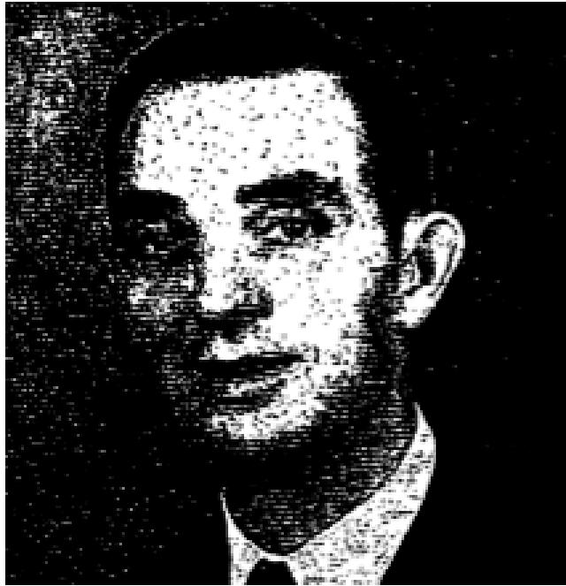

WHEREVER the Lord Jesus Christ went in His earthly ministry, multitudes who needed help followed Him. There were the blind, the halt, the maimed and the lame who needed a touch from our co ' compassionate Christ. "And Jesus, moved with compassion" healed many.
MUST HAVE FAITH TO APPROPRIATE DELIVERANCE
One of the most common sayings by persons who come, for healing is, "I know Christ is able," but to know that He is able is not sufficient. We must know His will in the matter and have faith to appropriate deliverance. We must overcome the common phrase used by many that seek to be healed; "IF it be Thy will." We read of a certain man afflicted with leprosy who came to Jesus, beseeching Him and kneeling down to Him saying, "If Thou wilt Thou canst make me clean," He meant, "There is no obstacle standing between me and health but Thy will, and surely it cannot be Thy will to leave me in this condition." He, as it were, throws the responsibility for his health or sickness upon Christ and thereby makes the strongest appeal to that loving heart.
In other words, this leper, who was an outcast from his people, was saying - "Lord, I know you are able, but is it your will?"
"I WILL, BE THOU CLEAN!"
No doubt the leper had learned of the healing ministry of Jesus and knew perfectly that Jesus had performed many miracles, but as to the willingness of the Lord to heal him the leper was uncertain. Immediately, Jesus "put forth His hand and touched him, and saith unto him, I will; be thou clean." There was absolutely no uncertainty in the Lord's answer. Jesus took away the "IF" saying. "I will.” There is no record in the word of God where Jesus refused to heal. Jesus never turned anyone away. He is still the same today.
Jesus was not afraid to come near this leper. When a person would come anywhere near a leper, he would raise his hands and cry, "unclean, unclean," but Jesus came to bring deliverance and set the captives free. Note the compassion of Jesus bending over the leper, with pitying love from His heart to put away all of his miseries. The compassionate Christ is near us all. He does not wait to be moved by the prayers that come from these leprous lips, but the sight of the sick touches His pitying heart and sets in motion all the wheels of His healing powers. In swift obedience to the impulse of pity, Christ thrusts forth His hand,

THE VOICE OF HEALING January 1954 Page 10
unafraid of the leper and touches him, bringing assurance of His sympathy and of His love for mankind.
TRUST HIM WHOLLY
Lastly, note the immediate cure. As soon as Christ had spoken, the leprosy departed. The suddenness of this cure and its completeness can be reproduced in us. Take Him at His word, trust Him wholly, and His power for healing and "straightaway" your affliction will depart from you. The centurion who came to Jesus said, "My servant is home sick." Jesus said, "I will come and heal him." But note with me the humbleness of this great man, the centurion. He said unto Jesus,
"I am not worthy that Thou shoulds't come under my roof: but speak the word only, and my servant shall be healed. For I am a man under authority, having soldiers under me: and I say to this man, Go, and he goeth; and to another, Come, and he cometh; and to my servant. Do this, and he doeth it."
"When Jesus heard it, He marvelled, and said to them that followed, ‘Verily I say unto you, I have not found so great faith, no, not in Israel. And I say unto you, that many shall come from the east and west and shall sit down with Abraham, and Isaac and Jacob, in the Kingdom of Heaven."
"AS THOU HAST BELIEVED, SO BE IT!
"And Jesus said unto the centurion, Go thy way; and as thou hast believed, so be it done
unto thee, And his servant was healed in the self-same hour." (Matthew 8:5-13).
Friend, note with me this last verse: "Go thy way, and as thou hast believed..."
This is past tense. Not that you are going to believe, but you have believed already. Hope anticipates: faith lays hold. Some people have no trouble believing that God is going to heal them sometime. When, how, or where they do not know, but you will hear them say that sometime He will heal them. This centurion believed, and Jesus said, "as thou hast believed, so be it done unto thee. And his servant was healed that selfsame hour."
"DOES THE LORD HEAL EVERYONE?"
I have heard some people say, "I know the Lord heals, but I doubt whether He heals everybody. How are we going to know whom He will heal?" If the Lord would heal one and not another, then the Lord would be showing favour. We all have a perfect right to pray, believing God will answer our prayers and expecting Him to give us deliverance. The Lord healed "ALL" who were brought to Him. He paid the price for our healing. "He took our infirmities and bare our sickness," The word "our" takes in EVERY believer! Praise His precious name! .
The Lord did not say, "Stay sick for My glory." We read in the scripture that He healed all that came to Him for healing. If you suffer from affliction, just remember that Jesus Christ will heal everyone that calls upon Him in faith.

THE VOICE OF HEALING January 1954 Page 10
If a rich man told me He would give me a large amount of money, or promise something of value, I would certainly have faith in him to keep his promise. So precious ones, you who suffer, perhaps are shut-in, let me encourage you to go to the Lord Jesus for your healing. He is the same yesterday, and today and forever. (Heb. 13:8) He will never leave you, and will heal you, for it is His will!
TO EXPECT IS TO RECEIVE
John 5:7 - "Sir, I have no man, when the water is troubled, to put me into the pool: but while
I am coming, another steppeth down before me.”
These words came from the lips of a paralytic man by the pool of Bethesda. Consider the scene with me please. This poor afflicted man lay under one of the five porches along with a great multitude of impotent folk, blind, halt, withered, waiting for the moving of the water. They were all waiting an opportunity to slip into the water when the angel caused the water to be troubled. The first afflicted person to get into the water would be heated. The scripture says: "Whosoever then first after the troubling of the water stepped in was made whole of whatsoever disease he had." (John 5:4)
Many people thronged the city, passing through these porches on their way to the temple, but none of the visitors were interested in those that lay at the pool of Bethesda. But there is one person who is VERY MUCH interested in all suffering humanity. His name is "Jesus." Therefore, He comes to his place where wrecks of humanity lie, and begins to speak to the poor afflicted man who needs help.
"WILT THOU BE MADE WHOLE?"
The paralytic man has lain at the pool of Bethesda for thirty-eight years. This is a very, long time to stay in one place and suffer, waiting for something to happen that has never taken place. This man no doubt had lost contact with many friends, and many had forgotten him as he lay there. Perhaps at one time he enjoyed the comforts of home and family - possibly he had a prominent place in society. Such is the man of our text that Jesus meets.
Jesus finds the man, and at once asks him an unusual question, "Wilt thou be made whole?" What is implied here in the question put forth by Jesus? Jesus is endeavouring to bring from the very soul of this man a request that Jesus heal him and bring complete deliverance. Another thing, Jesus is saying by these words "Wilt thou be made whole?" Jesus was considering the man's cure. There is definiteness in the tone of voice. The Lord most certainly was trying to give the man new hope. Jesus is always considerate of us. He ever cares and loves us. This man may have failed in many ways in his love for the Lord, but Jesus is saying, "You need not fall any longer, I'm here to help you."
PLACE YOUR TRUST IN CHRIST
The question also implies that, if the man is to be made whole, he must put himself unreservedly into the hands of the Lord Jesus as He says, "I know you are sick, but just put your trust in me and I will bring deliverance to you." While the man is telling the Lord he has no one to help him into the water. Jesus commands him, "Rise" "Get up!" This is a

THE VOICE OF HEALING January 1954 Page 10
strange command. Getting up is what this poor fellow has been trying to do for thirty and eight years. But there was power, "Divine Power," back of these words; the command of Christ cannot be ignored.
The lame man at Bethesda leaped to his feet. At once he was made whole; that is just like Jesus. It does not take Him long to perform a miracle. Affliction and disease must flee when Jesus speaks. I have found Him to be the greatest physician of "Jesus Christ the same yesterday, and today, and forever." In the tent meetings across the nation, the Lord has given deliverance to many who have been seriously afflicted. Men have been delivered from tuberculosis in its worst stages; the Lord healed a precious brother in the: prayer line, of an ulcerated stomach; and one elderly woman was all bent over when prayed for, but this same Christ, who commanded the man to rise, straightened her up. Friends, put your trust in Jesus, He can, He will, heal you now! The Lord has never lost His power!
BURN, YOUR BRIDGES BEHIND YOU
The next command the Lord gave to the man at the pool of Bethesda was, "Take up thy bed," The Lord was not thinking of the value of the old bed when He said "take up thy bed". He was simply helping the man and keeping him from having a relapse, Jesus was saying, "Man, burn your bridges behind you." In other words, "You don't have to return to this way of living again. You are healed - you are made whole. Now believe, me, trust me, and I will keep you well.
Then came the final command to the man who obeyed the Christ of Glory; "Walk!" Don't sit down complaining any longer, get away from here right now. You have been around here too long.
"Immediately, the man was made whole and took up his bed, and walked." Surely Jesus was a real friend to this man, and He is a friend to all who trust Him. The man of Bethesda must obey the Lord, if he would receive his healing. HE DID OBEY AND WAS MADE WHOLE!

THE VOICE OF HEALING July 1954 Page 11
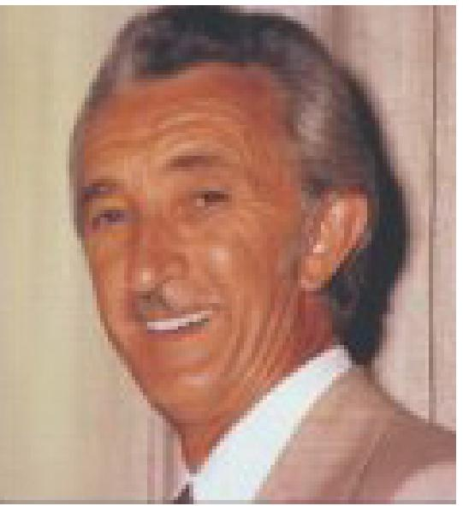
Deliverance From Evil Spirits
An Examination of the Scriptural Basis for the Ministry of Deliverance, by Pastor Leo C. Harris of Adelaide, South Australia
Multitudes are today rejoicing in this last-day outpouring of the Holy Spirit with the accompanying "ministry of deliverance." These are the days of an age-ending clash between the powers of darkness and the authority of Christ operating in and through the church "which is His Body." Praise God for souls saved, sick and diseased bodies healed and many liberated from the power of Satan!
However, as we challenge the forces of evil, it is imperative that we do so on the ground of God's Word. The weapon placed in every believer's hand is "the Sword of the Spirit, which is the Word of God" (Eph. 6:17), and this is particularly important in cases where deliverance is sought from the power of evil spirits in the minds and bodies of men and women.
Possession By Evil Spirits
The New Testament teaching concerning demon possession is clear, and the casting out of devils occupied a prominent place in the ministry of Jesus and of the early church. These would appear to be rather obvious cases of spiritual, mental or physical bondage to the power of one or more demons. The ministry of deliverance from such possession is based on the commission of the Lord Jesus in Mark 16, verse 17 reading, "In My Name shall they cast out devils." Divine equipment for the effective ministry of casting out evil spirits is provided in one of the nine Gifts of the Spirit outlined in 1 Cor. 12:8-10, namely, the gift of the discerning of spirits.
The writer has proved in his own experience, however, that at times when there is an atmosphere of faith and power, an evil spirit will often manifest itself in a person. It can then be cast out in the Name of Jesus. The presence of demons must be detected, either by the gift of discerning of spirits or by their being aroused by the presence of the power of the Holy Spirit, and once they have been exposed they have lost much of their ability to resist exorcism.
The casting out of evil spirits is part of the ministry of deliverance as much as the laying of hands upon the sick for their healing (Mark 16.17-18).
How Do Evil Spirits Attack Believers?
That men and women are attacked by Satan and his demonic forces, without being
completely possessed by them, is perfectly obvious. What then is the nature of such attacks?
It should be remembered that these remarks are for the benefit of Christian people, as the first step for any person seeking personal victory is to accept Christ as Saviour.

THE VOICE OF HEALING July 1954 Page 11
Fellow-believer, we must understand that Jesus Christ has completely and eternally defeated Satan and all the powers of darkness. Careful and prayerful study of the epistles to the Ephesians and Colossians makes this fact abundantly clear.
Moreover, every believer is regarded as being "IN CHRIST" and "INDWELT BY CHRIST" (Gal. 2:20; Col. 3:3 etc.). Every believer therefore shares in the complete victory of Christ over all demonic power!
How is it, then, that Satan manages to bring so many Christians into such utter defeat? How does he bind THEM with fear, depression, doubts and spiritual failures? Here is the answer, and herein lies the real secret to a glorious victory for every child of God!
Satan has been stripped of all authority over every Christian. He no longer has any right to hold you in captivity. If he seeks to rule in your life he is a usurper! He is a defeated foe, now and for ever!
But we are warned of his subtle weapons in such words as "the WILES of the devil" (EPH. 6:11); "which DECEIVETH the whole world" (Rev. 12.9), and in the next verse, "the ACCUSER of our brethren." Christian friend, the devil's weapons against you are WILES, LIES, DECEPTION and ACCUSATIONS. He has no real authority over you. He must rely on deceiving you into submitting to his usurped power!
Friend, that fear which torments you is one of his lies. That depression which holds you in the depths of despair is one of Satan's deceptions. That doubt which binds you, that complex which undermines; your spiritual experience - they are Satan's subtle, subversive tactics to hold you in defeat! That sin which you think you cannot overcome - it is one of the enemy's lies. You CAN overcome it. "Walk in the Spirit and ye shall not fulfill the lusts of the flesh." (Gal. 5:16).
How Deliverance Comes
Many people in such circumstances as these feel they must try some unusual, spectacular
means of obtaining deliverance. But what does the Word of God say?
There is a word that is used three times in the New Testament with regard to our attitude toward the devil and demons. That word is "anthistemi," and is translated "withstand" and "resist" in the following passages:
"That ye may be able to WITHSTAND (Satan and evil spirits) in the evil day." (Eph. 6:13) "RESIST the devil and he will flee from you," (James 4.7); "The devil ... whom RESIST steadfast in the faith." (1 Pet. 5 - 8,9).
Some suggest that long-standing cases of bondage require more drastic measures. Friend, the Bible knows of no more drastic measures for defeating Satanic attacks. Of course, for demon-possession there is no provision made for self-administered deliverance, but only the casting out of the spirit by one using the authority of Mark 16:17. For the numerous attacks,

THE VOICE OF HEALING July 1954 Page 11
deceptions and bondage by evil spirits, short of actual possession, the remedy is extremely simple and plain.
We Have a Complete Armor!
Our defensive armour is described in Eph. 6:11-18, and a most important part of it is "the shield of FAITH." Our only aggressive weapon is "the sword of the Spirit, which is the Word of God." This passage describes our WHOLE ARMOUR. With this armour we are FULLY EQUIPPED for both defense and offense against evil spirits!
Take hold of the SHIELD OF FAITH - faith in His promises, faith in His declarations concerning your position in Christ. It is written that you are dead with Christ, buried with Him, raised with Him and seated with Him in heavenly places (Eph. 2 etc.). Take up your God-given position in faith. Learn to exercise your throne-rights. Claim your share in the victory and authority of Christ.
Thrust your SWORD at the enemy! Quote Scripture at him. Declare; "it is written," as Jesus did in the wilderness temptations, and then say aloud any of the great promises such as found in Luke 10: 19; Gal. 2:20; Eph. 2:5-6; Col. 2:10. Read them. Memorize them. Believe them. Then thrust them at the enemy. Declare them in bold, positive faith!
In Luke 10:19 Jesus told His disciples, "Behold, I give you power ("exousia" - authority) to tread on serpents and scorpions (symbolic of demons), and over all the power ("dunamis" - energy, force) of the enemy; and nothing shall by any means hurt you." Times innumerable we have seen poor, helpless, defeated folk learn to assume their delegated authority over all evil powers. We have seen them learn to SAY, rather than pray, to DECLARE rather than beseech, to cause the powers of darkness to flee before them as they exercise their throne-rights and force the enemy to obey them. What transformations have resulted! Hallelujah!
Fellow-believer, if your faith and God's Word are insufficient to drive the powers of evil from you, then it is time to seek out someone who has learned the authority of the ministry of deliverance. If your bondage should amount to POSSESSION, then don't fear, don't despair, for Jesus has provided the power of His own Name to bring you deliverance, But don't experiment! Don't run to a novice. Go to someone who has the experience, the courage, the faith and the knowledge of the commission of Christ as found in Mark 16:15-18.
Remember, demon-possession requires a ministry of deliverance, but for attacks, deceptive bondage and lying accusations by evil spirits you have the remedy in your own hands. Take the shield of faith and the sword of the Spirit. Remember you are united with Christ, who is "far above all principality, and power, and might, and dominion, and every name that is named, not only in this world, but also in that which is to come" (Eph. 1:21).
Don't wait for any manifestation. OBEY! BELIEVE! And as Paul exhorted (Eph. 6:13), "having done all... STAND."

THE VOICE OF HEALING September 1954 Page 22
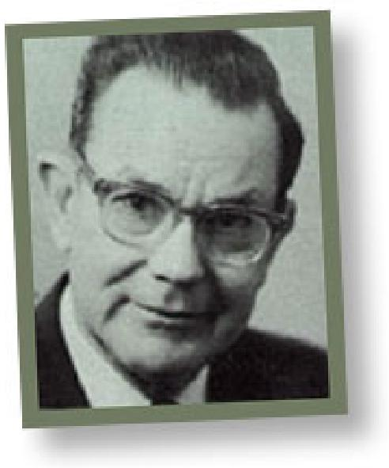
"...He Shall. Have Whatsoever He Saith"
Len Jones
"Let HIM say...” - And the "Him" means you!
"Whosoever shall say... He shall have whatsoever he saith," (Mark
11:23)
NOTICE the Scripture quoted above, does not say, "Let him PRAY," but "Let him SAY." For every one place you can show me the Scriptures, both Old and New Testaments, where things happened through PRAYING, I will show you many more where things happened through SAYING. It is time to begin to SAY!
Words are wonderful things Almost everything that has been done has been done with words When the world was made, it was made with a word – five times in Genesis 1 we read "Let there be..." and "Let them be," and many more times "Let the waters be gathered together,” "Let the dry land appear," "Let the earth bring forth." "By the WORD of the Lord the heavens were made," (Psalm 33:6)
"He spoke, and it was done, He commanded, and it stood fast," (Psalm 33:9). He still upholds all things by the WORD of His power.
The Lord Jesus Christ is referred to as the WORD of God. Every miracle that Jesus performed happened through a word. "Jesus SAITH unto them, fill the water pots with water," (John 2:7). He SAID to the nobleman, "Go thy way, thy son liveth," (John 4:50). He SAID to the damsel "I say unto thee, arise," (Mark 5:41). He SAID to the impotent man, "Rise, take up thy bed, and walk," (John 5 8). He SAID to the blind man, "Go, wash in the pool of Siloam" (John 9:7). He SAID to Lazarus, who had been dead four days, "Come forth," (John 11:43). He SAID to the man with the withered hand, "Stretch forth thine hand," (Matthew 12:13).
We could fill pages with instances in the Scriptures where things happened through a word. We are convinced of that, and have no doubt about it. But here is something else that we are also convinced of, and which also we have no doubt about - the time has also come when we also should be doing something about it. It is time to speak the word! It is time for us to say, "Be thou removed."
The reason many prayer meetings are so dull, and it is the hardest meeting of the week to get people to attend, and the reason many prayers are powerless, is because we ask God to do things for us, that He has already done for us. We put off to the future things that God says are for us right now.
How often we have noticed in the Scriptures the mighty "saying." They believed there was power in "saying," so they spoke the word in faith. There are so many instances that one

THE VOICE OF HEALING September 1954 Page 22
hesitates to start quoting, but here are a few; Joshua said, "Let the sun stand still, " Elijah said, "There shall not be dew nor rain these years, but according to my word," (1 Kings 17:1) - notice be didn't say: "According to God's word" but "According to my word." Isaiah said, "Behold I will send a blast upon him, and I will cause him to fall by the sword," (2 Kings 19:7), and here again, believe it or not, he did not say; "God will" but "I will." The Apostle Paul said, "Thou shalt be blind, not seeing the sun for a season," (Acts 13:11).
Even in the Old Testament they did this, and they didn't have anything like the light we have today, which is no wonder why Jesus said, "He that is least in the Kingdom of God is
greater than he." If Old Testament saints could speak the word, how much should you and I be able to "SAY" unto this mountain or that mountain, "Be thou removed and cast into the sea." Come along and let us start in right now and do some "SAYING."
How much faith have you got to have? Just enough faith to "SAY the word!" Does it happen straight away? Jesus said to the fig tree, "No man eat fruit of thee hereafter for ever," (Mark 11:14). And nothing happened? The fig tree still stood there as full of life as ever? Yes, something happened all right, for next day, Peter saw the fig tree and noticed that it was dried up from the roots. He said to the Lord, "Master, behold, the fig tree which thou cursedst is withered away," (Mark 11:21). And do you know what Jesus said in the next two verses, "You go and do the same thing."
The reason we don't speak the word is because we don't THINK anything will happen if we do! We don't FEEL anything will happen. We push aside what Jesus says, preferring to go by what we FEEL and what we THINK. Surely that is a tragedy, and after all these years of Christian living, we ought to know better than that just like your problems stand over you, threatening you, and roaring at you. So, one time the giant Goliath, nine feet high, with a helmet of brass upon his bead, and a spear like a weaver's beam, roared at the stripling David, "Come to me, and I will give thy flesh to the fowls of the air, and to the beasts of the field." So our troubles and weaknesses stand over us and roar at us. David didn't pray, he faced Goliath and SPOKE the word, "This day will the Lord deliver thee into my hand, and I will smite thee, and take thine head from thee." And just like Goliath fell then, so will our Goliaths fall today.
Daniel, with, confidence in the same God in whom we trust, SAID, "Bring me in before the king, and I will show unto the king the interpretation."
What a predicament Moses was in, yet he never doubted but spoke the word, "Fear ye not, stand still, and see the salvation of the Lord. For the Egyptians whom ye have seen today, ye shall see them again no more forever."
It was the Word of God on the lips of Jesus. It was the Word of God on the lips of Paul? It was the Word of God on the lips of David, Elijah, Moses and Daniel! That was the way God did things in the days that are past. God has not changed His methods God has never changed His methods! He is still looking for people through whom He can speak the WORD OF FAITH! Will you be that person?

THE VOICE OF HEALING January 1954 Page 11
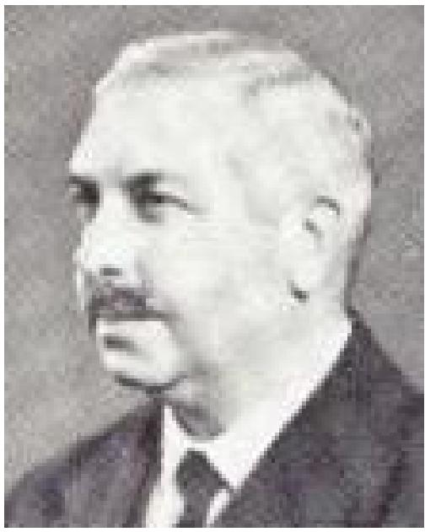
Donald Gee Column
Healed – but not Saved!
AMONG THE FIRST things we teach our little ones in the home is to say the equivalent of "thank you" and, in travelling all over the world, I found that one of the first expressions I wanted to learn in any language was its phrase for thanks for some act of kindness or help.
In Luke's Gospel there is an arresting story of ten lepers who stood at the entrance, to a village as Jesus passed that way and unitedly called over to HIM to take pity on them. He shouted back in reply, "Go and show yourselves to the Priests." It is a capital lesson in how faith works that instantly they obeyed Him, started off on their way to the Priests, and found themselves miraculously healed.
"One of them when he saw that he was healed, turned back. and with a loud voice glorified God. And fell down on his face at His feet giving Him thanks," (Luke 17:11-19).
Where were the nine? We echo the Master's question. it seems plain that they were so occupied with their healing, and probably their plans for what they would now do with restored health, that they had no time or thought for anything but utterly selfish emotions, They were set free from leprosy, and that was enough. If it were not for the fact that continually we get examples of the thing, we could hardly believe that in the ministry of divine healing today there are men and women who take miraculous healing in answer to the prayer of God's servants, and then go off to continue to live wholly unto themselves. They do NOT give their hearts and lives to Christ; they do NOT get converted; they do NOT seek fellowship with any church; they do NOT show the slightest concern about their sins. They have secured what they desperately wanted -physical healing, and they are satisfied.
Far deeper questions are raised than the unethical nature of such ingratitude. The solemn issue at stake is whether it is tragically true of them that they are healed, but not saved. Those nine lepers who showed themselves to the Priests were physically healed by an act of God. Was any deeper work of healing grace done in their souls? The fact of their gross ingratitude proves that it was needed.
In the case of the stranger who returned to give thanks we notice a significant turn in the words Jesus spoke to the man now sobbing out his gratitude at His feet - "thy faith hath made thee whole." Literally "thy faith hath saved thee." The man had already been healed (verse 15). It seems legitimate to regard this parting benediction from his Saviour as conveying something much more complete and final. The man was made WHOLE - every part of his personality was saved, not only his body but his soul and his spirit. He left with the glow of perfect health thrilling his whole personality. Samaritan though he was, his heart was right with God. What of the nine?

THE VOICE OF HEALING January 1954 Page 11
The other day a correspondent wrote to me about making "Healing a substitute for Evangelism." I am not regarding the phrase as necessarily a criticism of our healing evangelists, The perversion, if such there be, comes rather from the Public. The unsaved can be, and often are, intensely and personally interested in divine healing, Indeed the whole subject has now become a major popular item of interest all over the world.
Nevertheless a heavy burden rests upon the evangelist to see to it that he does more than seize this present wave of popular appeal for selfish interests. It is a fatal shirking of responsibility in the light of eternity to pander (cater) to this universal desire for healing and then do nothing more. Every Christ-given evangelist, worthy of that great office in the body of Christ, DOES make it his business to preach Christ as the Saviour from SIN; he DOES stress the need of the soul as infinitely greater than the most painful need of the body. We cannot emphasize this priority too much. It is a dreadful possibility of which we, who preach the gospel of God in the matter of Divine healing, need continually to remind both ourselves and those who hear us that it is possible to be healed – and not saved!

THE VOICE OF HEALING February 1954 Page 21  Donald Gee Column  This Near Hysterical Question  A FRIEND OF MINE in Hong Kong writes, "Of all things, here is an article enclosed in our daily English newspaper on 'Divine Healing in the Church of Scotland' - what next? I had heard of this before but never believed the practice of praying for the sick was so common." | 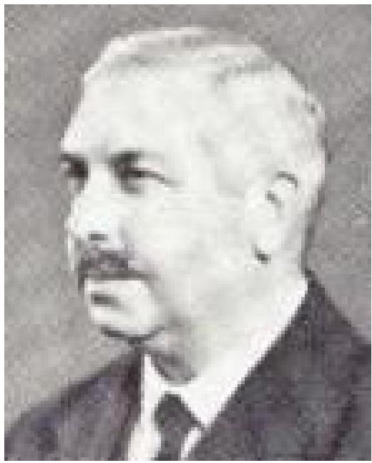

The article he enclosed is by Liam Regan, and headlined FAITH HEALING
“IN SCOTLAND”, it says, "Every week throughout Scotland, in the great cities and in smaller communities, a steadily-growing band of Church of Scotland ministers are practicing 'faith-healing.' Without publicity of any kind, they are holding these regular services in their churches and their halls. Some truly remarkable results have been reported by considerable numbers of people who have clearly benefited, both physically and spiritually, from such healing services. I was the first reporter to attend a special Church of Scotland 'faith-healing' service, which was held by the minister of one of Glasgow's largest churches in the West-End of the city. This was no packed group of excited near-hysterical evangelists, but a solemn congregation of about 100 people typical of the average churchgoing members of the community.... There was a remarkable feeling, an atmosphere, of everyone in that crowded church hall being at one with each other; the minister, the anxious patients, and the quietly praying friends and relatives seated just behind them. The minister walked slowly to the first person in the front row, an elderly man, and stood by his side. While the old man, sat still, the minister spread out his hands, palm down, not exactly ON the patient's head, but about half an inch above it. Quietly the minister prayed, quietly the old man prayed . . ." and so on.
The article goes on to report that "only the other month something like 200, ministers crowded into an Edinburgh hall to hear one of their colleagues give a lecture on Divine Healing - as they prefer to call it." This present interest in Divine Healing in the orthodox national church of Scotland shows the world-wide notice the subject is attracting. It is not a phenomenon peculiar to the Pentecostal Movement. The Spirit of God appears to be causing a revival of faith and practice in many sections of the Church in this part of the evangel that she was commissioned by her Lord in the beginning to proclaim.
But why that gibe at "excited near-hysterical evangelists?" After forty years of world-wide personal experience of healing evangelistic meetings I think I can understand what that Scottish journalist means, but I have a shrewd idea that these same journalists would have said exactly the same things had they been reporting the healing ministry of our Lord in Galilee, or that of the apostles in Lystra and Iconium. How about when the crowd yelled, "The gods are come down to us in the likeness of men?" (Acts 14:11). Quietness forsooth! I hold no brief for deliberately worked-up excitement aimed at producing a fictitious show of supposed Pentecostal power, but I challenge anybody to practice a healing ministry that

THE VOICE OF HEALING February 1954 Page 21
includes some genuine miracles without producing some entirely reasonable excitement. We can forgive the evangelist if he gets a little excited too, It seems high time we preached a gospel, and enjoyed a salvation, that gives us something to get excited about. Is anything else likely to prove a force sufficient to overcome the world? We need more excitement, or, more accurately, more causes for excitement in our evangelism. There are plenty of much less reputable causes for which multitudes of people (including some journalists!) are getting "near-hysterical" today.
Having said all that, I think there is another side to the matter. This newspaper reporter has written in Scotland, for Scotland, about Scotland and I, too, know something about the land of the Covenanters. The facts remain that hundreds of Scottish Presbyterian ministers are intensely interested in Divine Healing, that an increasing number of them are practicing it in the Name of the Lord Jesus, and that avowed miracles of healing are taking place. Moreover, all this is happening with "quiet" prayer, and no emotionalism beyond a "remarkable feeling, an atmosphere." What then? Ought we not be big enough to see that the Holy Spirit works in a variety of ways to meet the diversity of human and local temperaments?
It is an unfortunate mark of spiritual and mental immaturity in many of us that we cannot see any working of the Holy Spirit except in ways that appeal to our own temperament, conform to our own tradition, or fit in with our own ideas. For that reason it is to be feared that many of us will never have a ministry big enough to touch more than a limited segment of humanity. Probably, even so, we shall have a field large enough to occupy us during life's short day. But the truth ought to shine into our hearts that the Master does possess other equally faithful servants who differ from ourselves in almost every way, and yet are being equally used for His glory. How good it would be if, instead of trying to force everybody into our mould and then reviling them if they do not fit, we were wise enough to rejoice greatly that the grace of our Lord Jesus Christ, the love of God, and the communion of the Holy Ghost is shared by a far greater company than many of us dream of.

THE VOICE OF HEALING February 1954 Page 6
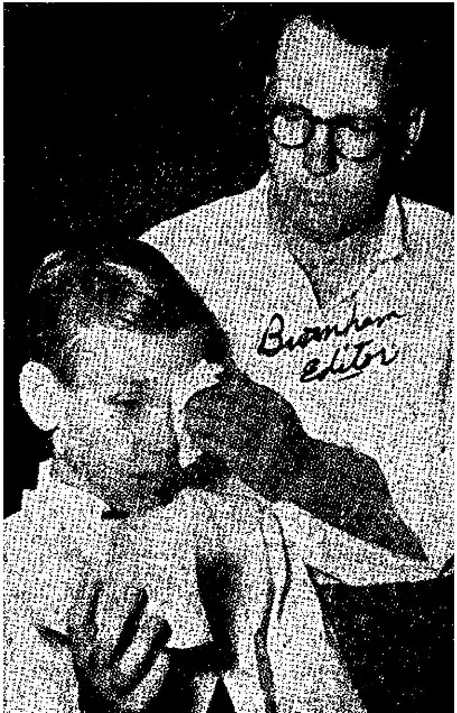
Ronnie Coyne -
The Boy who Sees – with a Plastic Eye!
It was during the month of May, 1950, that the Coyne family moved to Sapulpa, Oklahoma. One day in August of that year, while the mother was taking a nap, she was aroused by a cry coming from her son, Ronald, who was down the street a short distance. His brother came in and said Ronald had stuck a wire into his eye.
At first, the mother thought little about it, but the boy continued to cry and late in the afternoon she noticed a white spot on the eyeball. Immediately the parents took the boy to a doctor and later to one of the best eye specialists in Tulsa, Dr. Otis Lee, at the Springer Clinic. He realized the seriousness of the accident and rushed the boy to St. John's hospital.
PARENTS ARE ADVISED EYE BALL MUST BE REMOVED
A few days later the mother was notified that the eye could not be saved and would have to come out. She refused the doctor's request but agreed to come to the hospital. Arriving there she looked into the eye, while Ronald was asleep, and saw that it was white and cloudy. Then she realized that the sight was gone. Surgery was then performed in an attempt to save the eye, but it was discovered, during the operation, that an abscess had formed and there was no way to drain it. The mother was informed that Ronald might lose the other eye, or he might even lose his life, if the infected eyeball was not removed.
RONALD IS FITTED WITH A PLASTIC EYE
During these hours, the mother desperately held on to God, hoping that the eye might not be lost. She would not give her consent to the removal of the eyeball, but finally her husband gave his permission for the operation to proceed. A plastic eye was fitted, to take the place of the eye, which was removed. Four days afterwards, Ronald came home. For ten months, sight was totally gone in his right eye. The eyeball is the camera of the eye arid, after that is removed, there can be no sight. At least, medical science (up to this date) has never recorded anyone seeing after the eyeball was gone.
RONALD CONVERTED AT A VACATION BIBLE SCHOOL
About this time Ronald began to get anxious about his soul. He asked his mother the question, "If Jesus comes tonight, will I be ready?" Shortly after this, he went to a Daily Vacation Bible School and one day he came home with a big smile and said. "Mother, I got saved!"

THE VOICE OF HEALING February 1954 Page 6
AFTER PRAYER OF FAITH – RONALD SEES AGAIN WITH BOTH EYES! About two weeks after Ronald was saved, the family began attending a revival in Sapulpa, sponsored by REV. Lonnie Osborn (brother of Evangelist T. L. Osborn). Ronald had an infection in his tonsils, so his mother told him to go up and be prayed for, not wanting to have the tonsils removed by Surgery. The lady evangelist, Sister Gillock (sister of Evangelist Osborn) prayed for him and then noticed that something was wrong with his eye. She asked the boy if he believed the Lord could heal his eye. She didn't know the eyeball had been removed, but thought the plastic one she saw was a real eye. When Ronald said he believed he could be healed, she prayed that he could see. And God heard the prayer of faith!
RONALD BEGAN TO SEE OBJECTS, with his right eye! First he saw the steps, then the microphone, and then was able to count fingers.
All were astonished who knew the facts. The parents and others tested him for four days. The absolute conclusion was the boy was seeing!
NEWSPAPERS CARRY STORY OF MIRACLE
Soon the news spread. The local newspaper wrote an article on the healing. Reporters came from the Tulsa World and the Tulsa Tribune and these papers carried the story. About this time, the Lord visited the mother and told her to "Go and tell the people." At first she did not know how she could do this. However, since that time, she has taken Ronald to many meetings, and the demonstration has been made, to vast audiences. of what God has done.
AUTHENTICITY OF MIRACLE TESTED AT TVH CONVENTION
At the Dallas VOICE OF HEALING Convention in December, 1952, Ronald stood before the congregation and showed the people how he was able to see through the plastic eye. The Editor of THE VOICE OF HEALING personally tested the boy a number of times, and there was no doubt in his mind that the boy was able to see equally well with the plastic eye in, or the plastic eye out. It was in fact a continuous miracle!
JESUS REFUSED TO PERFORM MIRACLES FOR UNBELIEF
There is an odd principle about God's manifestation of the miraculous. When Jesus healed during His earthly ministry, He performed most amazing miracles for those who came humbly to Him. The blind who had never seen received their sight. Cripples from birth, walked, after receiving the command to rise; even the dead were raised. However, Jesus flatly refused to perform miracles for unbelief or to satisfy vain curiosity. The unbelieving Jews came to Him and asked for a sign from heaven. The request was refused. Herod the king asked for a miracle. Jesus would not even talk with him. They brought a blind man to Him in unbelieving Bethsaida, and Jesus would not heal him until he had taken the man out of the city.
SKEPTICS DO NOT SEE THE MIRACULOUS
God still holds to this principle today. Occasionally, when a rank sceptic has come to test the
child, or if he is handled roughly or "cowed" by a strong personality, the eye may

THE VOICE OF HEALING February 1954 Page 6
temporarily go blind. However, after the sceptic leaves, sight returns. On one occasion charges were brought against the boy that he could not see and that he was a "fake." It was claimed that Ronald slyly looked out of the corner of his good eye that was supposed to be covered, and thus was able to see,
TVH EDITOR MAKES TEST OF AUTHENTICITY OF MIRACLE FOR RECORD The officials of a large Full Gospel movement delegated the Editor of THE VOICE OF HEALING to make a thorough investigation of the matter.
The Editor, having previously made the test of Ronald Coyne's miraculous sight, knew beyond any contradiction that the boy had been able to see, but, of course, there is the possibility that one may lose his healing. Lazarus was well and strong when Jesus was in the home but, when He had gone, Lazarus became sick unto death. Taking Brothers Alton Hayes and Joseph De Grado with him, the Editor of TVH drove to Sapulpa, Oklahoma, and there made the test in the presence of these brethren, They all tested the boy's ability to see out of his right eye, and all saw that there was not the slightest doubt that the boy could see, and could see equally well out of both eyes! Knowing that some thought the boy was seeing out of the corner of the good eye when it was supposed to be covered, we took special precautions to prevent that possibility, YET THE BOY SAW PERFECTLY, WHETHER THE PLASTIC EYE WAS IN, OR REMOVED. The Editor's wife was also present when the tests were made.
We then took the boy and his mother to another city, where Evangelists Velmer Gardner and Clifton Erickson were, and they were permitted to make tests, which thoroughly proved to them that the boy was able to see. We offered to bring the boy before those who had requested us to make the investigation, for their personal observation. They replied that they would accept our report without reservation. (This they confirmed later in a written statement.)
Eye specialists and physicians have tested the boy and have given written statements attesting to their finding that the boy was and is able to see! Yet we found it to be true that if a man is a sceptic or if filled with a spirit of unbelief the boy may not see in his presence. This is also true, if the eye is handled roughly.
TESTS BY DOCTORS AND NURSES PROVE BOTH EYES HAVE 2O-20 VISION During the investigation the boy was taken to several physicians and, in a couple of cases, a curious result took place. Ronald was taken to Dr. M. in a city in Missouri, who has an established eye practice. Believe it or not, this doctor failed to notice that the eye was plastic, but recommended a treatment which, in the course of time, he thought would bring the eye up to normal!
Another doctor, who was an unbeliever in Christianity, had his nurse make the test (no information being given concerning the eye except that we wished to have a test made as to the boy's ability to see). THE NURSE MADE SEVERAL TESTS AND GAVE HIM A RATING OF 20/20 VISION. The doctor, after stating that he had perfect confidence in the

THE VOICE OF HEALING February 1954 Page 6
nurse's ability to make an accurate test, noticed that the boy's eye was plastic. He shouted to the nurse to make the test again. Still the boy could see! With that the doctor became angry and walked over to the boy, shouted at him, and handled him roughly. Ronald's sight then failed. Half an hour later his vision returned, and we found by a test that it was as good as ever!
Of course, this doctor was an exception. Other physicians, who have faith that God is able to perform a miracle, examined Ronald's ability to see and have given statements testifying to the miracle (See statements below).
It is quite evident that the miracle has not been performed by God to convert sceptics who do not want to believe. It has not been given for the purpose of exploitation. The miracle is given to build the faith of those who want to believe! It is evident that those who make the test themselves should not bring with them a person who has a spirit of unbelief.
M.D. CONFIRMS MIRACLE

TO WHOM IT MAY CONCERN: RONALD R. COYNE, of Sapulpa, Oklahoma, was examined by me and I tested his sight both with the plastic eye in and with it removed. He can see either way and is able to read each way. He can read anything other children of his age can read. His sight is normal for his age.
Truly this is a miracle of GOD. There is no other answer.
(SIGNED) Robert E. Aelmore, M.D.
Hutchison, Kansas
(Photostatic copy of this affidavit is on file in THE VOICE OF HEALING office.)

THE VOICE OF HEALING February 1954 Page 6
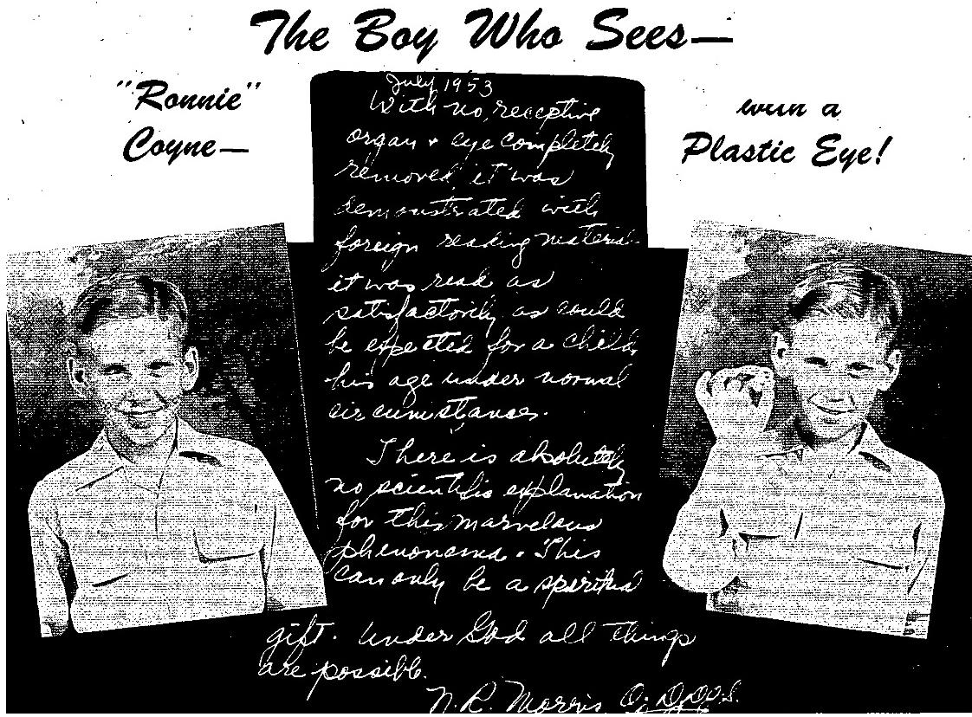

THE VOICE OF HEALING February 1954 Page 6
Chattanooga News-Free Press
Baffling Boy ‘Sees’, Reads With Plastic Eye; Youngster, Optometrist Agree It's ‘God's Gift’
Ronald Coyne, 9, Astounds Audience
By GEORGE BURNHAM
Nine-year-old Ronald Coyne, faced with the Impossibility of seeing with a plastic eye after has right eyeball had been removed, apparently goes ahead and sees anyway.
Ronald has a simple explanation:
“God gave me the power to see through the plastic eye.”
The right eye of the youngster from Sapulpa, Okla,, was removed in 1950 after an infection caused by a wire stuck in the eye. Ronald and his mother said his sight was recovered in the eve at a religious service several months later.
Doubters naturally are plentiful. Such a thing just can't be. When an eyeball is removed, sight is gone, according to doctors,
But Ronald is ready to give a demonstration to those who doubt.
Each night this week in an evangelistic revival being conducted here by the Rev. Thea F. Jones in a tent on Dodds Avenue, Ronald has read everything offered to him by persons who came up out of the audience.
N. R. Morris of Chattanooga, doctor of optometry and doctor of optometric science, attended the service last night by request and held a private examination of Ronald.
The doctor's statement is as follows,
"With no receptive organ and eye completely removed, his ability to read was demonstrated with foreign reading material. It was read as satisfactorily as could be expected from a child his age, under normal circumstances. There is absolutely no scientific explanation for this marvellous phenomenon. This can only be a spiritual gift.”
"Under God all things are possible."
Things were given Ronald to read that be had never seen before. They were offered by Baptists, Methodists, Catholics, Presbyterians and members of other denominations. The boy is appearing at a Church of God revival sponsored by the Missionary Ridge Church of God. Photographer John Goforth handed him a sentence which he read; "My name is John Goforth and I am a photographer for The Chattanooga News-Free Press." He can also read with the plastic eye removed.
Here's how Ronald's story come to light here this week:
Reporter Julius Parker was told by a friend about the boy. He passed on the information to his city editor, who suggested that I go out and see what was happening at the services.
I talked with Ronald and his mother. At my request and with his good left eye completely covered, he
d f ___ Bibl J h ¹ ⁸ H th d i l b f -__-___ d ____ d i l it d

THE VOICE OF HEALING February 1954 Page 6
SANITY SUSPECTED
Returning to the office next morning, I told the city editor and other interested reporters what had happened. It looked for a while as if I would have to get an affadavit that I hadn't gone nuts.
To check the story further. Reporter Parker and his friend. Dr. Morris, accompanied me to the service last might. They, too, had Ronald demonstrate his strange gift.
“This thing makes chills run up and down your back,” stated Parker.
"It's amazing commented the doctor. "There is absolutely nothing in the eye except fatty tissue. The organ has been entirely removed.”
Ronald's mother. who is here with him, said that her Son was given his sight to show the power of God and to lead others to Jesus Christ. "Give all the credit to God,” she stated. This is what she had to say of the occasion on which Ronald reportedly received his sight.
"Ronald had an infected throat and we were having a citywide meeting in Sapulpa conducted by a lady evangelist, Sister Gillock.
“Why don't you go up and be prayed for and then you won't have to go to the hospital to have your tonsils removed,” 1 told him. That suited him fine because the hospital was like jail to him, since he couldn't go home when he wanted to each night.
"He went through the healing line to have his tonsils prayed for but after praying the lady evangelist asked him what was wrong with his eye, He told her that he was blind and she asked him if he believed that the Lord could heal his eye. He told her he did believe that the Lord could. She didn't know that his real eyeball had been removed and the ball she saw was just a plastic eye, so she commanded the blinded eye to see in the name of Jesus. God heard that prayer of faith.
"Ronald began to see objects. First he could see steps, then the microphone, and then he could count fingers. Now I was doing alright when she was praying for his tonsils, but when she began to pray for the eye I froze. My daughter, Carol, and I both tried to tell Sister Gillock that Ronald had a plastic eve, but the power of God was so strong that I had to either sit down or fall. God didn't intend for me to tell that it was a plastic eye! I finally sat down.
"I finally got it said after he had already begun to see. ‘He can't possibly see; its a plastic eye’ Sister Gillock slapped her face in astonishment, ‘Why didn't you tell me?" Most humans wouldn't have asked God to do the impossible and she was just human, but her husband began to jump up and down shouting, ‘It’s a miracle. It’s a miracle."
"God later told me to ‘go and tell the people.’ That is what Ronald and I are doing now. He goes to school and will enter the fifth grade next year. His eyes were being tested in school one day and the examiner marked it down that he was blind in the right eye since it had been removed, Donald spoke up and said he wasn't blind in that eye. The examiner gave it a test and found that both eyes were 20-20.”
The service tonight at 7.30 will be the last one in which Ronald will appear here. The tent is located on Dodds Avenue in the Lakeview Section.
His mother will tell all about it. She adds: “I know that Ronnie can see and 1 don't waste time worrying about how he does it. We just accept it and say, “Thank you, Jesus."

THE VOICE OF HEALING September 1954 Page 9  The Power of Dominion in Action  Evangelist Richard Vinyard  I am going to speak to you on the subject of dominion. There are several ways in which we can get healing. One is to constantly intercede to God for deliverance. But that may take a long time. I had a cancer on my body when I was pastor at Kirkwood, Missouri. I prayed for five years and the, Lord finally healed me of that cancer. The thing fell out and there isn't a trace of it in my body. | 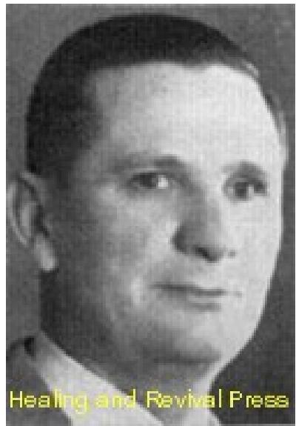

Then there is another kind of healing. I thank God for the men in the healing ministry today who are bringing healing to the sick people. There is not one man, but many. All of us are co-workers together with God. God uses pastors to pastor churches, He uses evangelists, He uses men of faith to minister Divine healing. I was talking to a missionary who said that when he left America for the mission field he never expected to return, because he was failing in health. But when Brother Branham was in Africa he prayed for him and God healed him. He said that he had been in the best health since.
Yet there are some people who have not yet been healed. Some have told me that they have prayed twenty years for healing and are not healed. Others have gone from meeting to meeting and still need deliverance. But thank God, friend, there is deliverance for you.
God Created Man to Have Dominion
I want to talk to you about another phase of faith that will help you who have failed to get your healing. I am going to take another step to help you get your healing from God. God had a purpose when He created man. I don't believe God's purpose has ever been changed since the beginning of time. God tells us in His Word why He created man. You will find it in the first chapter of Genesis, the 26th verse: "And God said, Let us make man in our image, after our likeness." God's plan was that we would be in His image, after His likeness. Then God said, "Let them have dominion over the fish of the sea over the fowl of the air, and over the cattle, and all the earth, and over every creeping thing that creepeth upon the earth."
I want to talk about this dominion that God gave man when He made him. When God gives a man dominion He places him in a position of real authority. God created us to have dominion over His creation. A whole lot of people have not received their healing because they have not taken their place in God Almighty. God says He wants us to have dominion over everything. David in his writings, says, speaking of man, "Thou madest him to have dominion over the work of thy hands. Thou hast put all things under his feet." I believe that when God said "all things," He meant "all things."
When Jesus came to earth, I believe the purpose of His death, and the purpose of His resurrection, was to restore to man the things that were lost by the power of sin. Jesus was God, manifest in the flesh. I believe that God wants us to be manifest in the flesh today. Because the Scripture says, "Christ in you the hope of glory."

THE VOICE OF HEALING September 1954 Page 9
When Jesus walked on the face of the earth, He showed us His dominion over the elements. Everything in heaven and earth, Jesus said, was under His power. Hallelujah! All disease, all demons, all the afflictions, death and hell were under the power of Jesus Christ. He came to show us, to reveal to us, and to guide us into the plan of the Living God. This dominion that is recorded in Genesis, was seen in the life of Jesus Christ. It was His plan, My brother, for man to take his place over the domain of God, to rule according to God's plan, to dethrone demon power, to dethrone disease, and to trample under foot the scorpions and the serpents and to break the power of the enemy that God might be glorified in man. Dominion in Action!
Now it is wonderful to talk about those things. It is wonderful to talk about the power that Jesus gave us. It is wonderful to see it in the Scriptures. But I will tell you something better, and that is to have it in your life. I don't believe that God gave out anything in His Word but what He made available. I don't believe God asks you to believe anything that He did not give you the intelligence to believe it with. I am going to show you this thing in action before I am through; I am going to show you that the men and women who will believe God's Word can do the thing that I am telling you about.
God has set the pattern for the Church. In Mark 16:17-18 it says, "These, signs shall follow them that believe; In my name shall they cast out devils;" This is the believer's privilege. Do you believe it? If God did not intend men to have dominion over the he imps of hell, He never would have put that verse in the Bible. "They shall take up serpents; and if they drink any deadly thing, it shall not hurt them;" This is the power of dominion I am talking about.
Listen friends, when Christ rose from the grave He conquered all the powers of hell when He spilt His blood in Pilate's judgment Hall, and on Calvary. He paid for your healing! Jesus placed all things under subjection of men and women who believe God's Word He gave us dominion over demons and disease. The touch of my hands when I am believing God, taken for what it is worth - has power to heal the sick.
I want to show you this dominion in action Luke 9:1, tells us that Christ gave His disciples authority over all devils, and that they might heal the sick. Christ was just giving back to man that which he had lost through sin. Christ saw in those germs that cause disease the "creeping things" on the earth that man should have authority over. Jesus said in Luke 10:19, "Behold, I give you power to tread on serpents and scorpions, and over all the power of the enemy." This is the thing that Jesus brought to the New Testament Church. This is the thing that He paid for on Calvary's Hill. This is a part of your salvation and my salvation.
Jesus declared that all power was given unto Him in heaven and in earth. Paul tells us that we are heirs of God, and joint heirs with Jesus Christ. The thing that Jesus has, and the thing that Jesus possesses, if I understand my heritage right, is all power in heaven, and all power in earth, and I am co-sharer with Him. That is restoration, my friends, of the dominion that God gave man when He made him. God never made man to be whipped by disease, demons, distress, discouragement and despondency. He created him to whip them.

THE VOICE OF HEALING September 1954 Page 9
Moses at the Red Sea
The power of dominion let us look at this power in action. This is no new doctrine. It is the old-fashioned Word of God. The reason some folks can't get through to God, is because they don't realize what they can do. Let's look at Moses at the Red Sea. What did Moses have to go on? Nothing more than I have - God's Word! God told Moses to take the stick in his hand and hold it over the sea, and start forward. What was it! It was man taking dominion over God's creation. He took God at His Word.
On one side of Moses was a mountain, the enemy surrounded him from the rear. There was only one thing for Moses to do, and that was to believe God. Isn't it awful how we have to be crowded into a corner before we take what is ours? He raised that stick up and started for the Red Sea. I imagine some of the people said, "What is that fool preacher going to do?” Where does he think he is going now?" But, brother, when his feet bit the water of the Red Sea, he had dominion over it. When a man of faith takes God at His Word, he reverses the nature of things and makes his least desire a command. Moses was a man that dared to take his place in God.
Joshua Commanded the Sun to Stand Still
Joshua was another man of faith. God did not even talk to Joshua about it. You know there are some things that faith will do without a blue print. Old Joshua had a fight going on, and it was a red-hot battle. He knew if the sun went down, he was going to lose that battle. Joshua began to analyze the thing. He knew if that sun set, that rascal would get out of his hands. He had to whip the thing right now, and right there (I would to God that Christians would get that way when it comes to healing). So Joshua looked up at the sun and said, "I am going to fix it so I will have time." So, as he looked at the sun he commanded, "Stand still."
Brother, that man took over the elements of God's creation and made them obey his command. He took dominion. I tell you when the sun looked down and heard the voice of Joshua, be said, "Look here. Who is this talking? It looks like the image of God, and is like God. Why that thing talks like God. I had better do it" I want you to know that that man took the place that God created him to take.
You talk about the power of faith. Some folks think we are fanatical to believe in Divine healing. Listen, we are going to have to hurry to catch those Old Testament men of God. Joshua, the man of faith, took his place in God and won that battle. But listen, if he had not had faith enough to reverse the elements he would have lost that battle. I want to tell you something, you are losing the battle because you do not take dominion over the things you fight. A lot of you haven't gotten the victory because you haven't taken the victory over the elements that stand between you and that victory.
Elijah and the Inexhaustible Meal
Let us take a little time with Elijah. He made things to happen that had never happened before You know, faith makes things happen that never happened before. Elijah went down to a widow woman and said, "Bake me a cake." She said, "Look, this is all I have, this little

THE VOICE OF HEALING September 1954 Page 9
bit of meal, and this little bit of oil. When I get the cake baked, my boy and I are going to eat it and then we are going to die." You know what that old prophet said, by faith; This was the man of faith against the elements. He said, "Woman, bake me that cake, and I will eat it, and I promise you something - That meal will never fall, neither will that oil." He took dominion over the elements. That meal kept coming out of that barrel, oil kept flowing. Why? Because faith has power to create what does not exist.
One day, Elijah and Elisha were taking a little trip. They came to the Jordan river. They did not have any engineers like the Army has. The old prophet surveyed the situation. He took his cloak and smote the Jordan and it backed up and they went through. You know what he did? He took dominion over the work of God's hands.
Old Elijah did not go to heaven by way of the grave. He went by a chariot of fire, which goes to show that our teachers of the resurrection of the dead cannot be far wrong, because faith in Jesus will quicken our mortal bodies. We are going to come out of the grave just like the Son of God came out.
Elisha's Double Portion
Elisha had been around Elijah and now he had one desire. He wanted a double portion of the Spirit that was upon Elijah. Listen, I wish this thing would so catch fire that every pastor and every evangelist would get so on fire with faith that they would rock the communities and churches with the power of faith. It is for you folks! It is not just for the few. Elisha wanted what Elijah had. As Elijah went up into heaven he threw his mantle down, Elisha caught it, and clothed himself with the mantle of Elijah and started back to the Jordan. This man of faith took dominion over the Jordan, just as Elijah had before him.
Elisah went forth with a double portion of faith. We are still playing church to some of the things that happened in Eliahs'a ministry. One day he saw a fellow looking down into a pool of water. The man of God said, "What happened?" The fellow said that he had borrowed an axe from his neighbour and the head had fallen into the water. Elisha grabbed a stick of wood, threw it into the pool, then something happened that had never happened before. The iron began to float on top of the water. Faith takes dominion over the elements, and makes nature reverse itself.
God has created us to have dominion. Naaman came to Elisha one day to be healed of leprosy. He figured that Elisha would come out and put his hand on him and heal him. He had it all fixed up. Don't try to fix it up - let God do the healing. Listen, you talk about a fanatical meeting, well this was one. You know what Elisha told Naaman to do? He told him to go jump in the river. I have never told anyone to do that yet to get healing. I have told cripples to run, and the dumb to speak, but I never did anything like that. But when Naaman dipped seven times in the Jordan, the healing power of God made him whole.
The Power of the Image of God
I want to tell you of one more instance. The son of the widow woman who had been so kind
to Elisha, had died. Right away Elisha got blamed for it. The mother came to him and said,

THE VOICE OF HEALING September 1954 Page 9
"My boy is gone." Elisha told Gehazi to go and lay his staff on the boy. Gehazi laid his staff on the boy, but he was stiff and cold. He was dead. Brother, I want to show you the image, the likeness of God, in its dominating power. The prophet walked in where the boy was lying. Listen, there was a scene back in the beginning that was enacted just like this one. There lay the lifeless form of a human being. God put his lips to man and breathed his breath into man, and he became a living soul.
The dead body of the widow's son felt the same power, saw the same image, the same likeness that the first creation felt when God created man. That power is man taking his place in God. Elisha took dominion over the elements. Death is not supposed to be conquered until the trumpet sounds, but faith reversed the condition, changed God's mind, and made that boy live. The power of faith reversed the nature of death.
Friend, what about that disease that is eating the life out of your body? You have prayed and prayed and can't get healed. You have been anointed by the deacons and you were not healed. You hopped an airplane and flew a thousand miles to get someone to pray for you. Listen, why don't you take your place in God, take dominion over that situation. Tell the disease to go back to hell from whence it came - that Jesus Christ has given you power over all the power of the enemy.
One night I was preaching in a healing campaign in Peckville, Pennsylvania. Right in the middle of the campaign I had a heart attack, the only one I ever had. I felt like someone had run a knife through me. Weak and trembling, I turned white, and held on to the pulpit. The devil tried to kill me in the middle of the campaign. The next morning I was so weak I could hardly crawl out of bed. I couldn't eat that day. When I started preaching that night the perspiration broke out all over my body. I was trembling from the top of my head to the soles of my feet. I opened my Bible, leaned on the pulpit, and started preaching faith to the people. The old devil said, "You had better be careful or you will have to go to the hospital. Why don't you close this meeting and take care of yourself?" I said, "Devil, I am preaching the Bible and you are not putting me to bed I am staying in this meeting." I started preaching faith that night and it wasn't long before the Holy Ghost anointing began coming down on my head. I preached for an hour and thirty-five minutes. Just before I began praying for the sick the weakness hit me again, but 1 started anyway. Somewhere between the first and last person I prayed for, I got healed. I took dominion over that heart ailment, and have never had one attack from that day to this. God will meet you too, if you will only believe.

THE VOICE OF HEALING Jan 1954 Page 9  Len Jones Column  We Are What We Say!  WRONG CONFESSIONS imprison us, and right confessions set us free! Talk weakness and you will be weak! Talk sickness and you will be sick! Talk poverty and you will be poor! Confess your fears and the disease will grow! Keep looking for the tumour and growth and you will get it all right! The best way in the world to get old is to talk about it - keep talking about it and you will not be disappointed! This is faith in reverse and it is just as powerful in the wrong direction, as in the right direction. | 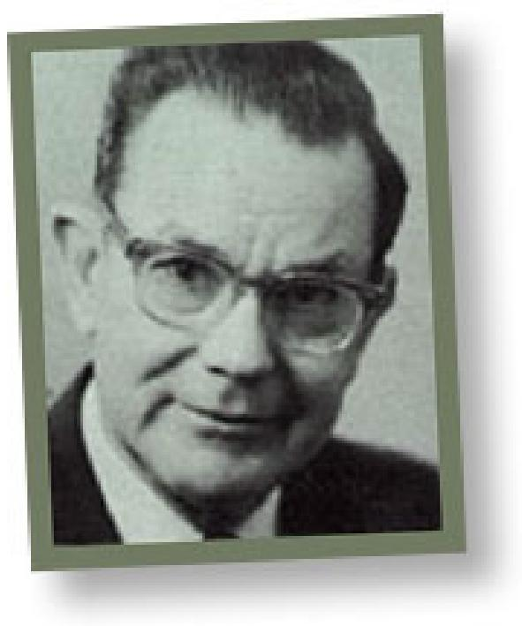

If wrong confessions imprison us, right confessions set us free. Right confessions are confessions that refuse to take notice of what you feel, what you think and what you know. Right confessions listen not to the testimony of the senses, and take no cognizance of aches, pains, symptoms, tumours or growths, believe that what God says is truer than what these things proclaim, however loud and insistent may be their voice. What you feel and see could be wrong, but God's Word is never wrong! The testimony of your aches and pains is still not as reliable a witness as the testimony of God's Word.
People go through life listening to and proclaiming the testimony of their senses. They turn their back on the clear testimony of God's Word, preferring rather to believe what they think, feel, see and know is it any wonder so many are in the trouble they are?
Christianity in Hebrews 3.1 is referred to as a "CONFESSION" so that we can say, "Christianity is the great confession, and Christ Jesus is the Apostle and High Priest of our confession." The Greek word is "homologia" and means either "profession" or as the margin puts it "confession." Just think, what a strange thing that Christianity should be called a "CONFESSION" " That is worth thinking about.
Well, if it is crystal clear, and it is, that Christianity is a "CONFESSION," it is equally crystal clear in Hebrews 4:14, that we, i.e., you and I, "are to hold fast our confession." This is confirmed and repeated in Hebrews 10:23, where it says the same thing, with the additional remarks that if we do He is faithful and will give us what we confess, and that we are to do this "without wavering" suggesting that there is a tendency to waver. The fact that this is repeated on two occasions is sufficient proof that we would do well to heed this clear injunction.
How do we hold fast our confession? "We hold fast our confession, by confessing to the truthfulness of God's Word boldly, without wavering." For instance if God's Word says, and it does, "By whose stripes ye were healed" (1 Peter 2:24), then we believe it and confess it. If God's Word says, and it does, that "He will quicken our mortal bodies” (Romans 9:11), then we believe it and confess it. If God's Word says, and it does, "Sin will not have dominion over me" (Romans 6:14); that "the law of the Spirit of life in Christ Jesus hath made me free

THE VOICE OF HEALING Jan 1954 Page 9
from the law of sin and death," (Romans 8:2); that "I can do all things through Christ who strengtheneth me” (Philippians 4:13); that I am "more than conqueror through Him that loved me" (Romans 8:37); then gladly will we hold to it regardless of consequences.
Knowing the value of confessing our Lord, in Whose steps we also should follow, never miss an opportunity, regardless of consequences, to confess who He was and what He was. How the Jews gnashed their teeth when He said, "One greater than Solomon is here," and "Before Abraham was I am," but He said it just the same. Some of His disciples left Him when He said, "My flesh is meat indeed and my blood is drink indeed" (John 6:55, 60, 66) but He still said it. It was HIS confession in Matthew 26:64, "Here-after shall ye see the Son of man sitting, on the right hand of power, and coming in the clouds of heaven" that brought about His crucifixion, and caused the High Priest to rend his clothes, and the people to spit upon Him and smite Him, but He still said it.
It is the confession of our mouth that is an integral part of our salvation and through which we receive forgiveness (Romans 10.9). It is that confession with our lips that brings the thing to pass. If confession with our lips will bring us through to one of the promises of God, forgiveness, it should not be thought strange that the same confession with our lips, will bring us through to all the promises of God. All the struggling in the world will never get us there, but "believing with our hearts and confessing with our mouth" will; and all the struggling in the world will never get us through to that inward purity that we long for so much, but "believing with our hearts and confessing with our mouths" will. "Where-by are given unto us exceeding great and precious promises; that by these we might be partakers of the Divine nature." (2Peter 1:4).
Alright, let us get busy! Let us hold fast our confession, for the Lord is faithful Who has promised, and will do for us what we confess. If our unsaved friends thought it presumptuous when we first said, "I am a child of God and I am going to Heaven," let us not be surprised if our friends will still think it presumptuous on our part when we say "All things are mine," "God has blessed me with all spiritual blessings in heavenly places" and "I am a joint heir with Christ." This is the way of victory! We are what we say. We are what we confess!

THE VOICE OF HEALING January 1954 Page 8
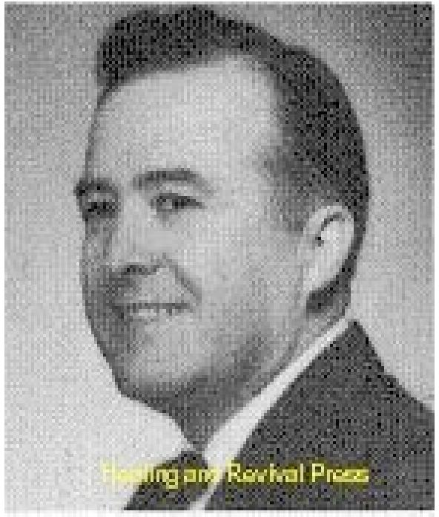
"The Word of Wisdom"
Evangelist W. V. Grant
THE SPIRITUAL GIFT of the Word of Wisdom is a supernatural manifestation of God's Spirit, which gives one a portion of God's wisdom at the time it is needed.
WHAT IT IS NOT
It is not something learned by the natural mind. It cannot be education, training, methods, or natural wisdom in any sense. A man without the Spirit may use methods, which prove, many times, both helpful and harmful. What works beautifully in one church may not "go over" in another. Many pastors and workers meet their specific problems when no one but God knows the solution.
This gift is not the ability to have a spiritual insight. One may be old in the Lord, having known Him for many years and yet not have this gift. There is a vast difference in fruit, though mellow it may be, and Spiritual gifts. One with not much Spiritual judgment at other times may have this gift manifested through him at times.
The Word of Wisdom "given by the Spirit," is never psychology, which is science of the natural mind. If psychology intrudes into the supernatural, it is not the supernatural Spirit of God (James 3:15); but "is earthly, sensual, devilish."
The Gift of the Word of Wisdom is not Divine wisdom, which every Christian has more or less. Solomon had Divine wisdom, but only once or twice did he receive a special revelation for a special problem. A young convert may have the revelation of the Word of Wisdom.
NOT A HIGH DEGREE OF INTELLECT
It cannot be just a high degree of the intellect, such as many of our doctors, statesmen, and educators have. Many of them who have never received the Spirit may be wiser in the
natural than the children of God (Luke 16:8).
This gift is not all of God's wisdom. He speaks a word to us giving to us part of His inexhaustible wisdom, which is ever before Him. It is not just for church officials or special workers, but it is for ALL who may be faced with a problem beyond their understanding.
It is not just a "new idea" which accidently comes into a person's mind, which may be experienced by a sinner.
It is different from a ministerial gift, which is also set in the church (Eph. 4) and may be developed by study (2 Tim. 2:15). But the Word of Wisdom is given by the Spirit, as He wills. Spiritual gifts should be manifested to confirm the ministerial gifts.

THE VOICE OF HEALING January 1954 Page 8
This gift is not a product of the natural mind. It works through the spirit of man instead of through the mind.
Just as all Christians have Divine faith and only some have the Gift of Faith, so all Christians have Divine wisdom, but all do not have the Gift of the Word of Wisdom.
WHAT IT IS
Just as wisdom is knowledge rightly applied, so the Spiritual gift of the Word of Wisdom is the supernatural ability to apply knowledge already possessed, regardless of how one obtains that knowledge. It isknowledge rightly applied by the Spirit.
It is God showing the HOW. WHY, WHEN, WHERE, and WHAT of a matter. It is the supernatural solution of a problem.
It is something every mother needs in her home, as she cannot handle every child alike. It is something every pastor, teacher, and church leader needs at times, since he cannot handle every member alike. It is something every merchant should have at times, as all customers will not respond to the same kind of treatment. You see how every lawyer, policeman, sheriff, governor, and army officer could be benefited by a supernatural solution to his problems. What a wonderful gift for a pastor who cannot keep a church six months! It beats calling officials in for a church trial and causing a split in the church!
It builds a church and brings revivals. It may come by visions, dreams, revelations, a still small voice, or an audible voice. God speaks in many ways (Heb. 1:1). There are diversities of operation (I Cor. 12:6).
BIBLE EXAMPLES - SOLOMON
Solomon was faced with a problem. Two women claimed the live baby after one had been smothered to death during the night. It seems that, like a flash, the Spirit showed Solomon to call for a sword. He started to divide the live baby between the two women. The woman who cried for the baby's life was the mother.
If this was wisdom which Solomon already possessed, then he would not have asked for a Word of Wisdom. But if it were given by the Spirit for that need, it was a Spiritual gift. I believe it was a direct revelation, as it worked in that case. The same thing might not have worked in a similar case.
Tradition tells us that Solomon was called in to see if he could tell the difference in some real fruit and artificial fruit. Like a flash he got a revelation. He simply walked to a window, let some bees into a room, and told which was the real fruit.
THE LORD GAVE PAUL THE SOLUTION
Paul was faced with death by a mob. In the natural there was no way out. Then the solution came. He made a speech about the resurrection, The Pharisees believed in the resurrection, but the Sadducees did not. The mob was divided; Paul escaped! (Acts 23:7).

THE VOICE OF HEALING January 1954 Page 8
God was the only One who knew this would work. If Paul had tried to use this method in another place, he might have been killed.
This gift came in very profitably in the conference at Jerusalem (Acts 15). If James had not received the solution to this problem directly by the Spirit, Peter probably would have been "cast out of the church" for "heresy," as he had preached to people who did not belong to their "chosen few."
"WORD OF WISDOM" GUIDES IN BUSINESS
During the depression, when eight million people were unemployed, I failed to get a job. I only had $15 for which I had picked peanuts, making about 70 cents per day. I had a chance of renting a service station for $3 per month or buying it for $4 per month. I owed $14 for board and had no down payment. Men with natural wisdom said I was crazy to take it at all, as it needed thousands of dollars worth of labour and material and was in no condition to be operated successfully.
I went far into the woods and lay on my face until God showed me what to do. He told me to buy it.
After I went into business God would very often give me a Word of Wisdom in my dealings. I soon owned a four-pump service station, grocery store, meat market, cafe, barber shop, garage, pawn shop, used car lot, and many other things, all paid for.
How much better was that than working for a few cents per day or being unemployed. Every businessman and every breadwinner needs a Word of Wisdom nearly every day!
WISDOM IS GIVEN TO MAKE LIFE"S IMPORTANT CHOICES
After being in business awhile, God, by a Word of Knowledge, showed me I should marry. I picked out a certain girl. My uncle and several others, by natural wisdom, advised me to marry her. After keeping me awake all night, the Spirit, by a Word of Wisdom, showed me the WHO, WHEN, WHY, WHERE, AND HOW. He showed me a sickly looking orphan girl. I had not known her name but two weeks. In two weeks we were married. Men, by natural wisdom told me I would always be out doctor bills on her because of TB and cancer. But for about 15 years I have paid out nothing for medicine on her or any of our family. She has gained about 40 pounds and is not sickly at all. The other girl died shortly after we were married.
THE 'WORD OF WISDOM" DIRECTS IN CHURCH PROBLEMS
Just after 1 became a preacher and built my first church, a main charter member asked to withdraw her name because of a little misunderstanding. I knew that would not do because she had so many friends and relatives who would go out with her and go to a close-by church. I also knew a church trial and a split would not do at that time. Suddenly, like a flash, the Spirit flashed me the solution.

THE VOICE OF HEALING January 1954 Page 8
"Wait 30 days," I answered, "then, If you have not changed your mind, we will take your name off."
Within three days she was shouting the victory and the church grew and multiplied. God's Word of Wisdom will work!
ENABLES PASTORS TO COUNSEL WISELY WITH MEMBERS
1 found that one of my deacons who ran a store was using tobacco. He had about as much influence over the people as I did at that time. I knew a church trial would not do. After seeking God many days I went to his store. I did not feel free to mention it to him until after I had stayed with him about half a day, talking about his business, looking at his hogs, and talking about how wonderful our church and Sunday School was.
Then God gave me the grace and the words. He could not quit tobacco as long as he sold it. "I have talked to your wife," I began, and she says she cannot quit it as long as you use it. That influences your boy to use it. Your grand-daughter. who is a young convert, does not quit smoking because she thinks her dad, grandfather, and grandmother are wonderful."
I was unloading his shelves while I was talking. I put Bibles in the place of the tobacco. He quit selling that which was causing all the trouble.
"But if any man lack wisdom, let him ask of God that GIVETH to ALL men ... and it shall be given him" (James 1:5).

Afterword
As I complete this task, the Florida Healing Outpouring is into its 10th week. Amazing miracles are being watched around the world via www.god.tv, and Todd Bentley has become amazingly well-known in Christian circles. This outpouring was prophesied in March when Rob deLuca called Todd out at the Downpour Conference in Queensland. I was there. He said: “The Lord told me when you go to Florida in April revival will break out!”
Also, prior to this, Paul Keith Davis’ WhiteDove ministries (www.whitedoveministries.org) hosted a conference: “Honouring the Fathers” – focusing on the Generals and their lives. Paul Keith was told by the Lord that honouring the anointing of the pioneers of Healing would usher in a new move of God. So far, there have been over 20 resurrections, multiple blind eyes opening, deaf ears opening, chronic injuries healed – even a glass eye seeing and amputated stumps growing out of the Lakeland outpouring! It’s all on youTube.com. Bob Jones prophesied that the Glory would begin to “Abide” between June 22 – July 22 – God is taking it to a new level.
Since I began this task, our team has been to India and back with our Senior minister – Raf Shaw, where we saw God do miracles through us! Over 1000 saved in 4 crusades in 3 states, and the miracles have opened the door for the local churches to break new ground in evangelising their areas. We saw blind eyes open, deaf and dumb children speak, witchcraft curses broken, Jobs restored, cripples set free, and many Christians encouraged by the Lord’s manifest power in their situation. One town, known as the “graveyard of missions” is opening 8 new churches in the month of June. Praise God.
I have had 13 students healed at school in the last month, as I do relief teaching: pains, headaches, injuries, Lactose Intolerance, Coeliac’s disease and Osgood-Slatter’s disease. I now have students who don’t know the Lord seeking me out for healing, and asking all sorts of questions. Amazingly, the heathen get healed far more easily than Christians. I asked the Lord why? He said: “Christians have ‘issues’ (doctrines).” But the unsaved simply accept it and get healed. There is a Harvest coming!
We must never forget to honour the Pioneers who broke the ground from which we now reap. They were not correct in ALL their doctrines. They made some mistakes, which we (with 50 years benefit of hindsight) are amazed by, yet without their efforts we would have a much harder task.
I have been reading the “blue books” – Owen Jorgensen’s biography of William Branham. I am amazed that this incredible prophetic minister had so many insecurities and doctrinal blind spots (to the point where he gave the enemy a chance to kill him before time), yet he walked a path that no-one in his experience had walked. He lacked the Smith Wigglesworth stories when he grew up; he lacked the knowledge of John G. Lake. In his experience, his prophetic gift was unique. We have had knowledge of true godly prophets since 1989, when John Wimber introduced us to Paul Cain, Bob Jones, john Paul Jackson, Rick Joyner, Larry Randolph and others. Even that has an established and verified prophetic history. We have been alive for the Toronto outpouring, which Bob Jones had prophesied 10 years prior.
Do NOT allow those who have issues to detract from you receiving from God in this move. I have investigated and lived through these varied moves of the Holy Spirit, and there was a lot of good fruit. That is the ONLY biblically correct way to judge. NONE of us are fully correct in our doctrine. All of us have strengths and weaknesses. God allows ministers with error to be used in breakthrough – it’s part of the offence that we have to overcome to receive. Do we allow our offence at some minor doctrinal issue to take precedence over our hunger for another touch from our Father (whose job it is to sort out the rest)? That is dangerous ground.
We have lost much, but the Lord in His mercy is giving it back. We have also grown in other ways, so we can better apply what we are now re-gaining. Hopefully, we can avoid the pitfalls that so many of these great men fell into.

But we must never forget the message of the Baseball Game (Bob Jones, 1987):
Bob was caught up in the spirit where he and the Lord stood by to observe a baseball game. The Lord's team was playing Satan's team. The Lord's team was at bat, the score was tied zero to zero, and it was the bottom of the 9th inning with two outs. (For the uninitiated, Baseball has 9 innings – Top being first team to bat, bottom being last team to bat. 3 outs = side away)
They continued to watch as a batter stepped up to plate whose name was Love. Love swung at the first pitch and hit a single because Love never fails.
The next batter was named Faith, who also got a single because Faith works with Love.
The next batter up was named Godly Wisdom. Satan wound up and threw the first pitch; Godly Wisdom looked it over and let it pass, because Godly Wisdom does not swing at Satan's pitches.
Ball one. Three more pitches and Godly Wisdom walked, because Godly Wisdom never swings at Satan's throws.
The bases were loaded. The Lord then turned to Bob and told him he was now going to bring in his star player. Up to the plate stepped Grace. Bob said he sure did not look like much!
Satan's whole team relaxed when they saw Grace. Thinking he had won the game, Satan wound up and fired his first pitch. To shock of everyone, Grace hit the ball harder than anyone had ever seen.
But Satan was not worried; his center fielder, the Prince of the air, let very few get by. He went up for the ball, but it went right through his glove, hit him on the head and sent him crashing on the ground; then it continued over the fence for a home run!
The Lord's team won.
The Lord then asked Bob if he knew why Love, Faith, and Godly Wisdom could get on base but could not win the game. Bob answered that he did not know why.
The Lord explained, " If your Love, your Faith and your Wisdom had won the game you would think you had done it by yourself. Love, Faith and Wisdom will get you on base, but only my grace can get you home. My grace is the one thing Satan cannot stop.
May His grace abound to us all as we press on to see His Kingdom Come on earth, in the same way it already is in heaven.
Paul Davies (June ’08)

