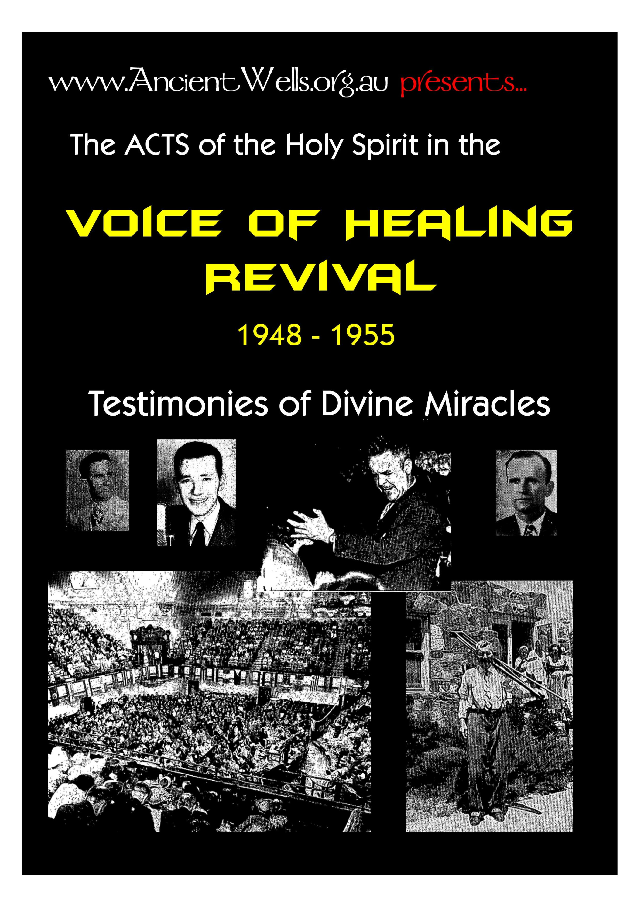
www.Ancient,Wells.org.au presents...
Testimonies of Divine Miracles

About AncientWells.org.au
The Ancient Wells ministry began in Adelaide, South Australia, in April 2007, under Ramoth Gilead Ministries, Inc. Ramoth Gilead is based in Middleton, South Australia, and headed up by Raf Shaw, who ministers internationally, teaching mostly about hearing God being the key to just about everything. Details of all meetings are on the website: Mondays at Middleton, Wednesdays in Adelaide, Fridays in Belvidere, and the Sunday One Accord Fellowship in Middleton.
Raf began ministering as a new Christian on the building sites where he was working. He was taught early on in his faith that “My sheep hear My voice”, and was determined to press in to God until he could hear clearly. The fruit of this began to manifest, and fellow workers got saved as they witnessed God’s miraculous power in action. He is now in full-time ministry, mostly because the phone never stops, and because the Lord told him to meet the need. In, the early ‘90s, God told him to move to Middleton, south of Adelaide, and establish a “Place of Refuge” for His people. Raf and his wife Denise still live there, and minister all over the world as the Lord them. He has learned that God is the provider of every need, financial, spiritual and physical, and ministers effectively to every kind of sickness and disease.
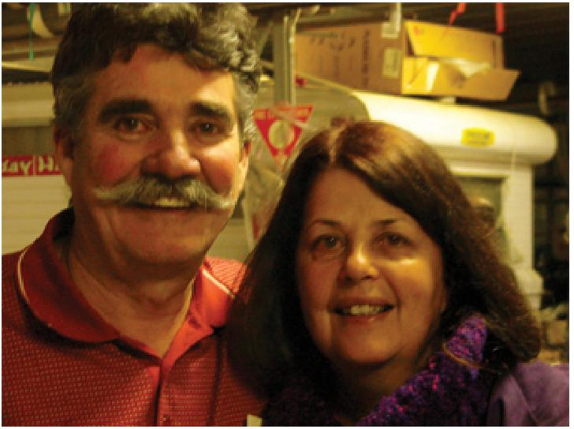
God put on Raf’s heart the great need for healing meetings in Adelaide, after so many sick Christians were seeking him out for effective prayer ministry, and driving to Middleton for meetings. The first Well of Healing meetings began on Wednesdays in Term 2, 2007, and have continued since. Healing rooms run during the day for those who want private, focused ministry, and the open meetings are every Wednesday night. Details and maps are on the website.
The AncientWells.org.au website is managed by Paul Davies, a high school teacher by training, and “Raf’s shadow” according to his wife. It is full of useful teaching from Raf, both as audio and video files. These are free for download or streaming online, and can be accessed through our iTunes podcast.  We also have an archive of the original “Voice of Healing” magazines from the 1950s Healing revival, free to download or read online as PDF files. Teaching, testimonies and news articles about some of the most amazing healings from that Move of God. There are also useful and encouraging clips and messages from other ministries. | 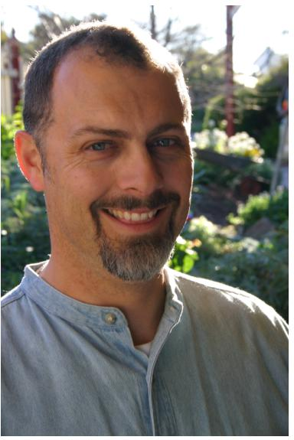

We try to post testimonies of what God has done in meetings, but we are in the midst of training Christians to email them in, or write them down, rather than just tell us verbally. So, we don’t have as many online as we see God doing each week. In the last year, we have seen several cancers healed, and a host of other major and minor diseases and disabilities. We have also had a Psychiatrist send us several of his patients for prayer ministry.
We are NOT trying to establish a church, or steal sheep (we don’t want them). We simply want to assist Christians in accessing their inheritance of health from their Father. We want to teach them so they can help others in the churches they come from, because unless we move forward as a body, we end up working against each other.
All our stuff is free, because God told Raf clearly that “Selling product undermines your spiritual authority,” and denies faith in the Father to provide. God put this project on Paul’s heart after reading some of the magazine articles, and noticing the depth of relevant teaching inside.
If you’re ever Down Under, come to Adelaide and visit! Please email testimonies and comments to: testimonies@ancientwells.org.au.

THE VOICE OF HEALING 1950
December 1950 p 8,9 | “A Cloud of Witnesses”

From every section of the Nation attest the power of God in Divine Healing for Paralysis, Insanity,
Cancer, Goiter, Deafness, Migraine, Club-feet, Diabetes....from case-files of our Evangelists.

McGaheysville, Va.
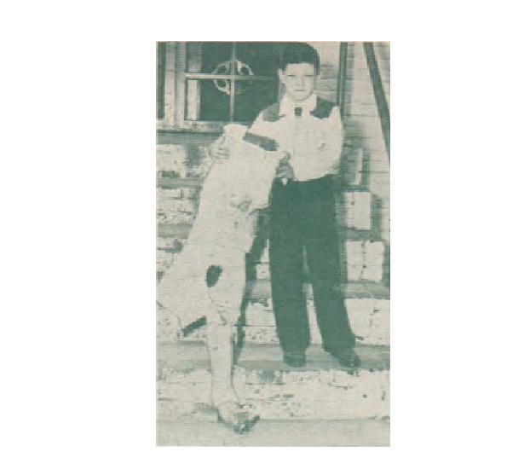
Boy Cuts His Own Cast Off
July 16, 1.450.
Dear Sister Nankivell:
About four years ago our little seven-year-old son, Archie Leo Kyger, started screaming each time we tried to pick him up. At that time he was only three years old and he tried to tell us about his leg hurting him. A doctor who examined him claimed that one leg was shorter than the other, and warned us not to let our son exert himself at all. Another doctor, a bone specialist examined him and claimed he had a severe bone disease. An X-ray revealed that a piece of a bone about the size of a dime was chipped from the knuckle which joins the hip bone. The doctor placed Archie Leo in a cast May 10, 1949.
About three months later we placed our son in a Richmond hospital. For seven months the boy lay with a cast on, never once leaving his bed. In June, 1950, against the doctor's judgment, we brought our son home no better, still in a cast which almost completely covered his body, and with the doctor's words still ringing in our ears, that he would have to stay in the cast for at least three
more years, and that he would probably be paralyzed in his hip the rest of his life.
How very sorrowful we were! We began to realize that God was the only one who could undertake for little Archie Leo. I, his mother, felt that our son could never be healed unless we started attending the Pentecostal church where we knew God was blessing - especially as Archie Leo told us one day that he would never have been in that cast if we had been serving God and attending church as we should have. How our hearts ached when we heard the truth from the lips of a child. Each time Archie Leo heard church bells he begged to go to church but it was impossible for us to take him while he was in the cast.
The morning after you prayed for Archie Leo we awoke and found him trying to remove the cast by cutting at it with scissors. So I, the father, carried him out in the yard and removed the cast with a hand saw. As soon as the cast was off, he walked a few steps. That was on July 7, 1950, just nine days ago. At this time our boy is still walking and growing stronger each day. This morning he climbed the steps to his Sunday School room with just a small amount of help from his teacher.
The hip which was to be paralyzed is perfectly well, for which we give all the praise.
We also want to thank and praise God for saving both of
our souls on the same night that He healed Archie Leo. We can't praise God enough, and we mean to go on with God and serve Him the rest of our lives or until Jesus comes. May God bless you as you go forth winning souls for Him and praying for the sick.
(Signed) Mr. and Mrs. Archie Kyger.
Endorsed by Rev. E. C. Ridenour, Pastor of Elkton Pentecostal Church.
Texarkana Father Writes of Condition of Deaf Mute Daughter
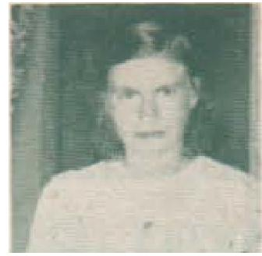
Evang. W. V. Grant seems to be experiencing remarkable success in praying for the deliverance of deaf mutes. He has numbers of irrefutable testimonies on file, such as the following from E. H. Tiller, Texarkans, Texas:
"My daughter, Nellie, has been deaf and mute all her life, 37 years. Ever since your revival here in June of 1950 she has been improving. She can hear me call her from another room and is learning to talk. She meets people on the train now and talks to them. They don't know she has ever been deaf and mute."

THE VOICE OF HEALING 1950

Pastor V. D. Dial, 1925 W. 9th St., also substantiates testimony with statement that Miss Tiller can both hear and talk. several months after healing.
Paralyzed Arm and Hand Healed Instantly
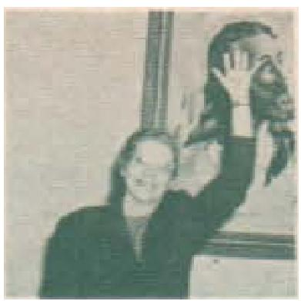
My arm and hand were completely paralyzed. I believed it to be the result of an operation performed on me earlier. I could not even raise my arm or hand. They were numb and helpless. I was forced to quit my job as ironer and presser as I could not even use my hand to hold a cup.
I had attended Rev. A. A. Allen's Healing Revival in Evansville, Ind.. and although I didn't believe in healing as he preached it, I purchased his book titled, "God's Guarantee To Heal You!"
I was reading this book one morning and was about halfway through. I was reading the chapter, "Have the Faith That God Gives", when, suddenly, faith seemed to come from heaven and God spoke to me saying, "Go to the morning service where they are praying for the sick and you shall be healed this very day."
I dropped everything and went to the meeting, getting there at the close of the morning service. Brother Allen prayed for me and said. "In Jesus' name I command you to raise your arm and wave your hand to Jesus". The Power of
God seemed to go through my arm and hand. The pain and numbness suddenly left and I immediately raised my hand without pain over my head.
I was healed on Friday morning. I made arrangements to go back to work immediately as my arm and hand were as strong as ever. I was back on the same job on Monday morning and used my hand all day long ironing and pressing without pain.
Since then I have worked two full weeks without any symptoms of paralysis returning.
(Signed)
Mrs Maud Luiz
2707 N. Heidleback
Evansville, Ind.
Dear Brother Grant:
Hopelessly Injured Back and Leg Restored
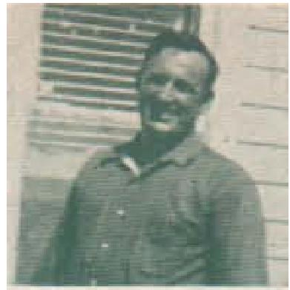
I had been afflicted four years with a ruptured disc in my back. When the disc would slip out it would hit the spinal nerve, and paralyze my leg. I couldn't lift anything at all without it putting me down where I couldn't turn over. The doctor said my leg was perishing away and I would never be able to walk anymore without it bothering me. They operated and drilled on it four times, and wanted to operate again, saying it would either cure me or cause me to lose my mind. I spent $1800.00 in three weeks on doctor bills, but to no
avail. Since you prayed for me in your Denton, Texas revival in October, I can lift a 100-pound sack of feed without it hurting me. I had been treated by 16 doctors in all.
C. R. Brumley
Rt. 1, Aubrey, Texas
Suffered with Migraine Headache 27 Years, Healed
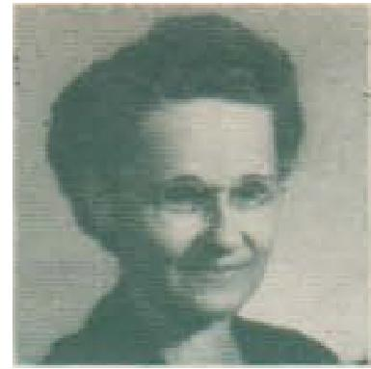
Alexander City, Ala.
Oct 21, 1950
Dear Editor:
I have been enjoying life so much since July 10th 1949.
I attended Gayle Jackson's revival in Dothan, Ala., to be prayed for for terrible migraine headache I had had for 27 years. On Sunday morning of July 10, 1 woke up about 5 o'clock with a terrible headache, worse than usual. We were in the Houston Hotel in Dothan, where Bro. Jackson was also staying. My husband called him to our room; he was kind enough to come and pray for me, and the Lord healed me instantly. My relatives and friends are amazed at my new life, for no one hardly ever came to see me without finding me in bed with a wretched headache. I took all kinds of strong dope, and for the last two years had to take dope at night to sleep.
Several doctors have my record, and they had just given up the case.

THE VOICE OF HEALING 1950

No one knows how thankful
I am to be well again.
Mrs. W. C. White
Rt. 3
Alexander City, Ala.
Deaf 15 Years--No Ear Drum Now Hears
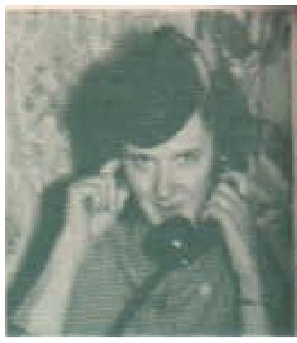
Miss Violet Hansen, 3267 Wrightwood Ave., Chicago, Ill., had four mastoid operations in five years. Her ear drum had been eaten away by infection, causing her to be deaf for 15 years. She attended Rev. Richard Vinyard's revival in Chicago on October 4, 1950, and was healed by the power of God. She is pictured phoning a friend in the parsonage five minutes after this healing took place.
Among the many outstanding testimones submitted from the Salvation-Healing revival conducted by Evang. Wilbur Ogilvie in Wyoming last March comes this account from Mrs. Charles Ernest, Star Route, Powell, Wyoming:
Goiter Vanishes from Throat Instantly
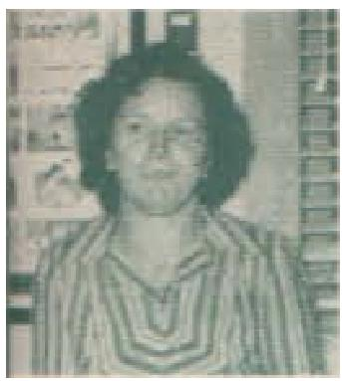
"I praise God for His
wonderful healing power during a three-night meeting in Powell conducted by the Ogilvie's. I was ailed of a large goiter that was of several years' standing. It vanished instantly from my throat as prayer was offered by Bro. Ogilvie from the platform for the entire audience."
Confirmation from Rev. H. E. Dreyer, Presbyter of the District And Mrs. Ernest's Pastor
"Mrs. Ernest was healed the first night of our meeting. Bro. Ogilvie had driven about 500 miles that day and was quite tired and said he would just pray a mass prayer for the entire audience instead of individually At this time the goiter on Mrs. Ernest's throat disappeared, and several others testified of pains leaving their body. (As the meeting progressed, there were all manner of diseases healed, including crossed eyes straightening right before the audience.)"
Hadn't Walked In 12 Years
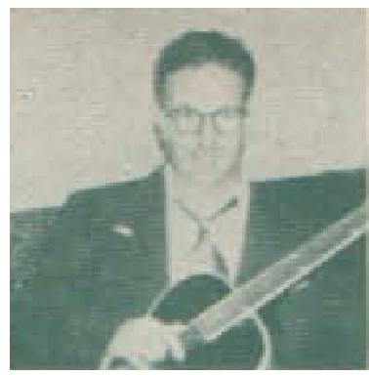
The opening night of Louise Nankivell's meeting in Clarksburg, W. Va., Arthur Burkhammer of Center Point, W. Va., was raised from his bed.
Absence of marrow from the
bone had caused his body to begin petrification, rendering him unable to walk for 12 years. He attended the meeting regularly giving his testimony and singing on the stage. Reported by Pastor Russell W. Harvey.
Oklahoma City Girl Hears As Hanson Prays
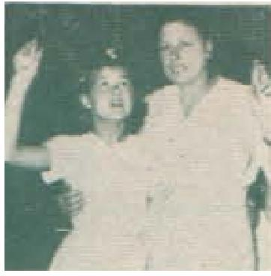
From the hundreds of testimonies in the Hanson files comes this report of the healing of a deaf mute:
A friend interested in the child brought her to the service one night but Bro. Hanson did not feel led to pray for her but asked that one of the parents bring the child. The next night the mother came, and after hearing the message of salvation and deliverance gave her heart to the Lord.
Afterward, the , little girl who had been totally deaf since the age of three and now twelve, was prayed for, and could hear. Her ears were opened to sounds instantly, but as usual with such cases she had to be taught how to speak. The deafness was caused by infected tonsils and adenoids and the mother asserted that the child had been unable to hear anything. Both were rejoicing in the deliverances wrought for them and were praising God and weeping.

THE VOICE OF HEALING 1950

Mother's name and address:
Mrs. Edna Burgett,
732 S. E. 26th St.
Oklahoma City, Okla.
Insane Woman Restored Perfectly
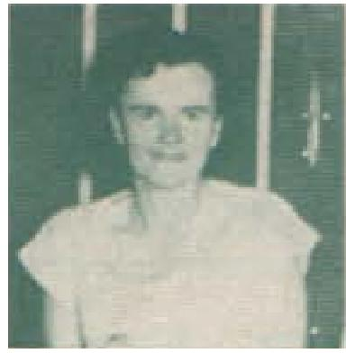
Due to domestic trouble over which I brooded and worried night and day, I lost my mind. I was placed in an insane institution, as my folk could no longer control me. Regardless of what this "voice" told me to do, I'd do it, but the voice was never satisfied. It always told me to do something else.
Finally, I was sent away to the mental institution in Clark Summit, Penn. I wouldn't eat I lost weight fast. They forced me to be fed through my nose. Brother Schiavone, my pastor, was one of the co-operating pastors with the Osborn Healing Campaign in Scranton, and he came and got me out of the institution for a week.
He had to sign to be
responsible for me for the entire week. When he brought me to the prayer line, the "voice" told me not to go in that prayer line. Sister Osborn came and sat by me in the audience, and talked to me for about thirty minutes, trying to persuade me to go into the prayer line for prayer. I would not say a single word to her, but the voice told me not to go in the prayer line. Finally
Sister Osborn took me by the arm, and seemed to over-power me so that I could not resist going with her, and she marched me right into the prayer line, and up to Bother Osborn. He prayed for me and commanded the insane demon to leave my mind in the Name of Jesus Christ.
Instantly the voice stopped talking to me. I have never heard it since. I was free from the demon that had bound me. The next morning I woke up hungry for the first time since going insane. There was no voice to tell me not to eat any longer. I ate three hearty meals that day and every day since. It has been over three weeks now since I was delivered, and I have gained already six pounds and am feeling just wonderful.
I feel so happy. When I went back to the institution, the doctors and nurses were amazed, and Dr. Davis, the supervisor said,
"That evangelist ought to come and pray for all of them".
I have been back twice now for check-ups, and the last time, they gave me my clothes and my rings. No one knows how thankful I am to be free now. Jesus is so wonderful.
Stella Caolo,
203 North Hyde Park Ave.,
Scranton, Penns.
For reference, contact Mary Colaney
203 N. Hyde Park Ave.,
Scranton, with whom I lived for several months. Or contact Rev. S. Shiavone, Scranton, Penns.
Note by Brother Osborn:
Stella attended the Harrisburg campaign and gave the most wonderful testimony over the microphone, of how God had healed her and delivered her from the awful tormenting demon that had bound her.
Cancer Passes from Body After Prayer
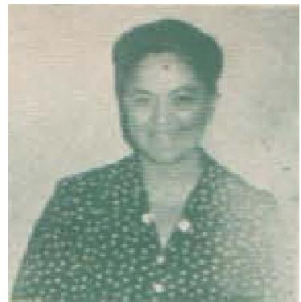
Mrs. Twila Dent, 1318 Nth. Greenview Ave., Chicago writes:
"During the meeting of September 22, 1950, conducted by Rev. R. R. Vinyard, the evangelist discerned that there were three women in the congregation suffering from a certain ailment. I was one of them.
Dr. E. J. Smith of Columbus, Ohio, told me I would have to be operated on for cancer of the womb, with which I had suffered four and a half years. But praise God, I passed the cancer after being healed by God and am well."
Mother Can "Hardly Believe Her Eyes" as Clubfoot Child Walks
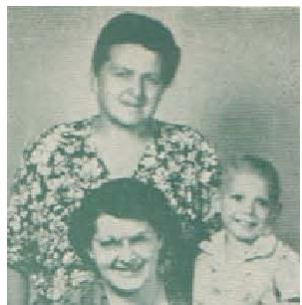
Rockford, Ill.

THE VOICE OF HEALING 1950

Dear Brethren and Sisters in the Lord.
Oh, what a wonderful Saviour our Jesus is! Our three-fold testimony of healings in the July campaign in Minneapolis by Brother Branham is real and lasting. Mother fasted and prayed before I arrived in the Twin Cities and we attended the services every afternoon and evening until we all were delivered. Monday night, Brother Branham put his hand over his eyes, and said, pointing to my baby boy, "There is something wrong with that boy's feet. It has a club foot. It was born that way.
There has been an operation which was unsuccessful." The operation was on myself 7 years ago, and the internal wound didn't heal properly. That was all that happened that night, but we kept coming to the services expecting more each time. We received a healing card for Shelton, and he was prayed for Tuesday afternoon by our dear Brother Lindsay with Sister Lindsay standing by. As soon as he finished praying for the little fellow, Brother Lindsay put him on the floor and Sheldon walked so straight I could hardly believe my eyes. Others who had seen him walk before marvel at how perfectly he
places his feet. The following evening our precious Bro. Branham prayed for me and my mother. My stomach trouble is gone and I am perfectly well. Mother's
diabetes is gone, her hearing better, and
many of the minor ailments we both had are gone. We know healing is real and God's Word is true as it says "By His stripes ye are healed".
Thanking God for His grace we are, Mrs. Evelyn Larson and Mrs. Michael Kaiser and Sheldon Larson.

December 1950 p10
Tested Cancer Case Of Theresa Demand
25248 Westlake Road
Bay Village, Ohio
Psalm 103: 2 & 3
2. Bless the Lord, 0 my soul, and forget not all his benefits: Who forgiveth all thine iniquities - who healeth all thy diseases.
I had a serious operation eight years ago on one breast, two years later on the other breast. Two years ago cancer appeared on my breast and I had another operation. I could not lie on my side for eight years because of the pain. Cancer covered my entire chest and spread to my abdomen. In my panic I went back to my specialist and he said he could not do more for me.
I then heard of Brother Branham in Windsor, Canada and went to his meeting. Brother Branham prayed for me, and the Lord healed me. Brother Branham said I would be very ill for 72 hours, which was so. After 72 hours I passed the cancer. After six months I went back to my doctor and he examined me. He was shocked and speechless to see that I was still alive. Then he examined me and said I was good as gold. I told him my Jesus is still on the throne, yesterday, today and forevermore.
I can say I touched the hem of His garment. That is why my heart goes out to others who are in the same condition as I was in. I want other souls to be healed and also give their lives to my Saviour. Now it is just a year since I was healed and have gained 17 pounds, still praising my Lord and giving Him the glory and honour in what He has done in my life.

THE VOICE OF HEALING 1950
December 1950 p11
17-Month-Old Child Run Over By Heavy Truck Is
Healed: Doctors Amazed
(Editor's Note: In order to encourage our readers to place their trust in God, without doubting or fear, even when tragedy appears to strike, we publish this amazing testimony, verified by the family's pastor).
Hamilton, Mont.
505 N. 2nd St.
Nov. 7. 1950
The Voice of Healing
Shreveport, La.
Dear Editor:
God miraculously spared and healed our dear baby boy. On the morning of Tuesday, Aug. 29, 1950, my husband was leaving for work. He drives a gas and oil truck weighing approximately 4 tons and that morning he had quite a heavy load of gas on the truck. Our 17 months old baby boy had just gotten out of his crib and I did not notice that he had left the house, but as my husband drove out of the yard, our little 5-year-old girl, who was standing on the porch, screamed, "Daddy ran over baby." I ran out of the house and found him lying face down in the driveway, motionless. I ran to pick him up, then realized that my husband didn't know he had run over him, so I ran to stop him, then back to the baby. He had not moved since I first saw him and as I picked him up, he seemed lifeless. His face was a mess of blood and dirt, and he was bleeding from his nose and ear. We cried out to God from the depths of our hearts to save our baby, as we knew that God was our only hope. In a few seconds he began to move and to cry. We called our pastor, Rev. Vernon Griggs and then started for town, as we lived 2 miles from Hamilton. On the way to town baby opened his left eye. It was a terrible sight, flat and colourless. Brother Griggs and my husband's brother met us at the edge of town and prayed for him, then we took him to the hospital. We all felt the assurance that God had met us but not until later did we know just how much God had done for us. When we got to the hospital, the nurse cut his clothes off and there, plainly visible, were the marks of the tire treads straight down his back on each side of his spine, and across the side of his head. X-rays were taken which showed the skull was fractured in 2 places, across the side of his head, and behind his ear. X-rays of the chest showed at least 9 or 10 broken ribs. He was also bleeding from his bladder, indicating an injured kidney. The place of the accident was examined and the tracks were clearly visible and showed that the outside dual tire had passed over his body and head. The ground where this happened was packed hard as cement but had a thin layer of dust so that the tracks were plainly visible and showed where the tires had left the ground for a space of 1.5 feet, and the outside dual tire was directly in line with the little pool of blood where his face lay. When we realized how much God had already spared him from, when we knew the natural thing would have been instant death, we knew that He who had begun a good work would also finish it, but little did we realize how soon it would be!
The doctor held no hope for his life. In view of the injuries that were already evident he said it was very probable that the spleen was ruptured and his whole insides crushed. He said an operation would be impossible because he could not give an anaesthetic with the skull fractured, and that there was a great danger of pneumonia; with so many ribs broken, they would likely puncture his lungs.
They immediately put him under an oxygen tent and made preparation for a blood transfusion and to feed him through his veins. Although the doctor held no hope, thank God, our hope was not in man. Although he was badly bruised and his head was swollen out of shape, he was never unconscious from the time we first prayed for him. He didn't seem to have much pain and would take his food well even though his mouth was

THE VOICE OF HEALING 1950
badly cut. The blood transfusion was never given, and after 2 days had passed and no complications had set in, the doctors were really amazed. Before the end of the first day, the indications of kidney injury were gone. On the third night after the accident, baby began to be very restless and would cry out in pain and dig at his head. The nurse gave him a strong hypo so he would sleep, but it failed to take effect, and for an hour and a half he continued to be in pain, so we called Bro. Griggs to pray for him. The baby immediately went to sleep and slept good the rest of that night and since that time has never shown any signs of pain. The next day he was laughing and playing with his toys and could turn over in bed on either side or his stomach, and if not closely watched would try to get up. We could not praise God enough, for we had just sat by his bed those three days, longing for just one little smile from our baby's lips, and then to see him laugh and play was wonderful. He would wave his hands with such vigour that we knew God had completely healed him or he could not exert himself that way with broken ribs. On one occasion as I was out of the room for a few seconds he stood up in bed. On the 5th day the doctor dismissed him from the hospital and told us to keep him in bed for 10 days but it was impossible to keep him down as the moment we would step out of the room he would start romping around in his crib and trying to climb out. The sear on his face disappeared and in less thin one week after the accident, you could not tell that anything had happened to him. The only evidence was a tiny sear below his lip. The night before we took him home from the hospital, the doctor said he had examined the X-rays more closely and had found at least 14 ribs broken. The doctors and nurses admitted it was truly a wonderful miracle. The city and surrounding community has been stirred by this miracle. We cannot praise God enough for He truly turned our sorrow into joy.
Mrs. Loren Gibbs 505 N. 2nd Hamilton, Mont.
Nov. 8, 1950
Dear Sirs:
I wish to affirm this testimony. I saw the baby recently, although I resigned the pastorate in Hamilton,
leaving only six days after the accident to enter the evangelistic field and he was still in perfect health with
no apparent effects from the accident. Praise God
Sincerely, Vernon D. Griggs.

THE VOICE OF HEALING 1951  April-May 1951 p 2,3  As we enter this fourth year of publishing THE VOICE OF HEALING, we are happy to be able to remind our readers, as well as ourselves, that the unique Divine Healing ministry of Rev. William Branham, which was the foundation for the inception of this publication, is still effective and powerful, retaining those inimitable characteristics which made it a sort of prologue to the significant move of God which has been witnessed during there last four years.  As a monument to the permanent soundness of the miracles and healings around which this work revolves, we offer a recent letter substantiating a testimony which was published in our May, 1948, issue. (See letter from Mrs. Phillips below.)  Reflecting the light of victorious progress which so illumines our third anniversary issue is the account (at left) of the miracle healing of former U. S. Congressman Upshaw in a 1951 Branham Campaign.  CRIPPLED CONGRESSMAN WALKS  From Branham Healing Service | 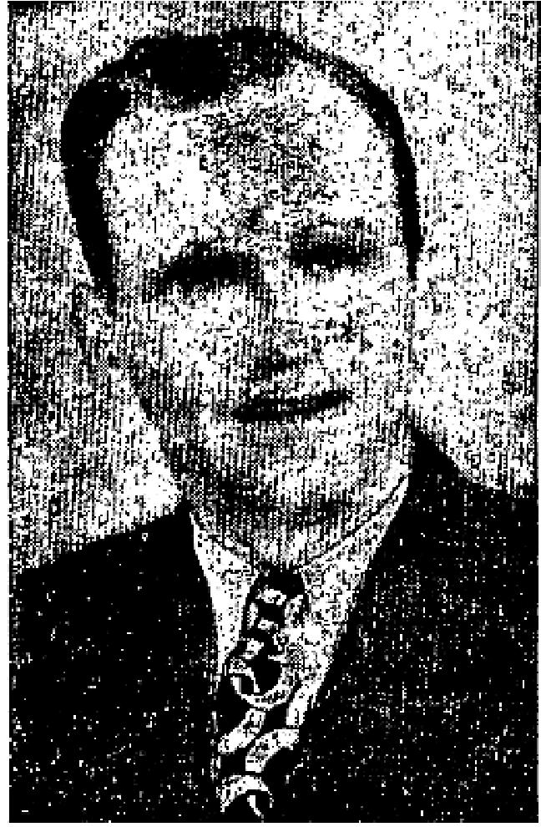
During the recent Branham Healing Revivals in Los Angeles' Calvary Temple, the 66-year-long dream of Hon. Wm. David Upshaw, whose suitesmanship as a U. S. Congressman, educator, Temperance lecturer, Prohibition candidate for President of U. S., preacher, and author is known to millions, became a reality, as God honored his steadfast faith and enabled hint to walk normally, unaided, after 59 of his 84 years were spent on crutches, and seven years in bed.
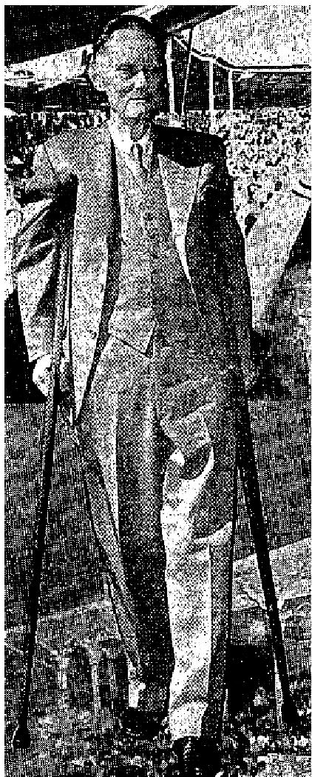
The glowing letters we are receiving from Mr. Upshaw would make delightful reading for you, our subscribers, but we must limit ourselves to the testimony printed below, submitted by the healed man personally.
"I who was lame am now made whole."
I walked into that Branham-Baxter meeting in Calvary Temple, Los Angeles in February, 1951, on my crutches that had been my "buddies"... my helpful companions for 59 of my 66 years as a cripple.... 7 of those years having been spent in bed. I walked out of the meeting, leaving my crutches on the platform with the "Song of Deliverance" ringing in my heart in happy consonance with the shouts of victory from those who thronged about me. Their tears of joy were crystal with the light of the skies, and chief among them was my blessed wife, whose dear face, glowing amid her joyous exclamations, "Praise the Lord," and "Glory to God," was beaming like a patch of heaven.
But my story will be a truer story, and far more helpful to those seeking what I now have, if it deals in something besides "Hallelujahs" and "Hosannas" to God on high! Manifestly, I cannot tell it unless I tell it in relative detail.
I was hurt when a farmer boy of 18, falling on the crosspiece of a wagon frame and fracturing my spine. Thank God I was converted just before I was hurt, so naturally I prayed at first to be healed. I know that

THE VOICE OF HEALING 1951
there was too much "Willie Upshaw" in that prayer. I wanted to be instantly healed, dash down to the lot, saddle a mule or a horse and go galloping to my church at Powder Springs, or Lost Mountain, or Mount Zion, and run up to the pulpit, stop the pastor, and shout. "Stop, Brother, I have been healed ... let me tell my story!" and every time I prayed to be immediately healed, the Lord seemed to say to me, "Not yet! I am going to do something through you in this condition you could not do otherwise.... leave it to me." I rested under the shadow of His wing.
Certain it is that if He had healed me then, in my impetuous youth, lying amid the wreckage of my shattered rosy dreams, I could not have written the books, "Earnest Willie" and "Echoes from a Recluse," which I sold from my rolling chair, making money to, enter Mercer University on that rolling chair at 31. And I never could have taught many millions of students in 42 states my motto, "LET NOTHING DISCOURAGE YOU... NEVER GIVE UP," inspiring many young lives with "A purpose linked to God." Yes ' and I never would have given years to Christian Education in Georgia without salary ... falling in my tracks, helping 7 boys and 52 girls through college.
"But," said my Bible-loving wife and some of her devout friends, "That contract with the Lord was long ago. He has brought you victoriously through many trials ... now it would honor Him far more for you to Cross the continent and witness for Him without crutches, not only as the personal Saviour of your soul, but as the Great Physician Who has healed your body." And I knew it.
Nobody knows how I suffered as I sat under the powerful preaching of Wm. Freeman, of winsome Oral Roberts over the radio, and dear Wilbur Ogilvie, who under God prayed away the incipient cancer on my face two years ago, after medical help had failed. All the time I have prayed for "appropriating faith." Somehow I just could not "take hold and walk."
Then came God's humble prophet, William Branham and that son of thunder (who can "out-Hollywood" Hollywood, and never get away from Calvary), W. J. Ern Baxter . . . making one of the greatest evangelistic Bible teams that has ever blessed the world since Paul and Barnabas laid the pillars of God's kingdom on the shores of Tiberius and the Mediterranean.
We just knew "Billy" Branham would be great, but we were not prepared for Baxter, who is an imperative John the Baptist, preparing the way for Branham.
I sat entranced, still praying for "appropriating faith" but holden, somehow of that contact, and . . . that contract with the Lord 60 odd years ago. Others were being healed all around me. Then Bro. Branham, exhausted, was carried from the platform. Angels were hovering near and I knew my blessed wife and her "prayer warriors" were wrapping me in prayer. I remembered how she said, "When you are trying to lead a sinner to accept Christ, you say,’Accept, confess Christ and step out... He will do the rest and bring the feeling.’
"It was the touchstone. Brother LeRoy Kopp, Calvary Temple's golden-hearted pastor, came back to the pulpit and said, "Brother Branham says THE CONGRESSMAN IS HEALED!" My heart leaped. I said in my battling soul, "Branham knows the mind of God ... I will step out and accept the Lord as my Healer." I laid aside my crutches and started toward the startled LeRoy Kopp and my happy, shouting wife. . . and the bottom of heaven fell out!
"Heaven came down our souls to greet, and Glory crowned the Mercy Seat." And now at 84, with no gray hairs, and without my boon companions for 59 years (my crutches) I began a new life, joyously testifying that Christ the Great Physician who said, "I am the Resurrection and the Life," can not only save the souls of wicked men and women, but He can and does heal the bodies of the sick, the maimed the deaf, the dumb, and blind, bringing Heaven down to this sinning, staggering world. My crutches are still on Lite Calvary Temple pulpit, and I am "Happy on the way. . . Leaning on the Everlasting Arms." Praise God!

THE VOICE OF HEALING 1951
William David Upshaw
2524 24th Street
Santa Monica, Calif.
COVERING THOSE OTHER SIX STATES BEFORE I GO TO HEAVEN
Wm. D. UPSHAW
Concerning his future activities without his. treasured crutches, Upshaw says. "Brother Branham told me today, 'I feel like the best part of your life is before you, fortified and stimulated by the new evangel of your Divine Healing, and I will help you to cover the nation!'
Since I got away from my seven years in bed, I have spoken widely over 42 states and several foreign countries, and now before I go to heaven, by the grace of God, I want to cover those other six states (and the regions beyond) speaking to schools, churches, and Civic clubs, fighting Communism that is crawling like a serpent into the Eden of our American life. Yes, and warning the high school and college boys and girls not to touch liquor in any form, teaching them my motto, "Let nothing discourage you ... never give up."' Through it all and above all stressing the fact that Christ Who saves the soul and heals the body is the basic solution for every personal, national, and international problem.
As soon as a car can be secured, with dependable prospects for expenses, my gifted and consecrated wife (25 years state lecturer for the Women's Christian Temperance Union in California), will rejoice to drive me over those other six states - plus all other possible territory until Judgment Day.
To all lovers of God and the American flag who make an investment in this sacred task in behalf of the Nation's youth I will send an autographed copy of my booklet "Scattering Sunshine" or "How to be happy when you ain't"; also the story of my conversion and healing. In the words of Woodrow Wilson, "We summons you to comradeship."
Wm. D. Upshaw (No grey hairs and no crutches)
2524 24th Street, Santa Monica, Calif.
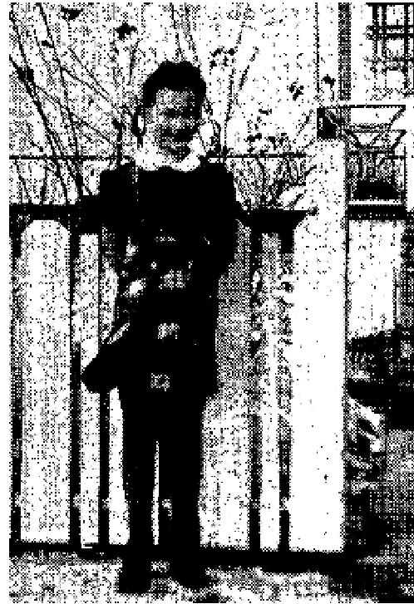
GIRL WITH SEVERED VOCAL CORDS SINGS OVER RADIO
Healed 4 Years Ago in Branham Meeting
Saskatoon, Sask.,
906 8th Avenue Nwth
March 9, 1951
Dear Sister Lindsay
At the age 9.5 years, Judith, our daughter, gradually became hoarse, finally could just whisper. After a long period of doctoring and diagnosing, an operation was decided upon as a growth was an her vocal cords. All was fine for a while, but then In 3 months it come back; once more an operation, and in 3 more months another. So in all, 3 operations were performed in 9 months and on the lost operation, the growth had become so large and was so difficult to remove, it dropped back in her throat and the doctor assisting told me she practically choked before they could got it out; and in the hurry the vocal cards had been
injured.
During the times before each operation the growths in her threat appeared to practically choke her and her breathing at night was only made possible by propping up with pillows. After these 3 operations the growth again grow worse than any of the previous. My husband and I decided that in all the doctoring, no help could be found so remedy the matter. It was at this time we decided the Lord alone could undertake.

THE VOICE OF HEALING 1951
I read of Bro. Branham's gift of healing and the anointed hankies that were sent. I immediately sent for one and placed it on her sleeping garment as instructed. Judith's breathing become normal, but still she couldn't speak above a whisper. I took her through the prayer line while Bro. Branham was in Saskatoon, on July 30th, 1947. The procedure for the prayer line was followed as in all Bro. Branham's meetings, and when Judith's turn to be prayed for come, the fast line was started, but when Judith approached Bro. Branham she put her arms around his knees and sobbed. In his compassion for children, he immediately prayed for her as if in the slow line.
The Lord revealed to Bro. Branham what was the need; that being new vocal cords. Bro. Branham told Judith to speak out, and inside of 3 days that is just what she started doing; after ever a year and a half of whispering. Site started singing "Only Believe." At first it sounded like a rooster just discovering he has a voice, but with encouragement to speak out and not whisper, which would hove been easier, she was singing and talking normally. At Christmas time she sang a solo in the Christmas concert and also sang ever the radio station here. Now she is the picture of health and just loves singing for the Lord.
Our prayer is their God will continue to use Bro. Branham in the healing of the sick, and keep him strong in
body.
Yours sincerely,
Mm Paul Philips
April-May 1951 p 4
TIME-TESTED CANCER CASE
I was an evangelist, but my ministry had been ruined by a dreadful cancer of the throat. The physicians said I would never preach again, my voice was gone forever. The cancer was eating from the right side of my throat to the left side. I had been examined by several outstanding throat specialists. I had been treated by Dr. M. D. Chatterton of Oakland for months. Many nights I was awakened by my throat filling with blood and was sure that I would die for I would strangle on the blood. My throat was so swollen I couldn't button the top of a blouse and I suffered excruciating pain and soreness. Evangelist Jaggers laid hands on me, saying "Sister Nathan, in five minutes you will not have the cancer."" I was instantly healed, the swelling left immediately, all pain and soreness. I can fold the blouse over my throat now. I have a voice that can shout from the house tops! I have gained 13 pounds in the past six weeks since I was healed. I have been examined four times by Dr. Chatterton since and there is not the slightest trace or symptom of the cancer. Mrs. Louella E. Nathan
FOLLOWING IS AN EXACT COPY OF DR. CHATTERTON's LETTER WRITTEN TO EVANG. O. L.
JAGGERS STATING THAT MRS. NATHAN IS HEALED AFTER THE FIRST EXAMINATION:
Dear Reverend,
This is to certify that I have this day examined Evangelist Louella Nathan and have found a remarkable change and improvement of her serious throat complaint. The recent change for the better is the most remarkable I've seen in her since she first came to me.
DR. CHATTERTON'S LAST LETTER TO EVANG. JAGGERS AFTER FOUR EXHAUSTIVE EXAMINATIONS:
Dear Reverend:
This is to certify that I have this day examined Louella E. Nathan and find that the large swelling in her throat is gone and all the bleeding has stopped. Her throat appears to he in very good shape and her voice has improved immeasurably. The improvement in her condition has been beyond all expectation.

THE VOICE OF HEALING 1951
Dr. M. D. Chatterton
Deafness and Weak Eyes
God miraculously restored my hearing and sight. I had been totally deaf in ray left ear for eleven years. I had twenty percent vision in my left eye, and my right eye also was weak.
On the evening of September 29th, 1950, Brother Jaggers laid hands on me and the power of the Holy Spirit healed the infection in my' car and created a new ear drum to replace that which had been destroyed by an infection.
My hearing is perfectly normal in that car. Both eyes are so much stronger and I duo not wear glasses, and
my eye sight is getting better each day.
Signed: Robert Daragan
1330 - 15th Street
Rock Island, Illinois
My left eye was crossed and I could not read well. I also had cavities in my teeth. When you prayed for me
the power of the Holy Spirit came upon me. My eyes are perfectly straight and my teeth are firm.
Signed. Mary Phipps
2800 - 31st Ave.
Rock Island Illinois
April-May 1951 p 5
EFFORTS OF TOUCHES BY RADIO
Discharged from T. B. Sanitarium
I was in Elmgrove Sanitorium in Bushnel, Illinois. I came to Rock Island, was prayed for and received instant healing. I went to Dr. Redington, heart and lung specialist in Galesburg, Illinois, and had another test taken. The county nurse and sanitorium doctors were astonished at the outcome of -my X-ray, which showed that I did not have T.B.
I know only God could do this great healing in my body and I praise him for it. I was a backslider who came
back to the Saviour and was baptized with the Holy Ghost in your revival in Rock Island.
Signed: Mrs. lack L. Smith
449 East Fourth St.
Galesburg, Illinois
Palate Created in Mouth
I was born without a palate in my mouth, and had been deaf in one ear for twenty-seven years, I can remember when my father and mother took me to doctors who used various kinds of medicines and tried everything to open my ear. Finally, my father and mother gave up, since the doctors could do nothing. When Brother Jaggers laid hands upon me and prayed, it felt like there were three or four round objects like marbles in my head between my cars and I could feel them move one at a time until they were gone. I was instantly healed and my hearing is perfectly normal.
The roof of my mouth had a large round hole in it. I can remember. when my father and mother tried to teach me how to talk plainly, but finally gave up. When Brother Jaggers laid his hands on me and prayed, God put a palate in my mouth. Already my speech is much plainer!

THE VOICE OF HEALING 1951
It is wonderful what God has done for me. When I was a small girl I had to sit at the head of the class in
school because of my deafness, so that I could hear the teacher. Some of the pupils would make fun
of me when I could not speak plainly because I had no palate in my mouth. My father and mother spent a
great deal of money for doctors who finally gave up entirely. Praise the Lord, it is wonderful how God
healed me.
Signed. Mrs. Maxine Creek
New Windsor, Illinois
April-May 1951 p 9
INCREDIBLE! (THE AMAZING STORY OF MIRACLES IN THE OSBORN, MISSIONARY CAMPAIGNS) - BUT HERE'S PROOF . . .
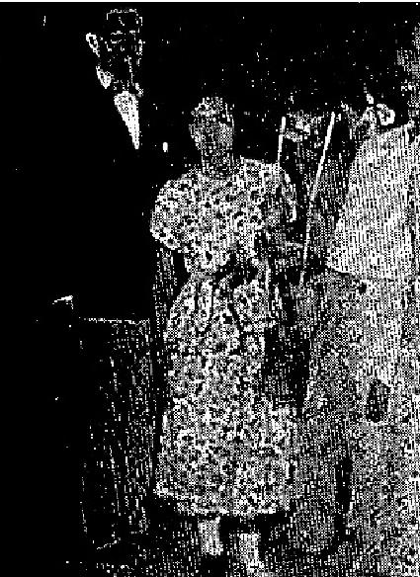
Fifteen years ago I became the victim of infantile paralysis, which rendered my left leg almost useless. In order to walk at all, I had to wear a brace at my hip and even then I would have to brace my knee with my hand in order to walk. During the Osborn Healing Campaign in the Baseball Park here in Ponce, I was perfectly and instantly healed. Also my left leg was two inches shorter than the other. I took off my brace, because as Brother Osborn prayed for me, it actually felt like the brace came open by itself. On examining, it, I found that the brace was still closed, but I felt sure if I would take it off, I would discover that I was healed. I took it off, and for the first time in 15 years, I walked straight and without a brace.
Marin Victoria Velez
Bda. Salistral
Playa de Ponce, P. R.

Last year when Brother Osborn came to Teatro La Perla here in Ponce, I and my family attended and I was walking on crutches. From a very early age, I had T. B. of the hip bone. My hip joint had been completely destroyed, and therefore I could not walk without crutches.
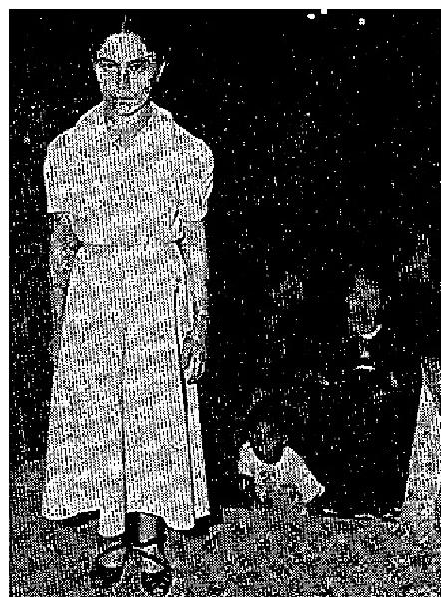
Brother Osborn laid hands on my forehead, and commanded that I be made whole, and then he took my crutches and commanded me to walk. I figured if he told me to, then I could, and I did. One year has passed now, and I have never used a crutch or any other aid since. I am perfectly healed. For many months we had callers from all over the Island, coming to see if it were really true that I had been healed. IT IS TRUE.
Blanco Justiniana
Mayer Cantera No. 181
Ponce, P. R.
Bro. Osborn writes:

This is the lady whose healing began the great Ponce campaign last year. She was the only one brought to the Pearl Theatre (where we opened services) who was a cripple with crutches. All eyes were upon her, wondering what I would do. Some said, "We'll lynch him if he doesn't cure her." As the critic's attitude was revealed to Jesus when the man appeared in the temple with the withered hand, I seemed to know what the audience was thinking. I called her to the platform and asked her to sit till I was ready to pray for her. The audience was on edge. I called for her and prayed a simple prayer, for she had great faith and was weeping. I commanded her to throw row her crutches down and walk. She did and was perfectly healed at that

THE VOICE OF HEALING 1951
moment, and the audience screamed for, joy. The critic was silenced and the meeting was on. For three days her house was full of people of repute to know if it was really true. For one year the Catholics have tried to turn her from the faith, but she remained faithful and gives a sweet, lovely testimony to all who inquire.

T. L. Osborn.
For two years I was totally paralyzed from my shoulders to my feet. I could not move or feed myself. I was carried to the Osborn Healing Campaign last year, and there I accepted Christ as my Saviour. My wife and others carried me like a baby to the water baptismal service in the Playa. In that condition I followed the Lord in baptism. When I came out of the water, I found I could walk with the aid of two canes. I have been getting around that way for one year, but this year I attended the meetings, realizing that I was a child of God, and had been serving Him faithfully.' When Brother Osborn reasoned with us concerning the promises of God, I saw that 1, as a child of God, had a right to a well body. I threw my canes down and at Brother Osborn's command, I walked. When he said, "In Jesus' name, WALK," I walked, and have been perfect in every way since.
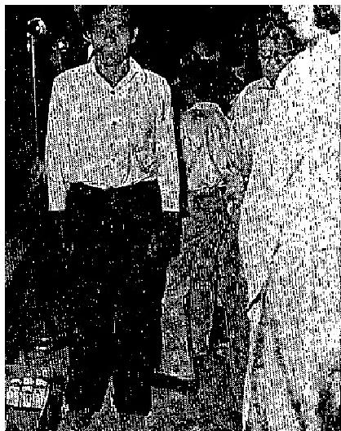
Mercedes Rodriquez
Bdo. Cerro Gordo
Yaucu, P. R.

For six years I had been suffering untold agony in my intestines. Finally I went to the doctor, and he said it was necessary that he operate. On further examination, and with further tests, it was proven that I had cancer of the intestines. Then the doctor refused to operate, saying that it was hopeless, and an operation would perhaps do more harm than good, I was bleeding continually through the intestines.
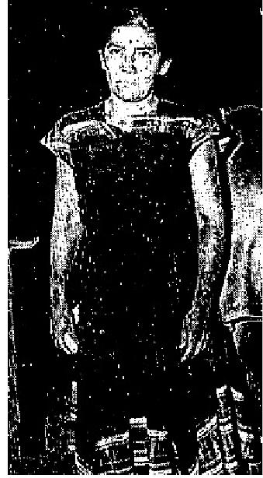
I attended Brother Osborn's Healing Campaign in Morrel Campos last year and I was instantly healed. The very next day after prayer, I was well. I was strong and could eat anything. The bleeding stopped immediately. In that campaign my husband and I were both converted, and we were baptized in water in the great water baptismal service conducted by Brother Osborn in the Playa. One year has passed, and I have proven to all that I am perfectly healed. My husband and my pastor can both verify this testimony. Carmen. Echevarria
California 58 A
Ponce, P. R.
Second Baptist Church in Ponce
Pastor: Rev. Julio Caesar Flores

April-May 1951 p 10
FORMER ARKANSAS PASTOR IS GIVEN UNUSUAL GIFTS
Many Cases Called from Audience by Discernment; 750 Receive Holy Ghost Baptism in One Meeting

My 10-year-old boy was born deaf and had never heard or talked and had also been blind in one eye since birth. Now since he has been healed he can see to read out of the eye which was once blind. With the ears that were deaf be can now hear the tick of a watch. A neighbor is teaching him to talk and he is learning fast.
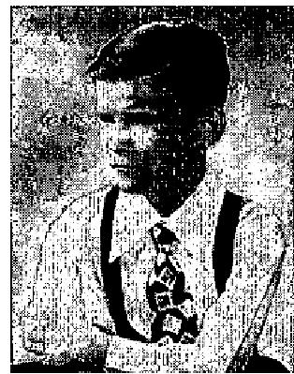
Fourteen years ago I cut my foot and since then it would swell up when I walked on it and it was very painful. After being treated in a Houston hospital for four months the Doctor said I would have to quit my work entirely. In the Fort Worth revival I was healed

THE VOICE OF HEALING 1951
instantly. I am completely well after limping for 14 years.
T. R. Downs
9918 N.W. 12th Street
Fort Worth, Texas
Deafness, blindness ...
Three years ago lightning went into my car. The ear burned and popped as loud as a .45 pistol. Ten years
ago an optometrist said, "your right eye is perfect, but the left eye is gone."
One night in the Fort Worth Revival Brother Grant said that there was some. one present who was blind in
the left eye and deaf in the right ear. I was walking to the bus line one day and realized that God had healed
me right there.
Mrs. Frances Carter
Fort Worth, Texas
Cancer, deafness, heart trouble ...
I had a cancer on my face for three years. The night I was prayed for in Brother Grant's Fort Worth revival,
it dropped off my face. It had been 5 years since I had heard a service and the Lord healed my ears also. My
heart trouble was so bad that my family had my clothes prepared for my burial, but Thank God I am healed.
M. A. Peck
1505 N. Houston
Fort Worth, Texas
Paralysis Healed ...  This woman had been in her wheel chair for 14 years with tier legs and feet paralyzed.  The knee and ankle joints were swollen stiff and she could not stand up. The doctors  said she would have to spend the  rest of her life in her wheel chair.  In the Fort Worth meeting Brother Grant felt led to roll her chair into the prayer room during the altar service. He had not prayed for her before but did now and she jumped instantly out of her chair ... healed.  Brother Grant sat in her chair and she pushed him 100 yards around the church and then folded up her chair, completely healed.  Arthritis, rheumatism, asthma ... | 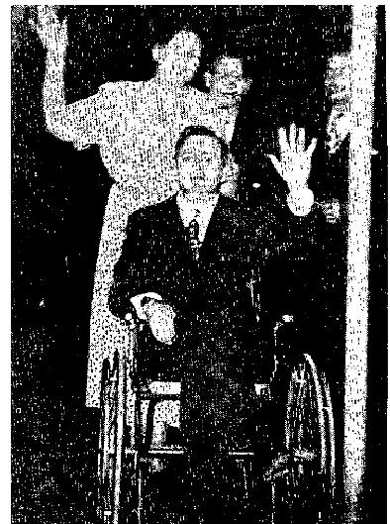

For ten years I had rheumatism and arthritis, and asthma for four years. During these years 1 was treated by several doctors and tried different kind., of medicine but only found temporary relief. For 4 or 5 years I had to use a cane to act around and suffered pain.
Since God healed me in the Fort Worth revival 1 don't use the cane and 1 have no symptoms of arthritis,
rheumatism or asthma.
E. M. Kimcrough
3701 6th Street
Fort Worth, Texas
April-May 1951 p 12
Coe Ministry Stirs Cities

THE VOICE OF HEALING 1951
Healing of Baptist Minister Impresses Plainview
In the Plainview, Texas, revival, led by Evangelist Jack Coe and party, the Assembly of God, Foursquare,
Pentecostal Church of Cod and the Church of God churches were all united in this great evangelistic effort.
It was the greatest revival ever to come to this section of the country. Hundreds came to the altar and people
received the Holy Ghost in the service while the songs were being sung, or in the healing line.
Sinners could not keep their seats, but would cry out that they needed salvation.
A Brother Chumbley, Baptist minister, had cancer of the stomach and was on a milk diet for 18 months. He was given up to die by several doctors, and had been turned out of several hospitals as incurable and he was told that each hemorrhage would be his last. He came night after night in the healing line and the line would be stopped before his turn came. He said to one of the workers, "If I don't get prayed for tonight I will be dead before I get back to the church."
One Sunday afternoon Brother Coe felt led to call him out of the line and pray for him. Immediately the
healing virtue went through his body, and be went out that night and ate a hearty supper and
has been eating everything he wants since.
Since everyone in die town knew him, it caused quite a sensation.
Dr. Zellars, a teacher at Wayland College attended the services along with others and after seeing the wonderful healing he was convinced that it was God. He wrote a letter, asking to see Brother Coe and have him explain the Baptism of the Holy Ghost,
The people of Plainview have a deep appreciation for this man of God, and the movings of God through Brother Coe will long be remembered in the hearts and minds of the people.

Cripple Walks!
On June 23, 1 came to the Coe Healing Campaign in Lubbock, Texas, all crippled up
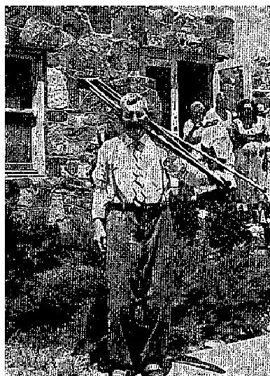
with arthritis. I had been crippled since 1927. 1 also suffered with heart trouble for
several years, and had been on crutches for four years. Alter Bro. Coe prayed for me I
could jump around and shout and praise the Lord. I am glad that God is the Healer of
all the nations.
W. S. Hambrick
Route B,
Lamesa, Texas.
April-May 1951 p 13
MIRACLES PERFORMED IN VINYARD, SERVICES
Victims of Total Blindness Enabled to See
Cancer of Nose Healed; Only Scars Remain
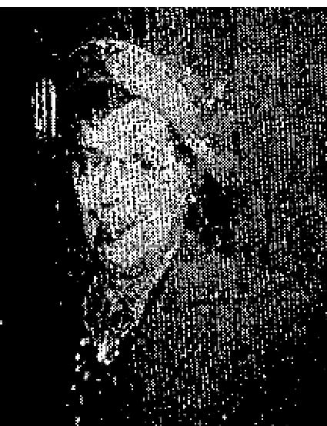
I was afflicted with cancer on my nose, which has been growing for about two and a
half years. It was very painful and covered the left lower side of my nose.
For several months. I went to doctors for radium treatments. These treatments failed to destroy the cancer. My doctor advised me to have an operation to remove the left side of my nose and a portion of my face. Instead, I turned to God!
One blessed Sunday morning in our church in July, 1948, 1 felt impressed to ask Brother Vinyard to pray for me. Now two and a half years later, there is only a very

THE VOICE OF HEALING 1951
small sear that is scarcely noticeable. My picture proves my testimony.
Mrs. H. R. Conover,
Overland Park,
Kansas.
Minister Hears Without Hearing Aid
I had been losing my hearing slowly for years. The doctors told me that in two years
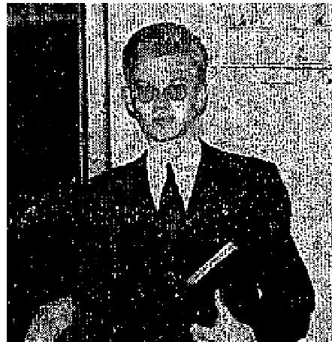
I would be stone deaf, and there was nothing that could be done. When attending
your meeting in Brooklyn New York, at the Calvary Gospel Assembly, I could not
hear without a hearing aid. While you were praying for others, you
took me by the hand and, said, "Preacher, the Lord wants to heal you!" You prayed
for me after I removed the aid and I heard perfectly, instantly. That was fifteen
months ago and my ears are still perfect.
Rev. Walter George Heil
60-20 70th Ave.,
Ridgewood, N. Y.
Victim of Total Blindness, Sugar Diabetes Perfectly Well; Eyesight Returns From the day you prayed for me, my eye sight returned, although I was stone blind as I was led to the platform for prayer. I have resumed all of my duties as a housewife, and have been taking care of my family for. this past year, since being healed of total blindness and sugar diabetes, which I suffered for 14 years. Carmell Colino,
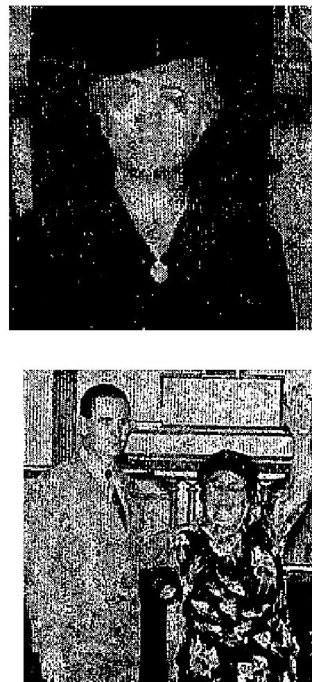
102 Laidlow Ave.,
Jersey City, New Jersey
Paralyzed Arm Restored
About five years ago my left arm became paralyzed. This paralyzed condition greatly handicapped me in my daily routine of work. Besides, it caused me great pain and misery.
During your revival at Corona, New York, you prayed for me, and the pain
immediately left me. My arm is perfect now. My picture proves my testimony.
Mrs. Theresa Repici,
5022 103rd St.,,
Corona, L. I., New York

Blind Preacher Sees
On February 2, 1944, 1 was taken to the Barnes Hospital in St. Louis, Missouri. I had a retinal detachment in both eyes, two breaks in the left eye and two breaks and a rupture in right eye. I was told by hospital staff that an operation in my case was useless, as it had gone too long. Dr. Ruth Freedman removed the 4th layer of my right eye and replaced It with plastic, using 180 pins to fasten it in place. Dr. Freedman did all that was humanly possible for me. May God bless and keep her. But my sight was gone. After about seven months under hospital care, I was sent home to begin life again.
For four years I followed God in the dark. I only missed a few Sundays preaching the gospel, and even when in the hospital I had the blessed privilege of leading two or three souls to Jesus. The government let me have a talking book in which I have most of the Bible, so I did not have to miss out on my Bible reading. The commission for the Blind sent me a teacher to teach me the braille system. I soon overcame my handicap to a great extent. The Humane Society of St. Louis, Missouri gave me a seeing-eye dog. The dog (Lady) has always proved herself trustworthy under any kind of trial, a real guide and faithful companion.

THE VOICE OF HEALING 1951
I will always love her for the time she took me to Excelsior Springs, Mo., a camp meeting, for without her it is doubtful if I would have gone, I had given up all hopes of ever seeing, again, and was happy in my new world. But I was told that they were having prayer for the sick, and someone asked me would I like to go and be prayed for. I wasn't so sure that I would. Don't be surprised at this. Remember I had been in the dark four years and had many prayers offered in my behalf. As a dear Brother took me by the hand and led me to the Healing line, I heard Brother Vinyard say: "Bring that blind man here." He prayer for me, asked if I could see, I could not. Again he prayed, asking me if I could see. I could only say no.
Then, thanks be unto God forever- Listen to this - he prayed again for me and rebuked the blind devil in the dear name of Jesus, and Glory to God, I saw! I saw his hand, then his dear face, then forms all around me; and I tell you, it was a little taste of heaven when I looked into the face of my wife whom 1, had not seen for years, and. my sons, and daughters and grandchildren, three of whom I had never seen! Oh I can't praise Him enough for this. My vision is now enough to get to get around and to read large type print, and this is through a part plastic eye. Once I Was blind but now I see!
Rev. Frank Miller,
Waverly, Mo.
April-May 1951 p 18
HEALED OF TOTAL BLINDNESS
After suffering for years from a serious diabetic condition, I went totally blind, I was led to the platform and
Brother Tannenbaum prayed for me and immediately I saw light and saw Brother Tannenbaum plainly. After
two days I wrote my name plainly, and my sister says I write a better hand than I ever did. I am feeling
wonderful and I can't thank God enough for what He has done for me.
Della Showell,
339 N. 66th St.
Philadelphia, Pa.
April-May 1951 p 20
SEATTLE PAPER HAILS MIRACLE
As a newspaper reporter we have experienced many spine-tingling moments. With our hearts pounding like a triphammer we have watched as condemned men dropped through trap-doors of the gallows and into eternity. We have had the unusual pleasure of feeling the handclasp of the immortal Franklin D. Roosevelt and realizing that as the chills raced up and down our back we were gripping the hand of the man who was President of the grandest and most glorious country that God had ever looked down upon. We have stood with uncovered head as the great of the nation's war dead moved slowly by on the black caissons. And now we want to tell you about the Gates family. This story is not only one to tingle the spine, but a true narrative to stir the soul.
About five months ago Jimmy Gates, 8, was playing in his front yard at 2251 West 64th Street, Seattle, when a pebble from a neighbor boy's sling-shot accidentally struck him in the right eye with almost bulletlike force. The little boy was rushed to a hospital by his parent, Mr. and Mrs. Everett Gates, who in subsequent visits were informed by the physicians that it might be a matter of two years before medical science could definitely determine whether their son would ever again be able to see with the injured eye.
Things looked tough for Jimmy. He'd had dreams of being a star football and basketball player later on. But a chap with only one eye would be a bit handicapped. A tackle could slip up on your "blind side" and drop you like nobody's business.
And then Jimmy got a miraculous break. He can hardly believe it's true even yet. Last Sunday evening in Seattle we interviewed the family. But let Jimmy's Dad, Everett, a carpenter, tell the story in his own words We took his words down, verbatim:

THE VOICE OF HEALING 1951
"We'd about given up hope of Jimmy ever getting the sight of that eye back again, My wife and I had never given much thought or time to churches or Christianity, although we had both gone to Sunday School when we were kids.
"Well, the other morning I read an advertisement on the church page of the Post-Intelligencer. The ad said that at a downtown church an Evangelist was conducting a healing campaign and that all manner of miracles were happening through prayer. Immediately my mind flew to Jimmy and his blind eye. I talked the thing over with Josephine, my wife, and we decided to give the thing a try.
"That night we went to the church and when the opportunity came Jimmy went up on the platform and the Minister laid his hand upon the blind eye and offered up prayer for the boy's healing. After the prayer Jimmy came back in the congregation and sat down between his mother and me while we looked on as others were being prayed for.
"Suddenly Jimmy was tugging at my coat sleeve and whispering over and over:
'Daddy, I can see out of my blind eye! Still unbelieving, but with my curiosity aroused, I held my folded handkerchief over Jimmy's good eye and was astounded when he readily identified various objects which I held in front of him!
"Life is so wonderful that we hardly know how to act - not alone because Jimmy got his sight back - but because with our own eyes we saw a divine miracle take place and know that there is a God in Heaven who looks down upon us and answers prayer."
Rev. W. W. Patterson, Pastor of Bethel Temple, Second at Lenora Street, where the healing services are still in progress, verified Gates' story in every detail, adding that when the parents were fully conscious of what had transpired they were both so shaken that they came forward and embraced the Christian faith.
Said U. S. Jaeger, the Norwegian Evangelist who prayed for little Jimmy: "Now don't get me wrong. In myself I couldn't heal a fly. But a matter of ten years ago God saved my soul and told me that my life work was to pray for the sick. I'm doing just that, and God is honoring His promise.
As we said before, little Jimmy's Dad is a carpenter in Seattle. Seems like we remember something about another Carpenter - a Carpenter who put in His journeyman days in a little town called Nazareth.
April-May 1951 p 21
CREATIVE MIRACLES IN ALLEN MEETINGS
NEW FLESH FORMS ON WITHERED LEG IN THREE DAYS
For five years I had blood clots on my left leg up to the knee. The veins were eaten out to the bottom of the foot, and the doctors declared it would never heal. They tried to graft skin on the limb but it would not grow and my limb was black to my toes. For two years the doctors insisted on amputating, but I would not consent.

THE VOICE OF HEALING 1951
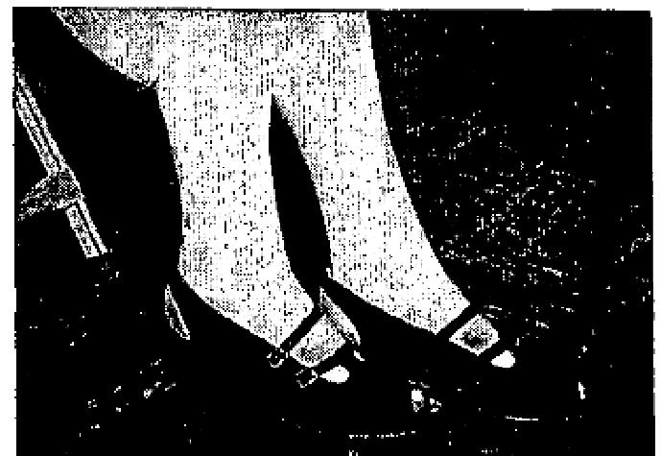
The running ulcerous sores had not only eaten away the veins but also much of the flesh was gone. Plastic tubes had been placed, in my limb where the veins were gone and these continually emptied matter and blood into a plastic bag. No one could see this as I kept the limb bandaged and only with great difficulty could I manage to get around at all.
While attending Rev. A. A. Allen's Salvation-Healing Revival, God gave me faith for healing. After Brother Allen prayed for me, new flesh and skin IMMEDIATELY BEGAN TO FORM AND GROW oil the limb. It amazed the doctors. The doctors removed the plastic tubes and sack. WITHIN THREE DAYS AFTER I WAS PRAYED FOR, MY LIMB WAS COMPLETELY COVERED WITH NEW FLESH AND SKIN. NEW FLESH EVEN FORMED WHERE THERE WAS NO FLESH AT ALL. The doctors said they could take no credit for the healing as they knew it was accomplished through some other source higher than man. No soreness has ever returned. I am completely healed.
Mrs. Mattie Kliewer
1219 58th Avenue
Oakland, California
Note: This healing took place in March, 1950. This testimony was given and picture taken on February, 1951. Note only slight discolorations on the left leg that was healed.
Sight Restored Instantly to Eye Burst by Shrapnel
During combat on Iwo Jima, I was wounded by shrapnel which burst my left eyeball. The eyeball was not
completely destroyed but there was no vision whatsoever, nothing but total darkness.
Several Army doctors examined this eye and all agreed that I would never see out of it again and I never expected to.
On "Miracle Night" in A. A. Allen's Salvation-Healing Revival in Ada, Okla., on Dec. 15th, 1950, the Spirit
moved in such a mighty way that I realized God was giving me faith to receive vision again. Brother Allen
placed his thumb upon my blind eye and prayed. As he prayed, fire seemed to go through my eye. When he
took his thumb away, he commanded me in Jesus' name to see out of that eye. With my hand over
my good eye, I opened the eye that had been blind. IMMEDIATELY I COULD SEE THE LIGHTS IN THE
CHURCH AND EVEN READ LARGE PRINT. My sight continues to get stronger daily.
Johnnie F. Foster
Route 1,
Stonewall, Oklahoma
June 1951 p 2
Ambulance Case Raised Up by A Miracle
I, Mrs. Lloyd Humphrey, 1933 Wank Avenue, St. Joseph, Missouri, do hereby declare the following
testimony to be accurate ind truthful.
I have suffered with heart trouble, and being a nurse I tried to obtain the best medical help possible. My heart was enlarged to the point where it resembled a long-necked gourd, reaching from the ribs on the left to beyond the midline on the right and pressing the diaphragm. Instead of the regular rhythm of the normal heart, I had "gallop rhythm," or irregular beating, so that I was in pain ' in most of the time. The pain

THE VOICE OF HEALING 1951  extended down the left arm, through the chest and up the left side of my neck. Ally breathing was very laborious and I also had "Cardiac Asthma," with the lung tissues filling with fluid - which had to be coughed up. This condition made breathing almost impossible. Hypodermics to dehydrate the fluid were given and I was placed under an oxygen tent as soon as an attack was over. Along with the heart condition came the complication of Bright's Disease which produces decompensation or dropsy, and I had only a 35% kidney function. The kidneys are a filter of the body and when they fail to function. poisons are retained in the body. As a result of this last, a severe case of arthritis was brought on and I was bedfast from Aug. 3, 1950 until March 1951, being unable to walk as the arthritis struck from the pelvis downward. | 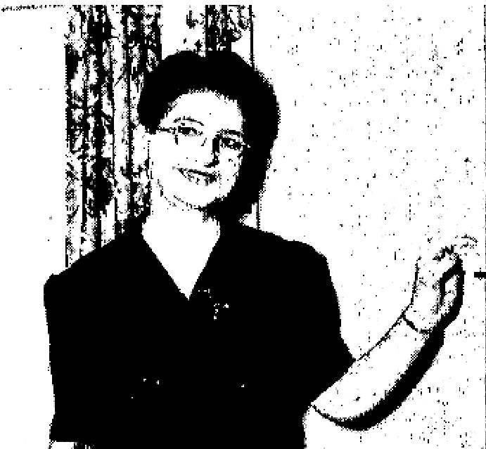

I had been given up by the physicians and told I was beyond medical help and could only live a short time. But then the miracle happened! Sister Louise Nankivell came to our city, to hold a revival meeting. I was taken in an ambulance to the auditorium and my breathing was so labored that I had to be fanned and have water to somewhat revive me. This was on March 18th, and Sister Nankivell prayed for me and within a few minutes the labored breathing stopped. She told me to "Put your hand in the hands of the Saviour and if He tells you to walk, get up and walk." I waited a few minutes, then it seemed that He said, ; Rise and walk." Several ushers had to help me at first and before I hardly realized it I was walking alone. When I went into the building I had the gray pallor of death and my eyes were sunken. Several of my former patients were there with me and they said that a glow of radiance came over my face, the pallor left and a rosy hue took its place. I was overjoyed and so thankful to God for healing me.
I want to say in closing that I was hospitalized four times in 1950 and I cannot recall exactly how many times in 1949. The records, my heart tracings and chest X-rays will substantiate my testimony. I am walking everywhere now, have had no more trouble with the former conditions and have been checked by my
doctor and he said "It is wonderful indeed.”
Mrs. L. Humphrey
1933 Wank Street
St. Joseph, No.
Witness: Rev. C. B. Roberts
June 1951 p 4
CANCER AND VARICOSE VEINS
I want to give my testimony of how God healed my body on Tuesday evening, October 28, 1950, I had a cancerous growth on my body. I also had varicose veins so bad that at times I could hardly walk. I also had a severe pain in my side and shoulder which had been bothering me for seven years.
When Bro. Jaggers prayed for me, the miracle-working power of the Holy Spirit removed the cancerous growth instantly. When I got home from the service, I couldn't find a sign of the growth on my body at all. I haven't had a pain in my limbs from the varicose veins since. The severe pain in my side and shoulder which had bothered me for seven years was gone.
I really praise God for sending such a man of God who isn't afraid to speak the real Word of God in boldness without fear.
(Signed)

THE VOICE OF HEALING 1951
MRS. BERT BRANHAM,
381 11th Street,
Moline, Illinois.
June 1951 p 5
Evangelist Estle Chaney
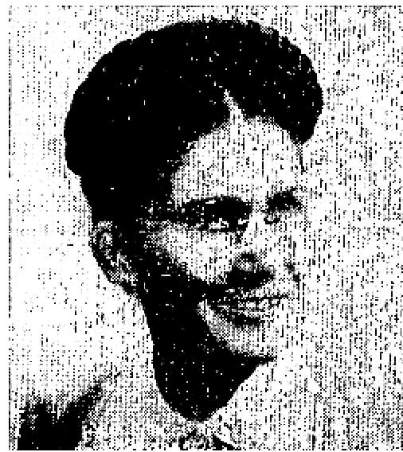
I am a minister of the Gospel and I want to tell you what the Lord did for me. In April, 1947, my health broke down and I was in bed for three months with a bad heart. The doctors said that there was no hope for me unless a higher power healed me.
I had to give up my mission in San Pedro, California, as I wasn't able to do any work. We moved to Farmington, N. M., in December, 1947, and I had another bad spell and was in bed a lot of the time.
On Sunday, January 14, 1951, 1 was in bed, feeling very bad and discouraged. I turned on the radio to see if I could get a church program to help me... and I got Rev. Jaggers. You will never know the blessing it was to hear the Word of God as he preached it. I felt the power of God go through me and it gave me a great
spiritual uplift. Then God spoke to me and said, "This is the man that is going to pray the prayer of faith for your healing." 1 could hardly wait to hear him each night. I wrote and told him about my heart trouble and also sent for a prayer cloth and the book "Everlasting Spiritual and Physical Health." The prayer cloth arrived on February 12th and I had my son place it between my shoulders. Sometime in the night while I slept, the Lord healed me, praise His name.
I woke up a new person and my heart pains were all gone. Before this I couldn't do a thing without becoming ill, and I would have to go to bed for a while. I worked all that morning doing my housework. The next day, Wednesday, I did three-weeks washing as well as a lot of other things. Praise God I am healed, and am doing everything that needs to be done around here, and am looking forward to the time when I can be in full time ministry for the Lord.
Evangelist Estle M. Chancy,
Farmington, New Mexico,
Box 142.
BLIND EYE OPENED
I am writing to tell you how happy I am that our little Danny can see again. He was hit with B.B. shot last November, and since that time he has been blind in his right eye. The eye specialist (Dr. McCoy of Springfield) told us he would never see again.
Rev. Jaggers prayed for him on his last night in Springfield, Illinois, and yesterday. Danny came home from school and said he could read large printed words. I have tested his eye and he, really can see. How I praise God for His miracles and wonder-working power. I hope this testimony will help others to have faith in the healing of our Lord.
Mrs. Floyd Leather
Williamsville, Ill.
VARICOSE VEIN HEALED

THE VOICE OF HEALING 1951  It is my pleasure to praise the Lord for healing me of a varicose vein on the ankle. It had been draining for three months and refused to heal. I attended the great Healing Convention at Kansas City, and the night Rev. Jaggers preached, he asked those to stand who were in pain. I was almost too uncomfortable to stand even for a few minutes. He prayed for us and before I reached my hotel that night the pain was gone. The ulcer healed from that hour, and in a few days was, completely well. Praise our wonderful Healer!  Mrs. Josephine Livernash,  Waxahachie, Texas. | 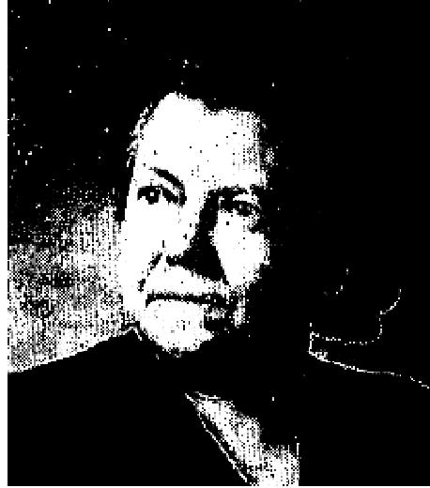

CANCER DROPS OUT
I received a prayer cloth for the healing of cancer and I am feeling fine and praising God for His wonderful healing. When I applied the prayer cloth according to instructions, the cancer dropped out, and there, was nothing left only a red place. Oh glory be to God!
Mrs. Ed Floyd,
Post, Texas.
June 1951 p 8
TEST CASE TUBERCULOSIS HEALED
I was suffering with T.B. in both lungs for two years. After being treated by many doctors, I found there was no help for me. 0ver $3,000 had been spent on streptomycin, but it did nothing and I grew worse. As time passed the disease got worse and continued to destroy my lungs. Finally I was taken to the country for it rest. While there a group of brethren called on me and spoke to me about the Lord. I accepted Him as my Saviour and purposed to serve Him.
When Evangelist Osborn came to Ponce last year, 1 was one of the many who were prayed for. I had heard the message of Divine Healing, 1 believed the promise and was healed instantly when Brother Osborn laid hands on me. To certify my healing, I had three doctors examine me and they confirmed the miracle. Also the Board of Health issued me a certificate of health and I am enclosing it with my testimony. I thank God for sending Brother Osborn to Ponce to preach the Gospel of Salvation for both soul ind body. I have enjoyed God's health in my soul as well as in my body for a Year now.
Oscar Marrero Perez.
Calle A 3 No. 58 Bda.
Borinquen, Ponce
Pastor and Witness:
Rev. Antonio Paunetto
Box 686, Ponce
June 1951 p 9
FATHER AND CHILD MIRACULOUSLY HEALED

THE VOICE OF HEALING 1951

"My little girl was born with a crippled right leg. When she would try to stand her leg would buckle under her, and she was never able to walk. But when I heard Brother Osborn's broadcast I put my child on the table by the radio and prayed, and God instantly healed her. From that day she learned to walk and has walked perfectly since and her legs are both perfectly normal.
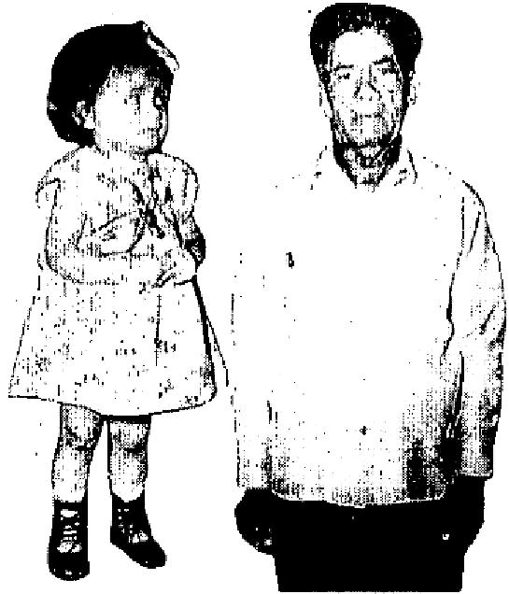
I am 78 years old and have been totally deaf for 25 years, have also been so near blind that I couldn't see anything more thin 2 feet front my eyes. I attended Brother Osborn's Campaign in Ponce and saw many wonderful miracles of healing. I had faith that God would heal me too, and when Brother Osborn prayed for all the blind, I was instantly healed. I can hear a watch tick from either ear and can read clearly now. My age did not keep me from being healed but the doctors said my condition was due to ‘old age’, but I am healed."'
Michael Toro, Tallaboa, P. R.

June 1951 p 11
PHOTOGRAPHIC PROOF - CROSSED EYES STRAIGHTENED AT JEFFREY’S MEETING
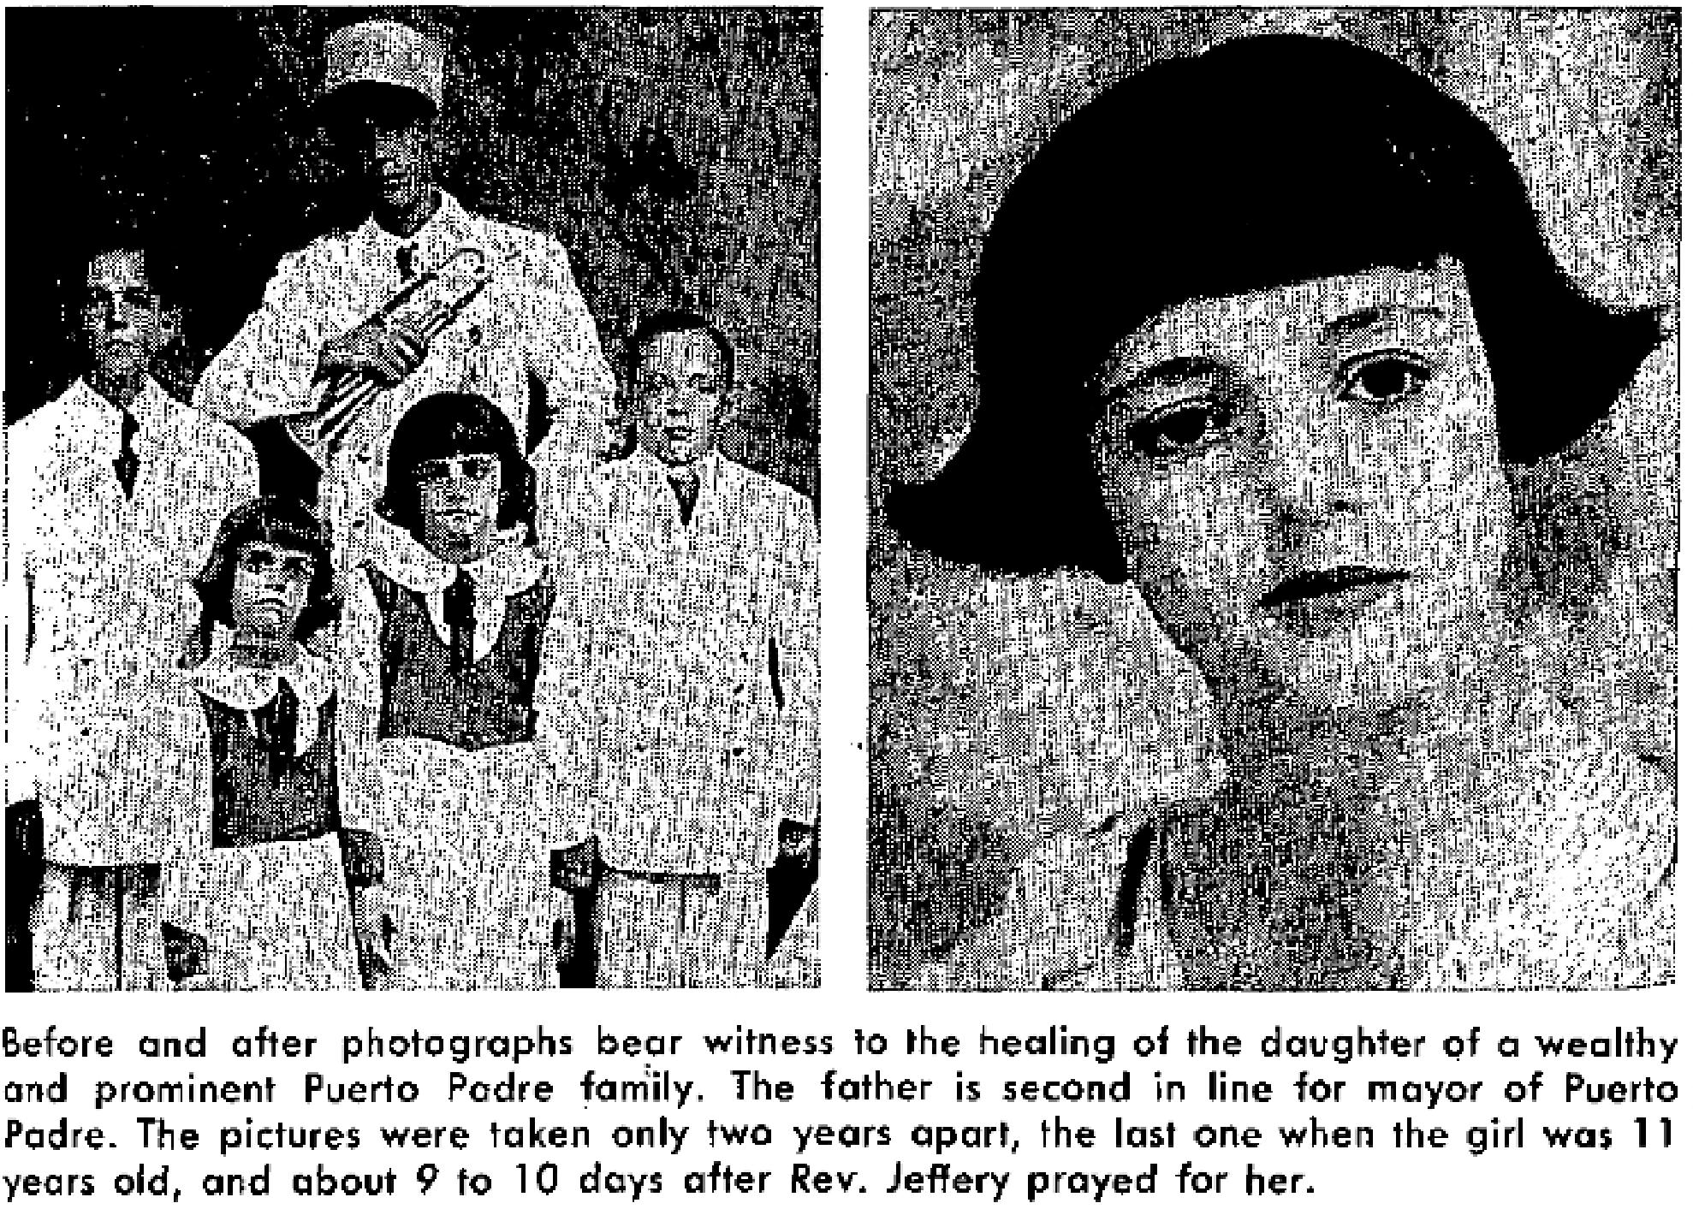
June 1951 p 13
Helpless Hand Healed - in Reesor Meeting
Excerpt from the Bridgetown, Barbados Advocate.

THE VOICE OF HEALING 1951
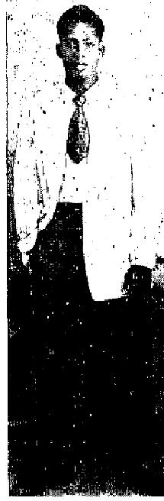 | "Harold Skeete of Roebuck Street, walked around for years with his hand in a sling. He was injured as a result of a truck accident seven years ago.  While the bones were not broken, the hand remained lifeless at his side. The only remedy was a nerve engraftment and he would have to go to tile States for this treatment. Skeete said that one of the preachers at the revival meeting in Queen's park prayed for him (Rev. Reesor) and told him to "believe that God will heal you." He felt a change in his body that he could not describe. When told to raise his hand he did so to his own amazement. Since then he has been able to move the hand about and he can feel if anything touches it."

June 1951 p 14
GREAT MIRACLES OCCUR IN THE McKAY MEETINGS
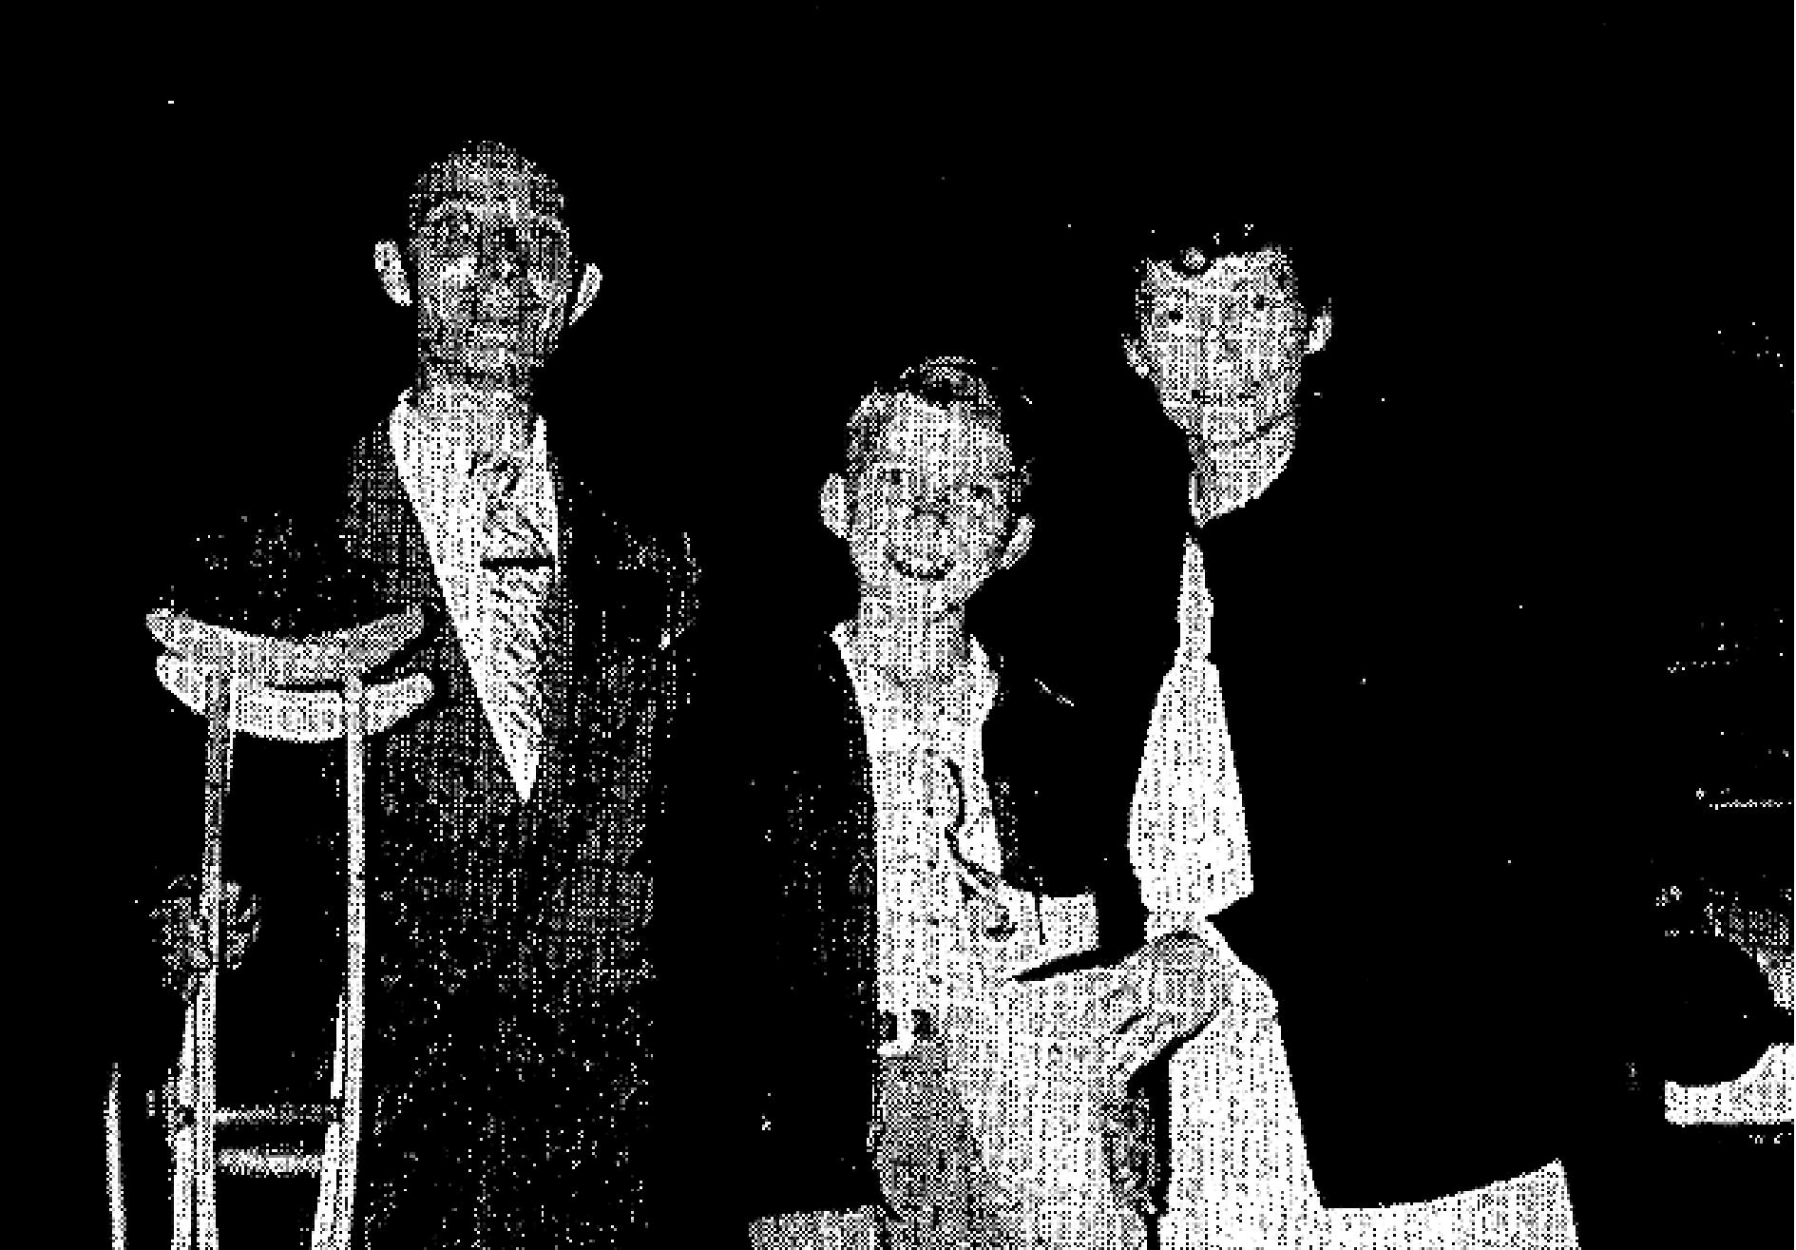
Rev. and Mrs. W. B. McCoy, with John Carey (center) who was healed of infantile paralysis.
In the photograph is John Carey of Dayton Beach, Florida. He not only suffered from the results of infantile paralysis but had a club foot. Now 11 years old, he has been in hospitals most of his life, and was never able to walk without it cast and crutches. He walks without either cast or crutches after being prayed for. Those interested in further information concerning this miracle can write Rev. W. B. McCoy, Box 1546, Orlando, Florida.
We have a report that the McKay revival in Jacksonville, Fla., in which 7 churches participated, was a wonderful success.

THE VOICE OF HEALING 1951
June 1951 p 15
Miracle of the Stone Blind Eye
(The following incident is of special interest because Mr. David Taylor is a business executive, and at the present time commands a large salary as a director of sales groups invarious parts of the nation. He has been a successful automobile dealer, president of the Kiwanis Club and the Chamber of Commerce in Darlington, West Virginia. Testimonies from men of this character are a stern rebuke to those who have challenged the fact that miracles take place today. The story of this miracle appeared in the Huntington, West Virginia, ADVERTIZER, and in the March 30th, 1950, edition of Charleston, West Virginia, GAZETTE. Mr. Taylor came to the Voice of Healing office and personally vouched for this testimony.)
Concerning this testimony of healing of my stone blind eye, I wish to say that these statements can be attested by some very prominent physicians and surgeons who examined me, both before and after healing of my eye.
For the record, I will say that my father was a Methodist minister and I had seen wonderful healings over a period of years, yet like some disciples and prophets of old, I discounted and limited the power of God. It took me forty-five years, and only after much worry and distress from a mental angle, to bring myself to a place where I would acquiesce to the simplicity of the teachings of Jesus Christ, and accept them by faith. There is a throne room in a man's heart and until such a time as he fills that room with the love of God, he feels very much out of order. Science has accomplished many wonderful things, but they never have been able to give a potent medicine for a broken heart. Only God can and will do that.
I was stricken with paralysis in my right eye while vacationing in California and after a period of many weeks without the sight of my right eye, and after many consultations and examinations with many renowned specialists who found nothing organically wrong, I was lying in a hospital waiting to be operated on the following morning, when I prayed aloud, "God, I refuse to limit Your power and I know further, that You are contemporary with our time, and. that You can do for me what Your Son did on the seashores of Galilee many centuries ago, by reason of Your being the same yesterday, today, and forever, and that Your Word is established in Heaven; therefore, if You will manifest Your healing power to me, and heal my eye. I will work in Your vineyard the rest of my days, as I know that over a period of years the Holy Spirit has been working with me relative to the plan that You have for my life."
I left the hospital the next morning before the operation, went home and enjoyed a delightful night's rest, and woke up the next morning perfectly healed. Some of the examining doctors were startled and amazed when they examined me after my healing. Dr. C. F. Lehenkering, physician and surgeon, of Darlington, W. Va., examined me before and after my illness.
In conclusion, I trust for any who might read this testimony, that it will tend to strengthen their faith, that they too, may be healed of their diseases, and infirmities through having implicit faith and confidence in God.
David V. Taylor
508 W. Malvern Avenue
Fullerton, California
July 1951 p 4
Stirring Results from Jack Coe Revival Under Mammoth Tent
AMBULANCE CASE DELIVERED
I had been suffering for 2 years, since May 12, 1949, with intestinal blocks caused from adhesions as the
result of an operation. Dr. Johnson of Bartlesville, Oklahoma sent me in an ambulance to Oklahoma City for
examination.. The University Hospital there sent me back home and said there was nothing that could be

THE VOICE OF HEALING 1951
done for I was brought in the ambulance to Brother Jack Coe's tent revival at Bartlesville and after being prayed for by Brother Coe. God healed me and I have been eating and working ever since.
Mrs. Cora Hadley
R. R. 3, Box 269
Bartlesville, Oklahoma
AMBULANCE DRIVER BEARS WITNESS TO HEALING
I want to testify that I took Mrs. Cora Hadley to the University Hospital in Oklahoma City, in an ambulance from the Moore Funeral Service, Bartlesville, Oklahoma. The doctors at the hospital there said they couldn't do anything for her, so I brought her back to her home.
Later, I drove her in the ambulance to the Jack Coe meeting here in Bartlesville. After Brother Coe prayed for her, she was able to walk to her seat in the audience. She was in every service after her healing and was walking and looked as though she had not been sick.
I saw a number of sick people that I had taken in the ambulance to the meeting, walk away, healed.

Chester W. Knight
Box 211,
Dewey, Okla.
CROSSED EYES HEALED
My son fell when he was 16 months old and the injury caused the left eye to be crossed. We had arrangements three times to have an operation. Dr. Johnson of Bartlesville, Oklahoma said that was the only way he could be able to see property again. We brought him to the meeting at Bartlesville. Brother Coe prayed for him, and Jesus healed him. His eyes are perfect.
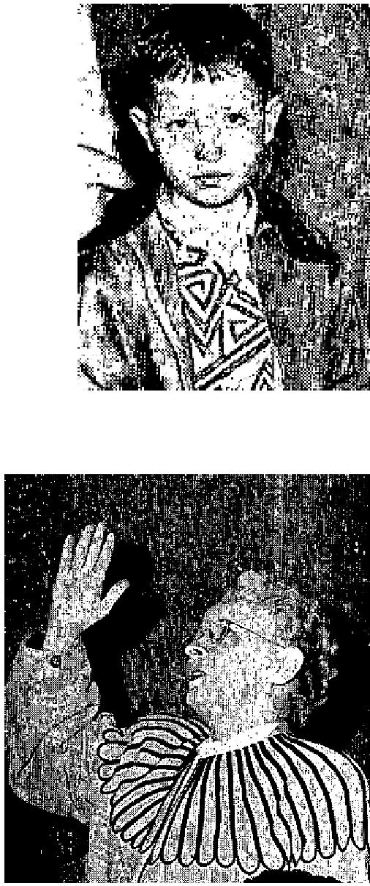
Mrs. C. E. Stiles
Box 312
Dewey, Oklahoma
CHRISTIAN SCIENCE PRACTITIONER CONVERTED AND HEALED I'm so happy about my great healing which I received in Rev. Jack Coe's revival in Tulsa, Oklahoma, seven months ago! I had the Smith Clinic of Independence, Kansas, and also Dr. Square of Coffeyville, Kansas, check me; they said I had cancer and diabetes. My mind also was affected so that my husband had to get a woman to watch me so I would not take my life. After prayer by Brother Coe, I was healed. I was then
sent back to Dr. Square, and he said the disease was gone. At that time, I only weighed about 100 pounds, now I weigh 130. I was a Christian Scientist for 26 years, and a practitioner 19 years. In Brother Coe's revival, I found I was not saved. I came home saved, filled with the Holy Ghost, and my body healed, for which I praise God. I am praying for Brother Coe and his work for Jesus.
Mrs. Ada Mowes
1620 N. Ninth
Independence, Kans.

(Ed. Note: We were happy to hear this remarkable testimony from the lips of Mrs. Mowes.)

THE VOICE OF HEALING 1951
PARALYSED AFTER OPERATION
I was operated on for appendicitis June, 1947 by Dr. Johnson, of Bartlesville, Oklahoma. I had been in bed since March 10, 1951. 1 was operated on a second time at the Washington County Hospital by Dr. Johnson, April 11, 1951. 1 was unable To walk until I was prayed for by Brother Coe in the Bartlesville meeting. I was brought to the meeting in an ambulance by Arnold Moore. I have been walking and praising God ever since.
Pearlie Atterberry
Ramona, Oklahoma

July 1951 p7
HERBERT E. CREEL, Chief of Police, ALTHA, Florida
The Chief of Police of ALTHA, Florida was brought to the Gayle Jackson meeting
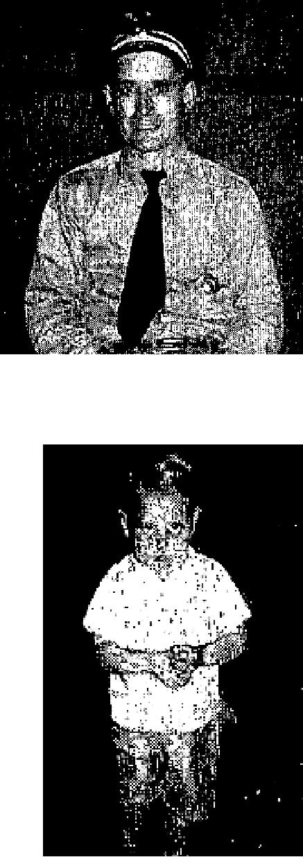
in Dothan, Alabama two years ago.
He had suffered with lock jaw for 14 months and 38 doctors had told him that there was no hope. After prayer, he was as healed instantly and has never had any ill effects since.
He posed for the accompanying photo in Tallahassee, Florida, where Brother Jackson recently closed a meeting.
BLUE BABY HEALED
When Brother Gayle Jackson was here two years ago, my 2.5-year-old baby was just barely alive. Several doctors told me that he would never walk. He had a hole in the upper partition of his heart, and instead of the blood passing to his lung, it passed back and forth. He was what is known as a "blue baby." The doctors also told me that he would eventually lose all use of himself as he grew larger. Furthermore, a heart specialist told me that if my baby received any help it would have to come from God, as there was nothing anyone else could do for him.
Thank God, Brother Jackson prayed for him and in less than two weeks time he was a normal little boy, running everywhere. I am thanking God for all of it.

Mrs. Alex Andrews
Pascagoula, Miss.
TEST CASE OF CANCER HEALING
I took this picture of Mrs. Sweatman of Biloxi, Mississippi, while I was in Pascagoula, Miss. She was healed of a terrible cancer two years ago in my meeting in Biloxi. Her testimony and picture have been carried in a previous issue of TVH. She has been completely healed now for two years. The cancer was on her nose, eating about half of the nose away, when she came for prayer two ago.
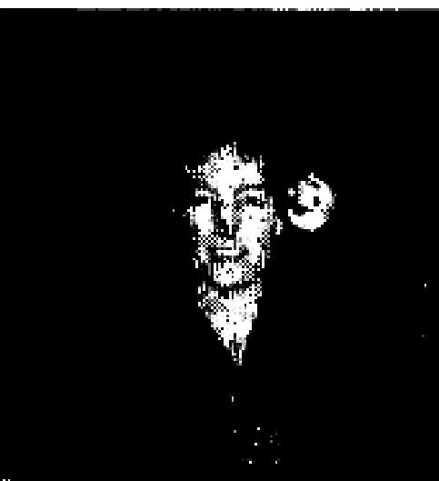
This picture taken of her a few weeks back shows she is still well ... perfectly well.
Rev. Gayle Jackson

(Occasionally TVH checks up on testimonies previously published. This is one example. The picture shows the scar where the cancer had been.)

THE VOICE OF HEALING 1951

CROOKED SPINE STRAIGHTENED
For some time I had suffered with a crooked spine ... the result of a light case of polio which I had about 4 years ago, and it didn't show up immediately. However, it left a paralysis in sonic of the muscles of my back
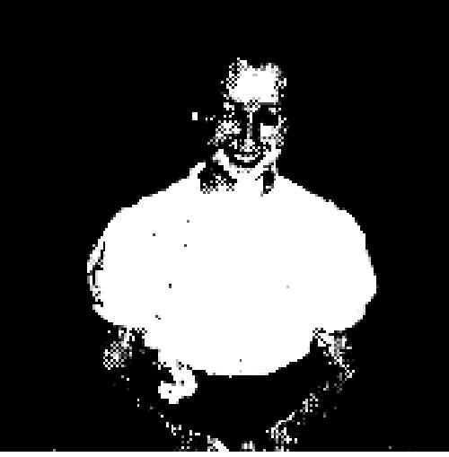
I first went through the healing line on Friday, April 27th. I received no relief, but attributed this to my lack of faith and understanding. I went through the line again a week later and asked Bro. Jackson to place his hand on my back as he prayed. As soon as he touched it, I felt my spine snap into place. I truly thank God for His healing power.
Betty Jean Core
1625 N. Branch Street
Tallahassee, Fla.

July 1951 p10
DOCUMENTED HEALINGS STOP OPPOSITION IN OSBORN CAMPAIGNS.
STATEMENT BY THE EDITORS OF TVH
These highly documented cases of healing, witnessed by physicians and clinics, were secured by T. L. Osborn in Puerto Rico. They represent healing from SERIOUS ORGANIC AILMENTS, and document the condition of the patient before and after deliverance. Great throngs up to 30,000 attended the T. L. Osborn meetings, and this resulted in an attempted persecution by the Catholic hierarchy. But so remarkable were the healings that Catholic doctors themselves, were willing to submit confirmation of the miracles. Because of the lack of space, photographs have to be greatly reduced, but the documents remain at TVH office for inspection by any persons interested.

ELEVEN-YEAR-OLD BOY HEALED OF BLINDNESS 1 am eleven years old and when 1 was two I had an infection in my left eye. My mother died and my father was very poor and also nearly blind, so he was not able to give me proper attention at the right time. As a result, I was later pronounced by two eye specialists, to be totally blind in my left eye.
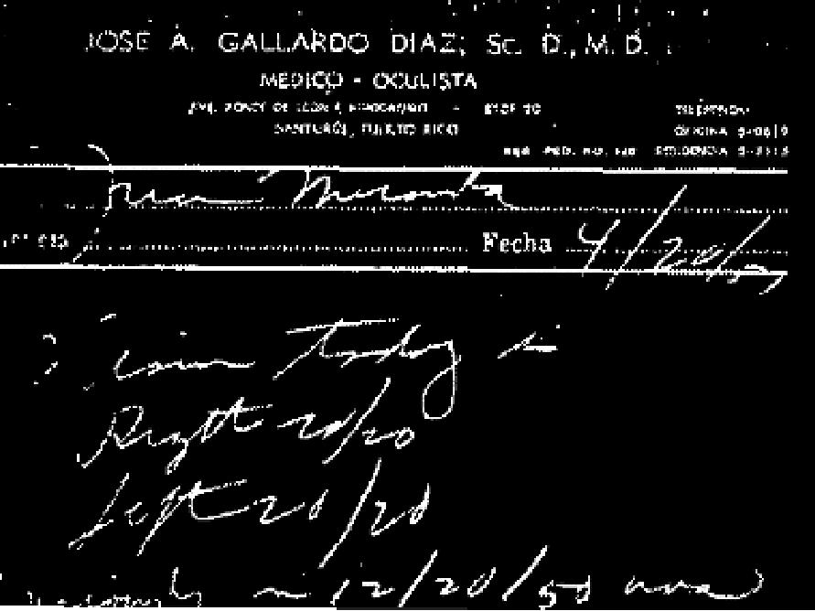
I waited four months for my turn to come to he operated on, an operation to divide the nerve. In the meantime I came to Brother Osborn's meetings and when Bro. Osborn told me to believe God's promise, I did, and my blind eye was opened and I can see good with it. I thank God for His love for me.
Miranda Concepcion
San Martin Kilometer 5
Box 322, Rio Piedras P. R.

THE VOICE OF HEALING 1951
LEG ULCERS HEALED
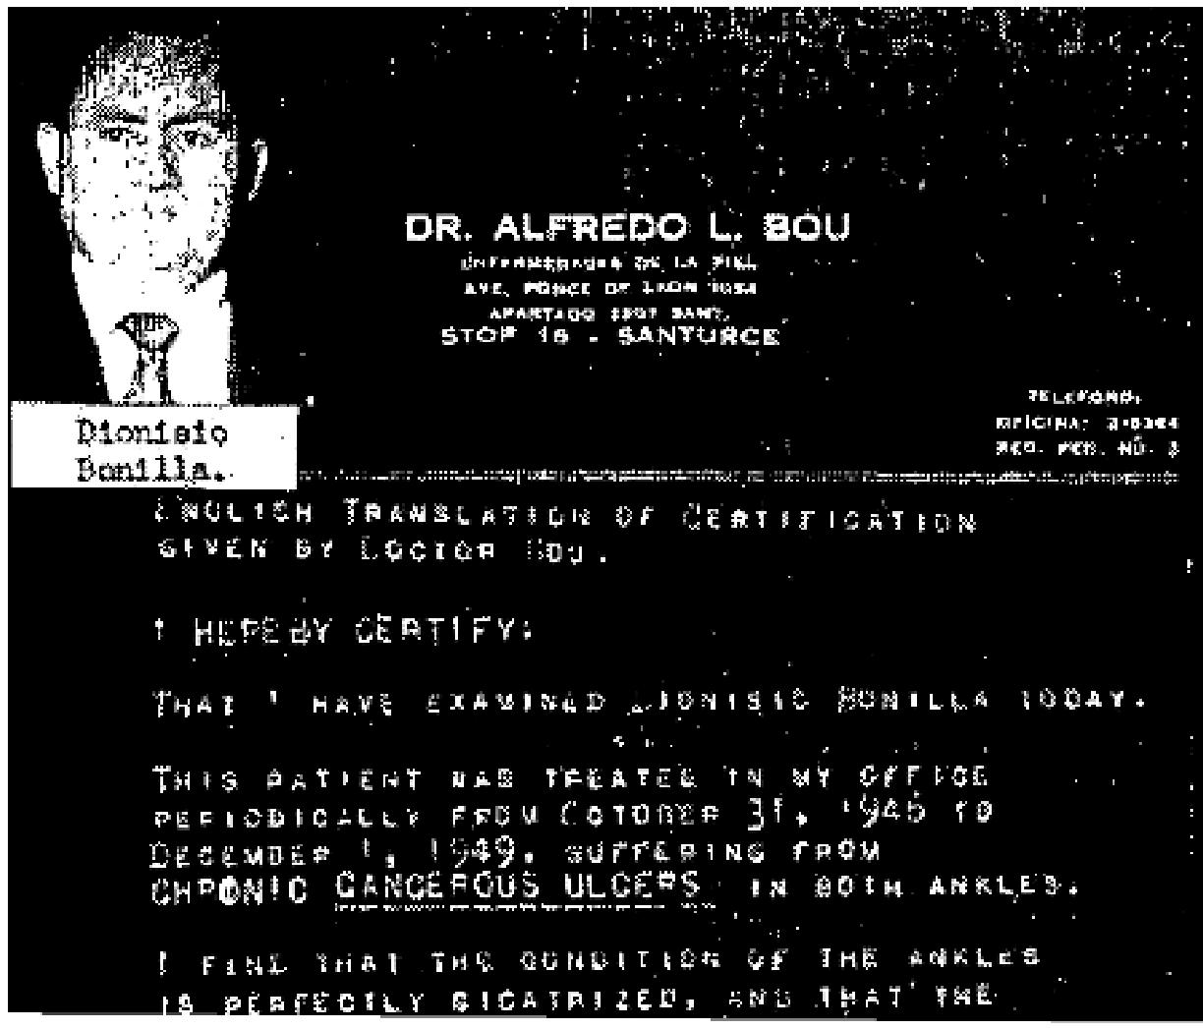
For a period of more than six years, I suffered front an infection in both legs. It was in the form of cancerous ulcers which covered the legs from the ankles up, and was continually draining. The pain was so terrible that I was almost unable to do anything, as I could not walk. During this whole period, I was treated
by many physicians and specialists of the skin, Dr, Bou being one of them, of Stop 16 in Ave, Ponce De Leon, Santurce, and the last one who treated me for about three years. My legs were getting worse every day. I decided not to continue spending my money without receiving any results, and I terminated my visits
to the specialist. A few months later, Evangelist Osborn came to the Island, to hold campaigns of Divine Healing. The first meeting held by Bro. Osborn was in our church, and I went into prayer line to be prayed for. Bro. Osborn prayed for me, and after that both of my legs began to dry until they cicatrized completely. Today I am perfectly healed! I was examined by the same specialist who had treated me for the past three years, and he declared me perfectly healed, and by written statement certified the same. Thanks to God for His miraculous power!
Dionisio Bonillia
803 Uropa
Santurce, Puerto Rico
I CERTIFY THAT the contents of this testimony are true, for I have been the pastor of Bro. Bonilla for about ten years, and I took him to the specialist, Dr. Bou.
Rev. Antonio Collazo  (Sup't. of the Church of God)  (Hdqtrs. at Cleveland, Tenn.)  CANCEROUS GLAND HEALED: DOCTOR'S TEST PROVES For more than a year, I had an inflamed gland above my left breast. I suffered much from it, and saw several doctors. Doctor Conde, the last physician who examined it, pronounced it cancerous, and advised me to go to the Cancer clinic for tests. I did not go, but instead, I attended Bro. Osborn's Healing Campaign in "Las Casas" Stadium. When Bro. Osborn prayed for the sick en masse, I laid my hand on the cancerous spot, and it instantly left. I returned to Dr. Conde the next day, and after he thoroughly examined it, he pronounced  me perfectly healed. He also issued a statement to that effect.  Gregoria Silva  J-K-11 #608  Puerto Nuevo, P.R., | 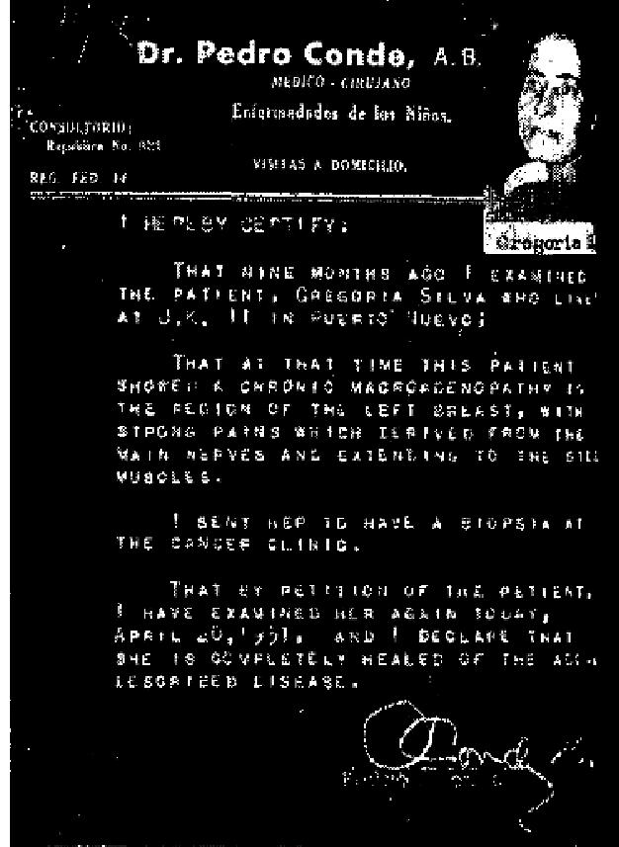

THE VOICE OF HEALING 1951
July 1951 p12
TESTIMONY OF MRS. MADELINE WARNER
I was born with a mole on the side of my face and up until 2 year ago, when I was 53, this mole never had bothered me. In the past year it became very painful and ugly looking and it was starting to grow very rapidly. I also had a burning sensation in my cheek and neck. I was advised by several physicians to have it removed as it was cancerous. I had trusted God for many years for my body and I did not want to submit to any medical treatment.
On January 12, 1951 as Brother Rudy Cerullo prayed for me, I felt the power of God surging through my body. Praise the Lord, He had begun the work. The cancer had already loosened around the edges. After coming home from the meeting, I began to pray and it was then that the Lord told me to believe Him, that He had started the work.
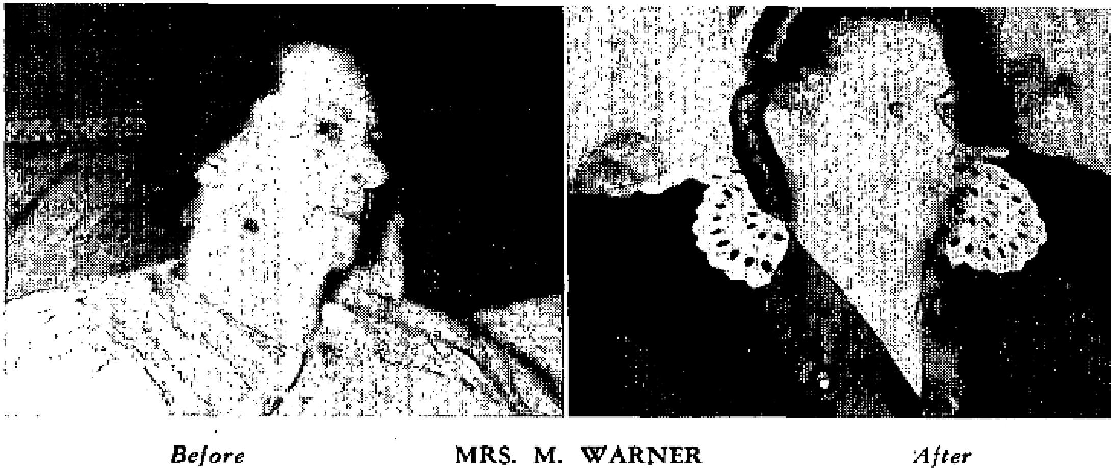
As I prepared for bed on February 3rd I felt something drop down on my dress collar. When I looked, a large piece of the cancerous mole fell off. A small piece was still there but 2 few nights later it too came off. The roots came out with both pieces, praise the Lord. It was truly a miracle. The roots were so imbedded in my face that it left small holes and now there is a small brown birthmark where the mole was. I took the cancer to the doctor a day or two later and he just looked at it for about five minutes. He said it was the first miracle he had ever seen. His mother-in-law asked him if it had ever happened before in medical history, and he said not that he knew of.
Before my healing, the mole protruded about one eighth inch from my face. Now that the cancer has fallen off, my face is smooth and all that is left to remind me of the affliction is the skin discoloration of the birthmark, I am praising God for my healing Truly it was done as only God can do it.
Signed:
Mrs. Madaline Warner,
2632 Emerald Street,
Philadelphia, Penna.
Witnesses:
Anna MacKrell, Sister; Elsie M. Beatty, "I saw it;” Mrs. L. Brown
Rev. Samuel A. Benson,
345 5 Frankford Avenue,

THE VOICE OF HEALING 1951  Philadelphia, Penna.  July 1951 p13  CRIPPLE INSTANTLY HEALED IN LITZMAN MEETING  About three years ago my son was afflicted with a terrible pain in his left hip and leg. He couldn't be moved one inch without suffering a great deal. We took him to the hospital and had him x-rayed and they found that he was suffering with a very rare disease, resulting in the gristle growing in between the joints and pressing the bones out of place. He was put to bed with weights on his foot and after he unhooked himself and got out of bed, the doctor put him in a cast. He still tried to move about on his good foot, causing his back to become crooked in the shape of an "S." His left hip grew worse until it was twice the size of the right one and he had to swing his leg around in order to walk.  When Brother Litzman prayed for him, the Lord instantly healed him and he was able to walk off the platform with only a slight limp. The healing power of God is stronger and greater than we can ever realize.  Mrs. H. L. Clarady  171.1 Margerate Drive  Houston 16, Texas | 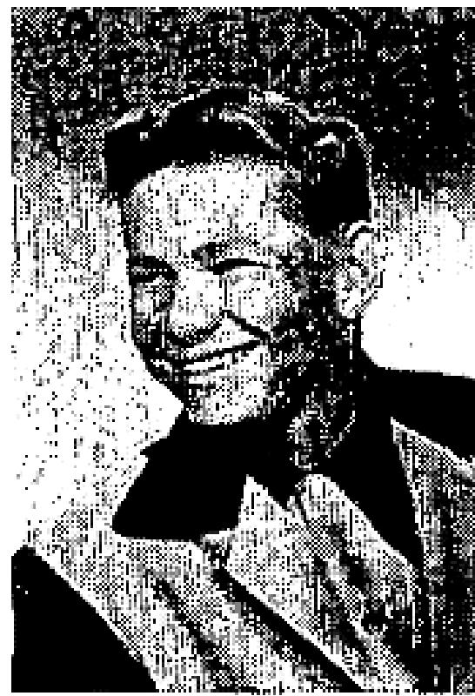

August 1951 p7
SIGNS, MIRACLES and WONDERS IN THE CAMPAIGNS OF TVH EVANGELISTS
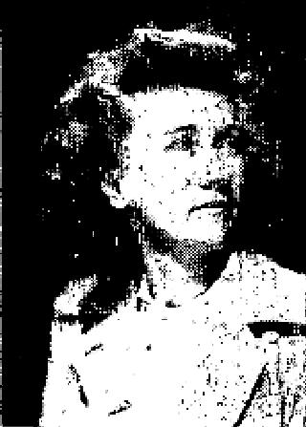
A. Tannenbaum -
NERVES HEALED
I had a sciatic nerve condition, and my right side, all the way down to my foot, pained constantly. I had both the services of a medical doctor and chiropractor, but the pains did not cease. Because of the unbearable pain when I tried to lie down, I had to sit up in bed to sleep at nights for three years, or more. I was also afflicted with a fallen Stomach and had to wear a special kind of belt made of leather and steel.
The first time I attended Brother Tannenbaum's meeting last October, 1950, in Holly Oak, Delaware, I went forward to the prayer line, and when Brother Tannenbaum prayed for me I was instantly healed -and that's not all, for my soul was also delivered from a life of sin. Sometime after this experience, I attended one of Oral Roberts' meetings in Philadelphia and there received the Baptism of the Holy Spirit. I can't praise God enough for what he has done for me and my family.
My husband's picture appeared in the January issue of TVH, along with his testimony of how he was marvelously delivered during Brother Tannenbaum's meeting from a blood disease he had from birth.
I was Catholic at the time of my healing and conversion, and never knew what it meant to he saved: didn't believe that a person could be saved and really know it. But when Brother Tannenbaum prayed for me I received such a wonderful experience I want to tell everyone about it. As the devil was cast out of my body. it came from the top of my head down to my feet and went down through the floor. I felt completely emptied out and my body like a shell an([ I knew then I was ready to accept Jesus to dwell in my body and soul. I now go to the Pentecostal Church at 8th and Lincoln in Chester, Pennsylvania, where Brother Albert Luzar is pastor.
Mrs. George Gascone

THE VOICE OF HEALING 1951
1102 Upland St.
Chester, Penna.
Velmer Gardner -
PERFECT VISION RESTORED
I praise God for healing my I I year old son. Two doctors had told me that he would always be blind in his right eye, since he had probably been that way from birth. But when Brother Gardner prayed for him May 30th, in the tent at Vernon, Texas, he instantly saw from this eye, and could actually count the fingers on my hand. His vision is now perfect.

Charlie E. Winters (father)
Box 314, Blair, Okla.
Signed by: Rev. W. W. Stephens (pastor)
Box 406, Blair, Okla.
William Branham -
HEALED OF CANCER
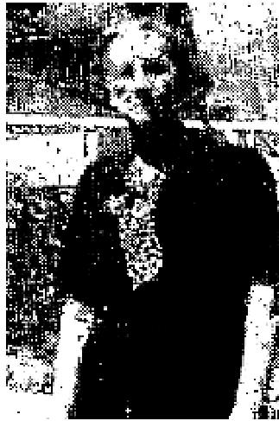
As I was sitting in a healing service during the Branham Healing Campaign in Kansas City, Kansas, in September, 1950, Brother Branham pointed me out to the audience and said that I had cancer. He also said, "if you will believe, you will be healed." I knew I was in ill health because I had been very weak
and was losing weight constantly. But I had no idea I had cancer. When he told me that I was healed, I accepted it with all my heart. I instantly experienced a strange choking which began in my throat and passed down into my abdomen. My stomach became rigid and bloated. After a few minutes the sensation gradually passed away. A great restfulness came over my entire body and I knew I was healed.
Mrs. Grace Boyd
1121 N. 36th St.
Kansas City, Kans.

Note from pastor; Since Mrs. Grace Boyd is a member of my Church, I have had ample opportunity to
observe her case and do attest that her testimony is true and accurate.
Rev. U. S. Grant
Full Gospel Tabernacle
Kansas City, Kansas

HEALED OF SUGAR DIABETES
I want to praise the Lord for healing me. The doctor told me I had incurable sugar diabetes and would have to take insulin the rest of my life. But when Brother Branham, Brother Lindsay, and Brother Hail were here in San Bernardino holding healing meetings in their big tent, I went through the prayer line, and was prayed for and was healed. I don't take insulin any more and can eat anything that I want. I am 71 years old and can truly testify to the healing power of God.
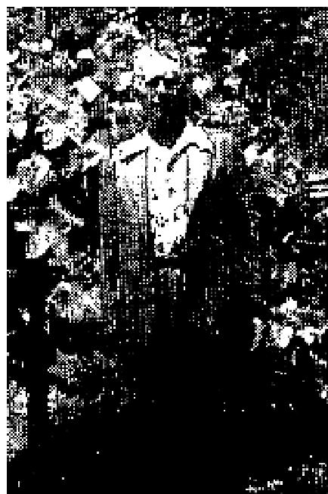
Adelbert Bechtel
748 Spruce St.
San Bernardino, Calif.
BACK TROUBLE HEALED

THE VOICE OF HEALING 1951
For quite some time, something had been wrong with my back, and for the last four or five months, I could not even bend over and straighten up without supporting my back with my hand. My ability to do my work had become very limited.
I attended the Branham healing campaign at Grants Pass, Oregon in May, 1951. As I sat in the meetings, and saw how the diseases of others were discerned and delivered, I knew it was real, but felt that I had done so little for the Lord that I was unworthy of healing.
I could only pray for a little fellow in a wheel chair afflicted with polio. About that time, Brother Branham called out my prayer card number. As I almost reached Brother Branham, he said "Don't come through this line unless you are going to believe, for something worse could come upon you." It frightened me for a second, but I refused to limit God's power and as I was prayed for, I received my complete healing. I am now lifting, stooping, and doing all my work without pain.
Mrs. Ada Lunsford
Box 473
Arcata, Calif.
Dale Hanson -  NORMAL BIRTH  I am praising the Lord for the miracle He performed in my baby's birth. About a month before the baby was born, the doctor told me that it would be a breech delivery. Since this is usually quite a hardship on both mother and baby, I asked Brother Dale Hanson to pray for me about ten days before the birth. When the time came, everything was perfectly normal. During his revival I was also healed of headaches and misplaced organs. The Lord is so wonderful. The St. Louis revival meant so much to me in every way.  Mrs. Mel Hargis  3502 Utah  St. Louis, Missouri | 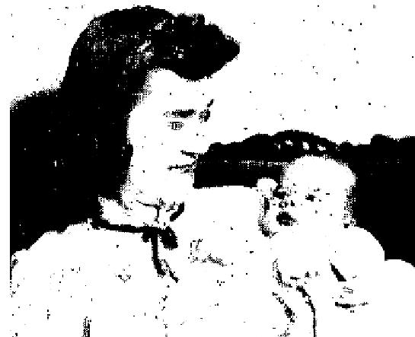

Warren Litzman -
CONFIRMED HEALING
I had been examined by several doctors for a sore in my throat that wouldn't heal, They wouldn't tell me for certain that it was cancer because I was so terribly nervous. I saw a doctor in Houston, and while there, attended Brother Warren Litzman's service and was prayed for one evening. The next morning I awoke, feeling deathly sick and I thought I was going to die ... but in a few minutes I began vomiting, and vomited up something white, about the size of a quarter. The next day I was examined by the doctor. He looked in my throat, and said there was a scar there, but it was completely healed.
I give all the praise and glory to my Lord and Savior.
Mrs. Pauline Brown
Houston, Texas
(Note. This healing took place over one year ago. Mrs. Brown is still praising God for complete
deliverance.)

THE VOICE OF HEALING 1951  August 1951 p 8  WOMAN PASSES CANCER AND NEW SPINE IS FORMED  During Rev. Erickson's campaign at Brightmoor Tabernacle in Detroit, Michigan, in December, 1950, I came to the Lord seeking complete healing from cancer of the spine and neuritis. I wore a large brace to hold my body upright, for the cancer had deteriorated my spinal column. As I was prayed for, the healing virtue of the Lord surged through me. I took off the brace and walked perfectly. Two days later I passed the cancer from my body. Then I found I had also been healed from neuritis, which had crippled and warped my body. | 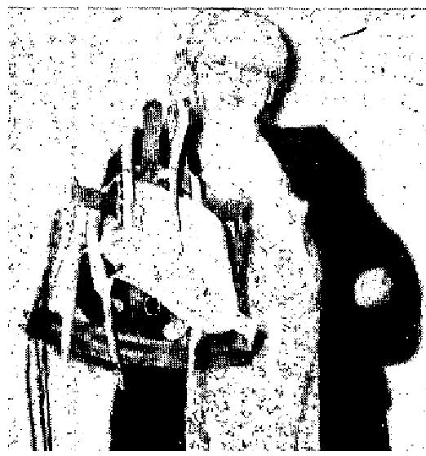

March 30, 1951, 1 went to Ann Arbor Hospital to have my three-month check-up. I underwent five checkups that day as five different doctors examined me and declared with amazement that it was a miracle. When Doctor Lamp (whose name I have permission to use) of the Deep Therapy Dept., examined me, he said, "This is a miracle. A new spinal column is growing in your back".
The man who had built my braces for six years said, "Praise the Lord, you've finally come to your senses and gone to Jesus the only physician chat can heal your sick body"
I'm still praising and thanking God for seeing fit to heal me.
Mrs. Della Mordriadge
15500 Iliad Ave.
Detroit 23, Mich.
(Note from Brother Erickson): Five months later in May, 1951, during our campaign at Berea Tabernacle in
Detroit, this lady came with this testimony. She is a member at Brightmoor Tabernacle.
August 1951 p9
THE RESULTS OF FAITH IN THE VINYARD HEALING CAMPAIGNS
SKIN CANCER GONE
I want to tell how the Lord met me in the Elmira, New York, tent meeting held by Richard Vinyard, I was afflicted with cancer three years ago, and had it removed. It was a skin cancer below my right eye, but it had begun to grow back. The doctor said that another operation would be necessary, but praise the Lord, I was healed one night at the Tent meeting. When Brother Vinyard asked those suffering from any disease in their body to lay their hand on that place and believe God, my healing took place right there. The cancer is gone, and can be verified by Dr. Burch of St. Joseph's Hospital, Elmira, N. Y.
Robert Thayer
1006 Lake Street
Elmira, N. Y.
HIP JOINT HEALED
This is our testimony of how God marvelously healed our daughter.
For five years she has been a patient in the Children's Hospital in Pittsburgh, Pa., with pertheas of the hip joint. At times her hips would be some better, but the same trouble would return time and time again.

THE VOICE OF HEALING 1951
On December 7, 1950, we were notified that we were to take her to the hospital to be operated on. It was recommended that a silver plate be inserted in the socket of her hip. My wife and I decided against this operation. We knew God could heal her so we would trust in Him.
On December 11th, we came to the Vinyard meetings in Mount Pleasant, Pa., and asked prayer for her. God answered and she was healed. January 5th we took her back to the hospital for an examination and the doctor pronounced her perfectly well. Whereupon, he discharged her from the hospital.
We sincerely thank God for His healing power.
Mr, and Mrs. Elroy Barrones
R.F.D.I
Scottdale, Pa.
GALLSTONES MELTED
For the past few years I have suffered with gall stones. In January, 1948 I started going to Doctor William Fowler of Kansas City. Every day for nearly seven months I would go to his office for two shots trying to get relief, build up my blood and gain weight.
At the July Christ Ambassadors' Rally, Brother Vinyard prayed for me. I had the faith that the Lord would heal me that night, and as I was prayed for I was slain under the power . . . on God's operating table. I definitely felt the crushing of those stones within me. Before this time I had to take a pill before and after each meal and at bed time. But from that night until this day, I've never taken another one, and I can eat anything and have gained twenty-five pounds. All the praise belongs to God, our Healer.
Yvonne Morris
24 Hiway and Allen
Independence, Missouri
August 1951 p10  JACK COE REVIVAL IN MAMMOTH  HEART LEAKAGE STOPPED  I was born with leakage of the heart. For almost all of my sixteen years I had been under the care of two physicians - Drs. Richard and William Lay. Most of my time was spent in bed and I could not participate in any amount of physical exercise. I was prayed for by Brother Jack Coe in the Bartlesville, Oklahoma revival and was instantly healed. Since then I have been able to walk distances, and can truthfully say chat I've never felt better in my life.  Elsie Holden  72() W. 6th St,  Pawhuska, Okla. | 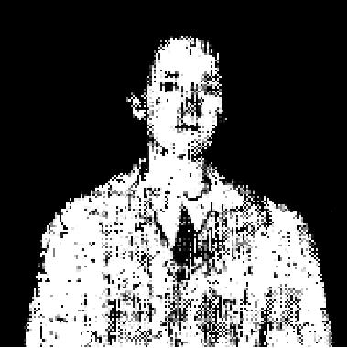

THE VOICE OF HEALING 1951
ABSCESSED EAR HEALED
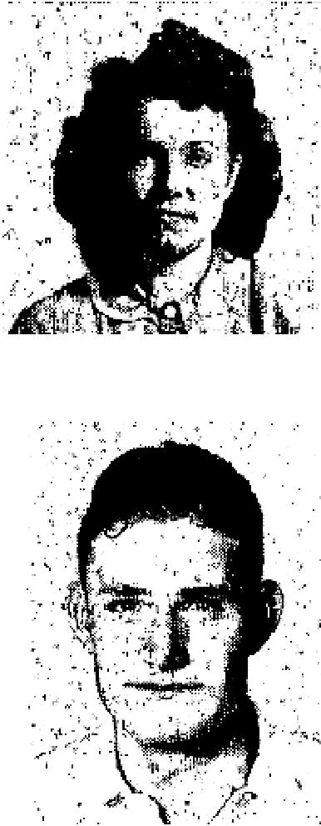
I was under treatment of Dr. Pittman, of Bartlesville, Okla., for deafness in my left ear
caused by abscess. Since Brother Coe prayed for me in the Bartlesville revival, I have
been able to hear perfectly. I praise God for my healing.
Maxine Tate
114 1/2 S. Virginia
Bartlesville, Okla.
CROSSED EYES STRAIGHTENED
I had crossed eyes all my life and had worn very thick glasses since I was six years old. These glasses were very noticeable and were not doing my eyes any good, for if I removed them, my eyes crossed in toward my nose. I was prayed for in Brother Coe's revival here and removed my glasses at that time,
My eyes have been straight ever since.
Daniel Turner
906 Avenue D
Lubbock, Texas

August 1951 p11
CANCER CURED
I praise God for healing me of cancer. In January, 1950 1 had, it removed from my hand and took a radium treatment. Then in July, it came on my arm, and I had to have it removed again. I was advised to go to various cancer doctors, Finally, in July, I decided to go to the Hoxsey Cancer Clinic in Dallas. We had heard they were curing cancers over there.

They examined me and said I might have a 20% chance if I took their medicine. I went back each month for a check-up and more medicine. Nevertheless, the cancer kept getting worse. In another three months, I could scarcely move out of bed - no medicine would ease the pain.
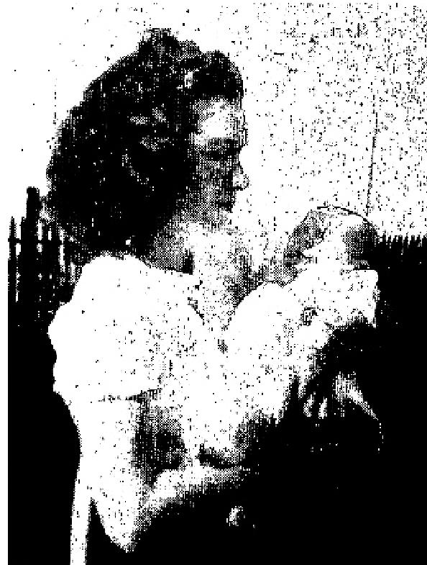
Then Brother Coe came to town. A friend called and told us about Brother Coe, and of the wonderful things being done through him. I got up from bed, and my parents took me to the meeting. I went several nights before I was prayed for; then God reached down and healed my sick body. The pain is gone, and I feel wonderful - Oh, praise the Lord for His wonderful love and mercy!
In April of this year, my little girl was born, in perfect condition thanks be to the Lord! The doctors didn't think I would ever live through childbirth - but God undertook.

My husband, children and I will always thank God for the wonderful things, He has done for us.
Mrs. Pauline Young
Rt. 6, Box 125
Texarkana, Texas
CATARRH OF STOMACH HEALED
I want to give a word of testimony for God's glory. During Rev. Stanley Karol's healing campaign in New York City, I received salvation and healing for my body. I had catarrh of the stomach for 10 years and suffered very much. I went to many doctors but received no help, however, when Brother Karol placed his

THE VOICE OF HEALING 1951
hands upon me and prayed for me, I was instantly healed! Today my stomach is well, and I am no longer in pain and discomfort.
K. Nalesnik
269 E. 10th St.,
New York City
HEALED OF BLADDER TROUBLE
For some time I had been suffering intense pain from a bladder condition but when I was anointed and prayed for by Brother Karol, the Lord graciously touched me, and I was made whole. Today, 1 can say that I am healed. I give all the praise to the Lord!
Mrs. L. Wrzesniwski
13th Street
Linden, N. J.
CANCER FALLS OFF
Some months ago, I bruised my arm quite severely. This later turned into a cancer about the size of a quarter. I went to the doctors and also to the hospital for treatments - nothing seemed to help at all. Then I went to be prayed for by Brother Karol, and Jesus miraculously healed me of the cancer.
The next day, after I had been prayed for, while raising my hand to hang clothes on the line, the cancer fell off on the ground. I reported to the hospital for a checkup and the four doctors who examined me were amazed at what had taken place. They tried to accuse me of tearing the cancer out, but I told them that God had healed me! Praise God for His healing power!
Mrs. Mary Slachca
4724 N. Franklin St.,
Philadelphia 20, Penn.
ARTHRITIS PAINS EASED
For a number of years, I had been troubled with arthritis of the back. The pains were so severe, that every
afternoon I was compelled to lie down and rest.
I attended Brother Karol's meeting, and in faith believing, I entered the healing line, knowing that all things are possible to them that believe. From the moment Brother Karol prayed for me, the pains left, and since then I have been feeling well and happy!
Bertha Barodzin
516 East 13th Street
New York City
August 1951 p12
CRIPPLE FOR SEVENTEEN YEARS HEALED
I was healed the minute Brother Valdez prayed for me, on Sunday, February 11, 1951.
I had been a cripple for seventeen years, and suffered from my head, eyes, back, legs, and hands. Thanks be to God, my pains are all gone!
Mrs. Catherine Cruz Boskie
1567 Wailele St.,
Honolulu, T. H.

THE VOICE OF HEALING 1951
CAN SMILE NOW
For twenty-nine years, I had never been able to smile or laugh. I was born that way. On February 14th, Jesus healed me. When Brother Valdez prayed for me, a strange feeling came over my face. My mouth felt soft and relaxed, and I felt myself smiling. When I got home, I looked into the mirror and saw myself smiling for the first time in my life! I was overjoyed and so was my husband. I would stand before the mirror and smile and then cry for happiness. I surely do thank the Lord!
Mrs. Eleanor Eli  2270 Kaululaau St,  Honolulu, T. H.  DIABETIC BLINDNESS HEALED  During the Valdez healing meeting in Hammond, Indiana, Mrs. Carrie Saulesbury was prayed for. She had been blind for two years, because of a diabetic condition chat had caused a film to form over her eyes.  She said, "When Brother Valdez laid his hands on me, it seemed there was a warm feeling came over me, and when he cold me to open my eyes, it seemed as though they were glued fast - and then all at once, they came loose, and I have been able to see ever since." | 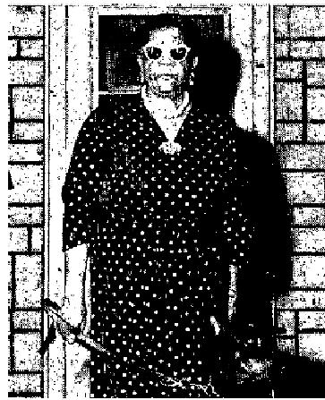

Speaking of the seeing eye dog, which faithfully led her around during her blindness, she said, "Many times as I have been petting and brushing my dog, Lackie, I'd say to myself, “how I wish I could see what he looks like as he has been such a help and blessing to me” and now, just think, I have the privilege of seeing him. I can now do my own work and go to town by myself.
When Mr. Saulesbury came home from work on Wednesday evening, the night after his wife had been prayed for), he found his wife sewing - she had even threaded her own needle!
Signed: Pastor V. J. Cox
1010 Bauer Street
Hammond, Indiana
CLUB FOOT HEALED
Our daughter was born with a club foot, but Brother Valdez prayed for her and now she is all right. Jesus
healed her!
Mary Kiko
1215 Kanoelani Road
Honolulu, T. H.
August 1951 p14
GAINS 36 POUNDS IN 6 MONTHS

THE VOICE OF HEALING 1951
This testimony is sent to us by Evangelist Gayle Jackson. He states that Curtiss Boykin of 3628 Bienville Street. New Orleans, Louisiana, is perfectly well after being prayed for last year in the New Orleans meeting. Mr. Boykin is now attending meetings and acted as usher for the recent Jackson Revival in
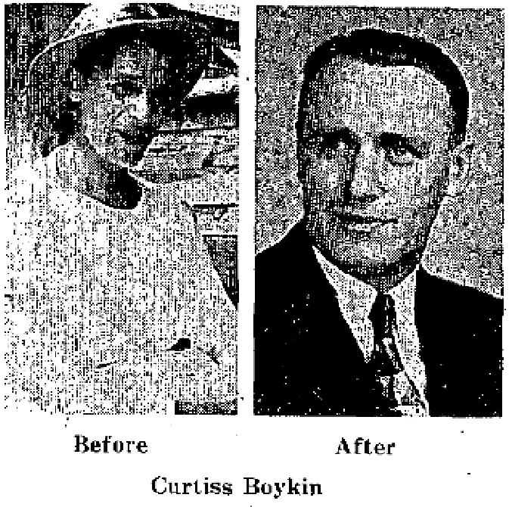
New Orleans. He was healed of cancer of the bladder and weighed 119 pounds it the time he was prayed for. Six months later the second picture was taken and his weight was 155 pounds. Of this later picture, Mr. Boykin writes: "Taken six months after I was prayed for. Praise God, I was healed by our Saviour, Jesus Christ. The Doctor could find no trace of cancer." The doctor had previously given him only two years to live. He had a powerful effect an the crowds at this year's New Orleans Meeting because of his wonderful
testimony.
TIME CONFIRMS HEALING OF BLIND EYE
Mrs. Tierney was prayed for a year ago in Brother Gayle Jackson's New Orleans Revival. She was totally blind in one eye, and central vision lacking in the ocher. Also, it was rapidly going totally blind. This year, she is attending Brother Jackson's Revival without needing any help, and has good eyesight.
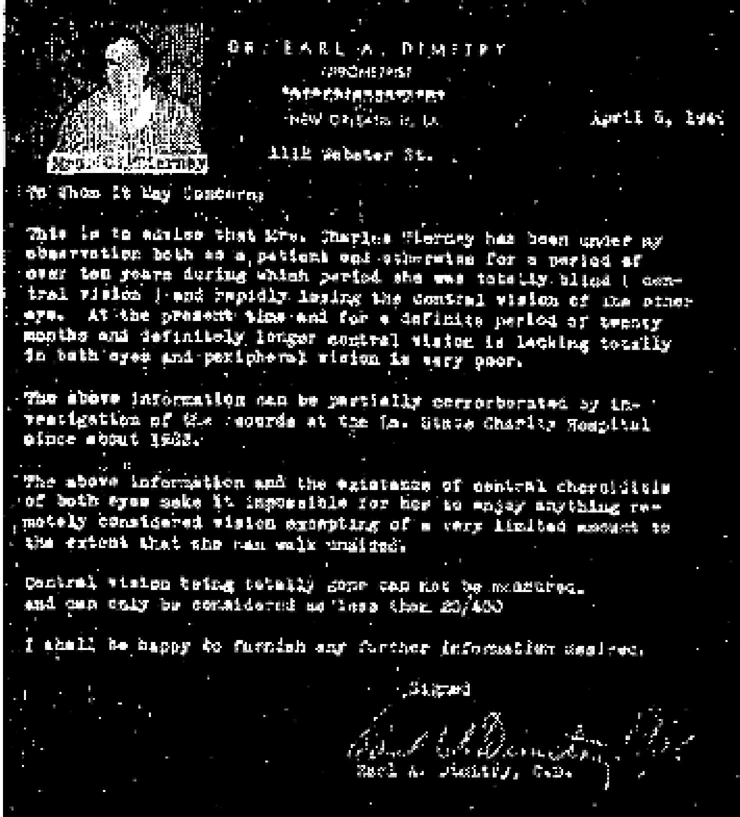
WEEPING ECZEMA HEALED
After we had taken our baby daughter, Brenda Diane Penton to eleven different doctors, most of them baby specialists, trying to get her Cured Of Weeping Eczema, and had spent over $2,000, she still was not well.

THE VOICE OF HEALING 1951
We brought her to Brother Gayle Jackson and he told us to believe as he prayed. After he prayed for her, she began to get well at once, and is now perfectly well. We give all the glory to God!  We are enclosing two pictures of her, one showing her before Brother Jackson prayed for her, and the other after the Lord healed her,  Mrs. Orza Penton  589 E. Line Street  Pascagoula. Miss,  P.S. - This healing is now two years old. I personally examined the child only last week. She is perfectly well. Gayle Jackson | 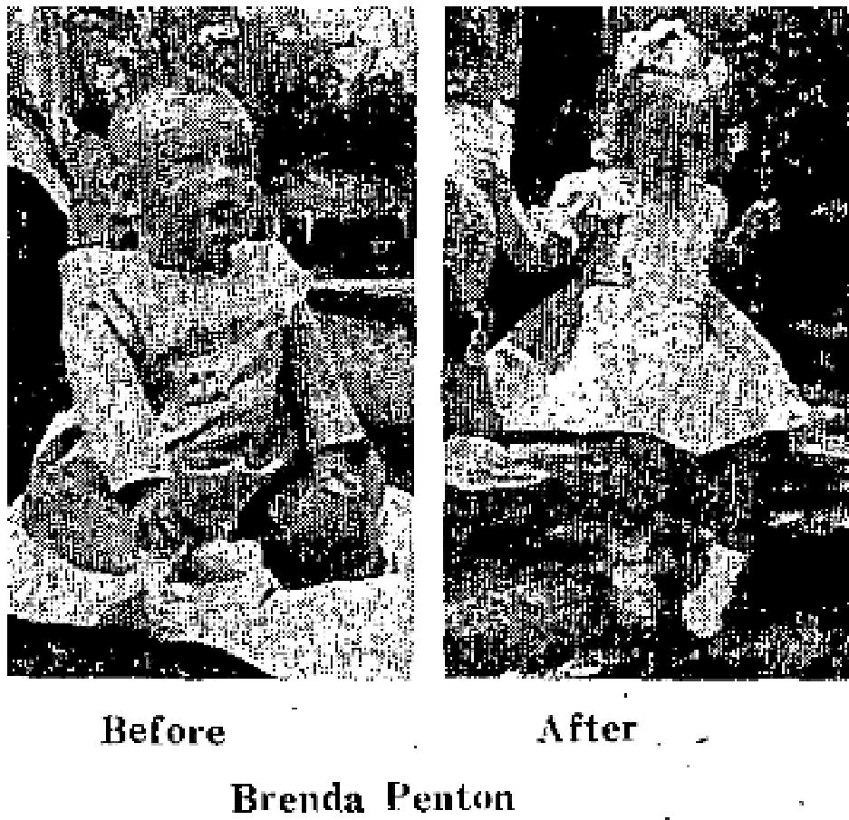

Note stiff tubes am each arm in "before" picture. (To keep child from touching face.)
HEALED OF RUPTURE AFTER 40 YEARS
I'm sending my testimony in praise to God for what He did for me (luring the Gayle Jackson Revival in Tallahassee. I had a rupture for 40 years, but God healed me. Thank God, I no longer have to wear a truss. I work hard every day and have never felt better.
John A. Thaxton
R. R. 6 Box 43A
Tallahassee, Fla.
August 1951 p16
CANCER DISCERNED AND MIRACULOUSLY HEALED
Before being healed in the Paul Cain Revival at Calvary Temple, Los Angeles, I had spent a small fortune
on doctors at Mayo Clinic, and, many others.
As I came before Brother Cain in the healing line, he said, "Sister, you are suffering from stomach cancer." I replied, "That's right." He then laid hands on me and bound the demon in Jesus' name. Suddenly he said, "The work is done - the cancer is dead, go home and spit up this cancer, in Jesus' name." At 2:00 A.M. that following Thursday morning, I became sick and when I opened my mouth, the cancer growth rotted out. I took it back to the Cain Revival in a bottle of alcohol.
My pastor will confirm this testimony, Praise the Lord for deliverance!
Mrs. Rosalie Insalco
704 S. Colombus
Glendale, Calif.
September 1951 p 2
OUTSTANDING MIRACLE STANDS THE TEST OF TIME
Twin City Girl, 11, Regains Hearing
By BILL KEARNS

THE VOICE OF HEALING 1951
(Times Staff Writer)
One day last month an ear specialist shook his head sadly and told Mary Ruth Gist of East Chicago, that she would never hear again without artificial aids.
But that was last month. Today the 11 year-old East Chicago girl is no longer wearing an ear plug and her hearing is 85 per cent restored. Mary Ruth and her happy mother, Mrs. Wilma Gist of 4722 Alexander, insist that the minor miracle was ordered on Divine authority. The story they tell is this: Mary Ruth first started showing signs of deafness at 11 months of age. The older she became the less she could hear.
It reached a point last January where Mary Ruth was almost totally deaf. Normally a good student, her school work fell off. Her instructors told the family that something should be done. No cure appeared in sight and doctor after doctor recommended the use of hearing aids. The specialist agreed. He told Mrs. Gist her daughter's hearing would grow progressively worse as she grew older. Then one day recently Rev. Melvin Planck told Mrs. Gist she should bring the girl to a Divine healing campaign underway at the Assembly of God Church at 4863 Magoun. Rev. Philip N. Green of Tampa, Fla., formerly of 4522 Towle , Hammond, was directing the healing services. His cure was simple, he told Mary Ruth.
All she would have to do is pray with him and have faith in God. The next day Mary Ruth went to classes at the Holy Trinity School in East Chicago without the hearing aid.
The ear specialist is still shaking his head, only now he's puzzled and not sad. But it's no mystery to Mary Ruth and her mother. It's a thing they call faith in God.

MARY RUTH GIST, 11-year-old East Chicago girl, smiles happily with Rev. Phillip N. Green, former Hammond man whom she gives credit for healing her deafness. The child, daughter of Mr. and Mrs. Carl Gist of 4722 Alexander, prayed with the conductor of "divine healing campaigns." The next day her hearing was restored. Her family says Mary Ruth was practically stone deaf for 10 months before the prayer meeting with Rev. Green.
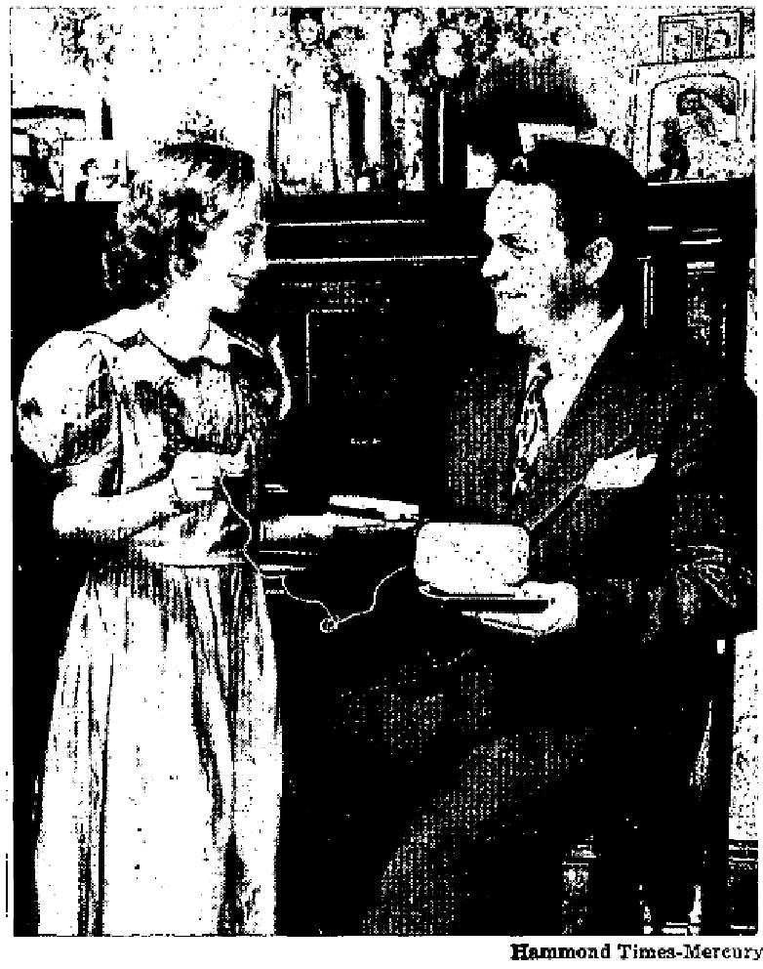
(Editor's Note: The above feature is as it appeared in the HAMMOND TIMES, November 19, 1950. Mary Ruth Gist had become stone deal in one car and almost completely deal in the right car. The Lions Club and Crippled Children's Association were authorized to furnish a hearing aid. Dr. Edward Sosson reported that hearing was so far gone that the aid would do no good. The healing has stood good and has been certified to by repeated examinations of the doctors. In January 1951, Dr. Stanley Zallen of East Chicago, India looked into the child's ears and found two sets of eardrums - new ones grown beside the old!)

CERTIFICATION I, the child's mother, certify to the actual details in the account of my child's healing,
and give thanks so God for it.
Signed: Mrs. C. M. Gist
I, Melvin Planck, as pastor of The church at the time of this girl's healing, having been present at the moment she was healed, and having contact with the family over the months since the healing, certify that the details of this Testimony are accurate, and that the girl still enjoys perfect healing months after the healing look place in my church.
Signed: Rev. Melvin Planck

THE VOICE OF HEALING 1951
September 1951 p 3
MIRACLE IN OGILVIE MEETING STANDS AFTER TWO YEARS
In Chowchilla, California, April 17, 1948, God marvelously, healed my eyes, from an injury existing since birth. I was handicapped in school, since I could not see over four feet without heavy-lensed glasses. My studies became such a strain that during my freshman year in high school I could hardly continue. Doctors even suggested removing the eye in order to see what was blocking the vision.
We heard of Brother Ogilvie's meetings and I went and was prayed for. I took off my glasses expecting God to heal me. I felt something warm go over my head. When I opened my eyes, I could plainly see the back of the church.  The following morning, I arose to discover I could not see except to distinguish a little light. I knew that the devil was trying to take my healing, but I was confident that God had done the work I was prayed for again after church, and I felt something leave my eye. My mother asked what that was on my left cheek. They examined it and found it was the cataract. it was the size of my little fingernail, white with black streaks running through it. | 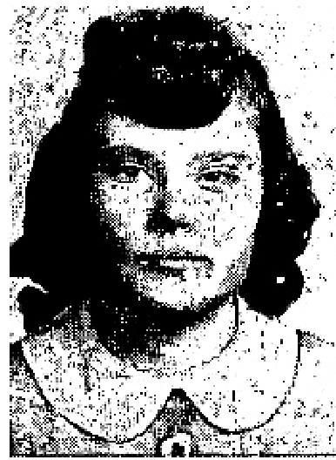

The following Tuesday, I started back to school. It was wonderful to see so well, without those heavy glasses. The teachers marvelled at my being able to see so well, because they knew my previous condition. I read a chart for one teacher, and her eyes filled with tears. She said she knew God could heal.
I was sixteen at the time of my healing. Now I am going on nineteen, and in), eyes are still healed. A doctor has never touched my eyes, nor have I had on glasses since that time. My Sunday School and Children's work require a great deal of studying and drawing, but my eyes never become strained or tired. We are still rejoicing in the miracle God performed.
Shirley Hydock
339 South Broadway
Turlock, Calif.
CURRENT REPORT OF HEALING IN 1949 BRANHAM CAMPAIGN
I was healed in Brother Branham's meeting in 1949, in Fort Wayne, Indiana. I had a bone disease, which was causing extra bones to grow throughout my entire body. This caused me untold suffering. I had several of the bones removed by operations, and I had 200 stitches in my body. The doctor had told me that I would never be able to live a normal life as these extra bones were growing on my spine, which was causing damage to the nerves. He said the only thing they could do for me was to put a steel brace on my back, (which I would have to wear the rest of my life) and operate on my leg, which would necessitate my wearing a cast and a brace for two years.
After the doctors had told me what my future life would be, my only hope was to get in the prayer line at the Branham Healing Meeting, while he was in Fort Wayne. It was on April 6, 1949 that God miraculously healed my body and for the first time in my life, I was able to bend over and touch the floor, bend my knees like a normal person and the pain I had had for years left instantly.
We have now moved to a 43 acre farm, and I thank God that I am able to take care of my house and other duties around the farm, while my husband works in town.
I thank God for Jesus Christ, the same yesterday, today, and forever.
Mrs. Sam Eichhorn

THE VOICE OF HEALING 1951
Rural Route 2
Ossian, Indiana
September 1951 p 7
SIGNS - MIRACLES - WONDERS IN THE CAMPAIGNS OF TVH EVANGELISTS

R. W. Holmes-
PARALYZED ARM RESTORED
I want to give my testimony of the wonderful healing power of God. My little grandson, who is two and a half years old, was paralyzed in his right side and was dumb from birth. He could not speak a word until Brother B. W. Holmes prayed for him in the Paris, Texas meeting. That night, after he had been prayed for, he spoke one or two words and began to use his little paralyzed arm. At this time, he is using his arm and hand in his play and is talking a lot.
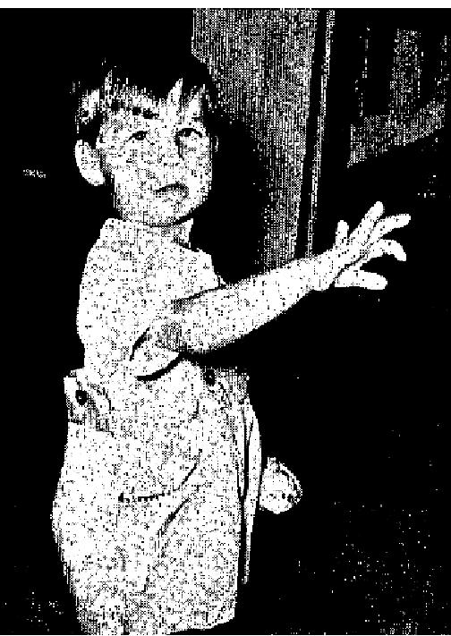
Praise God for what He has done! May this testimony help other suffering souls trust God for their healing.
Mrs. Rhodie Chappell
P. 0. Box 452
Brookston, Texas

I have known Bobby Skatts from birth as both his mother and grandmother attend my church. I know that he was both paralyzed and dumb from birth and I witnessed his healing.
When Brother R. W. Holmes laid hands on him and prayed for him, the Lord instantly healed him and he
began to use his hand and speak a little that night. He is now talking well and is no longer paralyzed in any
way. Praise God for His healing power!
Rev. C. G. Nichols
1608 W. Houston St.,
Paris, Texas
G. O. Baker-
BEDFAST WOMAN HEALED
In the month of April, 1951, MY son and daughter-in-law practically carried me into the church during the Baker Salvation-Healing Revival. I had been bedfast for three months, but God instantly healed me when Brother Baker prayed for me and I got up and walked out of the church and have been well ever since. Mrs. Bates, Stillwater, Okla.
James Reesor-
STOMACH HEALED
I was born with my stomach upside down, a condition that surgery could not correct. I could not keep food
in my stomach. I lived on food pills and prayers. Recently my heart had expanded so much that the muscles
and nerves had broken.
Two years ago I was operated on and twelve inches of my intestines were removed, leaving my bowels paralyzed, and my intestines inflamed with sores. Also, I have had leukemia - my blood pressure was never normal. Doctors could not understand how I lived, and just recently they told me I had no more than three months to live.

THE VOICE OF HEALING 1951
On March 20 and 21st, Brother Reesor held a healing meeting at the Church of God, which I attended. On the first night of the meeting, I was prayed for by Brother Reesor. I still suffered pain on the 21st ... so I was again prayed for on the second night.
The next day, I felt led to go see my family doctor, and asked him to fluoroscope me. I told him I was sure my stomach was back where it should be, as I knew the Lord had healed me!
The doctor said it was impossible ... that only a miracle could do that. He almost fainted, when he looked through the fluoroscope and saw my stomach turned the right way . . . he could scarcely believe what he saw. My blood pressure was up to normal and the heart test showed my heart to be perfect.
I thanked God for such a wonderful healing, and for a precious man of God like Brother Reesor.
I trust this testimony will inspire others and he in encouragement for many to have faith for their healings.
Mrs. Kay Farley
38 8 Hawkes Ave.,
Columbus, Ohio.
James Drush -
AILMENT OF 20 YEARS HEALED
I want to give my testimony of what the Lord has done for me. When I was about 20 years old, I was kicked by a horse and almost killed, injuring me in such a way that for 42 years, I have doctored, had Osteopathic treatments, but was not cured. I have had to wear a wide leather belt to support my back and part of the time I was not able to dress myself.
When Brother Drush was holding a revival in Rock Island, Illinois, I went into the healing line and when he laid his hands on me and prayed, the power of the Lord struck me on the shoulders. It was a warm feeling and ran down the entire length of my back and spine. I knew that God had completely healed me and now I can bend over and pick up anything from the flour without it hurting me at all. I do not wear the belt anymore and I surely do praise the Lord for healing me.
James Lashbrook
267 29th Street
East Moline, Ill.
I am acquainted with the above and as Pastor of the church where he was healed, I can verify that the above statements are true.
Rev. Ralph E. Price
Bethel Assembly of God.
A. A. Allen -
TUBERCULOSIS HEALING UNDENIABLY CONFIRMED BY X-RAYS
Early in December 1950, 1 had an X-ray made of my chest by the Los Angeles County X-ray Survey Foundation. On January 10, 1951, I received a report from the Foundation, which revealed that 1 had an abnormal shadow on my lungs, which should he investigated further. They advised me to see my physician soon.

THE VOICE OF HEALING 1951

I went to the Public Health Center for another X-ray and this last confirmed the first examination, revealing that I did indeed have a large spot on my lung.
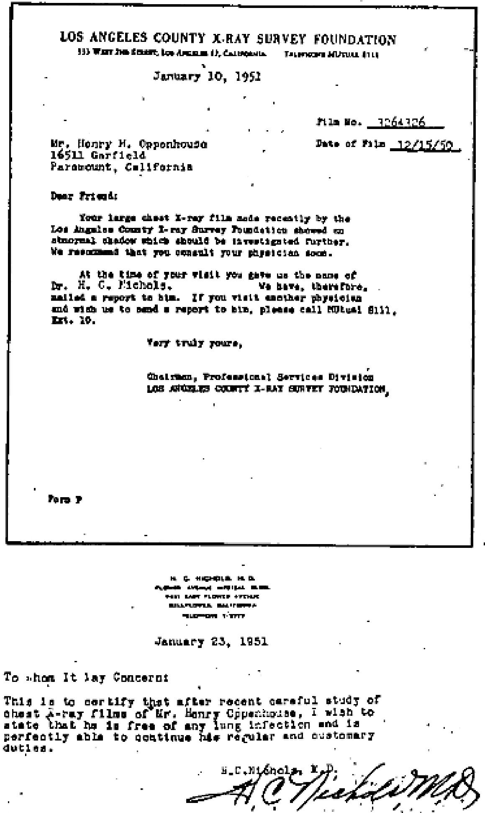
In the meantime, I had been attending Rev. A. A. Allen's Healing Revival in Bell Gardens, California, and I made up my mind to trust God for my healing. The night I received the report on the X-ray, I went to church expecting God to heal me, and I knew that when I went back to the doctor for a further check up, the X-ray would reveal that I was healed.
That night I was seated in the choir behind the evangelist. During a mighty moving of the Spirit of God, Brother Allen turned around and pointed to me and said, "Brother, God has healed you of T. B." I felt the power of God go through me, and could hardly contain myself, as I knew God had done exactly what the evangelist had said.
A few days later, 1 kept my appointment with my doctor, and went for another check-up. He made another X-ray and the following day I was called back to the doctor's office. The doctor was amazed. The spot showed up on the X-ray, but only as a scar. The doctor said it was entirely healed! Several other doctors were called in, and after thorough examination, found that I was free from any lung infection.
Henry H. Oppenhouse
16511 Garfield
Paramount, California.

September 1951 p 9
MULTIPLE ILLNESSES
I had rheumatic heart disease, dropsy, kidney stones, sugar diabetes, and tumours on my legs, I had three doctors regularly. They were Dr. Pugliese of Wilkes-Barre, Pa., Dr. Testa of Pittston, Pa., and Dr. Druffner of Avoca, Pa. They all had given me up and told me just to rest, because my heart could stop any time.
I was sitting in my seat praying for my husband who was being prayed for in Brother Osborn's meeting, and I felt the power of God go through me. The swelling left instantly. My clothes which had been very tight became loose. I lost inches around my waist, stomach and legs. I can do all my own work now, and don't even have to stop to rest. Thank the Lord for healing me!
Mrs. Mary R. Chere
378 Parson St.,
Pittston, Penna.

THE VOICE OF HEALING 1951
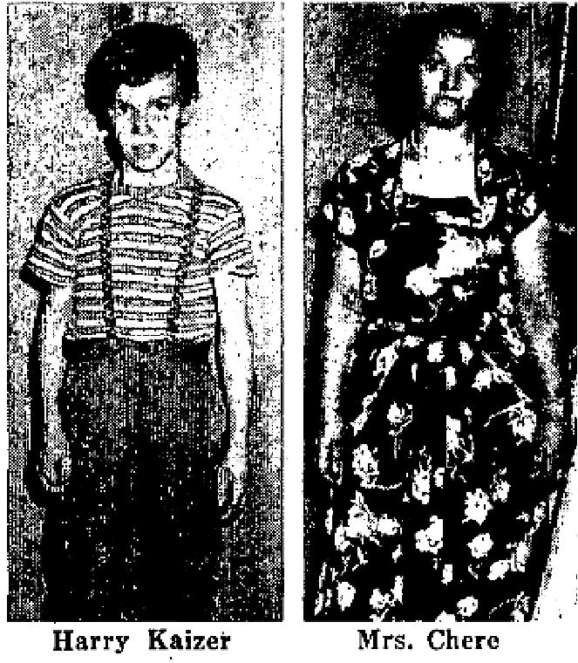
RUPTURE HEALED
I am twelve years old, and have had a bad hernia ever since I was born. Brother Osborn anointed and prayed for me, in the Scranton meeting, and my rupture instantly went in place. Now, for the first time in my life, I can run and jump like other boys without any ill effects. I thank the Lord for this.
Harry Kaizer
R. D. #3
Lake Ariel, Penna.
RECEIVES HEARING
The same night that my son was healed of hernia, I received instant hearing of a totally deaf ear. My ear had abscessed and gone deaf, but when Brother Osborn prayed for me, the abscess dried up, and now my hearing is perfect.
Mrs. George Kaizer
R. D. # 3
Lake Ariel Penna.
STROKE HEALED
Seven years ago, I had a paralytic stroke on my left side. A year later, I started having arthritis so, badly I couldn't walk. My left car was deaf from the stroke. Brother Osborn prayed for me in Scranton, and said, "In the Name of Jesus carry your cane and walk." I hobbled off, and went home, happy over the command. As I was about three blocks from the tent, on my way to the car, Brother Osborn and his wife drove by, and he called out, "Sister, you are healed, keep carrying that cane, and use that leg, and keep exercising it." This boosted me to the skies. I have done just as Brother Osborn told me to do, and can report that I am healed. My formerly deaf ear hears perfectly, and I walk all over unaided, the arthritis is gone. All my neighbors are amazed, and I am the talk of the block. I have three canes, but thank God, I use NONE!
Mrs. Clifford Miles
1116 Rundle St.,
Scranton, Penna.

THE VOICE OF HEALING 1951
September 1951 p 11
MIRACLE OF THE HEALING OF THE STONE-BLIND WOMAN
I am happy to give my testimony of What God has done for me. I was totally blind for eight years. I went to Baltimore, Md., to be examined by specialists. The doctors did all they could for me, but I was left blind and hopeless.
The Collett meetings were going on just a few blocks from my home. People everywhere were talking about the meetings. People would come and tell me that blind eyes were being opened, and that even the dead were being raised. I went to the meetings for several nights and I could hear the marvelous testimonies of the wonderful healings that were taking place.
I am a Methodist; my grandfather founded the largest Methodist church in Huntington, W. Va. Each night, while I attended the meeting, something within me seemed to say, "You try to get up on that platform, and you will be healed." When I went for prayer, I felt Dr. Collett place his hands on my head and pray a short prayer. I had never heard a prayer like this before - it seemed to be different. I felt something go all through my body, clear down into my shoes, and as a flash of light, all at once my eyes could see. I could see all the way back around the tent. I am over 70 years old, and have made several quilts since receiving my sight. I can thread my own needle without die aid of glasses. My eyes are perfect, thanks be to God for what Fie has done for me.
This miracle happened to me one year ago when Mr. Collett first came to the Tri-State area with this wonderful message of Divine healing. I now attend the Church of God and enjoy the services very much. And I want to say this, that many others in my community have been healed in these Collett Divine healing meetings.
Mrs. Maud Pruitt
Ceredo W. Va.
Witnessed by.
Argo Pruitt
BAPTIST MINISTER VERIFIES HEALING OF MRS. PRUITT
This is to certify that I, Rev. R. H. Ball, Baptist minister, 1675 Charleston Avenue, Huntington, W. Va., have
attended the Collett healing meetings in the Tri-State area for the past year.
I have seen many miracles take place. I saw Mrs. Pruitt, totally blind, receive her sight. I saw Mrs. Elizabeth Bandy of 800, 13th St., Ashland, Kentucky: receive her sight. I saw a woman raised from the dead: I have seen the dumb made to speak, and they are still talking after one year has gone by.
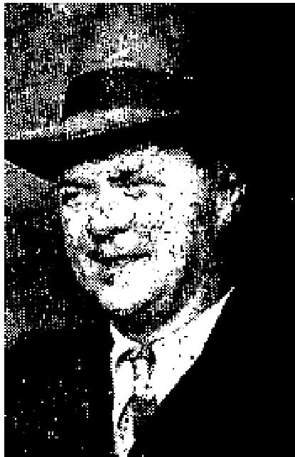 | I have seen the lame made to walk,and best of all, over 3000 souls were saved in one of the tent meetings.  After one year, I am still attending the Collett healing meetings, being so thrilled in my heart and soul for what God is doing.  In the Portsmouth, Ohio, meeting, I saw still more miracles take place. One man that had been deaf and dumb for 50 years, spoke and talked and sang songs in front of the congregation.  I have been a Baptist minister in this area for many years, and I say truly God has convinced me that Bible Days are here again.

THE VOICE OF HEALING 1951
Rev. R. H. Ball
September 1951 p 12
TESTIMONIES FROM W. V. GRANT CAMPAIGNS
CROOKED BACK HEALED BY PRAYER
For over five years, I was afflicted with high blood pressure, heart trouble, arthritis, broken ribs, injured
back and rickets. I was in bed over five years, unable to walk at all.
For over a year, I was treated by two doctors in Denton. and one in Fort Worth. I was treated with hot pads on 'my stomach and back. This caused intense suffering. It did no good and I gave up. On three different occasions, my children and neighbors thought I was dying. The neighbors said my hands felt cold and waxy like a dead person's.
I was taken to different doctors in Denton, who took 5 different x-rays of me. They said my back was crooked, that nothing could he done, and I was bound to die.
I was carried to Brother Grant's tent revival on a chair. I could not sit up so they held we on the chair. I was suffering so intensely, I was hardly conscious of the preacher praying at first. Someone asked me to try to walk - and I did. The power hit me. Brother Grant said I would not recover immediately, but that my healing would come gradually, From that very night, I began to mend. In almost 1.5 months, I began to walk by myself. I now go anywhere, and feel fine. Seven months have passed since I was healed. I am now well - and happy.
Mrs. Annie May Crawford
515 Acme Street
Denton, Texas
BROKEN SHOULDER HEALED
I fell down a stairway and broke my shoulder. It was very painful, and so stiff I could not move it, or even
lift my arm. The doctor said the bone was splintered. I was unable to dress myself, or comb my hair.
I was healed in the Grant revival in Waco, March, 1951. I could lift my arm above my head at once. I obtained faith just then to receive the Holy, Ghost. I now do my own work, dress myself, comb my hair, with no pain whatsoever - I am still healed.
I was also blind in one eye. After being prayed for in this meeting, I was able to see out of the eye that had been blind. The physician had said I would never see out of it, and that I would lose the sight in the other eye.
Mrs. A. I. Smith
Waco, Texas
DELIVERED FROM ARTHRITIS
I had arthritis several years. Dr. Simston sent me to Dr. Smith, an arthritis specialist. I could not raise my arm at all because of the severe pain. It affected my shoulder, arm, finger joints, wrist, elbow, and spine. I took different kinds of treatments.
I was prayed for by Bracher Grant, in his Waco revival, March, 1951, and immediately afterwards was able to raise my arm up level, and then above my head.
Mrs. Joe S. Landingham
620 Sherman Street

THE VOICE OF HEALING 1951
Waco, Texas
EYE INSTANTLY HEALED
When I was eight years old, I had granulated cancers on my left eye which left me blind. For 14 years I was totally blind in my left eye. I was created by an optical specialist in Fort Worth. He said nothing could be done for the left eye, but they would try to help the right eye. The State would not issue me a driver's license unless I bought glasses. The Spirit called me out in the Fort Worth Revival - I was instantly healed. I can read fine print out of the eye which was totally blind.

Mrs. G. H. Houston
2813 N. Ellis
Fort Worth, Texas
October 1951 p 2
STANLEY KAROL MEETINGS IN BANGOR, PENNSYLVANIA
Dear Brother Karol:
I want to thank Jesus for what he has done for me. I am a little girl eight years of age. My eyes were very weak and all I could see from my right eye was just a spot. After you prayed for me I was able to see the clock in the back of the building. I can now play like other children. I want to live for Jesus and praise Him forever,
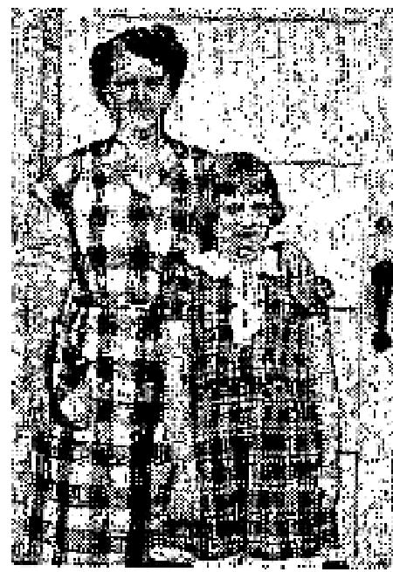
Pauline Searfoss
420 S. Main St.
Bangor, Pa.
This girl is a faithful member of my Sunday School and I knew her condition. I tested her eye in the darkness and am completely satisfied she has, been healed.
Rev. A. Sarbo
First Pentecostal Church
Bangor, Pa.

Dear Brother Karol,
I want to give my testimony in praise to the Lord for what He has done for me. I suffered almost five years
with heart trouble until you prayed for me. I am thanking God for His mighty healing power.
On Thursday, March 15, 1 went to a doctor for a heart checkup. He told me that my heart was now perfect. I just shouted, "Praise the Lord, Jesus healed me."
S. Malewicz
2031A S. 33rd St
Milwaukee, Wisconsin.
This woman had many heart attacks and was given little hope of living. She used oxygen at times (a total of 24 bottles). Today she is perfectly well and strong.
A. Jashinsky, Pastor
2405 S. 12th St.
Milwaukee, Wisconsin.

THE VOICE OF HEALING 1951
October 1951 p 3 October 1951 p 3
REPORT FROM OSBORN MEETING IN PANAMA
Our boy, Edward, was born cross-eyed. Then, after the big fire which swept over most of Elie City of Colon, we had to live out in a little tent, as so many others had to do,because our living quarters were destroyed. During this time, the boy caught cold and became very sick. We finally had to take him to the hospital where he remained for 14 days -almost dead. He finally got better, and we took him home, but he just wasn't right.
We were glad when we heard Brother Osborn was coming to Colon for a revival. We attended from the first night, believing that God would favor us by healing the boy. The boy also believed he could be healed. One of his ears had something wrong with it, causing it to swell badly, and when Brother Osborn prayed for all the sick at once, Edward put his hand on his ear - like Brother Osborn instructed, and that ear was healed. Friday, I told him to put his hands on his neck and eyes and pray to God to make his neck steady and to straighten his eyes. He did just like I told him. The next morning, after he had asked God to really heal him, he came in my room and woke me up, holding a book in his hands and said, "Daddy, look. I can see good. Both my eyes are straight, and my head doesn't move any more. Look, it is still!" | 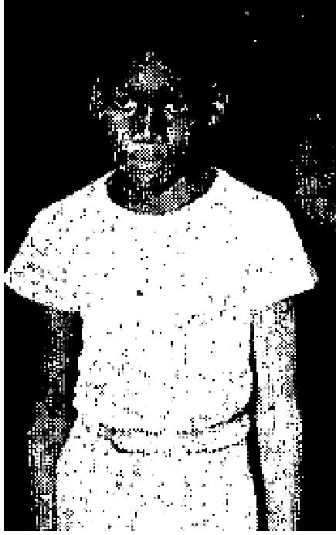

Before the miracle of healing, Edward had to hold any book to one side, so he could
focus one eye on the book. He couldn't focus his eyes straight ahead because of them being so crossed. But that morning, he was holding the book straight our in front of his eyes, and could see it clearly. He kept saying, "Look, daddy, I can see with the book out in from of my eyes and my neck is still." I told him to say, "Praise the Lord," and he did.
All his little friends came around to try to see if the neck still swings back and forth to each side any more, but he is really healed. Some of them used to make fun of him because he couldn't play baseball. He couldn't see the ball then - but now he is playing baseball too.
We give God all the praise for this!
Charles H. Bennett
Box 61
7030 Melendey Ave., Colon,
Cristobal, Canal Zone
October 1951 p 7
BABY BORN NORMALLY AFTER PRAYER
At my first examination, when I was expecting my third child, the doctor found that I have the RH negative blood factor, and that my husband's blood test was positive. Through blood tests taken every two weeks from then until the seventh month of pregnancy, it was decided by my local physician and the laboratories in Portland, Oregon, where these tests were sent, that the baby MIGHT not live, unless they brought the baby prematurely, and gave it complete blood transfusions to save its life, or at least prevent some serious deficiency. | 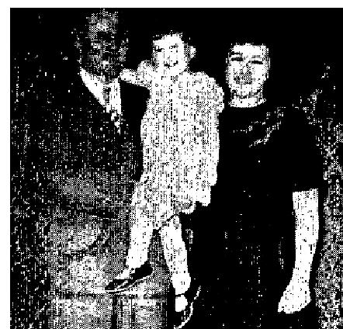

I was prayed for by Brother William Freeman, at the Grants Pass Assembly of God, and the next blood test report was a surprise, according to the doctor's own testimony to me. He said that my case Was one he could not understand, for everything now appeared to be all right in my blood test report They continued to take tests from this time on, and the baby was born normally, with no trouble, and no blood transfusions were

THE VOICE OF HEALING 1951
needed. After the birth of my little red-headed daughter, I overheard three doctors, as they passed my room, discussing the birth of this RH baby. Then in a few minutes, the nurse came in and told me that five doctors were examining the baby. They took tests for three days after her birth, but never found any reason to give her transfusions. They even kept her a day after I went home. She will be three years old in October, and her health has always been excellent.
We want to give God the praise for this, for we feel that God performed a miracle in our behalf. Praise the Lord forever.
Mrs. John Davison (Mother)
I have known the parents of this child for many years, as they have been members of the Assembly of God of Grants Pass, Oregon, of which I am pastor. We watched this case with real interest, and can vouch that every statement is the truth.
L. D. Hall, Pastor
Box 697
Grants Pass, Ore.
October 1951 p 8
LIFE FROM DEATH
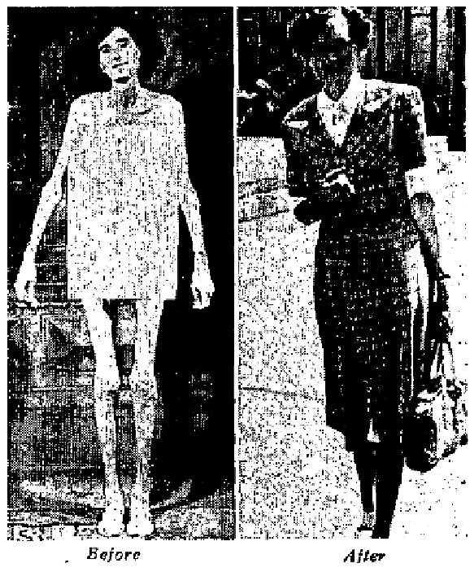
Photo at left was taken of Miss Nightingale in January, 1950, She was suffering from cancer of the stomach and had to be fed intravenously. Friends heard the Branham Pasty was to be in London and flew her from Africa to London. In answer to a call, the party went to where she was staying. A pitiful condition was hers, as the picture shows. After prayer, Brother Branham told her he felt she would be all right. One year later, photo it tight was taken, showing indeed life from death. Brother Branham considered her healing is a token for him to make his trip to Africa.

THE VOICE OF HEALING 1951
October 1951 p 11
HEALED OF FIBROID CONDITION
In June, 1950, [ was examined at the West Chicago Clinic and was cold I had a fibroid condition and should take shots and eventually have an operation. I had fully intended to have the operation and made an appointment with the doctor.
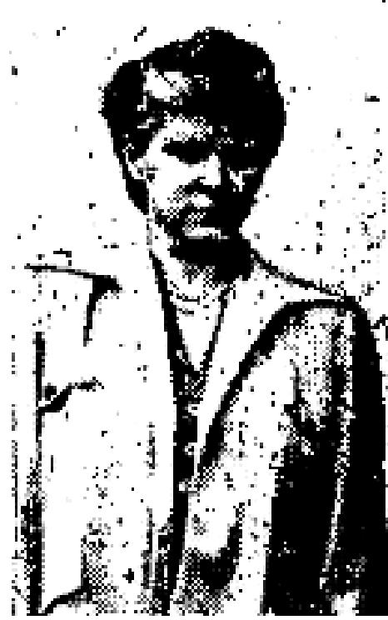
Sunday evening, April 28, 1951, Brother Erickson prayed for me. As I went to my seat, I felt the power of God as heat on my body and was completely healed.
I kept my appointment May 8, and my operation was cancelled. The growth is gone, and my blood pressure has returned to normal. There is no tenderness whatsoever, and I am feeling fine,
To God goes all the glory for my healing!
Mrs. John Yeager
7248 Archdale
Detroit 28, Mich.

October 1951 p 16
Paul Cain - A youth with a remarkable ministry is stirring cities in the West with Supernatural demonstrations of GOD'S power
BROKEN LEG INSTANTLY HEALED
I attended the Tent Revival in Riverside, California, where Evangelist Paul Cain conducted his healing services, I came to the service with a cast on my left leg, which I had only been wearing for 2 days. The leg was broken and had torn ligaments. The doctors had placed a cast from my hip to my ankle. Brother Cain, through discernment, told me what had happened. He also pointed to my mother and told her what her, afflictions were. He told her the church we were from. I was shocked, because no one in the service knew us. Brother Cain had no natural way of knowing these things - yet, he said, "Mother, does that give you faith?" Mother answered, "Yes." Then he said, "Go home, take this cast off tonight." She obeyed, and I was healed.
The swelling left instantly. I returned the next night, carrying the cast; walking very normally, and the great crowd rejoiced at the miracle. My mother is now saved. This great meeting turned my entire family to God. Praise the Lord for his supernatural gifts in Brother Cain's ministry.
Joann Bell
4460 Park Ave.,
Riverside, Calif.
Confirmed by- Pastor C. A. Goad.
(Many hundreds witnessed this.)

THE VOICE OF HEALING 1951  LARGE CROWD SEES CANCER DISAPPEAR  One night when I attended the Paul Cain tent meeting in Riverside. California, Brother Cain pointed to me and said the cancer I had on my face would leave, It was a very large growth, and as I stood hundreds around me could see it clearly. Brother Cain, whom God has especially blessed, said, "I COMMAND  THE GROWTH OF CANCER TO DISAPPEAR. NOW." People all around saw it fall from my face in two pieces. There is not a trace left.  Thousands of others were blessed also. I am so thankful for this miracle that instilled the fear of God in many hundreds there that evening.  Mrs. S. Hudson  Route # 2  Corona, Calif.  Verified by:  Pastor C. A. Goad  First Assembly of God  Riverside, Calif. | 

HEALING OF HOLLYWOOD WRITER AMAZES DOCTOR
I was a Catholic, and a writer at a Hollywood movie studio. After having received an injury to my back
about two years ago, was almost an invalid.
I attended the Paul Cain Campaign at Calvary Temple, and after Brother Cain prayed for me, I was healed. I was convinced by the supernatural power of discernment, was saved and healed, and now I have greater faith than ever!
It has been an amazing thing to the specialist, that I am healed.
Mrs. Robin Martin
947 S. Dewey
Los Angeles, Calif.
GROWTH DISAPPEARS INSTANTLY
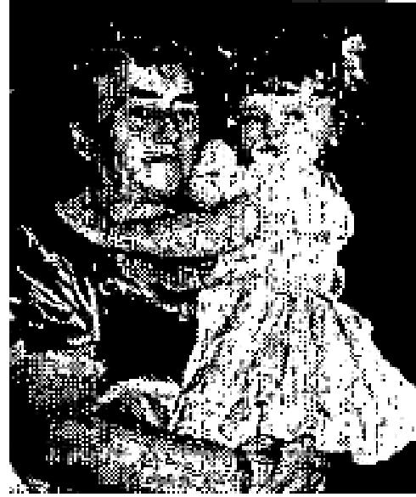
Paul Cain prayed for my little daughter, Darlene Brown, at Calvary Temple, Los Angeles. As soon as I heard of the things that were happening in the services there, I decided to go. The very first night, Brother Cain, who had never seen me before, pointed me out to the audience and told me everything that was wrong with me. I had never heard of such supernatural things, for I was not a Christian, and be told me so. He also told me what church I belonged to. This convinced me. Then, to my astonishment he said, "Mother, your child has a growth, is that also correct?" "Yes," I replied. Then he said, "Bring the child to me, Jesus is the best
Surgeon." He said, "The doctors have planned an operation, is this also true?” It was very true. Then before praying, he said, "GOD REVEALED TO ME BEFORE ENTERING THE SERVICE THAT THIS CHILD'S GROWTH WOULD DISAPPEAR." Then he prayed and said, "Audience, it's all gone." I looked and, through my tears, saw the, growth vanishing. After two minutes, no trace could be found.
Doctor Small, the surgeon, said, "What on earth has happened? This is truly amazing!" I told him it was Jesus. I am now saved through this miracle.

THE VOICE OF HEALING 1951
This can be confirmed by thousands at Calvary Temple.
Mrs. Darletta Brown
El Monte, Calif.
Confirmed by:
Le Roy M. Kopp, Pastor
Irwin Michalsky, Assistant
October 1951 p 17
SIGNS - MIRACLES - WONDERS - IN THE CAMPAIGNS OF TVH EVANGELISTS
Glen Thompson -  HEALED OF CANCER  In February, I became ill. Each day I grew weaker and weaker. In ten days time, I  had lost thirty pounds. I could not keep anything on my stomach-not even water, I  lay between life and death for days.  My husband called in a physician. He said the only thing that would help was an operation, but I was determined to trust God for my healing.  The next day, I heard The Healing Word Broadcast coming over the air. We drove to Paragould, Arkansas, for service that night. The closer we got to, Paragould, the worse I became. It looked like, my very life was going to be taken. I suffered terribly. | 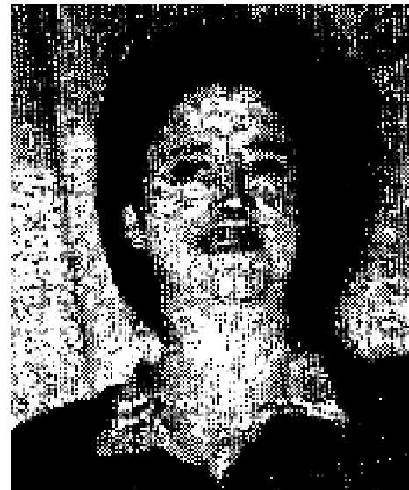

When I went through the prayer line, Brother Thompson began to rebuke the cancer demon, and I felt it pull away from my stomach. About five hours later, I vomited up the cancer in our hotel room in Paragould. The next morning, I drank milk and ate food - the first I had been able to keep down for many days.
In a few days, I went to have an x-ray made. It showed that one of my intestines had been stopped up, but was now gradually opening up. I went back in two weeks, and was again x-rayed - this time it showed my stomach to be in normal condition.
I am gaining my weight and feeling fine.
Mrs. A. V. Dunlap
2640 Caroline
St. Louis, Mo.
Ferdie C. Jay-
ONCE COLOR-BLIND
I had been color-blind all my life. I couldn't distinguish colors at all, and when driving in town needed
someone to tell me when to go or stop at the stop lights. Not being able to distinguish colors made my work
very difficult.
I have been saved 14 years, and always have believed in Divine Healing. I have been healed of things, including gall bladder trouble, but I never once thought about having anyone pray for my color-blindness, until Brother F. C. Jay of Wenatchee, Wash., held a revival here at Wilder, Idaho. He had such a wonderful ministry of Divine Healing, and God used him in such a marvelous way in praying for the sick. God spoke to me, telling me to get Brother Jay to pray for my color blindness - I did, on June 15, 1951 - and God Healed me! Now I need no one to tell me when to stop or go - it the stop signs.

THE VOICE OF HEALING 1951
Praise the Lord for deliverance!
Herman G. Miller
Route 2
Wilder. Idaho
I can verify the testimony of Herman G. Miller. The statements are all true. I know him personally. Before God Healed him, he couldn't distinguish one color from another, but now he has perfect eyesight in every way. I've never before heard of this type of healing. Surely it is wonderful - we praise God for it!
Rev. Bennie R. Harris
Pastor, Assembly of God
Wilder, Idaho.
T. L. Osborn-
X-RAY PROVES WATER ON LUNG GONE AFTER PRAYER
December 24, 1950, my doctor announced to me that I had water on my left lung, and that was the reason I had suffered such severe pain in that region. I entered the Diaz Garcia Clinic in January, remaining there for eight days, and they prescribed thirty injections of streptomycin. They gave me twenty-two, and there was no change. On April 20, at Bro.
Healing Campaign, when Bro. Osborn prayed for the sick, I instantly had relief from the pain, and I was told to go to the doctor and have another X-ray. For the first time I had a negative rest. I am healed. I feel like a new woman. Praise the Lord'.
Saturina Colon de Torres
Calle Buenas Aires #620
Santurce, P. R.

THE VOICE OF HEALING 1951
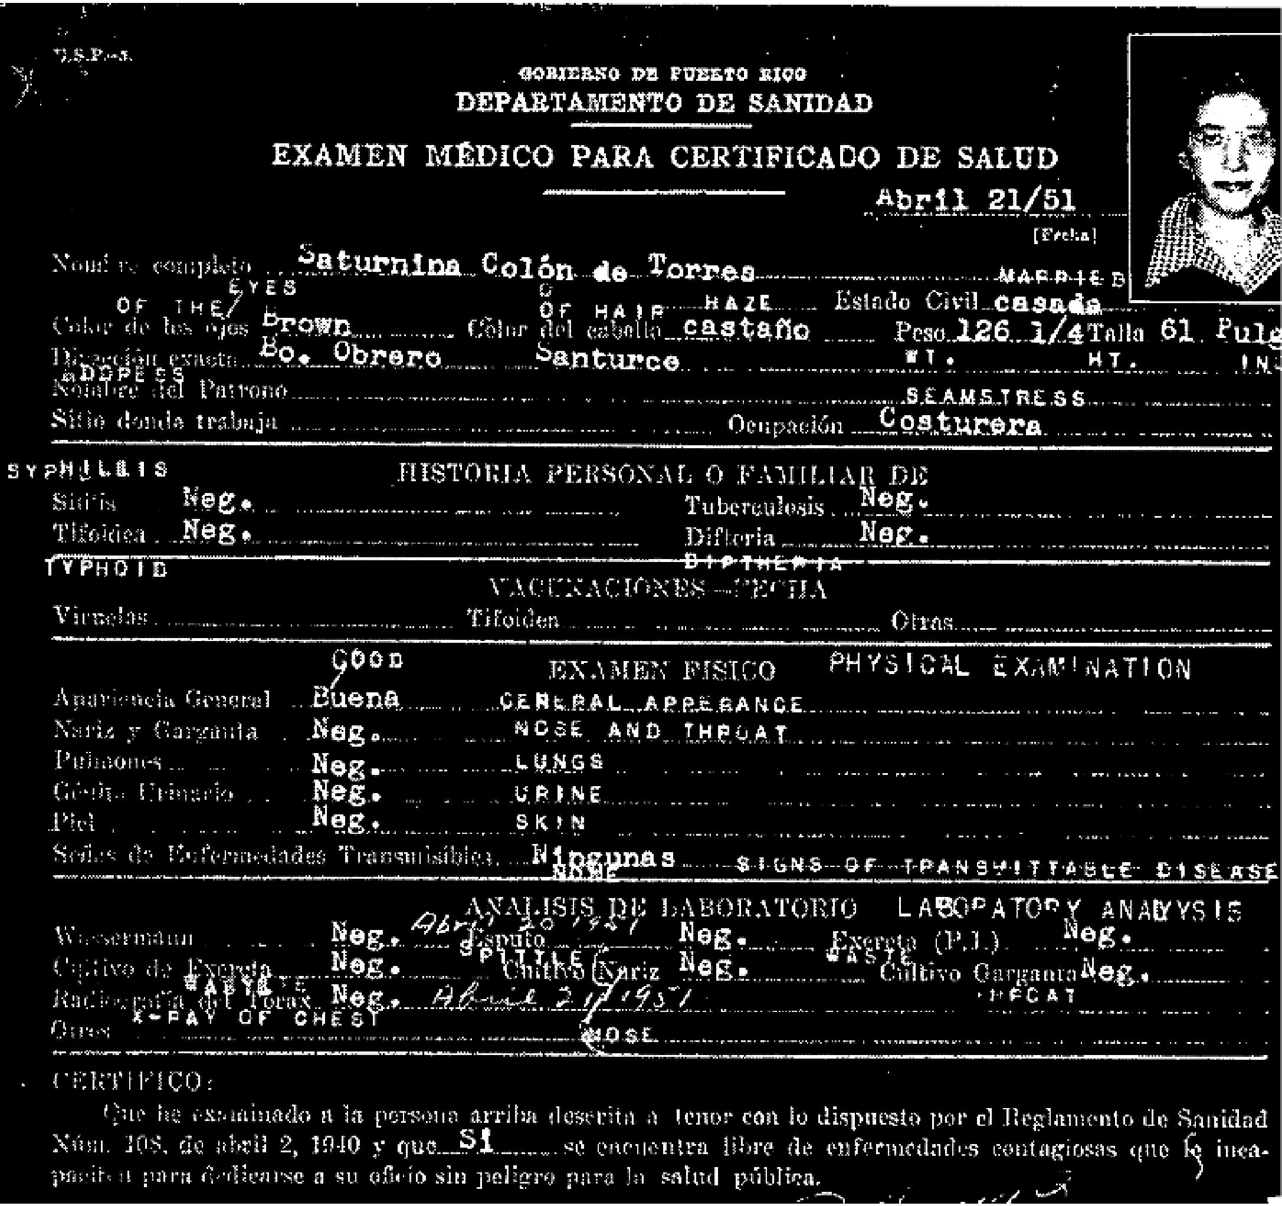
Clifton Erickson-
LEG LENGTHENED AFTER PRAYER
This is to testify to my marvelous healing on June 1, 1951. 1 was stricken 4 years ago with a severe virus
infection, and muscle paralysis followed. For many months, I could not walk or use my right arm. The
shoulder was completely set in the socket. One leg was 2 inches shorter than the other.
When God touched me, complete feeling and use was restored to my muscles and the shoulder was broken loose instantly, My hips are absolutely level, so my leg is the same length as the other. My hand is completely normal. I have undergone five major operations. My, how God has healed in every respect. When God's power surged through me, I was made "every whit whole."
Thank God, I had His joy and peace through every hour of suffering, and I go forth to glorify Him as never before. My husband and family are rejoicing in this, as they are born-again Christians.
Mrs. Fred Keiber
2048 N. 63rd St.,

THE VOICE OF HEALING 1951
Omaha, Nebr.
October 1951 p 18
OUTSTANDING HEALINGS REPORTED IN W.V. GRANT REVIVALS
INJURED SPINE AND BROKEN NECK HEALED  For three and one-half years, I suffered terribly and I was almost a nervous wreck. I had an injured spine, three vertebrae out of place at the base of my bend and neck, four bones out of place below my hip. When I was in the Hurley Hospital at Flint, Michigan, the doctors told me that my neck was broken, and that they could do nothing for me. I was forced to wear a brace and was under chiropractic treatments for 45 days, and finally could stand the treatment no longer. The vertebrae would come out. of place each time they were  adjusted, and the chiropractor also told me that I would never be well. | 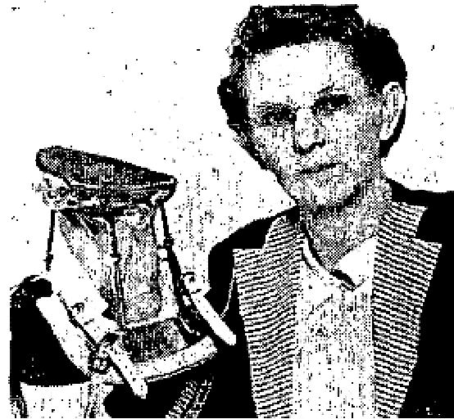

After this time, I was under the care of different doctors who gave me dope to try to ease the pain. Finally, I went to a Spiritualist reader and that made me feel worse instead of better.
When the demons were cast out of me, I later went to Evang. W. V. Grant for prayer, received the Holy Ghost and was healed of all my difficulties. The poison that was in my body came out all over me, and I was clean in body and soul and spirit. As I had no further use for the brace I had worn so long, I gave it to Brother Grant.
Mrs. Ada Johnson
1235 Norton Street
Flint, Michigan
Witness: M. A. Jollay
DELIVERED FROM CEREBRAL PALSY
My son had cerebral palsy and it prevented his skull from coming together naturally. He had never been able to walk, and when he would try, one leg would drag. The doctors said that if he ever picked that leg up it would be a miracle. Ever since he was prayed for in the Grant-Dallas revival, he has been walking without dragging his leg. I took him back to the doctor, and she said that there had been a miraculous change. I am so glad Jesus heals and proves Himself. My neighbours are talking about this miracle and they admit that it was just that, praise the Lord.
Mrs. W. L Henry
5011 E. Bluebird Lane
Dallas, Texas

THE VOICE OF HEALING 1951  DOCTOR HEALED  I had been afflicted for 12 years and 4 months with a pilonidal cyst and the doctor said there was a 100 to I chance of this cyst causing cancer. It was located at the base of the spine and was very painful.  When I was prayed for I felt the power of the Lord and knew, I was healed. Praise the Lord for it.  Dr. Oscar F. Love  2718 Brown St.,  Flint, Michigan | 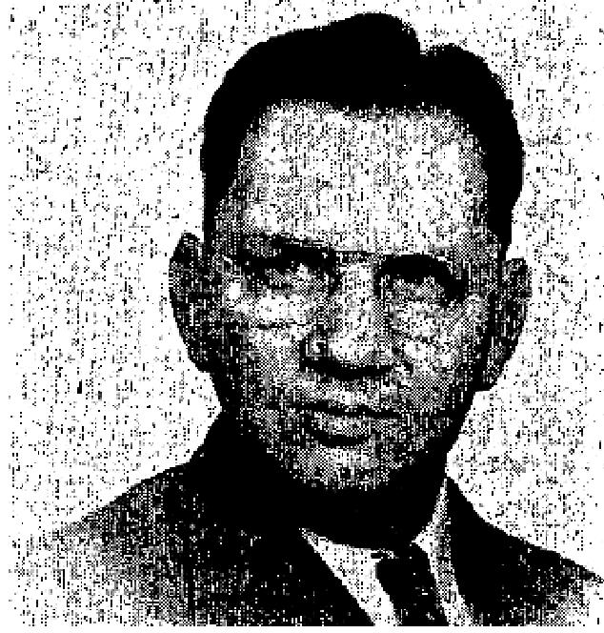
October 1951 p 21
TESTIMONIES FROM A. A. ALLEN YAKIMA, WASHINGTON REVIVAL
RUINED EARDRUM HEALED
My son Richard, 12 years old, was deafened in one ear four years ago by the explosion of a firecracker near the ear. A doctor, an ear specialist, said that the car drum was bursted; that it was impossible for him to ever hear with that ear again, the surgery could not help. He declared that "even a miracle" could not restore Richard's hearing.
On Thursday night, July 26, 1951, at the tent meeting in Yakima, Washington, Brother A. A. Allen prayed for Richard's ear and it was instantly healed. He immediately heard and responded to questions asked, with his good ear closed. He heard even the faintest sounds with the ear the doctor said would never hear again.
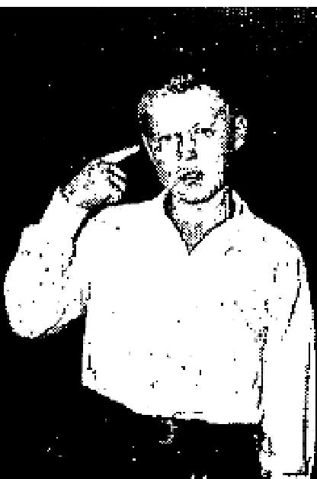
We do praise God for this great miracle which has come into our lives. I had drifted from God, hut am determined to serve Him now.
Mrs. Myrtle M. Fisher
411 Victory Lane
Yakima, Washington
THROAT LUMP HEALED  For three years, I had some sort of trouble in the left side of my throat. At times, something seemed to move. It felt like a worm crawling, and would choke me. I had it fear of goiter or cancer and as time went by, I felt this thing was getting worse.  I attended A. A. Allen's Salvation-Healing Revival in Grants Pass, Oregon, in March 1951. My faith was built up as I heard the preaching and as I read Brother Allen's book.  The last week of that revival, I asked Brother Allen to pray for my throat. He did, and I believed the work was done. Two days later, on my way to the evening service, I suddenly felt something come loose in my throat. I spit it out. It looked like flesh, light in color, with roots. | 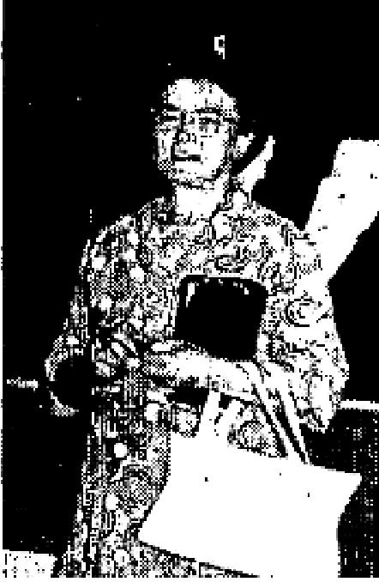

After five months; I am still praising God for complete deliverance front this awful thing and for the healing of my throat.
Gilla D. Wofford
338 N. Amherst St.

THE VOICE OF HEALING 1951
Albuquerque, N. M.
(Mrs. Wofford gave this testimony personally in the Yakima revival. It inspired others to trust in God.)
November 1951 p 2
MAN HEALED OF BLINDNESS, DEAFNESS AND SKIN DISEASE IN TANNENBAUM MEETING
I had been blind since the age of 11 years. I am 34 years old. I had been treated as a blind man, and my records are at the University of Minnesota Hospital, where I was operated on in 1940. The Blind Association of Minnesota handled my case. I received a blind pension. on the 24th of July, I was given the "blind" News and Candy stand (vending stand) at the Hibbing Post Office.
Brother Tannenbaum prayed for me, and God instantly opened my eyes, and they are getting better all the time. I also was deaf in my left car, and that is also healed. I had skin disease, which caused much discomfort, and thank God, it is now healed.
I came to Hibbing, Minnesota, to attend the revival, from the residence of my brother-in-law, Morris West,
118 W. 7th St., Duluth, Minnesota, and I am sure if anyone contacts him, he will verify my testimony.
John Dent
2301 4th Ave.,
Hibbing, Minn.
November 1951 p 3
REPORTS OF SPECIAL SIGNIFICANCE FROM SALVATION HEALING REVIVALS
KENTUCKY COMMUNITY STIRRED BY MIRACLE
This is to certify that we the undersigned attended the Collett Healing meeting at Raceland, Kentucky, and saw with our own eyes, the little boy, Danny Leo Glancy, of Hitchins, Kentucky,, who was a cripple when born. We saw the child walking perfectly after Brother Collett had prayed for him. The leg was 114 inches shorter and the tots turned backwards, but God performed a perfect miracle on this child, and today his foot is normal - a fact verified by physicians in Kentucky and Ohio.
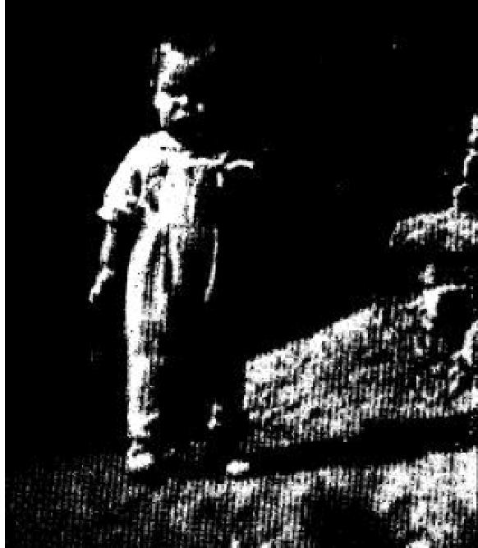 | Rev. Walter E. Pyle  Wheelersburg, 0hio.  Rev. William Mosley  So. Shore Ky.  (TVH also has on record many other signatures of persons who witnessed this miracle.)  Photo at left shows Danny Lee Glancy after miraculous healing had taken place. Compare exact length of legs as shown here with cover photo, which shows one leg shorter than the other,

FLINT, MICHIGAN PASTOR REPORTS - W. V. GRANT REVIVAL OUTSTANDING
By M. A. Jolley
Pastor, Riverside Tabernacle

THE VOICE OF HEALING 1951
We have witnessed one of the greatest outpourings of the Holy Spirit in the W. V. Grant meeting to ever visit this part of the country. As near as we could ascertain, there were between 400 and 500 who received the Baptism of the Holy Spirit, during the five weeks of the campaign. The prayer room was packed night after night, with members of not only our own congregation, but many who came from distant-points to attend the services.
The tarrying services were characterized by many features witnessed in the early days. People came of all faiths - even Catholics and Jews - to witness and receive this promised power from on high.
The number of people who showed evidence of definite heating in the campaign was unusually high in relation to the number prayed for.
We greatly appreciate the simplicity and sincerity found in the ministry of Brother Grant, and I am sure that God will continue to make him a blessing to the thousands who throng his meetings.
INSTANTLY DELIVERED FROM NEED OF BRACE  I had arthritis of the spine, which was rapidly spreading to my arms and legs.  My spine was also torn loose from the pelvis, and I had to wear a brace with a  piece of steel an either side of the spine. I could only  walk a short distance without the brace, then I would lose control of my legs.  A bone specialist in Chicago told me to wear the brace and return in a year; and if the spine had not fused back together, they would have to graft bone, providing the arthritis had quietened down. I was in touch pain the night Brother Stewart prayed for me. Then I felt the hand of God upon me and was instantly healed of arthritis. I had forgotten to tell Brother Stewart about the spinal condition. The next night, he prayed for me again, and I felt my spine being twisted and pulled, then set down upon the pelvis. | 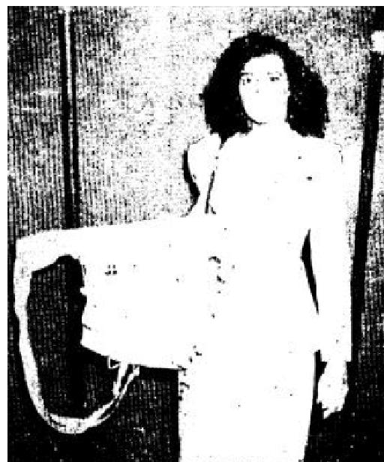

I thank God today that we have a living Savior who loves us enough to reach down in the filthy pit of sin,
cleanse and heal our broken twisted bodies, and pour forth His light upon our souls. Praise God for what
He has done for me.
Lucille Kinholt
11061/1 Connelly St.,
Clovis, N. M.
November 1951 p 7
SIGNS, MIRACLES and WONDERS IN THE CAMPAIGNS OF TVH EVANGELISTS
W. V. Grant
EYESIGHT RESTORED

THE VOICE OF HEALING 1951  I had an operation at Memphis for my right eye. The trouble was caused by arsenic lead, which caused pus packets to form behind the eyeballs. The doctors said my eyesight was gone, and there was nothing they could do to help me. For eight years, I was totally blind in that eye.  In May, 1951, I was prayed for in the Grant Revival in Riverside Tabernacle,  in Flint. Michigan, and received instant healing. I was able to see the  congregation after I was prayed for. I now see to read, and do not need my  glasses.  James Hammonds  4022 Fenton Rd.,  Flint, Michigan | 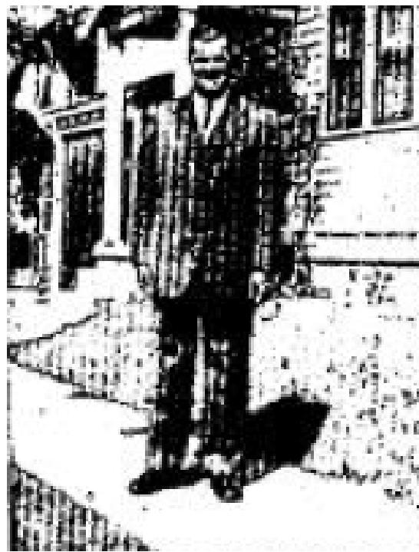
Confirmation:
This man was totally blind in both eyes at one time; but later he could see some out of the one eye. His
vision is dearer now than before he got his eyes burned out with acid.
M. A. Jollay, Pastor
Richard Jeffery -
SOLDIER MIRACULOUSLY HEALED OF CRIPPLED ARM
I was inducted into the United States Army August 15, 1944, and while at Luzon, on April 24, 1945, 1 was shot while in active combat. After arriving in the United States. I was sent to McCaw General Hospital, Walla Walla, Washington. Due to the injury in my left shoulder, where the bullet entered and shattered the socket bone, my left arm gradually became approximately two inches shorter than the right one.
On August 2, 1950, I was prayed for in Brother Jeffery's Healing Campaign in Butte, Montana. Before prayer, I showed the congregation my shortened arm by stretching both arms out directly in front of me, and all could see that my left arm was approximately two inches shorter than my right:
Immediately after prayer, I stretched forth my arm and they were the same length. Praise the Lord! All the
congregation saw the miracle take place. For this I wish to thank Him Who doeth all things well. One year
has passed since my healing took place.
William D. O'Brien
1306 E. Park PI.,
Butte, Montana
CONFIRMATION:
In July, 1950, William O'Brien was prayed for by Richard Jeffrey, that he might have more use of the arm
which was injured while in the U. S. Army. Immediately after prayer, I saw the miracle take place, as he
stretched forth his arms, and both arms be- came the same length. A whole year has passed
and the miracle of healing is absolutely sound. For all this, we praise God.
Elmer M. Trygg, Pastor
Vernon Griggs -
ARTHRITIS AND RHEUMATISM HEALED
For more than twenty years, I had arthritis or rheumatism in my hands and feet. In 1933, I had an operation for the removal of a tumorous cancer. A short time thereafter, a growth, about the size of a lemon, developed on the back of my right leg and doctors who examined it said it could not be removed, for it enveloped and encased the main blood vessels to the lower part of my leg.

THE VOICE OF HEALING 1951
On February 17th, I attended a meeting at Fort Hall, Idaho. and when Rev. Griggs prayed for me, I received
instant healing. I could use my hands freely, and when we got home from church the lump on my leg was
gone, too. I'm thankful for the healing power of God .
Mm M. A. Lewis
Ft. Hall. Idaho
Witnessed by: Nellie Grimes (sister),
Velmer Gardner -
VISION PERFECT AFTER PRAYER
Knowing my eyes were not as they should be, (especially the left one), I decided to consult a doctor. After
the examination. the doctor told me I was afflicted with myo-optic astigmatism. The vision in my right eye
was 20-30, and the vision in my left eye was 20-35.
Rev. Gardner prayer for me on Monday evening, August 27th, in Wayne, Michigan. On Friday, August 31st, I took my physical examination for West Point at Selfridge Field Air Force Base. The Army doctors pronounced my vision perfect - 20.20 vision in each eye.
Jesus Christ, the Great Physician, touched my eyes, and made them every whit whole. Praise His mighty and wonderful name!

Ronald C. Hudgens
1055 Earl Blvd.,
Ferndale, 20, Michigan
William Branham -
APPLIED ANOINTED CLOTH - HEALED
One day I noticed a lump in in my left breast. It was quite large and very painful. A week after I discovered it, I went to the doctor and he told me that there would have to be an operation. A couple of days after I had been to the doctor, I wrote Brother Branham for an anointed cloth. I put the cloth on my body and followed the instructions he sent. Two days after this, I became sick, and poison started to leave my body in a natural way. By that night, the lump was over half gone, and in less than a week it was all gone. There was not even any soreness there.
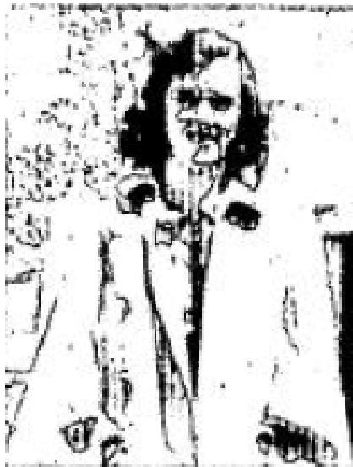
I do praise the Lord for the miracle He wrought!
Mrs. Paul Fisher
Mount Brydges
Ontario, Canada

Clifton Erickson -  TOTAL DEAF-MUTE HEALED  My daughter, Theresa James, was barn deaf, twenty-seven years ago. During these years, I have taken her to many specialists. including some at Barnes Hospital. St. Louis, Missouri, Mayo Clinic, Rochester, Minnesota, and other specialists in Little Rock, Arkansas, Memphis, Tennessee, and Springfield, Missouri -but she was never helped in any way.  She graduated from Central Institute, St. Louis, Missouri. and during the years she attended, she never heard one sound. | 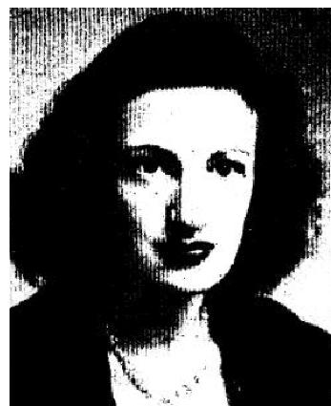

On August 1. 1951, Rev. Clifton Erickson prayed for her at Eureka Springs, Arkansas and, for the first time in her life, she was able to hear. Also, she is learning to talk much better as she hears.

THE VOICE OF HEALING 1951
I definitely believe if we will walk by faith, this healing is everything it is represented to be.
Fred W. Jones
Mayor, Harrison, Ark.
Confirmation:
As pastor of the Assembly of God, of Harrison, Arkansas, I would like to testify to the fact of the marvelous healing of Theresa Jones, the daughter of the mayor of our city, who was a total deaf-mute, who had never heard sound in her life, not even thunder. I was present the night she was prayed for, and before she left the platform she was able to hear the tick of a watch. A number of times she has been tested by the evangelist, and each time her hearing was perfect, to the extent that she could hear the ticking of a watch, Her speech is also coming to her.
Basil Edwards, Pastor
(ED, NOTE, It must be remembered that the deliverance of all deaf-mutes consists in his or her ability so hear. The process of beginning to learn the significance of sounds and becoming a normal person in this respect, requires time, patience, kindness and encouragement from all concerned.)
November 1951 p 10
PARALYZED 21 YEARS - INSTANTLY HEALED (See Photo on Cover)
Ruther Rasson, Route 2, Armuchee, Georgia,came through the prayer line in the Ogilvie campaign in Rome, Georgia, dragging his left foot and leg. Brother Ogilvie asked him what was the matter. He replied that he had been paralyzed in his left side for the past 21 years. Brother Ogilvie then asked if anyone in the congregation knew this man. Several raised their hands. One lady stood and said that he was her neighbor and that she knew he had been in this condition for a long time.
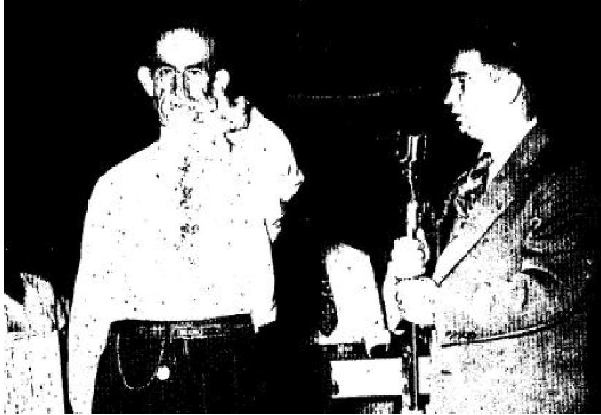 | As soon as he was prayed for, he began to swing his left arm over his head, and kick his left foot. He put his left hand high in the air,stretching it as though nothing had ever been wrong with it. He then began walking around on the platform. Brother Ogilvie told him to take a run down the aisle. The man ran like a little boy. He was filled with great joy. The crowd praised the Lord to see this great manifestation of God's power.  This man testified on the radio program and told people everywhere what great things God had done for him.

CANCER DISAPPEARS AFTER PRAYER - OPERATION CANCELLED

THE VOICE OF HEALING 1951
Mrs. Bell Dukes, 1012 Avenue B., Rome,Georgia, came on the platform in the Ogilvie Campaign at Rome. Georgia, with a hideous cancer on the right side of her face. She was in great pain and not able to stand the light in her eyes. The cancer was also eating into and around the eye. A number of people said they knew she was healed, for there was such a strong witness of the Spirit. There has been no pain at all since she was prayed for. Before prayer. the pain was so great she had not slept for several nights. Mrs. Dukes had been under the care of four doctors, and had undergone two operations for this cancer, and was due for another operation. Eight days passed, and the date came for her operation. She went on back to her family doctor, and after a thorough examination, he said there was no trace of cancer. This lady was on the platform a number of times in the Rome,Georgia, meeting. Thousands of people around that area know of her healing. She will be glad to give her personal testimony to those interested.
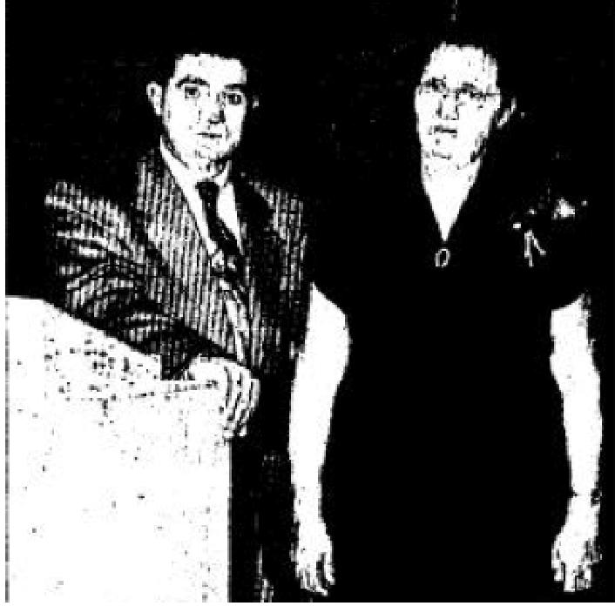
November 1951 p 12
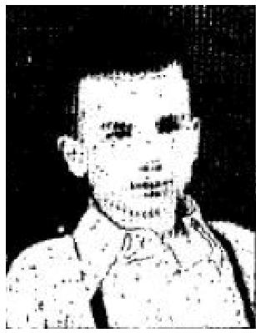
Many Testify of Healing In Coe Revivals
INSTANTLY HEALED OF RHEUMATIC FEVER

The day before Christmas, 1950, the doctor told me my son, Larry, had Rheumatic Fever.
He took an x-ray of Larry's chest which showed the left side of his heart very much enlarged. An electro-
cardiogram was also
made which revealed a very bad heart murmur.
Larry constantly ran a fever. The doctor said it might be a year or even two before the fever left.
Even then he couldn't promise me that Larry wouldn't be an invalid for life. Complete bed rest was
necessary to prevent his heart from becoming even worse. He was also put on a very strict diet.
I took Larry to the Jack Coe revival in May and asked Bro. Coe to pray for him. When Bro. Coe anointed him with oil and prayed for him, God touched and healed him instantly.
Larry has been running and playing every day since. He wasn't even weak from the six months he spent in bed. He gained six pounds the first week after God healed him.
Brother C. W. Shumway of the Orchard Park Assembly can verify this testimony,
Mrs. L. H. Palmer
203 South St. Paul
Wichita 12, Kansas
HEALED OF CANCER ON NOSE
I had a cancer on my nose for 1.5 years. When I was prayed for by Bro. Jack Coe in Wichita, Kansas, the cancer fell off my nose while he prayed.
Praise God for, deliverance.
Walter L. Meeks.

THE VOICE OF HEALING 1951
2261,/2 North Broadway Wichita, Kansas

RIGHT SIDE PARALYZED - HEALED IN COE REVIVAL
Three years ago, I suffered cerebral thrombosis, which paralyzed my entire right side. My voice was also affected and I was unable to lift my head, nor could I see to read. Yet. I was allowed to live.
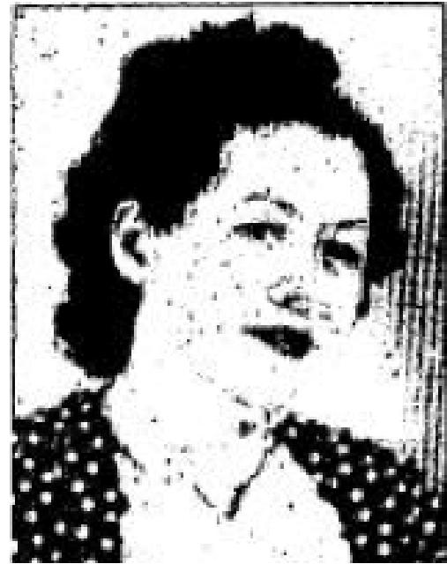
Dr. Morgan and Dr. Kirby attended me at St. Joseph Hospital in Wichita, Kansas. There was no hope for my voice, nor my arm. It was thought I would never walk again.
I turned to God for help. I attended the Coe Revival in Wichita. I got in the prayer line and God did in a few minutes what I bad been trying to do by treatments. Praise God I am well. Jesus has delivered me from all medicines. Previously I was spending fifteen dollars a month for medicines. My desire now is to tell others about "life insurance" from God.
Ruby Wright
455 Riverview
Wichita, Kansas
November 1951 p 13
HEALED OF DOUBLE HERNIA AND MALIGNANT TUMOR

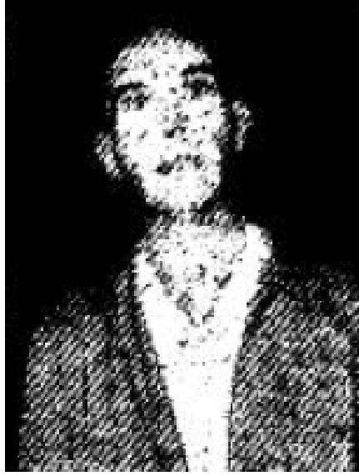 | I praise God for delivering me of a tumour of the chest, and also double hernia. I had been wearing a truss for years. Dr. Wedris had given me no hope ... said no more could be done.  I went to the Coe revival in Wichita, and there Brother Coe prayed for me and told me to go into the prayer room and remove my truss.  God healed me and I have been going ever since. I have never seen the truss again. I had Dr. Foust and Dr. Wedine, chest specialists, make x-rays. They said there is no sign of tumour.

Ray Penrod
1331 South Fern
Wichita, Kansas
HEALED OF T.B. IN COE REVIVAL
I had T. B. for 30 years. I was in Johnson Hospital at Longmont, Colorado, for three years. Dr. Johnson sent me home. Said he could do nothing for me.
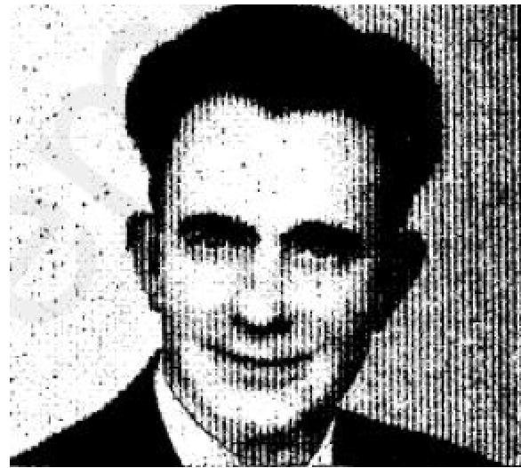
I went to the meeting in the Big Tent at Wichita, Kansas. Bro. Coe prayed for me and God healed me of T.B. and delivered me of the cigarette habit of _30 years. Praise His Name.
Lee Adkins
421 Lula Street

THE VOICE OF HEALING 1951
November 1951 p 14
ONE AND FIVE-EIGHTHS INCHES ADDED TO LEG
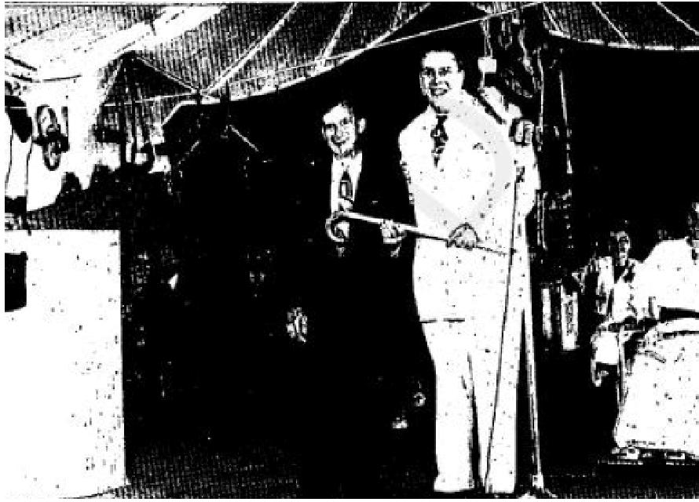
I had seven operations at the Veterans Administration Hospital. My kneecap was removed in a surgical fusion which made my right leg one and five-eighths inches shorter than my left. I suffered great pain in my hip due to this shortened condition. Doctors could do nothing further to help me. I left the hospital in April in this condition, and suffered until September. One Friday night, I attended the Dale Hanson tent revival, and saw people completely healed and delivered and decided, that's for me!"
On Sunday afternoon, Evangelist Dale Hanson prayed for me. The pain left instantly, and as I started to walk away from the tent, I noticed the shortage of my right leg had disappeared - I was not limping - I went to the Veterans Administration doctor for an examination, and he verified that the shortage in my leg had completely disappeared. My legs were now the some length! Praise God, I am completely healed from being a cripple. Previously I could not walk without my cane, but as soon as I was prayed for, I found I did not need it.
I can now work six days a week, ten hours a day. without pain. The Lord also delivered me from the tobacco habit. I had tried to give up smoking for 22 years but, until I was prayed for in this meeting, was unable to stop. I was saved, healed and received the Baptism of the Holy Spirit all in the same week.
I am glorying in my wonderful deliverance and wish to encourage others to put their entire faith and trust in Christ. God's promises are true.
Proof of the above mentioned disability before and after may be had through the Veterans Administration, through Claims #C 6-473044 or through U. S. Army Serial #337-52546.
Arthur J. Parker
453 Barrison Point Rd.,
Island View Beach
Baltimore 21, Md.
HEALED OF CEREBRAL PALSY  My baby was a "seven-month premature," and weighed three pounds. At thirteen months, she tried to walk, and we noticed that she walked on her toes on the left foot. We took her to an orthopedic doctor. He tried a plastic cast first and later a brace, but there was little, if any, improvement from them. We found she had a complete weakness on the left side involving her mind, speech and arm as well as her leg. Then, when she was five years old, she developed pneumonia. At this time, we consulted another doctor, and he also advised day and night braces. After a year, the day braces were removed and high shoes were used, still using the night braces.  We took her to the Dale Hanson Campaign in Baltimore, Maryland, where Brother Hanson prayed for her. Two days later, she begin wearing low shoes, | 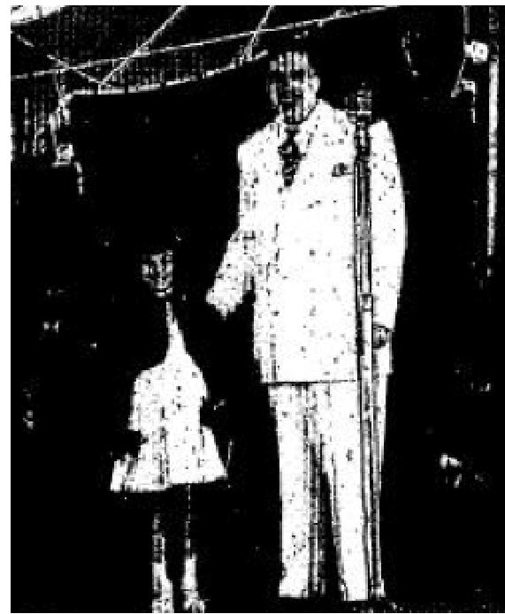

THE VOICE OF HEALING 1951
(they would not stay on before) and we noticed her hand was stronger and that she walked with her feet flat most of the time. Toe walking had become a habit and must be broken. Muscles on the leg had been spastic, and are now stronger. She is so happy and testifies of what Jesus has done for her.
Mrs. W. T. Myers
2554 W. Lombard St.,
Baltimore, Maryland
WOMAN SPEAKS FOR FIRST TIME IN SIX YEARS AND RAISES PARALYZED ARM AFTER PRAYER
For six years, my arm was paralyzed and I had been unable to speak a word. Dr. Frank Williams, who had been attending me, said medical science could do nothing more for me. The arm of flesh may fail, but Jesus never fails!  Friends took me to Brother Dale Hanson's Clarksburg, W. Va., meeting one night early in July, and Brother Hanson prayed for me, commanding me to raise my arm - and I was able to do it! He then encouraged me to speak, and I was able to say a whole sentence praise the Lord! My relatives and friends who accompanied me rejoiced to see this miracle of God's love and power. The enclosed photo, taken some weeks after I was prayed for, shows me with my once paralyzed arm raised, praising the Lord. Praise God for His wonderful healing power. | 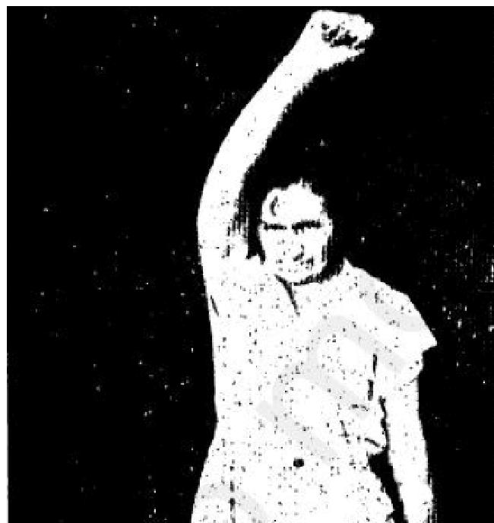

Doris Kiddy, 153 Camden St., Clarksburg. W. Va.
(Ed Note: THE VOICE OF HEALING has on record the names and addresses of eleven individuals who signed their name as a witness to the above mentioned healing).
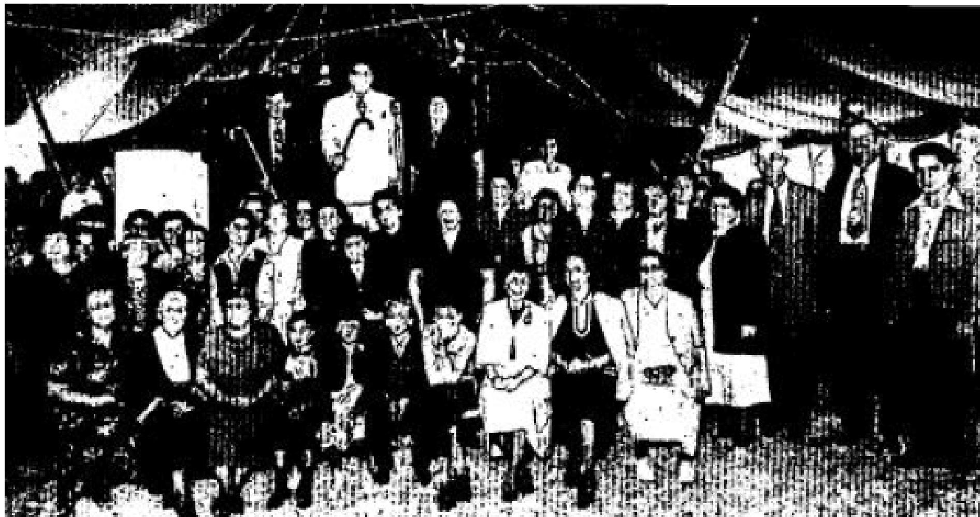
Above photograph shows but a few of the hundreds who were healed of all manner of diseases and afflictions in the Hanson Revival in Baltimore.

THE VOICE OF HEALING 1951
November 1951 p 18
MANY TESTIFY TO HEALING IN W. V. GRANT REVIVALS
USE OF LUNGS RESTORED AFTER PRAYER
I lost the use of my right lung on May 8, 1946. I was told that if I lived three days, it would be a miracle. This injury was caused from steel dust while I was working in a factory. The other lung had a spot on it the size of a quarter. I could not breathe well, and had to walk and talk very slowly. Three X-rays were taken - one each week for three weeks. They showed me the pictures and pronounced me incurable.
The night when Brother Grant prayed for me, (June 20, 1951) it seemed like a plaster was put over each lung. I immediately began to breathe normally, and can now sing and talk, and feel good in soul and body.
M. Roy
6317 Flint Road
Flushing, Michigan
GOITER DISAPPEARS INSTANTLY
For 35 years, I had a goiter that choked and strangled me. I had a hard lump in my neck. Brother Grant opened the Scriptures to a verse and asked me to read it. He asked me if I believed it, and then asked me to feel for the growth - I did - It was gone! God had healed me.
J. W. Baldwin
1545 Montana
Flint 6, Michigan
SPECIALIST GIVES NO HOPE - NOW USES EYE TO READ BIBLE
Last May 23rd, my thirteen-year old son, Gary, was shot in the right eye with a B. D. gun. He was taken to Wyandotte General Hospital, where a delicate operation was performed. The doctor said the chance of saving his eye was hopeless and recommended that it be removed. Another doctor was called in, and finally a third eye specialist examined the eye. All of these had the same answer - no hope.
We were informed of Rev. W. V. Grant's healing campaign, then in progress in Flint, Michigan. Rev. Grant was contacted by telephone and on May 30, visited Gary in the hospital and prayed for-him. The very next morning, when the doctors removed . the bandage from the eye, they were amazed that Gary could see. He improved daily and was soon home again with us. Now he can read the Bible with the eye that was injured.
Dr. Hewitt told me that it was only God that restored the eye. As his father, I am willing to answer any inquiries concerning this healing.
Francis R. Hitchcock
1086 23rd St.,
Wyandotte, Michigan
EYE ONCE TOTALLY BLIND NOW USED TO READ

THE VOICE OF HEALING 1951
I had retinal hemorrhages from my right eye, which caused me to lose my sight in that eye. My physician sent me to an eye specialist. who said nothing could be done, and I would always he blind. I was totally blind in that eye for six years. I had been totally deaf in my left car for 15 years, caused from a burst eardrum. I also had arthritis, heart trouble, and high blood pressure for ten years. These afflictions caused me intense pain.
When Brother Grant prayed for me in June, 1951, my ear opened. I can now hear the clock tick, and I'm, able to read large print with the eye that was totally blind. I am free from the arthritis pain and swellings.
Lucy Pruett
1379 N. Cornell
Flint, Michigan
FULL USE OF ARM RESTORED AFTER PRAYER
I could not lift my arm. in fact, I could hardly move my wrist or fingers. When Brother Grant prayed, I felt the power go up my arm, and I knew the work was done. Immediately I tried, and could move my fingers, then my hand, and then I could lift my arm. It is now normal. I had been crippled by falling head-first down a stairway while carrying a load.
Mrs. Margaret Hicks
Howell, Michigan
December 1951 p 2
Mrs. Dilworth Has Right To Love Lord; Sees Again
BLIND MORE THAN YEAR BEFORE HEALER RESTORES SIGHT
By F. C. McCONNELL III '
The 40-year-old wife of a Greenville news vendor always believed in God, but now she has a "miracle" to back up her faith. .
Mrs. Sadie Crawford Dilworth, wife of Denver Dilworth, of 4 King Street, Judson, was cured completely of medically-attested blindness in a Pendleton Street tent meeting after more than a year “against a black wall,” she says.
What's more, Evangelist Doyle Zachary, young divine healer of this city, prayed Mrs. Dilworth completely out of congenital epileptic fits, according to her amazing story of faith in God.
But Mrs. Dilworth has several substantial pieces of evidence in the form of two insurance policies paid in full by reputable insurance firms upon loss of her eyesight.
Doctors, to the satisfaction of the firms, proved Mrs. Dilworth became completely blind July 10, 1949, and the policies were paid in full. She also drew for a year and 16 days state assistance for the blind.
On a hot July night last year, Mr. and Mrs. Dilworth entered the healing line at Evangelist Zachary's tent meeting.
"There I stood against a black wall," Mrs. Dilworth recalls. "The preacher asked me if I believed in God. He said we all (members of the congregation) would have to pray and “get close to God humbly.”

THE VOICE OF HEALING 1951
"He asked me if I believed the Lord could touch me on that night. He had one hand on my head and one on
my chin.
"He said, 'Amen.'
"I opened my eyes and could see. I screamed, 'Daddy, Oh Lord, I see you."'
The preacher called several witnesses to the front to prove her sight was restored. Mrs. Dilworth told him she had been blind for the past year. She firmly believes she is living on time God gave her for unfailing faith a year ago.
"I've got a right to love the Lord," she says.
Now, Mrs. Dilworth enjoys reading newspapers her husband brings home and the Bible regularly. She also has resumed her practice of reading for Mr. Dilworth, who never learned.
As for the epileptic fits, Mrs. Dilworth has never had a seizure since the camp meeting. Another ailment also is showing improvement, she says.
Another amazing thing about her miraculous "cure" is the fact that although she wore glasses for 20 years prior to blindness, she reads and goes about her business without them now.
Since the fateful day in July, Mrs. Dilworth has witnessed to her great recovery in dozens of area churches.
MIRACLE BABY
In the September, 1950, issue of THE VOICE OF HEALING we published the testimony of Mrs. W. T. Keeling, declaring she was healed of tumours, which passed from her body after Bro. Gordon Lindsay prayed for her. A year later, she submits the following testimony which we quote in part:
“... After having a Caesarean birth 14 years ago and 2 major operations, and being afflicted with tumors, I was told by 3 doctors that it would he impossible for me to have a child. A week after Bro. Lindsay prayed for me at the Life Tabernacle in Shreveport, I passed the tumors. This healing was in May, 1950, and on April 23, 1951 a baby arrived which God had promised me in a vision 3 years ago. The baby was perfect, and now Billie Ruth is a healthy specimen of a God-given child. Even the pints of blood which the doctor had said would be necessary for transfusions were returned to the blood bank unused. My condition was so good, my doctor told me he hoped the next child was a boy!
And I was the one who could not have any children! With God, there are no impossibilities.
Mrs. W. T. Keeling
3335 Exposition
Shreveport, La.
Pastor's Confirmation: I wish to verify this testimony, and also state that Mrs. Keeling's husband - a habitual drunkard., was converted in Bro. Dale Hanson's meeting in Texarkana, Texas, in 1948, and is now a faithful worker in our church. Co-Editor Jack Moore
December 1951 p 2
BEDFAST & GIVEN UP BY DOCTORS HEALED INSTANTLY BY PRAYER
I had been bedfast for 8 years and 9 months with T. B., and the doctors had given me up. It seemed that all hope was gone. Brother Wm. Branham came to our home, laid hands on me and prayed, calling the name of our dear Lord Jesus. Something seemed to take hold of me and at once I was up and thanking God for His power to heal. I went outdoors for my first time in eight years, then was baptized in the river. I am no* the pianist at the Baptist church here. Much more goes with this great healing. I have not room in this testimony to write it all. I will gladly write and tell the story, in full to anyone interested in my healing.

THE VOICE OF HEALING 1951
Georgia Carter
Milltown, Indiana
(The full story of the amazing healing of Georgia Carter,who lay in bed for over eight years, her body
wasted to less than fifty pounds, and who arose out of her, bed instantly healed, is related in the book:
WILLIAM BRANHAM A MAN SENT FROM GOD.)
December 1951 p 7
SIGNS - MIRACLES - WONDERS IN THE CAMPAIGNS OF TVH EVANGELISTS
A. M. Selness-
DELIVERED FROM RESULTS OF ACCIDENT
Ten years ago, I was in an automobile accident and suffered such severe injuries that I was unconscious for 36 hours. Through the prayers of the church, the Lord touched my body, and I was able to leave the hospital in 9 days. Three years later, I went to the doctor at the Monroe Clinic for examination, and was told that the cause of my suffering a nervous colon, an aftereffect of the accident.
Since then, I have had constant trouble with this, and about one and one-half months ago, it became almost
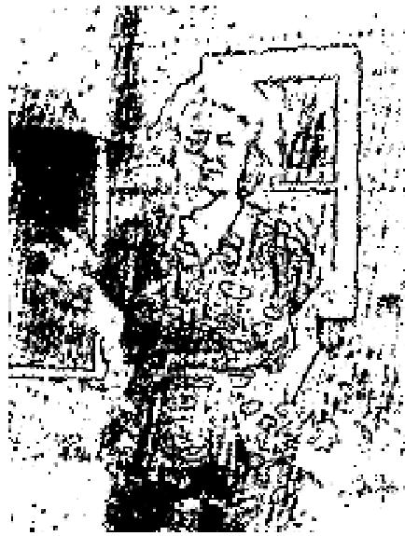
unbearable. In desperation, I made an appointment and was prayed for in a healing meeting conducted by Evang. A. M. Selness. I had the assurance of my healing after prayer was offered, even though the symptoms continued for about two days. I was instructed not to accept defeat because of symptoms, so
I continued steadfast in faith and now have complete victory, Praise the Name of Jesus!
Mrs. Fred Wilkie R. R. #2
Beloit, Wisconsin
(As pastor of The Beloit Gospel Tabernacle, 903 Vernon Ave, Beloit, Wis., I hereby verify the authenticity of this healing, Signed: Albert Taxdahl.)
Russel B. Park-
SUN-SPOT VISION HEALED
When I was twelve years of age there was an eclipse of the sun, visible in this section of the country. As a boy of that age, I did not realize the danger of looking directly at the sun with my naked eye, so I looked until I could see the sun plainly. After that, I could see but a few feet, then the sun spots would blot out my vision. It became worse all the time. On Saturday night, June 16, 1951, I attended a revival meeting conducted by Evang. Russell B. Park in San Angelo, Texas. He called for anyone who had faith that God would heal him right then to come forward. I knew God could heal my eyes, so I didn't hesitate. When Brother Park prayed for me, God healed me. The sun spots are gone. Praise God for the healing touch.
Alfred L. Creel (Age 25)
2023 S. Van Buren
San Angelo, Texas
Louis Kaplan -

THE VOICE OF HEALING 1951
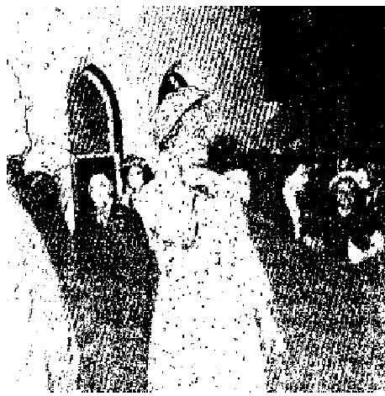
DEAF EAR OPENED
Mrs. J. Beary, 60 Fairview Ave., Toronto, Canada, had her deaf ear opened instantly when a deaf demon was cast out by Brother Louis Kaplan who was testing her hearing when this picture was taken. Mrs. Beary testified a week later that she could now hear the sermon perfectly sitting in the center of the church, whereas she formerly had to sit in the front pew.
A. A. Allen -
ONCE TOTALLY BLIND SEES AGAIN
In March of 1951, 1 bad a stroke. My blood pressure went up to 210. 1 was unconscious four days. After consciousness returned, 1 was blind. I was taken to two eye specialists and one head specialist. They declared I'd never see again. I was totally blind. One morning, while listening to Rev. A. A. Allen's Radio Broadcast, I learned he was conducting one of his special meetings in Tyler, Texas. My son drove me to Texas. As I was unable to see, my son led me to where Rev. Allen was ministering to the sick. Inasmuch as I was unsaved, Rev. Allen would not pray for my healing until after I promised to make a full surrender to God. Some of the ushers led me to a chair where I sat, while another group of sympathetic saints sought
God with me, in the behalf of my salvation. God saved me.
They led me back to Rev. Allen. He placed his hands upon me and prayed. "Thou Spirit of Infirmity, Thou who makes this man blind, I bind and rebuke you now, in the name of Jesus! I command you in Jesus name to go now!” Brother Allen then said to me, while he still had his thumbs over my eyes, "My friend, in Jesus name, in the Power of the Spirit, I command you to open your eyes and see normally this minute!"
Brother Allen took his thumbs front my eyes, and I realized that God had instantly healed me. The first thing I saw was many people. Then I saw their faces. 1 saw the Evangelist clearly, even the color of his tie and suit. Now, I can see perfectly. To God be all praise and glory! Once I was blind, but now I see!
J. 0. Bryan
Chatham, La.-
Witnessed by and affirmed by following ministers:
Rev. M. L. Fauss, (Chairman) Pastor,
Southside Assembly of God
Tyler, Texas
Rev. D. D. Lewis, Pastor
Rose Center Assembly of God
Rev. Allen H. Jurnigan,
White House Assembly of God
Tyler, Texas
Rev. R. D. Ashcroft
Swinney Town Church of God
Rev. Henry B. Ellis
Church of God
Tyler, Texas
S. K. Mabry-
BOY HEALED - DISCARDS BRACES

THE VOICE OF HEALING 1951
After two years of being in braces day and night, our son, Johnny Sims, is now free and walking by himself, through the help of our Lord and Saviour Jesus Christ.
During the Church of God Camp Meeting here in June, he was prayed for by Brother S. K. Mabry. the Lord wonderfully touched his body, and one month later, he began to walk. He now walks and goes any place be wants without help. We praise God for His wonderful healing power.
Mr. & Mrs. W. L. Sims
858 Sandell Dr.,
Ft. Worth, Texas
To Whom It May Concern:
In regard to the claims that are made by the parents of Johnny Sims I know that he was brought to the St. Joseph's Hospital in Ft. Worth, Texas. The parents later took the boy home from this hospital strapped to a brace, unable to move any way except to turn his head. His father was saved in our church, just before Johnny was taken to the Ft. Worth hospital.

Rev. Ray E. Heady
Pastor, White Settlement
Assembly of God
Herbert Leonard -
DISCARDS NECK BRACE AFTER PRAYER
I was in a car that turned over three times, throwing me out and breaking my neck. A doctor put my neck in traction with Crutchfield tongs in my head, and after nine weeks, my neck and body were put in a brace. On
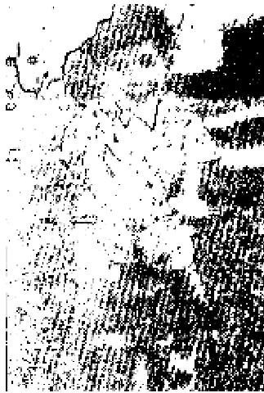
the 5th of September, I went to the doctor lot a check-up, and he told me to come back on the 26th of September for an X-ray; but on the night of September 21st I went to the tent revival conducted by Brother Herbert Leonard. Brother Leonard prayed for me and I felt God touch my body. On the 26th of September, I returned to the doctor. He didn't want to take the brace off, but I showed him that I could move my head without suffering any pain. He said, "We will take a picture and see." The X-ray showed the formation of a new bone. He then said I could go and leave off the brace. I haven't worn it since.
Edward Howze
929 N. 13th St.,
Waco, Texas
Confirmed by;
Mrs. D. C. Howze
929 N. 13th St.,
Waco, Texas

December 1951 p 10
HEALED OF EPILEPSY
I'm thankful to God for saving my soul and healing me of epilepsy with which I had been afflicted since the
age of 11. I am perfectly well since I was prayed for in the Coe Revival in Little Rock, Arkansas.
Ruby Shrader
Rt. 9, Box 40B
Little Rock, Ark.

THE VOICE OF HEALING 1951
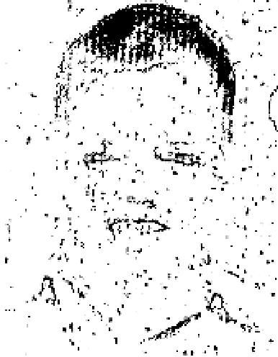
DEAF MUTE HEALED
David Driver, 1457 Otis Avenue, Wichita, Kansas, was a deaf mute. Brother Coe prayed for him in the Wichita revival, and he was healed. Over 100 people stood up in the meeting as witnesses that they knew the family and knew that the boy was healed.
Several times after his healing, Brother Coe had the boy come up to the microphone
and talk to the people in the congregation.
Miss L. Driver, (Sister)
HEALED-DISCARDS CRUTCHES
My knee was crushed 20 years ago, and had been out of place since I was 14 years old.
I am now 63. For the past 7 years, I was on crutches, but when I attended Brother Coe's tent revival in Little Rock, Arkansas, and was prayed for, God healed me, and now I no longer need the crutches.
J. R. Stondridge
Scott, Arkansas
December 1951 p 11
STOMACH CONDITION HEALED
Praise God for a wonderful healing! I had suffered for years with stomach, back, and kidney trouble, and
arthritis of the spine.
Dr. Westfall, of Halstead, Kansas, and Dr. Calhoun, of Wichita, were my doctors. They had treated me for years. My stomach was in such a bad condition that I could not retain my food. Since Brother Coe prayed for me in the Wichita meeting, I am well and can eat anything I want.
Anna May Sanders
1522 North Mosley
Wichita, Kansas
RHEUMATIC HEART HEALED
I'm 13 years old, and have had a rheumatic heart all my life, but God healed me when Brother Coe prayed for me in the tent revival at Little Rock, Arkansas. I have been feeling well ever since, get around fine and nothing bothers me.
Ruby Fruman
1121 Garland
Little Rock, Ark.
HEALED OF DEAFNESS
I had been deaf in my right car since I was 16 years old. Dr. Hal Dilday, of Little Rock, said nothing could be done for me. I came from Little Rock, Arkansas, to Wichita, Kansas, on Sunday afternoon. Brother Coe called for those who were hard of hearing or deaf in one or both ears to come forward. I went forward, and the moment Brother Coe prayed for me, the deafness left. I stayed two weeks longer and enjoyed the rest of the meeting. Praise God for His healing power!
Mrs. Jess Green
1114 Woolf Street
Little Rock, Arkansas
HEALED OF TRIPLE RUPTURE

THE VOICE OF HEALING 1951
I had suffered for 24 years with a triple rupture and had tried many ways to get rid of it. On May 26th, in Brother Coe's meeting in Wichita, Kansas, I entered the healing line and was healed instantly. I certainly praise God for His healing power. I am well and doing all my work and testifying for what the Lord has done for me!
Mrs. Marion Taylor
Norwich, Kansas
December 1951 p 12
MANY TESTIFY TO HEALING DURING VALDEZ CANADIAN CAMPAIGNS,
HEARING RESTORED TO VICTORIA, B. C. WOMAN
When I was 14 years old, I was stricken with scarlet fever,, which left me deaf in my left ear. Doctors told
me that I'd never be able to hear with that ear again, and that I was fortunate to hear with the right car.
I also had a growth on my right side - but when Brother Valdez prayed for me in his Victoria healing campaign, my right side was healed, and my hearing was restored. Praise the Lord, now I can hear a watch tick with my left car!
Mrs. E. Lambier
1002 Gasper Ave.,
Victoria, B. C.
DISCARDS LEG BRACE AFTER PRAYER
In 1949, while working for Stockers Transfer Co., I stepped off the end of a truck. I broke the ligaments and tendons in my ankle and split my ankle bone. I had to have two muscles removed and the ligaments and tendons replaced. I was in the hospital for three months and was obliged to use crutches for ten months. For a year after I stopped using the crutches, I had to wear a brace. Rev. Valdez, Jr., prayed for me when he was in Victoria. That night when I got home, I took my brace off and I could walk perfectly. The next night I walked onto the platform without my brace and gave my testimony. God is my Healer.
Charles John Rodway
1848 Hollywood Crescent
Victoria, B. C. .
SHORT LEG MADE NORMAL BY PRAYER
When I was 17 years old, I injured my left hip while playing football. Since that time, I suffered with this injury and my left leg became an inch shorter than my right leg. Rev. Valdez, Jr., prayed that God would cause my left leg to grow out to its normal length. I went home that night believing God had healed me. It was three days later when I noticed my leg had lengthened to its normal size, and I could walk with perfect comfort for the first time in 55 years.
Charles M. Forster
657 Langford St.,
Victoria, B. C.
HEARING AND SIGHT RESTORED TO INJURED WORKMAN
In 1942, 1 fell from a scaffold while working for So. Burrard Yards in Vancouver, and injured my left side, breaking many bones and leaving me deaf in my left ear and blind in my right eye. My doctor told me that he had no hope of helping my hearing, but that an operation might restore my sight. The operation was unsuccessful. When Rev. Valdez came to Vancouver, he prayed for me, and God instantly healed me, so that I was able to hear Rev. Valdez as he whispered in my left ear. I was so happy I nearly forgot about my blind

THE VOICE OF HEALING 1951
eye and started to leave the platform, hut Rev. Valdez called me back and prayed that God would open my blind eye. Immediately I could see clearly, and I counted his fingers without any difficulty. I don't know how to thank God enough.
Wm. H. Webb
874 West 6
Vancouver, B. C., Canada
December 1951 p 13
TWIN MIRACLES OCCUR IN OSBORN CAMPAIGN BODY CASTS DISCARDED AFTER PRAYER
We are praising the Lord for the marvelous way He has healed our nine-year old son. Frankie had always been a very active boy, and one day while climbing a tree onto a garage, he and the others he was playing with decided to jump off the garage. They did, and it seemed that none of them were hurt. This was in September, 1950. Very soon after this, however, Frankie started to limp, and had to give a skip to keep pace with the other boys, The State nurse from school noticed it, and came to the house requesting me to take him to the clinic. I refused, but in April, the State nurse came again, and insisted he should be taken to the clinic. I took him to the clinic, and he was x-rayed. They said it was Perth's disease. This disease destroys the joints, and it had settled in his hip, and the hip joint was being destroyed. They put a cast, an his body, from his chest down over one leg to his toes. He had this cost on for three months, when we heard of Brother Osborn's healing campaign in Altoona. When Brother Osborn came to Frankie in the line, he asked us if we believed God would heal him, and we said, "Yes." He then asked if I would be willing to cut the cast off, and bring it back the next night. I said I would. We cut it off and saw that Frankie was healed. He doesn't limp any more. All' the stiffness is gone from his leg, and he is completely well. The Perth's disease had to surrender to the Power of God We are so thankful!
Mrs. Blanche Rhone
719 Fifth Ave.,
Altoona, Penna.
BODY CAST #2 DISCARDED IN ALTOONA AFTER PRAYER
My boy also had that terribly destructive Perth's disease. He too was in a cast, very similar to that of Frankie Rhone. We took him to the Osborn Healing Campaign, where Bro. Osborn prayed for him. One of the ushers took him in the prayer room, and cut the cast off. He was wonderfully healing. Praise the Lord! There, before that large audience of people, he walked back and forth, showing how he was completely healed. At this time, the cast has been off a couple of weeks. All our family is rejoicing over this miracle. He had been in a cast for about ten months -the cast covered most of his body,, and down one leg. Now both legs are normal. I am so thankful-to God for His healing power!
Mrs. Melvin Chamberlain  R.D. # 2  Williamsburg, Penn.  NOTABLE HEALINGS IN OSBORN REVIVALS  SHAKING PALSY - HEALED  Rev. J. E. Snowberger, Williamsburg, Pa., was afflicted with shaking palsy, Doctors said  nothing could be done. He states that when Brother Osborn prayed. for him in 1949, he  was definitely healed. Now, two  years later, he testifies that this healing stands and he is sound and well. | 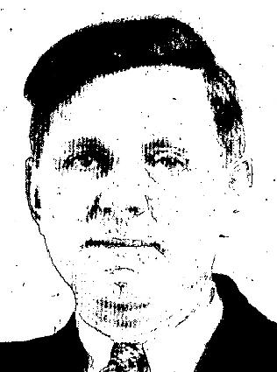

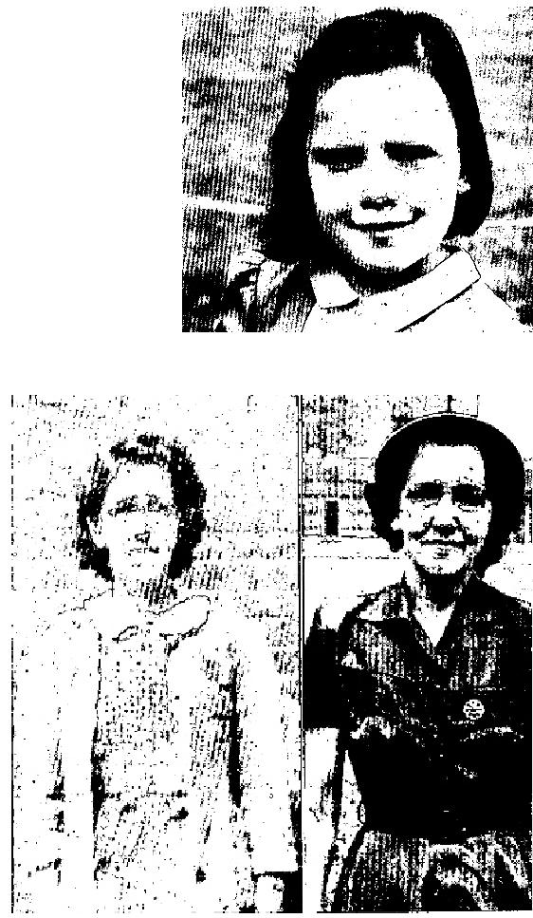
THE VOICE OF HEALING 1951
SCALP INFECTION - HEALED
Seven year old Aletta Marie Evans, Box 788, Altoona, Pa., was afflicted with a ringworm infection of the scalp. This caused numerous bald spots on her head. It had been treated by a doctor, but to no avail.
Brother Osborn prayed for her and now her head is normal. New hair is growing in and the bald spots are fast disappearing.
CANCER OF BOWELS HEALED
Mrs. Stella Bishop, Petersburg, Pa., was healed of cancer of the bowels in the Osborn campaign, She had been unable to steep without the aid of drugs for over a year. Since Brother Osborn prayed for her, she has eaten anything she desires, and is able to sleep well, without the use of drugs. She states that she has gained 7 pounds. (Photo at right shows Mrs. Bishop before and after her healing.)

December 1951 p 2

THE VOICE OF HEALING 1952
January 1952 p4
SIGNS - WONDERS - MIRACLES: IN THE CAMPAIGNS OF TVH EVANGELISTS
R W. Holmes -
Crutches No Longer Needed
I had arthritis for ten years and used a crutch most of the time. Sometimes it became so bad that I was
bedfast. For the past year and a half I depended upon my crutch completely to get around. I took many
different kinds of medicine, and went to doctors, but none of them did me any good.
When Brother R. W. Holmes prayed for me during his Paris, Texas, meeting, the Lord instantly healed me, and I have not used my crutch since. Now I am able to do all my work without the use of a crutch or any support whatever, and can even work in my garden, (something I could not previously do). I truly praise the Lord for His healing power today!
Pearl Christopher
Route 5,
Paris, Texas
Clifton Erikson -
Life Restored To Stiff Leg
My twenty-year-old sort has had no feeling in one foot and leg since birth. He has been from Burlington,
Vt., to Boston, Mass, to all kinds of doctors and hospitals, and they could not determine the cause of the
trouble.
Recently, however, my son went through the healing line in Brother Erickson's meeting, and when Brother Erickson prayed for him, the feeling instantly came into his leg. The next day the big toe joint, that had been stiff for fifteen years, became limber, and has been free ever since. We praise God for his healing!
Mrs. E. V. Towne
Sherburne Center, Vt.
A.A.Allen -
GROWTH ON FACE DISAPPEARS
For about two months, I had some kind of growth on the side of my nose, that spread under my eye. It grew so rapidly and was in the way of my wearing glasses, that I decided to see a doctor. He told me that he would remove the ' growth and have it analyzed. I made an appointment to return to have this done. However, I did nor keep the appointment, but decided to trust God. I wrote to Brother A. A. Allen and asked him to pray for me that God would remove this growth. He sent me a prayer cloth. I placed the cloth on the growth, and now, praise God, it is gone. I praise God for the healing and for His good ministers that are always so ready to help.
Mrs. Ada Hendrix
Canyonville, Oregon
Jack Coe -
Given Up to Die By Mayo's - Now Well
I am thanking the Lord for His wonderful healing power. I was sick for the past two years; the last year of
which I was practically bedfast and helpless. On August 25, 1951, I was healed in the Jack Coe meeting at
Little Rock, Arkansas, and am well today.
I had a disease called scleroderma, which is the tightening of the derma to the bone, checking all circulation where it sticks.

THE VOICE OF HEALING 1952
This is the diagnosis of the Mayo Brothers, of Rochester, Minn., given us in March of this year. In October,, 1950, I became very stiff and sore in my joints. My joints were enlarged, and I grew worse and worse. I went to 9 of the most prominent doctors in Arkansas, and none could find any. thing organically wrong with me. I had X-rays, fluoroscopes, blood tests, skin tests, complete check-ups, through one clinic after another, chiropractor adjustments - all with no results. I was getting worse, as the disease was advancing rapidly. By this time, we knew I was losing grounds fast, so our family physician advised me to go to Mayo's.
On the fourth day, one of the doctors called my sister out of my room to tell her, "We cannot do your sister any good. You may go back home." This came as a severe blow to me, I knew it meant just a matter of time for me. Mayo's gave us a treatment of therapy light, followed by a cocoa butter massage to try to add to my comfort. This was applied through my family doctor, with shots prescribed by Mayo's. I grew worse all the time. As the swelling in my feet and hands would be reduced, the derma would stick; as it stuck, my skin would itch and turn dark. I was partly petrified and dead in parts of my body, My stomach was affected, and I could not eat. The skin on my chin and cheeks were stuck and one side of my face was drawn out of shape. I could hardly open my mouth for drink or food. I had no appetite.
My hair and eyebrows were coming out. The skin stuck so tight to my bones that the blood could not circulate properly, and I could not feel the change in temperature from hot to cold. I lay lifeless for hours at a time in a deep steep. My nurse would apply my therapy treatment and massage twice daily and my skin would become dry between treatments and terrify me with itching. I could not stand the touch of clothing or bed-clothes. My throat was closing up as it stuck, and we knew the disease was in the last stage. I was turning black, and was mentally ill. I could not think or talk clearly. I was living in a fog, I could not even stand up. I was not responding to any treatments, and the doctors told my folks that I had but a few days to live. I had lost weight until I weighed only 85 pounds.
THEN WE HEARD OF JACK COE'S MEETINGS. At first, I could not think clearly enough to reason with myself, but I prayed for a clearer mind and faith to ask our Lord to heal my body. The third day my mind was brighter, and my folks and I could talk it over about our going to the meeting. We lived about 100 miles from Little Rock. My son, my sister and I made the trip in a car. They made me a bed in the back seat. My son carried me under the tent, and I lay on a stretcher during the service that night. Then Brother Coe came to me. I was praying so hard I don't remember all that he said - but when he said, "Get up and walk - I did-and have been walking ever since. We got home from the Little Rock meeting about 2 o'clock on Sunday morning, and that same morning at 10 o'clock, I went to Sunday School and church. My pastor and church members were surprised to see me, but they rejoiced with me because they knew that it was the work of the Lord.
The first 7 weeks after I was healed I went to church every night, testifying of my healing. I have received such a great blessing that I want to tell it to everyone. I eat anything I want, and feel fine. I have no pain, my skin is gradually becoming loose from my body, and the swelling is all gone. I can wear shoes and clothes, and live like other folk.
My family doctor said that God was the only one who could save me - that no medicine or human hands could have done it. I am so thankful for my healing, that I am always willing to accept any opportunity to testify for our great Lord and Master. I have been healed 10 weeks and have gained 9 pounds. I now weigh 94 pounds, and gaining every day in faith, courage, strength, and weight.
Mrs. Jackie Rhodes
P. 0. Box 14
Delight, Arkansas

THE VOICE OF HEALING 1952
S.K. Mabry
Crippled Boy Walks
I have always believed in the healing power of God. My little son was crippled from birth. For two years, he
could only walk on his toes. I took him to Rocheport, Mo., where Brother Mabry was conducting a healing
service in the City Auditorium.
Brother S. K. Mabry prayed for him, and that night he walked off the platform as well as any child of eight years could. Praise God for his healing power!
Mrs, J. M. Blackburn
Rocheport, Mo.
January 1952 p9
Minister Healed and Revived by Jackson Ministry
As a small child I was afflicted with osteomyelitis, a bone disease, and three inches of my left leg above the knee had to be removed. For four years, I could not walk. Nine doctors said I would never walk, and had very little hopes of my living. In answer to my mother's prayer, I recovered and today I am able to walk without a limp.
However, as a result of this affliction, I suffered with severe heart trouble, bronchial asthma, hay fever, severe headaches. weak eyes, and had to wear glasses.
Last fall, Brother Gayle Jackson came to San Antonio for a city-wide revival, and at first I was overcome with doubts and the spirit of apostasy, but after attending one service, all doubts were swept away, and Brother Jackson's anointed messages caused me to return each night of the eight weeks he was here. One night during the revival, I received a prayer card, and a few nights later, Brother Jackson prayed for me. God healed me of every affliction, oh, glory to His name! No longer am I weak. My heart is sound, the asthma and hay fever are gone, and I preach God's Word without glasses. Any one of these diseases and afflictions would have been a miracle, but God confirmed His Word by delivering me from all of them.
Far surpassing my deliverance from these afflictions was the spiritual blessing I received from the Jackson revival here. After many days of fasting and prayer, and encouragement from Brother Jackson, I reentered God's service in a Divine healing ministry in June of this year. In post years, my ministry has been fruitless and barren, but praise God He has now given me power to release the captives and I have seen more results in the past 60 days than I have seen in all the past five years of my ministry. God sent Gayle Jackson to San Antonio for my wife and me.
Rev. Russell B. Park
915 Highland
San Antonio, Texas
Healed in K. C. Campaign
I had suffered for seventeen years from three serious ailments (the doctors said either of them could have killed me). I prayed constantly and never lost faith that some day God would deliver me. How, I didn't know, but I believed in His promises and Divine healing - so I waited on the Lord.
Then I read that Gayle Jackson was coming to Kansas City in a revival campaign. I was determined to see him, for I felt confident that because of his great faith in God, if he prayed for me I would be healed. I attended the meeting, Brother Jackson prayed for me, and God healed me - Praise His name!

THE VOICE OF HEALING 1952
Evangelist Gayle Jackson is truly a man after God's own heart and his faith in God is an inspiration to those who are prayed for. God healed me as He promised to do when we believe He is the same yesterday, today and forever.
Mrs. Paul W. Upton
111E. Ruby St.
Independence, Mo.

January 1952 p10
Four Modern Miracles from the Letter files of Evang. Jack Coe
DEAF LEFT EAR
I'm thanking God for His wonderful healing power. My 8-year-old son, Ronnie, had infected tonsils which had affected his hearing. The hearing in his left ear was practically gone, but after Brother Coe prayed for him, his hearing was immediately restored. His hearing had been so bad that he could scarcely hear what his teachers were saying, and the next day after he was prayed for he came home from school and said, "Mother, Jesus completely healed me." I can even hear a whisper. There's no limit to what God can do if we put our trust in Him.
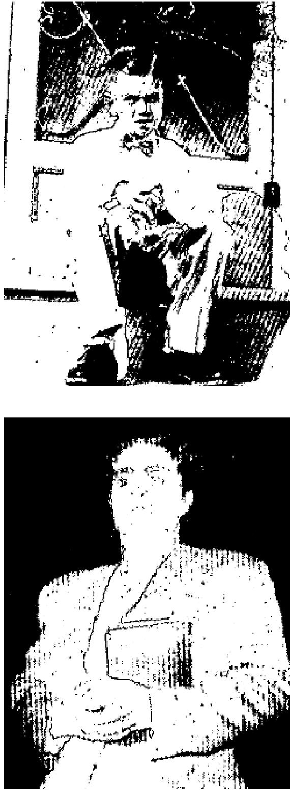
Mrs. R. W. Rankin
605 No. 32nd
Ft. Smith Arkansas
LADY MINISTER HEALED
I fell and broke my spine and lay in bed for a year, paralyzed from my waist down, and for twenty-two years I have-worn a heavy support for or my back. I never went without it. Doctors said I could never be any better.
I've been an Assembly of God minister for twenty-six y-ears, have had numbers of folk to pray for me and had almost given up hope of ever being healed. But I attended Brother Coe's healing campaign at Ft. Smith, Arkansas, where Brother Coe prayed for me and God marvelously healed me. I took off my support threw it
away, and haven't had it on since.
I also had a bad case of heart trouble, and stomach ulcers. I couldn't eat anything - just drink milk, but praise God, He healed me of all these afflictions.
Mrs. A. L. Gilpin
Box 121
Panama, Oklahoma
I the husband of Mrs. Gilpin, verify this testimony to be true. Rev. A. L. Gilpin

THE VOICE OF HEALING 1952
RAISED FROM AMBULANCE COT
In 1936, 1 suffered a severe attack of rheumatic fever, which affected my heart. In November, 1950, I had a recurring attack which resulted in heart block. I was examined by three doctors and told that I could not sit up for six months. I suffered intense pain as I labored for or breath, and was given nitro-glycerine every fifteen minutes.
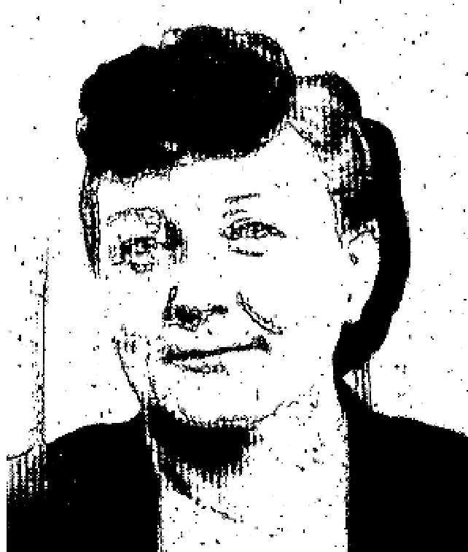
I was prayed for or in Brother Jack Coe's revival in Carthage, Mo., was instantly healed and
raised from an ambulance cot, and able to preach in a local assembly the following Thursday night. My healing still holds good today. Praise God for His wonderful healing power!
Alice Boyer
2528 East Avenue
Springfield, Mo.
POLIO VICTIM COULDN’T WALK - CAN NOW RUN
Praise the Lord for what He did for me! I had polio and was unable to walk. I was in Sparks Hospital in Fort Smith, Arkansas, where Dr. Shears was my attending physician.
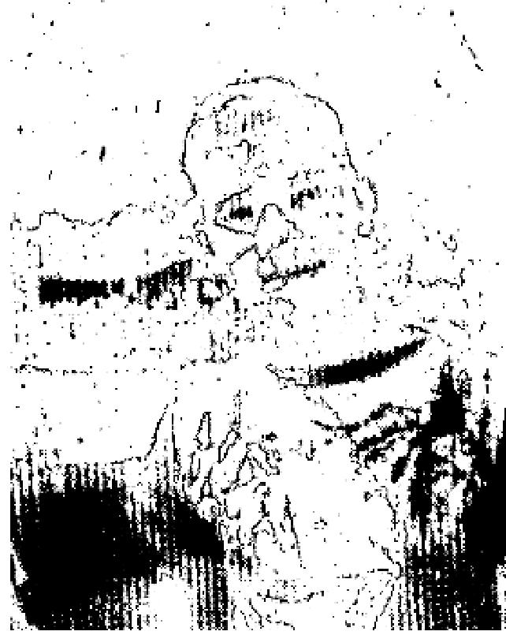
While Brother Jack Coe was in a healing revival in Fort Smith, I attended. He prayed for me, and the Lord wonderfully healed me. Now I can walk and run and play.
Kenneth Riley
2234 N. 7th
Ft. Smith, Arkansas
January 1952 p11
Two Goiters and Stomach Ulcers Healed By God's Power

I was in the hospital and had a goiter removed. One year later, I was back in the same condition but with two goiters this time. With this, I also had a severe case of stomach ulcers and was on a special diet, unable to eat many things, I could not take any nourishment except milk and raw eggs. I found it impossible to sleep, and my eyes were bulging out of my head because of the goiters choking me.
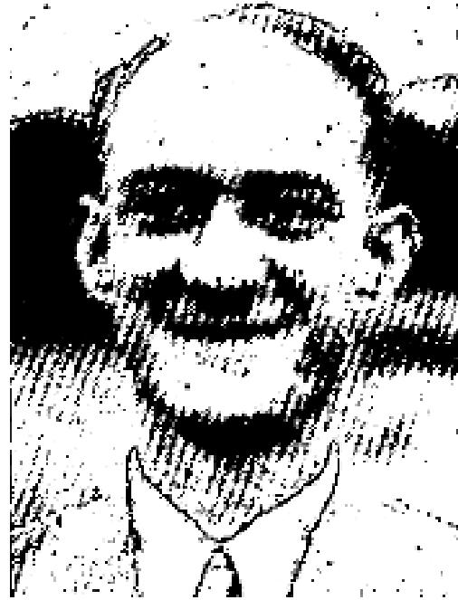
My sister went to Brother Osborn's healing campaign and was saved and healed of an injured spine, of kidney, bladder, and skin trouble. She convinced me that I should go, and I did. After the message, on the very first night, I went forward, with many others, and accepted Christ as my Saviour. After this, Brother Osborn prayed for me, and God instantly healed me. The goiters vanished, my eyes went back like they should be, and I can eat anything I wish. I was also delivered from the habit of smoking.
Mr. George M. Drasher
594 After St.,
Hazleton, Penna.

THE VOICE OF HEALING 1952
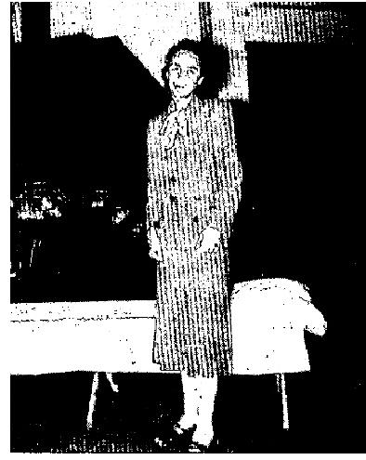
January 1952 p12
BEDFAST VICTIM RAISED UP AT COLISEUM
Alice L. Barran of Tamer, Iowa was carried into the Cedar Rapids meeting a helpless victim of brain pressure, having one hard convulsion after another. She was raised from her cot, and writes a few days later, "I am well now and joyfully serving Him who is able to do all things whatsoever we ask in faith believing."
January 1952 p13
CRIPPLE LEAVES CRUTCH I had been crippled with a hip condition for seven years. I had been to all kinds of doctors and my hip had been operated on twice. X-rays showed that the bone was worn out in the socket and the flesh was like ground-up meat from the jagged bone.
Eighteen months ago 1 was operated on and a metal cap placed in the hip joint. In another operation the cap was removed. My muscles were so weakened from the cutting in these operations and I suffered such pain that I could not walk without a crutch from the time of the first operation.
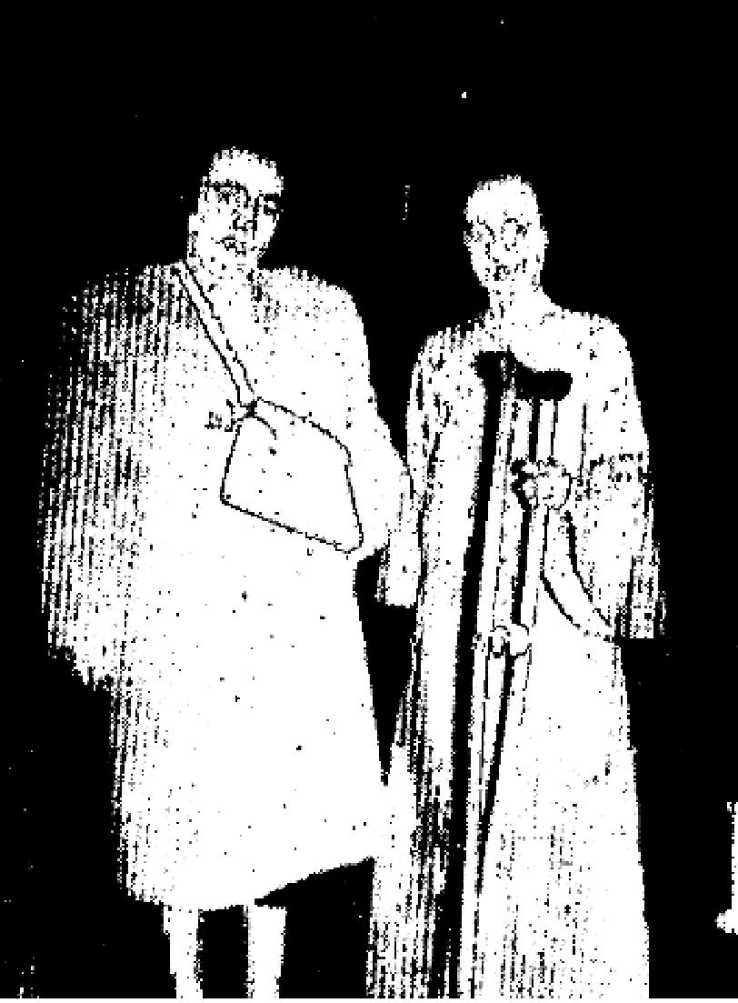
I had been in so much pain that I came for prayer with doubt and fear. Sister Nankivell discerned the fears that were troubling me and rebuked them. Faith suddenly took hold of my heart and I threw my crutch down
and have not used it since. In fact, I left it at the service. Two days later I even helped someone move. My muscles are strengthened, and I have no more pain.
Signed by:
Mrs. Bertha Chambers
Rt. 2, Box 357
Salem, Oregon
Endorsed by:
Pastor Walter S. Frederick
HEALED OF T. B.
A kidney specialist in Portland had diagnosed my case as T. B. of bladder and kidney. I suffered severe pain and had passed much blood from these regions that I was to go to the T. B. hospital in The Dalles immediately.
I prayed for God to give me a sign by letting someone who did not know of my condition tell me what was wrong with me. I then made a special effort to get to Portland to the services where I heard how wonderfully God was moving in healing sick bodies.
God spoke to Sister Nankivell and told her my condition and she called me out of the congregation. I knew then that it was God's chosen time for my healing. I now have complete victory and deliverance from my disease.
Nadine Kaneaster
1003 Court St.
The Dalles, Oregon

THE VOICE OF HEALING 1952
February 1952 p9
MIRACULOUS CANCER HEALINGS IN A. A. ALLEN MEETINGS
I had a cancer on my hand which was getting worse rapidly. When I attended A. A. Allen's Tent Revival in Yakima, Wash., in July 1951, it had spread and was very bad.
One night I entered the prayer line for healing. Rev. Allen prayed for me and commanded the cancer to go! During the next few days THE CANCER BEGAN TO DRY UP. As it withered, it loosened and came out by the roots, leaving ugly holes where the roots had been. These holes gradually filled in and smoothed over with new flesh.  It has now been three months since I was healed. My hand is as smooth as a child's and only a small scar remains. No pain has ever returned. To God be all praise and Glory!  Nola Sherrill  Calico Rock, Arkansas  Oct. 26, 1951 | 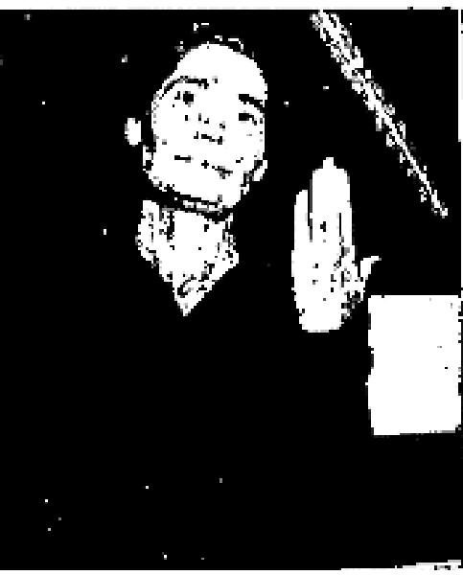

On October 26, 1951, Nola Sherrill attended the A. A. Allen Revival in Memphis, Tenn., and testified to the above miracle of healing. At this date there was no sign of any cancer on this woman's hand.
Rev. Robt. Fairchild
Chairman, Memphis, Tenn. I
I affirm that in July, 1951, Nola Sherrill had a cancer on her band and was prayed for by Rev. A. A. Allen in the prayer line.
Rev. B. V. Jones,
Chairman, Yakima, Wash.
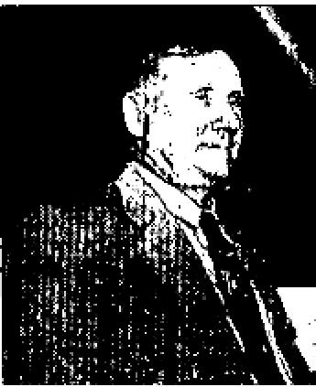
On my right cheek, near the right eye, a horrible lump began to grow. It continued to grow and to get worse as it spread. It was soon obvious that it was cancer and diagnosed as such. It caused me much anxiety and pain.
One night while attending the Allen Healing Revival in Yakima, Washington, God spoke to me saying, "Get into the healing line and I'll heal you of this cancer." I entered the prayer line and Brother Allen prayed for me, cursing the cancer in Jesus' Name! He commanded it to leave. Three days later the Spirit of the Lord came upon me in an unusual way, I realized that something was taking place as the cancer began to tingle. SUDDENLY THE CANCER VANISHED! I could never find it. It just disappeared. I ran to my wife and asked her to look. THERE WAS NO SIGN OF THE CANCER! Even the skin where the cancer had beer; was smooth and no discoloration was left. This testimony is being given three months later. To this time, no soreness or pain has ever returned.
W. W. Moorehead
Knob Creek, Arkansas
Oct. 26, 1951

THE VOICE OF HEALING 1952
In July, 1951, W. W. Moorehead attended the Yakima meeting and entered the prayer line afflicted with the above described cancer.
Rev. B. V. Jones
Chairman, Yakima, Wash.
This is to affirm that W. W. Moorehead attended the A. A. Allen Revival in Memphis, Tenn., and on the night of Oct. 26, 1951, testified to the above healing. At this date there was no sign of a cancer, not even a scar.
Rev. Robt. Fairchild
Chairman, Memphis, Tenn.
February 1952 p11  Miracle Healings Of Blindness, Deafness Frequent Great Meetings  TOTALLY BLIND  About 30 years ago I was hit with a limb in the left eye. Later I want to a doctor who said I had cataracts on both eyes. For 20 years I had no sight in the left eye, but when Bro. Grant was in Ardmore and called for someone who was blind in that eye, I went forward and was healed. Now I can read with the left eye, and it is better then the other one. I also was healed of partial deafness, heart trouble and throat trouble.  Arozome Azloett  Ringland, Oklahoma | 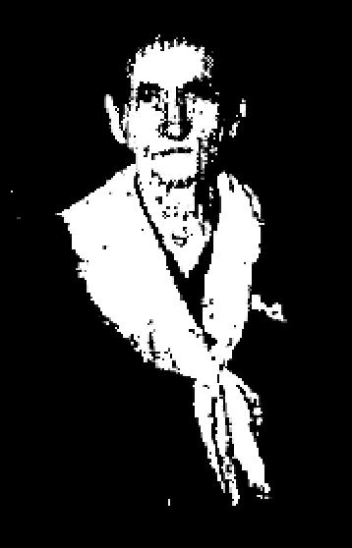

TOTALLY DEAF EAR, GOITER
I had been deaf in both ears for twelve years - totally deaf in my right ear. The ear specialist in Montreal, Quebec, said it was hereditary and nothing could be done to help me. Seven years ago I purchased a hearing-aid which helped me to hear some out of the left ear. Through a friend I heard about the great Camp Meeting in Wheatley, Ont., and we decided to attend. As we had never been in a Pentacaostal Meeting, I had never heard healing of the Holy Ghost preached. While Brother Grant was praying for a lady with a goiter, I received healing for a goiter I had, while yet in the audience. Then 1 went to the prayer-line and received instant healing for both ears. I discarded the hearing-aid completely healed! I received the Holy Ghost.
Doris Campsen
South Botton, Quebec
W itness: Rev. Enison. Minister
TOTALLY BLIND EYE
Arsenic lead had caused pus pocket to form behind my eye-balls, and because of this 1 underwent an operation in Memphis, Tenn., for my right eye. The doctors said my eye-sight was completely gone and they could do nothing to help me. For eight yeas 1 was totally blind in that eye. I was prayed for during the Grant Campaign in Flint, Mich., and now I can see to read with my right eye and do not need glasses.
James Hammonds
4022 Fenton Road
Flint, 7. Mich.
Witness: M. A, Jollay

THE VOICE OF HEALING 1952
February 1952 p12
Kansan, Given up to Die Healed In Coe Meeting
December 3, 1951
I was born with fiber tumour of the spine, for which I was operated on at Mayo Clinic, Rochester, Minn.. in September 1945. The operation was a success, as far as the operation was concerned, but it left my back very weak, and at times I could not be moved in bed, or even dress myself.
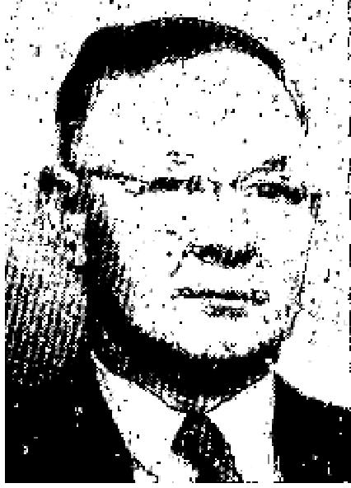
My local doctor gave me six Months to live and Mayo said they had done all that was possible at the time, so I had to retire from my work.
I thank God for heating me when Bro. Jack Coe prayed for me at the tent revival in Wichita, Kansas. I had been troubled with arthritis for over twenty years and that, too, left instantly. I am able to, do any kind of work now at the age of 67 years. I was also healed of high blood pressure when prayed for by Bro. Morrison and Bro. Noah at the First Assembly of God church here. Praise God forever!
O. H. Baker
727-S Ida Ave.
Wichita, Kansas
March 1952 p3
This Month's Cover
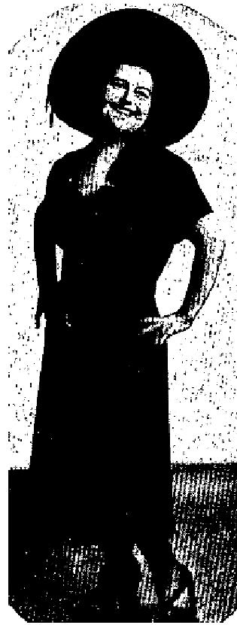
"FAT LADY OF THE CIRCUS" NOW WEIGHS 126 POUNDS
In May, 1951, when I was dying with a heart affliction, I received upon request an anointed cloth from Rev. and Mrs. W. B. McKay, and the Lord wonderfully healed me of heart trouble.
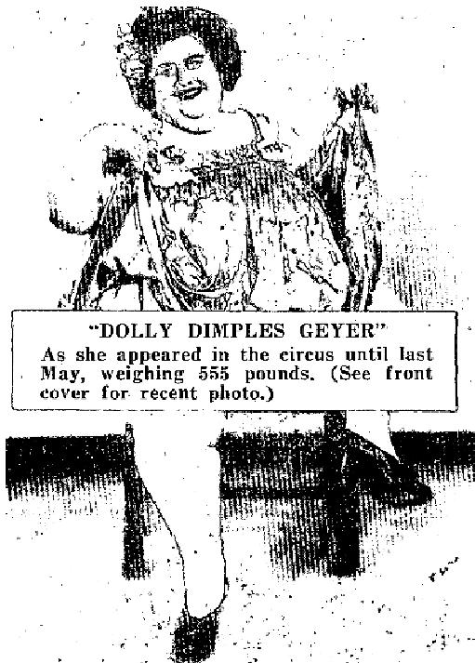
Then when their tent was erected on the Orange Blossom Trail in Orlando, I attended the meeting and was prayed for that I might lose a great deal of weight, as I WEIGHED 555 POUNDS THEN. God answered, and since that night, only six months ago I HAVE LOST 429 POUNDS. I do believe it was the prayers of God's servants, Bro. and Sis. McKay and other friends whip prayed on my behalf that I have lost all this excess fat.. I 'have not felt one moment of ill effects in losing this tremendous amount in such a short time.
Since my husband and I found, the Lord in the McKay meeting we are happy in Jesus.
This miracle is of God, and I have testified in many public gatherings and on radio programs and magazines to God's healing and keeping power.
Mrs. "Dolly Dimples" Geyer
Box 21, Lockhart, Florida

Crippled Trainman Discards Crutches and Brace in Meeting

THE VOICE OF HEALING 1952

On January 16, 1943 1 was crippled in a train accident. Being a railroad man, I was sent to the Cotton Belt Hospital at Texarkana Ark., where the doctors told me there was no hope. I spent time there and in Campbell Clinic in Memphis is trying everything I knew but all the best specialists said the same thing - that I was to either die or him a hopeless cripple the rest of my life. The three lower vertebrae of my spine were crushed, three ribs broken loose from my backbone and the right sciatic nerve severed.
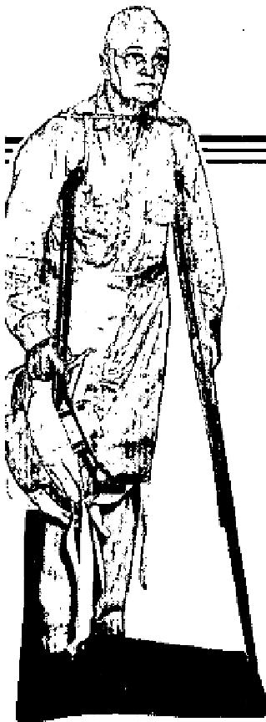
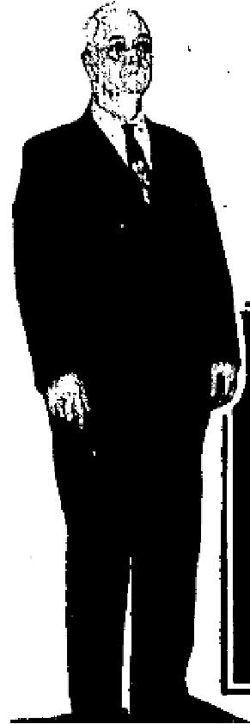
It was on the night of January 10, 1949 that God instantly healed my body, while Sis. Huffstutler was preaching and praying for the sick in Pine Bluff, Ark. She did not even pray for me, only looked at me and said, "Brother, " has already healed you!"
I took one leap in the air, and when I hit the floor, I was perfectly and completely whole.
I walk better than I had in all my life, and have better health than ever.

Mr. Neal Thomas
120 W. 14th St.
Pine Bluff, Ark.
INDIANA MAN WALKS WITHOUT BRACE
(Pictured on cover with P. N. Green)
This testimony is to certify that I had a back injury in October, 1950 and was in a body cast from March 12 to May 16, 1951. When the body cast was removed in Indianapolis, the bone specialist immediately put
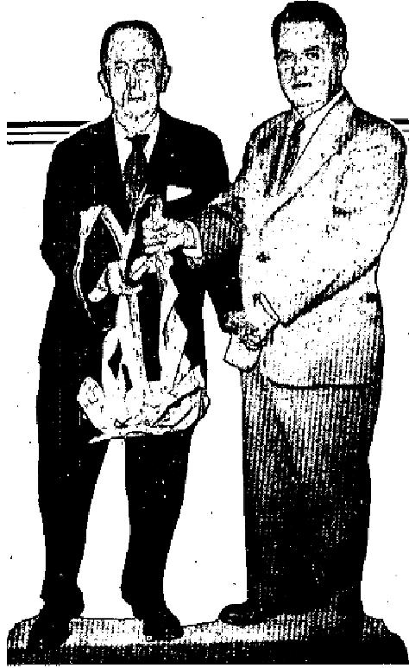
a leather-covered steel brace on my body and I had to wear it every day from May 16 until the night of October 22nd when Brother Green from Tampa, Fla. prayed for my healing in the Assembly of God Church,
Bedford, Indiana. Since that night I have not had the steel brace on, although the doctors told me that I would never be able to walk again without it.
James Johnston,
1815 West 16th St.,
Bedford, Ind. 4

March 1952 p4
SIGNS - WONDERS - MIRACLES - IN THE CAMPAIGNS OF TVH EVANGELISTS

WILLIAM A. WARD
HEALED OF CANCER
For two years, I was tortured with cancer of the breast and under-arm, also in sternum bone. I went to the Nichols Cancer Sanitarium two years ago, and they removed my breast. I returned to the hospital four different times, and the last time they said there was nothing else to be done but return home and take something to kill the pain. . The main leader in my arm is completely severed. I lived on drugs for some time, but I didn't give up. I went to two other doctors, and they said they couldn't promise anything, but suggested x-.ray treatments, so 1 took eighteen of them. I grew worse - becoming so bad that I had to be
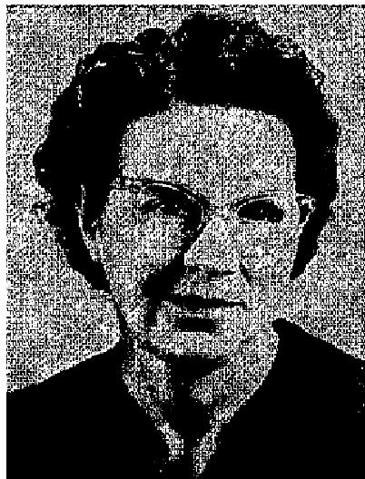
helped on and off the bed, and I could not move my head without assistance.

THE VOICE OF HEALING 1952
I never gave up. I said that I would be healed, It seems as though I've lived on faith for the last two years, praying for God to heal me, but seemingly I didn't get anywhere. I heard of the William A. Ward Healing Campaign coming to Douglas, and I lived for that time to come! I went up for prayer the first night of the meeting, and every pain left me instantly! I haven't had a cancer pain since the night of November 17th when Brother Ward prayed for me, I saw many other miracles during this meeting.
I can't thank God enough for what lie has done for me. I have consecrated my life to God to use as He wills.
Mrs. G. W. Clark, P. 0. Box 612
Douglas, Arizona
G. O. BAKER
DOCTOR DECLARES HEART PATIENT WELL
Since my healing a year ago, I have had no recurring heart attacks. I now enjoy good health, have gained in
weight, and am busily engaged in keeping busy with home and church activities.
On Armistice Day, I took a trip by car to General Grant Park - 35 miles from Kingsburg. an altitude of 6,500 feet. My healing was again verified, as I had no ill effects whatsoever from the high altitude.
My heart is filled with praises and thanksgiving to my wonderful Lord!
Hannah E. Bodeen, 1517.5 Tulare St.
Kingsburg, Calif.
EDITOR"S NOTE: Accompanying this testimony was a Progress Record Sheet from The General Hospital of Fresno County, in which Dr. Robert B. Rowe states: "Miss Bodeen seems to be a new woman.”
R. W. HOLMES
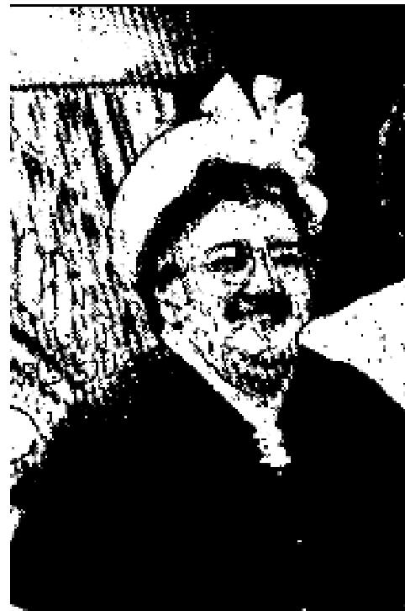
LIFE RESTORED TO APPARENTLY DEAD BODY
On November 26, 1951, I attended Brother Holmes' salvation-healing campaign at the First Hebrew Christian Synagogue in Minneapolis, Minn. While sitting in the pew listening to him preach, I had a "passing out" feeling. I gripped the pew in front of me, in an effort to hold myself up, but to no avail. It seemed like the whole church was full of light, and the last thing I saw was Brother Holmes and Brother Hansen standing on the platform. I could see nothing - I knew nothing.
I have no idea how long it was before I came back to this world, and consciousness, but I knew their prayers were calling me back. The anguished cries of Brother Holmes, Brother Hansen, and others came clear up to
heaven, and seemed to draw me back. I knew they were praying, though I could not hear what they were saying, and I was unable to move. Then it was as if my soul had come back to life, but my body was still dead. It seemed that I was waiting - just waiting. I was unable to pray, and unable to move. Then, all at once, I felt a cool, soothing sensation begin at my neck and start down my body. Praise God! Slowly and evenly the cool, healing, life-giving power of God went down one. I knew the dividing line all the way. Once when it got to the center of the trunk of my body, it seemed that the upper half was beginning to
live, but the lower half was still dead. It passed over my heart and lungs, over my stomach and down to my feet. It was then chat I raised my arms and could talk.
Resurrection power lifts you up: commands you in the name of Jesus to arise and walk! I love Jesus more than ever, and I'll praise Him as long as I have breath.

THE VOICE OF HEALING 1952
Katie B. Krause, 1519 Elliot Ave., So.
Minneapolis, Minn.
I was privileged to attend this sister at the time God performed this mighty miracle. I can truthfully say that all evidence of death was present, and there was no evidence of life. Only through God's resurrection power could her faculties have been restored. Praise God for this miracle.
Signed: Mrs. Rudolph Meier
1022 13th Ave., So.,
Minneapolis, Minn.
GAYLE JACKSON
ANEMIA VICTIM GAINS 52 POUNDS
Over two years ago, I was healed in Brother Gayle Jackson's revival in Biloxi, Miss. At that time, I weighed
but 94 pounds, was anemic, had low blood pressure, and some kind of bone trouble. The doctors I consulted
said they couldn't cure me, but could only give me medicine to help me along.

Mrs. H. L. Kenmar
436 State St.,
Bay St. Louis, Miss.
U. S. JAEGER
ALASKAN DOCTOR AND CAPTAIN'S WIFE HEALED IN RECENT REVIVAL
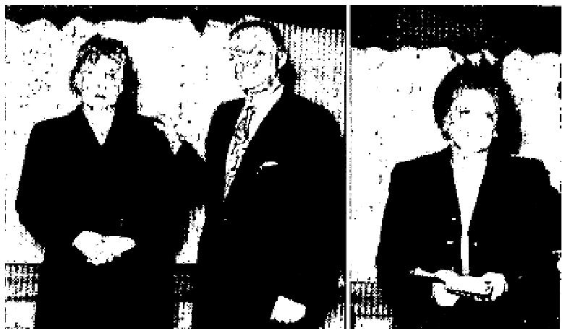
Dr. Kathryn Fuller (above left with Bro. Jaeger) was prayed for by Bro. U. S. Jaeger and was healed of cancer in her throat. She has a clinic in Ketchikan, Alaska.
Mrs. Hudson, (above right) wife of Captain Hudson, of Matlakatla, Alaska, had sugar diabetes and was going blind. She was healed, filled with the Holy Ghost, and cart now read the smallest print. Her husband was the man 'that opened the door and. made Bro. Jaeher's Matlakatla meeting possible.

L. C. Robie
ARTHRITIC CRIPPLE HEALED
Evang. L. C. Robie of Union Springs, N. Y. is being used mightily of God in the
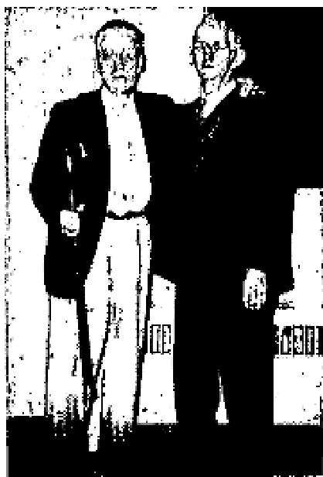
healing ministry. His bold faith has resulted in many fine healings. He stands at right
holding the cane that was used by Mr, Chammings.
I have known Mr. Samuel Chammings of Walnut Valley, N. J., for many years and we were neighboring families for a long time. for the past two years he suffered very much from crippling arthritis, and was unable to work any longer. He was unable to wear shoes or tight clothing of any kind, But, on the evening of November 12th while Evangelist L. C. Robie prayed for him, something miraculous happened - he sprang from his chair, walked and leaped, praising the Lord for being delivered from the affliction of arthritis. Only God could do this!
Miss Mary E. Myers, R. N.
Walnut Valley, N. J.

THE VOICE OF HEALING 1952
March 1952 p8
CHOICE LINES FROM TESTIMONIES SUBMITTED TO BRO. VALDEZ
After being on crutches several years with multiple sclerosis, I was given almost instant relief when Rev. Valdez prayed for me; my afflicted eye was also healed.,, ... WALTER KEPLER, 822 DOMINION ST., KAMLOOPS, B. C.
"...Since birth I have Suffered with a Hole in the top of my head which had no bone, only a covering of skin. As soon as Bro. Valdez touched my head, the bone was restored and it was made whole." . . REV. DAVID DYCK, 815 8TH AVE. WEST, CALGARY, ALBERTA.
"... My little boy had a T. B. spot on his lung. Three days after prayer be was x-rayed and the trouble had cleared up. His heart, which bad beeps displaced, was now in normal position also.”.. MRS. FLORENCE BACKMAN, NORTH KAMLOOPS, B. C.
"...For twenty-three years I had arthritis in the form of a peeling of the skin about the face. I also suffered from a dislocated backbone. I was healed when Bro. Valdez prayed for me." . . NM. ALAN FERGUSON, 116 10TH AVE. WEST, CALGARY, ALTA.
"...I was deaf in my right ear for fifteen years; doctors were unable to help me. Since Bro. Valdez prayed for me I can bear even a watch tick. Also I had broken my wrist and two fingers would sometimes fall useless and I could not completely close my hand. I can now close my hand tightly and have full control of the two injured fingers MRS. M. H. NICSON, 558 NICOLA, ST., KAMLOOPS, B. C.
March 1952 p10
Broken Foot Instantly Healed

Mrs. Chloe Sroder rejoices as she holds up the crutches which had held her up. God miraculously healed her: instantly of a broken foot. X-rays were proof of the break.
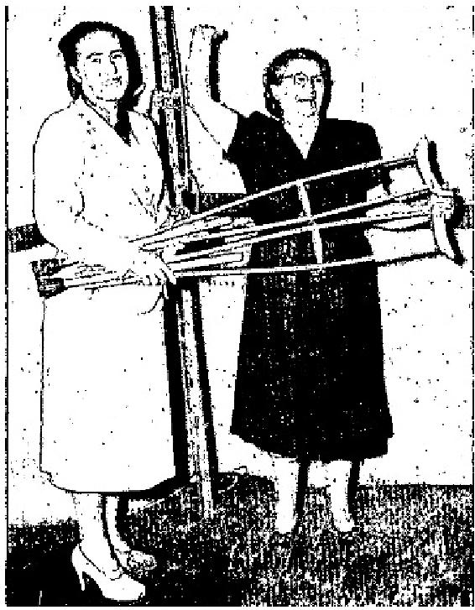
X-Rays Show Tubercular Healed
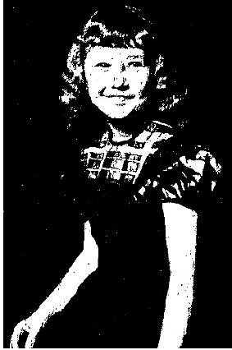
Janet Derryberry was wonderfully healed of tuberculosis in Sister Wicks' St. Louis campaign. X-rays showed her. lungs to be perfectly well.

March 1952 p11
With MILDRED WICKS In Her Great Gospel Tent
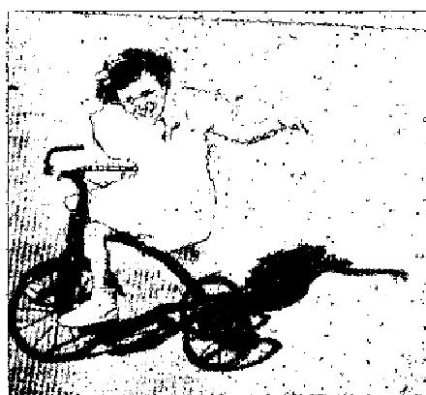 | SPASTIC PARALYSIS VICTIM LEAVES BRACES AND WALKING AID I'm writing about our daughter you prayed for in Los Angeles while you were here.  Phyllis Jean had never walked, nor even stood alone without her braces on. For these near six years she has been paralyzed - spastic paralysis, for which you know there is no medical cure. After you prayed for her we took her braces off and she began walking by holding onto the furniture, something she had never done without

THE VOICE OF HEALING 1952
braces. A few days later I put her on a tricycle. Before she had never been able to sit there alone, but this time she did. She could not ride it so I pushed her and helped her for about half an hour. I told my wife, "You put her on there tomorrow and believe God and she will soon be riding." That next afternoon 1 drove up in front of the house and there was little Phyllis Jean riding the tricycle. It was a borrowed one, from one of the other children. Well, maybe you can know how I felt... You talk about a camp meeting ... I had one all by myself when I saw what the Lord had done for her. I came in the house praising God for healing her. My wife said she had been around the block once that day and didn't want to get off the tricycle.
NOW HE IS FREE - HE WALKS - NO MORE SUFFERING
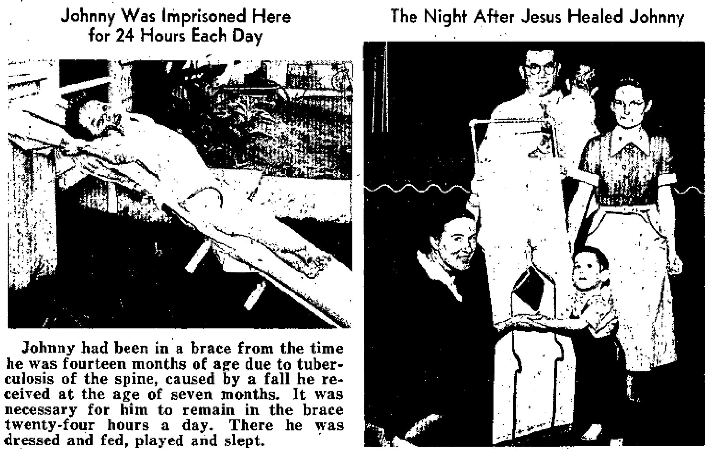
Johnny was three and a half years of age. He had never, walked! Instantly he walked through the power of Jesus Christ! This was in the Ft. Worth meeting! Now, six months later, Johnny is running and playing and living a normal life.
March 1952 p13
CANCER EMITTED FROM THROAT IMMEDIATELY AFTER PRAYER
Springfield Woman's Claim Verified by Doctor
I want to thank and praise the Lord for His wonderful healing power.  I had been doctoring for a cancer for about two years. Dr. Wakeman of Springfield, Missouri, had operated and removed one cancer. Later, I was sent to Columbia, Missouri, to a specialist. They examined me and said I should have another operation but that I was too weak for it. The doctor did not tell me I had a cancer in my throat.  I went to the revival Brother Coe was conducting in Springfield and he prayed for me. I felt the power of God go through me. I returned to my seat and soon | 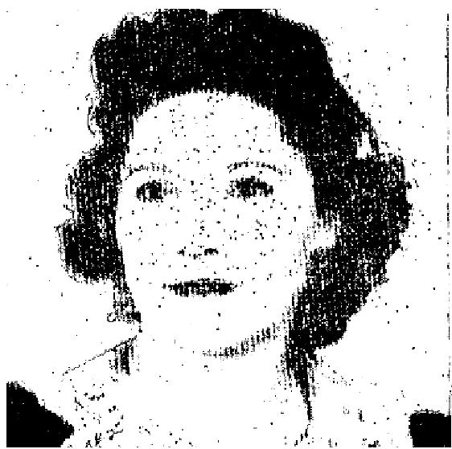

THE VOICE OF HEALING 1952
my throat began to hurt. I rubbed it and in a moment I belched and a cancer came out.
I called my Doctor and told him what had happened and what the thing looked like. He verified that it was a cancer. I was able to attend the revival regularly after this, as well as do my housework. My strength and color are returning.

Mrs. Dale Towe
2354 Division
Springfield, Mo.
March 1952 p14
‘MIRACLE’ SETS BOY WALKING NORMALLY
(Sunday Tribune Reporter)
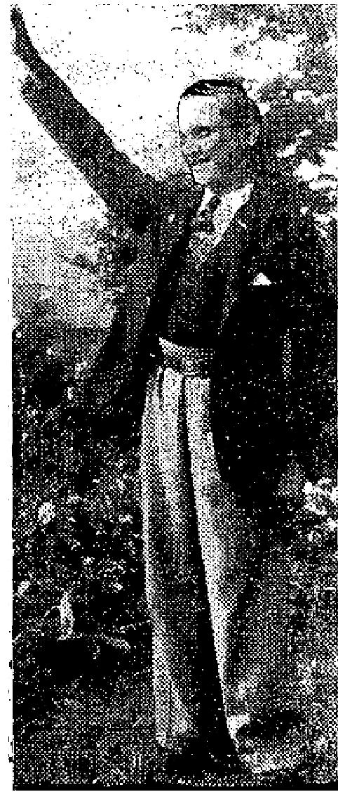
A faith cure, described by his mother as a "miracle," has enabled 16-year-old Ernest Blom of Eastview Road, Red Hill, Durban formerly a cripple, to walk normally for the first time in his life.
Last Sunday evening. Ernest astounded a packed congregation of more than 500 people at the Full Gospel Church in Beatrice Street, Durban, by rising from his seat and walking without the slightest difficulty to the pulpit to testify that "a miracle happened and I am now completely cured."
Excited groups of people gathered outside the church later to watch Ernest
walking and to congratulate him on his recovery. His mother, Mrs. Mary S. Blom said: "Ernest is the youngest of my family of 10. When he started to walk, I noticed that his left leg was shorter than his right. He could only walk on the tips of his
toes, and had to drag his left foot.
WENT TO HEALER
"From the age of four until a month ago, he was under the care of a specialist. For
two years he wore a leg iron without any noticeable improvement. The specialist
latterly suggested an operation, said he could not
guarantee that it would be a success, so I gave up the idea.

"I heard of Pastor William Branham's remarkable faith-healing successes in the States. When my daughter and a friend heard he was to visit Johannesburg they motored from Durban three weeks ago and took Ernest along. They attended his opening meeting in the Maranatha Park Hall, at which 15,000 people were present."
Ernest himself here took up his story. He said. "I was right at the back of the hall. Pastor Branham asked all the people wanting in be cured to lay hands on each other's hands. I laid my hands on those of a man sitting beside me. Pastor Branham said. 'I will pray for you.'
"WEIRD SENSATION"
"I experienced a weird sensation. It was just like cold water running through my body. I began to cry. My
sister said. 'Are healed, Ernest?' I replied, 'Yes. I am sure I am healed.'
"Because of the huge crowd I could not move, but as I was being helped from the back of the hall I kept repeating, 'I am sure I am healed."

THE VOICE OF HEALING 1952
Branham said; 'All you people who are healed, will you come forward,' I was assisted to the sick bay by others, He told me to walk up and down the platform on which he was standing.
"URGED ON"
"I broke into a sweat but something urged me on, and I managed to walk normally across the platform and
back.
"When I got back to Durban and my school friends at Hunt Road School saw me walking into the classroom, they were flabbergasted.
"My left leg is getting stronger every day. I can now play cricket and other games."
March 1952 p16
Authentic Confirmed Proof That People Get Healed and Stay Denied in the Gardner Campaigns FRACTURED SPINE HEALED
I had a very serious operation on my spine and the doctors said I would have to go through another one, as the operation had fractured my spine. I was prayed for in the revival you were conducting, and the Lord touched my body. I had not been without pain for over one year, but Praise the Lord, I am free of all pain now!
Mrs. Gertrude Narvaez
5617 Avenue "P"
Galveston, Texas
(The testimony of. Mrs. Narvaez has been confirmed this week after standing for 3 years. It is also signed by her pastor, Joe Whinnardie, Y.P.S.M., Rutan Outpost of the Salvation Army, 2528 61st St., Galveston, Texas.)
Esther Ivey -1654 Highland, Springfield, Ohio writes:
"I was very sick 4 years ago with strep throat and lost the hearing of my right ear from it. The doctor told me I would be deaf the rest of my life, as the ear drum was bursted. I am glad to report that when Bro. Gardner prayed for me in his revival here that the Lord instantly healed me. I also praise the Lord for healing me of arthritis and nerve trouble."
(This testimony was in TVH 1.5 years ago. Confirmed on Jan. 14, 1952 by Sister Ivey, and endorsed by her pastor, Rev. R. E. Keaton, 1221/2 N. Isabella St., Springfield, Ohio.)
BOUND 12 YEARS WITH. T. B. OF THE SPINE
I am writing to tell you how God wonderfully touched my body after you prayed for me in Cincinnati,. Ohio, last June. I had T. B. of the spine and could not walk around for 12 years. I weighed 120 lbs. After you prayed for me I weigh 160. I am able to do all my work and take care of my children.
I have read your healing book, THE GOD OF MIRACLES LIVES TODAY, three times. It certainly built up my faith in God for healing. Mrs. J. H. GardnerBox 70 8, Wash. Blvd.West Portsmouth, Ohio
(This testimony has been confirmed this week, after standing for 2 years.)

THE VOICE OF HEALING 1952
March 1952 p19
HEALED IN COE MEETING
I suffered a torn ligament in my right ankle and the Doctor at St. Joseph's Hospital, Wichita, Kansas, told me it would take several weeks before I would be able to walk on it again. Brother Coe prayed for me
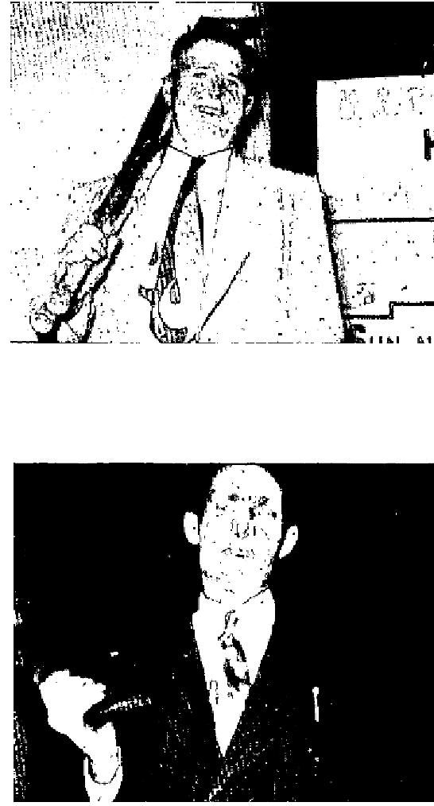
while I was sitting in the balcony at the Hutchinson, Kansas; meeting and I was healed. I laid down my crutches and walked off without them.
W. M. George
210 E. Marlin
McPherson, Kansas
Over a year ago I was working in the timber and a tree fell on me. I received a concussion, and my spine and right shoulder and arm were partially paralyzed. I was in the hospital in Springfield and Kansas City six
different times. The doctors said 1 was past any help they could give me and they sent me home.
Brother Coe prayed for me and God healed me. I was immediately able to run down the aisle and to bend over and touch my toes.
Steve Broke
Route 3
Ava, Mo.

April 1952 p4
SIGNS - MIRACLES - WONDERS IN THE CAMPAIGNS OF TVH EVANGELISTS
EVANG. S. K. MABRY  MOTHER AND TWO SONS HEALED; X-RAYS REVEAL NO SYMPTOMS OF T. B.  The doctors took X-Rays of my smallest son's chest and found him to have T.B. and an enlarged heart. He was also found to be anemic. He is four years old.  He had to stay in bed all the time. I put pillows under his head and a table over his body for him to put his toys on. He had been in bed for a month when Bro. Mabry came to Lubbock, Texas. Our pastor, Rev. W. E. Mitchell, of the Church of God in Lamesa, Texas, went to hear him. He and Bro. Mabry joined hands and prayed for my son and God marvelously healed him! | 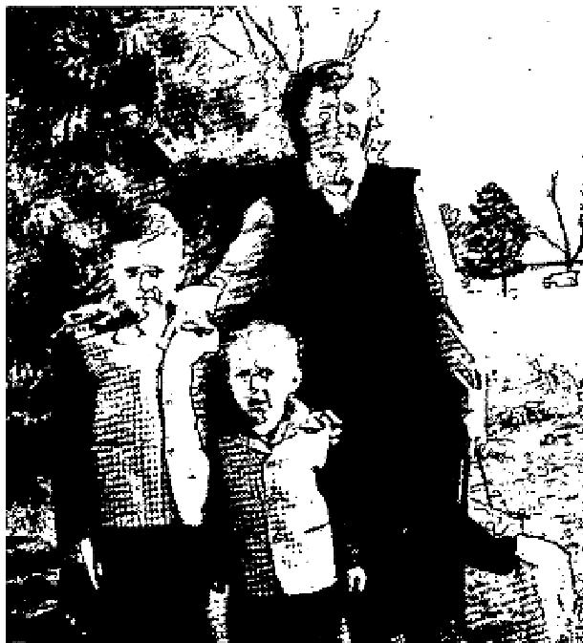

I then took him to a chest specialist and had him X-Rayed again. The doctor
said he definitely did not have either T.B. or an enlarged heart. He never went back to bed after that and how
I do praise God!
Bro. Mabry is now in Lamesa. Last Sunday night he prayed for my eyes. I had worn glasses for about six years. God healed my eyes and I haven't had my glasses on since. He also prayed for both my boys' tonsils and God healed them. God is still on the throne and is the same yesterday, today, and forever!
Pray for my family that we will stay close to God.

THE VOICE OF HEALING 1952
Mrs. Alta Wood
204 So. Sixth
Lamesa, Texas
EVANG. RUDY CERULLO
GROWTH ON CHEST - DISAPPEARS
I went forward for prayer in the Cerullo healing campaign in Albany. I had a growth on
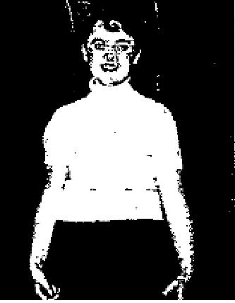
my chest which first appeared three months ago, and was growing larger. Immediately -
after prayer, the growth disappeared, and now I am completely well.
I am so happy that I received the Baptism of the Holy Ghost during this meeting
Miss Rosemary Heathy.
Albany, N. Y.

EVANG. T. L. OSBORN
SUGAR DIABETES HEALED; DOCTOR'S STATEMENT VERIFIES
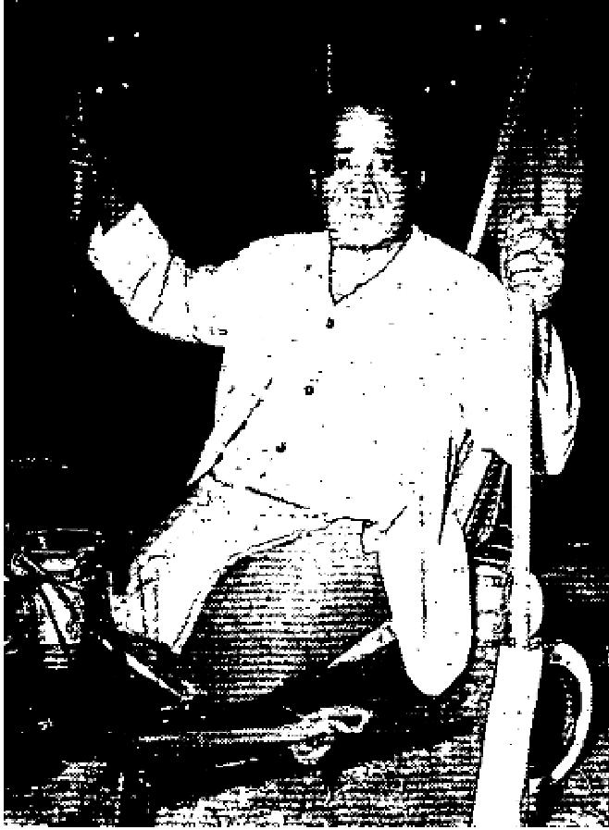
On the first night of Bro. Osborn's Altoona campaign, I attended on my little cart and gave my heart to the Lord. I have been a new person ever since. I am so happy.
Then Bro. Osborn prayed for me about the 4th night of the meeting and God wonderfully healed me of sugar diabetes, from which I had suffered for many years. It was the diabetes which caused me to lose my legs. My heart and eyes were affected also.
After Bro. Osborn prayed for me, he told me to return to my doctor and have an examination and to request a certification of the results for the glory of God. After a thorough examination, my doctor pronounced me cured of diabetes, as is shown on his signed certificate. (This was enclosed with the letter.)

I am so happy for this miracle. I believe I am the happiest man in Altoona.
I make my living with my little cart on the streets selling different small merchandise. During the campaign I had the pleasure of selling and giving out many copies of "THE VOICE OF HEALING" on the streets. Many people have come to the campaign and been heated.
I wan t also to thank Bro. Osborn and the wonderful people who attended the last night of the great campaign, for the offering of over three hundred dollars which was collected to buy me a motor conveyance so I can get around and go to church. It has been hard to push myself around with two sticks. Thank God for all He has done for me.
E. D. Copeland
2410 N. Branch Ave.
Altoona, Pa.
EVANG. WILLIAM BRANHAM

THE VOICE OF HEALING 1952
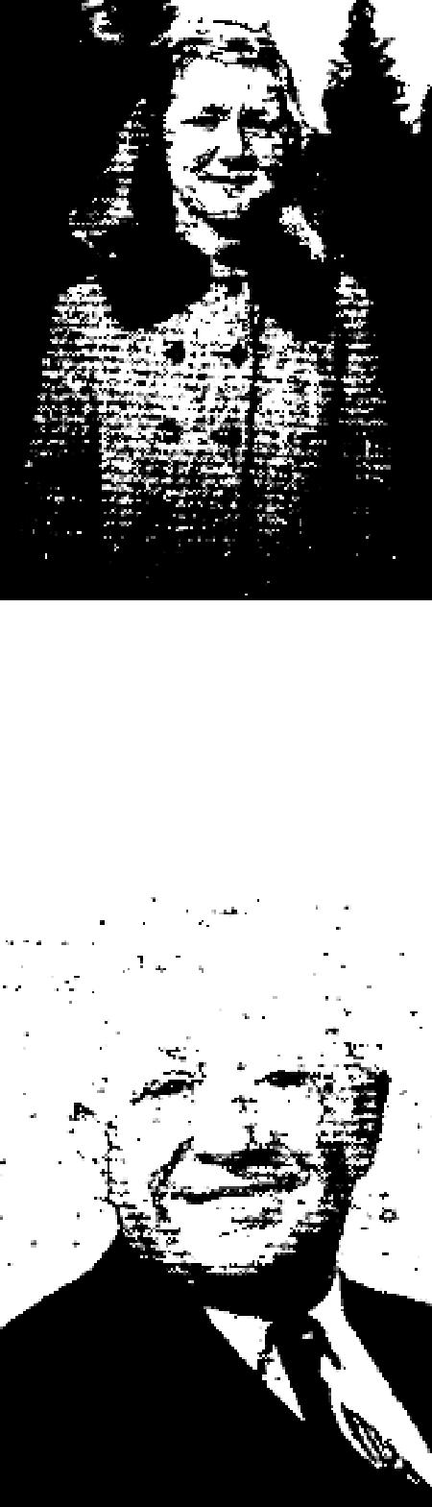
CHILD'S LIFE-LONG AFFLICTION HEALED
Dear Brother Lindsay:
You will find enclosed a picture of our little girl, Janice Reeves. Janice had infant
eczema all her life until we attended one of Brother Branham's meetings in Grants
Pass, Oregon, in December, 1950.
Brother Branham anointed a handkerchief and Janice wore it. Today she is completely healed.
We do praise the Lord for His wonderful healing power.
Mr. and Mrs. Claude Reeves
Box 182
Westport, Oregon

EVANG. CLIFTON ERICKSON
REMARKABLE TESTIMONY OF HEALING OF BLINDNESS
Dear Brother Erickson:
I write to give you some details of my physical condition, and how God healed me
- when you prayed for me.
When I was a small baby not two years old, I fell into an open fire-place and was badly burned. My left eye was so damaged that it became blind and turned back in the eye socket. Now at 63 years of age God, in answer to your prayer, has wrought a miracle so that my eye is now straight in the socket, and I can also see plainly with it.
I also had a broken left wrist recently; the X-Ray showing it to be fractured in three places. God again heard prayer, healed my wrist, and my Pastor, Rev. C. Nelson, has a written statement from my doctor. After
thorough examination the doctor declared my wrist was perfectly set and healed, whereas before prayer he stated it would never get well and strong at my age.
I praise God for my healing, which has affected my relatives so that some have turned from the Catholic Church and accepted Jesus as Saviour.
Yours in Christ,
Henry Pizzano,
42 Eden St., Chelsea, Mass.

April 1952 p7
Pastor Fortunato Evangelizes Home Area
CHILD HEALED OF T. B., X-RAYS REVEAL
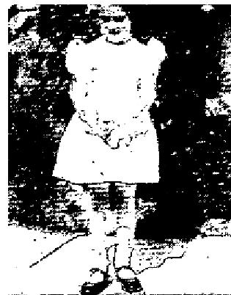
Diann lost her appetite, slept day and night and lost 10 pounds in two weeks. Doctors' tests; on January 16th proved that she had T. B. Pastor Fortunato prayed for her on January 20th (1950). An X-ray taken on January 23rd showed that her chest was clear. The doctor could not understand this phenomenon. Almost immediately after she was prayed for, her appetite came back. She gained four pounds in one week. We thank God for healing her.
Nauvita Everett
2057 Carver St.
Philadelphia 24, Pa.

THE VOICE OF HEALING 1952
PASTOR TESTIFIES TO WONDERFUL HEALING
I had been ill since February, 1949. I was constantly losing weight, to the total amount of sixty pounds. Dr. Notali's report stated that all the symptoms indicated ulcers, with possibility of cancer. He ordered me to the hospital. On the day I was admitted to the hospital, Bro. Fortunato anointed and prayed for me, according to God's Word.
In the hospital I was thoroughly X-rayed from head to foot and underwent three other tests. To the amazement of all the doctors, all the X-rays showed no trace of any illness. Hence I was discharged on Dec. 30. Notwithstanding all this report, Dr. Notali insisted on another examination it his office. Again this special test proved all negative. Thank God that the days of miracles are not over.

Pastor Louis Parisi
Norristown Pa.
SIGHT RESTORED TO WOMAN
Twenty-four years ago I was accidentally hit in the eye with a stone. The eye was injured so severely that it was sightless. Two specialists said an operation would be useless because the sight could not be restored. I
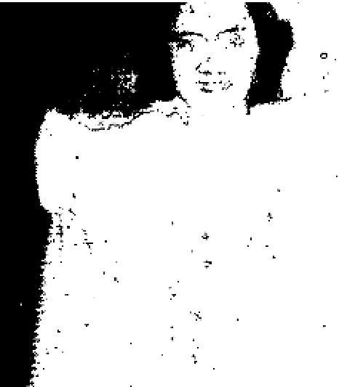
always feared going totally blind, and wore glasses to relieve the strain on my right eye. I always had unbearable headaches.
Bro. Fortunato prayed for me in Star Junction, Pa., and a miracle was performed on my eyes. I can see with the injured eye, don't haveto wear glasses any more and I don't have any more headaches.
Mrs. Andrew Scheponik
707 11th St.
Charleroi, Pa.
April 1952 p8
CANCER DISCHARGED EIGHTEEN HOURS AFTER PRAYER In the spring of 1951, I was operated on for what the doctor thought was prostate gland trouble. However, it proved to be a cancerous growth; and, owing to scar tissue, the doctor said he was unable to remove all the
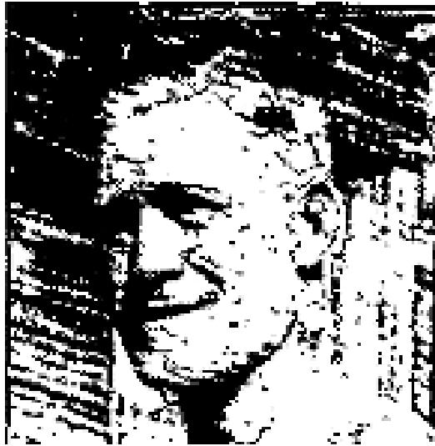
cancerous part. I seemed to be all right, and in three month's time was doing light work. How
ever, four later, I became very sick and was unable to work. I returned, to the doctor who had performed the operation and he told my wife, the cancer had gotten into the bloodstream and had spread to my liver and kidneys. He gave me from six weeks to six months to live.

My body became so swollen I was almost helpless. Not being satisfied, I went to several doctors and spent some time in hospitals, but got little or no relief. I had been saved about two months and, knowing the power of God, decided to let God heal me. When I heard that Brother Stanley Karol was holding tent meetings at Pound, Wisconsin, I had my daughter take me there.
I got in the healing line, and Brother Karol prayed for me. I went home, not feeling anything. Eighteen hours later, a warm feeling came down over me and, praise God, I knew I was healed! Five days later, the cancer, which was about the size of a quarter. was discharged through my bladder. I know the cancer is gone, because strength is there, and I am able to do many things.

THE VOICE OF HEALING 1952
I will be more than glad to answer any letter regarding this testimony.

Mr. Harry Gooding
Star R. I Box 189.5
Iron Mountain, Mich.
Abscessed Tooth Falls Out After Prayer
Dear Brother Karol,
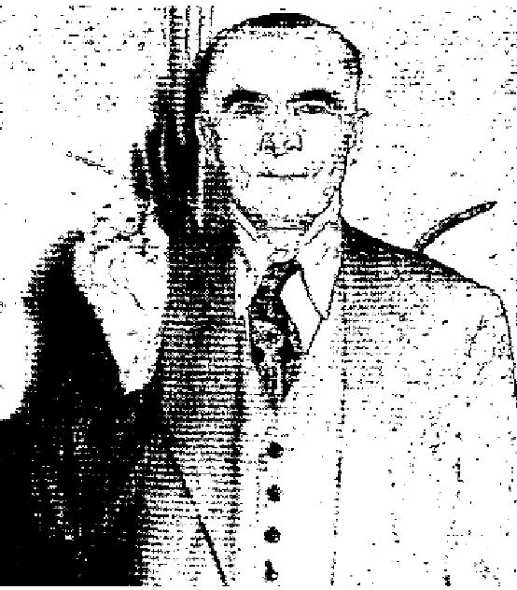
I am writing you my testimony to tell you what Jesus did for. me. As you gave the invitation for the sick to come forward, I too asked that you pray for me as I needed victory in my life and also at the same time I had an abscessed tooth which caused me considerable pain. Praise God, after you prayed for me, I received victory in my soul and two days later my tooth which had given me so much pain just fell right out of my
gums without any pain or after effects whatsoever. I am also giving you this tooth as a testimony of God's miraculous power to heal.
M. G.
New York City, N. Y.

Healed of Asthma  Having heard of Brother Karol's meetings at the Full Gospel Tabernacle in-Pound, Wisconsin, my wife and I drove over to be prayed for. I bad suffered from asthma for over. ten years, but thank God, I was healed of this condition when Brother Karol prayed for me. I give God the glory!  Fred Kitzmann  Marion, Wisconsin | 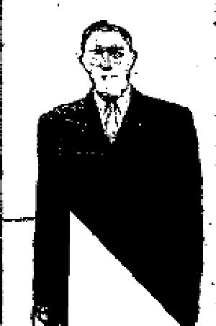

Rupture
I was ruptured for fourteen years, but when Brother Karol prayed for me, I was instantly healed! I thank and
praise my dear Lord Jesus for this wonderful miracle!
Mr. C. Pleszak
2620 N. Rockwell St.
Chicago, Illinois
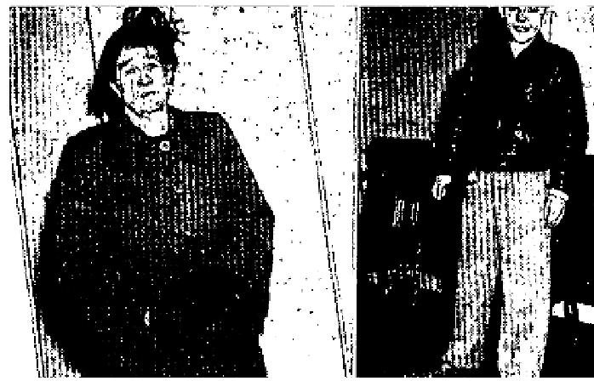
April 1952 p10
Healed In Oregon Meetings Under Wilbur A. Henry
Since Bro. Henry prayed for God to heal me of sugar diabetes and arthritis, I have thrown away my insulin and am doing my own housework and walking free of pain." Mrs. Mary Suderland, 663 Tyler St., Corvallis, Oregon
"Our son (far right) has had our trouble all his life. According to the Otalogist in Portland, the right eardrum was gone and the left one punctured. He has been wearing a hearing aid. On Feb. 8, after Bro. Henry prayed for him, he could bear a whisper, and still can." Mrs. Henry Seadore Rt. 4, Box 72, Corvallis, Oregon

THE VOICE OF HEALING 1952
"I thank God for healing me of stomach ulcers that I have suffered with for four years because of alcohol." Carl Young (right) Brockway, Oregon  "The Lord wonderfully healed me of leakage of the heart and partial deafness when Bro. Henry prayed for me. It is so good to be able to work again." Lewis Fox, Box 25 Summit, Oregon (far right) | 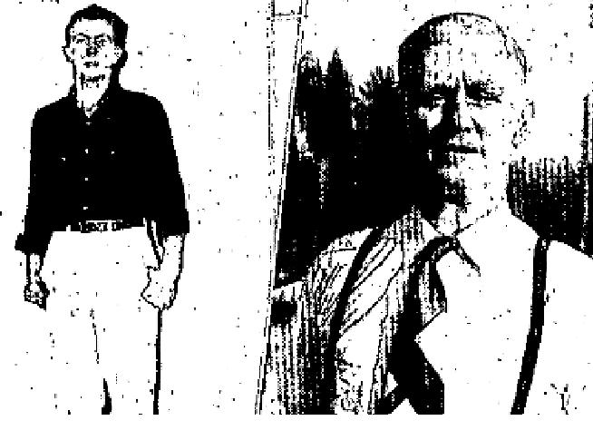

Testimonies
“When 1 was nine years of age I lost my hearing in one ear after whooping cough, measles and small pox settled in my ear. The doctor said I would never hear normally again. For 34 years I was very handicapped and embarrassed as I could hardly hear at all. But when Bro. Baker prayed for me God opened that ear and now I can hear perfectly. Also, I was in a terrible nervous condition, vomiting almost everything I ate, but now I eat anything I want with no reaction, the nervousness is gone, and I feel the sweetest peace in my soul and body I have ever known.
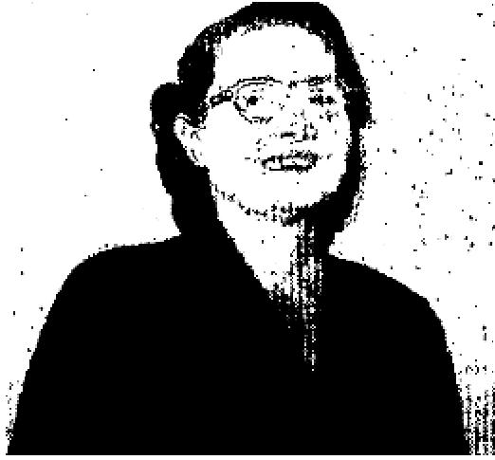
Mrs. Howard Simpson
616 W. Broadway
Yale, Okla.
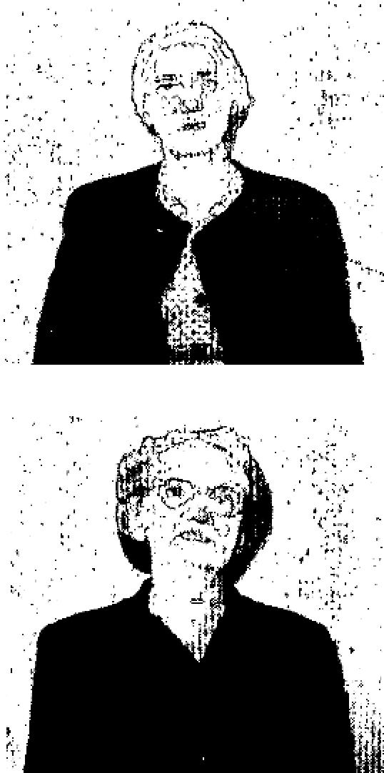
I attended the Baker revival in Yale, Oklahoma and was wonderfully healed of varicose veins and a cataract on my right eye, which I had been unable to see out of for many years. I no longer need my glasses that I had worn for 17 years.
Mrs. Effie Afartin
Yale, Okla.
Through God's wonderful heating power in the G. O. Baker revival, I was healed of an inward goiter I had suffered with for 52 years, and many other ailments. I was also saved and filled with the Spirit in this revival.
Mrs. May Wyckoff
112 North D. St.
Yale, Okla.

April 1952 p13
Cancer Victim Raised Up
Silia CHRISTIAN
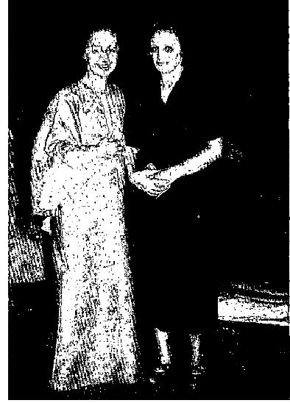
2715 E. 57th, Huntington Park, Calif.
Had been ill two and a half years with cancer of throat, lungs, intestines, left hip. Was brought to Nankivell meeting in Calvary Temple on a cot. Christ appeared to her with tears in His eyes and bent over to kiss her. Through this experience she was saved. All pain left her body and she is up for the first time.
No Longer Deaf

THE VOICE OF HEALING 1952
I have been deaf since 1930... Could hear nothing in my left ear, not even the tick of a clock placed close to my ear. I was prayed for In Sister Nankivell's meeting, on January 16th, 1952 cat the Lakeside Assembly of God, Milwaukee, Wisconsin, and was instantly healed. I can hear perfectly now, thank God! I also had a bad back and it, too, was healed!  Peter Hartman  2SY3 N. 10th St., Milwaukee, Wisc. | 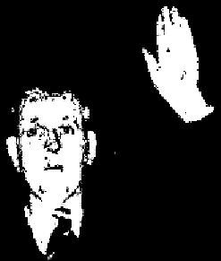

May 1952 p4
SIGNS - MIRACLES - WONDERS - IN THE CAMPAIGNS OF TVH EVANGELISTS

EVANG. H. E. HARDT
ASTHMA FOR 16 YEARS; NOW WELL
I have had asthma for 16 years. This winter I have been unable to sleep for
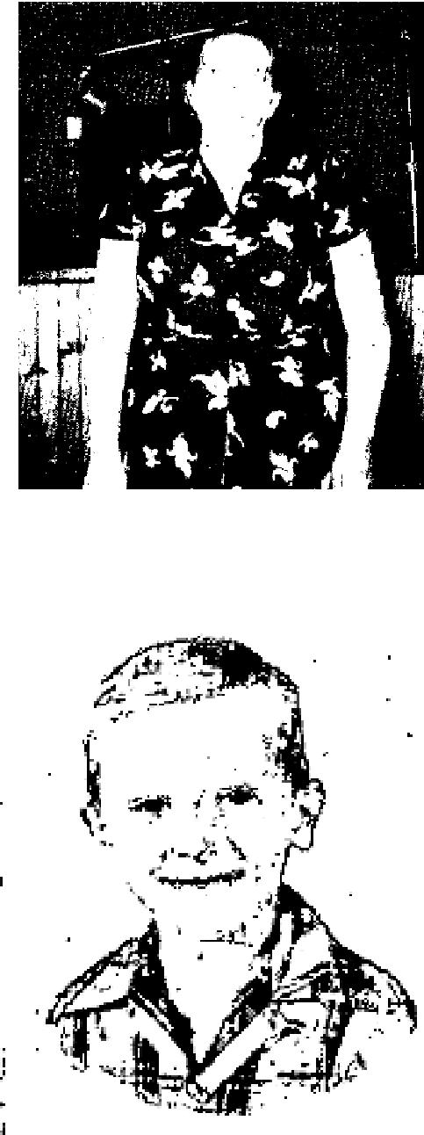
shortness of breath, wheezing and coughing. My family was often disturbed
during the night by my wheezing,
On January 2nd in the meetings conducted by Evangelist H. E. Hardt, I was prayed for and was instantly healed. I went home, went to bed and slept soundly. Since that time I am perfectly well. God bless you and your great work.
Mrs. Pearl Laws, Normalville, Penna.
EVANG. WILLIAM BRANHAM
CHILD HEALED AFTER WRITING FOR ANOINTED RIBBON
After writing to Brother Branham requesting prayer for our son, Charlie, who had suffered from asthma, we received a letter with a ribbon which had been anointed, and were instructed to put it under his pillow. Brother Branham felt led to tell us to watch Charlie on sweets. This was very appropriate for the only times he had attacks after prayer was after he had eaten sweets.
Our pastor has also prayed for Charlie, and we want you to know that God has completely healed him. It isn't necessary for him to watch the sweets now, as he is healed. He has been healed since September and during these months he hasn't even had a cold. He can 'now run and play and is able to sleep.
Praise the Lord for all the happiness this healing has brought us. Mrs. Charles Stauffer, Wooster, Ohio

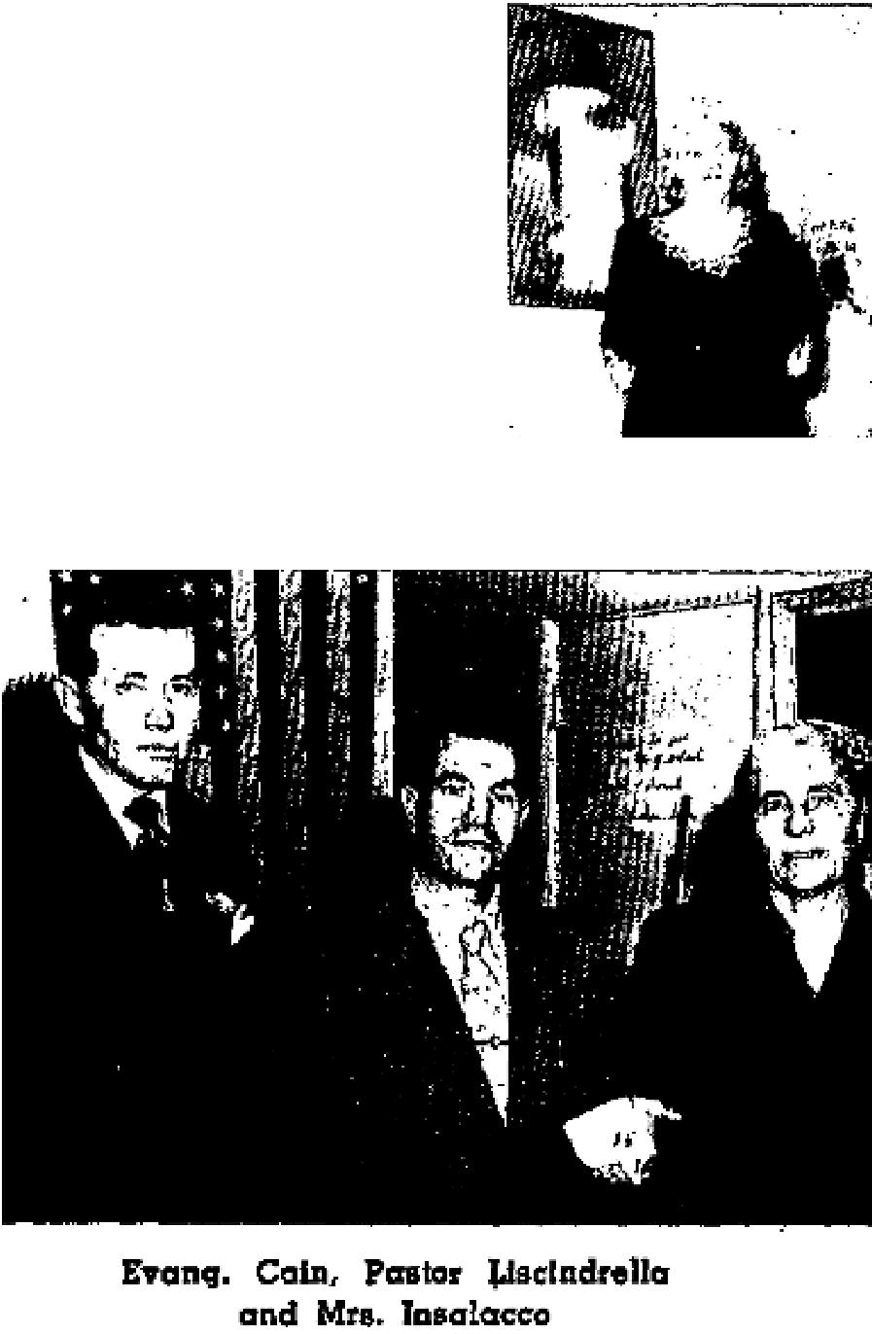
THE VOICE OF HEALING 1952  EVANG. DALE HANSON  MAN SPITS UP LARGE CANCER  Dear Bro. Hanson,  I came to you in Joliet, Illinois, and told you that I had cancer of the throat, and had been fasting for 27 days. On Wednesday night, April 12, you cast out the demon and prayed for me. I was very sick from then until Saturday morning, vomiting all the time. I was so weak that I could not speak and fought death those three nights, as the devil was trying to take my life. However, the Lord old me I wouldn't have a testimony for Him it I gave up. It was a real battle of faith. | 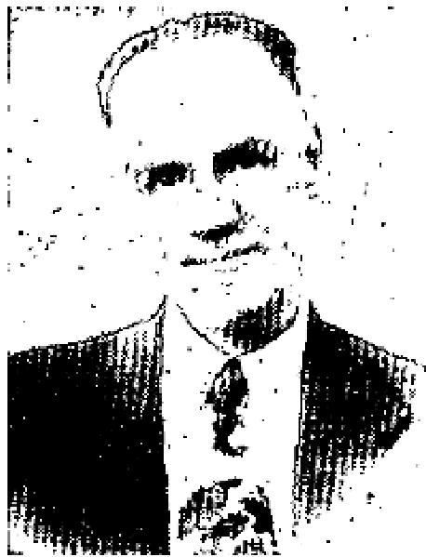
The Lord had spoken to me on the 10th day of my fast and assured me that He
would dry up the cancer at the roots. That is just what He did. Praise the Lord, on Saturday morning, April 15, 1 vomited the cancer with the roots. There were about 15 webs of roots from a cancer about 1.5 inches in diameter. My wife and I began thanking and praising the Lord because we knew this was the end of the cancer. Immediately after that I took a teaspoon of orange juice in a little water. This was the first water that I had been able to keep on my stomach for four days. From that time I was able to eat more and more, and haven't vomited since expelling the roots.
I do thank God that He is the same yesterday, today and forever. I have been back to work for several weeks and am in perfect health. We give God all the glory and praise for my healing.
I do want to thank you, my dear brother in Christ, for praying for me. May God continue to bless you and anoint you with the Holy Ghost upon you.
Robert L. Sipe
West Roosevelt Rd., Wheaton, Illinois
EVANG. WILBUR OGILVIE
VICTIM OF ULCERATED STOMACH NOW ABLE TO EAT ANYTHING I had suffered with stomach ulcers for a number of years, and was not able to eat anything but milk and raw eggs. Two days after being prayed for by Rev. Ogilvie, I became deathly sick and vomited up six large pieces of flesh, Since that time, I have been able to eat anything and am feeling fine.
Mrs. John Corea, Meeteetsee, Wyoming
EVANG. PAUL CAIN
CANCER OF THE STOMACH EMITTED
This is to confirm how the Lord miraculously worked upon Sister Rosalie Insalacco, For about ten years she has suffered stomach trouble. During this time she has been examined by many doctors and specialists, and has had many x-ray examinations. These examinations have never shown any trace of cancer. The night of May 15, 1951, she decided to go to Calvary Temple in Los Angeles, California, where the Lord had been using Brother Paul Cain in a supernatural way.
When Sister Insalacco went for prayer, Brother Cain discerned hex illness and told her she had cancer of the stomach, and if she would believe, the Lord would heal her.

THE VOICE OF HEALING 1952
For a sign, he told her she should go home and spit up the cancer. Sister Insalacco went home believing. On the morning of May 19th, at 2:30, the Lord answered as Brother Cain had cold her. The cancer, which looks like a small octopus, is preserved in a bottle of alcohol as a testimony for any one who cares to see it, (Above)
Pastor D. Liscindrella  1030 S. Brand Blvd., Glendale, California  EVANG. PHILIP N. GREEN  MINISTER'S CHILD HEALED OF SERIOUS ILLNESS  Dear Brother Green  I am praising and thanking our precious Lord for the gift of healing that He has bestowed upon you. My little girl, Veronica Jean, was afflicted with locked bowels for over a year. On June 25, 1951, my wife and I brought her to your meeting in Whiting, Indiana.  God instantly delivered her and she has not had any trouble since. Praise His Holy Name.  Pastor Floyd Petrucci  Christian Assembly, Gary, Indiana | 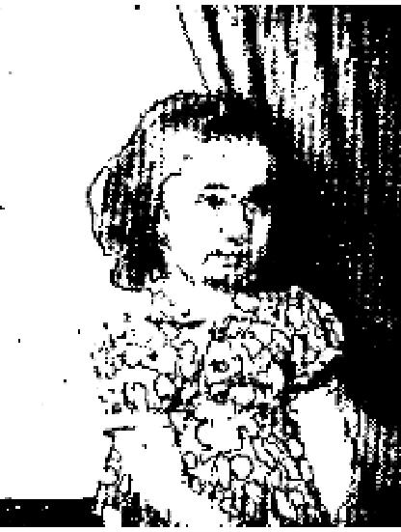

May 1952 p13
New Ear Drum Created; Hearing Restored
"At the age of 6, I was stricken with diphtheria which caused me to have a very painful ear ache. During the night the nurse that attended me heard my crying and came to put some oil in my ear. By mistake she heated acid and poured that in my ear. The acid ate the eardrum away. On Oct. 29, 1950, Bro. Velmer Gardner started a revival in Memorial Hall. The first night of the service the Lord led Bro. Gardner to call for all that were completely deaf to come to the platform.
Bro. Gardner prayed for the Lord to restore my hearing, and Praise God I heard his voice speaking to me as clear as a bell. I heard immediately from an ear that had been useless to me most of my life, My God had in the space of a few short minutes recreated a new ear drum."
Mary Pearl Stucky
1727 Highland, Springfield, Ohio
Confirmed and signed by Rev. Arthur H. Parsons.
Growth Disappears From Girl's Neck
I praise the Lord for healing my girl 10 years old of a growth on the side of her neck. This growth had been there all her life and it times it would give her much pain. The first week of Bro. Gardner's revival here, she went through the healing line and was prayed for.
When we got outside the church she said, "Mother, it is healed." Thank God the growth is completely gone.
Mrs. Dewey Sharron
2700 7th St., Bay Harbor Sta.
Panama City, Florida

THE VOICE OF HEALING 1952
Healed in April, 1950. Confirmed March, 1952 and signed by her pastor, Rev. Wiley Davis Box 881, Panama City, Fla.
Healed of Goiter 1.5 Years Ago Confirmed
Pear Bro. Gardner: I had a large inward toxic goiter for about fifteen years. I was prayed for in your services
here in Memorial Hall, Springfield, Ohio, Sept., 1950. The dear Lord healed me instantly. Two days later I
went to the doctor for an examination. He examined me with the flouroscope and said, "Mrs. Smith, your
goiter is gone". I have had no symptomssince, Confirmed 11/2 years later and signed by:
Mrs. Lois Fay Smith, Jamestown Street, So.
Charleston, Ohio and also signed by her pastor,
Rev. Arthur 14. Parsons
1727 Highland Ave, Springfield, Ohio
Lady Feels Enlarged Heart Return to Normal Size
Six years ago I had an attack of rheumatic fever which left me with an enlarged heart. As you prayed for me, the mighty power of God came on my body and I felt a hand reach down and crush that large heart to normal size.
Mrs. Everet Shaver
Gen. Del., Hermiston, Oregon
Prayed for in 1948, still healed today. Signed by her pastor, Rev. John Friend.
May 1952 p14
SHORT LEG HEALED
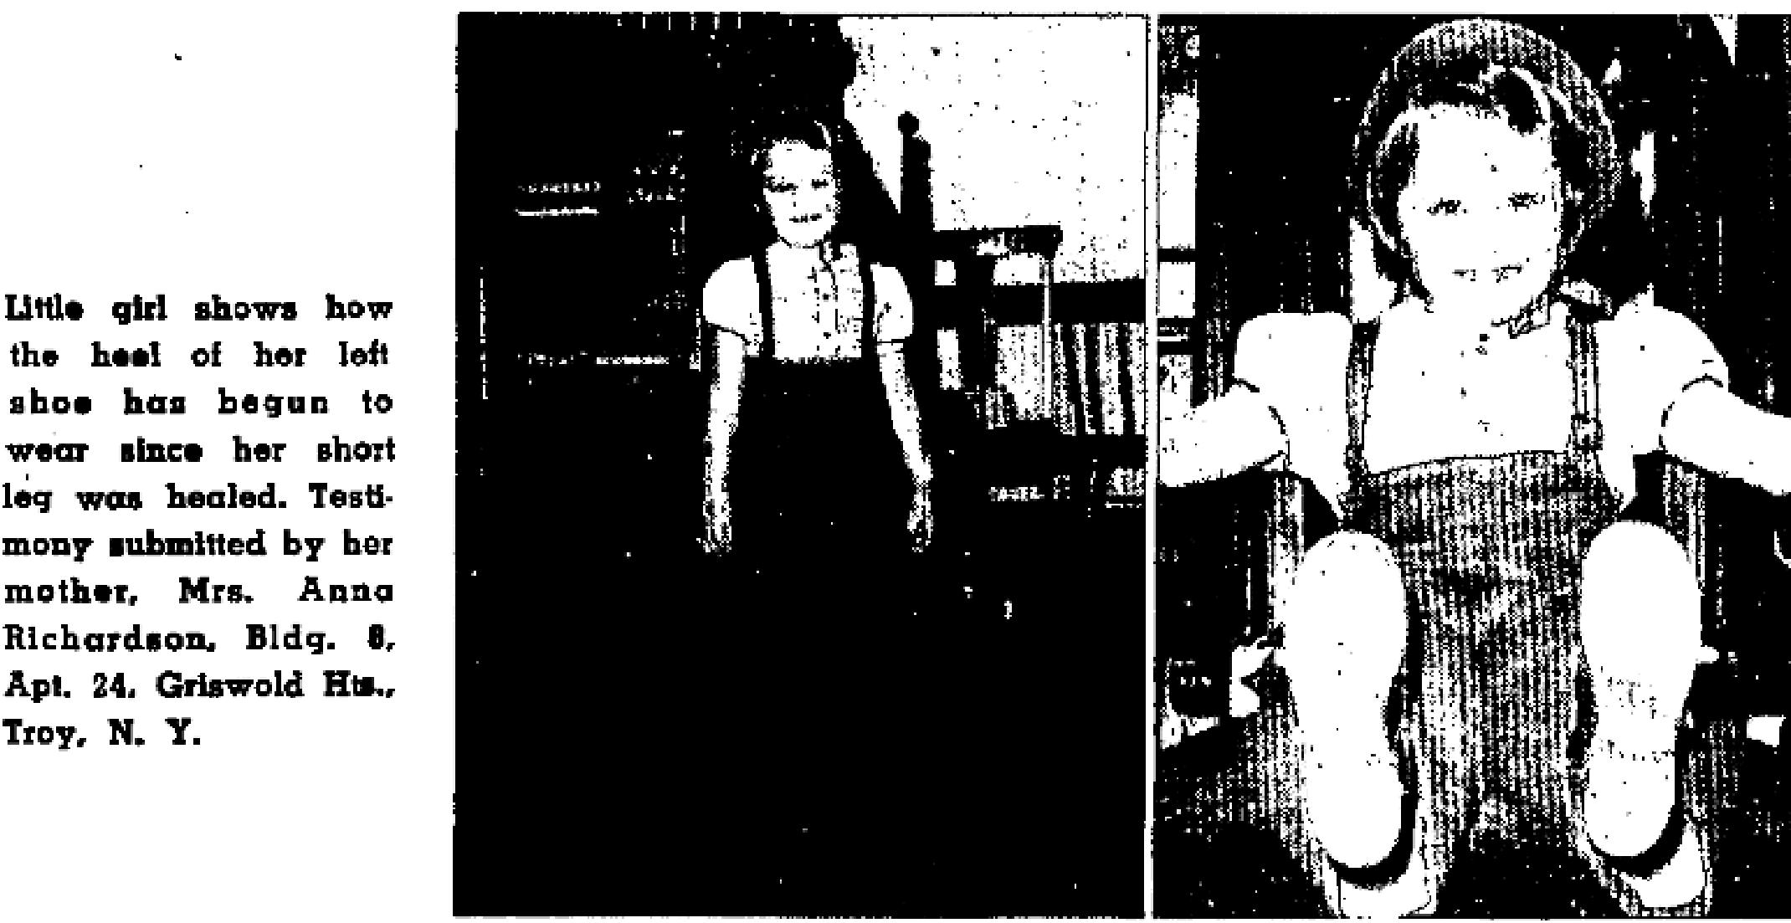
May 1952 p15
Blind Eye Opened
In February, 1951, I was stricken with rheumatic fever. I remained in bed almost five months. The fever
affected my heart, and left my right eye completely blind.

THE VOICE OF HEALING 1952
On February 3, 1952, Bro. G. O. Baker prayed for me during a service at the First Assembly of God church. Since that time I can see perfectly out of my right eye.
Modena Horn, age 11, Lamesa, Texas.
I verify this testimony. Her eye is perfectly healed. Rev. W. M. Bozeman, LAMESA, Texas.
Deaf Boy Hears
My son, Dean, now 11 years old, was born with a deafness which grew worse as he grew older. At times, I would call him quite loud even though he would be standing dose to me. One doctor at the Lamesa General Hospital told me his hearing would grow worse until he would be totally deaf.
But, on the night of March 11, 1952, GOD graciously healed him. Now his hearing is perfectly normal. I praise the Lord for this healing.
Mrs, Myrtle Seely, Box 242, LAMESA, Texas.
I verify this testimony to be true. Rev. W. M. Bozeman, LAMESA, Texas,
Drawing of Nerves Relieved
Due to a nervous condition, I suffered a drawing in my face for six years. I also suffered severe headaches.
Bro. Baker prayed for me and I was completely and instantly healed. I am praising God for it.
Oleta Bannister, 1608 N. 13TH, Lamesa, Tex.

I verify this testimony to be true. Rev. W. M. Bozeman, Lamesa, Texas.
FEET AND EYES HEALED
On August 4, 1951, I went into a healing line conducted by Bro. Russell B. Park to have my eyes prayed for and was healed instantly, so that I could see to read fine print and could read a post office sign a block away.
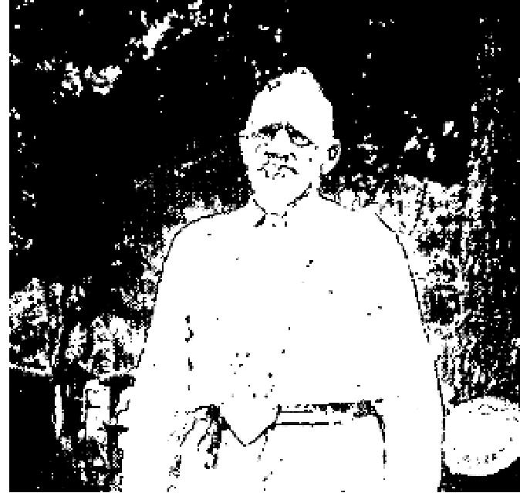
A few minutes later I went into the healing line again to ask God to heal my feet which had been water-poisoned since I was a young man. 1 was again healed instantly.
Praise God! He is big enough to supply all our needs. Praise His Name!
W. T. McEurn
Box 32, Rock Island, Texas

May 1952 p16
Afflicted Child Now Normal
The little girl who has been living in my home about a year was crippled in her right leg and right arm and hand. She walked on her toes as she was unable to walk with her foot flat on the floor. Also, though nearly five years old, she could not speak except to say a few words. She could not make sentences. She has been examined by several doctors, but there was nothing they could do to help her. Rev. Valdez, Jr., prayed for her, and she was healed by the power of God and now walks normally on both feet. She can also talk in sentences. To God we give all the praise.
Mrs. Daisy Swales,

THE VOICE OF HEALING 1952
260 Yonge Blvd,
Toronto, Oat., Canada.
Was Deaf 30 Years
I was totally deaf in my left ear for over thirty years. I was examined by a doctor, but he said the only thing he could do was give me some drops and keep cotton in my ear to absorb the drainage. He told me he could do nothing to restore my hearing. The Lord healed my ear when Rev, Valdez, Jr., prayed for me and now I can hear a small watch tick. I thank God for it all.
Memo Kapisky
Route 2, Malton, Ont., Canada.
THE FOLLOWING IS THE DOCTOR'S STATEMENT
To whom it may concern:
I hereby certify that Mr. Metro Kapisky has good normal hearing in both of his ears and no disease.
Dr. W. H. Brydon,
38 Main Street North,
Brampton, Ont. Canada
Veteran Claims New Eardrum Created
I was in France during the war and my left ear drum was completely destroyed by the explosion of a shell. I was examined by a doctor in the military hospital who said there was absolutely nothing he could do to restore my hearing. Rev. Valdez, Jr., prayed for me when he was in Toronto and God instantly created an ear drum in my left car and I can now hear a small wrist watch tick.
Ronnie Maxwell Barrett
45 Marcia Ave.,
Toronto, Out., Canada
Evangelist's Comment: After being prayed for, Mr. Barrett went to Dr. Spring, 988 Glencarin Avenue, Toronto, to have his left ear examined. After the examination Dr. Spring told him his ear and hearing were normal. Although Dr. Spring refused to give him a written statement, he gave permission to use his name in verifying the healing.
Broken Back Healed; Cost Removed
My back was broken by a fall down some steps. After taking X-rays, Dr. Theobald put me in a cast. I had worn the cast for five weeks when Rev. Valdez, Jr., came to Toronto. I went through the healing line on Thursday night. On Friday morning I was able to got out of bed without any assistance. My husband had had to help me out of bed before that time. Saturday I had no pain and the following Wednesday, I went to see Dr. Keith, 280 Bloor Street, West, Toronto. After a thorough examination, he could find nothing wrong and removed the cast. He could not understand why I had the cast on, because he said he could find nothing wrong with my back. However, my x-ray is at at Toronto hospital to show my back was broken. I feel fine now and have no pain. I do my housework with ease. I thank God for this miracle.
Mrs. Ruth Anderson
181 Swanwick Ave.,
Toronto, Ont., Canada

THE VOICE OF HEALING 1952
June 1952 p8
MINISTER MIRACULOUSLY HEALED OF TUBERCULOSIS IN WICKS MEETING
TWO years ago last winter the doctor called me aside in the General Hospital and advised me to send my
husband to the Glen Lake Sanitorium. TUBERCULOSIS!
When I returned to my husband's bedside, he, who had used his voice for 20 years preaching and singing the gospel story, could but whisper in weakness, "Take me home!"  How could I take him home? I must separate him from our two small children. No income to care for us! A bedridden husband. This! After twenty years of working for Jesus? All night I battled in prayer as the demons of doubt, fear, and discouragement danced with fiendish glee in diabolical darkness. In the morning God put a peace in my heart with the promise, "I'll raise him up! I'll honor him and show him my salvation!" | 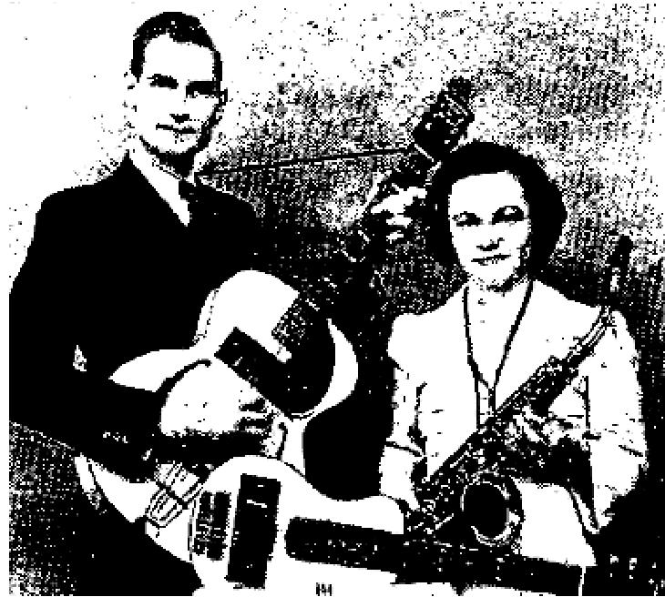

A few days after taking my husband home from the hospital, against medical advice, Rev. Russell H. Olson, pastor of Freemont Tabernacle, called to invite as to a healing campaign conducted by Evangelist Mildred Wicks. My faith was weak and I doubted the wisdom of taking my husband to the meetings, for he was very ill, with constant fever and chills.The pastor encouraged me with the assurance "our whole church is
praying during communion service and God is able if you bring him tonight."
This ministry was new to me. I had termed it mass psychology, auto-suggestion, hypnotism! But we didn't need healing then. Now it was different. Our all depended on a touch from Him.
My husband was taken to the Tabernacle with a temperature of 102°. Our confidence and faith were strengthened during the service. The pastor, with divine authority, challenged, "Devil, take your hands off this couple!" Sister Wicks turned from the healing line, saying, "I perceive you have faith for your healing. Arise! Jesus Christ maketh thee whole!" With a thousand people praising God, my husband arose, the power of God vibrating in him like waves of electricity. In praise and adoration to Jesus he walked off the platform instantly heeled.
Six weeks later an x-ray revealed that God's miracle had been complete.
Mrs. L. Victor Peterson,
The Upper Room Mission
1305 E. Franklin
Minneapolis, Minnesota,
CELESTIAL BEING RESCUES ENGINEER FROM HOTEL FIRE
(Editor's note.- The Los Angeles Examiner, March 25, 1952 {9 AM edition} headlined the story of a hotel fire which took eight lives and from which the engineer and his wife in the incident below were saved by a celestial being according to his testimony).
ENGINEER SAVED FROM HOTEL FIRE BY CELESTIAL BEING
"I Was awakened about 2.30 A.M. in the hotel room where my wife and I were stopping for the night. A fire had broken out on the third floor and was racing upward at a terrific rate. I got up and closed the door and opened the window to the street. My wife fainted. She regained consciousness for a moment and I told her that we could not go out the door for the hallway was full of fire. I felt that the end had come for both of us, but I prayed and asked the Lord to deliver us. Then, turning to the door of the room, I saw a celestial

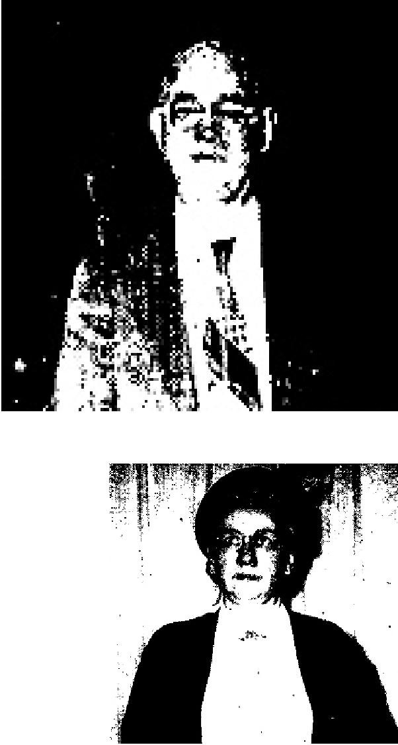
THE VOICE OF HEALING 1952
being and a voice came to me saying, "the Angel of the Lord encampeth around about those that fear Him and delivereth them," then I heard again, "you can touch his body but you can not take his life," and again, "the Lord is a consuming fire .. . I picked up my wife and opening the door, stepped out into the corridor and started down the hall. As I went, the flames receded and the terrible smoke seemed to roll back, until we reached the lobby,
Surely, "The eyes of the Lord run to and fro throughout the whole earth to show Himself strong in the behalf of those whose heart is perfect toward Him."
Sent in by: Rev. L. D. Johnson
420 No. Curtis
Alhambra, Calif.
June 1952 p12
Healed of Deafness At the Age of 72
As a child I suffered an illness which left me hard-of-hearing, As the years passed by, it became increasingly difficult for me to hear. Finally, I suffered with an abscess which left me totally deaf. The Lord healed me of the abcess but my deafness remained.
My pastor informed me of the Vinyard Salvation-Healing meetings being held in Chelsea, Massachusetts. He took me to the services and when Bro. Vinyard prayed for me, I felt the mighty power of God pass through me. I knew I was healed. Praise the Name of the Lord! I haven't worn a hearing aid since. I now can hear perfectly.
Mrs. Rose Slate,
Box 216,
Old Country Rd,
Plaistow, New Hampshire
June 1952 p13
Healed of Neuritis And Partial Deafness
In 1949 1 was afflicted with neuritis in my back and shoulders. After many treatments and X-rays, I was none-the-better. Then I heard of the Vinyard meetings and decided to trust God for my healing. Prior to this, I had not been in church for 20 years. After accepting Christ as my Saviour, I entered the prayer line. God restored my hearing and healed me that night of neuritis. All pain and soreness is gone! Praise the Name of our Lord!
Arthur Fortuna
805 West 8th Street,
W. Wyoming, Penna.
Woman Testifies Of Disappearance of Multiple Ailments
After I had suffered for many years, God sent Brother Vinyard to Wyoming Valley, Pennsylvania. Through him I found Christ as personal Savior and Healer on August 22, 1951. As I stepped into the prayer line. Brother Vinyard said, "Sister, you need a general overhauling". This was true for I was very sick.
The morning after I was saved I awakened with terrific pains. I was accustomed to having to take morphine or other pain-killers,but this day I believed God was going to heal me. I read the book, "Bible Days Are Here Again”, and faith filled my heart as it revealed to me that I could be healed. I had been a heavy smoker for 12 years and had tried to quit but

THE VOICE OF HEALING 1952
could not. That morning God delivered me from that awful habit so that for days afterward I could not stand to be in the room where there was cigarette smoke.
Within two weeks after my salvation, many healings and miracles took place in my body. Fever left my lungs, a rib which was rubbing against my heart was moved; a serious rheumatic heart condition which I suffered from childhood was healed! Praise the Lord, all pain and symptoms are gone. My heart is normal today.
I was totally deaf in the left ear for 23 years, and hearing in the right ear was only about fifty per cent. Two doctors said that I would never hear again. After prayer my hearing was immediately restored.
I also had a nervous stomach and colitis, for which I was in the hospital four times. Apparently nothing could be done for me. But praise God, Jesus healed me of all these afflictions.
Curvature and ankylosis of the spine caused my back to ache terribly. Just two years ago, after examining X-rays, doctors told me there was no help for me. After prayer, I felt the warm hand of Jesus on my back, and, Glory to God! the soreness and pain left me and his never come back.
Serious trouble in the rectum, necessitating hospitalization thirteen times and two operations, caused me much pain and misery. However, on September 25, 1951, I realized that God had healed me and restored those portions of my rectum which had been removed during the operation. Praise His Name!
Later I attended another of Brother Vinyard's meetings in Moosic, Pennsylvania. At this time, God healed me immediately of weeping eczema of both ears.
I thank God that He took a sinner like me, saved me and made me whole. I have gained 24 pounds and have never felt better in my life.
Signed:
Mrs. Bertha Evans
1301 Murray Street
Forty-Fort, Penn.
June 1952 p14
IDOL GODS THROWN AWAY AS CUBANS WITNESS WORKS OF CHRIST
Paralysis  Ada Martinez was paralyzed. Her right leg was stiff and helpless. She worshipped many idols who, in turn, were supposed to heal her ailments and protect her from harm. The image of Saint Lazarus, the "healing saint" was kept before her constantly, but he didn't seem to see her needs. When Bro. Allen prayed under the big tent in Havana, she saw cripples walk away without crutches, blind people crying, "I can see," and a big man leaping and shouting, "my ears are open." All her images and idols had never been able to do this.  When Bro. Allen prayed for her, life came back into that numb limb and she was immediately able to walk normally. She took all her idols and images (see picture) to add to Bro. Allen's "collection," and she is now happy in serving a LIVING God. Pastor Howard S. Coffey confirmed this miracle. | 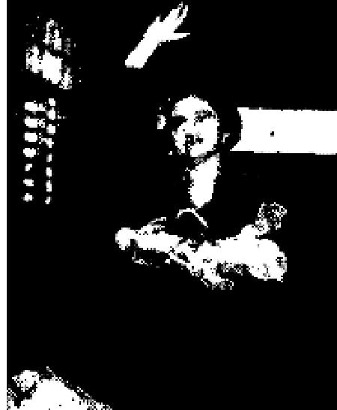

THE VOICE OF HEALING 1952
Deafness
A smile of elation breaks out of the face of Mario Chau when he discovers he is able to hear after 14 years of deafness. Said he, "The first night I attended I saw immediately it was different than anything I had ever seen, but I liked what the man said from the Bible, and when I saw so many being healed, I went up. Now I can hear everything."
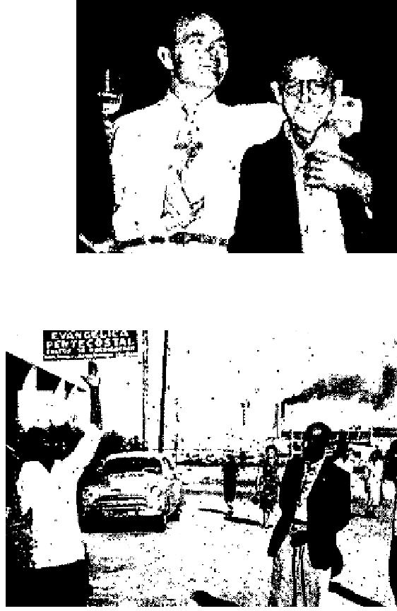
Paralysis
Allen Hurdle, 807 Agado, Havana, had been absolutely helpless for months. The strange affliction had come upon him suddenly while committing sin, and be was constantly in such paralyzing pain that he could not even move. After months of wasting away, being given up by doctors and sent home from the hospital to die, someone told him about the Allen meeting. Friends
improvised a bed in the rear of their car to take him. His agonizing screams of pain brought a policeman from his beat who thought he was being murdered.

He writes, "I cried to God in desperation and He saved my soul. When Allen finally came to the car to pray for me, he looked at the medal of Saint Christopher which was supposed to protect me from harm sickness and accident and asked. 'If this medal is supposed to protect you from all these things, why do I read on the back side IN CASE OF ACCIDENT OR SICKNESS CALL A PRIEST?
Then I realized that all the years I had worn the medal it had never brought the protection it was supposed to. I told Allen to take the medal off. He did. He then said, 'Now we are going to call on One who KEEPS His promises!' He prayed in the Name of Jesus and the pain left so suddenly I was amazed. I sat up and got out of the car without any assistance, praising the living God, and have been well ever since."
Deafness  When a small child, Hilario Gonzalez was injured by a fall which retarded his growth and left him totally deaf. For 22 years he suffered continual pain in the neck and head. Many doctors had been consulted, but could not help. His mother went with him to he prayed for, and like many others, his ears were opened and the pain left his neck and head. | 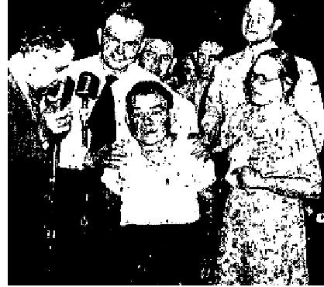

BLIND MAN SEES INSTANTLY
Thirty years ago, while fighting in the war of Independence in Cuba, one of my eyes was shot out. Then four years ago I lost the sight of the other eye, leaving me totally blind.
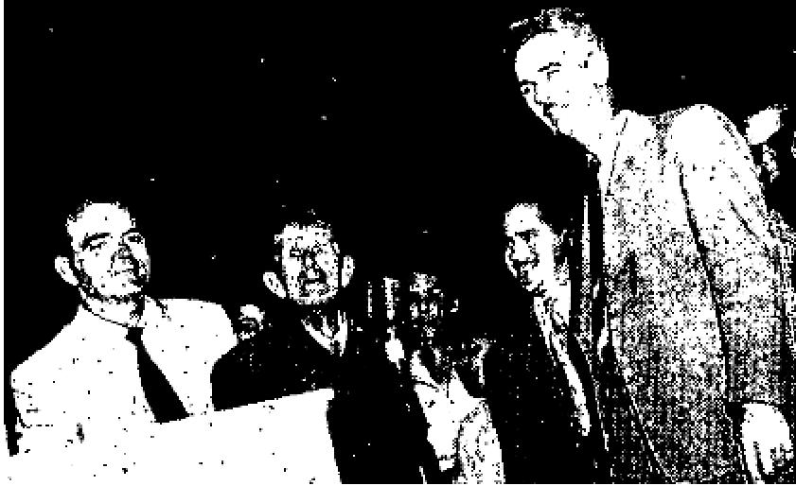
A congressman's son advised me to go to the Allen Tent Revival, as it had been reported to him that God gave people new eye sight and performed many other great miracles of healing here.
I went to the tent and Rev. Allen prayed for me at the close of the service. After he prayed. he took his hands from my eyes. When he did, the power of God went all over me, and instantly, GOD RESTORED SIGHT TO BOTH EYES. I was so overjoyed at this great miracle that all I could do was just jump up and down and shout and fell everyone what God had done for me.
Manual Avila Petez,
Calle 3ra and A, Guanabacoa, Habana, Cuba

THE VOICE OF HEALING 1952
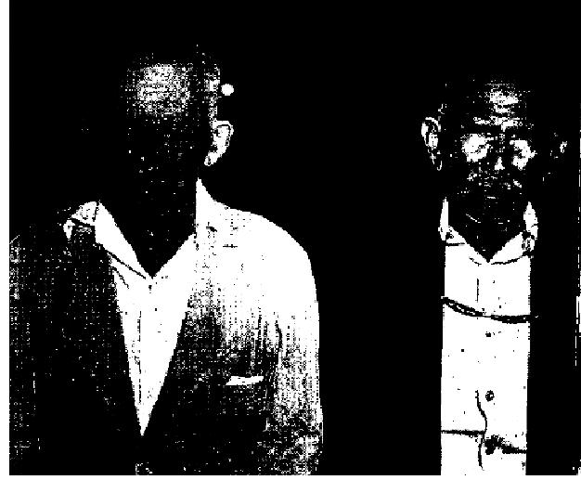
June 1952 p16
BLIND MEN SEE
These two men give glowing testimonies of being healed of blindness as Bro. Osborn prayed. Calle Trinidad, on the left, asked friends to lead him to the meeting. The first night, after the evangelist prayed for all the sick people at one time, Calle took his hands off his eyes and could see light! He was happy for he knew he was being healed. He went home rejoicing ever all he had heard. and the next morning he could see objects! Clearer and clearer became his sight until he could see everything!
Punta Cardon, right, laid his hands on his eyes when Bro. Osborn told all those with eye trouble to do so while he prayed, and when the prayer was finished, he could see hundreds of little black spots. He kept believing, and in a few moments those spots began to fade away and everything was clear. Now he claims good eyesight.
Below: On the night this picture was taken in Punto Fijo, police broke up the meeting and arrested the evangelist. (Story above.) Picture below left shows how the cars and buses were jammed. bumper to bumper, all the way to town. (almost halt a mile.)
June 1952 p17
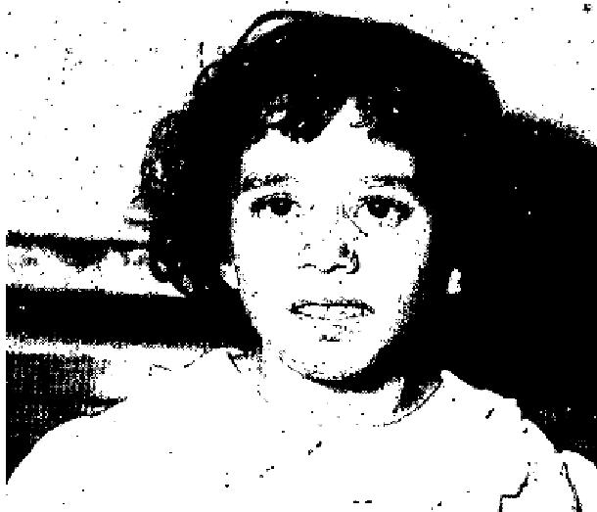
CROSS-EYED FOR SEVEN YEARS
My little daughter, seven years old, was born with eyes extremely crossed and very weak. I took her to Evangelist T. L. Osborn's Healing Campaign in Punto Fijo. There must have been at least 12,000 people there that night (the second night of the campaign) and we were a long way back in the crowd. I knew it would never be possible to reach the evangelist with her, but, I was made happy when I heard him say we could be healed where we were, and then instructed us before he prayed en masse for all of us. My little girl had listened to all of this and followed his instructions. When Bro. Osborn told all those with blind eyes, or
eye trouble of any kind, to, place their hand, on their eyes and he would pray for all of them, she did this. When he finished the prayer, she looked up at me. I can't explain the emotion that overwhelmed me when I saw her eyes. for the first time in her life, PERFECT-LY STAIGHT! Oh, Praise God!
Edui Zavarce,
70 Calle Rafael Gonzalez
Punta Fijo, Falcon, Venezuela, S.A.
June 1952 p18
Fern Huffstutler Conducts one of Toronto 's Greatest Revivals
Testimonies Gleaned From Campaigns . . . . . . .
For five years I have been doctoring for inward cancer. I have been operated on 8 times, have taken shots, tablets, radium, electric needles, etc. I had all the treatment allowed by the state of California. Finally, I went across the border to a famous Mexican doctor, Dr. Diaz Montez, who operated on me. I was given two gallons of blood to sustain me through the surgery, and many godly people prayed. When the incision was made, Dr. Montez found that God had already performed the work, and had tied the muscles to muscles and nerves to nerves. But I still suffered with the cancer. It was moving toward my heart and I was told it would be only a matter of time. I took 12 shots of narcotics a week for the pain and then lapsed into comas and would spend days in unconsciousness. The cancer drainage was profuse.

THE VOICE OF HEALING 1952
When Sister Huffstutler came to Imperial Valley for a great healing campaign, God spoke to me and told me that when she laid hands on me, He would fill me with the Spirit and heal my body completely. This He did! Instantly the drainage and all pain stopped. I received new strength and returned to the doctor. He was amazed. He made an examination and found no trace of cancer. I praise God for His goodness.
Mrs. Arthur W. Smith
Box 722
Seeley, California
Dear Sister Fern;
Just a note of thanks and appreciation for the great work you have done in Toronto during the past six weeks. You may know the number that came to the altar but I am sure that many hundreds have been helped that you may never know about.
In my humble opinion, you arc without a doubt one of the most outstanding evangelists to visit our city in recent years. I, personally, have been helped, along with many, many others.
May the Lord continue to bless your ministry.
Yours very truly, Jesse Wetter, Inspector of Police, No. 1 Division, Toronto, Canada.
EYE CANCER
After being examined by an eye specialist and a medical doctor, I was told that I had cancer creeping over
my eyes. I was also told that I would lose my sight within a year.
While Sister Fern was in Toronto, I had her pray for me. After prayer, I felt a sensation in the back of my eyes, and I could see better immediately. Two days later I went back to the specialist and an examination revealed that the growth was receding. I did not need new glasses. Praise God.
Madge Wilkes
139 Lyttan Blvd.
Toronto, Canada
July 1952 p4
SIGNS - MIRACLES - WONDERS IN THE CAMPAIGNS OF- TVH EVANGELISTS
EVANG. RUSSELL PARK  BENT BACK, NERVOUSNESS HEALED BY PRAYER  I am writing this testimony to let people know what God can do. When I was four years old I was afflicted by a high fever which left me in a weakened condition. I was left stooped and bent, my back and hips were stiff, and I was very nervous. Then at the age of thirteen I suffered a stroke in one side and my eyes were left crossed.  On September 28, 1951, I went to the Union Tent Revival conducted by Bro. Russell Park in Trinity, Texas. He prayed for me and I was instantly touched by God. The next morning I noticed I was completely healed. My eyes are straight and, as you can see by the picture, I stand very straight now. | 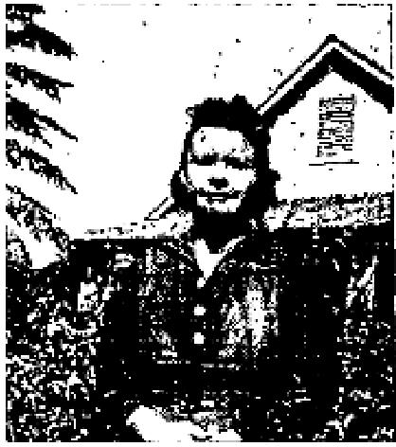

I can't praise the Lord enough for sending Brother and Sister Park our way. There is power in the blood of Jesus Christ. Beatrice Gates, General Delivery, Trinity, Texas

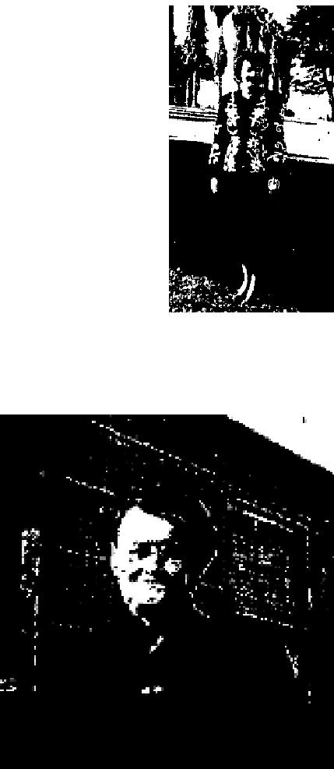
THE VOICE OF HEALING 1952
EVANG. GAYLE JACKSON
MIGRAINE HEADACHES 27 YEARS; NOW GONE
I suffered intensely with migraine headaches for 27 years. The pain extended down into my
neck and shoulders as it grew worse. I was healed instantly in the Gayle Jackson revival, here,
after prayer in the healing line. I praise and thank the Lord for healing me.
Dorothy Beuchler, 3177 A Street, San Diego, California
EVANG. WILBUR HENRY
"PERMANENT" INJURY HEALED IN MEETING
Six years ago I received a permanent injury of the spine. After several x-rays, the specialists told me that there was nothing they could do for me and sooner or later I would be a cripple from arthritis. For the past two years I have suffered much and my back was so stiff I could hardly bend over. Brother Henry prayed for me and the Lord instantly healed me. Praise His Name.
Lucy Miller,1828 Ellen Street, Roseburg, Oregon

As Mrs. Lucy Miller's Pastor, I wish to confirm the healing she received from the
Lord during Evangelist Wilbur Henry's meeting it; Roseburg, Oregon, during January.
Rev. Vernon L. Klemir
Assembly of God, Roseburg, Oregon
EVANG. U. S. JAEGER
MULTIPLE AFFLICTIONS DEFEATED BY FAITH
I want to praise the Lord for the miracle which He has performed in my body.
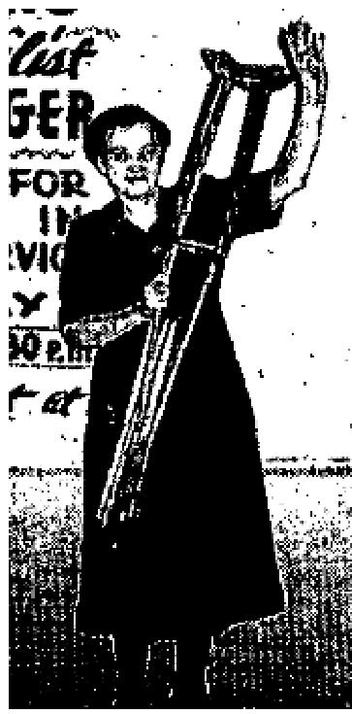
I have had Berghers disease for nearly 7 years in my feet and legs. The American Medical Association told me that there was absolutely no cure for this disease. Thirty-two doctors, to whom I have gone, could do nothing for me. I have undergone seven operations, which resulted only in drawing up my hip and knee, so that just my toe touched the ground and I could walk only with the aid of crutches, and that with much pain.
My feet and legs were black and swollen. I had not been able to wear shoes for years. I also suffered with a cerebral tumor which caused much agony. I was unable to raise my head; my back was crooked, and my hands were drawn up so I was unable to open and close them, I also had high blood pressure, and hardening of arteries to the extent that one eye was blind. I suffered excruciating pain continually.

One night I had a dream. Jesus sat at the end of my bed. He told me to go to the Normana Halt where Brother U. S. Jaeger was ministering to the sick, and that he would pray for me and I would he healed. On March 4th 1952, I was able to find someone who would take me. Brother Jaeger asked if there were any backsliders. I had been a backslider for 24 years. He was looking directly at me. I had to raise my hand and a gentleman helped me up to him. First Brother Jaeger prayed for my salvation and I experienced the joy of sins forgiven. Then he asked Jesus to heal me. He took my crutches, telling me to walk in the Name of Jesus. I was so frightened! But to my amazement my leg, back, head and hands were straight. I can now see with the formerly blind eye. All pain has gone. I was made whole again, from the top of my head to the bottom of my feet. I ran with joy all over the place.
I feel like the happiest woman on earth. My heart is filled with praises and thanksgiving for what my wonderful Lord has done for me. Truly, a new day has dawned in my life.

THE VOICE OF HEALING 1952
Mm E. C. Crawford
1301 Market, Tacoma, Washington
EVANG. VERNON GRIGGS
GLAND DISORDER CORRECTED IN PRAYER FOR BLESSING
Praise the Lord for what he has done! I had been going to the doctor regularly for
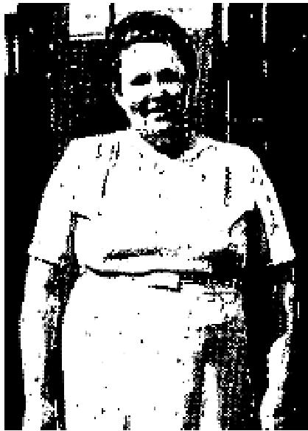
monthly checks on my heart. I was overweight and was put on a strict diet, but didn't
seem to lose weight as I should. On the night of January 23, 1952, I was standing
with a group in prayer for spiritual things when God revealed to Brother
Griggs that someone had been healed of gland trouble.
Since that time I have lost about 20 pounds. When I returned to the doctor on February 11, he found my heart in good condition. I had also been healed of rheumatic fever and arthritis. I don't have any pains in my body any more.
My husband was healed of arthritis also. The Lord has blessed us both, spiritually as well as physically.
Mrs. Isaac Hill
1018 W. Wishkah Sr., Aberdeen, Washington
MIRACLE HEALINGS OCCUR WHEN TVH PLACED ON BODY Fever Broken

Dear Editor:
I have a testimony that should have been given some time ago ... About one and one-half years ago, I was home alone with my four children and I took a high fever of 101.2 (°F), and my skin broke out in big blotches that burned like fire, and was very itchy. Our local nurse told me it looked like hives or poison from weeds, and also told me how to care for it. But I did not do as she instructed me, for I was trusting the Lord to heal me. As it was bedtime, I went to bed and took the Voice of Healing, and as I read, I was blessed by the wonderful testimonies, etc., and the Spirit of the Lord caused me to pray in other tongues; and as I did, I put the Voice of Healing on my chest and in a few minutes I got up to get a drink of water. I looked in a mirror, and there was hardly a mark to be seen. Jesus had healed me the fever was gone! (All this happened in from 20 to 30 minutes.) I was thrilled, for I knew of others who had been afflicted with the same thing, and they had taken penicillin, and then developed another rash from the medicine.
May God bless your work! I know of a home where unsaved were blessed and prepared for salvation through reading The Voice of Healing, distributed by faithful readers. God saved a boy from that home. He was doped and sick in his mind from drink. He thought he had killed someone, but because he read many copies of the Voice of Healing he was helped to receive faith for deliverance for his soul and body. He is now a member of our church.
Mrs. C. Mintz
Gooderham, Ont., Canada
BOIL OPENED
Last October I had a boil on the inside of the lower lid of my eye. It was very painful. I prayed, "Lord, you will have to open this boil, for nobody else can." As I prayed I laid The Voice of Healing magazine upon my cheek and prayed, "Dear Lord Jesus, these are your witnesses that you heal." The power of the Lord came upon me and when I got up off my knees, the boil opened. I got a cloth and wiped the drainage and as I did so the core came out. It has never hurt any more. I thank my Lord Jesus for His goodness to me, and also

THE VOICE OF HEALING 1952
for your paper.
"Oh, give thanks unto the Lord for He is good; for His mercy endureth forever."
Mrs. Martisha Francis
387 W. 8th Street, Pomona; California
July 1952 p10
ACTIVE FAITH BRINGS HEALING TO POLIO STRICKEN WOMAN

I was stricken down eighteen months ago with polio. I was; taken to the Burge Hospital in Springfield, Mo. and was there five months. Dr. Yancey and Dr. Music put me in braces up to my hips on both limbs, sent me home and told me it would be a long time before I could ever walk without the braces, if ever.
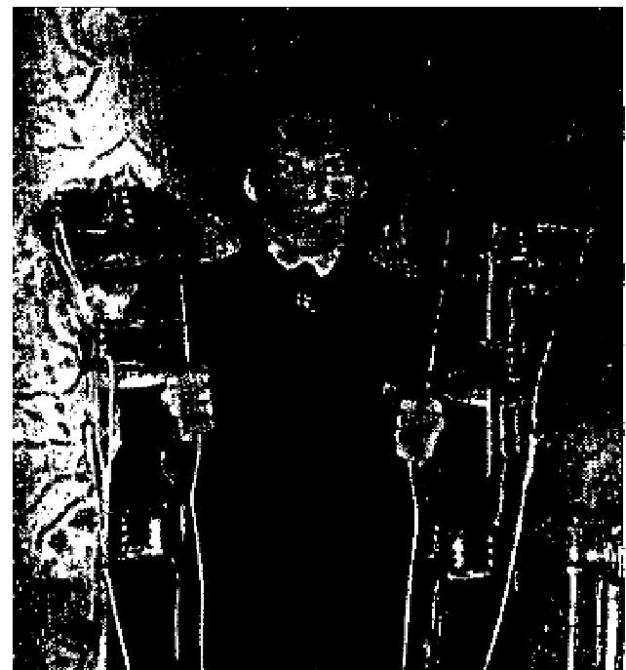
I had to do all my work in my home by way of a wheel chair. Hearing of the Jack Coe Healing Revival in Springfield, I went and God did for me in a few minutes what no one else could do Bro. Coe prayed for me and instructed me to go take off the brace. I removed them and walked back in the services without them and have been walking ever since. I was go sure God would heal me that I even took my shoes to the meeting. I wore them home, praise God!
Mrs. Johnnie Sallee
710 S. Forest
Springfield, Mo.

July 1952 p12
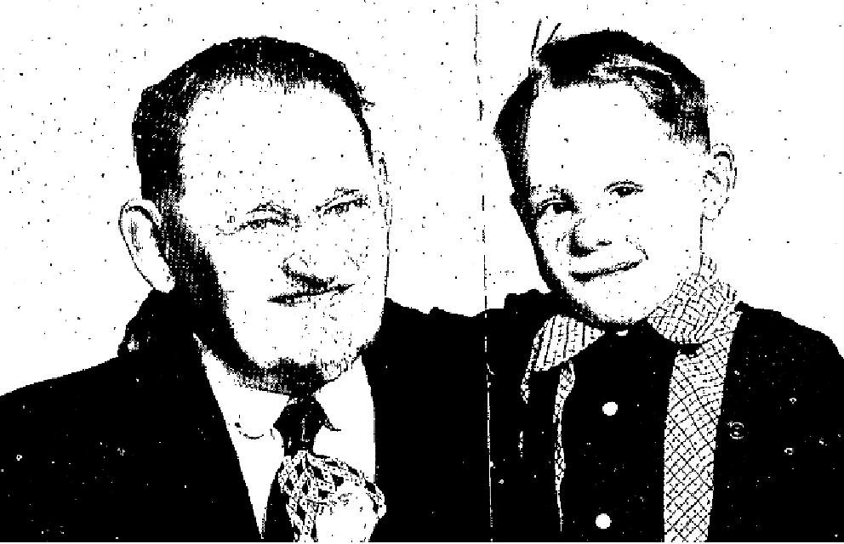
RESTORED TEETH
TO WHOM IT MAY CONCERN:
I examined Adolph Stroh, 4 1/2 years old, on the first of April, 1952, and found his physical condition to be as follows:
He was undernourished, aid the bone construction was under-developed and lacking in calcium, the necessary material for the formation of healthy teeth. All of his teeth at the time of examination were soft, black, and rotten. The child had but recently been brought to America from Germany, where it was impossible at that time to secure the proper food.
On the sixteenth of April, 1952. he was prayed for by Rev. W. V. Grant, who was holding a healing campaign at Bethel Temple in Seattle. On the 19th of the same month, after another examination, I found that all the teeth were covered with a new enamel, perfectly white and normal in every respect.
Signed: W. L. MARTIN, Sari. Physician
Subscribed and sworn to before me this 28TH day of April, 1952.
My commission expires DECEMBER 6, 1954.
C. H. CASE, Notary Public In and For the State Of Washington

THE VOICE OF HEALING 1952  July 1952 p13  TESTIMONIES FROM PEOPLE MIRACULOUSLY HEALED BY GOD  TORN LIGAMENTS MEND  Two months age I was in an automobile accident and the ligaments were torn loose in the top of my right foot. I wore a cast for six weeks, at the end of which period my foot was weaker than it had been before.  On April 19, 1952, I came on crutches to Bethel Temple. Brother Grant said, "If you want your healing stand up and praise the Lord." I stood to my feet; the Spirit of the Lord was there mightily. Suddenly I realized that I was rocking back and forth from my heels to my toes. I thought, "I can't do this!" But then I said, "I know it is you, Lord, and I know that I'm healed."  I discarded my crutches and I left them at the church. The crutches had a made the joints in my hands, arms and shoulders sore, but I was also healed from the soreness!  Margaret Soper, BETHEL TEMPLE,  Second & Lenore Sts.  Seattle, Wash. (MISSIONARY) | 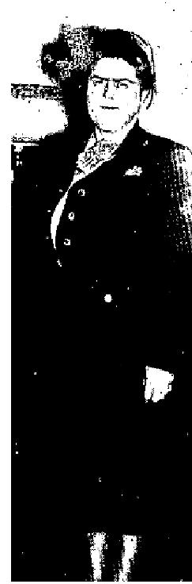

TUMOR DISAPPEARS
For two years I have had a tumor on my body. The doctors wanted me to submit to surgery. But while I was sitting in the audience during the Grant Deliverance Meetings in Bethel Temple, Seattle, the Lord healed me. I RETURNED TO THE DOCTOR FOR FURTHER TREATMENT AND HE TOLD ME THAT HE FOUND NO SIGN OF THE TUMOUR. Praise the Name of the Lord!
Ethel Choir,
Mirror Lake, Washington.
SIGHT RESTORED
I had been blind in my left eye all my life. The pupil was enlarged and the eye was swollen. I had fainting
spells as a result of the terrible pains in the eye-ball. I had less than ten percent vision when I was born.
One night during his revival in Seattle, Brother Grant said, "Someone is here who is blind in the left eye." I went forward and after prayer the swelling left and the enlarged pupil was made normal. I can now see to read ordinary print with the eye Hallelujah!
I was also healed of a painful cyst in my right wrist which I had had for one year, and a chronic pain in my left knee caused by falling on ice.
Evangelist Ruth Helgeson,
Missionary to Formosa
107 W. 51st St., Seattle, Wash.
NURSE GETS HEALING
A hurting in my right shoulder and right lung crept down my right arm and settled in my fingers. Eventually it came down my left shoulder and settled in the muscle of my right arm. I went to a chiropractor and took five treatments which didn't help. I went to an M. D. and spent a day in his office taking X-Rays, fluoroscopes, and all kinds of tests. He said that the lower part of each lung was filled with moisture and was collecting in the cells; of the lower part of the lungs, thus throwing my heart, which is very serious. I took medicine for a week and then went back. This condition had left my right arm and hand (from the elbow

THE VOICE OF HEALING 1952
down), numb and stiff. I could not use them. . . but when I attended the Grant Revival in Seattle, I was INSTANTLY HEALED. I can now raise my arm and hand and use my fingers, which I could not do before.

Bertha M. Cole (50 years a Nurse)
6516 - 32 Ave., N. W.
Seattle 7, Wash.
CAST DISCARDED
I fell on January 13, 19 52, and turned my ankle. I went to the hospital two days later with pains up into my hip. I was put in a walking cast and used two crutches. In February I suffered, worse than at the beginning. I went back to the hospital, and was booked for surgery. In order to, take X-rays it was necessary to use an injection of local anesthesia. They told me that my ligaments were torn. I was put into another cast on April 6.
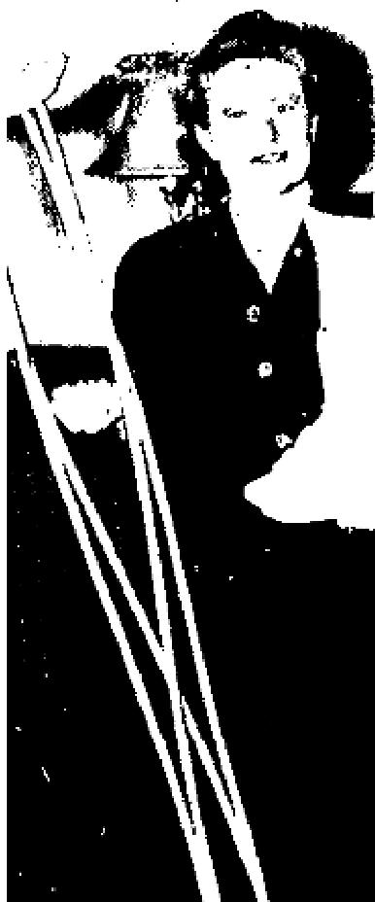
Before ore Brother Grant prayed for me at Bethel Temple in Seattle, the cast it as perfectly as a glove, but as soon as I was prayed for it became so loose it was uncomfortable I went to the doctor, who told me "they sure made a good job of it." He was amazed and would not be satisfied until he had taken four X-rays, He said, "As a precaution we will put another cast on for 4 weeks."
After waiting 48 hours for the cast to dry I went to church with that cast tight; but after prayer it swung loose. I went home, took a hammer, putty knife, and some hot water, chiseled the cast off, and brought it and the crutches to Brother Grant. I am completely well.
Annie Anderson, 911 Alder Ave., Apt. 7S7
Seattle 4, Washington.

HEMORRHAGE CEASES
I was healed of a hemorrhage of the head which I had had for one year. The hemorrhage had given me much pain until I was prayed for by Rev. W. V. Grant. Since Jesus has healed me, all the pain has left my head and the hemorrhage has ceased.
Jerry Kenum, G. D. Carnation, Wash.

July 1952 p14
HEARING RESTORED TO BOTH EARS OF WYOMING MAN
I had been deaf for about 10 years, Doctors told me they could do nothing for me. In December of 1950, I was examined for a hearing aid and, at that time, 54 percent of my hearing was gone in both ears. I purchased the hearing aid 'and ware it until March 13, 1952, when Brother Ogilvie prayed for me and God healed me. I removed my hearing aid at that time, and have not had it on since!
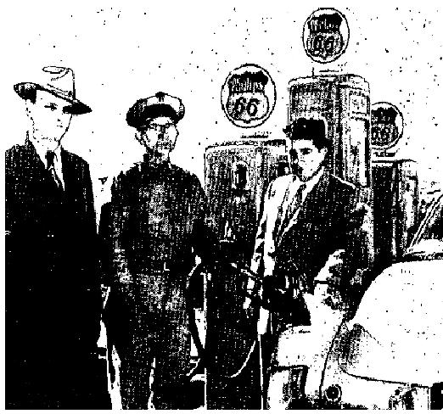
Now I can hear the telephone, the doorbell, and the bell it the Phillips "66" station, where I am manager, Praise God for what He has done for me!
Charles L. Oliver
Phillips "60" Station
On Highway 30
Green River, Wyoming

THE VOICE OF HEALING 1952
July 1952 p15
IN OGILVIE CAMPAIGNS TESTIMONIES SHoW POWER OF GOD
MINE INSPECTOR HEALED
I have worked in the coal mines in Colorado and Wyoming for the past 30 years. My as an examiner for explosive gases and loose rock or other danger necessitated my walking almost continually for eight hours a day. In 1936, my feet became lame and, after consulting a chiropodist I was fitted with arch braces for both cross and long arch. After having worn these braces for 16 years, I was healed after prayer by Rev. Wilbur Ogilvie. I attended the Ogilvie meetings in our church in Rock Springs, Wyoming, and was prayed for. My left ear, which had been deaf since 1943, was opened, and my feet were healed. I took the braces out of my shoes, and am walking better than I have for 20 years. The pain is gone, and my feet are getting stronger all the time. Praise the Lord!
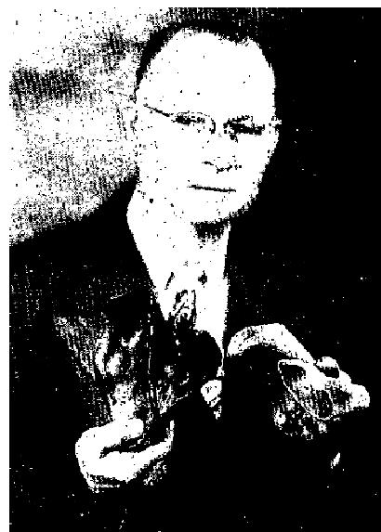
Henry R. Williamson
Box 475
Rock Springs, Wyoming

INJURED EYE NOW SEES
On his fourth birthday, my son, Ronnie Dean, lost the sight of his left eye. He
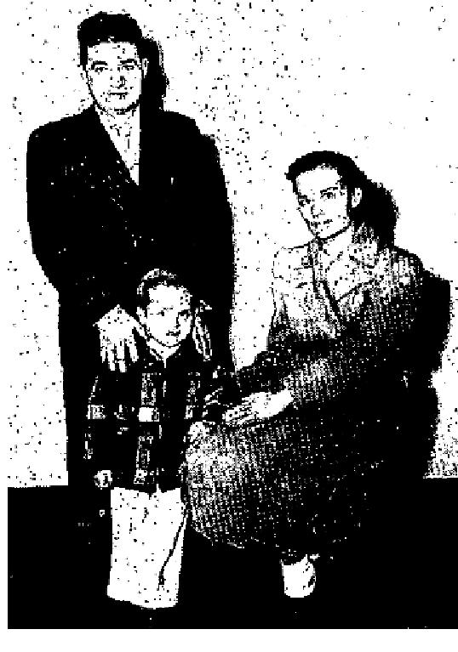
was very ill and in the hospital. They sent him home, saying nothing more
could be done, that he was totally blind in that eye, and
probably always would be.
We attended Brother Ogilvie's meeting in Casper, Wyoming; he prayed for Ronnie and, in a matter of minutes, his eye started clearing - and the vision returning. It is getting better every day and I know that Jesus has touched him, Praise His wonderful name!
Mrs. Edith Maher
1026 N. Kimball
Casper, Wyoming

CROSSED-EYES HEALED
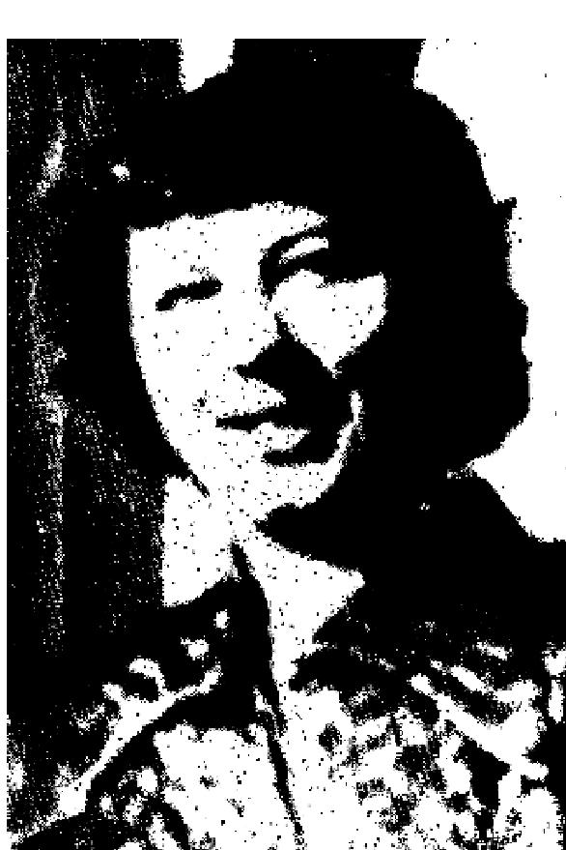
I truly thank the Lord for healing my eyes. For 12 years I had worn glasses. I was cross-eyed and farsighted and had terrible headaches if I took my
glasses off for just a short time.
On March, 1950, Brother Ogilvie came to Cody, Wyoming. I was prayed for, and God instantly healed me. At the writing of this testimony, I have been healed 2 years, and during this time, I have never had to use the
glasses once! Praise God for His healing power!
Mrs. Oliver Moore
523 Ave. G-Box 209
Powell, Wyoming
Note-- Brother Ogilvie and I saw this lady in March of this year. Her
beautiful brown eyes are now straight, and before prayer they were so crossed that the color could hardly be seen. Mrs. W. Ogilvie

THE VOICE OF HEALING 1952
July 1952 p17
TOMMY HICKS REVIVALS MARKED BY APOSTOLIC - BIBLE DAYS POWER
Curved Spine Straightened  Dear Brother Hicks:  I am praising God for healing me of a double curvature of the spine when you prayed for me in the city of Long Beach, Calif. I had an appointment with the doctor to be measured for a heavier brace, but instead Jesus delivered me of the one I was wearing!  Ruth Carpenter  5363 Olive Avenue  Long Beach, Calif. | 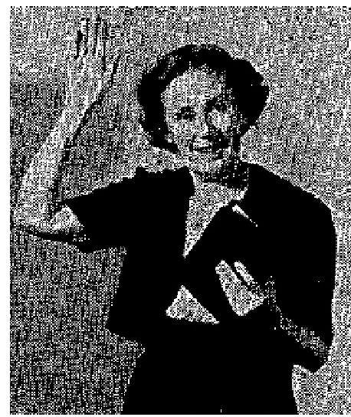

Husband and Wife Healed
While Brother Tommy Hicks was in Grand Junction, my husband and myself were prayed for and my husband was healed of ulcers of the large intestine, and God wonderfully healed me of a goiter and hemorrhoids.
We do thank God for healing our bodies, and for Brother Hicks' ministry, We are so glad he came to our, city.
Mr, and Mrs. Leonard Gould
Grand Junction, Colorado
Healed of Partial Blindness
I was waiting in the prayer line in one of Brother Tommy Hicks' meetings, but could not see to fill out the
prayer card which has been given me. Another lady filled it out for me.
When Brother Hicks prayed for me I felt a coolness come into my eyes and I was wonderfully healed. Now I can see fine and have never even bad my glasses on since that night, Thank God!
Miss Dileia Wiseman
1040 California Avenue
Long Beach, Calif.
Healed of Tumour
During the month of March, I was taken very sick with severe pains low in my back, over the kidneys. These pains reached around the left side, ending with sharp knife-like pain in the bladder. I was very sore all through the abdomen. On Thursday evening, April 24, 1962, Bro. Tommy Hicks prayed for me, also he said I had inward infection. The following Saturday, April 26, I passed a pear-shaped tumor about the size of my fist, and passed smaller pieces for the next few days. I praise God that today I can testify to my complete healing. I give God the glory, and thank Him for the blessing that Bro. Tommy Hick's ministry has been to me.
Sincerely,
Mabel Geradian
138 Cloverleaf Ave.
Porterville, Calif.

THE VOICE OF HEALING 1952
Healed While Seated in the Audience
I had for many months suffered with a pressure around my heart and my blood circulation was affected in
such a way as to cause me real concern.
While I was seated in the audience one night, Brother Tommy Hicks called me out, having discerned my sickness. At that moment I felt the healing power of God surge through my body and I am healed!
Alma Glaze, Box 284, Gridley, Calif.
Crossed Eyes Straightened
My daughter had been wearing glasses since 1950. One eye was completely turned in but we knew that God could heal her. This was made a reality the night you prayed for her. She has not worn her glasses since and HER EYE IS STRAIGHT! Praise the Lord!
(Daughter's name: Merlene Miller, age 9.)
Mrs. Ned W. Miller
2275 Pasadena Avenue,
Long Beach, Calif. (mother)
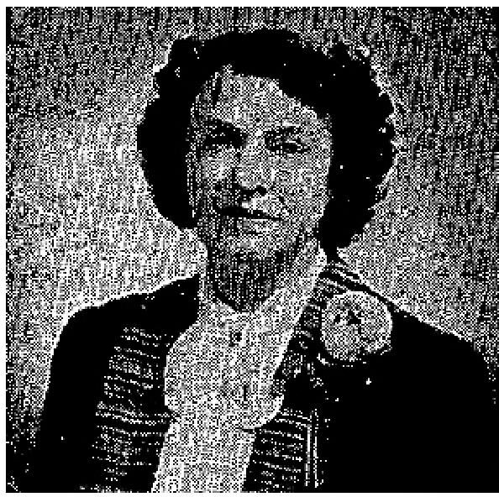
Cancer Removed
In January of 1951 1 was told by the doctors that they could do nothing more to help me. I was in great pain and my body had to be turned in bed most of the time. At times I could not even walk.
In June of that year I was able to attend Brother Tommy Hicks' revival in Long Beach. While bringing his message the Spirit of the Lord was mightily upon him, he turned and pointed to me and declared that I had an internal cancer and that it would pass from my body.
I felt the healing power of God flow, through my body and what a thrill I experienced as I began to dance and sing in the spirit. I was free! I knew something had taken place. Later in the evening, Brother Hicks told me that within 24 hours the cancer would begin passing from my body. Rev. Hicks was a stranger to me; I had never seen him before.
The next day, according to his word, the cancer began to pass from my body - hundreds of pieces that looked like a great spider. This continued for several days. I was able to attend the remainder of the revival, sing in the choir and to help many find our blessed Christ.
It is wonderful to be well, to feel so good and most of all to have such a glorious Saviour! He is longing and waiting to deliver you.
Lora Weintraub, Marshalltown, Iowa
Healed and Delivered
I have been healed of a cancer and a tumor. I had taken shots for over a year, but to no avail, Since Brother Tommy Hicks prayed for me, God has healed me and made me completely whole again. My husband was also wonderfully healed of deafness and delivered from the smoking habit, which he had tried many times to stop, but could not.
Mr. and Mrs. Clyde Kirk III
68 Way, Long Beach, Calif.

THE VOICE OF HEALING 1952
August 1952 p10
THESE FOUND THAT CHRIST STILL HEALS TODAY
Diabetes
For about seven years I suffered from sugar diabetes. I was placed on a rigid diet and
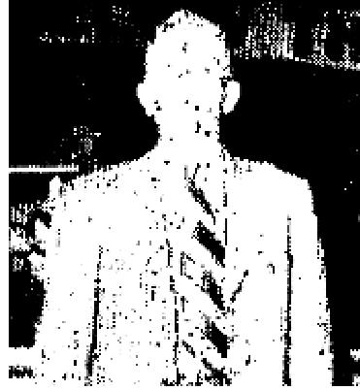
took thirty units of insulin daily. The doctor said that if I ever quit taking the insulin or
discontinued the diet I would die.
Ten days ago I had A. A. Allen pray for me. After he prayed for me he told me to go home and eat
and to take no more insulin. Since that time, I have not had one shot, I have disregarded my strict diet and I eat everything I want. I feel fine. I am completely healed, To God be all praise!
(Signed) Rev. J. W. Gary
1242 Goodrich St.,
Greenville, Miss.

Severed Nerve
Eleven years ago, an accident severed a nerve in my foot. Within about five years, my limb from the hip
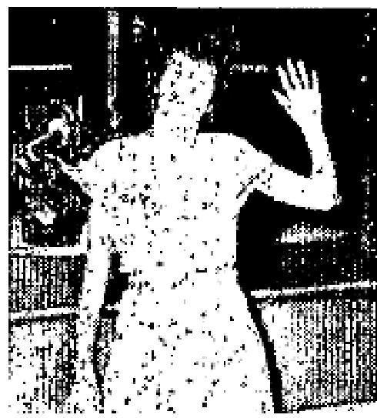
down became paralyzed. Four operations were performed but it got no better. I took all kinds of shots but they did me no good. My limb was stiff and helpless and I had to drag the foot as I could not use or control it.
On May 25, in Greenville, Rev. Allen prayed for me and INSTANTLY, LIFE RETURNED TO MY FOOT so that immediately, I was able to use it again.
(Signed) Essie Kilpatrick
Rt. 1, Box 18
Greenwood, Miss.
Hernia
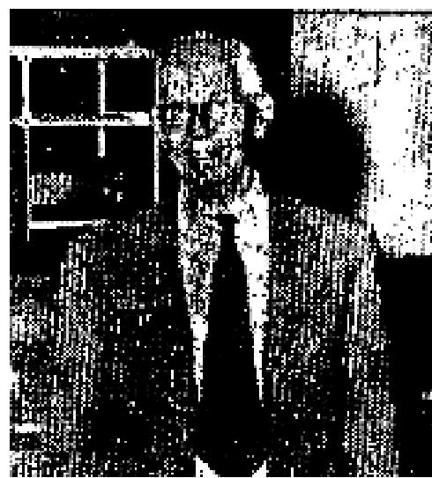
For three years I had a severe hernia which was caused by hard coughing. Although I wore a truss that cost $145.00, it did very little good and I was unable to do any work.
On Jan. 15, I attended the A. A. Allen Healing Revival in St. Petersburg, Florida. Brother Allen prayed for me in the prayer line. As he prayed, I COULD FEEL THE HERNIA MOVING! Next morning it was all gone! The next night I was able to drive my Car to the services. To this date, April 30, there has been no sign of the hernia.
W. A. Cox
1438 E. Turner
Clearwater, Florida.
August 1952 p11
God Healed Me ... IN NANKIVELL MEETINGS:

THE VOICE OF HEALING 1952
Of A Large Tumor
I was prayed for by Sister Nankivell on Friday, May 30. I had a tumor for eight years. Doctors could do nothing for me. I have even been in hospitals and they found they could not operate.
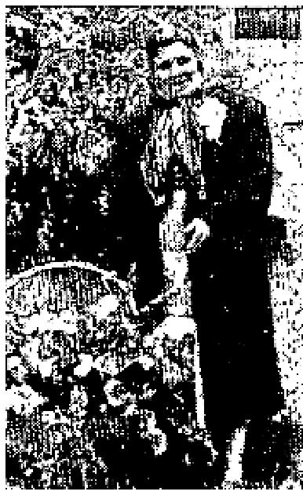
However, on Sunday after Sister Nankivell prayed for me, the tumour broke and went
from me, and I feel
better than I have in 29 years. I lost three inches around the abdomen in one week,
after being prayed for,
and am still getting smaller.
Mrs. Ella Gray,
R.R. #3, S. Dixie
Troy, Ohio.

Note by Carol Gray: The healing touch on mother was wonderful. I actually saw the tumour that fell from her; She feels so much better now, that she goes out and weeds the garden."
Signed, Carol Gray

Of Crippled Leg
My daughter Diana, who is now four years old, was born a cripple. On May 30th,
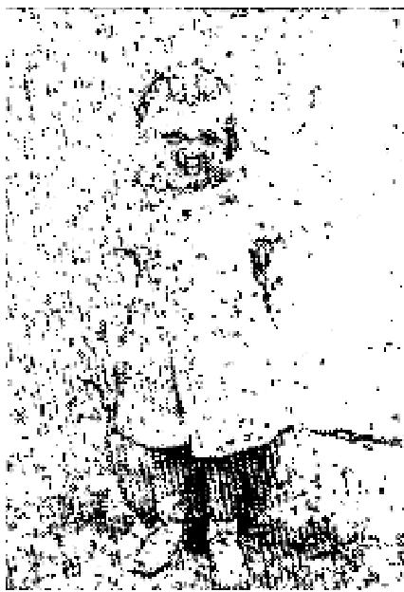
we took her to Sister Nankivell and had her prayed for.
Praise the Lord, day my daughter walks like any other child. She used to drag her left leg, which was about one inch shorter than the right. A few days later it had grown over a half inch.
When the weather was damp or rain was in the air, she used to complain tearfully of the pain in her knee. I have even seen her fall from the ache, but praise Jesus, when it rained yesterday, it didn't bother her,
The Lord surely did touch her leg, and we are praising and thanking Him for the healing touch on her.
Mrs. Carol Gray
100 Center Circle,
Troy, Ohio.
Of Soreness And Lump
I was saved and healed the first night of the Louise Nankivell meetings in Indianapolis, April 8th, 1951. My sister and I were called out of the audience together that night.
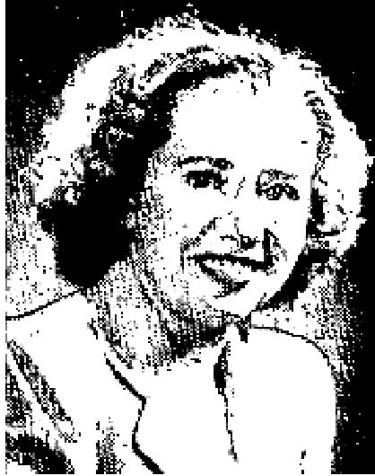
I had been suffering with my left breast soreness and a lump. Thanks be unto God,
Jesus saved my soul
and took the lump and soreness all away. Yes, praise His precious Name, He saved
and healed me, and I do
thank Him for it.

I was not only saved and healed at that time, but I am so thankful to say that Jesus has kept me saved and healed up to the present day.

THE VOICE OF HEALING 1952
Miss Ozeta Briscoe,  308 Swan St,  Terre Haoute, Ind.  Of A Spinal Injury  Mrs. Pauline Hartley, 514 Hall Ave, Dayton 4, Ohio, found Christ as her Savior  the opening night of the meetings at Dayton Memorial Hall.  The following night, May 26th she was prayed for in the healing prayer line. She instantly discarded her  her neck brace, throwing it on the door of the platform. Mrs. Hartley had been suffering since 1944 from  a spinal injury, and it required a brace to hold her head up. She had been to Mayo's and had had two operations. | 

Mrs, Hartley left her brace at the Hall. She returned at different times, appearing on the platform without the brace, and telling a marvelous story. "Can't you see I am happy?" she asks, as she testifies to her marvelous deliverance.
Rev. I. W. Phillips
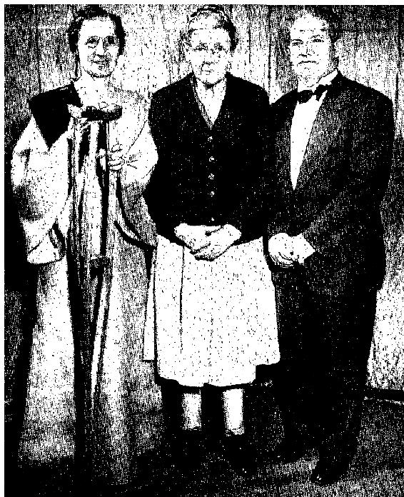 | MRS. DORA E. CARROLL, 29 Green St. Dayton, Ohio, pictured in center with LOUISE NANKIVELL, who is preaching in sackcloth in fulfillment of a vow, and REV. I. W. PHILLIPS, poster of Calvary Gospel Tabernacle.  Mrs. Carroll was brought to one of the services in Memorial Hall an a bed. After being prayed for by the evangelist, she arose from her bed and walked. A victim of arthritis, she had been unable for a long time to get around without crutches, and she had worn out two wheel chairs. Mrs. Carroll has never used the crutches since being prayed for, and is getting along entirely without them. Healing verified by Rev. I. W. Phillips.

August 1952 p12  CLUBFOOT HEALED  My son who is three years old now was born clubfooted. Dr. Carrol of Dallas had treated him since he was one month old. His ankles were stiff and be had to sleep in splints. Since he was prayed for in the Grant Revival in Stamford his ankles have not been stiff and he has discarded his splints and has not worn  them since. According to the doctor he would have had to have an operation if the stiffness had not left.  Mrs. W. H. Boldowk,  407 E. Cambell  Stamford, Texas | 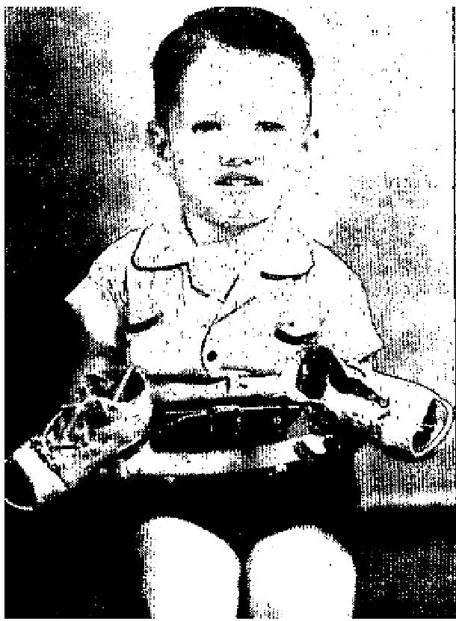

THE VOICE OF HEALING 1952
SUGAR DIABETES CURED
I had sugar diabetes for 10 years. I could not eat sweets. I suffered much in my body. The doctor said I had 40% sugar. I was prayed for in the Grant Revival in Stamford, Texas, on May 24. 1 discarded my insulin. I now have no pain or trouble.
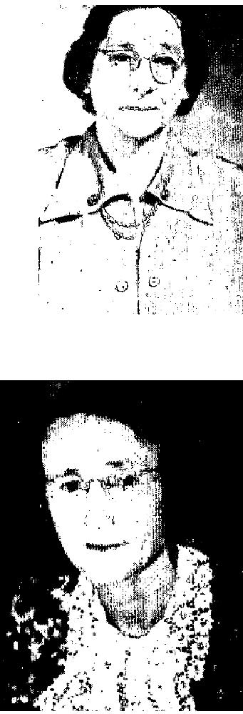
Mrs. G. U. McLellan
305 S. Swesson
Stamford, Texas
GROWTH DISAPPEARS
I fell from a car in 1934 and bruised my side causing a growth to come. It grew to the size of a half-gallon bucket. The doctor's medicine did me no good. After reading the scripture given me in the Grant revival God gave me the assurance I would be healed. As Brother Grant prayed for me I quit suffering (I had suffered continually.) The GROWTH DISAPPEARED INSTANTLY. Now my dresses are so small and loose!
Mrs. R. N. Schoonover
No. 5th Street
Haskel, Texas

GOITER LEAVES INSTANTLY
For 4 years or more I had goiter. I had choking and nervous spells. I was treated by Dr. B. B. Griffins in Graham, Texas. Dr. Nell in Stamford had given me a goiter test. A third doctor said I would never have health until I had an operation.
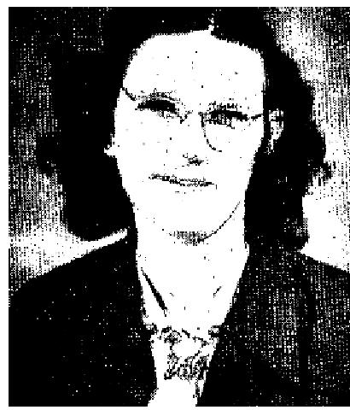
I was healed in the Grant Revival in Stamford. The goiter left instantly. I have none of the old symptoms since. Hurting spells in my side was also healed.
Mrs. Nollon Green
General Delivery
Haskel, Texas
SHOULDER STRAIGHTENED
Eleven years ago I fell while mopping and injured my neck and shoulder, CAUSING MY RIGHT SHOULDER TO DROP THREE OR FOUR INCHES. This same fall caused my neck to crook. For It years I suffered terribly. I was listening to the radio broadcast in Stamford; and while Brother Grant prayed over the air I felt the healing virtue. In a few hours my right shoulder had straightened the same as the other. The next night while in the services I received healing for my stiff neck in the audience.
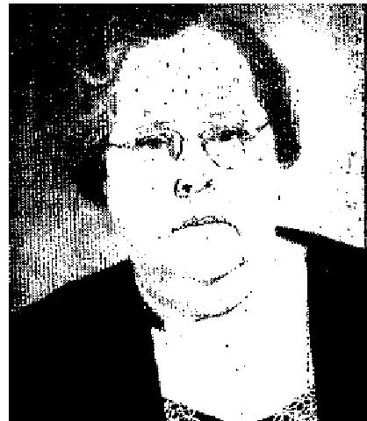
Mrs. Nell Liles
304 E. Handlan
Stamford, Texas

August 1952 p16
SIGNS - MIRACLES - WONDERS IN THE CAMPAIGNS OF TVH EVANGELISTS
EVANG. RUDY CERULLO
GOITER MELTS AWAY AS MANY LOOK ON
About eight years ago, I became afflicted with a goiter that grew until some folk told me it was the largest
they had ever seen.

THE VOICE OF HEALING 1952  Two years ago, I was advised by Dr. Wallace H. Brown, of Shreveport, Louisiana, to have an operation on the goiter, because, by this time, it was causing smothering spells - and by this time, I could hardly breathe. However, I decided against the operation, believing that the Lord would heal me.  In the back at my mind, I had always felt that either one or the other of two well-known evangelists would  have to pray for me it I were to receive a healing, as I had great confidence in these two evangelists. In the course of time, I was prayed for in turn by each of these - but to my utter amazement found that I was none the better. By this time, my goiter was so large that, whenever I was in public, I would cover my neck with a scarf. | 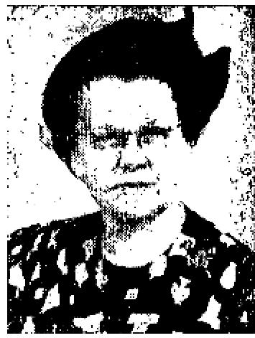

In the providence of God, I attended service one Sunday night at Life Tabernacle, here in Shreveport, where Rev. Rudy Cerullo was preaching. After the message, he offered to pray for the sick. The Lord spoke to me, and told me that this was also one of His ministers, and that if I would, in faith, have Brother Cerullo pray for me that night, I would be completely delivered. Immediately, I obeyed, jumping to my feet almost before I knew what I was doing, I rushed to the platform. Brother Cerullo laid his hand on my throat and commanded the goiter to leave in the Name of Jesus. When he laid his hand on my throat, I felt the goiter leave. I was completely healed, in the presence of many people, and now, after a year's time, there is absolutely no trace of the goiter. My many friends who have known me for years are here this morning to verify what I am saying. To God I give all the glory!
Mrs. Walter Gray
1145 Prospect
Shreveport, La.
P. S. This testimony war given to the Ladies Sunday School Class, and it caused much rejoicing by members of the class who had known Sister Gray for many years. - Ed.
EVANG. LOUISE NANKIVELL
DAYTON'S MEMORIAL HALL SHAKEN BY THE LORD
From the opening service on May 25, God's Divine presence was manifested and God mightily anointed
Sister Nankivell as she Ministered at Memorial Hall.
The Spirit of the Lord rested upon the opening service as Sister Nankivell was directed by God to call out and pray for a man who had a strange muscular disease. God touched him and from this time on we witnessed a great visitation from God. Bed patients were brought from long distances - one case being brought 300 miles.
As we witnessed this great visitation to Dayton, we saw bed patients arise and walk. One lady threw her crutches away. Deaf ears were opened, The lame walked, the blind saw, backsliders were reclaimed, and sinners were saved. We all rejoiced as night after night we saw the demonstration of God's power upon the meetings.
The meetings had a far-reaching effect. People came from hundreds of miles. They came from Kansas, Oklahoma, New York, Tennessee, and surrounding states especially to attend these services. God blessed them and many testified to being renewed in their faith.
Although some were skeptical when they came, they went away believing when they saw the work of God. Many stirring reports have come to us of healings. One lady who sat through an entire service stood to her feet at the close crying out, "Rev. Phillips, may I testify?" When she came into the meeting her eyesight was so bad that she could only distinguish light from dark but as the meeting progressed, God touched her sitting

THE VOICE OF HEALING 1952
in her seat and she could see me standing on the platform. Such shouts of praise and victory I am sure never rang out before in Memorial Hall.
As Sister Nankivell ministered in sackcloth in fulfillment of her vow, God anointed her. Almost every night in the preliminary part of the service she would call many from the audience who were strangers to her telling them their ailments, and as she prayed for them God would touch them.
Many notable miracles took place in the prayer line such as the following: One lady threw away her cane as she went shouting. A young lady totally blind came and as prayer was offered God opened her eyes. Before prayer was completed she cried out, "I can see, I can see, I can see the lights," A great shout of praise rang through the huge auditorium as she pointed out tights and told the color of books held before her, and waved her arms just as she saw Sister Nankivell doing. I could tell of many more. The first Monday night a lady wearing a neck brace threw it to the floor. Miracles and signs followed the ministering of God's word nightly.
While praying for the sick in the prayer line at the closing portion of the service, nightly Sister Nankivell was moved to tell many their ailments and troubles, instructing them what they should do for complete deliverance. A number came in the prayer line who were unsaved and as Sister Nankivell ministered to them and prayed for them they were saved and healed.
One night it was revealed to her by the Spirit that a lady in the prayer line was suffering with a heartache and a great loss. The sick lady confirmed this stating that she had lost her daughter and her heart was heavy. God touched her and comforted her heart.
In another instance it was revealed by the Spirit that a man in the prayer line was dabbling in spiritualism and the man in the prayer line confessed that this was so. Another time a man in the prayer line came to her and she told him that God revealed to her that he was careless in telling the truth, which he acknowledged.
In every case these people were strangers to Sister Nankivell and we rejoice in this great visitation of God's Spirit.
The ministry of Sister Nankivell will long be remembered here, and I would like to add a word to the faithfulness of the Lord. When we first thought about a healing and salvation campaign we asked God to direct us to the person to get for such a meeting. In due time God directed and we arranged the meeting with our Sister. Then it was a great step of faith for our church was only a little over a year old. In faith we prepared for the meeting, and in faith we engaged Memorial Hall. In faith Sister Nankivell come and we are rejoicing in the miracles that have taken place both in the souls and bodies of the people. Great is our God and greatly to be praised for His wonderful work to the children of men. Again I say, FAITH IS THE VICTORY.
Rev. Irwin W. Phillips  EVANG. T. L. OSBORN  SHORT LEG GROWS LONGER AFTER PRAYER  THE miracle which God has wrought on my daughter is too great for me to explain. My heart  is so full of joy I find it difficult to speak. I am not affected by emotionalism, but this miracle  has affected our lives to the profoundest depths of our hearts.  My daughter was born with a physical defect; one leg was shorter than the other. We took her to all the doctors we could afford, but nothing could be done, The nerves, leaders, bones and muscles were all affected. We knew none but God could ever heal her. We always believed that some day God would grant us this great blessing. | 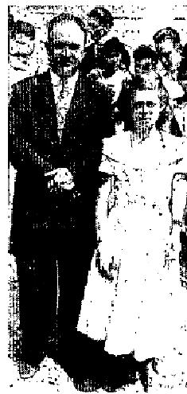

THE VOICE OF HEALING 1952
We have attended all the services of Brother Osborn's campaign here in this great bull-fighting ring along with the thousands of others. Last night, after the clear sermon on the "Gospel" in which Bro. Osborn explained how Jesus Christ has already taken all our infirmities, and desires to make us perfectly whole, we joined in the great mass prayer, believing God heard us. After the prayer, we were thrilled with the testimonies of so many others. Everywhere, I heard and saw miracles; blind saw, deaf heard, paralytics walked, and hernias and other sicknesses disappeared, Then the service was dismissed and we walked home.
As we were walking home, my daughter said, "Papa, I feel strange feelings in my leg, like pains. I believe God is healing me," I said, "Good, daughter; keep praying and believing." But she insisted that God was healing her. Her faith was great. She kept saying how she was being healed, and when we reached the house, to our indescribable joy she was perfectly healed.
Immediately we began to examine her legs. Every way we could check and measure them, they were both exactly the, same. She walked perfectly. She has no limp. Here she stands, perfectly well; both legs are exactly the same. She would tell you about it, but she is so happy she cannot talk. (The young lady was weeping all the time her father was talking.)
Many people know us, and know that we tell the truth; you also know the condition my child was born in, and how we have never been able. to find help. It was impossible for anyone except God, but with Him all things are possible.
We have always had faith, but this has increased our faith and our love for God more than anything else in our lives.
Recaredo Murillo B.
375 V. E. Botica Santa Elena
San Jose, Costa Rica
(Daughter's name "Maria Eugenia.")
September 1952 p7
"Chicago's Divine Healing Center"
FORMER ROMAN CATHOLIC NUN
I suffered much pain in my left arm for over a year. Also my arm was very stiff so that I could not comb my
hair, tie the bows on my apron, or stretch it during all that time. I visited eight doctors but not one gave me
hope. I was given all sorts of treatments including X-ray, but my hand gradually became worse.
I came to the Good Shepherd Bible Church and was prayed for. The pain left me completely and I was able to raise my arm above my bead. I praise God that now I have no pain in my arm and am able to go to my work. This healing I received over a year and a half ago, Jesus is truly wonderful. He is my Saviour and Healer!
Victoria Szczepanski
4932 S. Laflin Street
Chicago 9, Ill.
HEALED OF GALL STONES
For about four years I suffered with gall stories and was told that I would have to be operated on. The
attacks sometimes were at times very painful and I did not know what to do.

THE VOICE OF HEALING 1952
In January, 1951, I became very ill and had such pain that I did not sleep for three nights. While having this pain I went to the Good Shepherd Bible Church, and there Pastor Siczko prayed for me. I came back home in less than an hour and just as I reached the house five stones and something that felt like sand left my body. For two days after other stones were leaving my body. Oh, how I praise the Lord for healing me. He is the Great Physician.
Mrs. Sophie Guzan
2335 N. Oakley Blvd.
Chicago, Ill.
September 1952 p 9
My Healing Still Holds Good ...
In his second great campaign in Springfield, Mo., Brother Coe felt led to ask for testimonies from persons healed in previous meeting held in January. Here are their testimonies as taken by tape recording:
Cancer Disappears
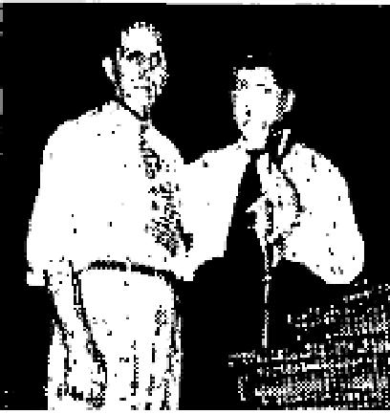
MY NAME is Loren F. Cline. I live on Rt. 6, Springfield, Missouri. The tenth of last December I entered the Frisco Hospital in St. Louis with a throat ailment. I was in the hospital for about one day and they sent me to a specialist at 607 Grand Avenue in St. Louis. He looked at my throat and said that I had a cancer, He told me to go back to the Frisco Hospital and make arrangements for an operation, which would mean my voice box being taken out,
In the meantime, he told me that it would be about a week before I could get into the hospital so that I could come on home and be back in time for the operation. I came home and in that time Brother Coe had started a meeting at the Shrine Mosque in Springfield. The first night of the meeting my wife and I went. I got in the healing line and was prayed for. When Brother Coe prayed for me, I felt God had touched me.
We had made an appointment for me to go to Mayo Brothers for an examination. When we got there the specialist examined me and could find no cancer. He didn't understand why it was that St. Louis had found cancer, and they couldn't find one. They examined me thoroughly and then said that as far as medical science was concerned that I had no cancer. He wanted me to come home and then come back in two months, which I did. At that time there were four doctors who examined me. Each said he could find no sign of cancer. They told me to come back home, and to forget it and let them do the worrying about it, for I had no cancer. So, I am sure that God healed me and I am giving him the praise for it. Thank the Lord.
Deafness  I had been deaf in both ears 22 years. The doctors told me that I would never hear, I can hear well now, from both ears. My doctor was Dr. Wasker in South Bend. Indiana. God has given me two new eardrums.  Miss Rose Lee Cooper  2505 W. Delaware  South Bend, Ind. | 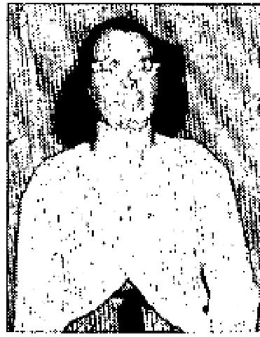
Heart Trouble and Dropsy
I was healed of heart trouble and dropsy in Brother Coe's meeting. He prayed for me and he told me to run. I was afraid not to run, but he told me to run. Something told me I couldn't. However, I started to run and almost fell. Everytime I would doubt he would tell me to run around again. I ran five or six times around the big aisle and I was completely and instantly healed.

THE VOICE OF HEALING 1952
I now work every day in St. John's Hospital in Springfield and do my own work besides.
Ruth Cowan
2128 W. Calhoun
Springfield, Missouri.
Tumour Healed
My son Paul is nine years old. For a year he had a tumour on his heel. We hesitated to have it removed because it was so painful. My husband had one removed and he suffered from it greatly. We tried to shield our child from this misery. This tumor was about the size of a dime and had a bloody core to it. I had to dress it daily. Every time I went to the grocery store I had it on my list to buy adhesive tape, and other medicine for the sore. I felt very impressed to pray for him. When I heard Jack Coe was coming to Springfield, we decided to wait and take Paul and have him prayed for.
I had told various friends of mine outside the Pentecostal church - Baptists, Methodists and Nazarenes. I said that there was a true God and that He loved my boy as much as anyone else, and that He would heal my boy the same as anyone else, It seemed there were so many things that kept us from being able to be there the first week. (If you serve the Lord, you know the devil does everything to keep you from God's house.)
When it was nearing time to go to church Paul came to me and asked if he shouldn't wash his feet. He said, "When I'm healed I'll have to show it and I want to show it."
That night, Brother Coe felt led to pray for children under 12 years of age. I tried to send the boy up alone, for I didn't want to face the people. However, he wouldn't go alone and I had to go down with him. I am thankful for it now. Brother Coe asked if I would be willing to take his shoe and stocking off after he was prayed for, and I said I would. After the prayer, we sat down and took the shoe and stocking off and Praise be to God, the bloody core was gone. Even the bandage was gone and we never did find it. After we got home we looked at it more closely and saw that there was new, pink flesh where the bloody core had been.
Mrs. Lester Butram
1622 N. Broadway
Springfield, Missouri.
September 1952 p 10
CLERGY AND LAYMEN ALIKE STIRRED BY CERULLO MINISTRY
MINISTER HEALED DURING TELEPHONE CONVERSATION
DEAR Brother Cerullo:
Just a few lines to report the outstanding deliverance I received during our conversation over the telephone while you were in Pittsfield, Mass., and I was in Claremont, N. H.
At that time I could only speak above a whisper due to an infection of the throat which closed my throat so that I couldn't even drink water without extreme pain. The doctor wanted to start me on double penicillin shots every three hours and lessen to single shots until the infection cleared and the fever of 104° would be gone. I told the doctor that I didn't want him to do this and he said that if by morning the fever and throat were the same, he would ask me to take these treatments.
It was at this moment when you called and during, our conversation you prayed and rebuked the infection and fever, and immediately the fever and infection began to leave. Thus in my deliverance God was glorified and others encouraged, May God richly bless you.

THE VOICE OF HEALING 1952
Rev. Morris Cerullo (No relation to evangelist)
Claremont, N. H.
CERULLO PRAYER CLOTH INSTRUMENTAL FOR HEALING OF PREACHER DEAR Brother Cerullo:
While you were in a meeting with my brother, Rev. David Garlock, in Troy, N. Y., I sent word for you to send a prayer cloth for my deliverance from the worst pain I have ever endured due to a kidney stone moving around in the kidney. The doctor advised an immediate operation, but I waited for your cloth to come first.
When the prayer cloth arrived, I placed it on my back around the kidney area, and whenever I placed the cloth it drove the kidney stone to another section of the kidney. This may sound far-fetched or phenomenal, but it is true. I continued placing the cloth on the spot where the pain showed itself, until finally the stone was driven to the place where it could be discharged from my body.
Oh, I do praise God for the outstanding way He delivered me, and for your faithful praying.
Rev. Wesley Garlock
Rumford, R.I.
INFLAMMATION OF VEINS CURED BY PRAYER
Twelve years ago I was operated on, caused from the birth of my only child. I had two cancerous tumors which were removed with my organs and appendix. This caused inflammation in the veins of my legs. I could only stand or walk on them about an hour at a time. My legs would swell, making holes and runs in my stockings. I could not go up or down stairs. The doctors said there was no help or curefor me and that the only thing that I could do was to stay off my legs when they got bad and pained me all the time.
I heard of Brother Cerullo's healing meetings which were being held in Troy, N. Y. I attended; Brother Cerullo prayed for me and God wonderfully healed me. I now do all my own work and stand all day. I shop and go up and down stairs, The swelling has gone and there is not any pain at all. I can stand on my legs any length of time without pain and all the inflammation of the veins is completely gone! I had had this
affliction for 12 years before I was healed. Thank, God for such a marvelous man that can be used of Him to help the sick.
Mrs. Minnie Griffin
R. D. No. 2, Saratoga Rd.
Ft. Edward, N. Y.
Endorsed by Rev. David P. Garlock.
September 1952 p11
FROM THE KAROL CAMPAIGNS ACROSS THE NATION COME THE MOVING REPORTS OF GREAT REVIVALS AND MIRACULOUS HEALINGS WROUGHT BY THE HAND OF GOD
HUSBAND AND WIFE DELIVERED BY PRAYER  MR. AND MRS. JOHN HAAG  The Lord healed me of a heart disease which doctors said could not be healed. I had it  since January 30, 1946, until Brother Karol prayed for me in Pound in 1951. At that  same time I was healed of arthritis  that I could not sleep nights. But praise God, now I am healed. | 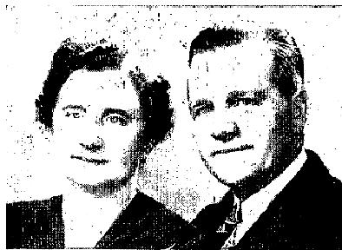

THE VOICE OF HEALING 1952
My wife too was prayed for. She had a bad cough as an after effect of scarlet fever and diphtheria since a little girl, over 35 years ago. Praise the Lord, she was healed, too.
John Haag
Athelstane, Wisconsin
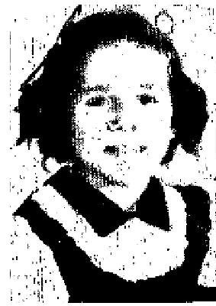
HEALTH REGAINED AFTER FAITH PRAYER
I want to take this opportunity to praise and thank my Lord for what He has done for my
daughter Grace.
She had trouble with her throat, off and on, since she was eight months old. Last October she took sick again, and we took her to three doctors, who finally diagnosed her case as cancer of the throat. When I took her to Brother Karol's meeting in Philadelphia, Pa., at the Kensington Pentecostal Church she was complaining with her throat and had a temperature. After prayer for her that night, she did not have a temperature nor did her throat hurt.
On April 12, fourteen hours after prayer, Grace coughed up a lump about the size of the first knuckle of one's thumb, which the doctors said was the growth. When I took Grace to the meeting she could not eat properly and had gone down to 39 pounds. Since Grace has received her healing, she has gained 17 pounds and has returned to school. The doctor said that her throat is healed and that she is doing fine.
I praise my Saviour for this healing.
Mrs. Elizabeth Heisler
919 Reed Street
Wilmington, Del.
YOUNG GIRL HEALED OF MULTIPLE AILMENTS
I am 15.5 years old. I want to praise and thank my Lord for healing me of anemia, adhesions, weak eyes, and nervous stomach which I had ever since I was just a few days old. Now, praise God, it is gone. I was also healed of nervousness. I was so nervous that every little thing used to get in my way and now I am all right. I was also healed of a deficiency of the thyroid and big lumps that use to grow on my neck. I also praise the Lord for my salvation.
Dorothy Andrews  2023 N. Winchester Avenue  Chicago 14, Illinois  NO HELP IN HOSPITAL GOD GIVES THE HEALING  For over a year I have suffered in my neck. I had two large lumps the size of an egg. There was great pain and my neck was stiff. The pain was so severe, that it extended down into my shoulder. I went to one of  Baltimore's leading hospitals, John Hopkins, for relief. The time spent in Baltimore was a disappointment to me. I returned to Hazelton in the same painful condition.  I prayed to God for deliverance each day looking forward that God would help me. | 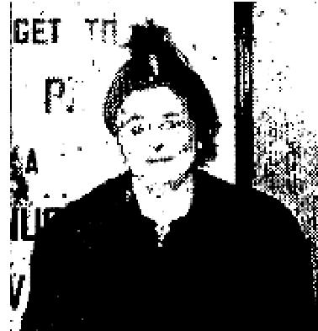

I started to attend services at the Faith Assembly Church in Hazelton, where William Caldwell is pastor. He made an announcement that there was to be a healing campaign with Evangelist Stanley Karol.

THE VOICE OF HEALING 1952
I am happy to say that I was prayed for and the growths are gone - they left fifteen minutes after I was prayed for. I also had one deaf ear; the doctors claimed that I needed a hearing aid. Brother Karol prayed for my hearing and with God's help I can hear again. I will not need the hearing aid now. Praise God for what He has done for me.

Mrs. Louise Glase
1017 E. Broad Street
Hazelton, Pennsylvania
September 1952 p12
DEAF MUTE HEARS AND SPEAKS
Little Betty Banks, my six-year-old cousin, had been totally deaf and unable to speak all
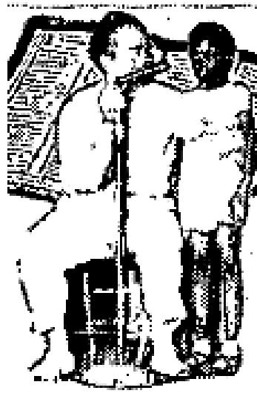
her life.
I took her to the Healing Revival in Louisville and there Brother Allen rebuked a deaf spirit and commanded her to hear. Immediately she could hear a watch tick and soft talking. Before she left the tent that evening she had to say several words. Since then she has been learning to talk and can ask for a drink of water. Her
favorite phrase now seems to be "Brother Allen!"
I have known Betty all her life and know these facts to be true.
(Signed) Eunice Chisholm, 3619 Bohne, Louisville, Ky.
GOITER DISAPPEARS
For three years I was plagued by a terrible goiter. I attended the A. A. Allen Healing Revival in Greenville, Miss. As I sat in the service on Sunday night, the Spirit of the Lord moved upon me in a miraculous way. Rev. Allen encouraged all to believe the Lord for healing where we were seated. I immediately claimed God's promise and know God touched me and healed me, although I didn't realize until three days later the goiter was gone. I do not know the exact moment the goiter left but three days after God touched me in the
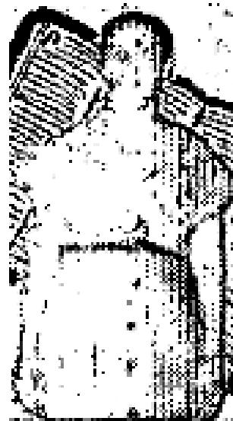
Allen meeting, I examined my throat and to my amazement, the GOITER HAD COMPLETELY DISAPPEARED.
Mrs. U. B. Smith
Box K
Wayside. Miss.

ACCIDENT VICTIM HEALED
March 10, 1950, 1 fell from a scaffold which fractured my skull, spine and pelvis. In the hospital I lay unconscious for twenty days. During that time the doctors pronounced in dead three times but my life was spared in answer to prayer.
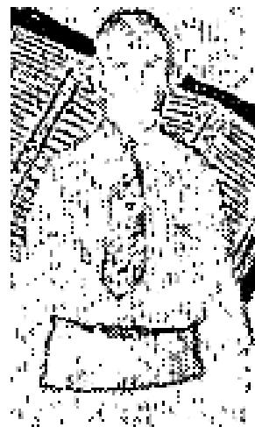
The accident left my back and hip stiff. I was in continual pain. As Rev. Allen prayed for me, the power of God went to my stiff back and hip and I was healed instantly. Immediately I found I could bend in any direction, I could touch my toes with my fingers, and even do a deep-knee bend without any effort or pain, I thank God for giving me this perfect
soundness through faith in His name.
John V. Yeager, Route 2, Depauw, Ind.

THE VOICE OF HEALING 1952
WITNESS:
I hereby witness that John Yeager is my husband and that I know the facts recorded herein to be accurate
and true.
Mrs. John Yeager.
WITNESS:
I have known John Yeager for eightyears. He was a member of my church at the time of the accident. I
know the testimony given herein to be true and accurate.
Rev. J. David Pitts
Pastor, Church of God
Louisville, Ky.

September 1952 p13
CANCEROUS TUMOR
For ten years I had a horrible cancerous tumor on my hip. It caused much anxiety and pain. I attended the Allen Revival in Louisville, Ky., and Brother Allen prayed for me commanding the tumour to "Go!" The thing dried up completely and dropped off. To God be all Glory and praise for healing me.
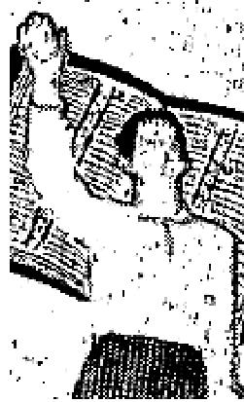
Elizabeth Hibbs, Route 5, Box 78, Bells Lane, Ky.

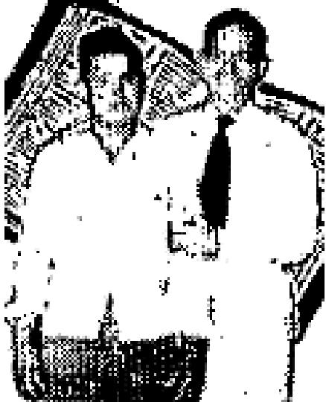 | DEAF MUTE HEARS AND TALKS  Tilango Rodriquez had been deaf and dumb all his life. He is now 20 years of age. On May 31, 1952, we  brought him to the A. A. Allen Healing Revival. In answer to prayer, God healed him and we know for a fact that he now hears and is speaking. We have known him over a sufficient period of time to know that he was totally deaf and dumb.  J. N. Gillian, J. W. White,  G. C. White, A. V. White  Rt. 2, Box 238, Hollandale, Miss., Ben Park, Petit, Miss.

September 1952 p14
KNEE STIFFNESS GOES
Six and one-half years ago I was out on a hill. I slipped and fell, cutting my knee on a sharp rock. I cut a four inch gash just below the knee cap of my left knee. The cut went to the bone, chipping it across the center of the knee. The result of the cut left me with a stiff left leg from the hip to the ankle and a numbness as a result of the nerves being severed,
On June 10 I went through the healing line of the campaign conducted by Evangelist Richard E. Jeffery in his tent located in the Globe-Miami area and received instant deliverance. As I went to the platform, I went with a stiff knee, but leaving it, I did so with a perfect soundness in both my legs. Only Jesus knows how much I appreciate the miracle of healing I received on June 10, 1952.
I do certify that this testimony is true and can be verified by my mother and my many friends. Jerry Mitchell
Subscribed and sworn to before me this 1st day of July, 1952 - Clyde Shute (Notary Public in and for Gila County, Arizona)

THE VOICE OF HEALING 1952
HEALED OF DEAFNESS
I want to testify to my healing. As far as I know I was born deaf in my right ear; at least I never remember being able to hear from it. I was raised in England, and not until later years did I even know that I had
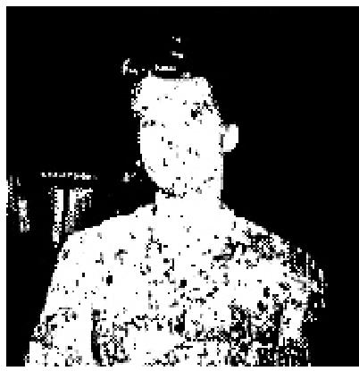
a soul that needed the salvation that Jesus gave me when I sought him for it. Then Brother Jeffery
came to Mesa, Arizona, with his tent and one night I went to the platform for the healing of my deaf ear. I received instant healing and can now hear the tick of a watch.
For this miracle of healing I do thank the Lord.
Mrs. G. A. Whisenant
871 S. Drew St.
Mesa, Arizona

Signed before me this 21st day of July, 1952. Marie E. Martens, Notary Public. My commission expires June 8, 1955.

THROWS BRACE AWAY
T. E. Vanosdell, was prayed for by Richard E. Jeffery in January, 1950, at his meeting in
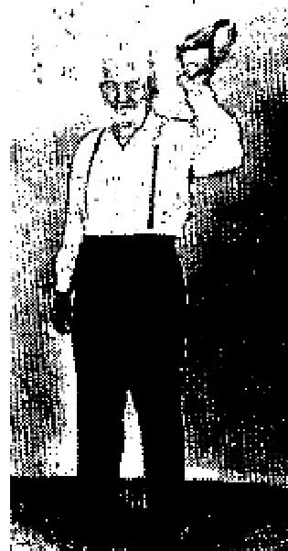
Tolleson, Arizona. I was instantly and completely healed.
At the time, I was 77 years old. I had worn a brace for twelve years. It was the first thing I put on in the morning, and the last thing I took off at night.
I came in the line to be prayed for and, after prayer, Brother Jeffery asked me to go into the back room and inspect the hernia. I was gone a few minutes, and came back to the platform with the brace in my hand as the picture shows me, It has been almost two years and I am still healed and very strong. Praise the Lord.
T. E. Vanosdell
Editor's Note: This testimony is now about 2.5 years old and is still good.

BLOOD TUMOUR DISAPPEARS  I wish to testify to the healing I received on June 10, 1952. I had had a tumour for nearly seven years when Evangelist Richard E. Jeffery came to the Globe-Miami area with his tent for a healing campaign. This tumor was on my back and lower part of my right shoulder blade.  Dr. Busse of Globe, Arizona, had told me it was a tumour which was caused from a bruise. Healing took place immediately and the tumour began to disappear. In four or five days it had gone and I am praising the Lord for this miraculous deliverance. | 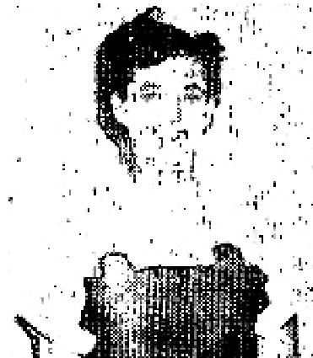

I wish to certify that this testimony is true and can be proven by my many friends. Rev. Russell, Pastor of the Assembly of God church in Globe, told the congregation numerous times during the healing campaign that he had noticed this condition many many times, The tumour was approximately the size of a large orange. For this wonderful healing I thank my Lord and Saviour.
I do set my hand this day to the truthfulness of this testimony.
Thalia Livengood

THE VOICE OF HEALING 1952
September 1952 p15
OPERATION NOT NEEDED - GOD DOES THE WORK
I praise the Lord for healing me of heart trouble. and saving me from undergoing an operation.
I had not been feeling well for some time, as I had had a real sick spell about four months ago and went to the doctor. He said I had to have an operation and so he made the necessary arrangements for me to go to the hospital the next day. Well, I felt better the next day, and I called him up and told him to cancel the arrangements for the hospital. I told him that I would wait awhile before I would go. So I went on working but some nights I didn't think I could make it. I am a janitor and clean offices and needed to be there every day as they didn't have anyone to take my place when I was off. I kept on working and in the meantime I had been getting THE VOICE OF HEALING paper and saw where W. B. McKay was coming on June 6. I was waiting to be healed in his meeting but the devil didn't want it that way, so had an attack of appendicitis on May 21,
They rushed me to the hospital to be operated on and Monday, May 26, at 9:30a.m., was the time set for the operation, but it was not God's will. On Monday morning at 3:15 I had a heart attack so they had to postpone the operation. They called in a heart specialist and I was under his care about two weeks.
June 9 was the date then set for the operation, but they decided I wasn't strong enough. They sent me home to build myself up for the operation. I came home on June 8 and on June 15 I went to Brother McKay's tent meeting and there God healed me. Praise His matchless Name - and I am feeling wonderful. Thank God for His healing power.
Mrs. Anna Martin, 2500 Cranberry Street, Erie, Pa.  HEALED OF TUBERCULOSIS IN McKAY MEETING  I want to tell you how, after five long and and tiresome years of being afflicted with that dreaded and lingering disease, tuberculosis, God so graciously and wonderfully healed my body.  Oh, how thankful I am to God for healing me and for Brother and Sister McKay's prayers that lead to this wonderful healing of my body in their Healing Campaign while in Eason, Md.  My husband, baby and I attended the meetings three times while in Easton, Md. It was on our second trip to the Healing Campaign that I was so wonderfully healed. | 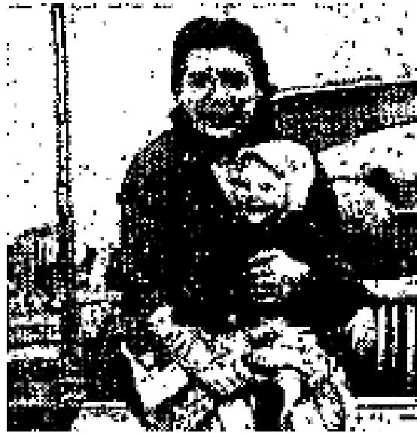

I received the prayer card that evening and was called to the healing line. Sister McKay took my card and as both started praying for me, I lost myself in God,
It was right then and there that God took my afflicted body and bathed it with HIS almighty healing power. I came out of that healing line rejoicing and crying for joy for I knew God healed me right there. Since then I have had X-rays taken of my lungs and three sputum specimens sent to Dover, Del. The specimen reports came back negative. The doctor said my X-ray shows just a healed sear. Oh, how I thank our God for healing my body and I want to thank Brother and Sister McKay for their prayers.
When I was afflicted with T. B., I only weighed 110 pounds. Now I weigh 163 pounds.
We are Christians and members of The Church of God in Salisbury, Md.
Mrs. Charles A. Jones, Jackson Avenue, Laurel, Del.

THE VOICE OF HEALING 1952  September 1952 p21  HEALED OF FEVER IN ERICKSON CAMPAIGN  I want to praise the Lord for healing me instantly of rheumatic fever in Brother Erickson's Healing Campaign. I had rheumatism as a small child, and I got over most of it. Often, however, it would come back into my knees and pain badly.  Several weeks ago, I came to the Healing Campaign with Rev. Dixon Cullimore of Frankfort, Kansas, who took a car - load of young people to the meeting at Topeka. Toward the last of the service, Brother Erickson cursed all demons of rheumatism, arthritis, etc., to leave the entire group, in God's name. I wasn't thinking of myself when he said that, but I felt a warm sensation in my knees. Then I thought, "Well, praise the Lord, I am healed of my rheumatism!" It hasn't bothered me since, and I know that it never will. Praise the Lord, the Great Healer!  Dean Percival, Age 17, Larned, Kansas | 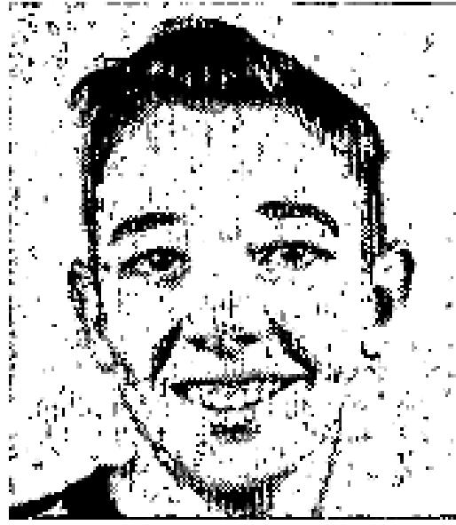

October 1952 p7
GIRL RECEIVES HEALING AFTER MINISTER PRAYS
About two months ago, my little girl who is six years old, took very sick one morning. Her face began to swell up and she had a high fever. Her whole body seemed swollen. She began to break out with red spots. The doctor told us that she had an infected strep throat, but I thought perhaps it was measles. Her body seemed to be burning up with fever and she could hardly move or raise her head.
Some Christian friends and myself had been praying for her most of the day. In the evening my husband went to see Rev. Lenard Darbee, who was at one time the pastor of a large Baptist church in Seattle, but he had received the Baptism of the Holy Ghost, and was at that time holding revival services in a Full Gospel Church. He prayed for her and left, and there was no apparent change,
In the middle of the night, however, I was awakened by the touch of a hand. I thought that it was one of the children, but I looked to find them both sleeping soundly. I had just laid back down when my little girl awakened, and sat up in bed and asked if she could have something to eat. (She hadn't been able to eat a thing up to that time.) I took her out to the light and looked at her, and she was back to normal except for spots on her body.
The swelling and spots had left her face, and the fever was gone. She sat at the table in the middle of the night and ate as though she had never been sick. Although it was about 8 or 9 days before all the spots left her body, she was completely healed. I believe that a Heavenly Being touched and awakened me at the moment of her healing.
Mrs. L. W. Dolan, 2402 - 4th St. N., St. Petersburg, Florida
October 1952 p10
HEALED OF DEAFNESS
When I was fourteen months of age I had scarlet fever which caused me to be deaf. When I was twelve years old Rev. Erickson prayed for me while he was in Columbus, Nebraska. God instantly healed me and I no longer need to wear my hearing aid. GOD HEALED ME!
George Lauhead, Age 12, Stockham, Nebraska

THE VOICE OF HEALING 1952
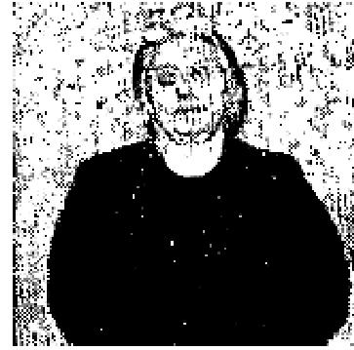
October 1952 p12
DRUGS UNNECESSARY AFTER GOD'S ANOINTING
Dear Brother Cerullo:
I came to your Troy, New York, meeting in January of 1952 sick in body and looking to God for deliverance I needed so much.
My two afflictions have kept me going to the doctor constantly. Inward trouble and bad nerves kept me down always. A box of pills for my inward trouble and a box. of pills for
my nerves were with me wherever I went. My nerves were bothering as always since I was a child.
Knowing the Lord could heal, I gave up my pills at times expecting victory, but always had to return to the use of needed drugs.
I was revived spiritually in one of our former meetings and in January I came to be revived in my body asking the Lord for a supernatural sign that God alone could give.
The night I came I went to the altar for prayer, and when you laid hands on me, before you could finish your prayer for my deliverance, I fell to the floor under such an anointing that when I arose I knew that was God's sign of complete deliverance.
To prove this I gave my pastor both boxes of pills and haven't used any since and now, 9 months later, I am completely well in body and nerves. Praise the Lord! Bro. Cerullo, that night God did for me what man has tried to do since I was a child. I am so happy. God bless you.
Mrs. Behr, Saratoga Springs, New York
October 1952 p13
SUGAR DIABETES CURED THROUGH PRAYER CLOTH
Oh, praise God forever for He is so good to me. I was afflicted with sugar diabetes and very discouraged about how the devil had me down in mind as well as my body. It seemed as though instead of getting better I was getting worse.
Through Bro. Garlich, Sr., I heard about Bro. Cerullo so I sent a cloth to be prayed over for the healing of my body. I wanted to really be healed, because it seemed that I would die with the sickness, since it began to affect my eyesight, weight and eating. All I wanted to do was drink water.
When the healing cloth arrived I placed it on my body and started to pray and praise the Lord for my healing. Oh, thanks be unto God for the deliverance I received. Since then I have gained 20 pounds, I feel fine, and all the color has returned to my face. Also, my eyes are well and I can see good. Now I do 3 washings and iron and baby sit for a living.
Thank God for my former Pastors Bro. and Sister Garlich and Brother Cerullo who prayed the prayer of faith over the cloth that brought we healing.
Minnie Shepherdson, Trumansburg, New York
"I FELT YEARS YOUNGER" REPORTS MAN AFTER PRAYER
THANK God for this and every opportunity to testify for the Lord. I thank God for saving my soul. Also, I thank God for healing my body at one of Bro. Rudy Cerullo's meetings at the Aroostic County Camp Meeting.

THE VOICE OF HEALING 1952
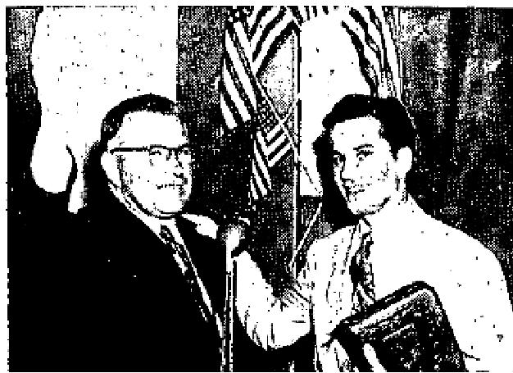
This was the nature of my afflictions and how I was healed: I was afflicted about 20 years with a cyst located at the base of the spine. One operation had been performed but was not a success. I also had a right knee with injured cartilage and ligaments (injury sustained in 1929) torn from the bone and the tissue had not attached itself to that bone again. This left the injured knee larger that the other and so stiff that I could not bend my leg back as far as the other,
With this condition upon me, God spoke forceably, one night while Bro. Cerullo waspraying for others, that it I were to be healed now was the time. I felt a force - a power pulling me to the platform and during this time Bro. Rudy Cerullo had a witness from God in a surge of power that someone in the audience would receive healing if they would come forward.
After I had gone forward Bro. Cerullo prayed for me, and I with him, and I believe it was right there instantly that God touched my body. Upon leaving the platform I felt years younger in my body and I had and still have a vitality in my body that I have not known for years. (No doubt due to the cyst.) The injured knee is now the same size as the other and I can bend it as much as the other. Thank God for healing power.
Cecil A. Hall, Station Master, Bridgewater, Maine
October 1952 p14
POLIO OF 43 YEARS GONE
Dear Sister Huffstutler:
I am writing to tell you how wonderful I feel since being to your wonderful healing meeting on Sunday night.
I am the lady that had polio 43 years ago. It is so grand how God has helped me. I have prayed hours every day since you prayed for me on Sunday and I feel Jesus healing my body. It seems just like electric currents going through my body. I got the magazine, THE VOICE OF HEALING and I read it over and over. Since you prayed for me, my leg has grown. God bless you!
Mrs. Archie Ellis, Cordova Mines, Ontario.
After receiving the above letter, this lady returned to the meeting and walked across the platform to show the thousands of people how in one week the emaciated leg that had dangled from her side for 43 years had grown to be the size of the other.
Signed: Fern Huffstutler  Fred Parlee.  NEW EAR DRUM  Dear Sister Fern:  I want to tell you and the whole world, that God has done something for me that no one else could ever do. I am 14 years old and was born without any ear drum in my right ear. I had never heard anything out of it in my life. There was also a drainage from my ear through my nose.  Then you prayed for me and God instantly put an ear drum in and I bear as well in that ear as in the other one. The drainage stopped too and I am so happy. | 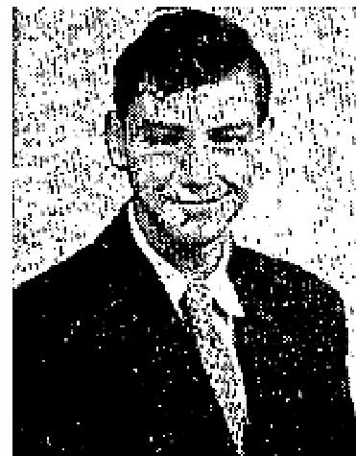

THE VOICE OF HEALING 1952
I was filled with the Holy Ghost in your revival too and baptized in water. If Jesus wants me to, I would like to preach the Gospel for Him. Thank you for coming to Canada.
Chesel Lee, Peterborough, Ontario.
This testimony can be verified by Rev Fred Parlee, pastor of the First Pentecostal Church in Peterborough. Chesel is a member of his Sunday School.
October 1952 p15  RUPTURED NAVEL HEALED  My son Paul Kent had a ruptured navel from birth. It had been taped all the time for the  entire three and a half years of his life.  My husband had attended the A. A. Allen Revival in Louisville, Kentucky, and saw the great miracles that were taking place there and we determined to get him to Rev. Allen's next meeting. | 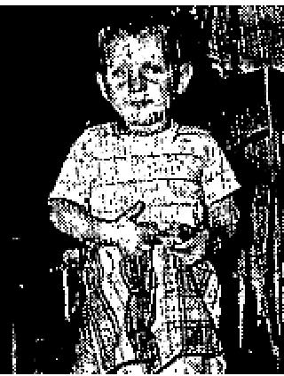
We drove to Indianapolis bringing our little Paul with us. When Brother Allen prayed for
him, he was healed immediately I took him out of the service and removed the tape and for the first time in
his life there was no evidence of the rupture. The horrible thing was gone.
Praise God forever!
Mrs. Betty Rivard, Bethany, Kentucky
I testify that the above miracle took place as stated above. Signed, Mr. Maurice N. Rivard.
October 1952 p16
BLIND EYE SEES
I was born blind in my left eye. I have visited eye specialists, but they all declared, there was nothing they could do to bring in my sight in that eye. While Rev. Valdez was in England he prayed for me. After his prayer I covered my right eye and he held up his fingers before me and I was able to count his fingers without any difficulty whatsoever. God has performed a miracle in opening my eye, which was beyond medical help, and I certainly do thank Him for it.
Mrs. Sykes, 10 Carpenter Avenue, Mansfield, England.
GOITER VANISHES
I had a goiter on the inside of my neck for several years which was visible from the outside. One evening while Rev. Valdez, Jr., was conducting special services in Nottingham, England, I was sitting down in the audience. He was praying for the sick as they passed by him and all of a sudden, Rev. Valdez stopped the line and turned around to face the congregation. He said, "Some one in this audience has a goiter. Please stand and God will heat you." I immediately stood up and he prayed for me and God instantly healed me. The goiter is completely gone. I thank God for this miracle.
Mrs. A. Wood, 4 Manning Grove, Nottingham, England.
October 1952 p17
DEFECTIVE EYE HEALED
My son who is now twelve years old was born blind in his left eye. My doctor said there was nothing
medical science could do for him because a part of his eye was missing. I had Rev. Valdez pray for

THE VOICE OF HEALING 1952
him while he was in Nottingham, and God instantly opened his blind eye and gave him perfect sight, Only God could have performed this miracle and we praise Him.

Mrs. Sarah Slater, 109 Whitemoor Road, Old Basford, England.
EAR DRUM CREATED
My ear drum was removed by a specialist here in Nottingham, so my case is a matter of record. Naturally, I could hear no sound at all, having no ear drum, but when Rev. Valdez prayed for me, God created an ear drum, for I could hear instantly. My hearing is so perfect that I am able to hear asmall watch tick.
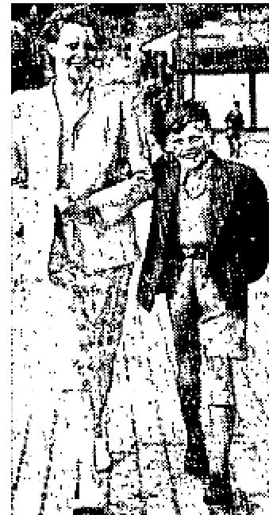
T. G. Simons, 27 Dale Avenue, Carlton Notts, England.
There was a medical doctor in the audience who examined this boy after he was prayed
for and he declared the boy to have normal hearing.
A. C. Valdez, Jr.
HEARING, SPEECH GIVEN
Dear Bro. Valdez:

I take great pleasure in writing this letter to you and by it conveying to you my  humble and sincere thanks to  God for the astounding miracle He performed for my little daughter, Valerie.  Since birth, ten years ago, she has never spoken one word intelligibly At the age of  eighteen months we  had her examined by doctors and she was pronounced deaf and dumb. We had  despaired since that time  and then your visit was announced. | 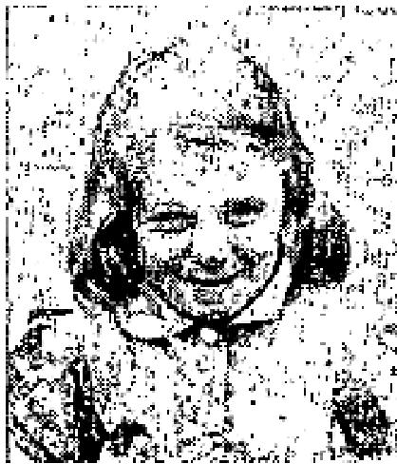

My wife and I were urged to see if you and your Divine Power could do that which doctors and earthly remedies had failed to do. I must confess that at first I was very cynical and inclined to treat the matter as utterly fantastic. Since Valerie was brought to you, my wife and I are now wondering and I for one am praying to the Almighty God for forgiveness of my sins and neglect of His house, of which I have seldom gone in to pray since I was a boy. For indeed, God has given hearing and speech to my little daughter, Valerie. To us, her parents, it is joy and overwhelming happiness, for after ten years of misery watching her try to speak and being unable to hear words of love and affection a miracle has happened and happiness is hers and ours and all through the Divine Power of God through you, His servant.
God bless you and keep you in your journeys over the earth and always give this Power to you to help others in distress.
Albert E. White, Nottingham England.
October 1952 p21
REMARKABLE TESTIMONIES FEATURE COE MEETING IN OKLAHOMA CITY
CEREBRAL HEMORRHAGE HEALED
I was ill and in the Norman Oklahoma, Hospital with cerebral hemorrhage and was half paralyzed,
including my tongue. There was little help for me.

THE VOICE OF HEALING 1952
I asked to go to the Jack Coe meeting in Oklahoma City. My children, who were unsaved at the time, did not want to see that I got there. Finally, after much begging, they permitted me to go. They put me in an ambulance and took me to the meeting.
I will never forget how Brother Coe came down off the platform to my cot and told me that the Lord was going to heal me. He said the Lord had already told him this before he ever came down to pray for me. He told me that I would be made every whit whole.
When he anointed me and prayed for me, I felt the power of God go through me and felt life and feeling return to my paralyzed body. Also, my tongue was loosed and I could speak.
I was in my night gown. When I got to my feet, I put a sheet around me and was immediately able to walk around. That night I returned home in our car, rather than the ambulance.
I returned to the hospital in Norman to check out my things, The nurse there, who had a growth on her head, told me that she thought it was cancer and wondered if Brother Coe could do anything for her. I told her that I knew he couldn't, for he didn't claim to heal people; but that the power of God could heal her.
I went hack to my doctor and received a statement from him as to what I had been healed of. However, he requested that I not use his name in any written testimony.
I am well and attending church every service. I am praising God for what He did for me and especially for the fact that after I was healed, my husband and my children gave their hearts to the Lord. Praise His name.
Mrs. Mary Lou Boone, Moore, Oklahoma.
Mrs, Mary Lou Boone was ill for several weeks previous to my first visit suffering from extreme nervousness and severe headaches. The day of my first visit, which was July 30, 1952, Mrs. Boone had cerebral hemorrhage. She was transferred to Norman Municipal Hospital for treatment. She had some improvement from time to time followed by relapses. The day before she left the hospital she evidently had an anginal attack of a rather severe type. At first I hesitated releasing Mrs. Boone from the hospital, as it was questionable as to the results that might occur.
Signed by Attending M. D.  EYE COMPLETELY BLIND BUT GOD GIVES SIGHT THROUGH PLASTIC ORB  PERHAPS the most outstanding miracle to be called to the attention of the great audience present at  Jack Coe's meeting in Springfield, Missouri, last July was that of the "seeing plastic eye."  Seven-year-old Ronald Coyne lost the sight of his right eye, therefore a plastic artificial eye was designed for him to wear. But soon an extraordinary miracle was performed by the mercy of God. Although it was absolutely impossible to see through the injured eye, Ronald discovered that he could see perfectly when  the plastic eye was put in place, | 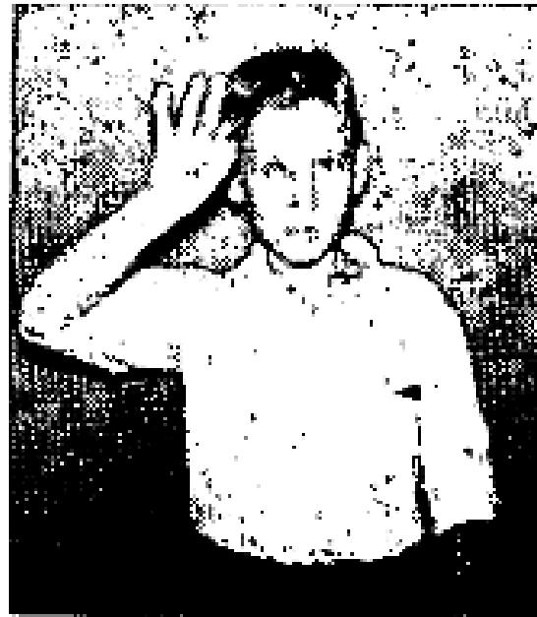

Ronald has been, of course, tested many times to determine for sure he could really see "through" the artificial eye, Dr. J. W. Graham, M. D., President Truman's family physician of Kansas City; Kansas, examined Ronald and found the miracle to be genuine. Dr. Graham's nurse reported: "This day my

THE VOICE OF HEALING 1952
eyes have seen the impossible." Jack Coe, TVH evangelist, personally covered Ronald's good eye and heard
the boy read from the Bible by his plastic eye. This amazing miracle of God received much publicity in
the Tulsa Daily World newspaper.
November 1952 p7
GOD INSPIRING FAITH
Dear TVH Editors:
Thank you very much for the letter with the anointed cloth in it and all the inspiring words you wrote about healing for me, and for all prayers you offered.
I must now send a few words telling you how much I appreciate your kindness. Believe me, Brother, this is the first time in life 1 have received such a wonderful gift without any charge. I have been accustomed to pay for everything, you can understand how surprised I was when 1 received this prayer-cloth free. God bless you!
Now I must tell you something that happened when I put the cloth on my body, as you said, and laid hold of God's promises. A sudden change immediately took place in my heart and I felt a great relief in my body. However, the most marvelous thing happened in my Spirit. I received a new God-inspiring faith and that faith is strengthening me day by day. My heart is now filled with joy and happiness and I believe God will heal me perfectly.
I'm now going around using the anointed cloth on sick people. One day a little boy four years old had been bitten by a venomous insect and blood-poison developed in his right loot. His mother came to me with the boy and I laid your anointed cloth on the swelled foot and, praise God! the boy was healed instantly. One day a lady asked me to put that healing cloth on her sick bleeding throat and she was healed just as fast as the boy.
God bless you and the workers on TVH. I'll assure you that you and your co-workers are all in our prayers before the throne of God.
Yours, in Christ
Ernest L. Netzel, Missionary, Hillared, Sweden
INFECTIONS CLEAR
Dear TVH Editors:
Greetings in Jesus Name!
I praise and thank God for your prayers and the anointed cloth that you sent me about March 8th.
When I discovered a lump on my left breast, about the size of a half dollar, I immediately wrote you for prayer and the anointed cloth. As soon as I received it, I placed it on my breast, in the name of Jesus, believing that God would heal me. The lump gradually became smaller each day then completely disappeared, Praise His Dear Name!
I am also healed of an infection which I had for one year and four months, something like oak poisoning. God has wonderfully healed me and I give Him the praise!
Yours, healed and kept by His power.
Mrs. Maude A. Pitter, 4002 N. E. 4th Street, Minneapolis 21. Minn.

THE VOICE OF HEALING 1952
PASSES POLYP
Dear TVH Editors:
I received the wonderful book "World Evangelization Now," and it has been a wonderful help to me.
I also thank you for the anointed cloth. The Lord answered prayer. Four days after I placed it on my body, in faith believing, I passed a polyp and in two days a much larger one.
Before I was healed, my back ached and my left wrist and hand had no strength left in them. Now, Praise the Lord! all pain has left my body.
Thank you very kindly for your prayers and prayer cloth.
Yours, in Christ.
Mrs. Edna Wall, 2144 North 75th Ave., Elmwood Park 35, Ill.
GAINING WEIGHT
Dear TVH Editors:
In the early part of December I wrote you for an anointed cloth for my husband who had severe pains across his stomach and was fast losing weight, was almost skin and bones.
He had been prayed for by two other ministers and was definitely helped but when your prayer-cloth came I pinned it on him and we both prayed and he never had another pain.
He is gaining a weight, color and strength, for which we thank and praise God, and thank you for your prayers,
Mrs. Henry Belohland, South Gate, California
November 1952 p9
CEREBRAL PALSY VICTIM ENJOYS COMPLETE HEALING
My son had cerebral palsy and it prevented his skull from coming together naturally. He had never been able to walk and when he would try one leg would drag. The doctors said that if he ever picked that leg up it would be a miracle. Ever since he was prayed for in the Grant Dallas revival he has been walking without dragging his leg. I took him back to the doctor and she said that there had been a miraculous change. I am so glad Jesus heals and proves Himself. My neighbors are talking about this miracle and they admit that it was just that, praise the Lord.
Mrs. W. L. Henry, 5011 E. Bluebird Lane, Dallas, Texas
STIRRING MIRACLES WROUGHT BY GOD
Bones Mended ...
I want to say that I came over to Seattle last Sunday evening with a BROKEN ELBOW AND ALL NERVES SHATTERED IN MY LEFT ARM; the result of a bad fall I had received three weeks ago on the cement floor. My arm was so twisted and stiff that I could not straighten it, nor could I lift it without using my other hand to put it where I wanted it.

THE VOICE OF HEALING 1952
When Brother Grant prayed for me the power of God went down through my right arm and then through my crippled arm. IMMEDIATELY I WAS ABLE TO LIFT MY ARM. The stiffness left my arm and the next day I was able to play the piano and pipe organ.
Rev. C. M. McPherson, Pastor, MEAD AVENUE GOSPEL TABERNACLE,
2002 East Mead Ave.. Yakima, Wash.
Blind Eye Sees ...
My right eye was blind for nine years. After Brother Grant prayed for me I could immediately see to read
fine print foot notes in the Bible.
E. D. Crawford, 1301 Market St., Seattle. Washington.
Ulcer Healed ...
Several weeks ago I became violently ill and after spending Thursday and Friday in bed, I was still unable to work. Later I went to Doctor Hardy here in Seattle and requested a check-up. He told me that I had a broken ulcer. I also reported to a Doctor G. E. Parsons for an Upper G. I. X-ray."
After prayer at Bethel Temple in the Grant Revival I returned to Doctor Hardy's office with the X-rays and other requirements for test and he reported to me that his research proved negative. He gave the praise to God.
J. T. Downs, Main 2897, Seattle, Washington.
Cancer Spit Out...
A cancer came into my mouth AUGUST, 1951. The doctors wanted to use surgery. but I did not give permission. Rather I had it prayed for, which helped, but as I became fearful the pain and misery returned. It swelled and began to grow. But when I was prayed for in the Grant Revival in Fort Worth, January, 1952, I went home and spit it out the pus, blood and flesh came out with it, leaving a slight sore which healed very rapidly.
Mrs. Howell Cook, 1819 Hemphill Street, Fort Worth, Texas
Tumor Vanishes ...
For two years I have had a tumor on my body. 'The doctors wanted me to submit to surgery. But while I was sitting in the audience during the Grant Deliverance Meetings in Bethel Temple, Seattle, the Lord healed me. I RETURNED TO THE DOCTOR FOR FURTHER TREATMENT AND HE TOLD ME THAT HE FOUND NO SIGN OF THE TUMOR. Praise the Name of the Lord!
Ethel Choir, Mirror Lake, Washington.  November 1952 p10  CANCER HEALED  My physician diagnosed a lump in my breast as cancer. He insisted I go immediately to Mayo Brothers Clinic for an operation. Appointment was made at the clinic with a surgeon who was world famous for cancer operations on women.  On the way to the clinic I stopped at the Allen Tent Revival in Wood River, Ill. On Tuesday night I went through the line for healing. As brother Allen laid his hands upon me and prayed, the Power of God seemed to go through me. I knew. the work was done. However I kept my appointment at Mayo's Clinic with the surgeon. | 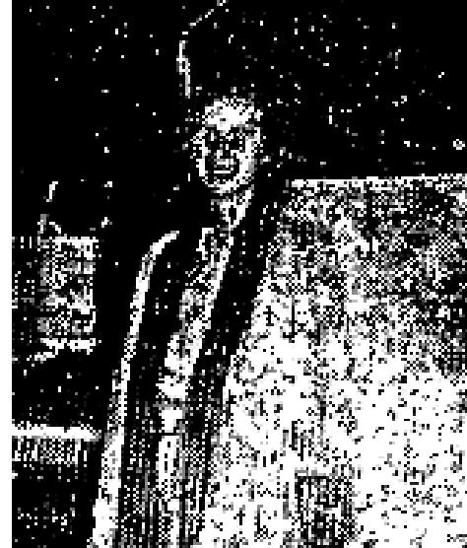

THE VOICE OF HEALING 1952
Upon arrival at Mayo's, the world famous surgeon examined me. To his amazement there was no sign of the lump or cancer, He informed me there must be a mistake as upon thorough and careful examination he could find no trace of cancer, not even in my blood.
I returned to the Allen Campaign and there I glorified God as I testified to the multitude in attendance what God had done for me.
(Signed) Irma Ahlberg, 623 E. Cleveland, Taylorsville, Ill.  November 1952 p11  FEMALE DISORDER CURED  On August 29, in Barstow, California, I entered the healing line of Rev. Alton L. Hayes for  healing.  God revealed to him that I had leakage of the heart and a serious female disorder. This puzzled me, although I had known my female organs were undersized for my age. However, I had great faith that the Lord would heal, whatever the condition. | 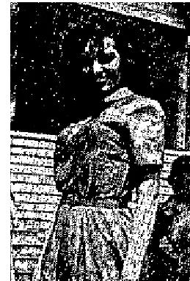

On August 30, at 3:00 p.m., a growth of a two-inch diameter fell from my womb, which my
neighbour, a registered nurse verified was either a growth of serious nature or a deformed fetus, which could
not have normally matured.
I thank and praise the Lord, that He wonderfully undertakes to heal us of infirmities we often know nothing about.
Mrs. Barbara A. Walton, General Delivery, Victorville, California
Pastor Rev. E. B. Wells, Assembly of God Church.
PRAYER RESTORES VOICE
Dear Brother Hayes:
Some three. years ago while attending SMU my cousin, Harold Brown, suddenly became very ill, a nervous break and stroke combined. He was rushed to his home in Moline, Illinois, and to a hospital, to stay almost two years. Doctors could not diagnose his case nor tell what caused the trouble.
Although he recovered sufficiently to return home, he had never been able to speak. It seemed he had either lost the knowledge of how to speak words or his nerves were so bad he could not control his tongue or lips to form words. Doctors could not explain this. They said his mind had become locked and nothing could be done to get it unlocked.
His father has always believed the Lord could heal him and had tried a number of times to get him to Brother Branham, Brother Paul Cain and Brother Freeman, but was unsuccessful.
We have tried for almost a year to get him to some one who could pray and have power over the demon spirits, but had not succeeded until we heard you were going to be here.
On Tuesday night; we called Brother Raculia and told him our story and requested prayer before we brought him the next night. During your message it looked as if we would fail again and that you would not get to pray for him, as he again had such horrible expressions and started a number of times to jump out of his seat and leave the building,

THE VOICE OF HEALING 1952
You could plainly see the two powers of the demons and God struggling with him.
Praise His Precious Name! Our God won the battle! When, at last. Brother Raculia came to him he was quieter than we have ever seen him in a service where the Power of God was manifested. The miracle, I believe, began when Brother Raculia came to him.
After you prayed for him the second time, you said you felt six demons leave him and he has been able to speak and to tell us what he wants without signs or by writing as he has had to do.
Now, instead of running from one who can pray for his healing, he runs to them.
Although I have always believed in the Healing Power of God. I have been amazed at what God has done for Harold. I can now sing the Chorus, "Isn't He Wonderful?" with a new meaning. Truly, He is so wonderful, and precious I don't see how anyone can not love Him!
"I'd rather have Jesus than anything this world affords today!"
Only Jesus can take a life that is wrecked by the powers of satan and make it worth living. Only Jesus Christ can set the captive free! Sincerely,

Eldora Smith, 1415 Fairview, Dallas 10, Texas
HEALED OF DIABETES
"Since you prayed for me on October 10, 1951, for diabetes, I have been a well man.
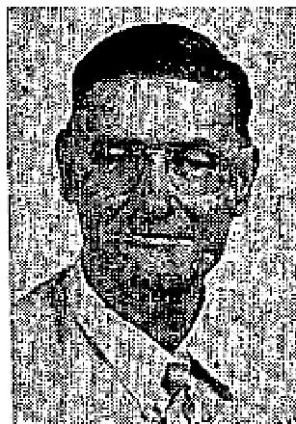
Before you prayed for me, I was suffering so severely I could hardly walk.
My feet and legs were covered with diabetic sores and I was taking from four to six shots of insulin a day. The shots are no longer needed. I have never felt better in my life."
Mr. H. M. Jimerson, 3119 Alabama Ave. Dallas, Texas
November 1952 p12
MIGRAINE HEADACHES GONE
After two years of praying Lord sent Rev. and Mrs. Russell B. Park to my rescue. They
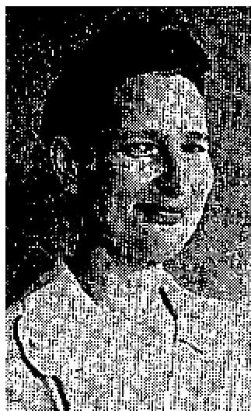
were sent right into my home to live during the revival and words cannot express the
blessing they have been to me. I pray that I
have been a blessing
to them, too.
On June 19, 1952, I was healed in Bro. Russell B. Park's revival in Somerville, Texas. I had a mastoid operation in the year 1938, The doctor cut my ear drum and I had never heard a sound out of it until Bro. Park prayed for me on the night of June 19th, 1952. After 14 year of deafness I am able to hear perfectly.

Not only this but I had had migraine headaches for which I took Histimine shots for over two years. I have not taken a shot of Histamine since that night in June.
Praise the Lord for His healing and the blessings I received during the Park revival. God bless them, keep
them in His care, and use them for His glory, is my daily prayer.
(Signed) Mrs. Emma L. Malkey, Somerville, Texas

THE VOICE OF HEALING 1952
Note: Evang. and Mrs. Russell B. Park stayed in the home of this lady while conducting a revival in Somerville, Texas.
CONVULSIONS HEALED
I want to praise my glorious Lord for healing me. I had terrible pains in the right side of my head that felt
like it would take the top off my head.
After suffering that way for two weeks I began having convulsions when I would lie down. I would have to turn my head so easy after I lay down or I would have another convulsion and when I would get up I would go side ways and backwards. I dreaded for night to come.
After hearing Brother Russell B. Park preach and studying Gordon Lindsay's book on healing and reading the Bible I knew God would heal me.
Brother Park prayed for me and I was healed. I am happy to say I haven't been sick since. Praise the Lord.
(Signed) Laura Haggard
1715 N. 7th St.
Grand Junction, Colo.  HEARING RESTORED  I was deaf in both ears. My doctor instructed me to purchase a hearing aid, which I did. At first I thought it would restore my hearing but I soon found that I was mistaken.  Brother Russell B. Park came to our town for a two weeks' revival. I went into the healing line to be prayed  for. Brother Park prayed for my hearing to be restored and miraculously, Instantly the Lord opened my ears and I now hear as well as I ever did. I need no hearing aid. I praise God for it!  (Signed) M. Varner, 905 - 14th St., Caldwell, Texas | 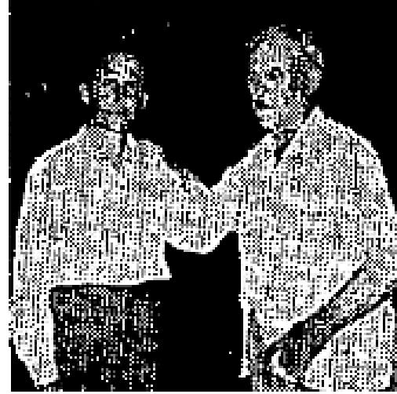

SISTERS MASTOIDITIS INSTANTLY HEALED  I want to praise the Lord for healing my two daughters, Barbara, age 12, and Rose Mary,  age 9.  Barbara had the measles when she was 4, which settled in her left ear. This condition was complicated as it ran into mastoiditis. She did not have an ear drum and the ear discharged all the time. The doctor was afraid to operate.  Rose Mary was only six weeks old when her trouble began. She also had mastoid trouble. She, too was totally deaf in her right ear and had no ear drum. It had been punctured 6 or 7 times by the doctor. Her ear also discharged all the time. Last October the drainage began settling in her jaw and it had to be lanced four times within a period of eight months. | 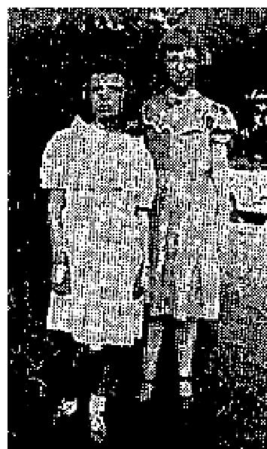

In June of 1952, Brother Russell B. Park prayed for both the girls and they heard and were healed instantly!
I want to thank and praise God for His wonderous healing power!
(Signed) Mrs. R. T. Eldridge, Somerville, Texas

THE VOICE OF HEALING 1952  November 1952 p14  TWIN HEALED OF POLIO  On July 21, my daughter, a twin, who is nearly two years old, was stricken with polio. Our pastor was gone, so my sister called her Foursquare pastor in to pray. God spared her life on the fourth day, and also delivered her from being a cripple, as the entire left side of her body was paralyzed and limbs were crippled. Later, our pastor also prayed and all pain left her body. Three weeks later, Brother Philip Green prayed for her, and she began walking at once on August 22.  Her healing was all gradual, that is, she first learned to hold her, head up, then her back then she sat up alone and it wasn't long after God straightened her leg out, until she began walking by herself; and now people ask me, when they see the twins, "Which one had the polio?" | 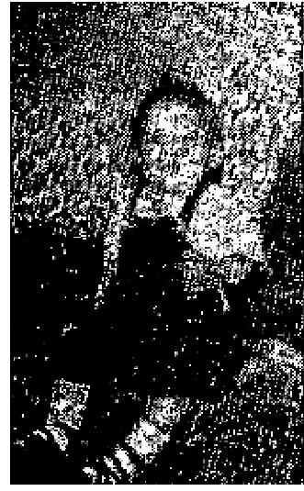

Thank God for His faithful servants, who first of all prayed God to deliver me from fear, so I could have faith also, and have courage to refuse all attacks of the devil concerning this child. God also delivered me from this disease the very day it tried to fasten itself upon me. Praise God for Bible deliverance!
Witnesses:
Mrs. Harry Belau - Mother, P. 0. Box 287, Jacksonville, Oregon
Rev. J. Skinner, Pastor of Assembly of God Church, Jacksonville, Oregon
Rev. R. H. Mathewson, Pastor of Foursquare Church, Medford, Oregon
Rev. Philip Green, Voice of Healing Evangelist
November 1952 p22
AILMENTS DISAPPEAR
Dear Brother Karol:
I cannot thank God enough for healing my body. When you anointed and prayed for me I received healing through God's power. I had been suffering for over two years with a number of ailments.
I had stomach trouble, low blood pressure nervousness, and had been crippled for over a year and could not walk. I was in the hospital thirteen times in two years. I have had six doctors to examine me and no one could give me any help.
I heard Brother Miles announce on the radio that Brother Stanley W. Karol would be at the church on the 11th of March for a healing campaign. Two had to carry me into the church, but after Brother Karol prayed for me I was able to walk immediately. Thank God that they did not have to carry me out, for by His grace I walked out!
Yours In Christ,
Irene Myers, Route 1, Box 150, Martinsburg, West Virginia
December 1952 p10  HEART TROUBLE GONE  I was ill for three years with a heart condition. The doctors had not been able to help me and had given me up to die. My condtion was so serious I could not drink water or eat anything and had to take medicine continually.  1 attended the Mastro Divine Healing Campaign in Bay Minette, Alabama, and had Brother | 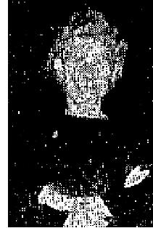

THE VOICE OF HEALING 1952
Mastro pray for me. After his prayer, God definitely healed me completely. I can now eat anything and everything. Thank God for His wonderful healing and saving power.
Mrs. Gladys Henery, Bay Minette, Ala.
Witnessed by Rev. Jack C. Smith, Bay Minette, Ala.
December 1952 p11
PARALYZED ARMS RESTORED
My arms were paralyzed by a tetanus shot. The doctors said the nerves in them were dead.
I had been in the hospital for three weeks taking treatment and the doctors sent me home saying they could do nothing for me. A specialist from Columbus, Ohio, was also called in and he said the condition might wear off in a year, or I might never be able to use my arms again.
On May 23, Rev. Velmer J. Gardner prayed for me and my condition began to improve immediately.
On June 7, during the night, my arms relaxed and my wife noticed that they were laying straight on the bed. She awakened me and we both praised the Lord and gave Him the glory for healing me.
The next morning I got up and drove my car for several miles. Praise the Lord!
Carl Thomas (42), Marion, Ohio, Statement by Pastor:
I wish to affirm that the above testimony of Brother Thomas is true, as he gave it to me. Rev. Zella Earhart, Pastor, Church of God, Marion, Ohio
SPINAL ARTHRITIS GONE
I have had spinal arthritis since 1943. Last January I was forced to begin wearing a spinal brace, as I, was
being drawn crooked.
Rev. Velmer Gardner prayed for me on June 8 (1952), while in Mansfield. That night I threw my brace away and, thank God, I know I will never need it again. Jesus will heal, if we only believe and serve Him.
Bertha Phelps, 493 Woodland Ave., Mansfield, Ohio
HEALED IN AUDIENCE
About fifteen years ago, I was struck by a car, from which I suffered severe head, shoulder and hip injuries.
During Brother Velmer J. Gardner's revival meeting in Mansfield, Ohio, while he was preaching on Divine healing, the Lord touched my body and healed me instantly, of my head injury, as I sat in the congregation.
I am praising God for complete deliverance.
Sarah Homer, 236 Gerke Ave., Mansfield. Ohio

THE VOICE OF HEALING 1953
January 1953 p9
Notarized Affidavits Confirm Healing
DEAF 15 YEARS - HEARS WATCH TICK
To whom this may concern:
I want to praise the Lord because. for the first time in fifteen years, I am able to hear out of my left ear.
Bro. Nunn prayed for me during the revival in Kilgore and God wonderfully healed me, Up until then I was unable to talk over the phone and hear out of my left ear but, Praise the Lord, I'm now able to hear clearly out of it.
I couldn't hear a watch tick before, but now I can hear one tick and even hear the ring of the watch. I can close my right ear completely and hear perfectly. I truly praise the Lord for it,
State of Texas: SS
County of Gregg: }
On this the twenty-fifth day of October, Nineteen Hundred and Fifty-two, personally appeared S. F. Howell who, being by me duly, legally and lawfully sworn, says upon oath that the statements made by the said person above mentioned herein and in the foregoing written statement concerning the matter and things set out in his above and foregoing declaration are true and correct so help me God, Amen
Signed: S. F. Howell (Affiant), Box 1141, Overton, Texas.
Subscribed and sworn to before me, a Notary Public, this 25th day of October, 1952. Signed: K. P. Charles (Notary), Notary Public (Seal), Gregg County. Texas.
BLIND 50 YEARS - SEES INSTANTLY
To Whom it may Concern:
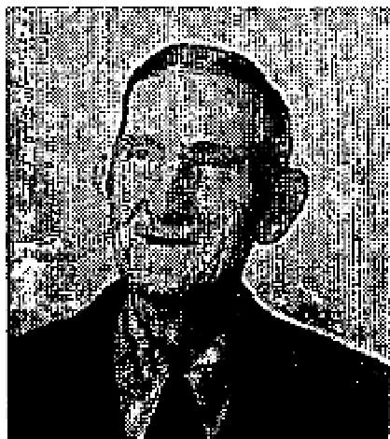
Approximately fifty (50) years ago I lost the sight of my left eye, due to exposure infection. I could not see anything at all out of this eye. I went to the Revival in Kilgore, Texas, in October, 1952, conducted by Rev. David Nunn, where he was praying for the sick and afflicted. I went through the healing line and Brother Nunn prayed for my eye. It came open instantly. I could see Brother Nunn, could count fingers that he put up before me, could see the lights, the poles and the people under the tent. Since that moment, my vision has become much better and each day it is clearer. I now can see the lines in the palm of my hand, and can also read with this eye, and can identify objects a hundred yards away.
It is so wonderful that I can now see so good out of this eye. Oh, how I praise God for what he has done for me, in giving me back the sight in my eye.
Signed: Justice Phillips (Affiant), Rt. No. 3, Box 31-A, Kilgore, Texas
State of Texas SS
County of Gregg: }
On this the twenty-fifth day of October nineteen hundred and fifty-two, personally appeared Justice Phillips who, being by me duly, legally and lawfully sworn says, upon oath: that the statement made by the said person above mentioned herein and in the foregoing written statement concerning the matter and things set out in his above and foregoing declaration are true and correct so help me God, Amen.
Subscribed and sworn to before me, a Notary Public, this 25th day of October, 1952.

THE VOICE OF HEALING 1953
(SIGNED) K. F. CHARLES (Notary), Notary Public, (Seal) Gregg County, Texas
January 1953 p11
SINUS-EYE TROUBLE GONE GOD HEALED HER
Dear Sister Nankivell:
My daughter has been marvelously healed of sinus and eye trouble, The sinus affected my daughter's eyes. She was healed Tuesday night, November 4, Praise His Holy Name. The Lord is as good today as He was yesterday.
My daughter can read now without having trouble. Before she was healed she had said there were small lines going across her eyes. She had worn glasses to help her read better, but glasses didn't help her much. The doctors said that they could give her stronger glasses, but to make her glasses stronger was just waste of money. It was the sinus giving her blindness at times. She now has put away her glasses and gives God all the Glory for healing her,
Mrs. C. J. Brunskill, 1505 Belmont Avenue, Fresno 1, California
This testimony endorsed by:
Rev. Claude Weaver, Pastor, Calvary, Tabernacle, Fresno, California.
CANCER CURSED NO TRACE LEFT
Dear Sister Nankivell:
I know that I should have sent you my testimony before of two healings received during your stay here in Portland (Oct., 1951).
Soon after you prayed for me, and cursed a cancer on the back of my tongue I was able to wipe many little hairy roots off my tongue with a white cloth wrung out of water. It was completely removed from my tongue within two weeks time and no sign of it has appeared since. Praise His Name!
Also a severe cough which I had had day and night, summer and winter, for fifteen years, left me at the same time, although I didn't mention it to you at the time, I had practically lived on different cough drops merely to keep from annoying others while riding buses and attending services, etc., and to avoid disturbing others in the apartment house of their rest. But I can truthfully say that I haven't taken one since I was in your prayer line at Pastor Davidson's church here. My friends that have known me over a period of years remark about me not coughing anymore.
Isn't the Lord good? How I thank Him!
Your Sister in Christ,
Mrs. Cecil M. Jones, 4624-A S.E. 67th, Portland, Oregon
January 1953 p12
DELIVERED FROM TOBACCO
I thank and praise God for sending Brother Hardt and his big tent to Geneva, N. Y. I have chewed tobacco since I was about nineteen years old. I was prayed for by Brother Hardt and God delivered me from tobacco,
Walter H. Lead, P. 0. Box 83, Hall, N. Y.

THE VOICE OF HEALING 1953
HEALED OF MULTIPLE AILMENTS SITTING IN AUDIENCE
Dear Brother Hardt:
First I want to tell you how sick I have been, then give my testimony of healing in your meeting conducted here in Owen Sound.
Around the first of last May I became very ill. The doctor said I had kidney trouble and old-time flu, which developed into arthritis in my knees, ankles, and feet, and my limbs were swollen very badly. I was in bed for thirteen weeks and in the house for four months. Large lumps came on my elbows about the size of large marbles, only flat instead of round. They were very sore and always filled with fever. On Friday night, October 17, as I sat in the church here in Owen Sound , where you were conducting services, you said, "Some one in the center row of seats is being healed." I felt a warm glow come over me. On Saturday morning the lumps were gone from my elbows and the swelling gone from my knees. I could get up and down with ease and suffered no pain. I entered the healing line on Saturday night, the 18th, and you prayed for me. My strength returned. The pain immediately left my hands, and lumps which had developed in my side as the after effect of gall bladder trouble disappeared.
I give God all the glory and thank you, Brother Hardt, for coming to Owen Sound. I went to the doctor today for a check-up. He found my blood pressure perfect and my pulse and blood test were perfect, too. He asked about the lumps on my elbows. I showed him - and he seemed spellbound. I give this testimony to the glory of God.
Yours in Christ,
Mrs. Charles E. Kilbreath, 1053 7th Ave., West, Owen Sound, Ontario.
TASTE-SMELL SENSES NOW NORMAL
Dear Brother Hardt:
Some time ago I suffered the loss of my senses of smell and taste, as the results of an operation. Also I had not been able to sleep. Three days after you prayed for me, my senses of smell and taste were normal and I am now able to sleep like a baby. I am strong enough to do my own work and have found a now place in prayer.
Oh how I praise God for this great miracle in my life and thank you, Brother Hardt, for your prayer of faith. God bless,
Yours in Him,  Mrs. Pauline Vikinoff, 28 Woodsworth St., Geneva, N. Y.  TORN MUSCLES-LIGAMENTS RESTORED AFTER PRAYER Dear Brother Hardt:  I want to praise God for His great healing power in my body. The muscles and ligaments of my body were all torn loose as the result of an accident, plus the type of work I was doing. I spent two months in a hospital, then was dismissed from the hospital and told that there was no more they could do for me. On Sunday afternoon I hobbled to the platform under great difficulty and leaning upon my wife. You prayed the of faith prayer for me, then asked me to bend over and touch the floor which I did quite easily. The more frequently I did it the easier it was. Then I walked from the platform unaided and was completely healed. After the service I was able to stand on one foot as you took my picture. | 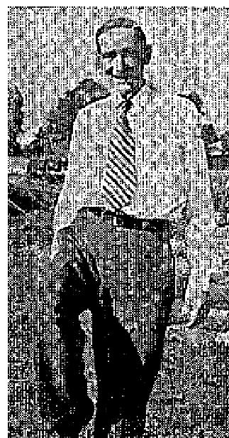

THE VOICE OF HEALING 1953
Oh how I thank God for His wonderful healing power, To Him be all the Glory!
Yours in Him,
Lionell Purdy, 10.5, King St., Chatham, Ontario, Can.
January 1953 p13
"GOD COMPLETELY HEALED ME"
Dear Brother Hardt:
I had suffered for years with bowel trouble. Never a bowel movement without the aid of medicine, sometimes going as long as nine days. Several times I was in the hospital for treatment but never received any permanent relief. I was also suffering with gall bladder trouble and a very nervous stomach. You prayed for me in one of your meetings in Auburn, N. Y., and God completely healed me. My bowels are regular now, and I feel fine in every way. Thanks to God for His healing power. I am so happy to have Him as my personal Saviour and Healer. I will ever praise His wonderful Name!
Alice Loeper, 5 Lewis St., Auburn. N. Y.  RHEUMATIC FEVER GONE  Dear Bro. Hardt:  My daughter, Helen Baker, now seven, was stricken with rheumatic fever when she was five years old. She was treated for kidney ailment. One year later her hands and feet began to swell and she was in much pain. | 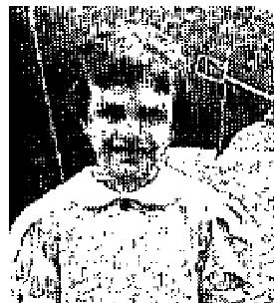

Her back was weak and she could not even sit up in bed. The Rheumatic fever had started again. The doctor told us that for the last year her sickness had been working on her heart consequently she was in the hospital for two months. As soon as she was able to sit up again we brought her home, She was in bed for thirteen months. During this time she tried walking but was unable.
On July 12, I took her to Geneva, N. Y. to the tent meeting where you were conducting a healing revival. After you prayed for her, Brother Hardt, you placed her on the ground in the tent and she began to walk, In less than a week she was walking normally and her legs were strong, and I knew that Jesus had healed her. Her whole family have turned their hearts to the Lord.
I thank the dear Lord for His healing power and thank you. Brother Hardt, for praying for her. Mrs. Herbert Baker, Lloyns, N. Y.
January 1953 p14
WORE BRACE 10 YEARS - NO LONGER NEEDED
Eleven years ago I fell and injured my spine, crushing three vertebrae. the doctors said I would never be able to walk again, even with a special fitted brace. I was fitted with a special heavy steel brace from my shoulders to my hips. For 10 years I had to wear this brace to sleep in and have worn out four braces.
On Oct. 16 I attended the A. A. Allen campaign in Evansville, Ind., and Brother Allen offered prayer for Me. He told me I could remove the brace as I would not need it further. I removed the brace immediately, I have no need now for the brace, as I am today as strong and agile as I used to be before the accident.
Elsie Posey, 306 Rudy Ave, Henderson, Ky.

THE VOICE OF HEALING 1953
January 1953 p15
Testimonies Affirm the Miraculous in HOMER PETERSON Meetings
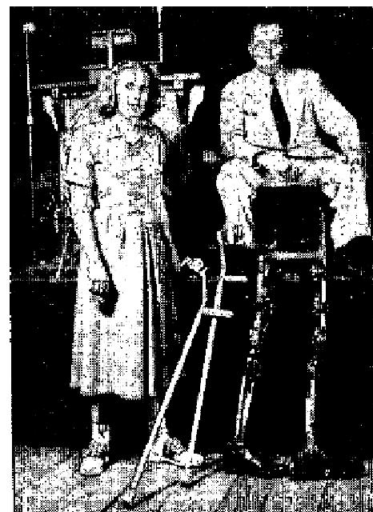
POLIO VICTIM NOW WALKS WITHOUT BRACES/CRUTCHES
I was stricken with Polio the 30th of August 1951. 1 had to spend seven months in hospitals and, for about five months, I wasn't even allowed to sit up at all. When I returned home from the hospital the 23rd of March, 1952, 1 was wearing two long leg braces which went all the way to my hips (see picture). These braces weighed eight pounds. They were quite heavy and tiresome to wear but, without them, I could not even stand on my feet, I also had to use crutches.
On August 5th 1952, when Brother Homer Peterson was holding his meeting in Hamlin, Pa., I went forward and was prayed for. I immediately felt the healing power of God go through my body, and I started to gain strength right away. I was able to walk around the house without my braces but still used my crutches. On the 17th of August I was strong enough to go out side of the house without by braces and, Praise God. I still do not have to use them! In September I was able to walk even without my crutches. Thanks to Jesus!
Junetta Mitchell
R. D. No. 1, Mosick, Pa.
Statement of Pastor: This testimony is true. Rev. George W. Clement, Pastor, Hamlin, Pa.
"CHARLES" ALSO WALKS WITHOUT BRACES  My son Charles, four years old, was stricken with Polio one year ago. He could not walk at all without the brace, but since Brother Peterson prayed for him, he can go up and down steps, and get around fine, He no longer needs his braces. The doctor also said the boy was healed. Praise the Lord!  Charles Shields, R. D. No. 1, Pittston, Harding, Pa. | 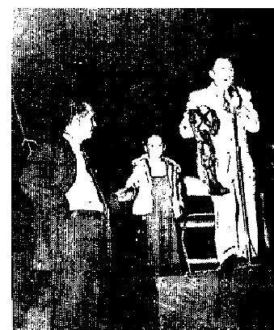

A. A. ALLEN;
TOTALLY PARALYZED - HEALED INSTANTLY
Two years ago I had cerebral hemorrhage which left me paralyzed completely. My condition continued
throughout these two years. Then, about two months ago, I suffered another stroke, becoming completely
helpless and speechless. Doctors, who had attended me previously, said there was no hope, that I would die.
However, I attended the Allen Revival in Galveston, being carried in on a stretcher. Brother Allen said to me, "In Jesus' name, arise and walk!" Immediately new strength and power went through me, and I arose alone from my stretcher and walked. Now I can also talk. To God be all praise!
Signed: Bessie VanWagner, Channelview, Texas
I affirm the above testimony to be true.
Signed, J. G. VanWagner (husband), Channelview, Texas
Statement of Pastor: This woman who was totally paralyzed was healed instantly, got off her bed and walked. She attended my church next morning, walking up and down steps, in and out of the church by herself. This was witnessed by hundreds of people.

THE VOICE OF HEALING 1953
James W. Drush, Pastor, First Assembly of God, Galveston, Texas.
February 1953 p7
God's Miraculous Power Manifested as L. D. Hall Ministers
INCURABLE AILMENT GONE AFTER PRAYER
Brother Hall was holding a revival meeting and having prayer for the sick at the Assembly of God church In Ontario, Oregon. I attended. I had polycythemia (excess of red cells in the blood), and the doctors say that this disease is incurable.
My blood count was (Reds) 5,980,000.
After Brother Hall prayed for me, the red count went down about a million counts. This past sickness of polycythemia had left my fingers and left hand stiff, and I couldn't bend them. Brother Hall prayed the prayer of faith for my left hand, and I can now bend all my fingers.
I thank God from the depth of my heart for this healing, and Brother Hall for the prayer of faith.
Ella A. Davis (May 11, 1952), Box 526, Ontario, Oregon
May 16, 1952
Dear Brother Hall,
This is to let you know that I had a blood count yesterday, and it is normal! Praise God for what He has done for me. My hand is getting better every day. I can hold on to things now.
Sincerely,
Ella A. Davis.
MOTHER AND SON - HEALED THROUGH PRAYER
I have had a nervous heart for a long time. My heart would miss beats, and beat too fast. I had a lot of
trouble with it.
Brother Hall prayed for me and I was healed instantly; so I am giving Him the praise for sending a man of God this way and I thank the Lord for my healing. I was healed the night of December 5, 1951.
My little boy, 12 years old, had been nervous ever since he was three years old. He had nervous habits, and his head and shoulders would jerk, also other parts of his body. Since Brother Hall prayed for him, his head has not jerked any more. I give God all the praise for it. He was healed Nov. 25,1951.
Mrs. Minnie Belle Willis, 1315 S. Lake St., Fort Worth, Texas
DEAF 28 YEARS NOW HEARS
I have been unable to hear out of my left ear for 28 years. But, praise the Lord, I can hear in that ear now, since Brother Hall prayed for me in the revival here in The First Assembly of God Church, Fort Worth, Texas.
I was also healed of a sore throat. The Lord is a Great Physician. Praise His Name! Mrs. Lottie Chenault, (Dec. 9, 1951), 515 Flint St., Ft. Worth, Texas

THE VOICE OF HEALING 1953
PAIN AND DEAFNESS GONE
Since Brother L. D. Hall prayed for me, the Lord has healed me of a pain in my left breast that has been
there for several years.
Also today, when Brother Hall prayed for my deaf ear, the Lord healed it. I praise God for healing me! Mary Moore, Black Canyon Route, Box 22, Phoenix. Arizona
HEALED THROUGH ANOINTED PRAYER CLOTH!
[We print below one of the testimonies of healing--Received by our TVH Prayer Service Department]
Dear TVH Editors: In November I wrote you for an anointed handkerchief and prayer for my rupture, arthritis, and varicose veins. I had had the rupture for 37 years.
I received the handkerchief on December 1st at noon. On December 3rd at 7:30 a.m., Jesus so marvelously healed me and I am praising Him for it. He has done much for me.
I will always praise my Blessed Savior for so great a healing. I thank you for your prayers and for the anointed handkerchief.
The article in the January issue of VOICE OF HEALING by Rev. Gordon Lindsay was a wonderful help to me. Your Sister in Christ,

Tena L. Michael, Bans Run, W. Va.
February 1953 p9
NOW WALKS WITHOUT BRACE
0n the fourth of July, 1952, I was in a car wreck. The eleventh vertebra in my back was fractured. I was kept in a body cast for two months. Then I was fitted with a heavy steel body brace, reaching from shoulders to hips. The Doctor said I must wear this brace constantly for at least six months, and must not even attempt to walk across, the room without it, (See picture above).
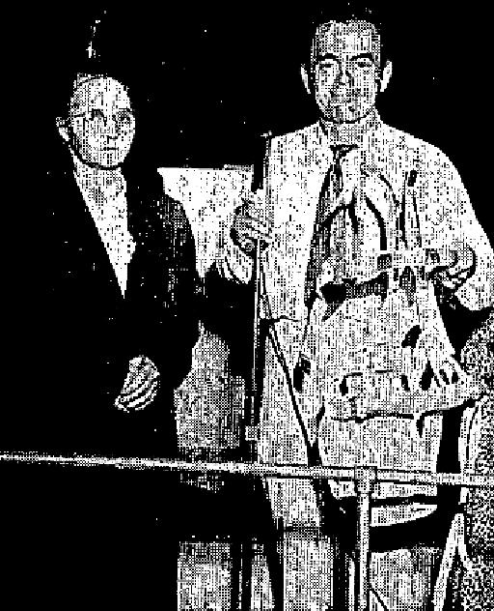
However, on Sunday afternoon, Nov. 2, I attended the A. A. Allen Revival in Galveston, Texas with my pastors, Brother and Sister Ashcraft, and my husband.
Brother Allen called me out of the congregation for deliverance from my affliction. As soon as he had prayed, I realized all soreness was gone.

I immediately went out and removed the brace. I walked over the rough ground back into the tent, and up and down steps, without the brace, and without any pain!
I surely praise God for this great miracle of healing which He has performed in my body. Mrs. S. E. McAdams, 74D9 Anzac, Houston 20, Texas
(Mrs. McAdams gave her testimony of healing in the Allen revival two weeks later, still praising God for her complete deliverance.)

THE VOICE OF HEALING 1953
TUMOR DISAPPEARS
Since 1928, I carried a horrible tumor on my arm as large as a lemon. It was on the inside of my arm at the joint, and caused me much pain, and hindered me greatly in doing my housework.
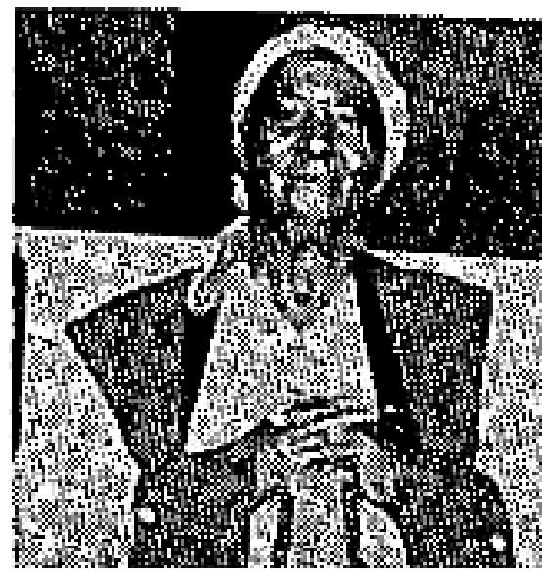
During A. A. Allen's revival in Galveston, one night in the healing line Rev. Allen placed his hands on this visible tumour and commanded it to leave immediately. The moment he prayed, it DISAPPEARED!
Now I can do all my own work. The tumour is gone completely! Mrs. Della Vaughn, 915 30th St., Galveston, Texas
PALSY-PARALYSIS GONE
In August 9, 1952, I was stricken suddenly with palsy and a partial paralysis of the right side of my head and throat. My face was drawn, dark and swollen. This condition persisted for over a month.
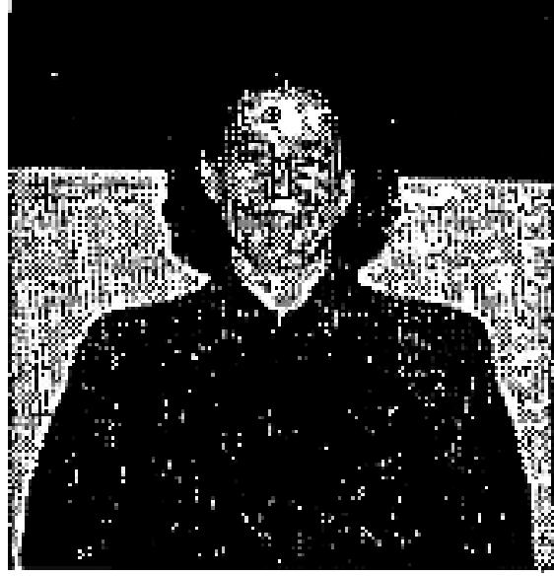
On Monday night, Sept. 15, still in this condition, I entered the prayer line at the A. A. Allen Revival in Rock Island. When Brother Allen prayed for me, God's power came upon me and took away all the pain and swelling.
I praise God for deliverance from this very uncomfortable and embarrassing condition!
Mrs. Helen Holder, 425 4th Ave, Moline. Ill.

February 1953 p18  SHORT LEG LENGTHENED TO NORMAL  (Testimony from Native of British West Indies)  Jeremiah 33;11: "Praise the Lord of hosts; for the Lord is good, for His mercy endureth forever!"  For over a year I suffered with an awful wound, a few inches above my heel, on the left leg. I was unable to move around unaided and the Lord, in answer to prayer, wondrously healed the wound. That was about three months ago. After the wound healed, one of my legs became much shorter than the other, and very  stiff and painful too, so I made a cane to aid my walking. | 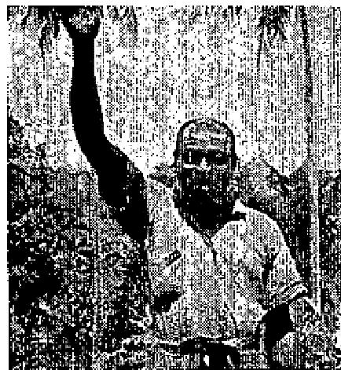

A little over a month ago my pastor, Rev. G. E. Fletcher, announced one Sunday morning that that very evening should be Lord's Supper and washing of the saint's feet. I was glad. With steady faith I went to that service and after supper my faith was set loose and I was gloriously healed. My short leg lengthened and became even with the other and I can now kick it vigorously, as I have since then, testifying to His healing power. Praise God! The healing stands good today as when I received it. Two days ago I was working an our tabernacle at "Bethel" and can now climb to the roof.
Amen! How I feel like praising God!
David Walker, P. O. Redwood, Jamaica, B.W.I.

THE VOICE OF HEALING 1953
Dear TVH Editors
I take great pleasure in establishing David Walker's testimony, which follows. He is a member of our
congregation at "Bethel" here in Jamaica, one of the churches that I pastor.
We have prayed for him and we know his testimony is true., Praise the Lord, It brought great joy to our hearts.
We will reply to all inquiries.
Yours in His service,
(Rev.) Gerald E. Fletcher, Bethel Tabernacle, Benbow, Jamaica, B.W.I., October 4, 1952
March 1953 p7
WRITES AFTER 19 YEARS
Dear TVH Editors:
I sent for a cloth anointed by you about two weeks ago. I received It and put it on my hand and claimed the
promise of God.
You see how well I can write. This is the first time I have been able to write with this hand for 19 years. A piece of steel penetrated my wrist and caused me to lose the use of my hand. I praise God for my healing.
Louis Bates, 303 Elm Street, Chillicothe, Ohio.
HEALED THROUGH PRAYER CLOTH
Dear TVH Editors:
I wrote you for prayer and an anointed cloth; therefore, I feel that I should write and thank you for Your prayers and tell you that the Lord has healed me.
I requested prayer for my right foot and leg which caused me so much pain and misery. The Lord also has healed my side, which had troubled me much, since you prayed for me,
Thank you again, and may the dear Lord bless you abundantly in every way!
Your Sister in Christ.
Mrs. R. V. Fagaly, Vancouver, Wash.  March 1953 p8  This Month's Cover Pictures  RUDY CERULLO  Cecil Hall Is Happy Because God Healed Knee Injury, Bad Cyst  I thank God for this and every time I have an opportunity to testify for my Lord.  I thank Him for saving my soul and healing my body when Brother Rudy Cerullo prayed for me in his Salvation/Divine Healing Campaign in the Camp Meeting of the Arostic County Pentecostal Fellowship in Northern Maine. | 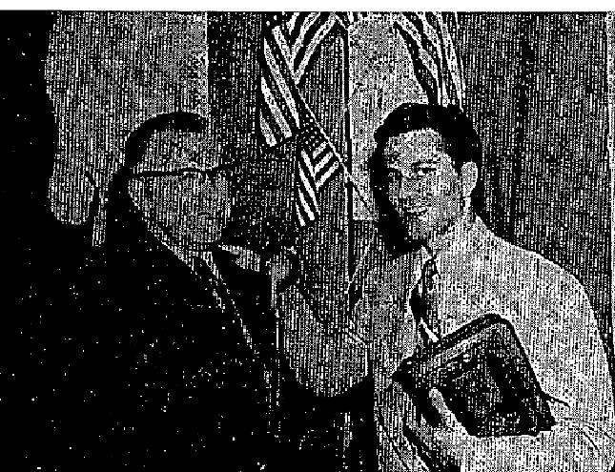

THE VOICE OF HEALING 1953
In 1928, I sustained a knee injury, through an accident, that caused the cartilage and ligaments of my right knee to be torn from the bone and, for 24 Years, this condition remained with the tissue never attaching itself to the bone.
Too, I had a worse condition - a bad cyst at the base of my spine, for which I had been operated on in 1936. From that day, until July 1952, when Brother Cerullo prayed for me, the incision of the operation and the pourous sore drained and never healed.
While in that condition, God led me to have Brother Cerullo pray for me. The Lord, through him, discerned my trouble that night and IMMEDIATELY I WAS COMPLETELY HEALED of the knee injury. I could bend my knee right away, after prayer, and I found it to be the same size as the other (the injured knee had been much larger than the left knee), and God knitted the bone and tissue together again.
The cyst closed up over night. It has opened and drained some since then but in November (1952) the cyst closed completely and has never opened since.
God has delivered me entirely! I praise Him again for salvation, healing my body, and for the faith and ministry of Brother Rudy Cerullo.
At the time of this writing (January 1953) six months have passed and I am still completely well and have had no recurring pain or trouble in my knee, or spine.
Praise the Name of the Lord!
Cecil A. Hall, Station Master, Bridgewater, Maine
Certified by: Rey. Edward Skane, Pastor - NOTE: "I have personally conversed with this man over long distance phone as of today (January 21, 1953) and this testimony was again confirmed by our Brother Hall. He again praised God, over the phone, that he was still delivered."
Evangelist Rudy Cerullo  PHILIP N. GREEN  Mary Ruth Gist Retains Hearing Has Two Sets 0f Eardrums!  EDITOR - We are publishing on our Cover Page this month a picture of Mary Ruth Gist, of East Chicago, Indiana (Twin City to Hammond, Indiana), with Reverend Philip N. Green, which we previously published  in the September, 1951, issue of TVH, with which we gave her full testimony, telling about her deliverance  from almost total deafness.  The story of Mary Ruth's healing was featured in the Magazine Section of the HAMMOND TIMES - Sunday Edition, November 19,1950, and the Hammond Times- Mercury sent their news photographer out  to her home to make this picture with Brother Green. | 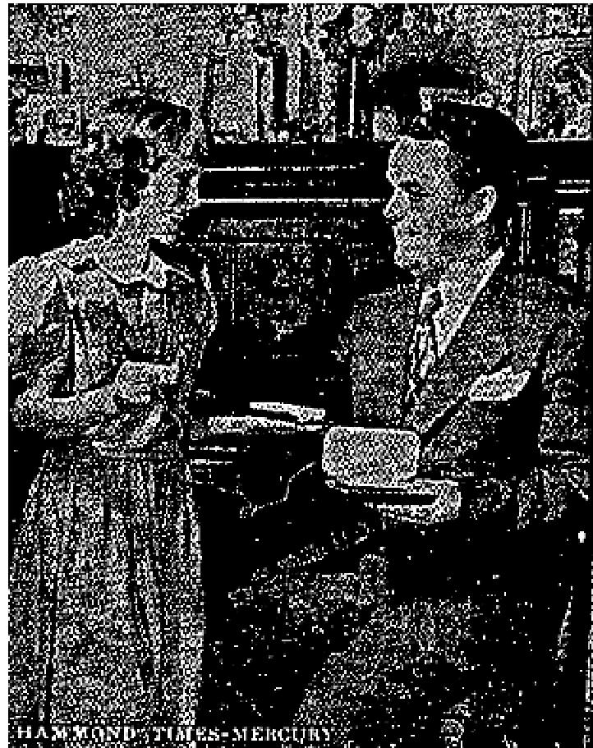

Mary Ruth had become stone deaf in her left ear and almost
completely deaf in the right ear. She wore a hearing aid but Dr. Edward Sosson reported her hearing was so
far gone the aid would do no good.

THE VOICE OF HEALING 1953
Mary Ruth's hearing was certified to by repeated examinations of the doctors. in January, 1951, Dr. Stanley Zallen, Medical Doctor, of East Chicago. Indiana, looked into the child's ears and found two sets of eardrums--new ones grown beside the old!
Her former pastor, Rev. Melvin Planck, also certified this healing. He was present when she was healed and has observed her since that time. He certified that the details were accurate and that the girl still enjoyed perfect hearing.
Of course, Brother Green has had many other miraculous healings and deliverances in all his meetings since that time, a number of which have been reported in THE VOICE OF HEALING from month to month. These, I am sure, you have read.
However, we felt this healing so outstanding, we wanted to tell you that it still stands good - after two years, and we print below a letter received from Mary Ruth's mother, written on January 25, 1953, confirming that fact. We also give a recent statement from Brother Green, and the doctors testimony of his findings.
*****************
Letter from Mrs. Wilma Gist - Mother of Mary Ruth!
Dear Brother Green:
I am so happy to tell you that Mary Ruth can hear today as well as she could the night after you prayed for her in your campaign, and we are still thanking God for it, and for sending you, Brother Green, back to your home town (Hammond, Indiana) to pray for our little girl.
She is doing well in school now and was so thrilled that you called her and talked to her on the phone. She, so excitedly, told her school mates and teachers about talking to you over the phone.
We quote below a recent statement from Rev. Philip N. Green, January 29, 1953:
I called (person to person call) Mary Ruth Gist recently. who lives near my home town of Hammond, Indiana, and talked to her over long distance telephone.
She conversed with me very normally and quite freely for some period of time, and could hear plainly every word I said, ' She did not ask me to repent anything.
I then asked to speak with her mother and she confirmed all Mary Ruth had just told me. Her former pastor also confirmed this healing.
I truly believe this is one of the most outstanding miracles I have ever seen In all my ministry, and the Doctor said this was the most unusual thing he had ever seen, also that he had never heard of anything like it in medical history.
He is the only Medical Doctor who ever called me about a healing that had occurred in any of my meetings.
He said, 'The old eardrums are yellow - and there is a space between them of tissue paper thickness, then a new set is shown just inside, which are white. These are the good eardrums, which she now hears through. She has two sets of eardrums!
PHILIP N. GREEN.

THE VOICE OF HEALING 1953  STANLEY KAROL  Grace Heisler Coughs Up Cancer Of Throat  Dear Brother Karol:  I want to take this opportunity to Praise and thank my Lord, for what He has done for my daughter, Grace.  She had suffered from trouble with her throat off and on since she was eight (8) months old. Last October she became quite ill again, and we took her to three doctors, who finally diagnosed her case as cancer of the throat, Very little hope was given and time too, as you heard me testify, | 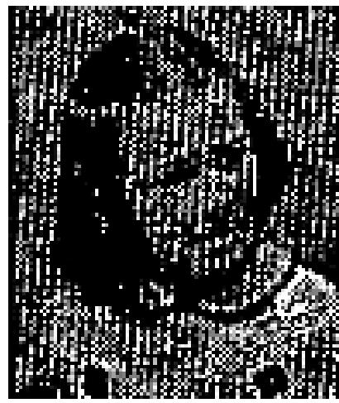

I then took her to your Salvation and Healing Revival which was being held in Philadelphia, Pennsylvania, In the Kensington Pentecostal Church. That was on April 11th, 1952.
When I took her in the church, she was complaining with her throat and was running a high temperature. It did not take very long to see the hand of God at work for, IMMEDIATELY AFTER YOU PRAYED, HER FEVER WAS GONE AND, ALSO, PAIN IN HER THROAT LEFT!
On April the 12th, just fourteen hours after you prayed for Grace, she was awakened by a cough and, in so doing, to all our amazement, coughed up the lump which was the cancerous growth.
It was about the size of the first knuckle of your thumb. I took it to the doctor and HE SAID THAT IT WAS DEFINITELY THE GROWTH.
The doctor also sold, "Her throat is healed!"
When I took her to your meeting, she could not eat properly and had lost so much weight, she weighed only thirty-nine (39) pounds. Since her healing, she has continued gaining and, to date, has gained a total of thirty-seven (37) pounds.
To God be all the glory, for He is the God of the impossible! God bless you, and your ministry Brother
Karol!
Elizabeth Heisler (Mother of Grace Heisler), 919 Reed Street, Wilmington, Delaware
March 1953 p9  W. B. MCKAY:  C. Skepnick Saved, Delivered From Leukemia,  Arthritis, Kidney Stones  I was born in Austria brought up in the Roman Catholic Faith, and was a faithful member for almost fifty (50) years.  I came to America in the year of 1904 and established residence in Boston, Massachusetts, and, for several years, had a successful grocery business in that city. The long hours on my feet in the store brought about a complete collapse of my physical system.  After several months of suffering and attending doctors | 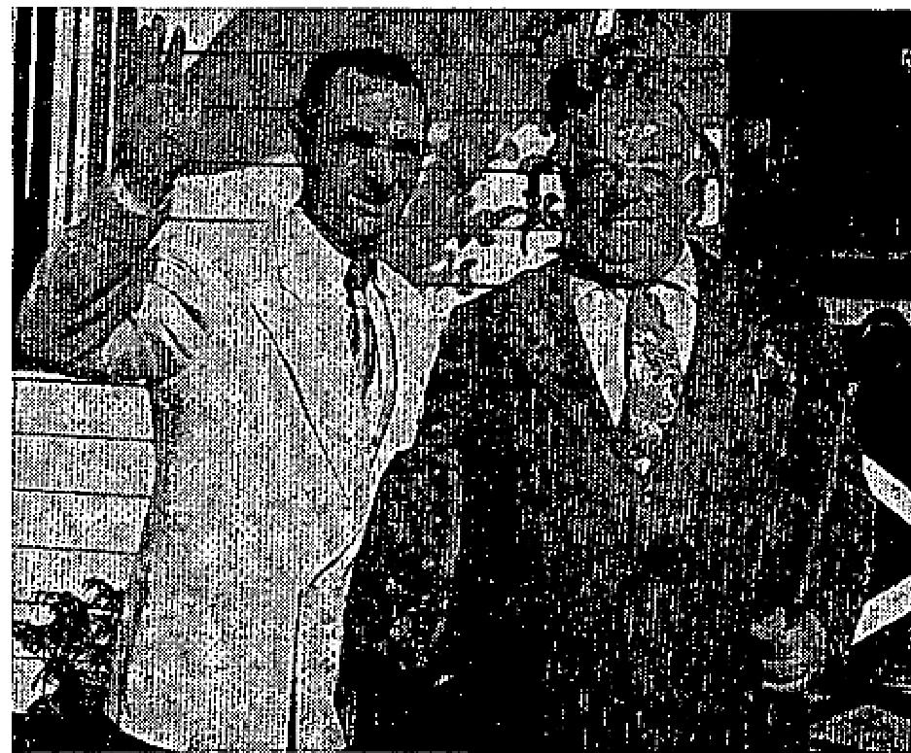

THE VOICE OF HEALING 1953
consultations, they diagnosed my case as leukemia arthritis in legs, kidney stones, and very much overweight.
My wife and I gave up the grocery business. Having been advised by the doctor to move to a warmer climate, we decided on Florida. We both believe now, that the Lord led us to Orlando, Florida.
The sunshine did help me some, but I was never able to go out on the streets of Orlando, without the aid of my two canes, A number of times, in the busy section of Orlando, I found myself fainting away and would fail to the sidewalk, creating a scene, and crowds would gather around me. The police ambulance would rush me to the hospital and I would stay there for several days until I was able to return to my home.
One day in Orlando, Florida, my wife and I were driving on the Orange Blossom Trail and passed the big Gospel Tent Cathedral of Evangelist W. B. McKay.
We drove on past but, when I had gone about three miles beyond the tent I felt a strange sensation urging me to go back to the tent; therefore, I decided to return to see what kind of meeting was being held in that tent.
My wife and, I had never attended a protestant church service before; so we went inside the tent and sat on the back seats but listened very interestedly and attentively to what the Evangelist was preaching.
The next day, we were both back but, this time, we sat in the center of the tent, and now I realize that God was leading me all the time and He had been talking to me during these visits to the tent.
On the third day of visiting the tent services, I became very much troubled about my spiritual condition, as well as my physical afflictions.
When Brother W. B. McKay gave the invitation to come and accept Christ as Saviour I found myself, so it seemed to me, being carried to the altar by an unseen force. My wife went with me, and we both accepted the Lord Jesus Christ as our own personal Saviour.
A large prayer line was formed, after the invitation to come and be saved was given, which I entered.
My wife assisted me and held on to me until it came my turn to be prayed for. Oh, Praise the Lord! The moment God's servants (Brother and Sister McKay) laid their hands an my head, and Brother McKay
prayed that prayer unto God, the power and healing virtue of our Christ went through me. IMMEDIATELY, I KNEW I WAS HEALED!
I threw, down my canes and walked all over the tent, praising God for completely delivering me from ALL THESE AFFLICTIONS!
This experience of God's healing power and my deliverance, took place many months ago, and I AM STILL HEALED TODAY! (January 1953).
Since God set me free, I'm happy to testify that my wife and I have received the baptism of the Holy Ghost, and are members of the First Assembly of God Church in Orlando, Florida, and our good Pastor is Rev. Vernon J. Cardiff.
My prayers will go with this, my testimony, that others who are afflicted will trust Jesus Christ and be healed, for "Jesus Christ is the same yesterday, and, today, and forever!" (Heb. 13:8)
Constantine Skepnick, L309 18th Street, Orlando, Florida

THE VOICE OF HEALING 1953
Verified by: Pastor Rev. V. J. Cardiff
Evangelist W. B. McKay, Orlando, Florida
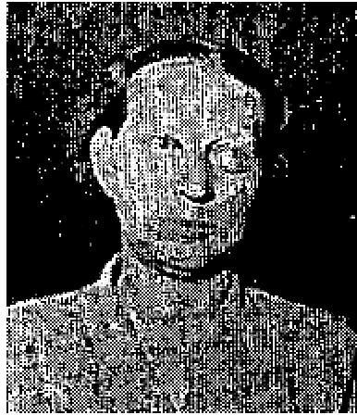
March 1953 p15
"INCURABLE ARTHRITIS" GONE
FOR three long years I had suffered with my legs. The joints in my legs were getting
stiff. I had to drag my feet when I walked, and could not do a day's work.
I went to a bone and joint specialist who told me I had active arthritis in both legs and that there was nothing he could do for me.
In August. of 1952, Rev. Warren L. Litzman held a city-wide Revival and Healing Campaign in Waco, Texas. I attended the services and gave my heart to God. When Brother Litzman called for the healing line, to pray for the sick, I entered the line. As soon as he laid his hand on me and began playing for me, I felt the healing power of God flow through my body. I RECEIVED MY HEALING INSTANTLY!
Today, five months later, my legs are still healed! I now do all my work and can walk as good as ever and never have a pain in my legs. Oh, Praise God! I know my God can do all things! Mrs. Willie Mangham, Waco, Texas
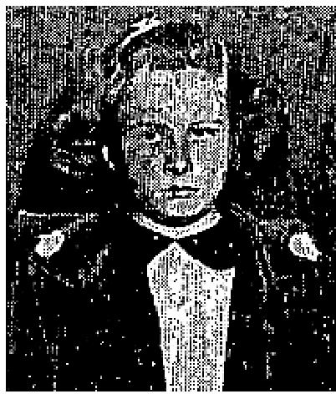
KIDNEY TROUBLE HEALED
My little girl, eight years old, had suffered severely from kidney trouble. Her gall bladder was infected and she was passing blood. When Brother Litzman prayed for Brenda, the Lord healed her.
I praise God for her healing.
Mrs. Melvin Cook, Waco, Texas
March 1953 p16 & 17  Signed Testimonies Prove God Heals, Today!  GOD HEALED ME OF:  NINE CANCERS  C. A. Rainwater, P. 0. Box 542, Russellville, Ark.  "Several doctors ordered me to quit work because I had an incurable heart disease. I had overworked. (I made a quarter of a million dollars by working day and night for seven years).  I was healed through prayer, and the doctors said I was well. | 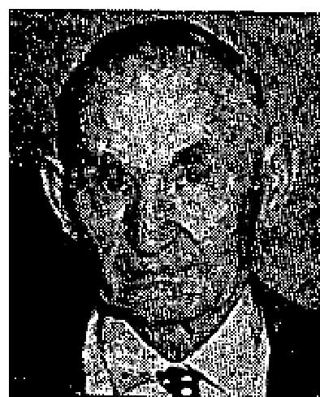
In 1952 my health failed again. The doctors found my heart was still all right but that I had cancers throughout my body. I had nine cancers cut out in Houston, Texas, and was ordered to return within two months to have more cut out. Instead of returning to the hospital, I went to the Grant Revival in Russellville, Arkansas.
Although I was a United Brethren, I there received the Pentecostal Baptism and was healed of those cancers while sitting in the audience. Some of them were on the right side of my head. You can see it is now clear."
This testimony verified by Rev. J. B. Lindsey, Pastor, Russellville, Ark.

THE VOICE OF HEALING 1953

PARALYSIS
Mrs. Bessie Lollis - writes:
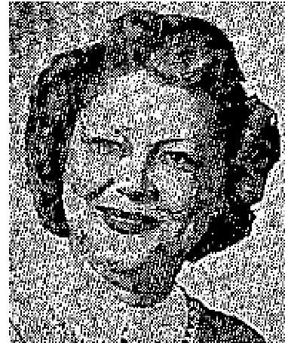
As she came into the healing line in the Grant Tent meeting in Meridian, Texas, for her daughter - Mrs. Inette Espensen, who was in the Vet. Administration Center, Ward A. G. E., Bed 12, Wilshire and Sawtelle Blvd., Los Angeles 25, Calif., her daughter was healed by proxy. The daughter had been so paralyzed she could not feed herself. Blood vessels had broken in her head and she had a leaking heart.
Within two days, she wrote a letter to her mother with the hand that had been paralyzed, stating that she was healed!
CRUSHED NERVE
Mrs. W. C. Locke, 1206 E. Elm St.. Breckenridge, Tex"
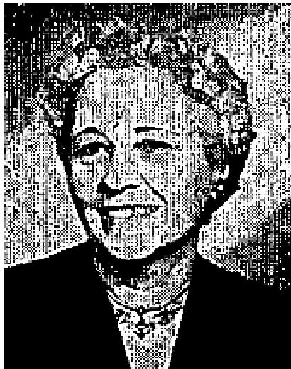
The nerve was crushed in my arm 25 years ago in a car wreck. The doctors said, I would suffer from it the rest of my life. I was never without pain, from the tip of my fingers to my spine.
I was healed instantly as I believed with him when Bro. W. V. Grant prayed for the sick and afflicted over his radio program, broadcast from Breckenridge, Texas.
This is the first time I have lifted my arm above my head for many years.

HOW TO RECEIVE THE HOLY GHOST
Dear Brother Grant: For three years I have wanted the Baptism of the Holy Ghost. I had often sought Him
but did not know how to receive.
I had been, and reared my boys to be Presbyterian. They only attended church on Christmas and Easter. We had never heard of the Holy Ghost before.
Two weeks ago I got your book, 'HOW TO RECEIVE THE HOLY GHOST.' Before I had read it through, I felt a strange sensation (which I now know was the Power of God) coming upon me and I suddenly began stammering in another tongue. I was unable to stop for hours. Every day and night since, I have had this same manifestation. How long will it continue?
I have read your book three times.
Mrs. Rittie Walters, Seattle, Washington.
{Isaiah 28:11 says - "For with stammering lips and another tongue will He speak to this people."}
CEREBRAL PALSY  Mrs. Katie McCoy, Shubuta, Miss.  Cerebral Palsy left my side paralyzed, with no hopes of recovery, according to five physicians. I had a vein in my neck ligated, and had two holes bored in my head and the brain fluid replaced by air.  About one year later, I began to grow worse and was ordered to the hospital. I went to the Grant revival instead and was completely healed. I can now write with the hand that was paralyzed and remember everything, I am normal in every way"' | 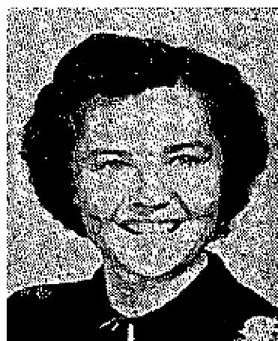

THE VOICE OF HEALING 1953
PARALYSIS
Estefana M. Argnijo, Arrowhead Courts, Haskel, Texas
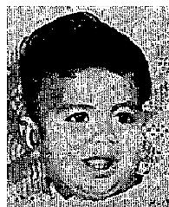
MY son Joe was paralyzed eight (8) months. Since Brother W. V. Grant prayed for him, he is
healed."
GOITER
Vivian Crandal, Rt. 5. Everett, Wash.
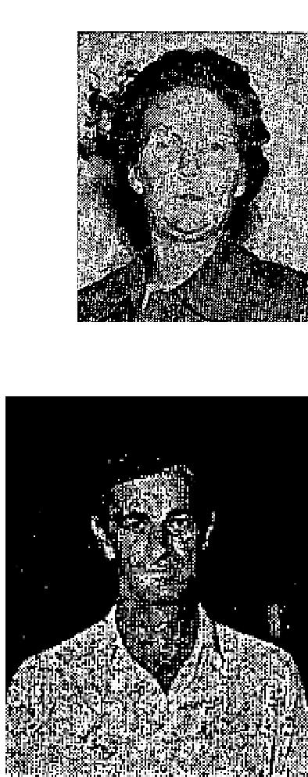
On March 27th I was healed of sinus trouble, while sitting in the audience of the W. V. Grant Revival in Seattle. The next night, as Brother Grant prayed for me, a fatted tumor which I had on my right arm for three years disappeared instantly. A goiter and kidney infection left me the same time. THE DOCTOR HAD TOLD ME THERE WAS NO CURE FOR THESE.
BURST EYEBALL
Ray L. Smith, Hox Bar Rt., Ardmore, Okla.
Thirty-one years ago I was hit in the right eye with a rock which burst my eyeball. I went to an eye specialist and he said the eyeball had burst and there was nothing which could be done to help me. FOR THIRTY-ONE YEARS I WAS TOTALLY BLIND IN THAT EYE.
Since Brother Grant prayed for me in the Ardmore meeting, I can see just as well out of my right eye as out of the left one. I can read with it, also, and am so happy that Jesus heals!
Witnessed by Rev. J. I. Green, Pastor, Hox Bar Rt., Ardmore, Okla.

BLINDNESS
Emily May Saver, Detroit 28, Mich.
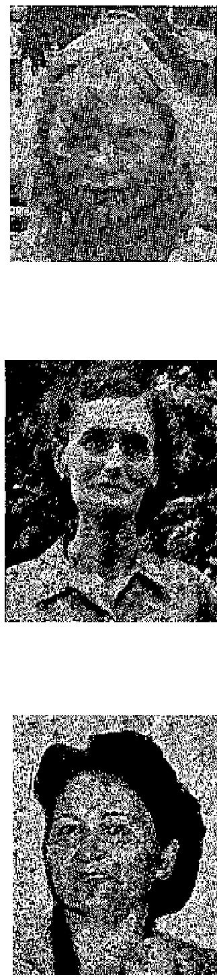
I was struck by a car on the way from school which knocked me up against a curb,
injuring my right eye and causing me to lose complete sight out of it. For a year I could
see nothing out of that eye, until I was prayed for by Brother W. V. Grant. After he prayed,
I could see instantly, even to read my Bible. Now I
can see good out of it!
TUMOR - WHILE READING BOOK
Mrs. Frank Smith, Russellville, Ark.
My doctors wanted to operate on me four years ago for a blood tumor. I refused and grew worse. I hemorrhaged for eight weeks without stopping.
Joy and faith sprang up In my heart as I read 'FAITH FOR YOUR HEALING' by Brother Grant. By the time I finished the book, the bleeding had stopped, and the tumor is now gone!"
HEART TROUBLE
Hetta Sullivan, Casa, Ark.
For six years I was up and down with heart attacks. A heart specialist said I had an enlarged heart and nothing could be done. One physician walked away during an attack, giving me no hope.

THE VOICE OF HEALING 1953
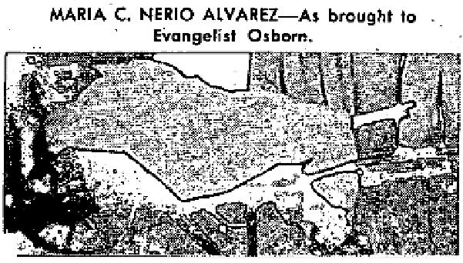
Having been in the bed for weeks, unable to move, I was carried to the Grant Revival In Russellville, Arkansas, on a stretcher.
Brother Grant prayed and told me to get off the bed. I did not know that I could but, when I tried, the healing power came. I even walked, ran, and praised God before hundreds of witnesses. I have been up feeling fine ever since that night.
April 1953 p16
A NOTABLE MIRACLE!
MARIA C. NERIO ALVAREZ (Av. Ferro Carril, 48 Calle., Guatemala, C. A.) was one year bedfast, unable to move herself, lingering between life and death, with cancerous growths (or knots) all through her abdomen. She suffered continuously. Was carried to campaign in wheel-barrow. Accepted Christ as Saviour the first night. The second night she was brought again in the wheel-barrow, and WAS INSTANTLY HEALED! When cripples were commanded to walk in Jesus' Name, she arose by faith and was whole. In three days every knot was gone. She now attends every service and is well. SHE HAS BECOME A PRECIOUS AND FAITHFUL BELIEVER!
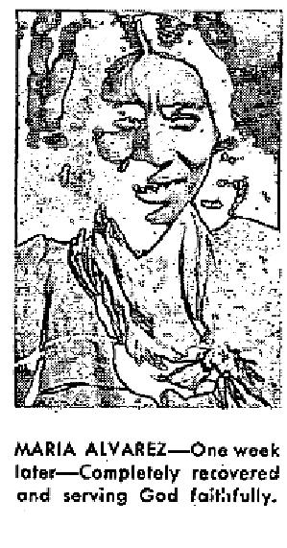
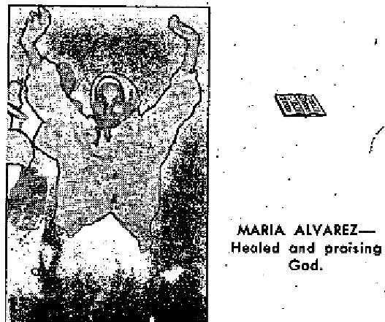
April 1953 p17  LARGE CANCEROUS ULCER HEALED  Martina de Flores, Callejon de Rubi No. 20, Guatemala, C. A., had a large cancerous ulcer on her foot swollen twice normal size , and wrapped in cloth. She walked on crutches, unable to put her foot to the  ground. After prayer, she believed and acted her faith, put her foot to the ground and began to walk without  pain. She left her crutches. Within 8 hours the swelling was gone and she was able to wear shoes. Was healed completely in three days. Not even a scar remains. She now serves daily as usherette in our great campaign!  Martina de Flores | 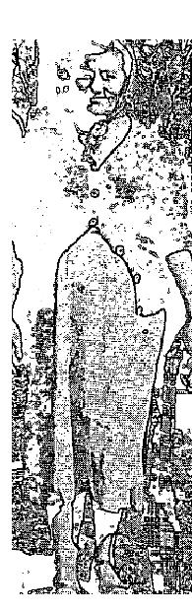

47 YEARS TOTALLY DEAF  Mrs. Romelia de Debrot, 7 Calle P. No. 34, Guatemala, C. A. was operated on in 1906 which  left her totally deaf. Could not hear sound for 47 years. She was standing on the platform  reverently praying, with her  young preacher son, when SUDDENLY HER EARS WERE PERFECTLY HEALED! She  had always  been a firm Catholic, but accepted Jesus Christ, as her personal Saviour, when healed,  TOTALLY BLIND - HEALED INSTANTLY!  Vincente R. Valdez (El Progreso, Guatemala, C. A.) was totally blind. When he accepted Christ  he was so  real that he believed anyone could lay his hand on his chest and feel God in him. His eyes were  instantly healed. | 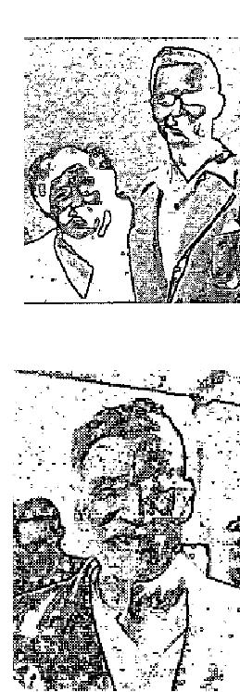

THE VOICE OF HEALING 1953
CHRIST APPEARS IN VISION - HEALED!  Lorenzo D. Castro, Calle Real, REF. No. 53, Guatemala, C. A., during prayer en  masse for all the sick, felt a hand stroke his hair.  Christ stood before him dressed in purple, placed His hands over the broken ribs  and healed them perfectly. | 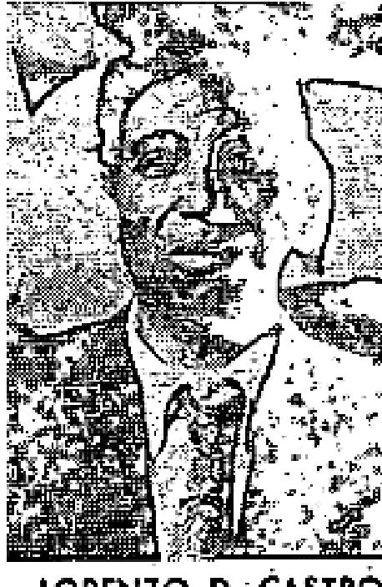
CRIPPLE HEALED - DRAGGED HERSELF ON GROUND 52 YEAR$ Maria Luisa Guiterro, (21 Ave. De
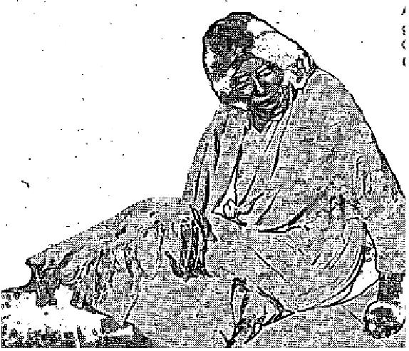
La Palmita No. 106, Guatemala, C. A.) in 1901 had smallpox and other serious fevers. Left her paralyzed from waist down. For fifty-two -years she never stood or walked. Her legs and hips were calloused from dragging her body on the ground with her hands. She was carried to the campaign and, when paralytics were commanded to rise and walk in Jesus' Name, her fifty-four (54) -year old son (who had never seen his mother walk), lifted her up, and SHE WAS HEALED.
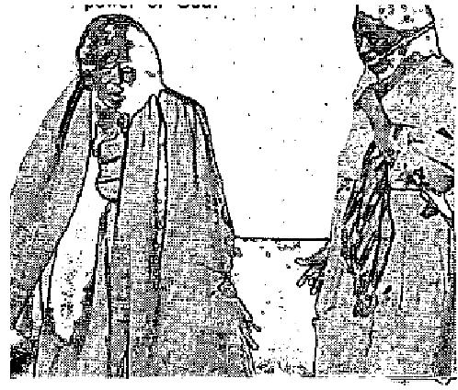
As she walked across the platform, the multitude was amazed and glorified God, because many present knew her! .

April 1953 p19
EARS OPENED - EYESIGHT RESTORED DURING PRAYER
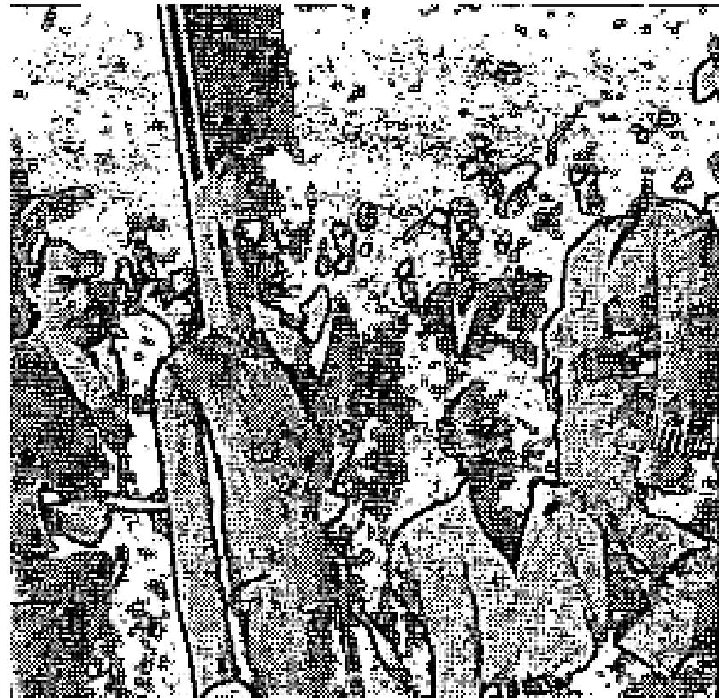
By Kentiba Heletework Ishete, Judge of the High Court, Retired, Addis Ababa, Ethiopia, December 15, 1952
Dear Mrs. Collins Daoud:
By the Grace of God I witness the following:
My son, Aklog Heletework, is now 10.5 years old. He had been stricken with disease when five years old. In consequence; his eyes, ears and limbs were rendered useless. With the exception of Dr. Anderson, all others said that he was hopeless. But even Dr. Anderson could help him little, in spite of his gigantic effort. Nevertheless, I never gave up hope, but was praying to God.

When I was informed of your arrival and the miracles
performed during your preaching, I took my boy to the prayer consecutively for eight days and, on the eighth day, thank God, during prayer, my son cried, 'Papa, my ears are open.' Afterwards, I found out that his eye sight was also restored at the same time!"

THE VOICE OF HEALING 1953
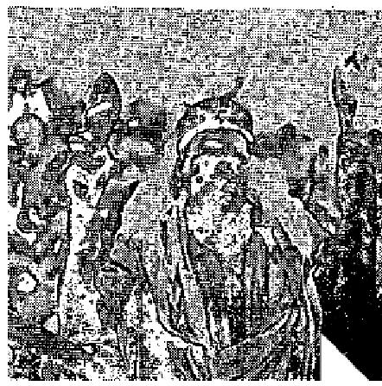
CRIPPLE - CRAWLED ON GROUND - HEALED BY GOD'S POWER! {Verbatum testimony, written down by the interpreter of, ATO SEMERO ZAREU OF GHEBRE MARIAM AYELE, the man who used to crawl on the ground and begged. Everyone knew him.}
Brethren, do join in applaud for me a sinner, who used to drag on the ground and now I am loosened by God. He loosened me.
I was like one of you two years ago. until suddenly I was struck crippled, in the town of Lekemti, where I was working under the - Ministry of Transportation. From then on, I crawled on my hands. These shoes were a protection to my hands as I crawled, This rubber innertube, which you see in my hand (hanging limp from left hand-black), was the seat and protection from the rubbing on the hard surfaces I crawled on.
THANK GOD, I AM LOOSED AND YOU, SEE ME STANDING ERECT. These shoes for my hands, and the rubber band are no more my means of locomotion. PRAISE GOD, I CAN USE MY FEET NOW AND FOREVER! Do join in praise with me. Blessed be the Saviour of the world!" (Picture on-lower right.)
April 1953 p22
"I WAS MADE WHOLE FROM THAT HOUR"
I had been suffering quite severely for several months before Brother Nunn came to Elkton, Virginia.
One night in the meeting, he called me out of the audience and told me that the Lord had shown him that I had been having trouble in the lower part of my stomach, in my left side and in my shoulder.
Brother Nunn said further, "The Holy Spirit tells me that you are healed." I WAS MADE WHOLE FROM THAT HOUR!
Brother Nunn knew nothing about my condition until the Holy Spirit showed him, and what he told me was true.
I also had an eruption on my hands and my little boy had risings in his ear, and when Brother Nunn prayed for us, the Lord healed my hands and my son's ears.
I praise God for ministers who are led by the Spirit to bring the message of deliverance to the people and who obey Him so devotedly, I also thank the Lord for what He has done for me and my family.
Mrs. Unis Dovel,
Elkton, Virginia
DEAFNESS NOW GONE - HEARS PERFECTLY
Dear Brother Nunn:
I praise the Lord for His mighty healing power! I had become very deaf in my left ear. When you placed
your fingers in my ears and prayed, THE MOMENT YOU REMOVED YOUR FINGERS it felt like a
mighty wind went through my head and I COULD HEAR PERFECTLY!
I am still praising the Lord for His goodness to me.
Jacob L. Wyant,
Elkton, Virginia

THE VOICE OF HEALING 1953
April 1953 p23
Featured Evangelist David Nunn
HEART TROUBLE, HIGH BLOOD PRESSURE DISCERNED - HEALED!
I want to praise the Lord for healing me of high blood pressure and heart trouble.
Brother Nunn called me out of the congregation and told me my condition exactly and said, "The Lord wants to heal you." He prayed for me and the Lord healed me instantly!
My blood pressure had become so high and I was suffering so severely from it and heart trouble. I had remarked to my husband that day, it seems I will be forced to seek medical assistance."
That very night, the Lord showed Brother Nunn my condition and then healed my body! We truly have a wonderful Saviour, who knows our every need. How I praise and thank Him for all He has done for me!
Mrs. A.B. Hensley, Elkton. . Va.  NOTARY AND DOCTOR CONFIRM "TB" GONE!  TO WHOM THIS MAY CONCERN:  I was examined by Dr. Heiligman and X-rayed. He found I had a spot on the lobe of the right lung. At first the doctor thought I had a cavity, because I coughed and spit up much mucous. He confined me to bed with T.B. May 5, 1952. I went to the Revival where Evangelist David Nunn prayed for me and God instantly healed me. Six days after I was prayed for all the T.B. flushed out of my entire system and I have never coughed again since. | 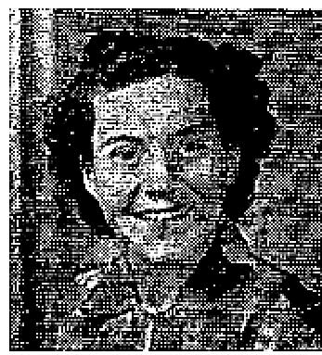

October 24, 1952, I went to Dr. Harold E. Kennamer, - M.D. in Overton, Texas, and was X-rayed again and the doctor found I was free of T.B. He said "that it showed that I had had T.B. but that it was a completely arrested case. I praise God for this wonderful miracle of healing. I was prayed for October 6, 1952:
Signed: Mrs. C. H. Condra (Affiant), Overton, Texas.
COUNTY OF GREGG: } SS
STATE OF TEXAS
On this the twenty-fifth day of October, Nineteen Hundred and Fifty-two, personally appeared Mrs. C. H. Condra who. being by me duly legally. and, lawfully sworn, says upon oath: that the statements made by the said person above mentioned herein and in the foregoing written statement concerning the matters and things set out in her above and foregoing declaration are true and correct, so help me God, Amen.
Subscribed and sworn to before me, Notary Public this 25th day of October, 1952. K. F. Charles, Notary Public, Gregg County, Texas
Statement of Physician:
This is to certify that X-Ray And Physical examination reveal that Mrs. C. H. Condra is free of infectious or
contagious diseases.
Signed: H. E. Kennamer, M.D., Overton,. Texas.
Statement by Evangelist David Nunn:
Sister Condra recently attended my meetings in Highlands, Texas (March 9, 1953) came to the platform and
gave her testimony of healing, confirming it still held good. She looked wonderful, and had gained weight.

THE VOICE OF HEALING 1953
She was exuberantly happy about what the Lord had done for her family. She then told us an interesting incident:
Her mother had worried about her little girl, fearing she had contracted "TB." Therefore, she insisted Sister Condra take the little girl to Brother Branham's meeting and have him pray for her.
When Sister Condra and the little girl stood in front of Brother Branham he discerned and told her the following:
"Sister. I see you have been healed of "TB." a, disease which has plagued your entire family, I also see you in a healing line of a great campaign, where a man of God prayed for you. YOU AND YOUR, LITTLE GIRL WERE BOTH HEALED THAT NIGHT!
You have been worried about her because she has been sickly but, you need worry no more, because God healed your little girl, and all your family the same night He healed you!"
David Nunn
GOD HEALS BAD COUGH, STIFF SHOULDER
Dear Brother Nunn:
I want to thank you for praying for me and I am grateful to God for healing me of a stiff shoulder. I had been unable to raise my arm for a long time. Now, I can raise it as high as I want to.
I was also healed of a bad cough which had troubled me for many years.
I had been unable to find any medicine to relieve me. Praise the Lord, He took the cough away the night you prayed for me! The hurting in the right side of my back, which accompanied it, is also gone!
I cannot thank the Lord enough for what He has done for me, and for ministers like you. Mrs. A. E. Williams
EAR DRUM RESTORED  As a small child I had tonsilitis and earaches. I cried night and day, most of the time, As I grew up, my ear frequently drained. My ear drum had perished. The doctor told me my ear drum was completely gone, never to be restored. I could not hear anything out of that ear.  I attended the Tent Revival in Cleburne, Texas, where Brother David Nunn was preaching and praying for the sick. He called for the deaf and blind to come forward and I felt led of the Lord to go and be prayed for. | 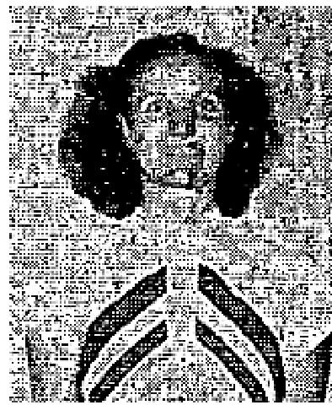

Brother Nunn had prayed for me once before, when he held a special service, but I did not take my healing at that time. Later, it seemed that God spoke to me, "Go up and I will heal you. " I obeyed, believing that God would heal me. When Brother Nunn prayed for me, something seemed to turn over in my soul. I felt the healing virtue of Jesus going through my body and instantly, my ear drum was restored. I could hear, Praise God!
Brother Nunn put his wrist watch to my ear and I could hear it tick. For the first time since I was a child, I can hear a watch ticking. It has been two weeks since I was healed and I can still hear the watch and anything else, I give God all the glory for what He has done for me.

THE VOICE OF HEALING 1953
Mrs. Eva Reynolds, Cleburne. Texas.
SIGHT RESTORED - BABY HEALED
Dear Brother Nunn:
I praise the Lord for healing my eye when you prayed for me. I had been unable to read with it, but after you laid your hands on it and prayed for me, I went home and read five chapters in the Bible with that healed eye, before I went to bed.
Glory to God for His love and mercy!
I also want to thank the Lord for healing my baby of an eruption on tier face, and a severe cough, when you prayed for her. The next morning the cough and the eruptions were all gone!
C. W. Clinedinst, Elkton, Va.
TUMOR PASSED FROM BODY
I was very weak and badly swollen around my waist. One night at your meeting in Oxnard, California, in March of 1952, you called me out of the audience and told me that I had a tumor. You prayed for me and the Lord healed me. Since that night the swelling has gone. The tumor passed, from my body and I give God the glory, and praise Him for it.
Mrs. Ada Sargent, Oxnard, California
WAS DEAF - NOW HEARS
"I thank the Lord every day that I attended the TVH Convention, December 9-11, in the Fair Park
Auditorium, Dallas, Texas, and went in the prayer line. Evangelist David Nunn prayed for me.
I could not hear in my right ear before he prayed for me.
I praise the Lord because I was healed instantly when Evangelist, Nunn prayed for me. I can now hear normal conversation."
Henry Jonischkies, Yorktown, Texas  HEALED OF FEMALE DISORDER  Dear Brother Nunn:  I want to thank God for healing my body. I went to your meeting in Cleburne, Tex., and you prayed for me for a female disorder. I had been to the doctor and he said an operation would be necessary, if I expected to get better.  Praise God, when you prayed for me, the Lord undertook and healed my body. Oh, praise His Name, He has provided healing for all who believe! | 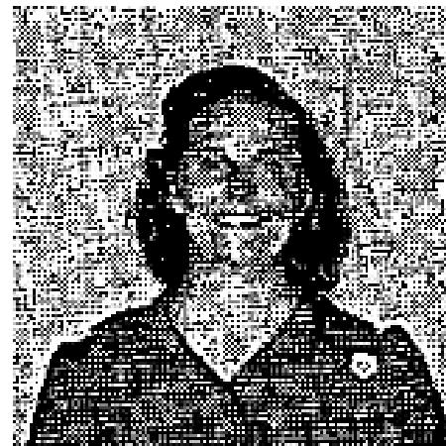

I have since gone back to the doctor and received a check-up. He told me that I was well in every way and that I did not need an operation now. I praise God for His mighty Healing power!
Mrs. George Bolden
Cleburne, Texas.

THE VOICE OF HEALING 1953  April 1953 p24  GALL STONES PASS AFTER PRAYER  I had been suffering so severely with my back and side for two months, before Brother Hayes came to our church, that I was unable to do my house work. I lost weight and could not sleep at night.  One night I went through the healing line as Brother Hayes was praying for the sick. The Lord revealed to him that I had gall stones and a weak heart. He prayed for me and told me that the Lord had healed me.  Within twenty-four (24) hours, the gall stones passed from my body, and I was completely healed!  I am giving God all the praise for healing my body!  Mrs. J. M. Vines, Dallas, Texas, | 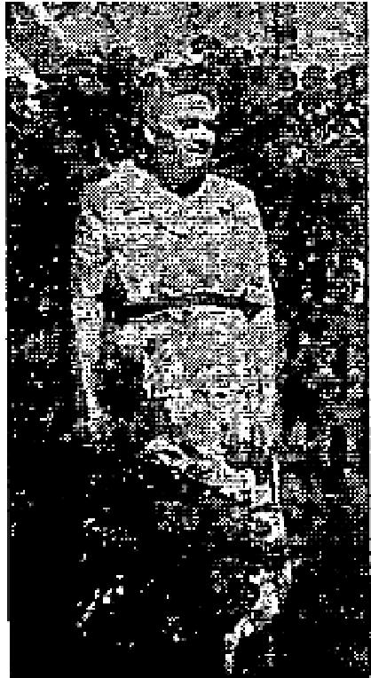

DISCERNED ILLNESS JUST AS PHYSICIAN DIAGNOSED
Brother Hayes discerned that I had a lack of calcium in my body, No one knew this but, when my children
were small, I was unable to give them the necessary calcium because of that deficiency.
The Lord I through Brother Hayes, revealed also that I had a severe heart condition and that my nerves were bad.
Few were aware of my heart condition or how bad my nerves were, but what Brother Hayes discerned about me was exactly what a medical doctor had told me that day, when I went for an examination. Brother Hayes knew nothing of my visit to the physician.
Brother Hayes prayed for me and I praise the Lord for victory through Him over every illness! Mrs. H.. C, Noah, Dallas, Texas
HEALED OF MULTIPLE AILMENTS  When Brother Hayes was conducting a Salvation Healing Revival at Oak Cliff Assembly of God, on one Thursday night the Lord, through him, revealed that I had sugar diabetes, acid in my system, pus on my kidneys, and that a vertebra had been out of place in my back for 15 years. That was true. He also told me that I had gall stones.  He prayed for me on Thursday night and on Sunday morning, the gall stones passed from my body.  I praise God because He has completely healed me!  Mrs. Rellie Smith, Dallas, Texas | 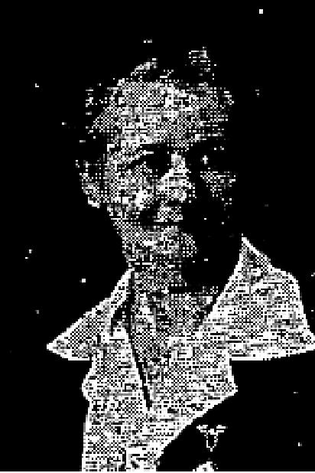

THE VOICE OF HEALING 1953  April 1953 p25  GOD'S POWER ENABLES CHILD TO WALK AGAIN  I praise God for giving my child, Betty Ann, strength to walk again. Last night, January 8, 1953 , was the first time she had walked since the 21st of October.  She had an operation in which a tumor on the brain was removed. Sister Kellner prayed for  her and she  began walking, praise God!  She's been walking all day and friends came in to see her walk!  Mrs. Luvenia Williams, Pittsburgh 33, Pa. | 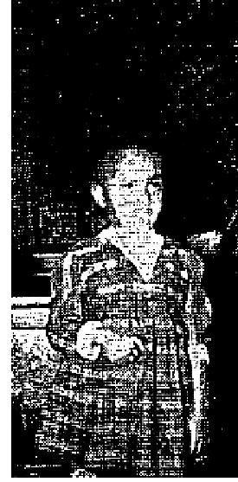

Testimony confirmed by doctor:
I took Betty Ann back to the Doctor and he found nothing wrong with her. He was thrilled over her walking. He had said he thought it would be at least six months before she would walk and he didn't think she would ever be able to walk properly. He asked me what had happened. I told him Sister Kellner and Brother Kellner prayed and Jesus did the work!'
Mrs. Luvenia Williams
Evangelist's note: The mother wrote this additional testimony a few weeks later when she returned with the child to the meetings, at which time the child ran back and forth across the platform with Sister Kellner while the congregation shouted and praised the Lord.
HAND DRAWN 54 YEARS - MIRACULOUSLY RESTORED I thank the Lord for His saving, keeping and healing power.
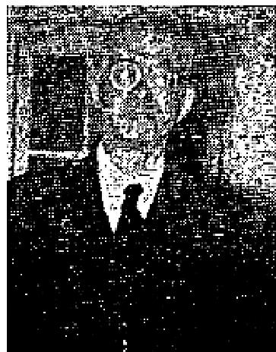
For 54 years, the fingers of my left hand were drawn up and I could not straighten them out. Sister Kellner took my hand in hers and prayed for the Lord to heal me.
My hand was healed instantly and straightened out!
Rev. Silas Huntley, Pastor of New Covenant church, Watertown, New York
Evangelist's note: Rev. Huntley came to the Watertown meeting several times, after the above healing, and gave testimony showing his straightened hand to the congregation, that it was perfectly normal.
Olive M. Kellner
HEALED OF GLAUCOMA  I had suffered with Glaucoma of the right eye for six years, had four operations and was  in the hospital ten  weeks, I had lost all vision in this one eye, and the Doctor told me that my eye was  incurable.  This January, I was suffering great pain and was to go back to the hospital for the removal of the eye ball on January 6, 1933. I did not go, however; I went to Evangelistic Temple instead and Sister Kellner prayed for  my eye and Jesus healed me! I have no pain at all in my eye. I can see to walk and I can see people with my right eye. | 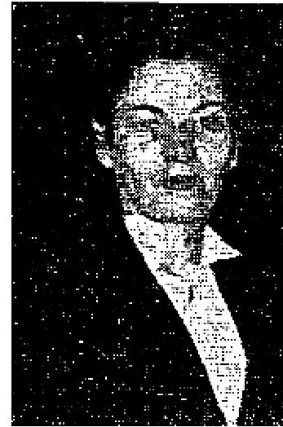

THE VOICE OF HEALING 1953
I thank God, with all my heart, for His goodness to me!

Mrs. Herman Gessner
Pittsburgh 11, Pa.
GOITER DISAPPEARS AFTER PRAYER
Dear Sister Kellner:
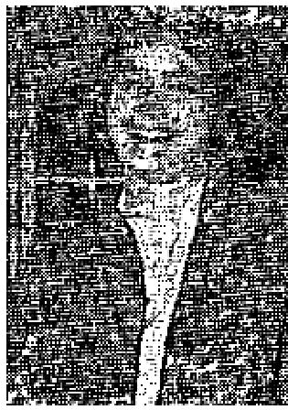
I have been afflicted with an inward goiter for a number of years. This had fastened itself around my windpipe and caused me much suffering.
During the meetings in Watertown, in September, 1952, you prayed for me. Almost immediately my thyroid gland began to function normally and I lost 20 pounds. The goiter began to disappear. I went from 34 to 27 inches around the waist. I wore a size 22 dress and now I wear a size 18.
Too my shoulders which were stooped straightened up and my height increased two inches.
Best of all, God met me spiritually and I received the baptism in the Holy Spirit.
Miss Marcia Isbister, Watertown, New York
(Endorsed by Pastor Allan E. Mitchell, Watertown, New York.)
April 1953 p28
EYESIGHT MADE NORMAL - PREVIOUSLY HAD NO THIRD DIMENSION Dear Brother Parrott:

Thirty-five years ago I was born without a third dimension in my eyesight. The remaining eyesight was very poor.
People all looked like skeletons. Their eyes, ears and nose seemed to be blurred into one form. Landscapes blurred together. I could not count the anklets hanging on a clothesline without using my fingers to count them. They blurred together. I have worn the best glasses obtainable for several years, but still could not count objects because of the blurring.
For the past four years I could not see anything up, down or to the sides. I could only see when I looked straight ahead.
My eye specialist said the nerves from my eyes were not contacting the brain any more and that nothing could be done for me. My greatest blessing came when I learned to step out on faith in God. Brother Everett B. Parrott prayed for me Nov 28, 1952. I heard a still small voice say, "Break your glasses. Trust me for your eyesight." I obeyed, prayed, trusted and believed!
Fourteen hours later, while on the way to town, my sight came to me! I have third dimension eyesight now, the skeletons and blurs are gone, I can see up, down and to the sides now.
I can count 18 telephone poles down the street and they don't blur.
Mrs. Otis Yount.
Tucson, Arizona

THE VOICE OF HEALING 1953
DIABETES HEALED THROUGH PRAYER CLOTH
Dear Brother Lindsay:
I received your prayer cloth and the books, "BIBLE DAYS ARE HERE AGAIN," and "HOW TO RECEIVE YOUR HEALING." I put the cloth on my body, and studied the books carefully and prayerfully.
I cannot find words to tell you what a help and a blessing they were to me, to show me how to trust God, for that was all I lacked.
I did not know it then, but Jesus was ready all the time to heal me. Today, I'm praising God for a well body! I had been afflicted, for at least three years, with sugar diabetes and high blood pressure.
I QUIT TAKING MY INSULIN AND FEEL SO MUCH BETTER THAN I HAD FOR FIVE YEARS. GOD HEALED ME!
I praise God for His healing power, and thank you for your prayers. May God's richest blessings follow you in His great work.
Yours in Christ Jesus,
Mabel Hobbs
Hood River, Oregon
May 1953 p9
DO THE HEALINGS LAST? ANSWER GIVEN BELOW!
Some people admit that God does heal the sick, but they ask, "Do the healings last?" The testimonies below are of miraculous healings which took place under the ministry of Rev. Raymond T. Richey a number of years ago. Each, one is good today! Many are testimonies of people who attended the APPRECIATION MEETING given in honor of the Richey Brothers a few weeks ago, by the ministers and the people of Houston. They ware present to testify and attest to the fact that their healing was still good.
You will notice that most of the testimonies are of ailments which would have been fatal had not God performed a miracle.
WHEN BROTHER RICHEY PRAYED, GOD HEALED ME...
...of Injury from Accident
I had been injured in a street car accident, and had not walked since, without the aid of a crutch. I was helped to the platform in Brother Raymond T. Richey's revival and, as I went forward, Mrs. Richey took my crutch away and handed it to a helper. I fell forward, but she extended her band to me and said, "You lean on me while being prayed for, THEN you will not need it."
Brother Richey anointed and prayed for me, and said, "Praise the Lord, sister." I told him I was doing so, then he told me to raise my right hand. I had not been able to do so but, at that moment, I did - clasping it above my head with my left hand, and running, WITHOUT HELP, down the steps and across the hall to where my friend sat!
All the time I was praising God. I still praise Him for what He did for me.
Mrs. Chas. Webb
Waco, Tex.
...of Diabetes

THE VOICE OF HEALING 1953
In 1921 my oldest daughter was anointed and prayed for by Brother Raymond T. Richey for diabetes. She was completely healed, taken off the strict diet at once, and has been in perfect health!
She is now married and has three children, and does not have a trace of diabetes.
Mrs. J. R. Hughes
Houston, Texas
...of Cancer
I praise God for healing me of cancer in 1916 - and it still holds good!
Mrs. L. A. Hutchinson
Houston, Texas
In 1929 I went to Brother Raymond Richey's meeting and was prayed for for cancer and God healed me. I
am still healed and praising the Lord!
Mrs. C. Rountree
Houston, Texas
In 1935 the doctor had me ready for an operation for an inward cancer but Brother Raymond Richey prayed
for me and I was healed!
Eva E. Kohl
Houston, Texas
...of Pneumonia
In 1927 my son, E. J. Orgeron, Jr., had measles and then developed pneumonia. Our doctor told us nothing
more could be done for him, and would not come out again.
We called Brother Raymond T. Richey and special prayer was held in his services. THE BOY WAS
INSTANTLY HEALED. lie is now 26 years old, living here in Houston, and attends the Lindale Assembly
of God Church.
Mrs. E. J. Orgeron, Sr.
Houston, Texas
...of Paralysis - Blindness
In 1923 I was paralyzed from head to toe and was blind - given up for lost.
Brother Raymond T. Richey prayed for me and the Lord healed me!
K. McDade, Jr.
Houston, Texas
In Rev. Raymond T. Richey's meeting held on Chenevert Street in Houston (About 1921) I was wonderfully healed!
I had been operated on and was given only six months to live by the doctors. After being prayed for, I went to be re-examined, and the doctor said I was in "perfect condition." Praise God!
At the same time, I was totally blind in my left eye, as a result of a hot pin hitting my eye - but my eye was
healed at the time of prayer, and I AM STILL HEALED!
Martha A. Breeding
Houston, Texas
...of Diarrhea

THE VOICE OF HEALING 1953
In 1932 my 18-month-old daughter was at the end of her earthly life, so the doctors told me. She had diarrhea in the last stage.
We took her to Rev. Raymond Richey's revival in Palestine, Texas, and God healed her completely, at the, very instant he prayed for her! Today she is married and has a little daughter of her own.
All praise belongs to God, because the prayer of faith was prayed.
Mrs. W. N. Swinney
Dallas, Texas

May 1953 p18
DIABETES, KIDNEY INFECTION GONE
DEAR Brother Karol:
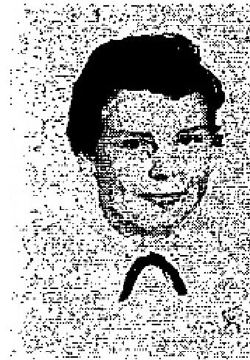
I praise my Saviour for - what He has done for me. I am thirteen years of age and had infected kidneys, diabetes, and my face was broken out in a very unsightly way, I seemed to be rotting away.
You prayed for me in your meeting in Philadelphia. On Tuesday, my face was much better and by Wednesday, after you had prayed, it seemed as if someone had taken their hand and wiped my face clean! You can see from my Picture (inset) how clear it is!

Before I was healed, as, I sat in church, my face would begin to drip with fluid as though someone had poured water on me.
I do thank my precious Saviour for this wonderful healing and for all He has done for me.
Since being healed I have given my heart to Jesus and find that by serving Him you not only feel better but get along better with others!
My sister, Grace, was the girl you prayed for who was healed of cancer of the throat.
Nancy Heisler
Wilmington, Delaware
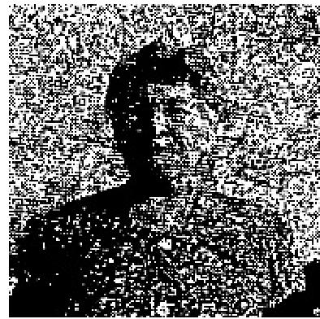
FORMERLY ENLARGED HEART IS NOW NORMAL
I suffered for ten or twelve years with an enlarged heart, with a tumor on it, I had been
in the hospital often.
and many times the doctor said that he did not think I would go home alive. My heart
was so enlarged, it seemed to fill my whole chest.
It was hard for me to bend over, I could not walk, lift, or carry anything, and spent
weeks at a time in bed.
When Rev. Stanley Karol came to Pound, Wisconsin, to hold meetings, on September
2, 1951, I went to his
services and he prayed for me. THE LORD HEALED MY HEART INSTANTLY. When I got home, I got
out of the car with my great granddaughter (one year old) asleep in my arms, walked up the step, and into
the house without choking. It seemed my chest was empty.
What a heavenly feeling! How I thank and Praise God for what He has done for me!
I can now walk up hill, carry things, dress myself and do not choke any more!

THE VOICE OF HEALING 1953
Mrs. Mattie Muzzy
Crivitz, Wisconsin
Dear Brother Karol: I AM STILL HEALED (March. 1953) and am praising God every day for healing and for sending you to Pound, Wisconsin.
I now arise early in the morning and work all day - until about 9 p.m., which I had not been able to do for
ten years.
Sister Mattie Muzzy
Crivitz, Wise.
VERIFICATION OF PASTOR - Reverend John Timms:
Dear Brother Karol:
I, Pastor John Timms, of Gillet, Wisc., would like to add a word of confirmation of Sister Muzzy's testimony, that she is feeling wonderfully well and is able to work hard.
I have known her for many years, and knew her heart condition before she was prayed for at the Pound meeting. I just happened to be at her house today, as she was writing you, and wanted to add this brief note. God bless you!
CRIPPLING ARTHRITIS HEALED  After reading a VOICE OF HEALING magazine which had been placed in my hands, I knew that it, was God's will that I be healed from arthritis in my hands, arms, neck and legs, I was the third person to whom that same copy of THE VOICE OF HEALING had been passed.  In it I read of Brother Karol's ministry, and prayed that God would make a way for me  to to his meeting.  God answered my prayer! | 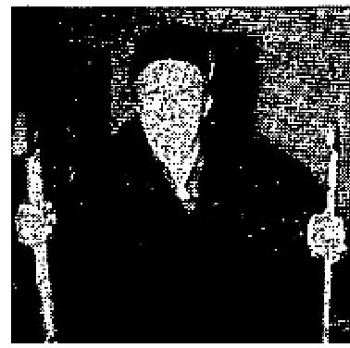

For nine years it been necessary for me to use a cane. For five years, I could not take a step without two canes. I suffered excruciating pain in my knees, hands and neck.
One Sunday night, I was permitted to go to the Faith Assembly of God in Hazelton, where Brother Karol was preaching, and I knew that God was going to heal me!
After singing the old time revival hymns which meant so much to me, praising and worshipping the Lord, Brother Karol spoke. He preached so simply, explaining so clearly that it is God's will for its lobe healed, and that we must step out in faith and accept it!
When Brother Karol prayed for me, I was able to walk for the first time in five years without my canes, ALL PAIN DISAPPEARED!
Mrs. B. F. Zimmerman,
Ringetown, Penna.
May 1953 p20
Ulcers Gone, Baby Healed
Although I am a Pentecostal minister, I was a bit skeptical of Brother Hayes' ministry. However, I got in the
healing line and Brother Hayes discerned and told me that I had ulcers of the stomach, which was true.

THE VOICE OF HEALING 1953
The Lord wonderfully healed me - and I can now eat anything I want to! I certainly thank God for healing me. My baby was also healed of Bright's disease in the healing line.
Rev: Dale Rollins
Grants Pass, Oregon
Delivered from Cigarette Habit
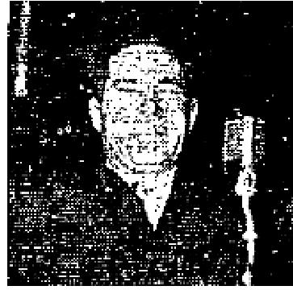
I had not been saved long and it seemed I could not give up cigarettes. When Brother
Hayes prayed for me, the Lord took the habit away immediately!
I was also healed of a hernia which I had for 32 years, and of ulcers, and heart trouble from which I had suffered since I was 14.
I praise and thank the Lord for healing and delivering me!
Arthur L. Morton
O'Brien. Oregon
Baby Heart Made Perfect
My baby is twenty-two months old and the doctors had told me she had not been normal since her birth.
The Lord revealed to Brother Hayes that she had been born with a weak heart. He prayed for her and THE LORD HEALED HER! This is the first time in her life she has ever had any color in her face. I am so happy and I praise God for it. I was healed, also, of female trouble.
Mrs. Agnes Gerkhe
Grants Pass, Oregon
Instant Triple Healing
Brother Hayes pointed me out in the audience and told me I had a very nervous condition, was near insanity, and that I could not sleep at night: also that I had Bright's disease and female trouble. This was true and the Lord healed me instantly!
Esther Snelling  Grants Pass, Ore.  Female Disorder Goes  BROTHER Hayes called me out of the audience and told me I had a bad nervous  disorder for 14 years.  That was true, because I had suffered from that trouble since I was a child. I had been under a doctor's care for a female disorder. infected ovaries, and Brother Hayes also discerned that. The Lord healed me and I praise Him for it. (See picture with husband and baby)  Louise Rollins (wife of Dale Rollins),  Grants Pass. Oregon | 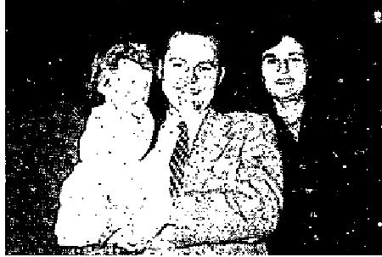

THE VOICE OF HEALING 1953  Diseases Reveled, Healed  On the second night of the meeting Brother Hayes held in Grants Pass, he pointed me out and told me the Lord had revealed to him that I had a serious infection in my kidneys, and that, for 11 years, I had suffered from a severe female disorder.  Everything he told me was true. When he told me that I was healed, THE PAIN LEFT IMMEDIATELY AND HAS NEVER COME BACK! Praise the Lord!  Florence Rudd,  Grants Pass, Oregon | 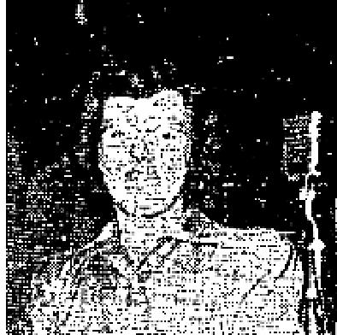

Delivered Completely
I praise the Lord for healing me. of a sore throat, when Brother Hayes prayed for me, also because the Lord set me free spiritually and gave me boldness to testify to others, on the job, street car, or I had the opportunity.
James McDowell.
Dallas, Texas
Cancer Now Gone  When Brother Hayes prayed for me. I was healed of cancer of the throat, and my  eyesight has been made perfect. Praise the Lord!  Leona Doney  Grants Pass, Oregon  Healed of T.B., Asthma  A YEAR ago (1952) when Brother Hayes was here, I was healed of T.B. and  asthma. I was able to go back to work immediately, to support my family.  I STILL HAVE MY HEALING TODAY! | 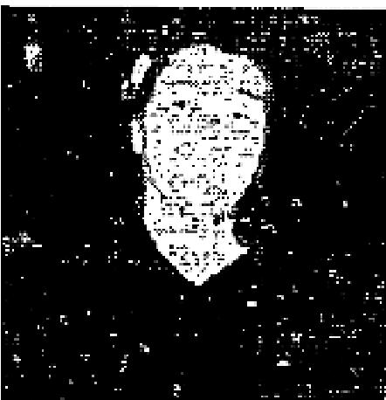

I had injured my back, and it was weak; therefore, I again entered Brother Hayes' healing line. That weakness was revealed to Brother Hayes and he told me what the Lord had shown him. He prayed for me and THE WEAKNESS LEFT COMPLETELY!
My two little boys were healed also, during the meeting in Grants Pass. Thank the Lord.
John Hopkins,
Sunny Valley, Oregon
June 1953 p18
HEALED OF T.B.
I was HEALED of T.B. while in the healing line in Wichita, Kansas, as Sister Fern prayed. I was hemorrhaging so, when she prayed for me, that my handkerchief vas full of blood, and I was so weak I could hardly stand.
As she prayed for me, it seemed that a hot streak penetrated my lungs and my whole body and it really burned like fire. By the time I reached my seat, I had become much stronger.
I wanted the people to know what God had done for me, so I returned to testify of my healing. I AM NOW SOUND AND WELL!

THE VOICE OF HEALING 1953
Sister Fern prayed for my eye too and can now see out of, it. I praise and thank the Lord for sending our dear Sister to Wichita.

Jessie Lindenman
Wichita, Kansas
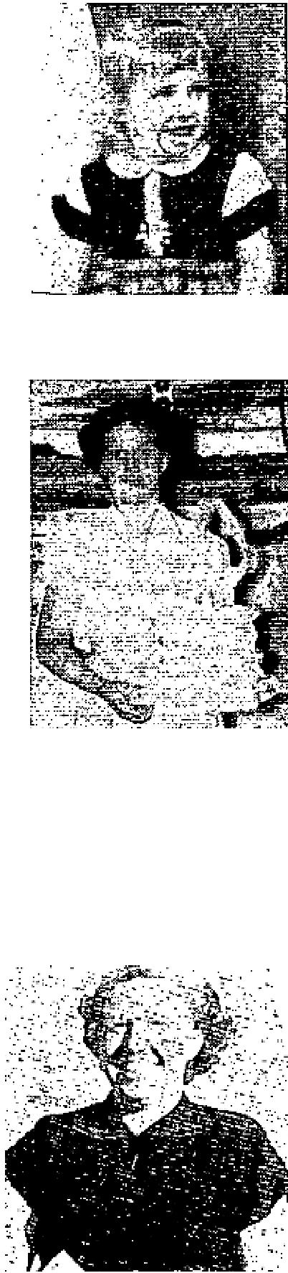
June 1953 p19
RUPTURE INSTANTLY HEALED
Judy McHenry, age three, suffering from a rupture about the size of a pullet egg, was taken to the Salvation Healing Campaign being conducted, at the First Assembly of God Church in Hutchinson, Kansas, by Evangelist Andrew S. Teuber. JUDY WAS INSTANTLY HEALED, as the Evangelist prayed for her, January 22, 1953.
Mrs. McHenry (Mother)
Hutchinson, Kansas
HEALED OF SPINAL CURVATURE
For five years I suffered with curvature of the spine to the extent that, when I would lean over to pick up anything. it was very hard for me to get back up again. Eventually, it was necessary for me to wear a large brace to support my back.
On February 12, 1952, I went to York, Nebraska, where Evangelist Andrew S. Teuber,
was conducting a
Salvation- Healing Revival, I was prayed for and instantly healed! Praise God!
I took the brace off and have never it since!
Helen J. Couch
Friend, Nebraska

RHEUMATIC ARTHRITIS GONE
When I was 14 years of age I had a spell of tonsilitis and had an abscess in my ear. The doctor lanced my ear. Soon I discovered I was completely deaf in that ear. I also was afflicted with colon trouble which caused a poison in my body culminating in rheumatic arthritis, We had spent large sums of money on doctors and medicine, seeking relief for my aching and crippled condition.
February 24, 1953, 1 attended the Salvation-Healing Campaign being conducted in my church, Central Assembly, Wichita, Kansas, by Evangelist Andrew S. Teuber. He prayed for me and I WAS INSTANTLY HEALED! I did not mention to the Evangelist that I was totally deaf in one ear but, when I got home, my
little girl three years of age wanted me to listen to her watch tick. She put it to my deaf ear and I started to tell her, "No honey, I can't hear out of that ear." Then I noticed the ticking, Praise God I could hear the little watch! I thank God. for this miracle of healing my body!
Mrs. Marcella Forbes
Wichita, Kansas
June 1953 p21

THE VOICE OF HEALING 1953
HEALED OF BROKEN NECK
Mathew Anderson, Mayo, Florida, suffered with a broken neck, and was forced to wear a brace support. Doctors told him he would have to wear the brace for many months to come. The moment Evangelist W. B. McKay laid hands on him and prayed for him, GOD HEALED HIM! He removed the brace right there, in the prayer line, and went on his way shouting the praises of God!
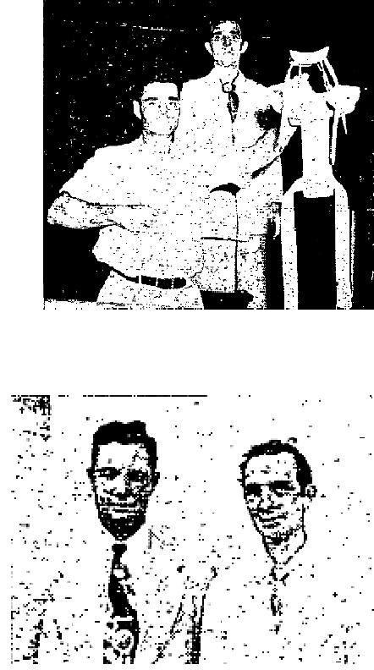
DEAF 21 YEARS - NOW HEALED
I was totally deaf in one ear for twenty-one (21) years. I learned about the great Gospel tent meeting in Branford Florida, being conducted by Evangelist W. B. McKay and decided to have him pray for my ear.
I went into the healing line, believing God for my healing and GOD HEALED ME INSTANTLY. I am a member of a Baptist church.

J. H. Mathis
Branford. Florida
EVANGELIST'S NOTE: Brother. Mathis is a business man in Branford, Manager of a Chain Store there.
After he was healed, he went everywhere telling what God had done for him.
W. B. McKay
STUTTERING GONE  Zack Meredith, Tallahassee, Fla., came to McKay Campaign with his father. He had been 'injured in an automobile wreck, in which his mother had been killed. Since the wreck, young Zack had had difficulty with his speech. He stuttered. As Evangelist McKay prayed for him, in the prayer line, GOD HEALED HIM and he spoke fluently, quoting scripture rapidly! | 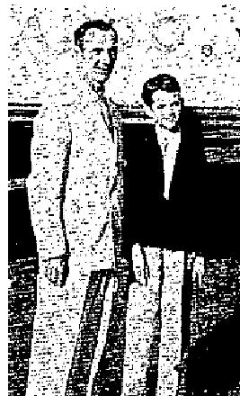

June 1953 p22
MEDICINE COULD NOT HEAL - GOD RESTORES HEALTH
Seven Doctors said medical science could not help me, that I would lose both legs. X-rays showed the veins
were filled with crystallized substance.
After having suffered five years with such untold agony, every bit of the pain left me the night Brother Litzman prayed for me. I have since been able to do my work, without pain, and can sleep at night!
Mrs. G. W. Ferrell
Hapeville, Georgia
VERIFIED BY: Rev. Jimmie Mayo, Pastor Atlanta, Georgia
INCURABLE HEART DISEASE HEALED THROUGH PRAYER
For six months I had gone to Grady Hospital, in Atlanta, for treatment in the Heart Clinic.
Six doctors said I had incurable heart disease, and would never be able to work again. They said, further, that I would not live unless I took the medicine they prescribed.
Before my appointment with another doctor they called in, I went to the meeting of Reverend Warren Litzman, and he prayed for me.

THE VOICE OF HEALING 1953
When I went for my examination from the doctor with whom I had the appointment, he examined me and asked why I was there. He then said there was nothing wrong with me and that he would discharge me, if my regular doctor would!
I have not taken any more medicine and feel no ill effects. I KNOW GOD HEALED ME!
The names of the doctors who treated me are: Dr. Hutchins, Dr. Huggins and Dr. Cooper, on the staff of the Grady. Hospital in Atlanta, Georgia.
L. L. Dupree
Atlanta, Georgia
June 1953 p23
HEALED OF RUPTURE THROUGH RADIO BROADCAST
Dear Brother Litzman,
For years I was ruptured, after having an operation in 1944. The doctor said another operation would be necessary, and that skin would have to be grafted on. He forbade me to do any kind of work. I decided to have the operation, but when the doctor told me how serious it was,. I decided not to have it.
When you were in Shreveport, I heard your broadcast over the radio and decided I would come to your meeting to be prayed for.
When you prayed for me, thank God. HE HEALED ME! I now do all my work, and am so happy I could trust God as my Healer!
Mrs. Thelma Ferguson
Princeton, Louisiana
STATEMENT OF PASTOR: "I affirm this statement is true."
Rev. Warren Dement.
Houghton, Louisiana
HEALED OF PHLEBITIS
Dear Brother Litzman:
When you came to Burkeville, Texas, in October, 1951, 1 had a terribly sore leg, caused from phlebitis.
On October 11, 1951, you laid hands on me and prayed for my leg. You told me then my healing would be gradual. I was completely healed within SIX WEEKS!
Nathaniel (Mickey) Williams
Newton, Texas
(Testimony written January, 1953)
WORE GLASSES 40 YEARS - NO LONGER NEEDED
I had trouble with my eyes and was always dizzy. An eye specialist told me I had a growth behind the eye,
which would eventually have to be removed. I had worn glasses for 40 years.
On March 4,3-952, I went to the American Legion Hut and had Evangelist Warren Litzman pray for me. GOD HEALED ME!
I no longer wear my glasses and the dizziness has gone! Thank the Lord for complete deliverance!

THE VOICE OF HEALING 1953
Mrs. W. M. French
Columbus, Kansas
HEALED OF STROKE AFTER PRAYER
I am past 76 years of age. Three years ago, I suffered a stroke and since then had been almost helpless.
I attended Brother Litzman's revival services, heard him preach and read his books on healing, then I went up for, healing. I had gotten so ill, I feared my mind was going,
When Brother Litzman prayed for me, I believed God, and HE HEALED ME! My mind is now sound, and I can walk without a cane! Praise God forever!

Joe Todd
Columbus, Kansas
June 1953 p24
Miraculous Healings Accompany WILBUR OGILVIE'S Ministry
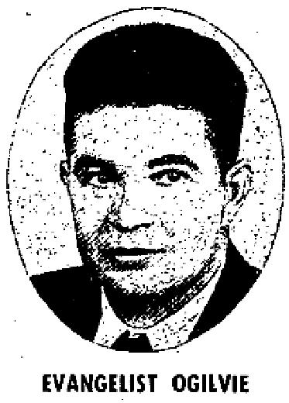
EVANGELIST WILBUR OGILVIE has been greatly used of the Lord bringing Bible deliverance to the people. Below are a number of typical testimonies received from his meetings
SAVED AND HEALED OF SINUS
Perhaps you don't know what it is to have your nose and ears plugged up, but I do.
And it was misery. Like many anxious parents, my folks took me to a doctor, trying to
find out what at was wrong. We ended up going to another doctor and finally two
specialists. All we were told was "Allergy: now we can not do too much for this. This
is a bad sinus district." Well to make a long story short, they did nothing that helped me.

Brother Ogilvie was holding a revival in our church. Each night as I saw him lay hands on the sick and I saw them receive healing, I thought, "Why can't the Lord heal me too?" I was prayed for and, immediately, my head was clear! I could breathe through my nose with ease! My ears felt literally unplugged!  I'm so glad Jesus healed my sinsick soul! And I'm ever so thankful that He also heals sick bodies!  Jean Klatt Thompson,  Mishawaka, Indiana. | 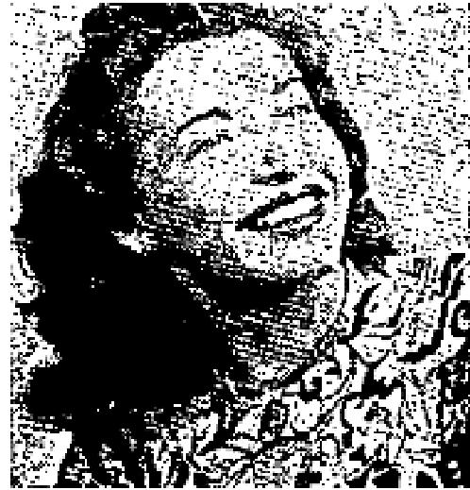

INTERNAL TROUBLE EASES AFTER EVANGELIST PRAYS  For years I suffered with a good sized lump in my right side. One doctor told me it was a floating kidney; another one said it was a growth of some kind which might later be a tumor or cancer.  I attended the healing meetings of Brother Ogilvie in1949, at Mishawaka, Indiana. The lump disappeared within three or four days, after he prayed for me!  I truly praise God for His great healing power! This healing still holds good today, February, 1953! | 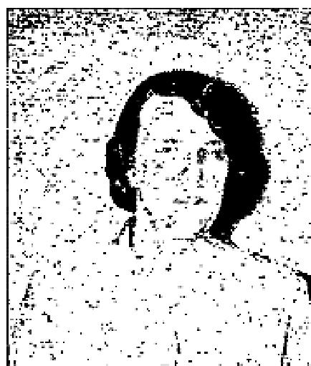

THE VOICE OF HEALING 1953
Mrs. Mary M. Britton,
Osceola, Indiana.
SLIPPED VERTEBRA STRAIGHTENS INSTANTLY!
I suffered from a slipped vertebra in my spine, which caused three inches difference in my height and very severe pain, also much difficulty in moving and sleeping.
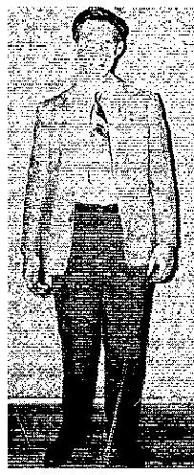
I attended the revival which Brother Ogilvie held in Mishawaka, and the Lord saved my sinsick soul and healed my body instantly! Truly I want to thank the Lord for His mercy and healing power, which He bestowed on me
Anthony C. Styles:
Mishawaka, Ind.

DELIVERED FROM STOMACH ULCERS - HEALING STILL STANDS!
I was afflicted about four years with bad stomach ulcers. Doctors said that I could not be cured, without an
operation.
In 1949, I heard of Brother Ogilvie's revival in our town, and went to see the miracles that the people were talking about. When I saw the great miracles God was performing, I decided to be prayed for. Brother Ogilvie prayed for me and INSTANTLY GOD HEALED ME! Four years later, at the writing of this testimony (February, 1953) my healing is still good!  I have never taken another dose of medicine. Praise the Lord!  Edgar R. Nichols  Mishawaka, Indiana. | 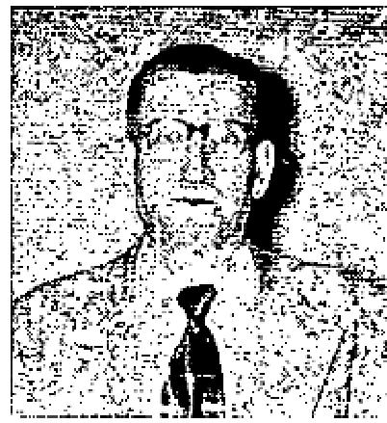
HEALED OF GALL BLADDER TROUBLE
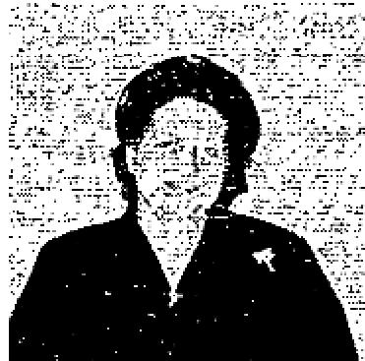
Three YEARS AGO, I came to Mishawaka for Brother Ogilvie's tent meeting. I came on a Friday night. The preceding Sunday, I had a gall bladder attack that put me in bed. The pain was terrific. It was worse than childbirth. I couldn't stand for a doctor to examine me. At the slightest touch I suffered unbearable pain.
I went to the revival on pillows, having told Brother Ogilvie my condition, he admonished me to believe God and give Him the thanks and the praise. He explained to me that a healing comes gradually; whereas, a miracle is instantaneous. Each day I improved and, within. one week, all pain was gone. I have never had gall bladder trouble since. Praise God!
Mrs. Theodore Harvey,
Michigan City, Indiana.
EYESIGHT RESTORED  Beinga member of a large household it falls my lot to do certain household chores; such as washing, ironing and hanging curtains. The latter I despise. One day I was driving a nail, to put up a curtain rod, and  my hammer slipped. The nail flew into my eye, leaving me totally blind. That necessitated an operation, which was unsuccessful. The doctors said they could operate again, but it was doubtful if I could ever see. | 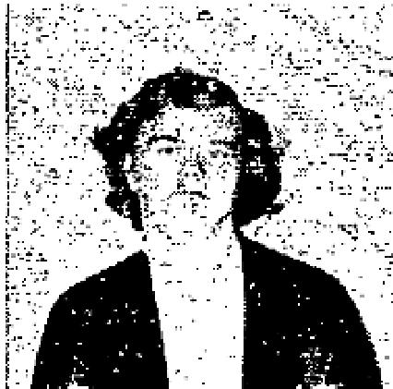
For one year, I saw out of one eye, but my good eye began to grow weak. Then
Brother Ogilvie held a revival in our church. I realized that, if God could heal my sin-sick soul, He surely

THE VOICE OF HEALING 1953
could heal my blind eye. Brother Ogilvie prayed for me and INSTANTLY I COULD SEE! My healing is thorough. I wear no glasses
and, several weeks later, at the writing of this testimony, I see clearly, I'm so thankful that we are serving the Great Physician!
Nancy Perkins, Age 17,
Osceola, Indiana.
June 1953 p25
PARALYSIS GONE AFTER PRAYER
I was afflicted with high blood pressure, which had caused me to become paralyzed on one side of my body. They sent me to the Wauchula Hospital in Florida in October, 1951, and again in February, 1952. However, I left the hospital still suffering severely and my blood pressure was over 300.
I heard of the Mastro Salvation-Healing Revival in Wauchula and resolved to attend it. My daughter-in-law assisted me into the large tent. I was suffering so severely I felt that I could not stand it any longer and would be forced to leave the service even before it began. word was sent to Brother Mastro of my suffering there in the tent. He came and prayed for me and immediately I felt the Healing power of Christ flow through my body. I instantly began to receive new strength and all the pain left my body. My heart, arm and leg are now perfectly well.
I was later examined by my physician, Dr. Collier of Wauchula, Florida. My blood pressure is now normal and I give God all the praise and glory for healing me.
Mrs. Mellie Segar, Gen. Delivery
Brownsville, Florida,
June 1953 p26
GOD STRAIGHTENS CROOKED FOOT
DEAR Brother Nunn:
On June 19,1949, I was in an airplane crash. I had several broken bones - one was a broken foot. The doctor did not put it in place; therefore it grew back so crooked, I could not put my foot down flat on the ground. I went to your meeting in San Benito, Texas, under the big tent. God spoke to me to have you pray for me. I obeyed His voice and had You pray. I was instantly and miracuously HEALED December 3. 1950. My foot is still straight. (April, 1953.)
Marie Case,
Corpus Christi, Texas.
DEAF 22 YEARS--NOW HEARS
Dear Brother Nunn:
I am so happy for all that Jesus has done for me. I had been deaf in my left ear for 22 years, caused from a mastoid operation! I had no ear drum and the bone was removed from behind my ear!
Therefore, there was nothing to hear with but, Praise the Lord, the night you prayed for me at Oxnard, JESUS PUT SOMETHING IN THERE FOR ME TO HEAR WITH, and I WAS ABLE TO HEAR-INSTANTLY AFTER YOU PRAYED!
I had another terrible malady of huge, red spots forming on my back and spreading all over my hips. Large knots would form, become filled with blood, and erupt. With that trouble, I always ran a high temperature

THE VOICE OF HEALING 1953
and suffered so severely. Since you prayed for me, the first of March (1952) all of that trouble has left me! THE LORD HAS COMPLETELY HEALED ME!
After that, I was afflicted with terrible headaches, and nausea, I had to begin wearing glasses the Doctor told me I would have to, wear them the rest of my life. One morning, as you prayed for the sick over the radio, I felt that, if I would remove my glasses and put my hands on the radio and pray with you. the Lord would heal me. I did just that and, Praise the Lord, HE HEALED ME AGAIN! I have not worn my glasses since, and can read all I want! I am so glad I trusted Him, for He never fails!
I thank the Lord, too, Brother Nunn, that He sent you to California for this great revival!
Mrs. R. B. Stone,
Santa Paula, Calif.
June 1953 p27
FACIAL PARALYSIS
CAROLYN MAE BROCK - who was healed of facial paralysis after Evangelist DAVID NUNN prayed for her. NOTICE her right eye (to your left) and her mouth. The eyelid would not close over the eye. The eyeball would turn up inside of her head and remain uncovered as she slept. Her mouth was paralyzed on one side and she could not smile evenly. Notice that dimples show on only one side of her mouth (before). In the second picture, (after) you can see the dimples on both sides of her face. She can now close both eyelids alike. READ TESTIMONY BY MOTHER BELOW, also verification by her Pastor, and Statement from Evangelist.
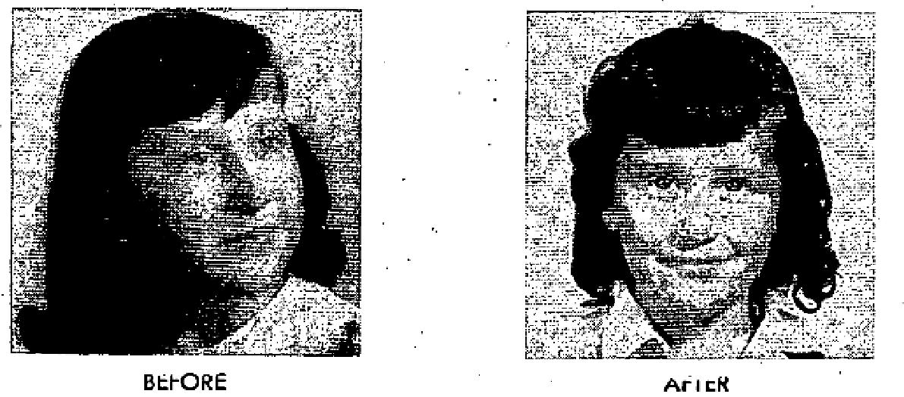
MY DAUGHTER, Carolyn Mae Brock, was paralyzed on her way to school by children tickling her. We took her to the doctor and he said that he would have her well in ten days. The doctor was not able to help her in weeks.
Finally, I decided to trust God. In August, 1949, on a Friday night, Evangelist David Nunn anointed her and prayed for her. In ten days, God did what the doctor could not do; she was made completely whole! (See pictures on this page showing Carolyn Mae before she was healed, and one year after she was healed!)
Mr. and Mrs. L. B. Brock,
Dallas, Texas.
Verification by Pastor:
"I was pastor of Carolyn Mae Brock, when she was paralyzed by children tickling her on her way to school. For two months or longer, she was paralyzed. Within ten days, after Bro. Nunn prayed for her, she was completely well."
Rev. A. T. Nelson, Pastor, Little Bethel Assembly of God.

THE VOICE OF HEALING 1953
Statement by Evangelist:
Carolyn Mae's mother and sister recently gave me a new picture of her, and again confirmed that she IS
COMPLETELY HEALED! No trace of the paralysis is left!
David Nunn.  GOD HEALED ME OF HEART TROUBLE  I was born with heart trouble. The doctor said "If he doesn't outgrow it by the time  he is 18 he will not live long." I am now 22.  Last year two doctors examined me and told me I still had the heart trouble. I could not work without becoming very weak and nervous.  One night, in the Cleburne revival, you called out those. that had heart trouble. I came and WAS INSTANTLY HEALED! I worked hard the next day and picked over 300 pounds of cotton, and was not  the least bit weak or nervous, for the first time. | 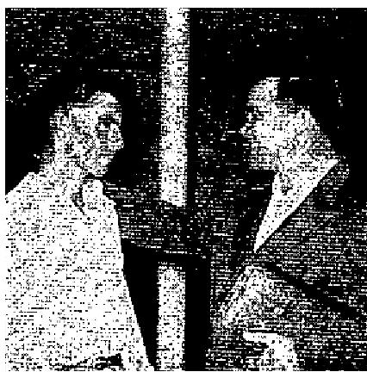

I was examined the following Saturday by a doctor, and was pronounced well! Thank God for healing me. I praise Him for this miracle.
Dean Adams,
Cleburne, Texas.
APPENDIX ATTACK HEALED THROUGH RADIO PRAYER
Dear Brother Nunn:
I want to thank God for healing my body. The Sunday night you closed your meeting in Ventura, California, I had a terrible attack of appendicitis.
I suffered all night long, and could not sleep. I tried to stay on the bed, but the pain got so severe I could not stand it, then I would get on the floor. I had to press my legs against my stomach to get any relief.
Thank God! Brother Nunn, when your broadcast came on at 9:15 on the morning of March 31, 1952, I heard the people testify of what great things the Lord had done for them, and my faith was quickened. I could feel the very power of God in my room! I got up from my bed and got into the kitchen the best I could. I walked some and had to crawl some, for the pain was so intense.
Brother Nunn, when you started praying for the sick, over the radio, you told us to put our hands on the radio and believe God and that God was going to heal us. I praise the Lord that, when you rebuked that sickness and commanded us to be well, then told us to stand upright on our feet, the Lord touched me and the PAIN LEFT INSTANTLY AND I STOOD and praised God for His wonderful healing power!
I want to thank the Lord because He is so wonderful and for His great power!
Emanuel Quanilla,
Santa Paula, Calif.
June 1953 p28
BEDFAST 18 MONTHS - WALKED IMMEDIATELY
My husband was bedfast 18 months with rheumatoid arthritis, heart trouble, and hardening of the arteries.
For 18 months, I attended him day and night. Doctors said that his age (79 years) was against him.

THE VOICE OF HEALING 1953

However, when he heard what was happening at the Allen revival, he had faith to believe that it he could get to the tent God would heal him. He was carried to the afternoon service on a stretcher, in an ambulance.
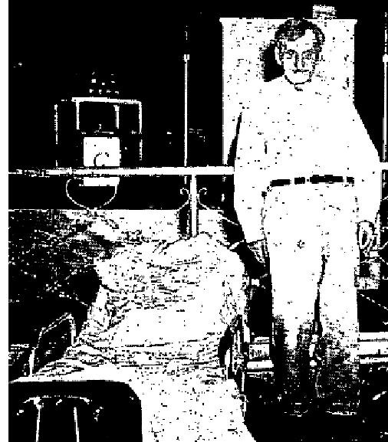
Brother Allen came off the platform to where my husband lay and said, "In the name of Jesus, I command you to arise and walk." Immediately my husband turned around and sat up On the side of the stretcher, then arose to his feet. He began to walk, a little feebly at first but, as new strength came. to him, he walked faster and faster. HE IS COMPLETELY HEALED!
Mrs. J. F. Larry
Houston, Texas

Evangelist's Note:
The following night, Brother and Sister Larry were back in the service again. Brother Larry declared, "I'm going to hear Brother Allen preach, if I have to live on one meal a day and save my money for bus fare!" A. A. ALLEN
July 1953 p9
FRACTURED ARM, HIP HEALED THROUGH ANOINTED CLOTH
DEAR TVH Editors:
I thank you for praying for me and for the anointed cloth.
THE LORD HAS HEALED ME! My hip and arm were fractured, but they are now completely well. I can walk one and one-half miles to my mail box now, without any pain in my hip whatever.
I thank our Lord for this, and all of the dear brothers and sisters in Christ, who prayed for me. I enjoy THE VOICE OF HEALING very much!
Amy Hughes
Baldwin, Michigan
BRONCHIAL TROUBLE GOES AS PRAYER CLOTH APPLIED
DEAR TVH Editors:
I praise the Lord for healing my baby of bronchial trouble, after I applied your anointed cloth to his ear.
He was in much pain and was running a high temperature but, within a few hours, after I applied the cloth and prayed for him, all the fever and pain left him, and he has had no trouble since.
I thank you for your prayers. and for the anointed cloth. I enjoy reading your magazine, THE VOICE OF HEALING.
May God bless you all!
Mrs. Tarka
Lancaster, Pennsylvania
July 1953 p12
1. TEETH ENAMEL RESTORED - Adolf Strof, Jr. (Evangelist W. V. Grant)

THE VOICE OF HEALING 1953
Statement from Parents;
Our 4.5-year-old boy has never had any solid upper teeth, caused from malnutrition, as we have just come from Germany. The gums were pushed back all across, and his teeth were black.
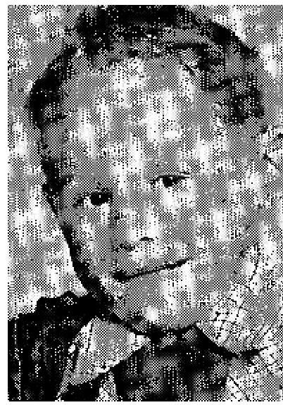
We attended the Grant Deliverance Revival in Bethel Temple in Seattle, Washington, and had him prayed for; my wife and I both gave ourselves to God. I was delivered from cigarettes.
The next day the old black tartar came off his teeth. New White has been coming in very rapidly. We went back and showed the Congregation within one week what God had done.
We, mother and father, were converted. One was a Lutheran and the other a Catholic.
Signed: Adolf Strof
Seattle. Washington
Statement from Physician:
TO WHOM IT MAY CONCERN: I examined Adolph Strof, Jr., 4.5 years old, on the
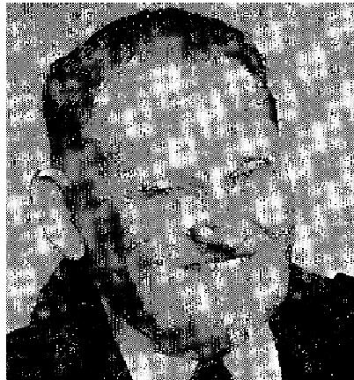
first of April, 1952, and found his physical condition to be as follows:
He was undernourished, and the bone construction was under-developed and lacking in calcium, the necessary material for the formation of healthy teeth. All of his teeth at the time of examination were soft, black, and rotten. The child had but recently been brought to America from Germany, where it was impossible at that time to secure the proper food.

On the sixteenth of April, 1952. he was prayed for by Rev. W. V. Grant, who was holding a healing campaign at Bethel Temple in Seattle. On the nineteenth of the same month, after another examinatio, I FOUND THAT ALL TEETH WERE COVERED WITH A NEW ENAMEL, PERFECTLY WHITE AND NORMAL IN EVERY RESPECT!
Signed: W. L. Martin, San. Physician, 17704 15th N.E., Seattle 55, Wash.
Subscribed and sworn to before me this 28th day of April, 1952. My commission expires December 6, 1954. C. H. CASE, Notary Public in and for the STATE OF WASHINGTON.
This miraculous testimony of healing was questioned by several people in Malvern, Arkansas, and one Baptist minister wrote Dr. Martin, asking for a confirmation of the healing, to which he made the following reply:
17704 15th Ave., N.W.
Seattle, Washington
July 30, 1952
Dear Reverend :
"RE: The healing of 4.5 year old boy, ADOLF STROF.
I am back from a trip East and do hasten to answer your letter of inquiry dated July 15, 1952.

THE VOICE OF HEALING 1953
Yes, I am a sanipractice physician, duly licensed to practice under the provisions of the laws of the State of Washington.
I have also given the above mentioned sworn affidavit to the fact that the little 4.5 year old boy, Adolf Strof, had the decayed teeth caused by lack of sufficient food in Germany.
It is also true that I was an infidel and preached for years that there was no God, and could prove it by juggling the true Bible record. It is also true that in 1905 God personally spoke to me. I sought forgiveness of sins and he graciously granted me salvation. Ever since that time I have served, and am serving, a living God, Who not only was present at Reverend Grant's meeting here in Seattle, but Who healed the boy. restored his teeth, and gave us an actual manifestation of His divine presence endorsing thereby His promises in the Bible. It is also true that we have many witnesses living right here who can testify to the above mentioned facts.
Yours in His Name,
Signed: W. L. Martin
San. Physician"
Evangelist: May 5. 1953
I recently talked with the family of this child, Dr. Martin and others in Seattle, and they told me little Adolph
Strof's teeth are still healed, his physical condition is fine and that everyone there is still thrilled over what
God has done on his behalf.
W. V. GRANT
2. HEALED OF CANCER - Florence Roberts (Evangelist Louise Nankivell)  Dear SISTER Nankivell: I thank the Lord for healing me of cancer during the revival you held for us in San Francisco, California. This was during your meeting at Glad Tidings Temple, January 18 to February 1953.  I had suffered for 27 months from an intestinal cancer. The Precious Lord touched my body while standing by my seat, during that part of your service when you "bind and cast out any and all infirmities of the body" through your prayer and special ministry given you by our Lord Jesus. My healing occurred on the opening night of your meeting! | 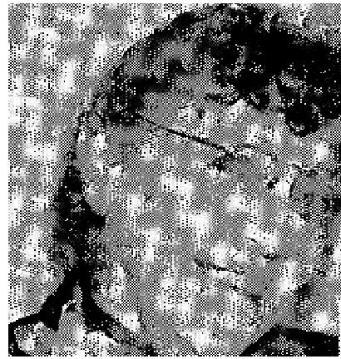

I praise the Lord that you had sufficient power with God because of your deeply consecrated walk with Him, to effect this mighty miracle without laying your hands on my body!
That cancer monstrosity actually slipped from my body on the same night I mentioned. Jesus of Nazareth operated, while I slept so deeply that I did not even suffer through it! Oh, Praise His Holy Name, for ever and ever!
Proof of this testimony, and any information desired concerning it, will be sent to anyone on request, (If requesting such information please send Mrs. Roberts return postage-TVH)
Mrs. Florence Roberts
562 Hayes St. Apt. 7
San Francisco 2, Calif.
Verified by Pastor: Rev. L. Keys, San Francisco, California

THE VOICE OF HEALING 1953
CONFIRMATION - TO EDITOR, MAY 29, 1953
"I hereby certify that my testimony of "A MIRACLE HEALING FROM CANCER" sent to Sister Louise
Nankivell, is true and that It still holds good! I am also sending you my photograph herewith.
I wish to state definitely that a real miracle of God was performed in my body on the night of January 18-19, at 1:05 a.m.
I had retired at 12:05 a.m., after our church services, and had been asleep just one hour. When awakened, I discovered the cancer in my bed, on the sheet together with a mass of spongy matter and much blood which had passed from my body. The odor, so horrible, was like that of a decayed corpse. It was nauseating.
Jesus truly performed an operation on my body while I slept, and NOW I AM COMPLETELY HEALED! I had lost 23 pounds but have gained that back. I was starved for food. All those twenty-seven months, I could eat only soft food. Now I am eating real beef, lamb, eggs, fruit and vegetables. Oh. truly I can say, LET ALL THE EARTH PRAISE GOD!
Signed: Florence L. Roberts, San Francisco. Calif
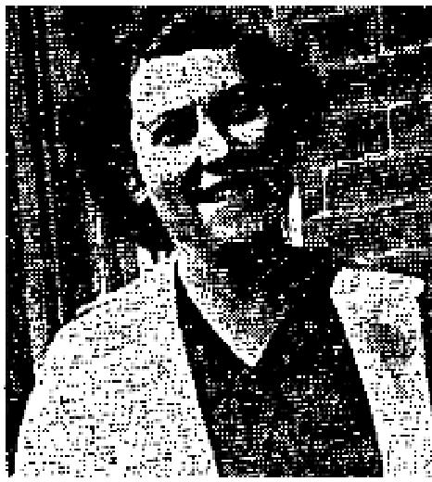
July 1953 p15
BACK INJURY DISCERNED - HEALED!
On the third night of our recent campaign with Bro. Alton, Hayes, I received
a wonderful healing from the Lord. Bro. Hayes was praying for the sick, when he suddenly swung round saying that the Lord had shown him that someone on the platform behind him had a need. He pointed to me and told me that I had been suffering from a soreness in my back, just at the base of the spine. for some months. This was perfectly true, and was known only to myself, my husband and the Lord.
Bro. Hayes commanded me to stand up and take the healing. In view of the marvelous way the Lord had revealed this trouble to Bro. Hayes, it was easy for faith to arise. and my healing was instantaneous. This trouble that I had had for seven months, ever since the birth of our last child, has not bothered me for one moment since that night! Glory to God!
Olive M. Whyte (Mrs.)
Toronto, Ont., Can.
July 1953 p16
"I was Paralyzed - Now I Can Walk!”
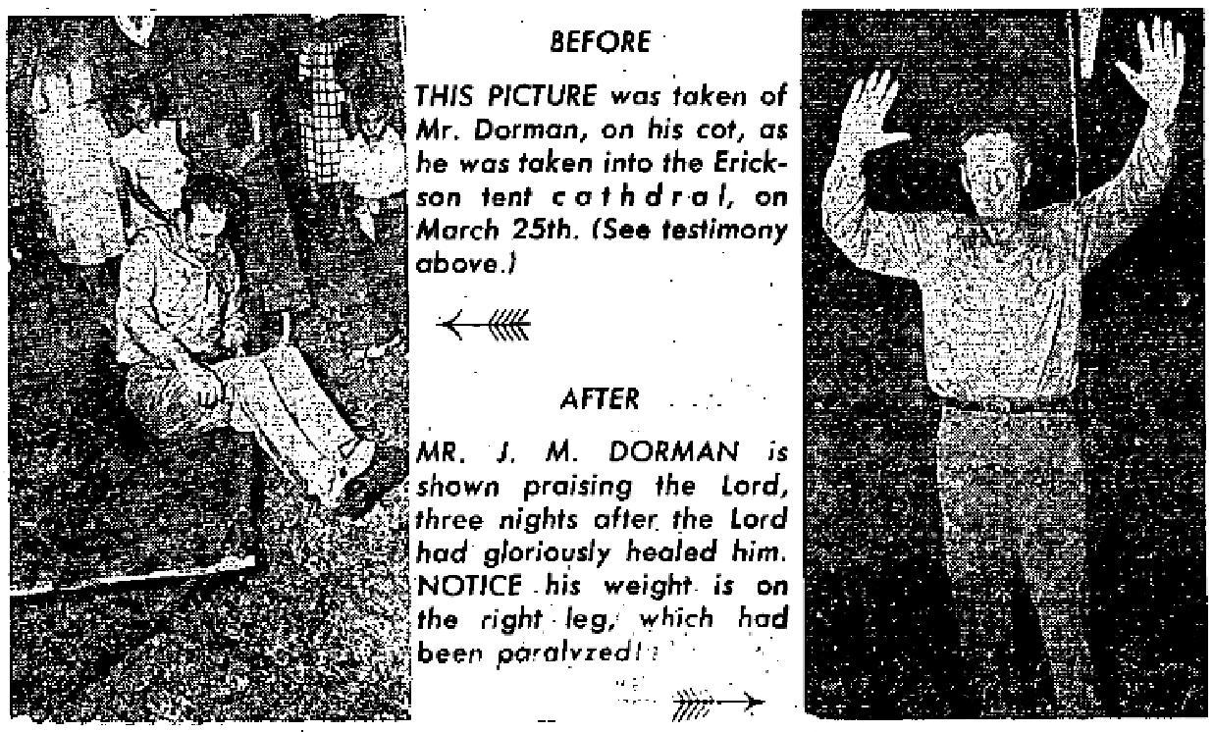

THE VOICE OF HEALING 1953
Dear Brother ERICKSON: Since 1948, I have suffered a series of heart attacks, On the 17th of March (195,3) 1 had a stroke and cerebral hemorrhage, which rendered me an invalid. My right side was paralyzed, my right eye was blinded and I was left with a speech impediment!
On March 25,.1953, when you prayed for me, as I lay on my cot in your tent cathedral, the power of God immediately filled my body and I WAS ABLE TO RISE FROM MY COT AND WALK!
Saturday, May 2. 1953, 1 again went to the doctor for a check-up and he confirmed the fact (which I already knew), by electrocardiogram, that my heart is better now than it has been in years. I am also now able to see out of my right eye! Each day I walk better!
J. M.. Dorman  Port Arthur, Texas  July 1953 p18  HERNIA MIRACULOUSLY HEALED  I had SECURED a new job in Toledo, Ohio, requiring that I take a physical  examination; during which the Company Doctor told me I had a hernia, This caused  me to lose my job.  I had been attending the Hill-Bradshaw Revival Campaign and, after the night the doctor told me of my condition the Lord revealed through Brother Roy Hill exactly what the doctor had told me! | 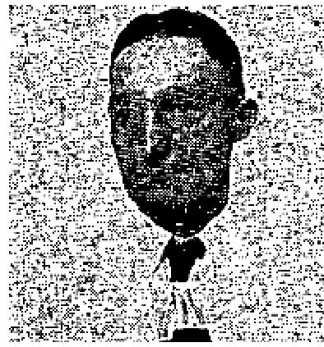

Brother Hill pointed me out in the audience and told me what the Lord revealed to him, and asked if it was true. Oh, Praise the Lord, I WAS HEALED!
When I sought employment elsewhere. I had to take another physical examination. That time the examining doctor found nothing wrong with me! Thank the Lord!
Arthur DePew
Toledo, Ohio
Verified by Pastor,
Rev. T. H.Staton,
Open Bible Church, Toledo.
BURST EAR-DRUM INSTANTLY HEALED!  I had a burst ear-drum, from which I had suffered much excruciating pain. During the  great Hill - Bradshaw  Salvation Divine - healing Campaign conducted in Mansfield, Ohio, Brother Roy Hill  prayed for me.  GOD INSTANTLY HEALED ME! I can now hear perfectly out of that ear! Thank God!  Mrs. Mabel Harmon  Sullivan, Indiana  Verified by:  Evangelists Roy Hill and Herb Bradshaw | 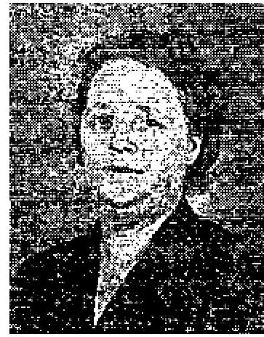

THE VOICE OF HEALING 1953
July 1953 p19
GOD INSTANTLY STRAIGHTENED BABYS FEET AND LEGS
Our little daughter two years old, had never been able to walk without failing down because, from birth,
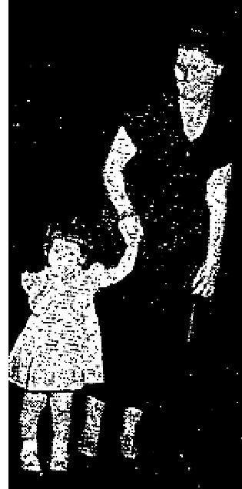
her feet and legs were deformed and crooked. The doctor said the, only way her limbs could be helped would be to break them and put them in a cast, then let them grow back straight.
However, I took her to the A. A. Allen revival in Beaumont, Texas, and Brother Allen prayed for her. Instantly, God straightened her feet and legs, so that she could walk immediately! Praise God, she is perfectly healed!
Mrs. Arthur Jones
Port Arthur, Tex.
July 1953 p19
3. RAISED FROM DEATH BED - RHEUMATIC FEVER - Gayl Wickham (Evangelist Alton Hayes)
FROM THE GRANTS PASS COURIER, FRIDAY, FEB. 27, 1953 (CHURCH PAGE)

LOCAL GIRL REPORTED CURED THROUGH PRAYER
"The amazing rapid recovery of an eleven-year-old girl from a combination of ailments through mass prayer by members of her family's religious faith, is being claimed by her parents, Mr. and Mrs. Jesse H. Wickham, Box 81B, Murphy Stage Road. "The child, Gayle Wickham, after coping with rheumatic fever for four years, neuritis for three months, and more lately, St. Vitus dance, her parents said, was hospitalized February 3rd.
"Three days later, with Mrs. Owen T. Fanning, 1449 Highway 199, praying at the patient's bedside, and a number of others, by arrangement, praying in their homes at the same time, the child declared that her neuritic pains had disappeared.  "A short time later, a visiting evangelist, Alton L. Hayes of Dallas, Texas, offered prayer at her bedside, and two days later, the child was sufficiently recovered to be released from the hospital.  "The attending physician told the Daily Courier that, following an examination of Gayle yesterday, he was prepared to say that she had shown 100 per cent improvement. | 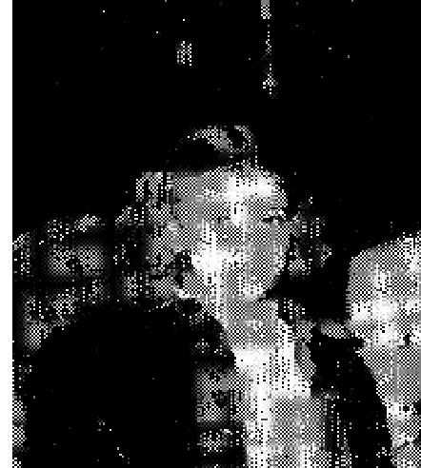

"The family belongs. to the Assembly of God church, which maintains a tabernacle at Oregon and A Streets."
Testimony from parents: OUR LITTLE GIRL is eleven years old. She has been ill the greater part of her life, suffering from allergies and other ailments.
Four years ago she became ill with rheumatic fever and was placed under a doctor's care. She was never able to go to school a full term without being absent so much she could barely pass her grades. Last year she was sick so much she did not pass.
We started her in another school this year, still under the doctor's care, and she seemed to be doing fine, when suddenly her legs began troubling her. She began dragging her right leg, then had to walk with crutches. At times, she could use neither leg. Her right leg became so sore she could not bear for anyone to

THE VOICE OF HEALING 1953
touch it. Her right foot then began to draw and the leg would draw backwards until, her foot was under her arm.
Another spasm of pain would come and her leg would draw forward until it would be over her shoulder. The Pain would become so terrific, she would pass out! We, of course, would then call the doctor. He came and only gave her a sedative and left some for us to give her when she had another spell. The spells then began to come more often, and we were forced to take her to the hospital, for she was more dead than alive.
We were desperate and sought God's help. We called Sister Fanning, a Christian worker we knew to have much success in praying for the sick. She, in turn, called other Christian workers to pray with her for our little girl. When Sister Fanning went to the hospital and prayed for our daughter, the Lord did definitely touch her body, and she began feeling better.
We were negotiating to get her into the Shrine Hospital in Portland, Oregon, as the doctors said she must have a specialist's care for some time to come!
Therefore, we were sent to a man who was to make the arrangements for us to take her there. He asked us if we believed in prayer. We told him that, we did, He then told us about Brother Alton Hayes, and said that he would bring him to the hospital to pray for Gayl.
We were at the hospital promptly at 2.00 o'clock that day. Brother Pete Fredrickson and Brother Alton Hayes, and his father, came in as promised. Our little girl was dying by that time. Her eyes were nearly closed and were becoming glazed over, as in death! My wife shook her several times and called her name but she did not respond.
At that time, Brother Hayes stepped up to the bed and said, "I want to pray for her now." He rebuked the devil and commanded him to loose his hold on her, "in the Name of Jesus." Praise God, she came back to life with a big yawn and the sweetest smile. In less than a minute she was sitting up, laughing and talking with us!
The next evening, before going to the hospital, my wife and I were praying and we made a vow unto God. That was at exactly 6:30 P.M. At that very moment, Jesus appeared to our little girl and, at first, she was frightened but soon regained her composure and said, "Who are you?" He replied, "I am Jesus. I have come to heal your body. You will have no more hurts nor pains." He then disappeared.
She felt of her leg, and surprisingly thought, "Can it be?" However, she found no soreness or pain. She kicked it against the bed and still felt no pain.
The doctor came to see her the next morning and said he could find no symptoms at all! He, therefore, released her from the hospital, so she could go give her testimony at the tabernacle, which she did, giving all the glory to God! She was up until 1 o'clock A.M., without any ill effects.
She is now walking everywhere, and is perfectly normal again! Praise God!
Mr. and Mrs. Jesse H. Wickham
Grants Pass, Oregon
August 1953 p19
MINISTER'S DAUGHTER HEALED OF POLIO!
Our little eight year old daughter was suddenly stricken with polio. She lost control of her right leg, as it
became paralyzed. She could not even walk.

THE VOICE OF HEALING 1953
We carried her to tile Alien revival, and Brother Allen cursed the spirit of infirmity, commanding it to go. God healed her immediately! We put her down on her feet, and immediately she could walk perfectly!
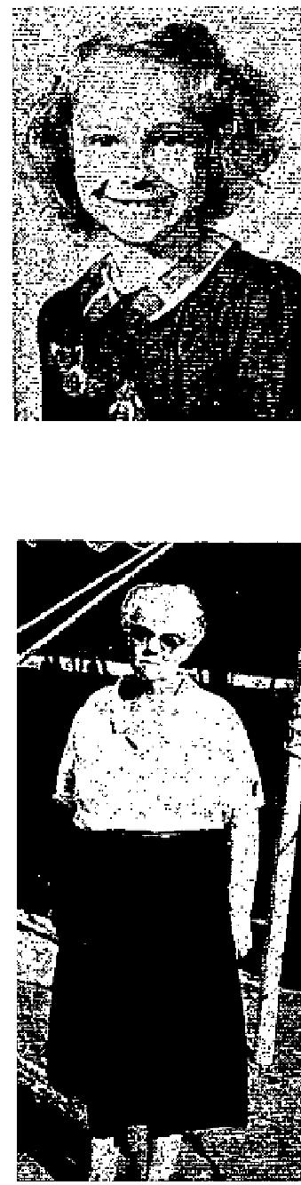
SHE DOESN'T EVEN LIMP OR SHOW ANY SIGN OF BEING CRIPPLED!
Rev. and Mrs. M. W. Stackpole
Warren. Texas
August 1953 p20
VERTEBRA RESTORED AFTER REV. ALLEN PRAYED
On November, 1952, I went to a clinic for examination. I weighed 248 pounds and was crippled in my hips and legs,so that I could walk only a little about the house. Doctors at the clinic agreed that I must lose weight immediately, or else my heart would stop or my right leg burst. They put me on a very strict diet.
In April, after, losing 55 pounds, my hip was no better, but worse. At this time, the doctor took X-rays and informed me that the spine was fused onto the hip bone and that, if I ever was any better, it would have to be through God's power, there was nothing more that man could do.
When I read in the VOICE OF HEALING that A. A. Allen was coming to Terre Haute, I determined to go there, I returned to the doctor and asked to see the X-ray. The doctor showed me on the X-ray that one vertebra was COMPLETELY GONE.

June 14, A. A. Allen prayed for me, and I knew immediately something had happened! I returned to the clinic for another X-ray, Both my husband and I saw the two X-rays together. 'ME VERTEBRA HAD BEEN COMPLETELY RESTORED and the doctor declared that I had an almost perfect spine!
Mrs. Tressie Adams
Shelburn, Ind.
"I know this testimony to be true."
Mrs. Zola Willis, Daughter of Mrs. Adams
August 1953 p23
DEAF EIGHT YEARS - HEARING RESTORED!
I want to testify to the Lord's healing power. I was deaf in my right ear for eight years. I went to specialists
and later had hearing tests. Nothing could help as they told me the nerve was dead.
On May 28th, 1953, Brother Russell Park prayed for me and my hearing was restored! I thank and Praise my wonderful Lord for healing me!
Mrs. Lena Hanninen
Iron River, Michigan
FROM THE IRON RIVER REPORTER
(Monday, May 25, 1953)
Polio Victim Drops Crutches, Pastor Reports

THE VOICE OF HEALING 1953
A child crippled two years ago by polio dropped her crutches and began to walk unassisted last week at the Iron River Assembly of God church during a salvation and faith healing service conducted by a southern evangelist, it was reported today by the pastor of the church, Rev. Howard L. Moody,
He identified the child as the eight-year-old daughter of a Trout Creek widow, Mrs. Claude Cootware. The evangelist, Rev. Russell Park, encouraged the girl to walk without her crutches. She did so and followed him as he walked down the aisle and circled the interior of the church which was filled with 200 persons, Rev. Moody said.
"Has this little girl been able to walk without her crutches?" Rev. Park inquired of the mother. "Not more than a step or two," answered the mother.
The pastor said the Cootware girl left her crutches behind her in the church as a testimonial of the power of faith to heal at the services which Rev. Park is conducting nightly at 7.,30 p.m. Rev. and Mrs. Park are staying at a Hagerman lake cottage secured for them by Rev. Moody.

September 1953 p9
MASTOID TROUBLE VANISHES
Dear TVH Editors:
I want to tell you about the healing of my little friend, Shirley Reeves (13 years of
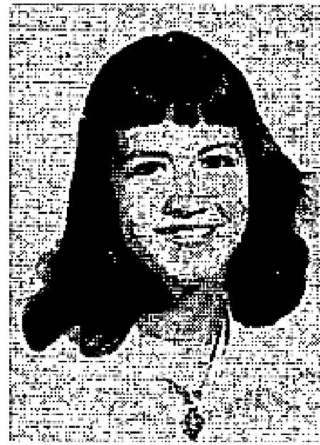
age), through your healing cloth service.
Last winter I wrote to you for an anointed cloth for her. She had mastoid trouble; from which she had suffered greatly, necessitating several operations.
The doctors had told her that she would it never get well. There was a drainage hole
behind her ear from
which pus ran continually.
After I received the prayer cloth from you, we prayed and pinned the cloth on her
body. SHE IS NOW
HEALED, and has had no further trouble since receiving the anointed cloth.
Mrs. Donald Miles
Catlettsburg, Ky.
INFECTED THUMB HEALED THROUGH ANOINTED HANDKERCHIEF DEAR TVH Editors:

I praise the Lord for healing an in-grown nail and a seriously infected thumb, on my left hand, after I applied the anointed handkerchief I received from you!
I do thank you for praying for me, and I greatly appreciate your ministry and THE VOICE OF HEALING magazine.
May God bless you mightily!
Your Brother in Christ.
W. M. Smith, Atmore, Alabama
CANCER EXPELLED AFTER ANOINTED CLOTH APPLIED
Dear TVH Editors:

THE VOICE OF HEALING 1953
I must write you to tell you that I am now healed of cancer - since I got the anointed cloth from you and used it as I was directed!
The cancer came out through my mouth. Praise the Lord! I truly thank God for His wonderful healing power and I thank you and Brother Hall and the others for your prayers. I give God all the honor and praise for His wonderful works toward the children of men!
Yours in Christ,
Minnie Campbell, Crystal Springs, Arkansas
MULTIPLE AILMENTS GO WHEN PRAYER CLOTH APPLIED
DEAR TVH Editors:
I wrote you for prayer and an anointed cloth; therefore, I feet that I should write and thank you for your prayers and tell you that THE LORD HAS HEALED ME!
I suffered severely from high blood pressure, rheumatism, indigestion and nervousness. I praise the Lord that I am healed and I do appreciate your prayers for me.
Mrs. Lula Adams
Chandler, Oklahoma
September 1953 p15
DIABETES AND SPINAL INJURY HEALED THROUGH PRAYER
Dear Brother Mastro:
I want to thank the Lord for healing my body when you prayed for me, in Miami, Florida. I had sugar diabetes and also, a vertebra had slipped in my back. I was unable to move my spine. My daughter asked you to pray for me one night, because I was unable to even attend your service. I WAS HEALED INSTANTLY - WHILE SITTING IN A CHAIR AT HOME!
You my use this letter as a testimony to help others, if you wish, for I am not ashamed to witness to God's power!
I thank the Lord for your ministry and thank you for your prayers. May God bless you!

Mrs. Q. N. Chapman,
Miami, Florida.
GOD HEALS CHILD OF DEAFNESS
We praise God and give Him the glory for healing our young son Luigi of deafness. He
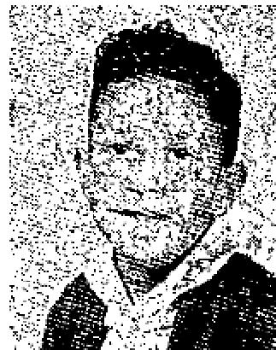
had been unable to
hear in his right ear for one and one-half years. The doctor removed his tonsils and
adenoids but it didn't
help his hearing.
We heard of the Salvation - Divine-Healing Campaign being conducted in Salinas, California, by Evangelist Michael Mastro and attended the meeting.

We took our son to be prayed for. After Evangelist Mastro prayed for him, HE IMMEDIATELY RECEIVED HIS HEARING and has had no trouble since. HE NOW HEARS PERFECTLY! Thank God!

THE VOICE OF HEALING 1953
Mrs. Audra Favera
Castroville, Calif.
Witnessed by:
Pastor Ray C. Kelly
HEART TROUBLE IS GONE SINCE EVANGELIST PRAYED
Dear Brother Mastro:
I had suffered from leakage of the heart since I was two years old I had to take two nitro-glycerin tablets and
one strychnine tablet daily. The doctors had said there was no hope for me.
You prayed for me in your Carrollton-Dallas meeting In January and THE LORD PERFECTLY HEALED ME! I am now enjoying good health, How I praise the name of Jesus, our Saviour and Healer, and I thank you for praying for me.
My doctor's name is Dr. W. O. Wagner of Carrollton, Texas.,
Mrs. Oleta Jones,
Carrollton, Texas.
HEALED OF FLOATING KIDNEY AFTER PRAYER
About 18 years ago I was injured over the right kidney playing football. Army doctors verified the injury
and said I had a floating kidney.
In July 21, 1953, I attended the Healing campaign conducted by Evangelist M. Mastro in Salinas,
California. My affliction was discerned by Brother Mastro, through the Holy Spirit, and I was healed. Praise God!
Glenn E. O'Brien
Orofino, Idaho
Witnessed by:
Pastor Ray C. Kelly
September 1953 p16
AFFLICTED SINCE BABYHOOD WITH POLIO - NOW HEALED. FRIEND'S STAMMERING HEALED
Dear Brother Hardt:
Do you remember me from the Ottawa campaign in November? I was the "polio" chap with the cane who,
with my wife, sang a duet.
I want to send a word of testimony to help others build their faith in God for healing.
The very next day, after you prayed for me, I was able to move my whole right foot up and down. This I have not been able to do since a baby. I am now forty years old. I have a quickening in my body and strength that I have not enjoyed since. I was fifteen years old. Oh, I can't praise God enough for saving my soul just six months ago, for healing my body of polio, and also of a kidney condition. That is all gone now, PRAISE HIS HOLY NAME!
My friend for whom you also prayed, who was afflicted with, a stammering tongue, is also completely delivered. Thanks for coming to Ottawa, I pray for your healing ministry continually.

THE VOICE OF HEALING 1953
Yours in Christ,
Mal Covell, The Jeweler,
Carlton Place, Ont., Can.
YOUNGSTOWN, OHIO, CHILD IS HEALED THROUGH PRAYER
Dear Brother Hardt:
About two years ago when you were conducting healing services in The Assembly Of God church in Youngstown, Ohio, my small boy and I sat on the front row. He coughed continually during the services; had coughed like that for a number of weeks. We had treated it like any ordinary cold, but it did not quit. My relatives were constantly urging me to take him to a doctor and I knew that, if the Lord did not intervene, I would have to have medical advice.
When you asked for the sick to come forward, I carried him to the Platform. After you prayed for him his coughing immediately stopped and he is still healed!
A friend, who had accompanied me to the meeting that night, and his wife were both saved! He is my life long buddy and his wife was a Roman Catholic.
Robert Barnes
Sharpsville, Penna.
HEALED Of TUMOR, KIDNEY TROUBLE
Praise GOD for sending Evangelist H. E. Hardt to St. John's, Newfoundland.
I have suffered for many years with kidney trouble and a tumor in my stomach. I was afraid of Doctors because they always told me I had to have an operation and I refused to have one, believing that the Lord would heal me. My stomach was so big that I could not tie my shoes in comfort.
I went to Brother Hardt and received a healing card. filled it out and was prayed for. My pains disappeared and in a few days I noticed that my stomach was soft and the tumor was all gone, I can not praise my Lord enough for healing me. Glory to His Name!
Mrs. Mary McDermott
St, John's, Newfoundland
September 1953 p17
MOTHER HEALED OF ECZEMA, SON HEALED OF GLAND INFECTION
Dear Brother Hardt:
I am praising God, from whom all blessings flow, for the great miracle if my body and mind.
How I thank the Lord for the Spiritual help I've received from your meetings.  The Lord wonderfully touched my body and healed me of eczema which I had on my hand and arm for over a year. I had taken several bottles of nervine to enable me to sleep, because the pain and burning were so severe. I did not get much rest day nor night and my nerves were almost entirely gone. How I praise  the Lord for the blessed rest He now gives.  The Lord also healed my soil of a glandular infection under his chin. What a | 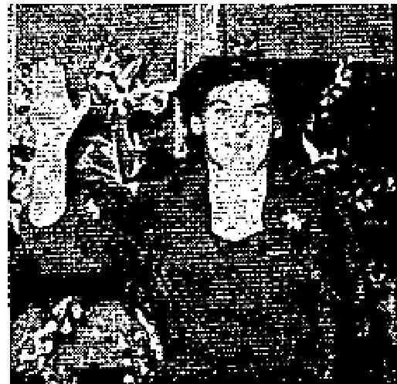

THE VOICE OF HEALING 1953
Great Physician we have! I give all the Glory to Him.
Mrs. Barbara Yinger
Detroit 28, Michigan.
Statement from Evangelist:
The glandular infection referred to in this testimony was the worst that I have ever seen. It was as large as
an orange and very hard, dark and angry. In a few days the child's face was perfectly healed and smooth.

H. E. HARDT
September 1953 p19
SHORT LEG MADE NORMAL THROUGH PRAYER
Dear Sister Kellner
I'm very happy to have a chance to tell what the Lord has done for me.
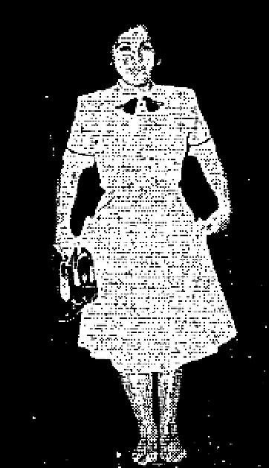
At one of your meetings in Plainfield, New Jersey, on April 16, the Lord spoke to you about my left leg. It was about two inches shorter than the other one and I could never stand with it flat on the floor. But now,
thank the Lord, after you prayed for me, I can. I also had no muscle in that leg but that also is growing.
I thank the Lord for saving me and I know that, if we believe, He is able to heal us and do so much more for us than we could imagine. Praise His name!
Mrs. Vito Amiano, Berkeley Heights, N. J.

HEALED OF T. B. AND ARTHRITIS
I had X-rays made last October which proved I had T.B. I was prayed for by Sister Kellner during the meetings at South Buffalo Tabernacle, which were held from January 20 to February 10, 1952.
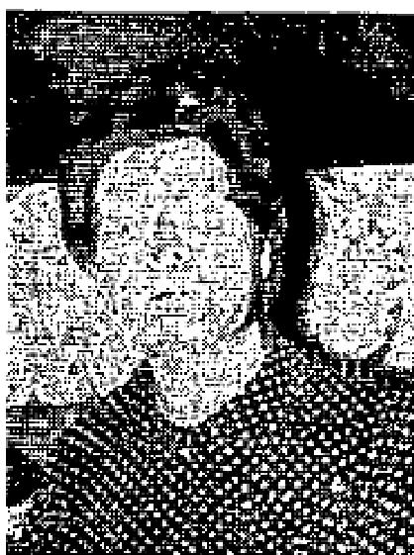
I was X-rayed again in March and Dr. Sidney Clayman phoned me to ask if I could stand some good news. Dr Clayman then told me my
lung was completely healed! I also had my arm prayed for which was afflicted with Arthritis. I had been unable to raise it but after prayer, I could raise it. It is healed and has not bothered me since! Praise Jesus for healing my body!
Mrs. Margaret Miller, Buffalo, N. Y.

Evangelist's Note: I talked with Mrs. Miller on the phone in March 1953, and she said that she was still healed and has had no trouble with T.B. or with her arm.
OLIVE M. KELLNER
October 1953 p8
I Received My Healing Through TVH
It was through the faith building ministry of the Voice of Healing that I learned how to receive healing for
my body. Pro. T. L. Osborne's messages were especially enlightening.

THE VOICE OF HEALING 1953  For about a year I had a sugar allergy. It was necessary to drink large quantities of grapefruit juice to somewhat control it. It caused excessive swelling, forming a head like a boil on various parts of my face, especially around my eyes. It was very painful. This happened about every two weeks.  When I fully realized that my healing was already purchased by Christ, and my deliverance depended on my accepting it. I claimed my healing. Instead of drinking grapefruit juice, I ate some candy. Jesus Christ delivered me from this affliction, as I stood on His promise in His Word. That was three and one half years ago and I am still healed! | 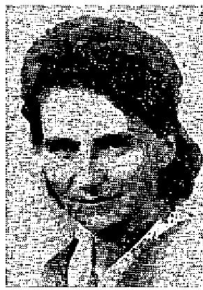

Recently I was also delivered from a severe cast, of sinus trouble. I have learned that when Satan sends symptoms of afflictions, to rebuke him, and claim my healing through the merits of Jesus.
Mrs. H. P. Gervais, Minneapolis 11, Minn.
Student in Bible Institute; Converted Reading TVH
DEAR TVH Editors:
The Voice Of Healing has been a blessing to us and many others. One of those who was converted through TVH while in the Hospital, has now enrolled as a student in the Assembly of God Bible Institute in Nigeria here and, for this and all others who have been blessed, we thank you and give the glory to Jesus Christ.
Yours in Him,
J. A. Agbede
Lagos, Nigeria, Africa
October 1953 p17  DELIVERED FROM TOBACCO INSTANTLY!  ["Begun use of tobacco at 3 years on Doctor's orders"]  AS A BABY and small child, I was restless, fretful, and failed to gain weight. When I was three, the doctors advised my mother to allow me to use tobacco, declaring that a craving for nicotine was the cause of my trouble.  Therefore, at the age of three, I began use of tobacco by the doctor's order. I chewed it. When I was ten, I stopped chewing and switched to smoking. | 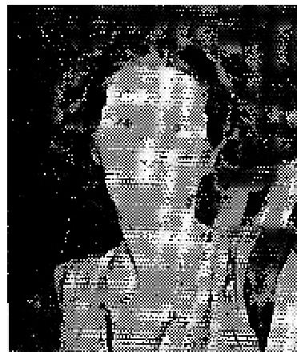

Many times I desired to stop the use of tobacco, but every time I would attempt to do
without it my entire body cried out for it. My weight would drop dangerously, and I was compelled to take it up again. I was horribly bound by this thing, until Brother Allen started his great Campaign, here in Rockford, BUT HERE, GOD SET ME FREE!
I have been gloriously free for two full weeks. No craving for tobacco has ever returned. My weight has remained normal. Praise God, at last I am free!
Mrs, Estelle B. Sischo, Rockford, Ill.
ON CRUTCHES 7 YEARS HEALED INSTANTLY
Because OF Arthritis, I've been unable to walk without crutches for more than, even years. Could barely
walk with crutches. I had not even been able to use my arms - couldn't even comb my hair.

THE VOICE OF HEALING 1953
When Brother Allen prayed for in me, I felt my spirits straighten. I arose immediately and walked alone. I found I could raise both arms straight above my head.
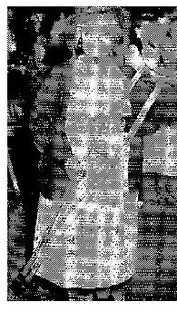
Mary Wilson, Rockford, Ill.
EAR DRUM - REMOVED BY SURGERY - RESTORED!
For twenty years, I could not hear from my left ear. Even as a small child, I had frequent ear infections, accompanied by severe pain and discharge from the ear. Ten years ago, while serving as a Women's S.S. in Germany, a surgeon removed my left ear drum hoping to stop the infection Even after that, my ear continued to be infected, having a very odorous discharge.
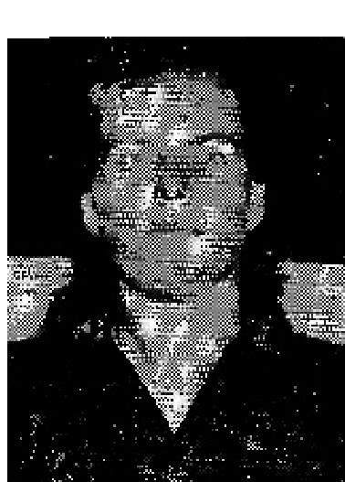
Since coming to America as a war bride. My ear had been treated frequently with penicillin. Last March the doctor said unless there was all immediate change for the better, more of the bone must be removed from behind the ear.
Men the Allen revival came to Rockford. I went through the healing line. Next day, I found I could hear from the ear perfectly, and the discharge from the ear is entirely stopped!
Mrs. Maria Louisa Akers, Rockford Ill.

WHEEL CHAIR VICTIM GIVES ALLEN FREE RIDE!  Mrs. Mollie Leathers, Loves Park, Ill., had been confined to her wheel chair eight months, SHE AROSE FROM HER CHAIR INSTANTLY AFTER PRAYER. Attended revival night after night, WALKING WITHOUT CANE OR CRUTCH, and gave joyful testimony of what God had done for her.  October 1953 p21  BLIND 38 YEARS - NOW SEES!  I have been blind for 38 years, and was led about from place to place. | 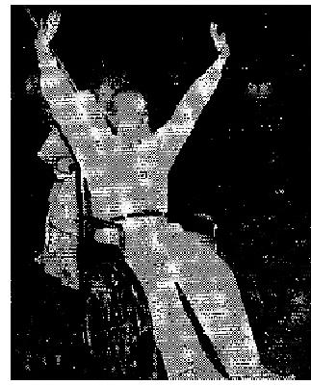

Brother Alton Hayes came to Checotah, Okla., on August 17, and prayed for my eyes. As he laid his hand on my head, I felt the power of God go through my body, it felt like a surge of fire go all over me! I KNEW INSTANTLY THAT I WAS HEALED.
Brother Hayes then took a song book and asked me to read to him from the book, I could read everything he held before me,
I am now going about giving my testimony of what God has done for me. He can do the same for you. Praise the Lord! I am so happy, I want to tell everybody what He has done for me!
Myrtle Beach, Checotah, Oklahoma

THE VOICE OF HEALING 1953  DELIVERED FROM STOMACH TROUBLE, TOBACCO HABIT  I attended the Hayes-Lindsay Salvation - Divine Healing Revival in Long Beach,  California.  I was backslidden and needed healing and deliverance for many things. I had been smoking about 35 years, had a bad cough for nearly 17 years, and also had stomach trouble. | 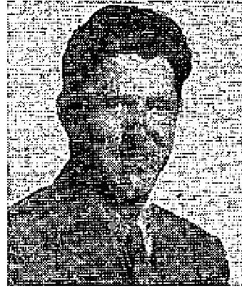

When I entered the healing line, to be delivered from my bad habits, my sinful condition
was brought before
me. I went to the altar, confessed and repented of my sins, and the Lord tool, me back. He delivered me
from my smoking and my cough, and the next night He healed me of my stomach trouble!
I now feel like a new man. Praise the Lord!
Glenn C. Perdergraft, Long Beach, Calif. -
HUSBAND, WIFE, HEALED OF ULCERS, TUMOR AND INFECTED KIDNEYS On July 8, my wife and I went through the healing line of the Hayes-Lindsay Revival.
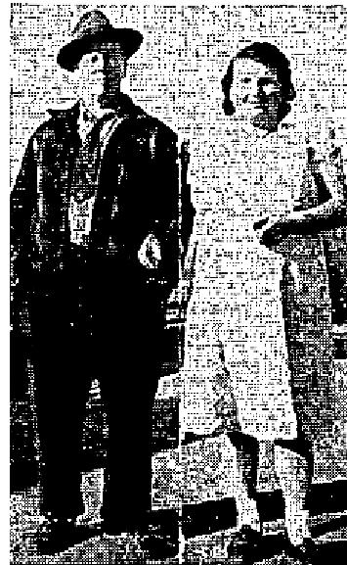
The Lord healed me of two small ulcers and heart trouble. My wife, Violet, was instantly healed of a four (4), pound tumor, of enlarged glands and infected kidneys.
Before we got home, her clothing was three or four inches too large for her. We now feel wonderful and rejoice in the saving and healing power of our Lord.
J. W. Van Gundy, Bell Gardens, Calif.
October 1953 p23
ARTHRITIC HEART AND RHEUMATIC FEVER GONE TO WHOM THIS MAY CONCERN:
I want to add my testimony to many others, telling of what God has done for my eleven year old son, Jerome, during the great revival in Laird Hill, Texas. conducted by Rev. David Nunn.
All of his life, my son has been afflicted with arthritic heart and rheumatic fever. I have had doctor after doctor treat him, but they all told me there was nothing they could do for him, that if he didn't out-grow it, it would finally kill him. All through school he has had to miss days frequently because of this condition. When he did go to school, he would have to go to the nurse's office to rest during play periods, so he could go back to class.
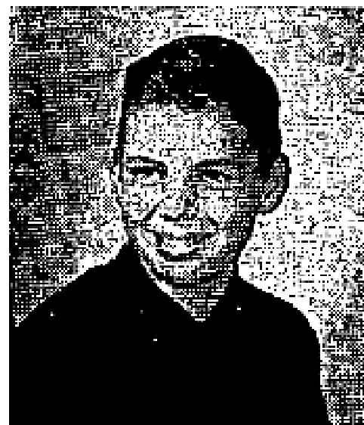
On September 14, 1952, he had a severe attack of rheumatic fever and Dr. Echols from Kilgore Medical Clinic in Kilgore, Texas, took him out of school and - confined him to bed for 30 days. This was the worst spell he ever had. I thought surely God was going to take him. Dr. Echols told me my only hopes were in God and if child lived, it would be through God's divine providence. I missed the first week of Brother Nunn's revival because of his illness.
One day I went to Dr. Echols and he gave me permission to take him out of bed and let Bro. Nunn pray for him, if I would be very careful, because his pulse rate was very high and it could cause a sudden heart attack. Brother Nunn prayed for him and God healed him! Within three days, I took him back for a thorough examination and Electrocardiogram, and had his heart tested. The doctor said he could not find one defect in

THE VOICE OF HEALING 1953
his heart. He took a blood test and could not find one trace of rheumatic fever. His blood had dropped from 32 down to 6 in three days, which is normal.
Dr. Echols told me to put him back in school and he has been going for two weeks with not one degree of fever or pain. He can run and play, ride his bike,and does what he couldn't do before. Oh,how I thank God for this! It has opened the eyes of my neighbors and caused them to believe in miracles for the first time in their lives.
Signed. Mrs. Jack Walters, Rt. 2, Overton, Texas.
State of Texas: County of Gregg:
On this the twenty-fifth day of October, Nineteen Hundred and Fifty-two personally appeared Mrs. Jack Walters who, being by me duly, legally and lawfully sworn, says upon oath that the statements made by the said person above mentioned herein and in the foregoing written statement concerning the matters and things set out in this, or her above and foregoing declaration are true and correct so help me God, Amen,
Subscribed and sworn to before me, a Notary Public, this 25th day of October, 1952.
Signed: K. F. Charles - Notary Public (Notary)  LEFT EYE BLIND SINCE BIRTH- NOTARY AFFIRMS HEALING  I want to thank God for healing my eye, and for His wonderful healing power.  I am 34 years old and have been blind in my left eye since birth. At the age of two my left eye crossed. Six years later I was prayed for and God’s power straightened my eye, but it was still weak, and I suffered from severe headaches.  One night, in our revival, Brother Nunn placed his hands on my forehead and prayed for my eye. Before he prayed for me, I could not see him, After he prayed for me, I was able to see not only Brother Nunn, but the people and the lights in the tent. | 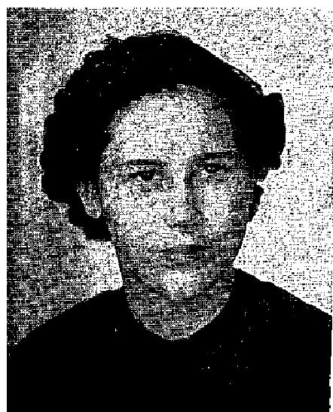

I had been to four doctors and they told me an operation would not help because I was blind from birth. Therefore, I am so thankful to God for healing me and for a godly man like Brother Nunn.
Betty Kerns, Kilgore, Texas.
Statement of Notary:
State of Texas, County of Gregg
On this the twenty-fifth day of October, 1952, appeared Betty Kerns who, being by me duly, legally and lawfully sworn, says upon oath, that the statements made by the said person above mentioned here-in and in the foregoing written statement concerning the matters and things set out in her above and foregoing declarations are true and correct, so help me God Amen.
Subscribed and sworn to before me, a Notary Public, this 25th day of October, 1952. Signed: K. F. Charles, Notary Public, Gregg County, Texas.

THE VOICE OF HEALING 1953
October 1953 p28
SIGNS - MIRACLES- WONDERS: IN THE CAMPAIGNS OF TVH EVANGELISTS
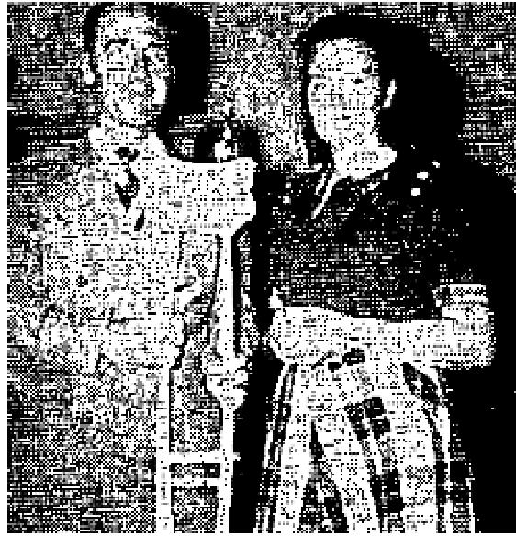
EVANG. B.D. BENNETT
SPRAINED ANKLE INSTANTLY HEALED AFTER PRAYER
I do thank God for His Wonderful healing power! While Evangelist B. D. Bennett was conducting a Salvation-Divine Healing Campaign in the Assembly of God Church in Imperial Beach, California, I had the misfortune of turning my ankle and tearing the ligaments loose. Within a few minutes the ankle was so swollen you could not see the ankle bone. The pain was almost unbearable. Toward evening the ankle turned black and I was unable to bear my weight upon it.
My husband borrowed a set of crutches for me to use to get to church, where Brother Bennett and the Pastor, Sister Eva Bailey, prayed for me. A few minutes later after they had prayed, Brother Bennett took me by the hand and commanded me to rise, in the name of Jesus Christ! I AROSE; AND WALKED, AND WAS MADE EVERY WHIT WHOLE.
Because of this miracle a Sailor, who was in the audience, came to the altar and gave his heart to the Lord.
I played the piano for the service that night and carried my crutches home with not a sign of the affliction. I thank God that, through this miracle, a soul found Christ!
Velma Warriner, Palm City, Calif.
Verification by Pastor Eva Bailey, Palm City, California
We have been blessed with a three week revival with Evangelist B. D. Bennett. The Spirit of the Lord moved in our midst to save, heal and fill with the Holy Ghost. The healing of Velma Warriner was the outstanding miracle of this meeting.
EVA BAILEY

EVANG. CLIFTON ERICKSON
RHEUMATIC FEVER, GONE!
Dear Brother Erikson:
On April 23, 1951, I was stricken with virus flu which ran into rheumatic fever. I
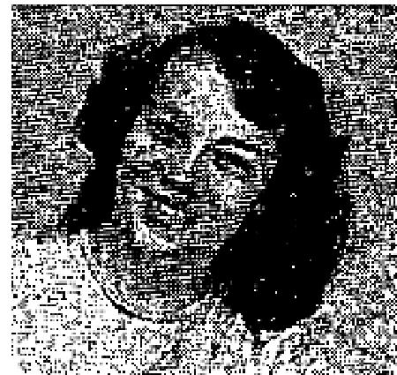
spent over 12 weeks in bed, 47 days of that time in the hospital.
On July 31, 1952, our pastor. Rev. Brannan, took me to Brother Erickson's campaign in Eureka Springs, Ark. I was so ill I had to lay on a cot during the service. Brother Erickson prayed for me and I have been perfectly healed since. I gained back all the weight I had lost within one week after being prayed for. Praise God for my deliverance!
Yours in Christ,
Ivalyn Sapp Cassville, Mo.
CONFIRMED BY: Rev, W. E. Brannan, Pastor, Assembly of God, Cassville, Mo.
EVANG. STANLEY KAROL
HUSBAND AND WIFE HEALED OF HERNIA

THE VOICE OF HEALING 1953  Dear Rev. Karol:  A testimony of what Jesus has done for us; Praise His Name!  At the Downers Grove, Illinois, meetings I was prayed for for sinus trouble, hernia, (which I'd had for 17 years and wore a belt for), and also tumors. I have never worn the belt since I was prayed for. The sinus is much better, and the backache which bothered me so that I could hardly lie in bed, has left me entirely.  My husband was healed of hernia also, for which we Praise His Holy Name! Mrs. E.L. Waddell, Downers Grove, Ill. | 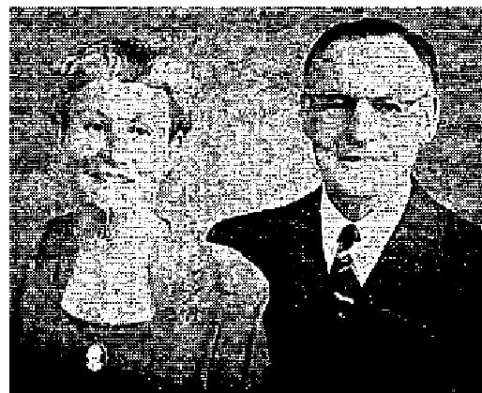

EVANG. A. C. VALDEZ
DELIVERED OF CHRONIC T.B. THROUGH PRAYER
Last year, 1952, 1 was under doctor's treatment for an aggravated chest complaint, which no treatment
seemed to touch. It got worse through the winter months, and the doctor advised me to visit the Chest
Clinic. This I did in the first week of September. An X-ray was taken; the result was bad.
Ten days later 1 was sent for again and another X-ray was taken. This time the verdict was Chronic Tuuberculosis and I was pronounced a hopeless case. The Director of the Clinic told me there was no hope whatever. He could not begin to treat me because my age was against me (67 years); my complaint was too long-standing. However, he said, "If you are alive at Christmas we will take another X-ray."
During October, 1952, A. C. Valdez, Jr. opened his campaign in Brisbane, Australia. I went to these services on the invitation of a friend who attends Glad Tidings Tabernacle, was prayed for, and I thank God that, from last October (1952) to this present day, I have not seen a doctor nor taken one dose of medicine!
I enclose a Medical Certificate obtained to prove my present condition.
Yours sincerely,
Mrs. Minnie MacLeod, South Brisbane, Queensland, Australia
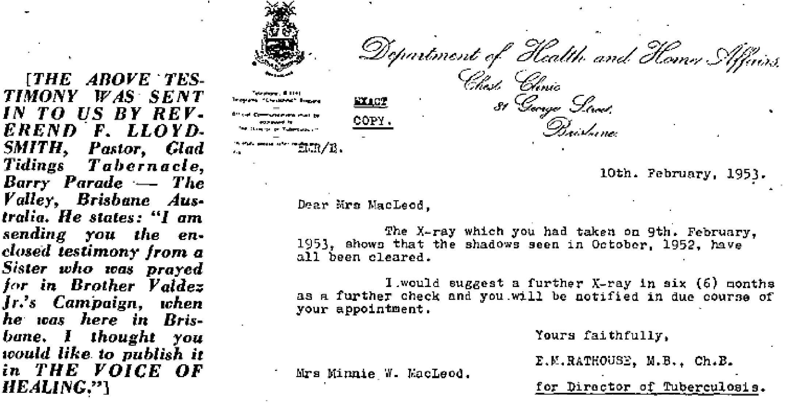

THE VOICE OF HEALING 1953  November 1953 p11  HEALED OF ARTHRITIS  I have been sick for many years with arthritis and could not be on my feet for any length of time, because of swollen knees and feet. My hands were so terribly. afflicted that I could not close them. The pain was so severe I could not sleep nights. My eye sight was very poor, because of cataracts on both eyes. | 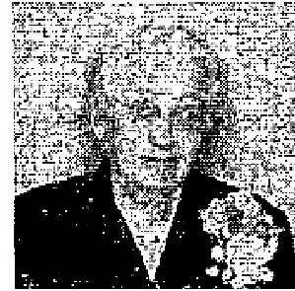
I heard of the Salvation-Healing Revival being held in the city of Aberdden, South Dakota by Evangelist Andrew S. Teuber. My husband and I attended the services and witnessed many miracles taking place night after night. I was convinced that God could heal me too! Therefore, I entered the healing line, and as Brother Teuber laid his hands on me. I felt the mighty power of God enter my body!
I praise God because HE HEALED ME!
Mrs. Fred Clocksene (Member of the Evangelical United Brethren Church), Groton. So. Dakota

November 1953 p13
INVALID 4 YEARS - NOW HEALED
Dear Brother Erickson:
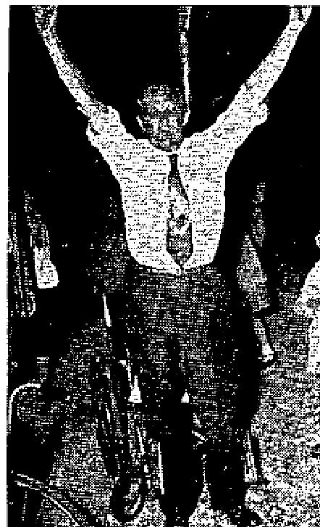
I have been a wheel chair invalid for four years; was totally helpless from my waist
down. The doctors had told me my condition was hopeless, that I would never walk
again.
I heard about your great revival in Savannah, Ga., and attended, seeking God's help. I was pushed, in my wheel chair, to the front of the tent, where I saw many mighty miracles done in the name of Jesus which inspired my faith greatly.
The third night I attended, the wonder-miracle took place. When you gave the altar call, I gave my life to Jesus. As you were praying for the sick, the power of God struck my body and went through me like fire,
down my spine and my legs. You turned to me and said, "Brother, God wants to heal you tonight!"

The power of God struck my body the second time and I felt life and strength enter my limbs! I began to move my toes, feet and legs. You turned and commanded me to rise and walk in Jesus' name. I SPRANG TO MY FEET AND WALKED IMMEDIATELY!
After the service, I pushed my wheel chair out of the tent. I am now attending a Full Gospel Church, AM STRONG IN BODY, and praising God every day!
Roy M. Denmark
Savannah, Georgia
UNDEVELOPED BONE IN HEAD MADE WHOLE  On Saturday night, April 18, 1953, I was healed of an infirmity which I had had since birth, twenty-three years ago. I had a soft-spot in my head about the size of a fifty-cent piece! This was a dent in my head about one-fourth an inch deep, about a half inch off the forehead hairline, in the middle of my head.  At times I could feel both my eyes straining from this place, also headaches that came directly from it. My heart-beat could be felt more clearly there than from the heart itself. This place was just like pressing a baby's soft-spot, being very spongy. It was exactly as if you would mash a sponge or a hand-full of cotton, but it would | 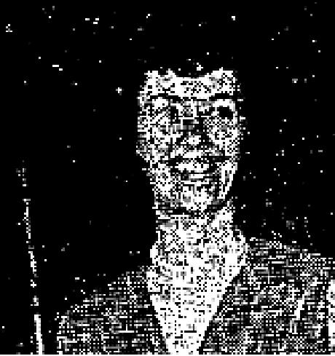

THE VOICE OF HEALING 1953
hurt so badly that I could not touch on this place. On the night of April 18, 1953, I entered the prayer line in Brother Erickson's meeting. He did not even lay his hands on me, just prayed and said he felt a definite change. I felt up there and the dent was still there. I had felt of it just before entering the prayer line and it was very soft, as usual. Instead of slightly mashing it, I was waiting for the dent to disappear, so I told him it was still there. Brother Erickson said, "I do not know to what extent you are healed, but I felt the change when it took place." I slightly mashed on the place and it was hard. I was so amazed that I pressed harder, and harder, then, told the audience that it was as hard as a rock, but I should have said "bone," for that is what it was. Yes, God placed a bone in my head, in a split second, where it had been a soft spot previously, and during my entire lifetime. All of the ministers on the platform pressed the place where the bone was placed and we all praised God for It.
I didn't understand at first why God left the dent there but now I think I understand it all. If He had removed the dent, how could I ever prove to unbelievers that it was ever there at all, as you couldn't see it for my hair! Sinners and Christians alike examined by head both during the service and afterwards. They could press as hard as they liked, and it was as though they were pressing on any other part of my head, for it’s all solid bone now! I am convinced that God is on the Throne and, if anyone in any way doubts this experience, you may feel free to examine my head to the extent of your satisfaction.
Betty L. Williamson,
Port Arthur, Texas.
Verification by Pastor: Since Betty is a member of my church, I wish to confirm this testimony. This miracle is a wonderful manifestation of the miracle working power of God.
Rev. Ralph E. Price, Port Arthur, Texas.
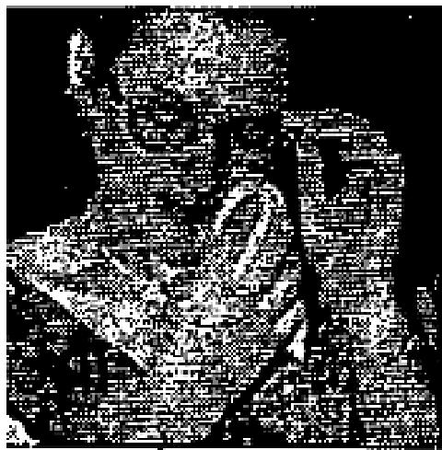
HEALED OF CHRONIC BRONCHIAL ASTHMA
Two months ago I was told that I could not be helped by medical science. I have
been an advanced chronic
bronchial asthmatic for 22 years, (I am 26 now). I am a wife and mother of two
little girls.
I was leaving my husband and children to go to Nevada in search of just a little relief. Before going, we had a family reunion, at which I was telling everyone goodbye, when my mother told me about the wonderful revival Reverend Clifton was holding in Port Arthur, Texas. My cousin Betty Williamson (see testimony on this page) had been healed the night before of a soft place in the top of her head. With my mother praying
for me to go, and my cousin's personal testimony (since I had despaired of all other help), I went to God.
I attended Reverend Erickson's meeting that night to try to get back to God. I had a Pentecostal background, was saved when a child, but had back-slidden. My mother suggested that, "if I would trust God, perhaps He would heal me." I replied that the greatest miracle He could perform would be to bring me back to Him, which He did that night and healed me too! More than that, He saved my husband also, and we now serve him together. I had been unable to sleep nights for over two months, Since Brother Erickson prayed for me, I have rapidly improved and have slept every night with no difficulty whatever.
Now, my only desire is to have a closer walk with Jesus.
Mrs. J. R. Jernigan,
Houston, Texas

THE VOICE OF HEALING 1953
November 1953 p14
When Brother Karol Prayed God Healed Me...
...Of Asthma
I am writing to give my testimony, and to tell you what God has done for me through the faithfulness of
your prayers.
I was in the hospital suffering from a severe attack of asthma, which I had had for the last 20 years. It had become so bad I was unable to work,
While in the hospital, the second time in less than three weeks, my wife wrote to you asking you to pray for me and. send an anointed cloth.
YOUR NAME AND ADDRESS WAS PICKED, WE BELIEVE, BY THE HAND OF GOD from THE VOICE OF HEALING MAGAZINE, as we asked Him to direct us which name to select from the list of Evangelists. Oh, how I praise the Lord, that I AM HEALED FROM THAT DREADED DISEASE - ASTHMA!
When I left the hospital, the doctor told me that I could not be cured, for the disease had been too long in duration. However, when I reached home, your letter and prayer cloth were waiting. My wife pinned the cloth to my clothing and, through prayer and faith in God, the battle was won. God never fails! Praise His dear Name!
I am a resident of the Six Nations Indian Reservation and I love the Lord and believe His Word.
I delayed in writing you, because I wanted to be sure of complete deliverance. My illness was in November, 1952, (one year ago), and the healing still holds good!
Maxwell General, Ohsweken, Ont., Canada
...Of Injured Spine
Dear Brother Karol:
I was in an accident December, 1938, and the end of my spine was bruised. From then on, I suffered very much with it and never knew what it was to sleep a night without pain in my back.
On April the 17, 1952, while you were at Brother Benson's church, I was in the prayer line, and Praise God, ever since that night I have had no more pain and have been able to sleep all night through without any discomfort.
Praise God for His wonderful healing power.
Mrs. Mary Conklin, Philadelphia 25, Pa.
...Of Accident Injury
Two weeks ago mother fell and was injured very badly. She was walking across a railroad track when she tripped and fell. Bruised and crippled, she could not move without much help and assistance. I lived 400 miles away from her and, as I went to her bedside, I took from Brother Karol a prayer cloth.
When the prayer cloth was placed upon her, the power of God struck her body; she immediately jumped to her feet and ran through the house praising the Lord. Next morning she was feeling wonderful.

THE VOICE OF HEALING 1953
[This minister's mother is Mrs: Caroline Frances Harrison of Coulwood, Virginia.]
Rev. C. C. Harrison
Waynesboro, Penn.
...Of Arthritis
Dear Brother Karol:
On May 15, while you were praying for the folk in the healing line, you said that, if those of us who did not have a healing card would raise our hands toward heaven and pray and trust God, He would touch our bodies and heal us in our seats.
I praise God that I have experienced just that. God marvelously touched my body and healed me of arthritis which had been troubling me for some months. I am able to raise my arm straight up which, before, was a great effort and caused much pain. I praise God for healing me.
Miss Rose E. Hloucal, Chicago, Ill.
...Of Misplaced Vertebrae
DEAR Brother Karol:
I want to praise God for healing me in one of your meetings. For the past four years I have been going to chiropractors and osteopaths for my back, the vertebrae would always slip out of place. I had pains in my chest, and difficulty in breathing - but, Brother Karol, when you prayed for me, the pain left instantly and I was healed!
I give God all the praise!
Mrs. Ann E. Corby, Chicago, Ill.
...Of Tuberculosis
Dear Brother Karol:
I have had a spot on my lungs for the past five years. I also spent 10 months in the Maryland State Hospital. My condition grew worse and the doctors told me I had to stop working for at least six months and a leave of absence was granted.
On May 5, 1953, I was prayed for by you in the tent meeting in Williamsport, Md. I felt the touch of God on my body and told my wife I was ready to go back to work. We went to see Doctor Young of Williamsport, Md., on May 27. He said, "Something has happened to you." I replied, "I know it. I am healed! I went to Reverend Karol's tent meeting and he prayed for me."
Although I was supposed to be out of work for six months the doctor sent me back in just nine weeks. This is what God can do! The other night Jesus appeared to me in a dream and assured me that I am healed. He said, "You have no T.B." I am back at work and I feel wonderful. Thanks be to God for healing my body.
Mr. Chester I. Domer, Williamsport, Md.
...Of Crooked Back
Dear Brother Karol:
You prayed for my 11-year-old son last March. He fell three years ago and hurt his spine. His back grew
crooked and one shoulder drooped, as well as his hip. I

THE VOICE OF HEALING 1953
The doctor examined him and wanted me to send him away to the hospital for crippled children in Baltimore, Maryland. The doctor said he would be a cripple when he grew tip and would have to be fitted with a special brace.
I brought him to your meeting and put my trust in the God of my salvation. You prayed for him and later I took him back to one of the best doctors in Baltimore, who, after examining him, said the boy was perfect and would never have to come back.
Thank God for healing my son! He is a wonderful Saviour and Healer.
Mrs. Paul Havermale, Big Spring, Md.
December 1953 p15
Arthritis, Rupture Vanish After Evangelist Prays
For seven years I was troubled with arthritis and was not able to work for six of those years. I also had a rupture on my right side.
On March 19th, I was so sick and full of pain I did not know what to do. That day, Rev. H.A. Christopher, Pastor of the Phillipsburg, Pa., Gospel Tabernacle, brought Evangelist Robie, who was holding Salvation-Hrealing meetings, to our home. When Brother Robie prayed for me, I was healed of both, completely. Praise God, He lifted me!
Mr Victor Fleck, West Decatur, Pa.  Delivered From Rheumatic Fever  At the age of 13 I had an attack of rheumatic fever and arthritis. Being a sinner, I  could not trust God. Therefore, off and on for two years, I suffered severe attacks.  Shortly after my 16th birthday I had such a severe attack that my parents took me to the hospital for immediate attention, where I remained for over 8 months.  There I improved, under the doctor’s care, but was told that I only had two years to live. I suffered many hemorrhages of the head because blood would not go through my heart properly. I was up and down constantly. | 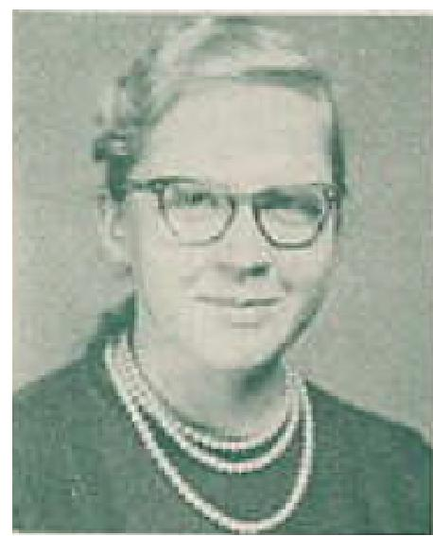

When Evangelist L.C. Robie came to Auburn, N.Y., I went with my parents to hear
him preach at a New Year’s gathering. I accepted Jesus as my saviour; then, as Brother Robie laid his hands
on me and prayed for me I was HEALED by the power of God!
I am still healed today and can do all the things I was never able to do before! Recently I was examined by the doctor who previously attended me, and he could find nothing wrong with my heart.
I owe my entire life to God! Had He not healed me, I would be dead by now, or an invalid on a wheelchair. How I praise His dear name!
Mary Ann Fries, Elbridge, N.Y.

THE VOICE OF HEALING 1953  Converted - Healed of Deafness  I thank God that I had a good praying mother, and by God’s help I am going to meet her.  I was a gambling and drinking man and ran a dance hall but, thank God, Jesus has taken all that away from me, and I am so happy, for He has washed me in His own precious blood! | 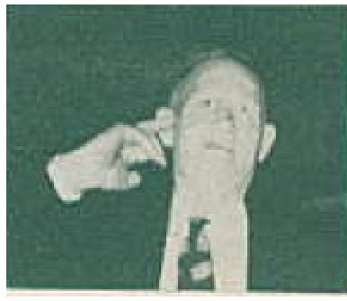

I thank God too, for His mighty healing power. I had an obstruction in my rectum for several years, causing me considerable trouble and pain. I tried everything possible, and it seemed there was nothing left for me but surgery. However, one night I let my faith loose, right while I was in my seat, as Brother Robie was praying en-masse for the people - and Jesus Completely healed me! It is so wonderful!
Some 12 years ago, while I was running a planer machine in the shop, something let go and hit me in the back of my head, back of my right ear. O had not been able to hear since that time. On April 2, 1953, I joined the prayer line and, as Evangelist Christopher prayed, God immediately gave me back my hearing! Praise His name forever!
Harry W. Lyon, Philipburg, Pa.
Miraculously Healed of Female Trouble  Our family physician, on January 2, found that I had very serious inflammation of my organs, and ordered three electrical treatments a week, and that I take some tablets to kill the infection (50 tablets - at a cost of $10) - to be taken three times a day. Nine years ago, I had the same trouble and treatment for that condition cost nearly $300.  On the following Sunday our church, Calvary Gospel Tabernacle, Corning, N.Y., of which Reverend Love is the Pastor, began a Salvation-Healing Campaign with Evangelist L.C. Robie of Union Springs, N.Y.  How God moved in those services! Over a hundred were saved, beside folk getting baptized with the Holy Spirit. Many miracles were performed before our eyes. | 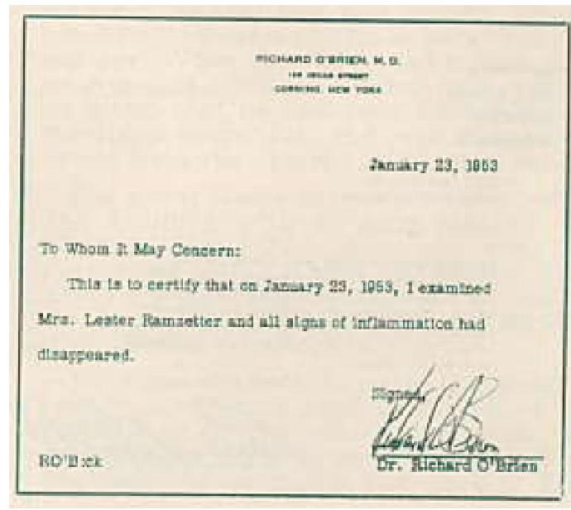

On Sunday night, January 18th, 1953, I joined the prayer line and, as Brother Robie prayed and laid his hands on me, I was instantly healed.
On the 23rd of January, I went back to the doctor, who admitted that a miracle had taken place! As I told him what had happened, though he was amazed, he recognized it as the hand of God. He willingly gave me this written statement.
Praise God for His matchless healing power.
Mrs Lester Ramzetter, Corning, N.Y.
December 1953 p16
Curvature of the Spine Discerned - Healed by God’s Power
For about three years I had not been able to work full-time at my job, having to take a few days off several
times per year, to take medical treatments for partial paralysis in my shoulders and arms.

THE VOICE OF HEALING 1953  On August 12th, 1953, I had an X-ray taken of my vertebrae which showed that I had a very bad spine. When the Healing revival conducted by Evangelist Roy Hill came to Galesburg, I went up for prayer, believing God still heals those who have the faith to believe; and, as Brother Hill perceived my needs, God gave him the picture of my spine, which he read, showing that I had a severe curvature of the spine, and that, in the lower part, it was twisted also. This verified the X-ray which the doctors had taken.  During Brother Hill’s prayer, the power of God began to move down my spine. I could feel the cartilage between my vertebrae expand and pop back into place. By morning I felt like a new person, for I knew God had healed me!  Now I can work a full day, overtime also, and feel no ill effect, nor tire as I used to. Oh Praise the Lord I am healed. | 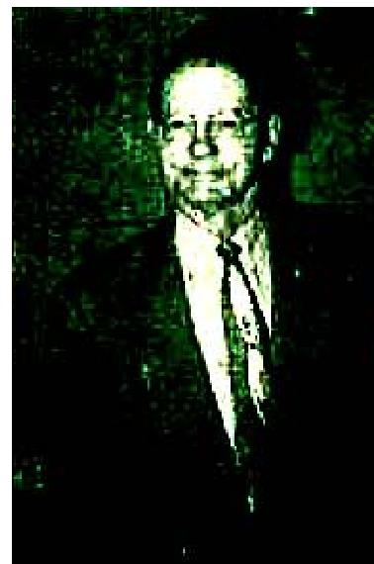

Thanks God for men of faith like Brother Hill who under the anointing of the Holy Ghost, speak without fear nor favour: through whose ministry the Gifts of the Spirit, promised in God’s Word, are so marvelously manifested.
Orel G. Wilcox, Galesburg, Ill.
Was Blind - New Pupil Created - Now Sees Perfectly  I am 12 years old and my left eye was completely blind! The pupil was entirely gone! All that was left was just the white of the eye ball. I had gone to several doctors, also to Dr. Toot. They all said my eye would never be any better and that I would never have sight in it!  one night at Christian Tabernacle, here in canton, Brother Roy Hill prayed for me and, after he prayed, I could see perfectly out of that eye! It now has a pupil in it - just like the other eye! | 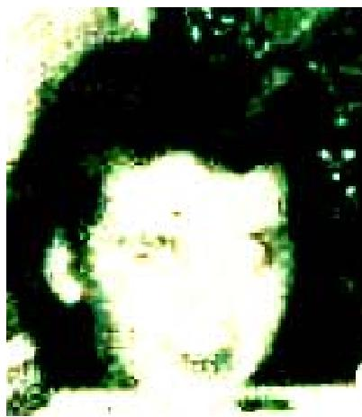

I praise and thank the Lord for giving me sight in that eye. That was the greatest night of my life! Bonnie Cox, Canton, Ohio
December 1953 p17
Dislocated Hip Instantly Healed
My hip had been dislocated for six months. It would slip out of place with each step I took and was quite
painful.
When Brother Ogilvie prayed for me on March 18, 1953, God put my hip back in place to stay. Since that time, I have even run up stairs in the hospital where I work, when in a hurry, and suffered no ill effects in that once lame hip.
Being a nurse’s aide in an operating room, I have seen the doctors operate and put pins in the patients’ hips, who were suffering an injury such as I had. Therefore, I can more understandingly appreciate how wonderful it was that, in my case, Christ, the Great Physician, painlessly and instantly put my hip in place to stay!
How I praise the Lord for my healing. Where he leads me I will follow.
Mildred Allen, Birmingham, New York

THE VOICE OF HEALING 1954
January 1954 p14
Mrs. George A. Wilson
WAS STONE BLIND - NOW SEES!
[Evangelist W. B. McKay Meeting)
I am a young colored woman, 23 years of age, I was totally blind.
This blindness came upon me very suddenly. One morning I awakened from a good night's sleep to find everything around me dark. At first, I thought I was dreaming, but soon found, to my complete horror, that it was real blindness, total blindness! I tried to make my way down stairs from my bedroom but, after groping about some time, had to call my husband to help me down stairs.
My entire family, troubled and afraid, began to search for a cure for my blindness. My dear husband took me to a physician in the small town of Delmar, Delaware, but lie was unable to do anything for me, nor could he give me any reason for my blindness.
My husband then carried me to other eye specialists, in Salisbury, Maryland, and Laurel, Delaware, but they gave me no help and said the same the other doctor had told me that I was totally blind, which I knew.
My husband carried me to the famous Johns Hopkins Hospital, in Baltimore, Maryland, and the doctors there were baffled. They also sent me away with no relief, nor my eyesight.
One night my husband said, "I helped place a house trailer the other day for a preacher, Evangelist W. B. McKay, He has a large tent and prays for the sick. We will go back to Seaford, Delaware, and see him."
On Tuesday night, June 2nd, 1953, I went to the tent for the service and entered the prayer line. As Brother McKay laid his hands on me, what I felt was almost indescribable. I had never felt like it in my life. The very moment he laid his hands on me, it seemed that the brightest light came in front of me, brighter than any light I had ever seen. Now, I was not afraid. Real peace and assurance came into my heart, and this scripture came into my mind, Psalms 121:1-2:
"I will lift up mine eyes unto the hills, from whence cometh my help. My help cometh from the Lord."
When the prayer was over. I looked straight ahead, and could see! At first, things looked hazy, then I saw Brother McKay's hand raised, and could tell how many fingers he held up. I was so happy I could not control myself, I cried out. "I can see! I can see! I can see!" as I left the tent, praising God. MY SIGHT IS NOW PERFECT!
It has been my privilege to go to several churches (colored) and tell what God has done for me. Many don't understand, but many do, that it was God who healed my eyes. through the prayer of faith, as Evangelist W. B. McKay prayed.
All I can say, to the glory of God is that "once I was blind, but now I see.'
Signed: Marcella Wilson, Geo. A. Wilson (Husband)
Witnessed by: Rev. W. B. -McKay, Mrs. W. B.- McKay, Rev. Bruce McCane, Jr., Pastor, Church of God, Seaford, Delaware,
CONFIRMATION TO EDITOR: NOVEMBER 22, 1953
I hereby certify the above testimony is true, and continue to praise, God for the miracle healing of my
blinded eyes, which I received when Evangelist W. B. McKay prayed for me in June of this year (1953).

THE VOICE OF HEALING 1954
The miracle still holds good, for I have perfect vision. I never tire thanking the Lord that I was permitted to be a witness of God's amazing power,
To others afflicted, I pray that you will It take your prescription of FAITH to the drugstore of PRAYER and remain there until DR. JESUS gives you the medicine of His blessing and healing power. It is a joy never to be described.
May God bless Brother and Sister McKay and all the evangelists who are carrying the message of FAITH
and healing power to the world.
Signed;
Mrs. George A. Wilson.
Delmar, Delaware
James Rubin Robison  "The Miracle Baby DOOMED TO DIE AT BIRTH,MARVELOUSLY HEALED!  (Evangelist Warren L. Litzman Meeting)  Our Grandson was born on January 27, 1953. He was so badly injured in delivery the doctors and nurses told us he could never be normal, that it would be better for him to die. They did not think he could live.  A three-inch gash was cut in his right temple, his eyes were in a critical condition and, his head was crushed so terribly behind his left ear that it caused the left side of his. face and head to be paralyzed, They rushed  him to the incubator but each time the lid was raised he turned purple. He was not bathed or dressed for four  days. | 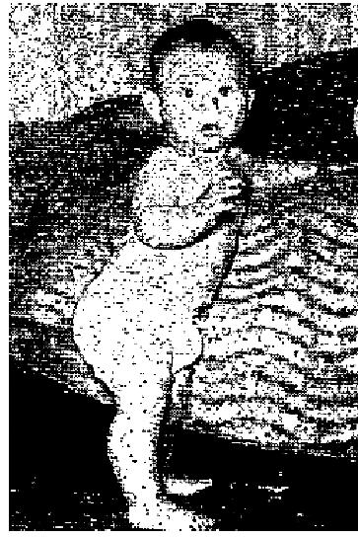

On the fourth morning, before trying to rest, I went my knees and prayed to God, asking Him what to do. He told me to call Rev. Warren Litzman, to pray for him. He was in a revival in Waco, Texas. I called him and when Brother Litzman, Brother Lewis, our pastor and a friend and I came out of that nursery, GOD HAD PERFORMED ANOTHER MIRACLE! Our grandson, James Rubin Robison, Is now 4 months old, weighs 14 pounds, IS PERFECTLY NORMAL IN EVERY WAY and Is a picture of health! (May 1953).
The doctors admitted that all the credit for this baby's being alive and healed belonged to God, and they charged no medical or doctor's fees on him after he was prayed for.
Dr. Stanley Cox, of Groesbeck, Texas, will verify this statement and testimony. We took the baby home from the hospital on the 14th day.
I, his grandmother, was with him at all times, before God touched him and since. I am happy to give this testimony to the glory of God.
Mrs. R. E. Smelscer,, Thornton, Texas.
STATEMENT FROM EVANGELIST:
I have secured added information regarding the "miracle baby" James Robison. He is still in perfect health, with absolutely no sign of sickness. His mother told me that he had never seen sick a day since he was healed by the Lord, and left the hospital. He is now six months old and weighs 20 pounds!. (August 11, 1953).
REV. WARREN Litzman

THE VOICE OF HEALING 1954
STATEMENT FROM HOSPITAL: (Cox's Hospital, Groesbeck, Texas)
"The baby will not live, and if it does, it will never be normal."
After the healing: "Only God could do such!"
VERIFICATION PASTOR: Thornton, Texas
As Brother Litzman prayed, I saw the baby move its paralyzed arm. I knew then that God had healed the
baby. I know that this baby is perfectly well today.
REV. CALVIN M. LEWIS
January 1954 p15
THEY RETURN TO GIVE THANKS!
Typical Testimonials of Old Friends Attending ALLEN CAMPAIGNS During Summer of
1953
BOY, AFFLICTED WITH INCURABLE NIP INFECTION, HEALED SEVEN YEARS AGO-NOW TRAINING FOR MINISTRY. LAWRENCE MATHER - (A. A. ALLEN MEETING)
SEVEN YEARS AGO, on Nov. 21, 1946, I was healed of Perthes bone disease, in answer to prayer. I had a hard fall while ice skating, bruising my hip bone. This caused a scar tissue to form, which hindered circulation, causing the ball and socket of the hip joint to deteriorate, and slough away. I had almost no hip socket left. My leg was 1 1/2 inches shorter than the other, and curvature of the spine was developing. From February, 1946, until July, my condition grew worse. Then, I consented to enter a hospital, where I remained four long months, with traction on my leg to pull it out of joint and give the have a chance to mend.
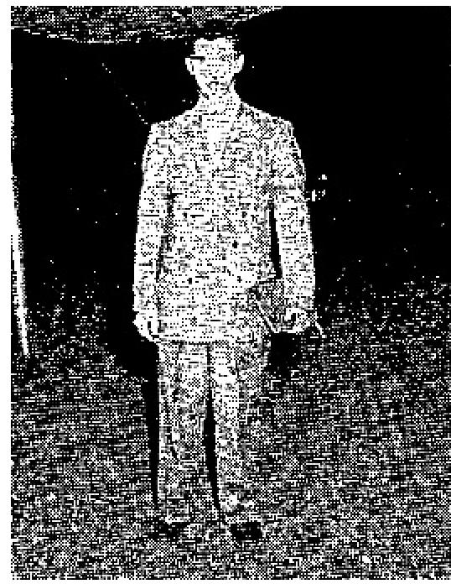
The last day of October, I went home, wearing a brace from my hip down, which I was told I must wear at least two years. My heart was very heavy, for I had always been very active; now I faced life as a cripple.
But, praise the Lord, just three weeks after I left the hospital God did the miraculous. Brother A. A. Allen, who was holding a revival in my home church in Rapid City, South Dakota, prayed for me, and God instantly touched my leg. I went home that night and took off the brace. I WAS PERFECTLY WHOLE.
The doctor who had treated me could not and would not believe what had happened: but an X-ray was taken, which proved the hip was normal and whole! Today, after seven years, I am still walking normally, and enjoy any form of activity, such as ice skating, basketball, etc. I am a student in North Central Bible Institute, Minneapolis, Minn., where I am preparing to be of service to my wonderful Lord, in any way that He may direct. Surely He has done great things for me - Lawrence Mather, Minneapolis, Minn.
LEG LENGTHENED THREE INCHES - NOW MINISTERS IN TENT  Because of sciatic rheumatism, my left leg was withered, and about three inches shorter than the right. When Rev Allen came to Evansville in 1950. I attended his campaign, and he prayed for me. Immediately all pain left. All the next day it seemed that fire went through my limb. With in three days, I was perfectly healed! My withered limb was the same size and length as the other. No sign of the trouble has ever returned  after three years. I am now in the ministry, and have a tent of my own, in which I am preaching the power of God to save, heal and deliver. | 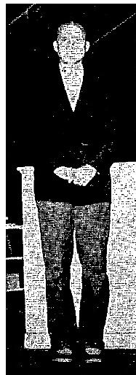

THE VOICE OF HEALING 1954
Everett E. Duncan
Henderson, ICy.
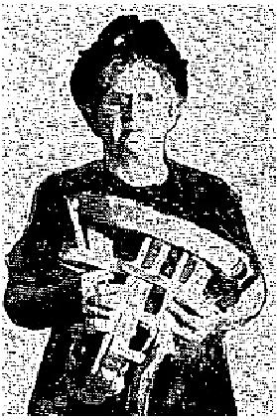 | Healed of Brace  THE PICTURE at right was taken during the A. A. Allen revival in Evansville, Ind., September, 1953, one year after Mrs. Posey had removed the brace she had worn for two years. She was healed instantly in the Allen revival in Evansville in October, 1952. Her healing has been perfect and permanent.

RUPTURE HEALED  July, 1952. Still perfectly healed! this child, the son of Maurice and Betty Rivard,  Bethany, Kr., whose picture and testimony appeared in TVH for Oct., 1952, was healed of umbilical rupture (from which he had suffered all his life! in the Allen Revival in Indianapolis in July, 1952. With his parents, little Paul visited the Allen revival in Evansville, Indiana, this fall. They are still rejoicing in his perfect healing. | 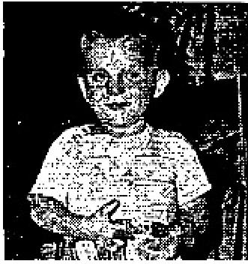

January 1954 p17
MULTIPLE AILMENTS DISCERNED, HEALED
Dear Brother HAYES:
When you prayed for me in your healing line in Long Beach, California. The Lord revealed, through you, that my heart was greatly enlarged and that one of the tour large veins at the top of my heart was ruptured. You also said it was only a miracle that I was alive. You also told me had a two pound tumor, that all my glands were twice the normal size, and my kidneys were badly infected.
All of this was free and I note praise the Lord be.. I am completely healed from all of these ailments I can now go to bed, lay on the same side all night and sleep like a child. Previously my kidneys caused me to have to get up frequently. Now they are normal and I sleep through the entire night.
The tumor melted away completely. How I do praise the Lord, and thank you for praying for me.
Mrs. Gertrude Schwab
Long Beach. Calif.
PRAYER DELIVERS FROM NERVOUS MALADY  In the Hayes-Lindsay revival in my home church, Maplewood Assembly. Dallas, Texas, God marvelously healed my nerves. For years, when I overtaxed my strength, I could feel my nerves jerking all over my body. It is wonderful now to be able to relax easily.  Rev. Alton Hayes was praying for those in the healing line ahead of me when, suddenly, I felt God's mighty  healing power surging through my body, as the very atmosphere seemed charged by the Power of God. | 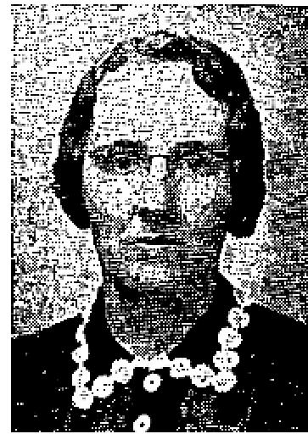

In Sister Mildred Wicks revival in Waxahachie several years ago. God performed a miracle and instantly healed my back of a curvature of the spine and four dislocated vertebrae. That healing holds good today. Praise God for His healing power.
Mrs. Minnie Lowery
Waxshschie, Texas

THE VOICE OF HEALING 1954
HIGH BLOOD PRESSURE INSTANTLY HEALED THROUGH PRAYER
THE LORD healed me instantly of high blood pressure, July 10th 1953, when I stepped on the platform where Brother Alton L. Hayes was praying for the sick, during the Hayes Lindsay Salvation Healing Revival in Long Beach, California.
I praise the dear Lord for His love and His goodness to the children of men.
Mrs. F. M. Jacoby
Long Beach, Calif.
January 1954 p18
RHEUMATIC FEVER GOES AFTER EVANGELIST PRAYS
Dear Brother Hardt:
I am happy to say that, after six months of much pain and misery with the Rheumatic Fever, with 41 days in
the hospital, not being able to work at all, the Lord graciously healed me at your Bible Healing Crusade,
conducted at The Dearborn Tabernacle, Dearborn, Michigan on May 3rd, 1953.
I knew I was healed while you were praying for me and I went to work the following morning polishing and rubbing, in my usual way, which is really hard work.
I am giving God all the praise and thank you, Brother Hardt, for praying the prayer of faith for me!
Edgar B, King, Detroit, Michigan
Witnessed by wife, Mrs. Edgar King.
STOMACH TROUBLE, MOTHER OF ANEMIA
Dear Brother Hardt:
During your tent meetings conducted here in September, 1952, my four month old daughter was very ill and we despaired of her life. Her doctor had put her on several different formulas, none of which satisfied her need. Milk would not remain on her stomach any length of time even with the help of medicine, intended to deaden the stomach muscles. She constantly had diarrhea and was not gaining weight normally.
I had only been saved about a month and did not understand about Divine Healing. One night during your great tent meeting I felt that, if you would pray for my baby, God would heal her and He did! Praise His Name! Within a few days a remarkable change was noticeable. She was now able to take her milk in normal quantities, without medicine,  Recently the doctor, when in conversation with my husband, asked about her condition. As my husband told him the story, he stated that he never expected her to live, and her recovery surely was a miracle. I do praise the Lord for His wonderful healing power and His goodness to me. | 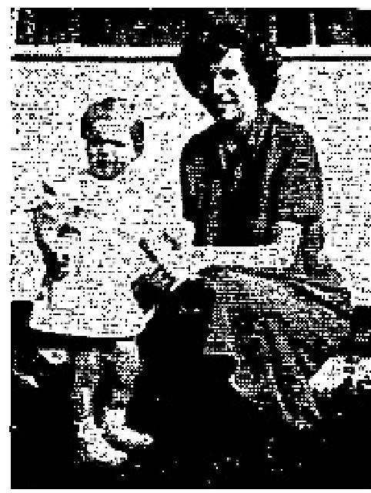

In your recent meeting in Newark you prayed for me. God wonderfully healed me of a serious anemic condition, which was discovered when I went for an examination following the discovery that I was going to be a mother again. A few days after prayer I returned to my doctor and he said my condition was normal and he seemed greedy surprised. Also a sinus condition was immediately healed.
To God be all praise!

THE VOICE OF HEALING 1954
Mrs. Arthur L. Stiglie, Newark, Del.
HEALED OF ECZEMA
Dear Brother Hardt:
Our little boy was healed during your deliverance campaign at Elm Tabernacle in May of this year. When Walter was one month old we noticed a rash coming on his body. When a doctor was called, he informed us our baby had exzema and gave us two kinds of ointment which I used, but to no avail. Then it began to spread over his little face, causing him to become troublesome and restless. When your meeting was announced, we decided to take him to you for prayer.
When you prayed I was confident that our baby was healed. Within a few days, his body and face were perfect. He was then five months old. He is now ten months old, and is still healed. I know it was the Lord who did it.
We want to give him all the Glory, and thank you, Brother Hardt, for your prayer of Faith. We are constantly praying for God's richest blessings on your ministry.
Yours in Christ.
Dexter and Ruth Policy, St. John's Newfoundland, Canada
KIDNEY INFECTION GOES
Dear Brother Hardt:
I want to give my testimony of how Christ my Saviour healed me of a very bad kidney infection, in your
meeting conducted in Newark, Delaware, under the Gospel tent.
I had pus in the kidneys and had been forced to take several shots of penicillin, attempting to clear up the condition.
I heard that many people were being healed in your meetings and decided to attend. After going several nights, listening to you preach about the healing power of God and seeing people being healed, as you prayed for them, 1 felt that God would do the same for me.
On Sunday night, after you had prayed for me, I knew that God had touched my body and I wanted to tell others about it and prove to them that God is a wonderful Healer. Therefore, on Monday, I went to my doctor and had a test made, which was most encouraging.
God has completely healed me and I praise Him for it I am now anxious to tell everyone of His wonderful
healing power.
Grace Olewine, Elktun. Maryland
DELIVERED FROM SMOKING CIGARETTES
I praise God for the wonderful revival
that came to Fairmont, W. Virginia, as Evangelist H. E. Hardt ministered.
I had smoked cigarettes since I was a little girl - cannot remember when I began. (Am now sixty-seven years old.)
Brother Hardt preached deliverance in his tent meeting, and I believed the message. I entered the prayer line, and when Brother Hardt laid his hands upon me, and prayed, I WAS AT ONCE DELIVERED! I am now happy and free!

THE VOICE OF HEALING 1954
Mrs. Snow Howard, Fairmont, W. Virginia
PRAYER HEALS CATARACTS AND DELIVERS FROM SMOKING
I was immediately healed of cataracts on both my eyes, when Brother Hardt prayed for me. The Lord also delivered me from the cigarette habit, after having been bound for many years. I have not desired a cigarette since!
Mrs. Mollie Riley, Fairmont, W. Virginia
February 1954 p16
These Mothers Testify
GOD HEALED:
My Son- OF A BLINDED EYE!
MY SEVEN YEAR OLD son was blind in his right eye. In February of 1951, took him to Dr. James Gavin
of Shreveport, Louisiana, for an eye examination. His report revealed a serious condition. The thoughts of
our son being blind all his life worried my husband and me very
much.
Two days after the examination by Dr. Gavin, I took him to Dr. W. G. Jones, also of Shreveport. His report of findings was also bad. He later, fitted my son with glasses, and advised that it would be a long time before our boy would be able to see out of the right eye, if ever.
On April 1, 1951, my son went through the healing line and was prayed for by Brother Warren Litzman, The following morning he asked me whether or not he should give his glasses back to the doctor or throw them away. He said that he didn't need their any longer, for he could see, perfectly without them. Praise God, he hasn't worn them since (Sept. '53)!
My husband and I cannot praise God enough for what He has done for us and our family. We have dedicated both our children to Him,
Mrs. Isaac C. Jackson
Shreveport. La
My Son- OF RARE BONE DISEASE!
About 3 years ago my son was afflicted with a terrible pain in his left hip and leg. He couldn't be moved one
inch, without suffering a great deal. We took him to the hospital and had him X - rayed and they found that
he was suffering with a very rare disease, resulting
in the gristle growing in between the joints and pressing the bones out of place.
He was put to bed with weights on his foot and, after he unhooked himself and got out of bed, the doctor put him in a cast. He still tried to move about on his good foot, causing his back to become crooked in the shape of an "S." His left hip grew worse until it was twice the size of the right one and he had to swing his leg around in order to walk.
When Brother Warren Litzman prayed for him, the Lord instantly healed him and he was able to walk off the platform with only a slight limp. The healing power of God is stronger and greater than we can ever realize.
Mrs. H L. Clarady
Houston 16, Texas

THE VOICE OF HEALING 1954
My Daughter- OF KIDNEY INFECTION!
Dear BROTHER LITZMAN:
You and Sister Litzman have been such a blessing to our entire family. I would like to give just a word of
testimony, for the glory of God.
My nine-year-old daughter bad been bothered with kidney trouble all her life and there seemed to be nothing medical science could do to help her. In fact, she seemed to grow worse all the time. We took her to your service one Sunday night and you prayed for her, SHE WAS COMPLETELY HEALED!
How we do thank the Lord for His goodness to us and also for the salvation and healing of the many others who were saved and healed in your campaign here in Abilene.
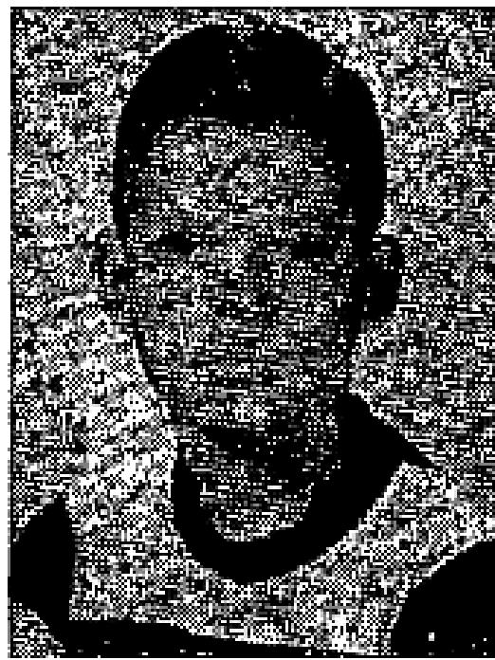
May the Lord continue to bless and prosper your ministry for Him.
Mrs. B, W. Gathings
Abilene, Texas
February 1954 p17
CANCER GOES WHEN EVANGELIST PRAYS!
Dear Brother DeGrado,
I am so thankful to God for the marvelous healing of my little boy, who had suffered from a running cancer for a period of two years. Although treated by physicians, his condition was none better.
One night as he came through the prayer line, you discerned this condition in my boy, and commanded the cancer to die by the roots. Immediately God healed him and, today, that cancer has dried up and gone, leaving his face whole.
May God bless you in your great work, of bringing deliverance to those that are bound and in need of liberation!
Mrs. Earnest Martin  Okmulgee, Okla.  February 1954 p19  CALIFORNIA WOMAN PASSES 15 POUND TUMOR  I had been suffering for months with pains in my stomach, but, being a Christian, I trusted God for my healing.  However, I did consult a doctor to determine the trouble. He told me I had a 15-lb. tumor and, unless I had immediate surgery, I might bleed to death from the pressure.  Oct. 18 I attended the Paul Cain Revival at Calvary Temple, in Los Angeles. Bro. Cain  pointed me out, in  the audience and told me I had this tumor, and that GOD would heal me!  I knew, as Bro. Cain prayed for me, that my tumor was healed. The next day, October 19, I told | 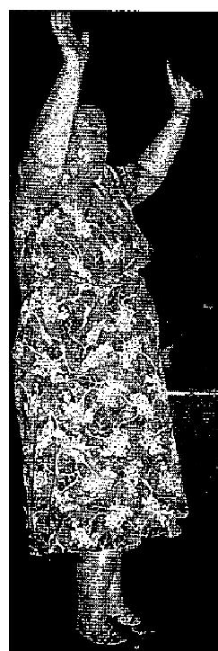

THE VOICE OF HEALING 1954
the doctor that JESUS had healed be. He scoffed, and insisted upon X-rays. In the next three days I lost 8 lbs. and 5" inches in my waist line, and in seven days I lost 12 lbs. and 9" inches around my waist. Then the doctor saw the X ray and said: "You amaze me, but I have to admit that GOD has healed your tumor; I can find no trace of it."
Don't we have a Wonderful SAVIOUR and HEALER? I am deeply grateful to HIM for What HE has done for me.
Mrs. Gladys Linza, Long Beach, Calif.
POLIO DISCERNED AND HEALED INSTANTLY
We took our little two year old baby (seriously afflicted with Polio) from the hospital, against the doctor's
orders, and brought him to the great Healing Campaign at Calvary Temple in Los Angeles.
Brother Cain had never seen us before and knew nothing about the baby's condition, for he was well wrapped up in blankets. However, he told the crowd, the minute he entered the pulpit, that there were a few people the Lord had told him would he healed. It was so wonderful that, out of hundreds waiting to be prayed for, he should call me. He told me what time I had taken the baby from the hospital, which the Lord had (supernaturally) revealed to him through the Holy Spirit. He knew the baby's age end also all about his condition. I thought would faint, as this prophet of God revealed such secrets. I didn't know that God was that real. I do now!
This great miracle is known so many thousands who heard Paul Cain and saw the gift of God work through him the night my darling child was healed instantly! The boy is jumping up and down,
He walks, he leaps. THANK GOD HE IS HEALED!
Mrs. Jerane Taylor,
Los Angeles. California
March 1954 p13
EYES HEALED THROUGH PRAYER
When I was six years old, in the first grade in school, I had to begin wearing thick loose glasses. I wore them constantly for 17 years, and could not do without them at all, as things were so blurred I could not distinguish one thing from another without my glasses.
As I paint and tint pictures, and play music, this was very inconvenient and to often I would wish I did not have to wear glasses. Mine were heavy magnifying lenses which made me so self-conscious. I have kept them to prove what God did for me.
On April 18, 1953 the Lord placed a bone in my head where before had been a soft spot from birth. See testimony and picture on page 13 of November 1953 TVH).
That miracle gave me faith to believe God could heal my eyes and I asked Brother Erickson to pray for the healing of my eyes. Brother Erickson asked me to remove my glasses, as he prayed. He instantly said, "I feel the same as when I prayed for you before. Your eyes are healed," I returned to my seat praising the Lord, for I had felt the "fire" of the Lord penetrate my eyes. The next morning I found that my eyes were healed and have not had to wear the glasses since, for which I praise God.
Betty L. Williamson, Port Arthur, Texas
NERVOUS CONDITION DISCERNED, VANISHES!

THE VOICE OF HEALING 1954
I want to thank the Lord for my wonderful healing during the recent Brickson campaign at Harrisburg, Pennsylvania. I was struggling to recover from a major operation, which seemed to affect my whole nervous system.
As I tried to believe God, I was tormented with the thought that "It was not God's will to heal me." One night as I entered the tent of Evangelist Erickson, I heard them singing "Only Believe!" It had never meant so much to me before.
I then heard Brother Erickson tell about the United Brethren brother who challenged the Lord. I said, "Lord, if you will reveal through Brother Erickson that someone in the audience has an internal condition causing much pain, I will know it is your will to heal me," As he prayed for the sick , he turned to the audience and said those words. I entered the prayer line and God has healed me, All the pain and soreness in any abdomen is gone! My husband and I also received such a wonderful spiritual blessing. Praise the Lord!
Mrs. Marlin Sweigard, Halifax, Penn.  March 1954 p15  CHILD CRIPPLED FROM BIRTH MIRACULOUSLY HEALED  Our little son, Michael Ray, was born with his left foot abnormally turned in at a 45-degree angle. Orthopedic treatments didn't seem to have any corrective value whatsoever. He began to walk at the proper age but could never run without tripping over his deformed foot and ankle.  Needless to say, this caused us great anguish at soul We not only prayed earnestly for his healing, but we had others pray.  We believe God heard our cries and sent Evangelist R. E, Henke to minister Bible Deliverance in the Napa (Calif.) Assembly of God. On the night of September 25, 1953, a friend at ours asked us to have our boy prayed for again. He offered to take the boy forward himself, declaring that he believed God would heal him. We were happy over this, knowing that the are bringing the sick must have faith too. | 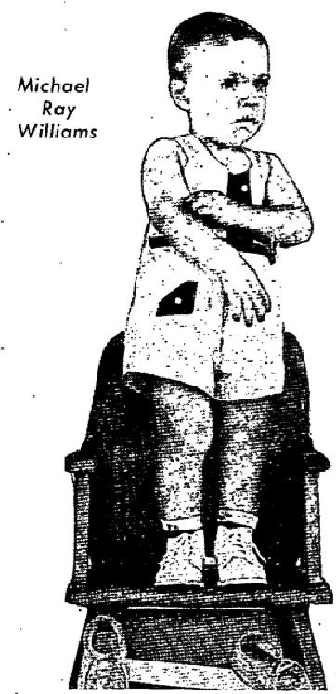

Thank God, our little 19-month old boy WAS INSTANTLY MADE WHOLE! We "turned him loose" in the church and it seemed he would never stop running! He seemed so happy that now his feet were PERFECTLY STRAIGHT and that he could run without stumbling.
This miracle not only caused great rejoicing in the church that night, but it was also the "talk of, the town " Certainly it made us love our Lord all the more and draw nearer to Him.
Mr and Mrs. John T. Williams, Napa. California
HUSBAND AND WIFE HEALED IN SAME MEETING
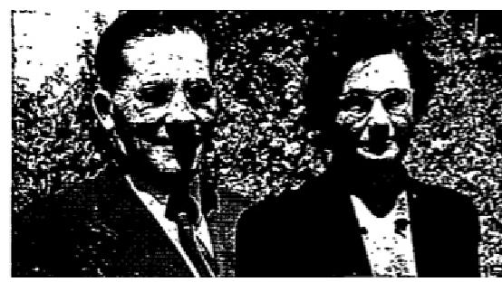
In September, 1939, the entire right side of my face and head became paralyzed completely. The doctor diagnosed my trouble as Bell's Palsy, resulting from nerve pressure. A dentist also called it by that name. Inasmuch as each one prescribed an opposite treatment, I went to the Lord instead. As I prayed, God removed some of the paralytic condition, but, from then on, very severs headaches came and went. These grew steadily worse, with an almost unbearable feeling of pressure in the back and right aide of my head, extending in blinding flashes of pain over the right eye and temple, clear down into the right shoulder.

THE VOICE OF HEALING 1954
Just before Brother Henke came to our church, the pain had grown so intense I went to an Osteopath physician for treatment to relax the "tightened nerves and muscles."
On Sunday, September 28. 2852, Brother Henke made it so clear in his sermon that "we are NOW the Sons of God." He challenged all who dared to believe God to stand and place their hands on the afflicted part of their body. This I did and Praise God THE PRESSURE LEFT INSTANTLY! This healing continues to be a blessed reality until this day! (January 6. 1954)
Mrs. H. P. Price, San Rafael, Calif.
For more than 40 years, from the age of 17, I had severe hemorrhoids. This was a chronic condition and during this time I had received no relief from this terrible ailment.
During Brother Henke's meetings, July 26 to August 14, 1953, I was prayed for and this condition was instantly healed! Not a trace remained.

Hushal P. Price, San Rafael, Calif.
BLOOD PRESSURE NOW NORMAL
For over a year I had been suffering from high blood pressure, accompanied with intense aching in my legs. My digestion was also so bad that I could eat very little food.
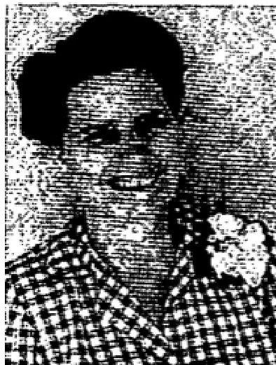
On June 2, 1953, I went through the healing line. Brother Henke prayed for me. God wonderfully touched my body. Immediately a warm feeling of well-being came over me and the pain ceased as I felt God's power surging through my body.
My blood pressure is normal and I can eat without having indigestion. Mrs. Lane. Shackeltord, A30, Ariz.

SEA CAPTAIN'S STIFF KNUCKLE INSTANTLY HEALED
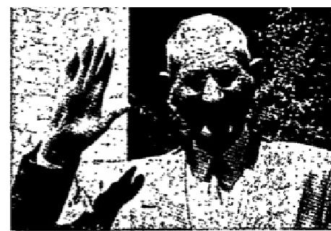
For many years I was troubled with pain and swelling of the knuckle of my middle
finger of my right hand. I could not bend it and it bothered me almost constantly.
During Evangelist Henke's ministry in Rafael, California, in 1952, God revealed my affliction to him as I was seated in the congregation He offered prayer for me: I wish to testify that my affliction disappeared completely and instantly! I now have the lull use of my finger, SUCH AS i HAVE NOT HAD FOR 50 YEARS! I thank God for His wonderful Healing Power.
I give my consent for the publication of this testimony.
(Sea) Captain K. V. Anderson, Mill Valley, Calif.

THE VOICE OF HEALING 1954  LADIES AFFIRM THAT GOITERS LEAVE INSTANTLY  I began to suffer from an inward goiter about two years ago. It kept me from singing into the Lord: therefore, I knew it was of the devil.  God showed Brother Henke my goiter and then he prayed for me. It disappeared instantly!  I can now sing long as I want without coughing or discomfort of any kind. Thanks be to God!  Mrs. Susie Van Beveren, Buckeye, Ariz.  I REALLY praise the Lord for my healing! When Evangelist Henke prayed for the Lord to heal the goiter that sister Susie, had, I trusted the Lord my goiter went too! I had been afflicted with it since I was a young girl and I'm 59 years old.  My hands were healed at the same time. I had eczema and my hands were so sore I had to wear a cloth on them, but, praise the Lord, I was healed in this campaign.  Munch, Austin, Buckeye, Arizona | 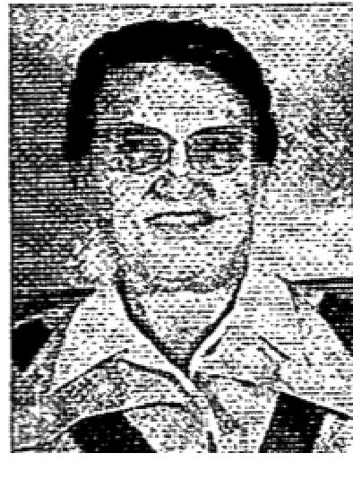
 | 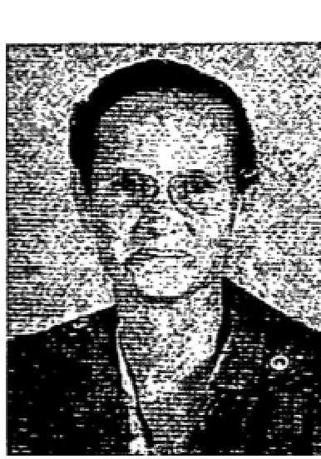

April 1954 p17
NEWSPAPER REPORTS FROM THE “MALAYALA MANORAMA” DAILY PUBLISHED IN
KOTTAYAM, TRAVANCORE, SOUTH INDIA, DEC 14, 1953
TRANSLATION OF PICTURE CAPTIONS
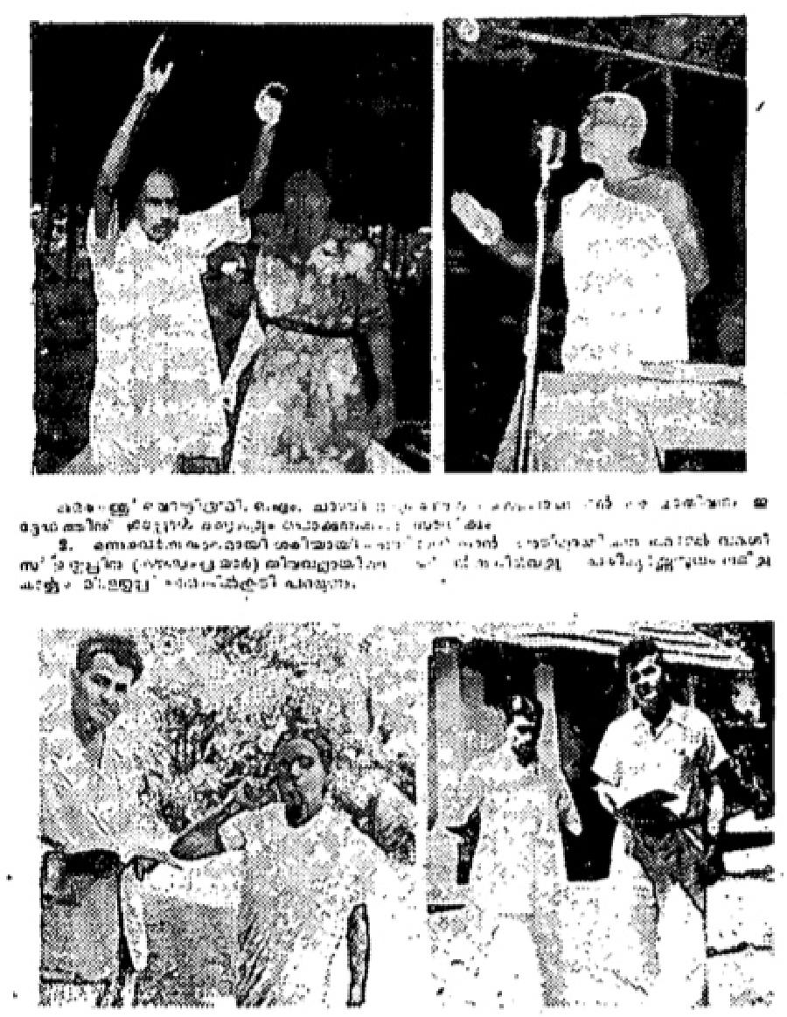
- Mr. O. M. Chandy (O. M. Alexander) of Oridattithra House. Kumarakam, for a long
time was paralyzed and unable to raise his arms, but now is able to raise both arms.
- Mr. Varghuese Euthrup (Varughese Uthup) Tharamar
Kovengumparayar, is telling over
the microphone on the platform how he was hard hearing far
over 18 months, and is
now healed perfectly in the meetings in Tiruvalla.
- Dr. P. A. Accamma, Kottoyam, Travancare, S. India, who was deaf for 8 years. Was
healed when Missionary Evangelist Jane Daoud prayed for her. (This picture replaces
one originally published on photostated page below. Original picture not available.)
- Mr. C. Abraham Ninan, who was healed of TB. is standing with Rev. M. A. Daoud.
Below are some of the many personal testimonies received of those who were healed at the meetings:
"I was suffering tram T.B. for the past 2 years. Only 2 years ago I returned home after some treatments in the Mission Hospital at Vellore. During the 2 years of my stay at the hospital, I also underwent an operation. When I was released from the hospital, they instructed me to take a complete rest. When I used to sit up, I had pain in my lungs. So I got no better. Last Sunday I visited the Daouds and they invited me to attend the meetings. Though the pains had been increasing, I went to the meeting the next day. They prayed far the sick and one who had been bed ridden or 8 years with rheumatism, stood up and then walked. Mrs

THE VOICE OF HEALING 1954
Daoud declared that there were others who had been healed also, and requested them to confess the fact. At once I felt complete healing and now my health continues to improve."
Sg. G. Abraham Ninan
Chempli Kuttapuzha, Tiruvalla
"For the past 11 days I was suffering from fainting fits and throbbing and numbness in my head. I attended
the meetings regularly and I was healed through prayer. Praise God!"
Sg. Sreemathi, Nalinakshi
Pullkathara House, Tiruvalla
“I was suffering from heart disease, I had pains in my chest and back. All the leading doctors in Tiruvalla
treated me, but I did not recover. I atended the meetings on the 3rd and 4th of December. I believed Christ
for my healing, and now I have received perfect healing from my complaints.”
Sg. Mrs Varky Chandy
Documents writer, Tiruvalla
“I could not walk erect because my backbone was crooked, but after prayer in the the meeting, my backbone
suddenly straigtened and I am completely healed. I praise God forever.”
Sg. Sreemathi Sosa
Kattupurathu, Tiruvalla
“ I was blind for the past 2 years. Now I have perfect sight. My faith has made me whole."
Sg. Baby Kizhakelathu
Tiruvalla
" I could not walk because my leg was broken. I attended the meetings and believed in Jesus Christ. At once
I received perfect healing for my leg. Now I have no difficulty in walking, I Praise God!”
Sg. Sri. Ayyappan (Hindu, Eezhaven)
Parlarathu, Thapavady
April 1954 p18
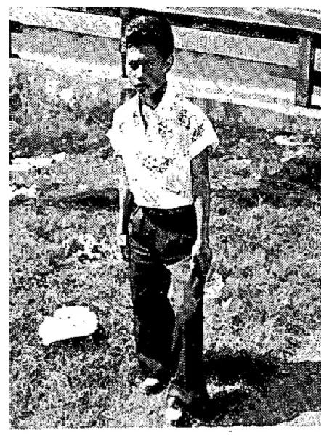
THE FIRST MIRACLE wrought by God that made everyone present at the Erickson campaign believe that this was of God was the healing of Generoso Francisco of Navotas, Rizal. Brother Gideon G. Sanoy, who was responsible for taking him to the meeting, testified that Generoso had been a Cripple from three years of age and had been so for nineteen years. He had been pronounced hopeless by prominent physicians. On January 15th 1954, he come to Bethel Temple and, while he was sitting on the front seat, the Spirit of God come upon his body and, at the command of Brother Erickson to stand and walk in Jesus name, he did.
He ran through the aisle and walked home without his crutches. His right leg immediately straightened and his left leg is gradually gaining strength. He was in the meeting almost every night, bringing more and more people to hear the Word of God and receive their healing. From his own lips he said, “I am praising the Lord for He not only healed my body but He has also healed my soul. I know Jesus as my own personal Saviour. Praise the Lord!
April 1954 p19
Gary Corcoran Healed of Gland Cancer
When Gary was five and a half years old, we began to notice a lump on the right side of his neck which did not go away. He then began to lose weight and his color got bad. We took him to Denver to a specialist. who did not encourage us any. We had a piece of the gland in his neck removed and laboratory tested. The answer came back that it was cancer of the glands. From then on, we went everywhere and to see every

THE VOICE OF HEALING 1954
doctor through whom we thought there might be a chance to save Gary's life. However, each doctor told us there was nothing that could be done. They told us that Gory had the type of cancer which would resist X-ray treatment and further that surgery offered nothing, except perhaps to prolong his life.
They said that, through surgery, one side of his neck would have to be removed and possibly his arm. After surgery, it would have been necessary to have kept his head in a cast constantly, because he would not have had control of his neck.
As he gradually grew worse, we finally gave up to have surgery performed and went to Kansas City.
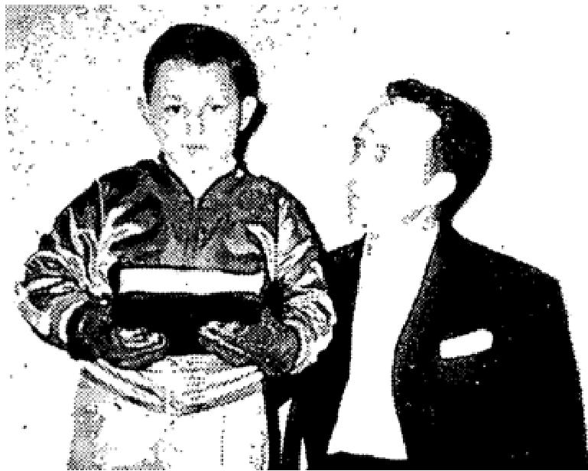
Surgery was scheduled for 7:00 o'clock am; but, at 9:00 p.m. the previous night, we canceled the operation. My husband and I could not hear to think about it and it seemed as though God was telling us that there was something better for Gary.
We then gave him a series of X-ray treatments, which the doctors said would do no good but would at least make us feel we had tried. They told us these treatments would scare him and affect his nervous system greatly, that the side of his neck would sink in, and that hair would never come back on that side of his head close to the neck. After keeping him in Kansas City a month we took him home. Of course, when we left, the doctor advised us that he had done him no good.
Rev. Russell B. Park came to Atwood, Kansas, for a revival, in October, 1952, and prayed for Gary. Two days after Gary was prayed for, he passed a piece of white rubbery substance and his condition began to improve gradually, We took him back to Kansas City and the doctors there just couldn’t believe what had happened. They finally told us that they had given him only 7 months, to live, when we left with him before he was prayed for. Now there is no lump on his neck and the scars which the X ray treatments left are completely gone, too.
Gary is now the perfect picture of health. See photograph above.) He says, "Jesus healed Me!" My prayer is that some day he will go out and preach the Word of God to all the world.
Mrs, Glenn Corcoran,
Atwood, Kansas
EVANGELIST'S NOTE: I wish it were possible, for everyone of our Voice or Healing readers to see and hear Gary. When we went back to Atwood for our second campaign, one night Gary sang so sweetly, "It Is No Secret What God Can Do." One can easily see that God has His hand on this little boy. He prays much himself and is extremely intelligent. I must say that the only scar on Gary's neck is where the piece was taken out for a test! The hair on his head is PERFECT and is no different from that on the other side. I wish you, as I have been privileged, could hear Gary and his parents give the lengthy account of this miracle. Only our Wonderful Jesus, through faith in His Word, can perform such a miracle. Glory to our God! If Jesus tarries, I believe that one day we will hear that Gary Corcoran has become a minister like unto a flame of fire for God, His life parallels the miracle of my life,
RUSSELL B. PARK
April 1954 p21
Outstanding Deliverances Wrought, as Evangelist L. D. HALL Ministers
DELIVERED FROM CIGARETTE HABIT
In Reverend Hall’s meeting, which I attended in September 1951, he prayed for me to be delivered from the cigarette habit. Jesus took the habit away and I haven't had any desire for a cigarette since. I had been bound by the habit for 15 years.

THE VOICE OF HEALING 1954
Philip M. Jenson Albany. Oregon
CANCEROUS GROWTH GOES WHEN PRAYER IS OFFERED
One year ago a serious and painful growth began developing beneath my left am. Having been a nurse, and recognizing the symptoms of cancer. I feared I would become a victim of this dread disease. Realizing that, as a child of God, I was entitled to the atonement benefits, I went to be prayed for at the tent meeting in lottery, Maine, by Brother Hall.
GOD COMPLETELY HEALED ME, the lump disappeared and all pain ceased. Thank God! Rev. Heater N. Crosby Haverhill, Miss,
CURVATURE OF SPINE HEALED WHEN EVANGELIST PRAYED
I was seriously injured when I was hit by a large trailer truck. My back was fractured, and I had to have considerable surgery. For the past two years, 1 have had increasing pain, and have been unable to sleep well because of it, If I had to carry an article up the stairs to my apartment, it was necessary to lay it down on each succeeding step, because of the severe pain.
I was examined by a doctor who told me that one vertebra was pushed by the side of another instead of being in its place and it had caused curvature of the spine.
Then I heard that Brother Hall would he in Newark, New Jersey, I fasted for several days to prepare my heart to receive healing. When Brother Hell prayed for me, I felt the bone slip into place. Since then THE PAIN IS GONE, and I sleep like a baby.
Mrs. Mary Armatys Newark, N, J.
HEALED THROUGH PRAYER-AFTER MULTIPLE OPERATIONS FAILED
I have had ten major operations on my stomach. There was an incision which did not heal, from which pus would come out with pieces of the lining of my organs. I was in such a serious condition that I had to wear two girdles to keep these organs In place. Four doctors at the hospital told me that I would never be able to work. At the time they told me this, I had had three operations within five weeks.
Since attending the meeting,, at she tent in Kittery, Maine, where I was prayed for by Evangelist Leon Hall, I only wear a light weight girdle. I do all my work in an eight room house and care for a little girl as well! My pastor, Rev. Paul Hardy of the Sailloft Mission in Portland, Maine. can vouch for this testimony.
Ethel M. Dwelley Portland, Maine  Sept. 6, 1953  PRAYER DELIVERS FROM STOMACH ULCERS, SMOKING HABIT  On December 25, 1952, on the way home from a Christmas party I became very sick with intense pains in my stomach. They were to severe that I called a doctor. I was treated by this doctor for about two months, but did not get any better. Then 1 went to another doctor, who took x-rays which showed ulcers on the intestines next to the stomach, I was put on a very strict diet, but t still suffered.  When I heard that Brother Leon Hail was going to have a tent meeting in Camden, New Jersey. I decided to be prayed for. I had been a Christian, but had drifted in many ways and had started smoking, Brother Hall's faith encouraged me, and I knew that, if I got right with God. I would be healed. So, When I was prayed for, I re-consecrated my life to God. He | 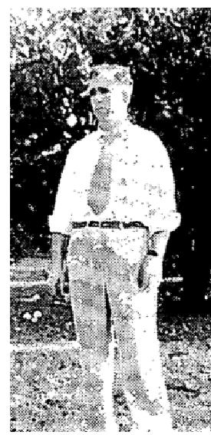

THE VOICE OF HEALING 1954
delivered me from my habit and, within a week. I was able to eat anything with no pain at all. Praise God for healing me.
Samuel Casella Woodbury, N, J.
June 1954 p17
TESTIMONIES FROM THE ALLEN CAMPAIGNS CUBA
THE BLIND SEE
(Dramatic story of how sight returned to a man totally blind.)
Many years ago my eye sight began to fail. Then, four years ago, everything went completely black. I was
totally blind and could not tell night from day I had to be led everywhere I went.
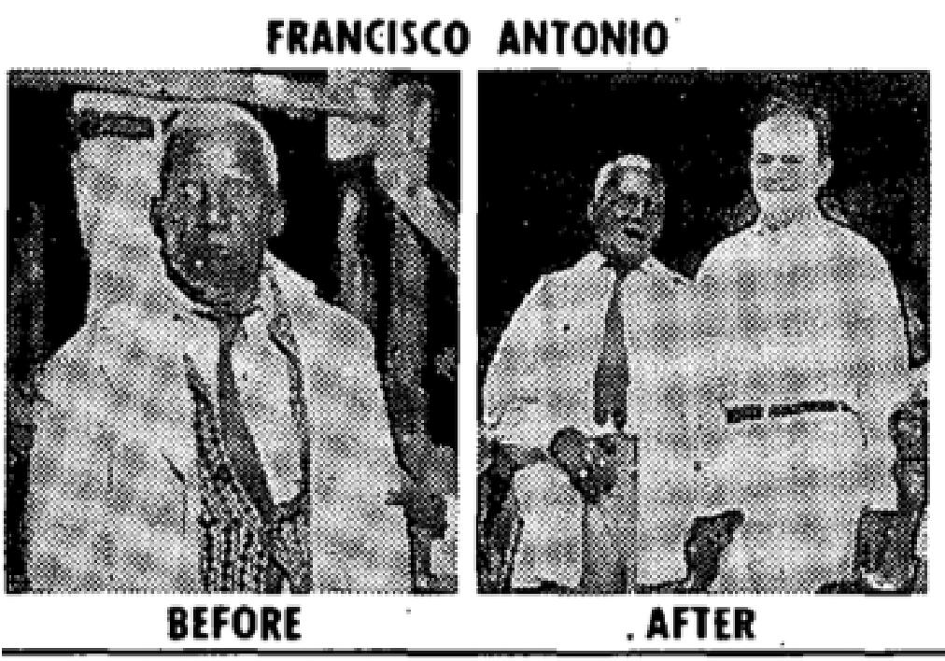
Everyone in our city of Santiago de Cuba was talking about a healing campaign being conducted by an American. They told me how many the night before had been healed of total deafness and I just said, "If people can be healed of deaf ears, they can be healed of blind eyes.”
The fourth night of the campaign, Brother Allen prayed for all the blind, as they stood before the platform in a group. I was among the number, which they told me was 24. Immediately after Brother Allen prayed, people all around me began to shout. "I can see"' Then, suddenly, I too could see the lights and the people who wore light clothing. By the time I left the campaign that night. I knew my sight was returning; although it was but a little at a time.
The next day, as I went to the afternoon service, I could see plainly that it was two women taking me to church instead of the usual one who generally led me. While Brother Allen preached, I could see him but he looked more like a white blurs, He preached about "God couldn't lie" and made me believe it. After he got through preaching, we all went up to him to believe God's promises. As I stood there, I just said , "Jesus, you can't lie; the work is finished.” That's all I did, besides believe! I believed too, for instantly perfect sight returned to both eyes. I could see everything clearly. I am completely made over. Even down on the inside of me there is something that sings. I now see everything!
Francisco Antonio  Santiago de Cuba, Ote, Cuba  INFIRM SPIRIT GONE  For one year I was bound by an infirm spirit. It came upon me suddenly and there were times when the pain was so intense that I wondered if I could bear the agony. Many people thought it must be arthritis. I went to all the doctors, trying to get relief; but they didn't know what my trouble was. They were perplexed.  People could hardly believe my story but, in my own words, it seemed to me like I was carrying a huge elephant on my shoulders that I was crushing all the bones to pieces. I couldn't even sleep all night because of the agony and pain. Then I attended the Allen campaign - and Reverend Allen prayed for me and rebuked the infirm spirit and it left, just as suddenly as it had come. Now I am free. To God be all thanks.  Augustine Vinent Santiago, Cuba | 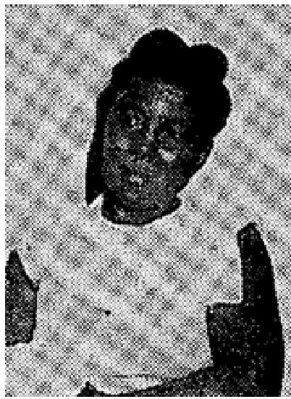

THE VOICE OF HEALING 1954
COUGH HEALED  I had contracted whooping cough, and was coughing and whooping terribly. When the A. A.  Allen campaign came to Santiago, I went, and was prayed for by Brother Allen. When he  prayed, I was healed instantly, and  haven't coughed or whooped since. Praise the Lord!  Esperanza Esteves Santiago de Cuba | 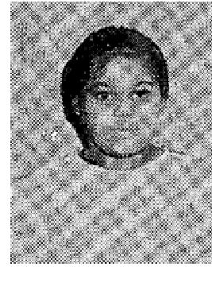

CHRONIC AILMENT NOW GONE  EIGHT years ago during a terrific fight I was struck on the side of my head. which injured my eye, ear and nose. During this eight years I was on awful pain, and the condition was just like cancer. Several said they thought that it was cancer. Many times, large pieces of flesh would be discharged from my nose.  I had given up all hope, till the campaign started in Santiago. One night I attended and saw what God was doing.  The moment the Reverend Allen prayed for me ALL PAIN LEFT, There has been no discharge since. There is even no soreness. Truly I am healed. I give God all praise!  Belin Quillart Santiago de Cuba | 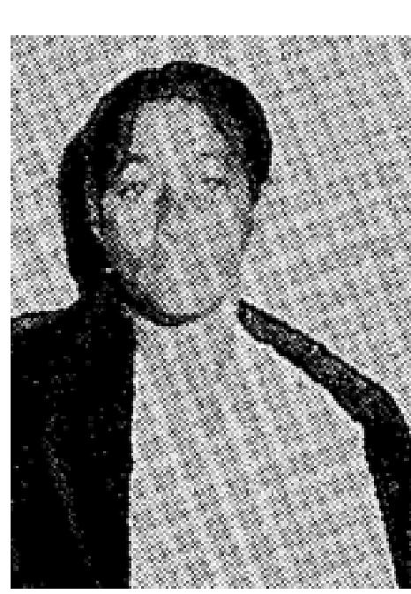

FACE PARALYZED, SPEECH GONE - PRAYER DELIVERS
I went to she dentist and he removed two of my molars. After the extractions, my face was paralyzed and I couldn't talk. I thought that, after the drug had lost its deadening effect, my face would be normal again. However, as the days went by. I became alarmed because, after the effect of the drug was gone, my face got no better. With great difficulty. I could use my tongue only a little. Fear gripped me and I was afraid my face would stay dead.
Then the Alien Campaign started in Santiago and I went. Reverend Allen prayed for me. When he prayed, I WA HEALED INSTANTLY. How good is that now I have the use of my tongue again and talk. All the paralysis is gone too, and I am completely cured. I give God the glory.
Egeria Granado - Santiago de Cuba
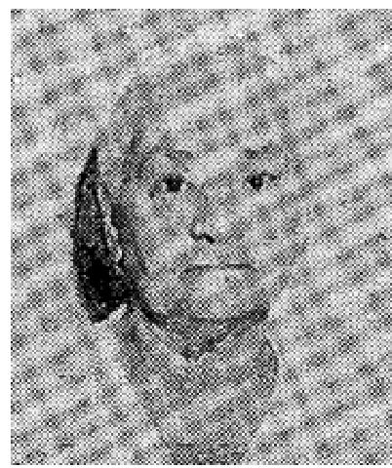
STOMACH ULCERS
For 19 years I had stomach ulcers. I tried all the doctors I thought might be able to help me but none of them could give me relief. Finally, one doctor said the only thing that could save me would be an operation; but I would not submit to one.
At times my whole abdomen would bloat and swell many times normal size and I would be so miserable that thought I'd die.
Then I heard of the campaign in town and went. The preacher, a good man from America, put his hands on me and prayed. Then a good feeling came all over me. I felt like nice cool oil; and then I knew was healed. All the pain left and all the swelling too. Now I can eat anything want to and it doesn't hurt any more. God did it through this man, whom he sent to Cuba.
Cristina Garay, Santiago de Cuba

THE VOICE OF HEALING 1954
June 1954 p22, 23
Northwest Arkansas Feels Effect of David Nunn Revival
GOD RESTORES SIGHT TO BLIND EYE
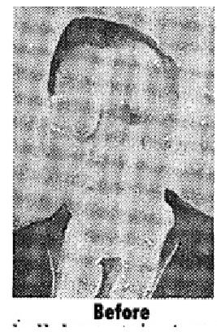
On the 10th of September, 1953, I was hit just over the eye with a knot from a planer, and it knocked a hole in the top of my eyeball, which filled with blood, clear through my forehead. I was sent to the Hospital, and they didn't know whether I was going to live or die. The blood left my eye and forehead and dissolved away, but then I couldn't see a thing. The best specialist on the Northwest coast, said the retina had been knocked down from the back of my eye. He recommended that the eye ball be cut in two and the retina sewed up, but said there was no guarantee that would do any good. I went through the operation, being in the hospital for 37 days. (I spent over $5,000.00 for doctor and hospital bills.) The doctor finally released me from the hospital and told me to go home, but he said that the eye was not clearing up like it ought to, and I couldn't see a thing. I heard about Evangelist David Nunn being in Grants Pass (in Revival Center Tabernacle); therefore, I fasted before the Lord, and went in faith believing that God would restore my eye. Brother Nunn placed his hand over my right eye and rebuked the affliction in the Name of Jesus. When he took his hand off and covered my left eye, he said, "Can you see?" I said, "Yes, Brother, I can see the outline of your shirt and body!" I walked back to my seat in the congregation and looked up at the roof of the Tabernacle. By that time, I could see the 2 x 4's in the roof. (Two days later this brother testified that he was able to read with this eye - January 10, 1954,)
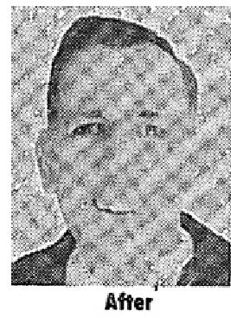
Rev. Robert C, Sawyer Roaeburg, Oregon  GOD GIVES SIGHT TO A MILK-EYE  I was blind in my right eye, not able to see since birth. I am 41 years of age. During the Revival in Fayetteville, Brother David Nunn prayed for me, and God gave me sight in that eye. I came home, placed my hand over my good eye, and went all through the house, able to see my way around.  I had heart and gall-bladder trouble also. God healed my whole body. I praise Him for everything.  Mrs. Mamie Harrison F'ayetteville, Ark. | 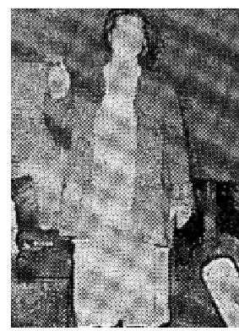

STATEMENT OF EVANGELIST: The pastor and I visited this lady before the meeting closed, and looked into her eye which God gave sight to, which was formerly a "milk eye." A new pupil was in the eye. I could see it plainly,
EVANGELIST DAVID NUNN
PARTIALLY BLINDED EYE RESTORED  My eye had been partially blinded by a piece of hot steel, which cooped and clouded the  lens. My vision was impaired to 50-20.  During revival services in the First Assembly of God Church in Clovis, New Mexico, Evangelist David Nunn prayed for my eye, and God healed me!  I can now read the finest print! Before God healed my eyes, my vision was to poor that one half (") inch letters, three feet away, were just a blur. | 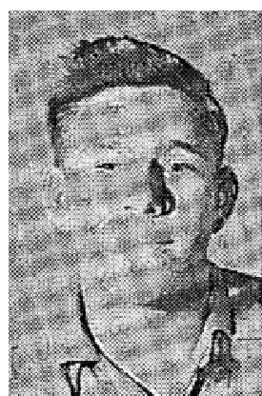

THE VOICE OF HEALING 1954
Though some people say, "God can't heal today." That is untrue; I am a living testimony that He does heal, and I have testified to my healing many times. I will be glad to confirm this to anyone who wants to write me about it.

Dalton Zion, Box 644, Portalea, N. M,
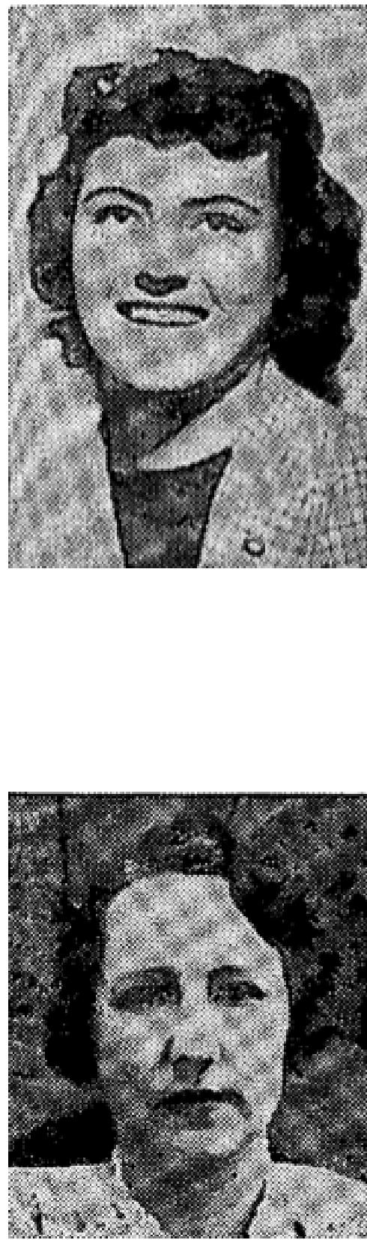
DEAFNESS IN ONE EAR NOW GONE
I was born deaf in my right ear, and am now eighteen years old. I had not heard
anything all my life out of that ear.
Before Brother David Nunn's revival began I was praying for it and felt that I was going to get healed in the meeting. The devil tried to tell me not to go up for prayer, that people would not believe it anyway. The first night of the revival Brother Nunn called for everyone in the audience who was deaf in one ear to to come forward. I knew that was my time and entered the prayer line. Brother Nunn tested my ear, and I couldn't hear a thing. After he had prayed, he tested it again, and I could hear the slightest whisper.
Someone asked me how it felt. I couldn't say exactly, but it was like a mighty wind which went through my ear and cleaned it out completely. I am still hearing and praising God for it!
Fannie Morris Plainview, Texas

HEARS IN DEAF EAR FOR FIRST TIME IN 53 YEARS
I was born in 1901, normal in every way except that I was perfectly deaf in my
left ear.
On September 6, 1953, God sent Brother David Nunn to Baton Rouge to preach the glorious news of salvation, healing, and complete Bible deliverance. On September 7, Brother Nunn requested ALL the deaf and hard of hearing in the audience to come to the altar 1°c prayer. Needless to say, I immediately arose and entered that prayer line.
Before praying, Brother Nunn tested me and found I was completely deaf - BUT after being prayed for by him, I COULD HEAR THE FAINTEST WHISPER in that ear, GOD PERFORMED A MIRACLE THAT NIGHT, placing a new ear drum in that deafened ear. I was enabled to hear for file first time in nearly 53 years!
God did not stop there! I had a growth on my stomach, and HE graciously healed that too! How I praise and thank Him! During this revival I have also received the baptism of the Holy Spirit, and am now enabled to go out into the highways and hedges to tell others what God has done for me.
Sibyl M. Schwartz, Baton Rouge, La.
HUSBAND AND WIFE HEALED, BAPTIZED IN HOLY SPIRIT  We thank God and Brother David Nunn for bringing us the message of true  salvation and healing for our bodies.  My wife and I accepted Christ as our Saviour, and God healed our bodies, during the David Nunn Revival Campaign in Fayetteville, Arkansas. The doctor had diagnosed my trouble as liver trouble. My wife had a growth in her arm, which | 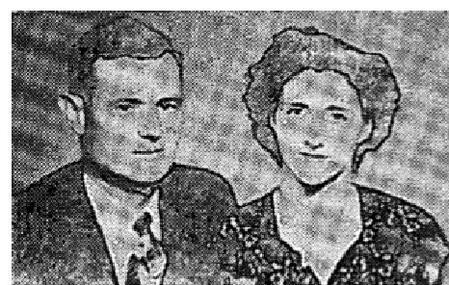

THE VOICE OF HEALING 1954
made her right leg and arm numb. When Brother Nunn prayed for her, the numbness left at once. When he prayed for me, God healed me completely.
We have also received the Baptism of the Holy Spirit (were formerly members of the Church of Christ), and are now members of the Pentecostal Holiness Church.
Garland Shelton (and wife) Fayetteville, Ark.
DELIVERED OF PROSTATE GLAND TROUBLE
For two years I had suffered with Prostate Gland trouble and arthritis in my right knee. I had gone to a doctor and he said the gland operation would cost $1,000. I was unable to have the operation. My knee pained so severely. I was unable to get up or down stairs, even by holding to a rail.
Evangelist David Nunn came to Baton Rouge, Louisiana, and I attended his campaign. One night I went up for prayer. When Brother Nunn prayed for me, MY BODY WAS INSTANTLY MADE PERFECTLY WHOLE!
Now I have no trouble getting up or down, and have gone back to work. THE GLAND TROUBLE IS COMPLETELY HEALED ALSO.
I praise God for this mighty miracle
T. J. Atkinson, Baton Rouge, La.
HEALED OF STOMACH TROUBLE
Dear Brother Nunn,
I am writing you again to testify that my healing still holds good. You prayed for me in September, 1950,
and the Lord healed me of severe stomach trouble. I had been unable to eat for some time, because soy food
would not digest.
After you prayed for me, I was able to eat anything I wanted and it did not hurt me, That is still true! I give the glory all to Jesus for healing me and thank God for sending you. His faithful servant, to pray for me.
Mrs. E. D. Clary Lewisville, Texas  PRAYER DELIVERS FROM MULTIPLE SCLEROSIS  I was instantly healed on March 1, 1954, in the revival conducted by Evangelist  David Nunn in the First Assembly of God Church in Fayetteville, Arkansas.  I had multiple Sclerosis so badly that, for the last year, I had to stay in a wheel chair constantly. This disease works like creeping paralysis, and the doctors said there was no cure for it. I had been thus afflicted for over six years, and getting worse daily. I also had ulcerated stomach. When Brother Nunn proved for me, God healed me.  I can now walk by myself, and am able to eat anything I want,  Leymon L. Solomon Fayetteville, Ark.  WITNESSED BY: Mrs Leymon L. Solomon | 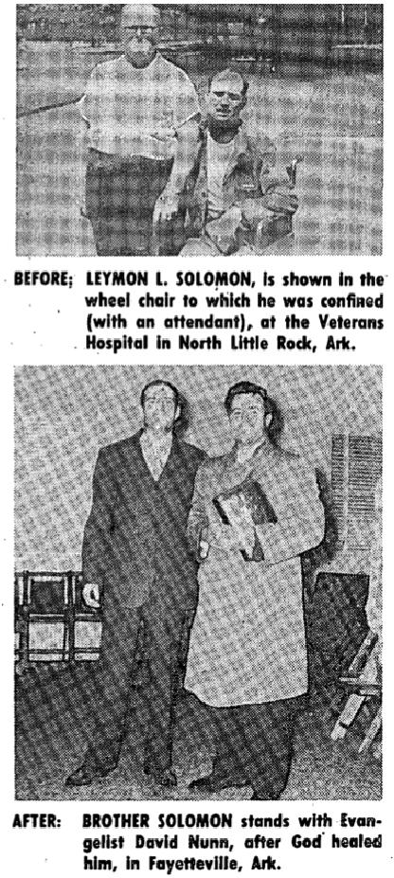

THE VOICE OF HEALING 1954
DELIVERED FROM BRONCHITIS
I had Bronchitis for 17 years and had been told by several doctors that there was no cure for my condition. I have been unable to hear well for eleven years,
When Evangelist David Nunn prayed for me, God opened my ears, restored my hearing and healed me of Bronchitis. I can now hear a conversation; and sleep through the entire night without coughing.
I thank God for sending Brother Nunn to Fayetteville, and for healing my body completely. Yes, God still heals today! Praise His Wonderful Name!
Mrs. Bessle Sherwood Hatton, Ark.
June 1954 p24
DELIVERED FROM ASTHMA, HAY FEVER
For twenty years, I suffered with asthma and hayfever, and spent hundreds of dollars on doctor bills, which
was of no avail.
Through some friends, I heard about the salvation healing revival campaign in York, Nebraska, with Rev. A. S. Teuber as the Evangelist.
The first night my wife and I attended, I went to him for prayer and the Lord definitely healed me! For almost a month now I have not had an adrenalin shot. Before then, I had to take them frequently, and they made me so nervous.
Also, I was afflicted with severe chronic headaches, which had been caused by a fever. Often I suffered so intensely I could hardly bear the pain. The Doctor gave me narcotic capsules to deaden the pain but they brought no relief. When Brother Teuber prayed for me, on the following Friday night, the Lord healed me completely and the headaches are now gone too! Praise the Lord!
Mr. H. Younglund
Osceola. Nebraska
June 1954 p25
METHODIST MINISTER AND WIFE RECEIVE BAPTISM IN HOLY SPIRIT
We continue to praise God for the glorious revival campaign conducted by Brother Andrew Teuber in
Liberal, Kansas. We were never so inspired, uplifted and benefited spiritually as in this meeting.
My husband is a Methodist preacher and has served at a pastor for eight years, but God moved in a gracious way and we both received the Baptism of the Holy Spirit in Evangelist Teuber's revival. Praise His Holy Name!  Rev, and Mrs. Everett F. White  Liberal. Kansas | 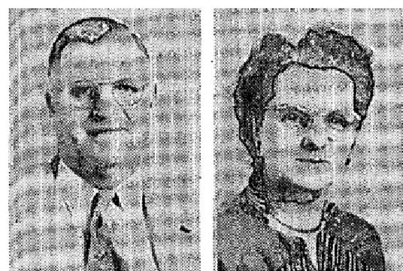

DEAF 40 YEARS - PRAYER RESTORES HEARING
I was prayed for by Evangelist Andrew S. Teuber, during the Salvation Healing Campaign he was conducting in Sioux City, Iowa. For 12 years I had suffered from an inward goiter that at times, shut off my breath. I also was totally deaf in my right ear for over 40 years. This was caused when my ear drum was punctured, as an after-effect of quinsy.

THE VOICE OF HEALING 1954
When Brother Teuber prayed for me my deafened ear was instantly healed to the extent that I could hear a faint whisper before I left the platform!
There is no trace of the upward goiter and the miserable effects from it have never returned! I praise God for His wonderful healing power and what He did for me!
Mrs. Caroline Rudd, Sioux City, Iowa
DEAF EAR INSTANTLY HEALED
For twenty-seven years I had been unable to hear out of one ear.
I attended Evangelist Andrew S. Teuber’s Salvation Healing Campaign, being conducted at the First Assembly of God Church in Hutchinsan, Kansas. On Friday evening, February 9, 1953, the power of God came down so mightily in the service the Evangelist prayed for the people en masse, as we were standing in the audience. Many were healed instantly and testified later!
At this service I felt the power of God through my body, and MY DEAF EAR WAS INSTANTLY HEALED! I am able to hear the ticking of a wrist watch, with the ear that had been totally deaf! Praise the Lord for this miracle!
Mrs. H. C. Paulson
Hutchinson. Kansas
GOITER GOES - WHEN EVANGELIST PRAYS
ON Sunday afternoon, May 4, 1952, at the Fremont Tabernacle when Evangelist Andrew S. Teuber asked those who wanted healing to come and be prayed for, I went forward and, immediately after he prayed for me MY GOITER WAS GONE!
Praise God, I was healed completely!
Jesus is the same today; the same loving compassionate Saviour! Praise Him forever! (This healing still holds good - May, 1954).
Lillian Larson, Minneapolis, Minnesota  GOD RESTORES HEARING  At the age of 2 years I had a mastoid infection which affected my left ear, and left  me very hard of hearing in that ear.  About five years ago I lost the hearing in that ear entirety. An ear specialist told me that the hearing in that ear was entirely gone, and that there was nothing that could be done.  One evening in Delevan Pentecostal Tabernacle, Brother Teuber was praying for the people sitting in their  seats who needed healing. The Lord in a wonderful way opened my deaf ear. I could hear plainly every word Brother Teuber spoke from the platform.  Praise the Lord, my hearing is restored. Amelia Kanderer, Buffalo 11, N. Y. | 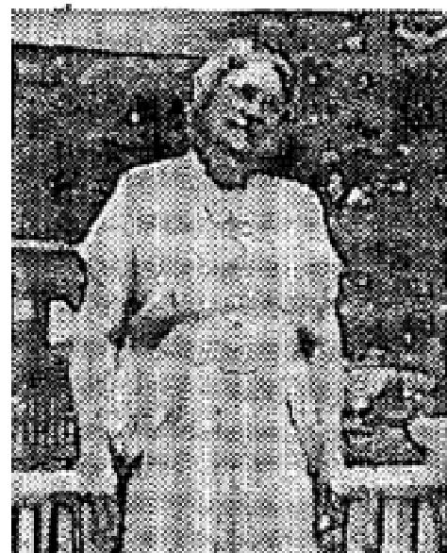

THE VOICE OF HEALING 1954
HEALED OF ARTHRITIS AND WEAK EYES
I had suffered from arthritis for three years. Last winter it got so painful I could hardly walk, and couldn't close my hands. Also my eyes were very weak, and I suffered from internal disorders. I attended Evangelist Andrew Teuber's tent Revival, and was healed. Now I see clearly, and the pain it gone. Praise God!

Mrs. Oscar Paetznick Groton. S. D.
GALL STONES AND GROWTH HEALED THROUGH PRAYER
After having an operation for gallstones a large growth came in my side near the
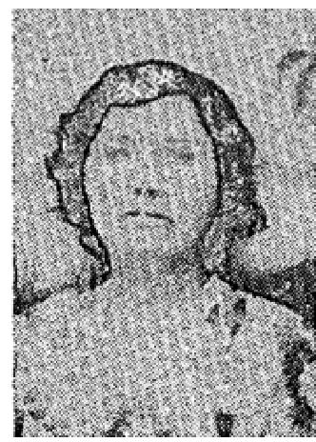
incision . The doctors could not tell what it was or what to do for it.
As I was prayed for by Brother Teuber, this growth, which had been in my side for over a year, is gone!
I praise God for healing me of this growth and also for delivering me instantly of asthma
and sinus. Above
all, I praise the Lord for filling me with the Holy Ghost.
Mrs. George Eaton, Hooker, Okla.
BODY HEALED - DELIVERED FROM CIGARETTES
I began to smoke cigarettes when I was in World War One, and have smoked all these
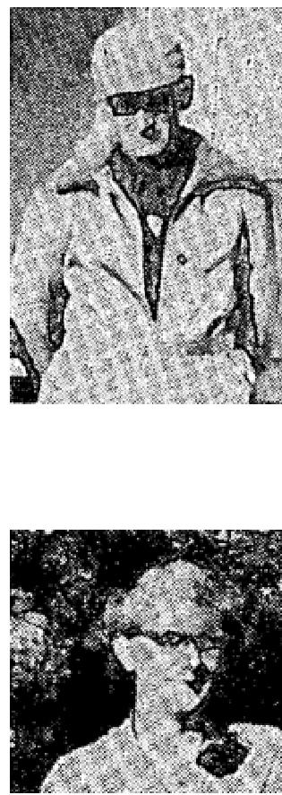
years. The past number of years I have been in ill health, suffering from a weak stomach,
and hardening of the arteries.
Evangelist Andrew Tanner prayed for me, and praise God I am delivered from the
smoking habit, and
healed in my body.
Oscar Paetznick, Groton, S. 0.
CANCER HEALED THROUGH PRAYER
I have been very ill, having had a breast removed because of cancer. As a result of this operation a running sore developed in my chest that would not heal, also the use of my arm had been impaired due to the operation, and it was necessary to carry my arm in a sling.

Evangelist Andrew Teuber prayed for me during his tent Revival here in Aberdeen, S. D.,
and God miraculously healed me! In two days the running sore was completely gone, and I now have the
full use of my arm, and am able to do my work without tiring.
During the campaign I also received the Baptism of the Holy Spirit, which means to much to me. Mrs. A. C. Robins, Aberdeen. S. D.
June 1954 p26
FEARS THROUGH RIGHT EAR FIRST TIME IN 34 YEARS
In 1918, during the flu epidemic. I was quite ill with influenza which caused me to loose the hearing in my
right ear which, naturally, has always been a terrible handicap to me.
I had one operation for this condition and the doctors said I had nerve deafness, for which they could do nothing.

THE VOICE OF HEALING 1954
When Rev. Gardner was in Mansfield holding his Salvation healing campaign, one night he prayed for the hard of hearing. As he prayed for me God restored my hearing. I could hear everything Rev. Gardner spoke and, the next day. I could hear over the telephone for the first time in thirty-four (34) years.
Only God can perform such miracles. Praise His Holy Name!
Mrs. Daisy Anderson, Mansfield. Ohio
HEALED OF GOITER, TUMOR, AND GALL-BLADDER TROUBLE
I had a toxic inward goiter. The doctor said I had so much toxic poison in my system that it was affecting
my heart, and that it would be necessary for me to have the goiter removed as soon as possible.
I was also suffering from gall bladder trouble and a tumor on my leg.
Praise the Lord. He sent Brother Velmer Gardner to Mansfield Ohio and he prayed for me and God wonderfully healed my body, for which I thank Him.
Mrs. Allen Wolfe, Mansfield. Ohio
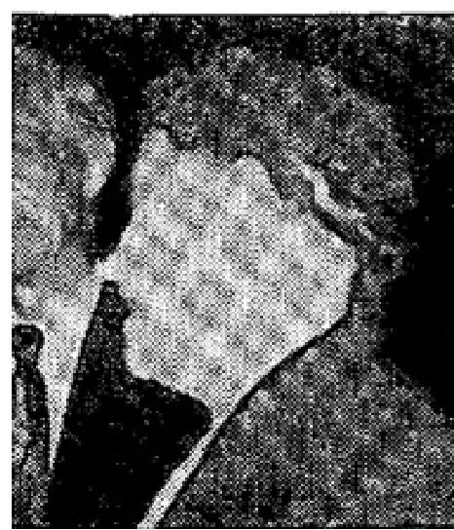
June 1954 p27
TESTIMONIES
About two years ago there appeared on the left side of my face, between my eye and ear, an ugly growth which later was discovered to be malignant. The doctors recommended plastic treatment. I suffered continuously and the cancer was constantly spreading and getting worse.
On February 20th, I noticed in the newspaper that Reverend H. E. Hardt of York, Pennsylvania, would be conducting a Bible Healing Crusade in the New Gospel Tabernacle in Winter Park, Florida. On the following day, we attended these meetings. The first night in the meeting, all suffering disappeared. Then, the fourth night, I went in the healing line. When Brother Hardt laid his hands upon my head, I felt something running down my face. When we got home, my husband removed the bandage from my face and
there the cancer was on the bandage. It was so repulsive that my husband would not let me see it.
Words cannot tell how thankful we are for God's healing power, also for a better understanding of the Bible. Mrs. Sarah Pennock, Orlando. Florida,
Dear Brother Hardt,
I want to give my testimony of how Christ, my wonderful Saviour, healed me of high blood pressure and
nervousness.
After taking one and two shots per week since last July, I was gradually getting worse. I had missed taking shots two weeks during that time. I was supposed to take a shot on the night I was healed, but didn't. I knew that, if God did not heal me. I would be a constant sufferer.
When I went in the prayer line, on the night of January 20th, 1954, and you laid your hands on me and prayed, I felt God's power go through me, making me every whit whole. I was instantly healed. Oh, how I do praise God for this great revival of healing power.
Mrs. Ella Simmons, Charleston Heights. S. C.

THE VOICE OF HEALING 1954
Dear Brother Hardt:
The wonders of God's grace are past finding out. I was a sinful, sick woman when you came to Charleston. S. C. I attended your meeting the first night and was deeply convicted. It seemed that you were speaking definitely and directly to me. When you gave the altar call I went forward for deliverance, and I was not disappointed. I had used snuff for forty years. I was delivered at once, and have never felt the slightest craving for it since. I am now saved, and I was also healed of a serious hip fracture. All praise be to God May God continue to bless you and grant that you may help many others as you have helped me.
Mr.. W. C. Warner, Charleston, S. C.
Dear Brother Hardt:
I have had high blood pressure for a number of years. On December 14, 1953, it was 224. The pressure in the back of my neck was very severe; my arms were lame, my eyes became affected, I was very nervous, and I slept very little at night. My next appointment with my doctor was March 11th.
I heard that you were coming to Orlando, Florida. I attended practically every meeting. On March 10th I was in the healing line. As you prayed for me, I felt the wonderful healing power of God go through my body. I can truthfully say, "with faith in God," that "with His stripes I am healed!" I can now sleep all night through; my nerves are so relaxed.
The following, day. March 11th, I went for my appointment with the doctor. He was so amazed that the reading of my pressure was 156. "Praise the Lord!"
Mrs. Harold W. Henning, Orlando, Fla.
June 1954 p28
LEG LENGTHENED 3! INCHES
It is with a heart full of love and praise to my Saviour that I write these few words of testimony, how on July the first, I traveled to Brother M. Cerullo's meeting, in Zanesville. Instantly, after he prayed for me, God gloriously straightened out a leg that, for fifteen years, was 3" inches shorter than the other. I had not been able to put my heel to the floor and had spent thousands of dollars for doctor's treatments; beside suffering untold pain day in and day out. Since being prayed for. I have been able to wear low heeled shoes. Two days after Brother Cerullo prayed for me, I removed the bandages which I had warn on my knee for fifteen years and am once again walking normally, I give all the glory so Jesus.
Mrs. Frances Reasoner, Cambridge, Ohio
CRIPPLE DISCARDS CRUTCHES
On DECEMBER 26th, 1950, I slipped and fell on an icy street. From this fall, I sustained a compound fracture and a complete dislocation of my left ankle. Every tendon and ligament was severed and torn. The doctors despaired of saving my foot. Much prayer went up to God, in my behalf, and the ankle mended; but a deteriorating type of arthritis set in and was causing me severe pain, which necessitated another operation on the ankle in February 1952. I recovered from this, but was still having intense pain.
The doctors took more X-rays and these showed that the bones at the ankle joint were full of holes and jagged edges, whereas they should be smooth. I had another operation in November 1953, to freeze or "lock" the ankle in place, so that it would never have any more movement in it. After this operation I'd been walking on crutches right up until the time. Brother Certtllo prayed for me. The Lord spoke to me and told me to go and be prayed for; but that first I must throw away the crutches. I did this; using only a cane to try and help myself up to the altar for prayer. After he prayed, he asked me to take off my shoe and walk. I know this was only the Lord; because the doctors said I would never walk barefooted, since my leg was

THE VOICE OF HEALING 1954
shortened in back by about 144 inches, which caused me not to be able to balance myself and also caused me much pain.
Praise the Lord I walked off that altar, in any bare feet, WITH NO PAIN AND COMPLETE DELIVERANCE, after Brother Cerullo had prayed I give all the glory to Jesus for my healing.

Beatrice M. Carlson, Rockaway, New Jersey
June 1954 p29
PRAYER STRAIGHTENS MISPLACED VERTEBRAS
I want to tell you, for the Glory of God, how God healed me. I had three vertebras in the lower part of my
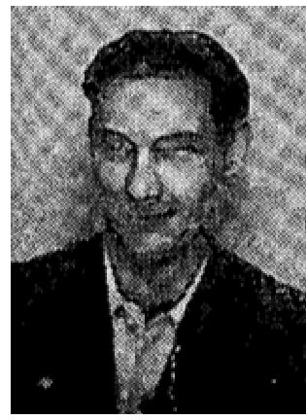
back, which were out of place. I had gone to the doctor for treatment, but he was unable to put them hack in place. They pained me continuously, especially when I bent over. I had to take my hand and place it on my back to help myself up again.
I went to the revival to have Evangelist Kelley pray for me. Since he prayed, I am able to bend over and touch the floor and there is no pain. I thank God for complete deliverance.
Arthur L. Johnson, Kansas City, Missouri

TOTALLY BLIND EYE HEALED THROUGH PRAYER
I was born with cataracts on both eyes. My left eye was totally blind. I was treated by four doctors in Tiflin, Ohio, then was sent to a clinic in Cleveland, Ohio, where I was operated on; but the operation was unsuccessful.
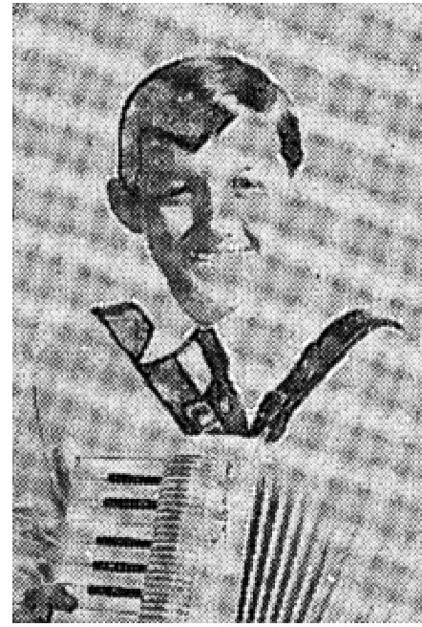
A friend suggested that I be taken to a Full Gospel Church where there was a Salvation Healing Revival in progress, conducted by Evangelist Rex Kelley. That night, Brother Kelley called me out of the congregation and commanded that sight come into my eyes. I SAW INSTANTLY AND CAN SEE YET! This happened October 8, 1951. I now ride a bicycle and make good grades in school.
The Lord has also given me the gift of music. I have never taken a music lesson, but can play an accordion and the piano.

All glory to Jesus. I thank God for His saving and healing power and for the privilege of continually serving Him.
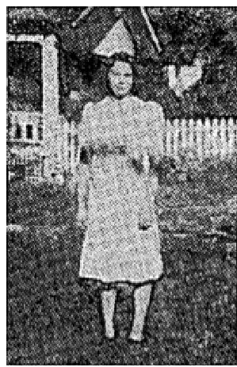
Billy Hill, Tiffin, Ohio
PRAYER REMOVES GOITER
Thank God for His many blessings and for healing.
This past week in revival here at Revival Center with Evangelist R. Kelley, God has been so good to me. He healed me of a goiter that was affecting my voice.
I also thank Him for healing my body. For many months I have looked forward to the birth of my first child. As my time for delivery approached, I spent nearly a week in continuous pain. X-ray revealed my condition was a false pregnancy. Brother Kelley prayed for me, all pain left my body. The Lord wonderfully healed me. I can never repay Him for His love and what He has done for me. I give all the glory to Jesus.

THE VOICE OF HEALING 1954  Catherine Harper , Kansas City, Mo.  PRAYER HEALS CYSTS AND INTERNAL DISORDER  About ten months ago a doctor told me I had cystic growth, on both breasts and that, unless these massed  lumps were removed by an operation, they would trouble me all my life. These cysts were most painful and it was difficult for me to rest at night. I often injured them in my sleep and the pain would awaken me.  I also had an internal disorder, for which I had been treated a number of times. I had been hospitalized just seven months ago to have the condition corrected, but it helped little.  On March 4, I attended a meeting at the Revival Center, where Evangelist Rex Kelley was conducting a revival. He prayed for me and God came on the scene. | 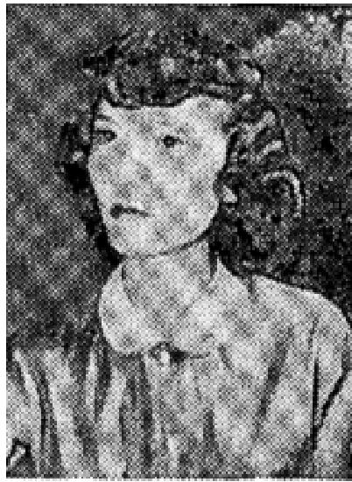

He healed me of all my afflictions. Praise, Him! The pain connected with the cysts is gone, and even the lumps have disappeared. For this I give Jesus all the glory.
Mrs. Betty Scott, North Kansas City.
CHEST PAIN DISCERNED - HEALED
I had suffered from stomach ailments for the past twenty-two, years; had been to many doctors for treatment
and had several X-rays taken. The doctors told me that they well unable to diagnose my trouble.
I went to Brother Powell's church in Dayton, Ohio where Evangelist Rex Kelley was conducting a revival meeting. I had never seen Brother Kelley before in my life.
As I sat there, suffering excruciating pain, Brother Kelley said. "There is a man on my left who is suffering with a severe pain in his chest. Whoever you are, get up, and God will heal you.” I had the very bad chest pain, therefore, I rose to my feet. His discerning me in the congregation gave me faith to believe God. He prayed for me, and God healed me! I can never thank Him enough,
Reverend John Centers, Lewisburg, Ohio
June 1954 p30  LADY WALKS AFTER 18 YEARS  I fell and broke my hip 18 years ago. The doctors set it twisted and it grew that way; making It impossible for me to walk. I had to sit in a chair constantly. I am now 70 years of age.  When Evangelist W, V. Grant prayed for me, during the Fort Smith, Arkansas revival, I WAS INSTANTLY HEALED!  I left the chair at the church for a testimony and have been walking without aid ever since, which is so wonderful, after being unable to walk for all those 18 years.  Mrs. Annie Jeffery, Olio, Arkansas | 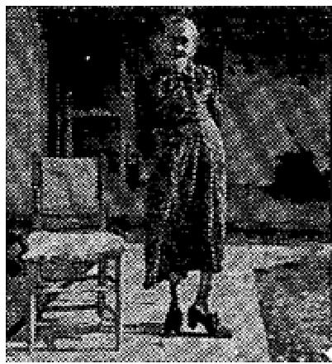

Verification by Pastor:
This is to certify that I the undersigned, had never seen this dear saint of God walk until the Lord healed her
body at Fort Smith; Arkansas during the W. V. Grant Campaign.

THE VOICE OF HEALING 1954
Reverend Calvin Carhie,, Pastor, Waldron, Arkansas
STATEMENT OF EVANGELIST:
The Photographer in Booneville, Arkansas, went 40 miles into the country to take this woman's picture. He wrote me letter, after taking this 80 mile trip, and said, "I am not going to charge you anything for this trip. Seeing that wonderful miracle is well worth the trip. The only trouble is that the lady is about to walk herself to death, demonstrating to her neighbors how she can walk."
This lady was a Baptist lady, and her people came to our Joplin campaign, about six months after she had been healed, and testified that her healing still held good and that she continues to walk anywhere she wants to, without assistance.
EVANGELIST W. V. GRANT
TB HEALED THROUGH ANOINTED CLOTH
I praise God for healing me through an anointed cloth. I had T. B., but went back to my physician, after wearing the anointed cloth which I received from Evangelist W. V. Grant, and he had an X-ray made of me at the hospital. The doctors said the scars were there - showing that I had had T. B,, but that I was now completely well! I still feel fine.

Nobie Stroup, Malvern. Ark
July 1954 p12
Healed of Nerves, Eye, and Heart Condition
I thank God for Brother Hill's ministry of deliverance. When in the prayer line March 25, 1954 in Portland, Oregon, the Holy Spirit discerned two injuries which I had. One of these was received when I was thrown from a horse many years ago and resulted in my nerves and right eye being affected. The other, an injury over my heart, received in an auto accident, when I was thrown against the steering wheel of our car.
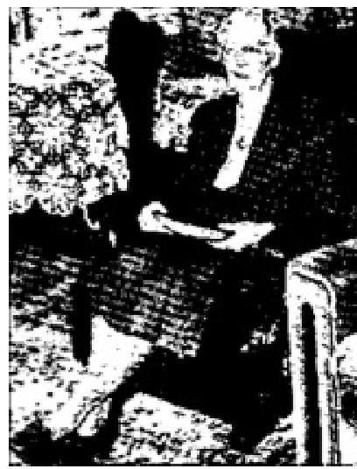
This, Brother Hill saw had caused a heart condition. As he laid hands on me, I was quickly and completely delivered by the power of God.
This truly in the hour of His visitation.
Mrs. C. C, Sargeant, Portland, Oregon
Healed of Punctured Ear Drum and a "Fluttering" in the Head
For about eighteen months I had been afflicted with a terrible throbbing and flattering in my head. While this was going on, it was very difficult to hear, and was very very painful. Sometimes I would be free from this for several days, then a quick turn of my head, or listening to music with deep bass notes would bring back this condition.
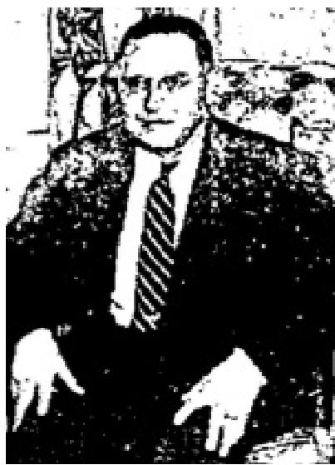
One night in one of your services in Bible Standard Temple in Portland, Oregon, you called me out of the audience and told me all about my affliction, and that the root of my trouble was in the right ear drum which had been punctured, and that there were two very small pin-point holes to the drum tissue, which caused a sort of vibration in my ear and head.

When you prayed and commanded the affliction to leave and my ear drum to be made every with whole, praise the Lord it left. Now I am able to enjoy music again and turn my head without any discomfort at all. Thank God for answering your prayers.

THE VOICE OF HEALING 1954
Rex N. Shinn, Portland, Oregon
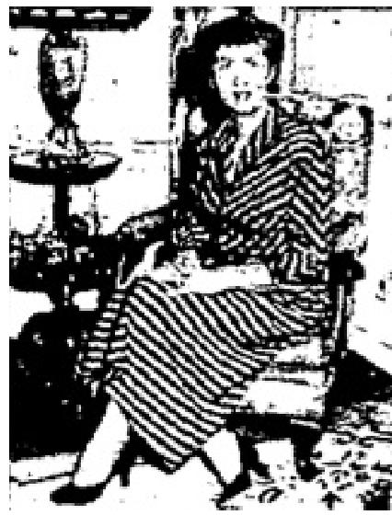
Healed of Bladder Disorder
Dear Brother Hill
I wish to thank you for your prayers, and praise God for His healing power.
In January, 1950, I had a severe bladder infection, which became so acute that in May of that year I was hospitalized, and a new opening made in the bladder.
This ended the infection, but left a pressure and several other discomforts.
Having seen, many other miracles performed, I decided that God was able to supply the needs in my body. Praise His Precious Name! The Lord revealed these needs to you while I was going into the prayer line, and as the prayer of deliverance was given I was completely delivered not only of this bladder condition, but also of chronic bronchitis that I have had for many years. How wonderful to breathe without a choked-
up feeling.
Along with these two marvelous healings, the Lord has also strengthened my eyesight, and I am able to read and work without the aid of glasses. Oh, Praise His Name Forever! I cannot thank Him enough.
Naomi Shares
Cancer Discerned and Healed
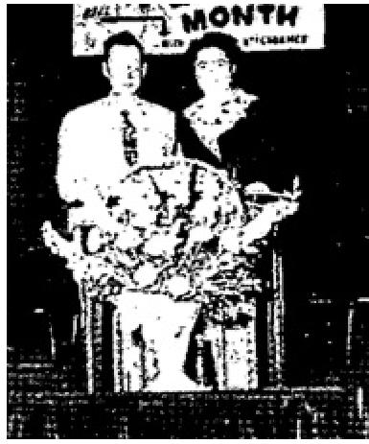
In December, 5952, I had an operation for cancer of the lower bowel. In March I went to Bible Standard Temple in Portland, Oregon where Brother Roy Hill was holding a meeting. During the meeting I felt I should go through the prayer line as I was having much pain in the lower part of my body. As I was being prayed for, the Spirit revealed to Brother Hill that there was still quite a bit of cancer still on my body mainly in the larger intestine and also in the remaining part of the bowel and also, that the female organs in the right aide were affected. He prayed and commanded the cancer to die and told me that it would pass from my body in five days, which would be the following Saturday. The pain ceased instantly and on Saturday I passed a greenish and orange mass. He completely healed me. The terrible weakness which goes with this disease has also left me. I give all the praise and glory to Jesus
Mrs. D. L. Bliss
Portland, Oregon
Witness: Theron Tousley
July 1954 p16, 17
Loose Tendons of the Jaw Healed
Dear Brother Vinyard:
I feel led to add my testimony to the many you have received, Though I wasn't prayed for, the Lord healed
me of loose tendons of the jaw. For 13 years, my jaw slipped out of place, when I yawned, and I carried a
letter to this effect, so that people would know what to do for me.
I don't know when God healed me - for I have felt His presence on the platform, so many times, as I played the organ. It came as a complete surprise, during the second week of the meetings. I truly thank GOD for His healing power!

THE VOICE OF HEALING 1954
Mrs. Beatrice Darlington, Montreal, Quebec, Canada
Heart Trouble Discerned and Healed
Greetings in Jesus! Just a line to let you know that the healing I received on March 20th, 1953 still holds good today. I sat in your meeting in New York City, with a very serious case, of heart trouble. On the way to the meeting, I not only asked God to give you discernment but also went so far as to ask the Lord to have you describe exactly how I felt. Words fail me to express how I felt, when you not only called me out of the meeting, but west on to say, "you feel as though a fist takes hold of your heart, squeezes it, and then lets go.”
When you prayed for me, I felt as though a bolt of lightning went then my body. The next day. I went into evangelistic meetings and have preached so hard ever since, without any ill effects whatsoever.
May the Lord use this testimony to encourage others.
Martha Reed, Southwestern Bible Inst., Waxahachie, Texas
Arthritis Healed
I had arthritis in my right foot for seven years, and suffered terrible pain. My work required me to stand most of the time. I suffered even more standing. On February 7, 1954, during the evening service at Evangel Pentecostal church in Montreal, Canada, Brother Vinyard said during the course of his message that some one in the congregation was suffering very bad pains to the right foot, and that if that person would come forward for prayer, they would be healed,
I knew it was I, so I went forward for prayer, and GOD wonderfully touched me that instance! I have never had any pain in that foot since.
Mr. Alfred Patent, Montreal, Quebec, Canada
Heart Trouble Healed
I want to thank GOD for the healing I received at the campaign in the Pentecostal church in Montreal. I have had heart trouble with pain in my left aide almost constantly, for three years, but have not had any pain since being prayed for by Evangelist Vinyard. Praise God for his wonderful love.
Ernest James Bunch, Montreal, Quebec, Canada
Hearing Restored
I wish to give public praise to GOD, for giving me back my hearing. I have been deaf for twenty-five years, and have been using hearing aids for about twenty years. I went to be prayed for when Brother Vinyard was praying for the sick. GOD marvelously healed me! I could hear Brother Vinyard speak to me although many feet from me (without hearing aid). I have not used the hearing aid since, and have no difficulty hearing ordinary conversations at the table. Praise his holy name!
Mrs. Lillie Heap, N.D.G. Montreal, Canada
GOD DOES GREAT MIRACLE FOR 8-YEAR-OLD CHILD
I write this, as a testament to the glory of God, to let the world know that God cannot only do miracles, but HE can do the impossible! Where all men failed the Spirit of the living God did surely heal and rebuild my son. The doctors had done all they could for him, but they told us that they could not put there what never was there, but Praise GOD - the Maker, and perfecter of all things did fully restore all that was not there!

THE VOICE OF HEALING 1954
My little boy, when born 8 years ago, was born with only a little bladder muscle. Soon after he underwent an operation, that lasted about six or seven hours and, in that operation, they destroyed completely what was
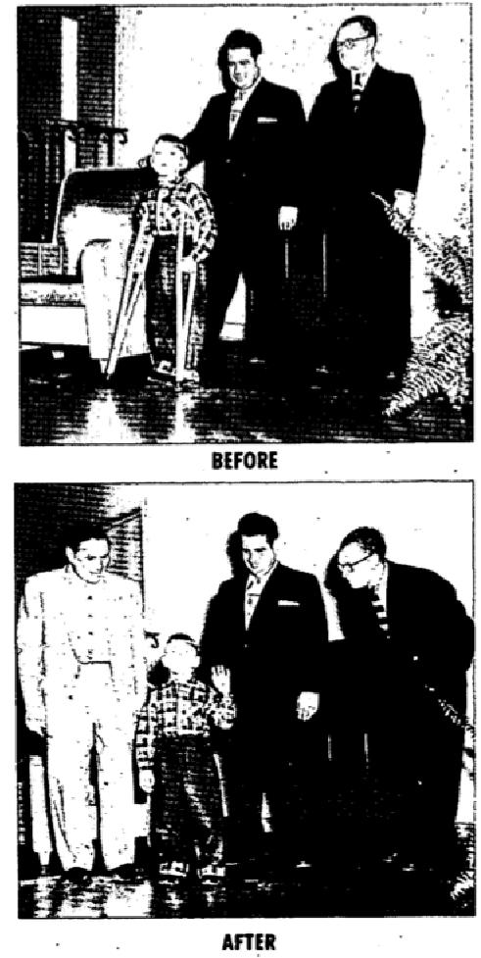
left of that muscle. That left him nothing to eliminate the waste of his body. This way he went to the amazement of all doctors for five or six years without any unusual results, no complications. Till that Friday night when Brother Vinyard prayed for him and God began rebuilding something that was not there, making something out of nothing.
Truly this is a miracle, in which I give all the glory to GOD! The hand of God has been on my boy from the day he was horn; restored him to life, divinely protected him from danger. made to walk again, made to speak, restored him from insanity, stopped paralysis. If I could tell all that God has done for that child, people would reach out and take from a willing Lord all that they need! When I think of whet the Lord has done for my boy, and the way HE reveals HIMSELF it leaves me with head bowed in shame, but ever grateful to a GOD who stands ever ready to meet our every need!
F.. Lewis,
Montreal, Quebec, Canada.
July 1954 p20
Afflicted Back Healed
I do want to thank God for my healing in the big tent.

Before coming to the tent meeting, the doctor told me he had done all he could for me. I had to take from 5 to 7 special pills to relieve me of pain, but praise God the moment Brother McKay laid his hands on my head I was healed instantly. No more pain and no more pills.
Praise God for servants like Brother and Sister McKay who pray and God answers their prayers. Mrs. Florence Spivey, Wilmington, N. C.

Healed of Deafness
I will always thank God for the McKay tent revival coming to Wilmington, N. C. The preaching of God's word by Evangelist McKay proved a blessing to me and increased my faith.
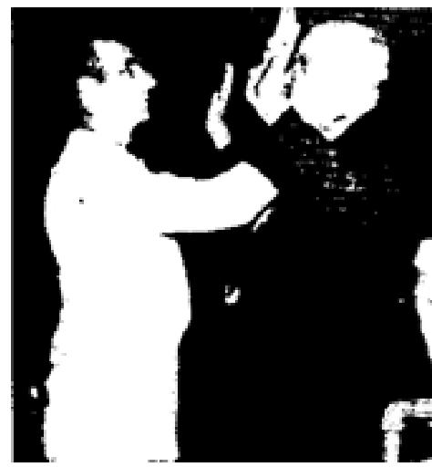
It was my privilege to be in the healing line and have Brother McKay pray for me. I was almost deaf. It was so annoying to me to have people repeat themselves. Now I can hear perfectly since I was prayed for. Praise the Lord this is truly a miracle.
Mr. Luther Carter, Wilmington, N. C.
July 1954 p21
HEALED OF BROKEN PELVIS BONE

My husband and I had gone home to Lamont, Calif., on a 30 day leave. We had a car accident, in which my
left pelvis bone was broken. I was hospitalized 13 days and stayed in bed 5 weeks after I came home
from the hospital.

THE VOICE OF HEALING 1954
I was prayed for by Evangelist John C. Parcel and the Lord instantly healed me. I walked out without my crutches, left them in the church, and visited two different hospitals that very evening. The next day my husband and I started back to Opheim, Montana. I stood the trip just fine.
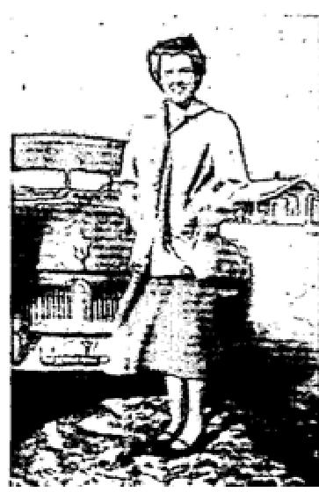
I am still healed, praise the good Lord, walking and doing my housework without any trouble.
Mrs. Patty Cochran, Opheim. Montana, 1954
CURVATURE OF THE SPINE HEALED
At the age of 5 years I fell from a horse, causing dislocation of the spine. Due to lack of
medical attention, my spine was left in the shape of an S.

I suffered intense pain from this condition and in recent years, doctors have tried to remedy this condition but to no avail. When Brother Poteet prayed for me, the power of God surged through my body. My spine instantly snapped into place. Since that time I have felt wonderful and have had no pain whatsoever.
I was, also, healed of a heart condition and sinus trouble. Praise God, for His goodness to me. Rev. Leon L. Martin, Poster, Memorial Assembly of God, Purcell, Oklahoma
DELIVERED FROM CANCER
I was healed of cancer on my left hand during Brother Poteet's meeting in Lamont, Calif. Brother Poteet prayed for me and after I got home I took the bandage off. Praise God, my hand was completely healed. The sore was gone and the skin was as pink as a new baby's skin. To God we give all the praise.
Elmer Phippo, Lamont, California
CATARACT VANISHES
Since childhood, I have had a cataract which has been forming on my right eye. As time went on, it
constantly grew
worse until sight was almost gone.
After Brother Poteet prayed for me, the cataract vanished, and I can now see better out of that eye than out of the one which has always been good. Thank God for His healing power,
Mrs. Thomas Williams
Purcell, Oklahoma

July 1954 p26
GROWTH IN NOSE EXPELLED - AFTER PRAYER
For some time I had had a growth in my nose. Doctors told me they did not know what it was nor what used it. I had growths cut out twice and each time they came back, making it hard for me to breathe. It closed up the left nostril, and caused my eyes and head to ache.
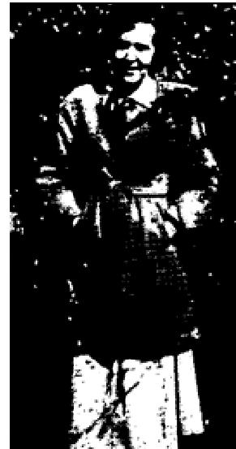
On Tuesday night, March 9th, Brother Degrado, after God had told him of my affliction, called me out of the congregation and prayed for me. The following day I became ill and felt this growth come loose from my nose. It dropped into my throat and I expelled it. I'm praising God for His mighty miracle working power, for I am free of this terrible thing.
Signed, Zelma A. Dunn, Chico, California, 1381 Fairway

THE VOICE OF HEALING 1954
“I certify this testimony to be correct."

Rev. Al Water, Chic., California
SINUS CONDITION GONE
Dear Brother DeGrado,
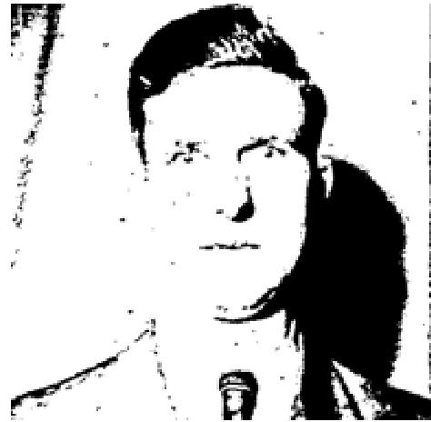
I had a very severe case of sinus trouble. I came to your meeting in
Valparaiso; was prayed for by you, and God delivered me by His power. I haven't
had a trace of sinus since. Praise God for His healing power!
Sincerely in Christ,
Reverend Arthur Raska, Hebron, Indiana
Verified by: Pastor W. Shabaz, Valparaiso. Indiana

PRAYER HEALS RUPTURE  Dear Brother DeGrado:  Having heard of the healing campaign you were conducting in Indianapolis, my  husband and I decided we would drive from Columbus, Indiana, to have you pray for  my deliverance from a large rupture that I had in my body.  You prayed for my condition and told me to go believing God for my healing. I went home and to sleep; however, at 3:00 am. I was awakened by a feeling of the sacred presence of the Lord. I fell God's hand laid upon my rupture and, upon examining myself. I found that I had been healed. The rupture was  gone!  The hand of the Lord passed over that entire area, leaving me every whit whole. | 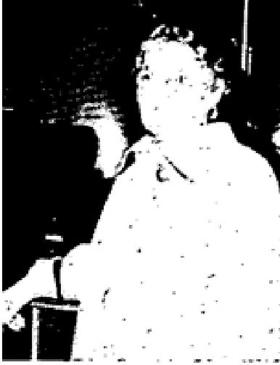

May God's blessing rest upon you, as you go from place to place bringing deliverance to those who are bound.
Sincerely,
Pancy Brown, 1121 Jackson, Columbus, Indiana
“I know this to be true and can witness to this marvelous healing."
Leslie Brown (husband)
PRAYER RESTORES FAILING SIGHT AND HEARING Dear Brother DeGrado:
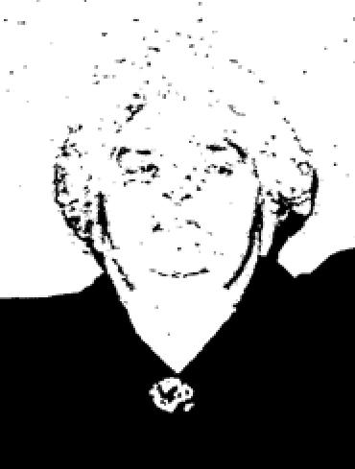
Thanks to you and the Great God we love and serve for the marvelous deliverance, that has been wrought in my body.
I was fast losing the use of both my eyes and ears.
The night I came through the prayer line in you revival in Chico, California, my sight and hearing were almost gone, But, thanks be to God. He healed my eyes and ears INSTANTLY when you prayed for me that night, and I am able to see and hear again. I praise the Lord for having sent you our way. May God continue to bless and use you in this marvelous way.

THE VOICE OF HEALING 1954
Yours in Christ,
Mrs. Alice Pedlanto, Rt. 1, Box 162, Carming. Calif.
July 1954 p28
Does God Heal the Sick Today through Handkerchiefs and Aprons?
HEALING FROM TUBERCULOSIS AMAZES FRIENDS
In 1951, I was in the Sanatorium at Tyler, Texas. on the critical list with tuberculosis. I weighed only 118 pounds. I wrote you for a cloth as I couldn't get to your campaign you were conducting in our city. I was healed and immediately began to amend after I placed the cloth on my body in faith. Soon I was placed on gradual exercise and began to work part time at the laboratory. On December 17, 1952, I was discharged. Now I weigh 167 pounds. People are amazed at my appearance. I wish to thank you for your prayers.
A. A. G, Huntsville, Texas
PAINFUL GROWTH VANISHES
Over a year ago, a growth came on my right temple, a dark colour, about the size of the end of my little finger. The pain got severe; the whole side of my face would draw or twist, causing discomfort and suffering. A doctor told me the growth was cancer.
One night, my husband turned on the radio as you were beginning your program. You said, "I want to pray for the sick and suffering right now. Place your hand on the radio." ... I did, and almost instantly the pain was gone. That drawing and twisting sensation left immediately. The growth gradually got smaller; now only a small light pink scar is left. It has been two months now since the healing took place, and I praise God for His power to heal, even over the radio.
Mrs. W,WM, Hatfield, Ark.
ENLARGED HEART BACK TO NORMAL
A few weeks ago, I had a big lump under my heart; I thought my heart was swollen. I did not go to the doctor, because I was afraid he would tell me I had heart trouble. I sent for a prayer cloth from you, and since I placed it on my body, praise the Lord, the lump is all gone. I can't thank and praise Him enough,
E, M., Hughes, Ark.
HEALING FROM RHEUMATIC FEVER ASTOUNDS PHYSICIAN
Last June I was bedfast, and could not move myself at all. My joints were swollen and so sore I could hardly stand to be moved. The doctor said I had rheumatic fever. He wanted me to go to the hospital at once. But then I received your blessed cloth. It was laid on my body in prayer, in the name of Jesus, and the next day I was getting up and sitting in a chair without any help. The swelling and soreness gradually left, and my strength returned. In a short time I was doing my house work again. The doctor was amazed at the way I had improved.
Mrs. E. K. Beechwood, Ky.
DELIVERED FROM CANCER OF STOMACH
I have been slow to write you, as I have been waiting for results I have been in a serious condition. The doctor said I had cancer of the stomach. I had 23 X-rays taken. He would not tell me just how bad it was, but warned me that if I was not very careful, I would not last long. Thank God, I don't have to worry about this now.

THE VOICE OF HEALING 1954
I wrote in and requested your special prayer for me. Now I thank God that my cancer is gone. I can eat anything and as much as I want, and nothing hurts my stomach in any way
I also had severe kidney trouble. Only God knows the severe pain and discomfort connected with this ailment. Praise God every symptom and every pain is gone. I am perfectly normal. I am new from head to foot. You may use my testimony if you wish. I know it will help someone else believe and get their healing, too.
G. F, Lagsdon, Pueblo, Cob.
SCAB-CANCER DISAPPEARS
I received the healing cloth that you sent to me while you were in Terre Haute. Ind., and I placed it on a scab
cancer on the back of my neck. The cancer completely disappeared in ten days.
C.O.W., Waycross, Ga.
STOMACH DISORDER, CHRONIC COUGH HEALED
I used the prayer cloths you sent me. Relief from a pain in my stomach which had distressed me for years came immediately and has never returned. Another cloth which I requested for my brother, was in my brief case when I stopped at my daughter's for a while before going to visit some 300 miles distance. At my daughter's, her 9-year-old boy had a chronic cough which is greatly increased when he gets a cold. The cloth being blessed for another party, I hesitated the first night to use it, but the next night I felt it was advisable and wise that I give the child a blessing he so surely needed. The child's cough ceased and at 2 am., his mother came in the room
Inquiring 'What has stopped his coughing." I then explained.
Mrs. L P. Hoyt, Phoenix, Ariz.
80-YEAR-OLD HEALED OF CANCER
I am so glad and thankful that I can report to you that I am healed of cancer. Oh how I praise God for His Healing power! I'll be 80 years of age this Feb and the doctor told me I had less chance of getting well than a younger person. I had nothing to look forward to but an awful death. The cancer was on my breast and caused much pain and swelling. It was still growing when I wrote to you for prayer. Now all the pain and swelling are gone. How I do praise and thank God, and thank you for your prayers.
Mrs. L. W.
Kerrvillle, Texas
TUBERCULOSIS GONE, ONLY SCARS REMAIN
I received a prayer cloth from you that was anointed, and I want to thank you, and all that prayed for me. I am so thankful to our dear Lord Jesus that my T.B. is gone ... I was bedfast, and didn't think I could ever be free from T.B. But now I am free. I went to my Doctor, after I had received the cloth. He fluoroscoped my lungs, and found no sores, just scars. Oh. I do praise the Lord for what he has done for me
Mrs. W. It. W., Louisville, Ky.
CRUTCHES THROWN AWAY
I received the two prayer cloths you sent me. I laid one on my broken leg and one on my shoulder. Praise God, I don't have to use my crutches any more, and my shoulder doesn't hurt either. I truly praise the Lord with all my heart that the work is done. I did have a little trial though .... I thought my voice had left me, after God had so wonderfully healed me of the other. I laid my prayer cloth on my throat and asked the Lord

THE VOICE OF HEALING 1954
to give me my voice, and it came back. How I thank God for His healing, and for men like you that he can trust and use for His glory.
Myrtle Staggs, Valley Station, Ky.
CANCEROUS GROWTH VANISHES
Some time ago, my daughter sent to you for a prayer cloth for me and also your book "God Will Heal you." I had a cancerous growth on my face. I read the book, and it inspired my faith so much. I placed the cloth on my face, and God's mighty power went through my body. My faith reached out for my healing and complete deliverance. Now the place is almost gone, and oh, how I do thank and praise God for His mighty healing power. I praise Him also for the men He has called out to preach the messages of deliverance,
Mrs. L R. Brookeland, Texas
July 1954 p29
GROWTH ON FACE DISAPPEARS
For about two months, I had some kind of growth on the aide of my nose that spread under my eye. It grew so rapidly and was in the way of my wearing glasses. I decided to see a doctor. He told me that he would remove the growth and have it analyzed. I made an appointment to return to have this done. However, I did not keep the appointment, but decided to trust God to remove this growth. You sent me a prayer cloth. I placed the cloth on the growth, and now it is gone. I praise God for the healing and for His good ministers that are always so ready to help.
Mrs. Ada Hendrix, Canyonville, Oregon
YELLOW JAUNDICE HEALED
I received your prayer cloth, thank you very much. My wife was very sick with yellow jaundice. She pinned that cloth on her the same day she received it through the mail. The next day, my wife was well. She is now up and around, doing her own work. We thank our dear Lord. He Is a wonderful Saviour.
Mr. G. A. G.,Terraville, So. Dak.
ALCOHOLIC DELIVERED
A few weeks ago, I wrote for your book, "DEMON POSSESSION TODAY, AND HOW TO BE FREE." After reading It, I sent for two cloths, one for myself and one for my son who is an alcoholic, Just a week ago, I got a chance to send him the cloth, by his mother, When she offered the cloth to him, he laid it aside, saying he might use it sometime. But even just touching it in that way, it had an effect on him, just the same. A few days later, on his way to visit me, he bought a drink, but couldn't drink it. He had suddenly lost the desire for it. But he decided to take it with him. Just before he got home he forced himself to drink it, and it made him sick. A few days later some of his friends got him to go on a spree with them, Afterward, I went to their house to get him. On the way home, he confessed that something had happened to him. He wrapped his arms around his old dad, and cried out to God.
Within an hour, he had been converted. The unclean alcoholic demon had to go. The sick are not the only ones who need an anointed cloth.
O. D. R. Mississippi

THE VOICE OF HEALING 1954
August 1954 p13
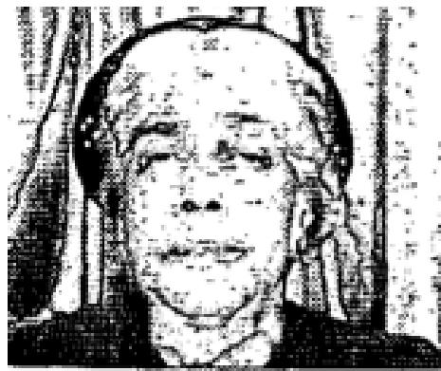
Spared Operation
I had been ill for many years. The doctor told me that an immediate operation was
necessary to cure me of my illness. This operation would cost a great deal of
money, and I could not afford it.
After you prayed for me, God healed me and now I feel wonderful. Mrs. Foster Parka, Dalton, Pa.
Seven Pound Tumor Vanishes
One night during your Hazelton, Pa., revival you picked me out of the audience and
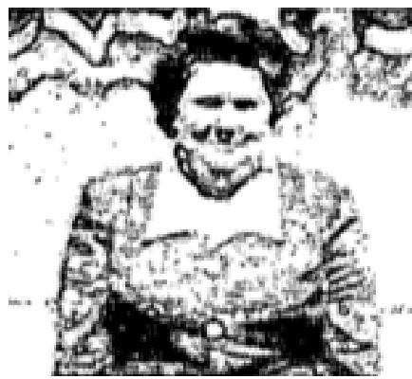
told me: “ A seven-pound tumor just left your body." I could feel God's power all
over me, and from that night on I never felt
better in my life. My waistline went down shortly thereafter.
I want to give God all the praise and glory for healing my body. Mrs. Joan Mitchell, Moseau, Pa.
Kidney Trouble Discerned and Healed
During the second night of Evangelists Hayes' and Noah's Healing Campaign, Brother Hayes picked me out of the audience and told me I had had a kidney condition for about 12 years, which I knew was true. He also told me of a few other ailments which I did not know existed. He told me that right then I was being healed in Jesus' Name. The next day Satan tried to steal my healing, but I rebuked him in Jesus' Name, and I
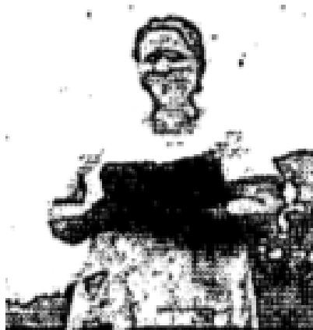
still have my healing.
Now I feel fine for by His stripes I am healed.
Mrs. John Laird, Scranton, Pa..

Healed of Stomach Trouble
During the Hayes and Noah campaign in Blush., New York, I felt led to go through the healing line and he prayed for me. I had been troubled with my stomach for years. Many things I could not eat without it hurting me.
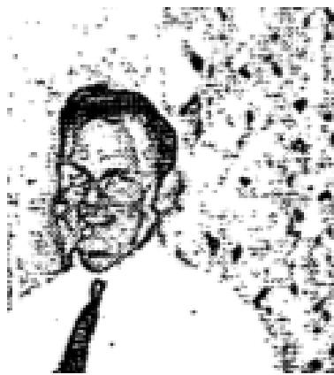
Some things I would eat would cause a pain in my stomach as soon as they entered, One thing was home-made bread, which I loved but could not eat. But thank God when I went through the healing line and Brother Hayes prayed for me,' believed that our Christ would heal me. Brother Hayes said the Lord showed him that I had three small ulcers in my stomach. Thank God I can now eat anything.
Rev. Marion Houghtaling, Westfield, Pa.

Eye Healed of Injury  About two weeks before the Hayes-Noah Meeting came to Scranton a needle flew into my right eye. The needle had been removed but severe pain continued in my eye and the the right side of my face. I had been to two different doctors and also had x-rays made, but still had the pain. On the fifth night of the meeting I entered the healing line. As you laid your hands on me you told me my faith had made me whole. Praise God Forever! It has been | 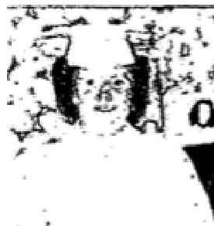

THE VOICE OF HEALING 1954
three weeks since and I haven't had the slightest headache, or pain, and I haven't had to wear my glasses since. Thank God for a mighty miracle.
Elizabeth Lestik, Dickson City. Pa.  Heart Condition Healed  I took my daughter, Rachel, who is six years old, to a revival meeting being  conducted by Evangelist Alton  Hayes, In Scranton, Pennsylvania. She was under the doctor's care at the time for  her heart, which  he said was not normal.  A few weeks later we took her back to the doctor for an examination. Much to his surprise, her heart was beating perfectly. He could not understand what had happened. | 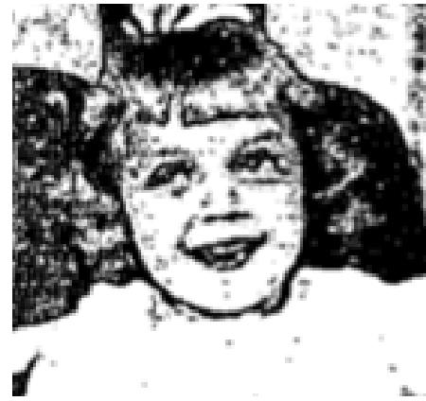

Rachel had been instructed to have only light activity, but after prayer, she ran around an any normal child would.
I certainly thank God for restoring her heart to normal.
Mrs. Mary Katzmanyk, Scranton, Pa.
Gets General Overhauling
Over a year ago my doctor told me I had a serious heart condition. I was not to go up and down stairs, climb hills, or do any heavy work. If I should have this severe pain in my chest I was to stop, even if in the middle of the road, as just one step could mean death.
I had a sacroiliac strain from lifting my ill husband. When I walked outdoors it felt as if my spine and hips were lead. I could hardly lift my legs to walk. The doctor told me nothing could be done for it. For a number of years I had been unable to raise my left arm over my head, or put it in back of me. I had diabetes for a number of weeks, and also had a lump under my right ribs that caused me severe pain.
I was prayed for by Brother Hayes and, praise God, the lump is one, also the pain in my right side. Tests showed no sugar. I can bend over, and have no trouble with my heart. I can walk outdoors without any distress, and can use my left arm in a normal way.
Ruth Singer
August 1954 p14, 15
Infected Foot Healed
Six months ago my foot became infected from an in-grown toenail. I went to a doctor and it improved for
awhile but then grew steadily worse.
Brother Karol prayed for me; the pals stopped immediately and, three days later, while looking at the toe, the nail straightened out with a snap and the swelling began to go away. It is completely healed.
Lorne Vandermerk, Matamoras, Pa,
Sinusitis and Eyes Healed
Since childhood, I have had weak eyes and have had to wear glasses with special lenses. During one of
Brother Karol's meetings I took off my glasses and asked him to pray for my eyes.

THE VOICE OF HEALING 1954
I am a school teacher and use my eyes constantly through the day. I have been able to do my work without my glasses, and have experienced no difficulty, or ill effect.  Besides undertaking for my eyes the Lord also healed me of a catarrhal ailment and sinusitis.  Myra Beers, Port Jervis, N. Y. | 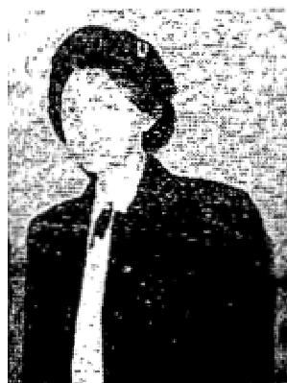

Crossed Eyes Healed
In July, 1961, Brother Karol prayed for my eyes which had been crossed since birth. I had worn glasses since I was 16 months old. At the age of seven I had had four operations, but I still had to wear my glasses continually. and my eyes were still crossed, one eye was sunken.
I do accounting work 8 hours a day, go to school 3 nights a week, and study almost every night. Since being prayed for I have not worn my glasses once.
Jeanne M. Washer
Healed of Enlarged Heart  In August, 1951, I was overcome by physical exhaustion. Before I knew the seriousness of my condition a specialist, and a professor of medicine, were telling me I was to forget about preaching and take a complete rest physically, as well as mentally, for the X-rays, cardiograms, and other tests showed an enlarged heart and circulatory diaturbances.  The blood refused to circulate properly through my heart and the result was extreme pain. So serious was my condition that I was forbidden to even read my Bible. The rest period lasted for six months with  little change in my condition. Talking and singing gave me much pain. The Holy Spirit was faithful in bringing to my remembrance the many promises of the Lord. | 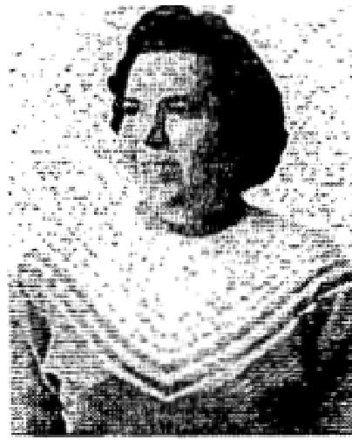

On a Sunday night I attended services in Moosie, Pennsylvania. where THE KAROL EVANGELISTIC PARTY was conducting a healing campaign. I was prayed for; the power of God went through my body and I knew God had healed me. The following Friday I went to Scranton. Pa., where a specialist took X-rays a of my heart. He sent them to a specialist in New York both confirmed the miracle which the Lord had wrought. My heart is now normal, and the circulatory disturbances have ceased. I can now sing and talk without pain. Unto God be all the glory.
Evangelist Mary Abate, Pittston, Pa,
Whole Family Saved and Healed  I have always believed in God, but the only time I would go to church was when I could not find an excuse to stay away. We were anxious for our children to go, and never stood in their way. My neighbor invited me to the Port Jervis Revival Center where THE KAROL EVANGELISTIC PARTY was conducting a healing  campaign. After much persuasion, by our children, we decided to go. After my first visit I decided that I would not go back, but a strange inner urge caused me to return.  At the close of a stirring message, I went forward and gave my heart to God. I then asked for prayer for my left ear. Twenty years ago I had a mastoid operation and it left me deaf in my left ear. Two years ago I went to New York City to have an | 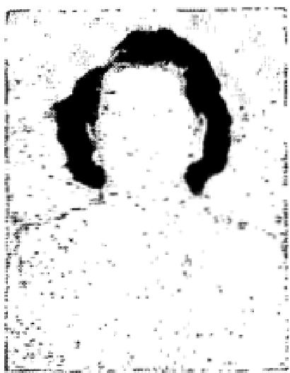

THE VOICE OF HEALING 1954
operation, but was informed that it would cost about $5,000, and still they could not guarantee that it would be successful.
The Lord healed me instantly and now hear perfectly.
My mother, who was suffering with arthritis so bad that she often talked of suicide as a way out of her misery, saw what God had done and came to the meeting seeking help. That night she gave her heart to God and the arthritis disappeared. For the first time in years she could bend her knees.
My son had an in-grown toenail and it pained him to wear his shoes, One night during the preaching the toenail just popped out.
My sister-in-law, who had a nervous breakdown, and could get no relief from medicine, came and gave her heart to God and was healed. Other members of our family came and were saved.
Our gratitude to God, and to the Karol Evangelistic Party.
Mr. Crane Vandermark, Matamoras, Penn.
Dear Bro. Karol,
When you prayed for me to Receive the Baptism in the T.V.H. Convention at Chicago. I felt the Power of God go through my body. On the way home I continued to Praise God. I was Baptized with the Holy Ghost and Fire before I got home. I went back to the service the next night end when I shook hands with you, I felt the Power of God in my hand. I went back to start a revival in my church at St. David, Illinois.
I was pastoring a Nazarene church at the time I received the Baptism. God it surely blessing the Nazarene Churches and I love all the Nazarenes, But God showed me more light and I must needs walk in the light. Praise His sweet name. Bro. Karol, I felt the anointing in my hand the first person I prayed for which was about three days later. The person was going blind and was healed instantly. I prayed for her daughter-in-law and she was healed from ulcers. She said she felt the Power of God go through her whole body. God has given me many healings since, and the anointing has been on me ever since to pray for the sick. I feel the T.V.H. Convention was a great success and I plan to be at the next one if at all possible. God has called me into the Healing Ministry as an Evangelist.
Evang. John Tolliver, St. David, Ill.  August 1954 p20  Growth On Child's Neck Vanishes  Our daughter Linda is eleven years old. She is saved and three years ago. February  12, when you were in Jamestown, the Lord baptized her in the precious Holy Spirit.  About a year and a half ago, she tripped over a boy in gym at school. As she fell she injured her neck. She was bothered at times with a stiff neck and soreness. It would also make a cracking sound when she turned her head. A Chiropractor refused to work on her. | 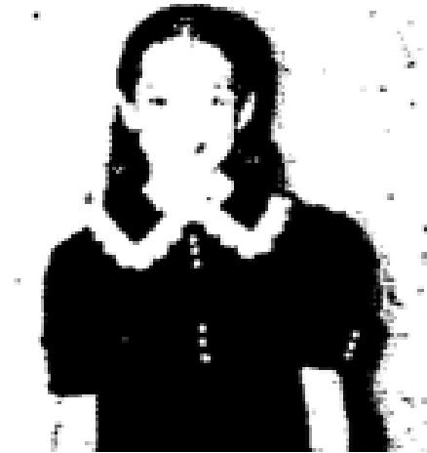

A lump formed on her neck half the size of an egg on the outside just below the
hairline and twice since Christmas she has fainted. A year ago, after having scarlet fever I took her to the Pediatrician for a check up and to get her certificate to go book to school. I asked him to look at her neck and he suggested I take her to an Orthopedic to have a cast put on. As we left his office I said, “Honey, we will trust the Lord for this."

THE VOICE OF HEALING 1954
On Friday evening, January 15, 1954, she went in the healing tine to he prayed for. Suddenly as Sister Kellner was praying for a man, Linda felt a warmth go through her body. Also it felt like there was something wet on her neck so she reached to feel and discovered the lump was gone. Saturday morning a sack the size and shape of an egg and bright red in color passed from her body.
She is feeling wonderful in body and spirit. We give all the glory to Jesus and praise Him for healing our little girl. Praise the Lord.
Mrs. La Verne H. Watcher, Jamestown, New York
To whom it may concern:
Mrs. Wood burn is a faithful member of Calvary Assembly of God Church and Linda a member of the Sunday school, and I have every reason to believe that the facts as stated in this testimony are essentially true.
Sincerely
Rev. Russell D, Goodwin
Pastor
Serious Throat Condition Miraculously Healed
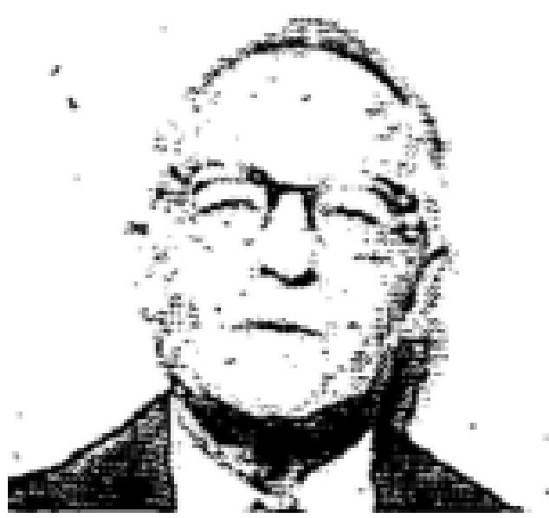
I was taken ill with a bad throat condition. X-rayed and examined and the trouble was pronounced infection in the white bone of the windpipe. I was under treatment by a good physician but my condition became worse.
I went to a throat specialist and used much penicillin dust but it failed to help. I then used the miracle drugs. This went on for about two years.
Finally I was reaching to the end of my endurance. My voice was failing and I was weak. I could not swallow, as no much of my throat was gone. The doctor said the adam's apple was turned brown. I don't know how much of the wind pipe was gone, it had been infected two years. I held my head away from people because my breath smelled so bad. The druggist looked like he thought it would be the last time I would be in there for medicine each time I went to him.
I went to church at the Evangelistic Temple in Pittsburgh, Pennsylvania, in January, 1953. The Kellners were there holding meetings and praying for the sick. The Lord seemed to say, "this is your night or never."
I went determined I would be prayed for if I had to stay until twelve o'clock.
I was prayed for depending on their faith only. At once I felt the power of God in me. I felt like I could breathe all the air in the country. I knew that the infection was killed. For about three days my throat became more sore because it was healing. Today I can sing again and I have a good voice.
About six months after I was prayed for I went to the Tubercular League Hospital for an examination. I was examined by a flouroscope machine: He turned me different ways and looked at my throat and chest. He could see where the wind pipe bone had healed and grown back and the throat was healed. He said the wind pipe was thicker where it had been gone and also said. "You have no cancer. There is nothing wrong with your throat." I am thankful to God and to the Kellners. I know there is no case too hard for our God.
J. B. Stutter, Pittsburgh 31, Pennsylvania

THE VOICE OF HEALING 1954
Cripple Healed By the Power of God  I fell from a six-foot stepladder. January 30, 1941, while working remodeling a building. Not realizing the extent of my injury, I did not go to a doctor until the following August. By that time I was so lame it was almost impossible for me to walk or do my work. I was X-rayed and it showed that the gristle cushion in the ball-and-socket joint was crushed and destroyed. Also that the left side of my hip bone was shoved up and  out of place so it was close to my short ribs. I took over one hundred Chiropractic treatments but received only temporary relief. | 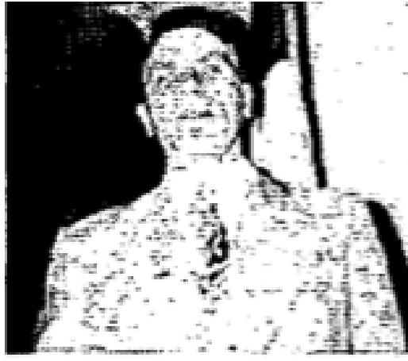

In 1949 I visited a medical doctor and he told me that arthritis had set in. He told my wife that I would be a wheel chair patient within three years.
For 13 years there was never a day I was without pain. Many times it was excruciating. I was able to sleep only on the flat of my back with my hands at my aides. if I laid on either aide for only a few minutes my legs ached unbearably from my hips down. I was so lame that some of the men nick-named me "Limpy."
On November 8, 1953, Brother and Sister Kellner came to our assembly to hold a Salvation Healing Campaign. On the tenth of November I went forward to be prayed for. Sister Kellner prayed for me and the Lord in His mercy healed me. Now the limp has gone!
Two days later I said to one of the men I work with, “Do you see anything different in me?" He said, "Why, Jimmie, the limp is all gone!"
Now I can sleep on either side and awake without any pain for which I praise God. James A, Frye, Turtle Creek, Pennsylvania
September 1954 p13
Delivered of Pain
All my life I have had hemorrhoids in the worst stage I believed in God for healing, and as Rev Kelly
prayed for me all the pain left.
For two days prior, and all during the evening service, I was suffering, but, as this man of God prayed, God delivered me completely
Mrs Mary Kelley, Flint, Michigan
Growth Discerned, Asthma and Lung Trouble healed  On June 6, 1954, after service, I went op to Brother Kelley and began to tell him just how I felt in my body, but Brother Kelley interrupted me by saying "Look straight into my eyes" I did, and this is what Brother Kelley told me "You have a growth in back of the bowels" Praise the Lord, Brother Kelley rebuked that  thing and demanded it to loose itself and come out. It left instantly.  I was also healed of asthma and lung trouble  Lee Frank, Flint, Michigan | 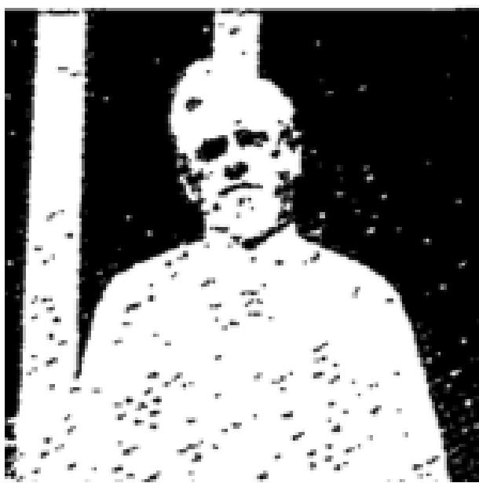

THE VOICE OF HEALING 1954  Healed of Headaches  I have had headaches ever since I was in an automobile accident nine months ago. When Brother Kelley prayed for me God healed me, praise His name. It really seems wonderful not to suffer those awful headaches any more  Vivian Duford, Flint, Michigan | 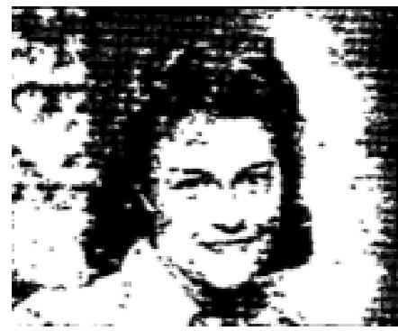
Healed of Sinusitis and Arthritis
For months I have suffered with sinus trouble and arthritis. I came to the tabernacle, heard God's word and believed Him for my healing. Brother Kelley told me to look him in the eyes. I did, and then he asked me where my pain was. It was all gone, and praise God, it has never come back
Mrs Elizabeth Kipfer, Flint, Michigan
Healed of Pain in Chest
I had been sick for shout six months. My nerves were so had I could not sleep or rest well at night.
Last Sunday I was suffering in my chest. Brother Kelley said, "There is a lady out in front of me who had a pain in the left side of her chest. If she would stand up she would be healed. I stood up and the Lord healed me.
Mrs Willis Abney, Flint, Michigan
September 1954 p14
Hearing Restored
For about five years, I was very hard of hearing I always sat in the second pew from the front, but could not hear the organ playing, just a few feet away, but now, when I go to church, I can enjoy the beautiful music, for when the Reid Party were at Glad Tidings, in Shreveport, Louisiana, I was prayed for, and my hearing was completely and perfectly restored.
Mr G W Lane
Shreveport, La
Sight In Right Eye Restored
Presumably the sight in my daughter's right eye had always been bad, but we were not completely sure until Thelma Lee, our 9-year-old daughter, began her first year of school. It was then we discovered the sight was so had in that eye that to read her books, it was necessary for her to turn her head on the side to see out of her good eye. We took her to our family physician, he checked her eyes, and informed us she had no vision out of the right eye. She was told to guard her left eye with her life an she'd never be able to see out of her right eye but, of course, he wasn't counting on the Master Physician to undertake.
We're overjoyed to report that, since Thelma Lee was prayed for by Tommy and Brother Reid, when they were at Glad Tidings in Shreveport, in January. 1954, God has completely restored the sight in her right eye. After the revival closed, we took Thelma Lee for another checkup by the doctor he gave her the typical eye test and found her vision perfect.
Mrs W H Schaefer, Shreveport, La.
Sinus Condition Healed
I had been bothered with a sinus condition for 20 years, and at times I would be in bed for weeks. I went to numerous doctors, but they could only give me temporary relief, but I finally went to One who gave permanent relief.

THE VOICE OF HEALING 1954
On January 10th I was in a revival meeting held by the Reid Evangelistic Party at the Glad Tidings Assembly of God, in Shreveport, Louisiana, when God laid on Brother Tommy's heart to call three people out of the congregation to pray for their healing I started to leave my seat and go to the platform when I saw there were three others ahead of me, so I prayed at my seat. Tommy Said there was someone in the congregation who was suffering with a sinus condition, and he would pray for that one first. I prayed along with the others, not knowing who he was praying for. As I sat in my seat praying for the one with sinus trouble. God healed me, but I did not realize it at the time.
I waited about ten days for someone to testify to their healing. One night God spoke to my heart saying, “I healed you of sinus trouble, now it is time to tell others about it.” I testified to God's wonderful healing power. I have not been bothered with this trouble since that night when God healed me.
Praise the Lord for the Full Gospel Church, and for His wonderful healing power! I'm certainly thankful that God sent the Reid Party our way. May God richly bless and keep them in the service for the Master is my prayer.
Mrs R. O. B. Hawthorn., Shreveport, La
Hernia Leave
I suffered terribly with hernia, for about 10 years. At times, I could not do my work, and had hemorrhages, (as many as two a week). While the Reids were in Shreveport, I was prayed for, and healed by the power of Jesus. The doctor had told me that I never would be able to go without some form of support, but Praise the Lord, I do not have to worry about that now, for He has completely healed me.
Mrs G W Lane, Shreveport. La
Bronchial Asthma Healed
My little daughter, Gloria Lee Bradley, who is just one year old, had been afflicted with bronchial asthma,
since birth. She ran high temperatures, had constant colds, and had a wheezing in her chest.
When the Reids came to Shreveport, she was prayed for, and God completely healed her. Since that night she has had no attacks of this ailment at all. Previously to this, she had such bad attacks that a vaporizer had to be used day and night. We had to give her a cough syrup and a wheezing medicine.
The next morning after she was prayed for, she coughed up about a tablespoon of phlegm and after that, the wheezing left. It ii wonderful what God can do, if we'll only believe.
Mrs H L Bradlev, Shreveport, Louisiana
September 1954 p15
Rare Skin Disease Healed
Friday night, May 28, 1953, in Brother Bennie Harris' tent revival God spoke to me regarding an affliction of the skin which kept me from being out in the sun and wind like other people. My skin would turn red and weep with fever and the itching was almost unbearable. I knew it was not God's will for me to have this so I entered the healing line and Brother Harris prayed for my deliverance.
On Sunday, May 30, 1 went to Sunday School and church in the morning and to the afternoon service in the tent. The sun was hot and the wind blew constantly but I praised the Lord continually for healing me and keeping me from the awful fever and pain usually resulting from the sun and wind. What a precious blessing was mine when I awoke the next morning. My face and arms were perfectly normal, just as though I had never been out in the sun and wind. I give the Lord all the glory Praise His wonderful Name.

THE VOICE OF HEALING 1954
Minnie C Lane,
Champaign, Illinois
Bronchitis Healed After Twenty-four Years
I praise God for my healing during the Harris Healing Campaign here in Lincoln, Nebraska. For the past twenty-four years I have been bothered with bronchitis, which was not only a handicap but caused me much embarrassment. I had taken treatments, including pencillin shots, which gave only temporary relief. Doctors have told me they did not know of a cure for my condition.
In September, 1953, 1 entered the healing line and Brother Harris prayed for me, in the Name of Jesus, that his bronchitis condition would be removed forever. Praise God I had taken about five steps when I realized the tenseness in my bronchial tubes was gone. I thank God for healing me Jesus is wonderful, I love Him.
Mrs Grace Hendrix, Lincoln, Nebraska,
Growth Disappears After Prayer
Our ten-year-old son, Carry, was injured in his nose at birth. As he got older his nose closed up on the right side. The tissue had grown from his nose to the ear drum. We had taken him to many doctors but nothing could be done without a serious operation. His breathing was so loud it was hard to sleep in the same room with him. Every morning his lips would he cracked and bleeding from breathing through his mouth. He was prayed for by Brother Bennie Harris and immediately his nose opened and he breathed naturally. His appetite has become much better. He had never seemed to have an appetite, for which the doctors blamed his nose condition. He is healed and we give God all the glory.
Mrs Hobbs, Evans, Colorado
Polio Victim Instantly Healed
I am happy that I have found Jesus Christ, not only as my Saviour, but as my Healer. Truly in Him I have
found that complete joy, peace and satisfaction which this world cannot give, neither can it take away.
I had polio which left me with a defective spine. The doctors said I would have to be under treatment for a year in order to prevent permanent disability. Then the Bennie Harris revival came to town I attended several nights but at first let the devil defeat me. On Friday, September 19, 1953, I responded to the invitation and yielded to God. Brother Harris prayed for me and God healed me. The next day I went to the doctor and he could find nothing wrong. He signed a statement saving my back was well I shall never cease to thank God for answering prayer.
Barbara Schnepp, Lincoln, Nebraska  After Thirty-eight Years, Backache Gone  I want to praise my precious Saviour for what He has done for me. I suffered with backache for almost thirty-eight years, but praise our Lord when Brother Harris prayed for me I was healed. We need not be discouraged for He can do exceeding abundantly above all we ask or think.  Anna M Bartman, Jeffersonville, Indiana | 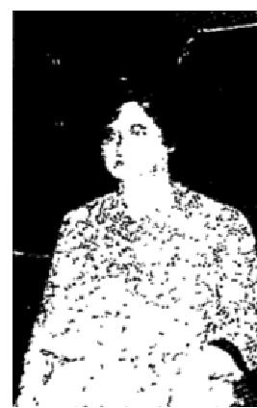

September 1954 p17
Healed of Deafness
I came to the Nankivell meeting seeking help for a deaf friend, by bringing her, because her need was so
great. Although I did not hear your invitation to come forward, my friend pushed me and said, "Go up."

THE VOICE OF HEALING 1954
About thirty years ago I had a mastoid condition in my right ear which left me unable to hear in that ear. Jesus is wonderful, and as you prayed I was healed and sound began to come slowly and I could hear your voice. That night I listened to your message. The next morning I heard your voice over the radio and as I sit here I can hear clearly. Praise the name of the Lord for His wonderful work.
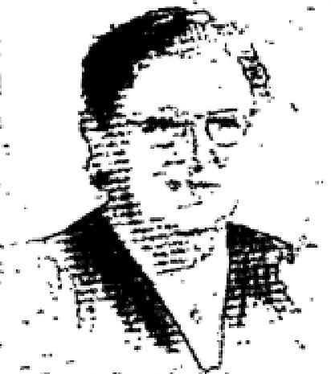
This letter may be used as Christ lays it on your heart to use it, as a testimony to His love and power.
Grace May Stanley, Melrose, Mass
Healed of Rhinitis and Lump in Left Breast
For 25 years I had suffered with Atrophic Rhinitis. Louise Nankivell came to
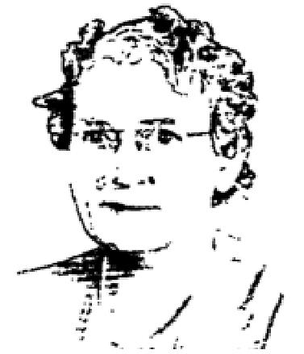
Haverhill, Massachusetts, to hold some services for the healing of the sick and I
decided to attend. On a Monday night I stood before the
servant of the Lord, dear Sister Nankivell, and she prayed for my deliverance.
While she was praying for me, I felt the power of God going through the right side of my body, and I went off the platform with the assurance that God had healed me.

Now I no longer have to snuff warm salt water up my nostrils to wash out the hard scabs that used to form in my head and nose. My sense of smell had nearly vanished, but I can now enjoy the fragrance of the flowers.
Later I was called out of the audience by Sister Nankivell to be prayed for, for a lump on my left breast. This work was completed in just a few days after special prayer in my behalf. I honestly believe I was spared from having an operation.
I have written this testimony of divine healing to strengthen the faith of all who read it. Mrs Lucy D Prince, Havershall, Mass
Delivered From Body Brace
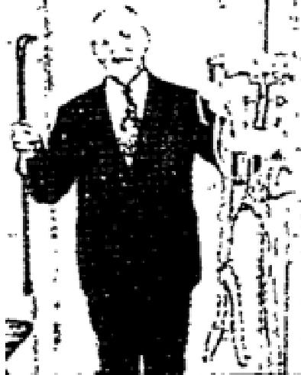
I want to praise the Lord for a wonderful healing in my body. Two years ago in October, I was stricken with an affliction that required two major operations. While at the hospital in New Orleans, in an unconscious condition, I fell from the hospital bed fracturing my spine and crushing it in on both sides. The doctor there said that I would he crippled and would have to wear a big body brace the rest of my life. So he fitted me with one.
While attending Sister Nankivell's meetings in Baton Rouse, Louisiana, March, 1954, she called me out of the audience, laid hands on me and prayed for me, binding my affliction. The Lord instantly healed me. I went into the prayer room and removed the brace, walking out perfectly normal, without either brace or cane and without any pain. Thanks be to the dear Lord for sending Sister Nankivell to our city.
Signed,
Arthur Hilbun, Kentwood La
Endorsed by Rev Ira M Bryce, Pastor Calvary Assembly of God, Baton Rouge, Louisiana

THE VOICE OF HEALING 1954
Prayer Delivered from Brain Concussion and Nerve Shock
Eighteen months ago, I was in a car accident I received a brain concussion, injured knees, (all ligaments torn,) and nervo shock. Also my mind would be blank from one to four hours. I read in the Buffalo paper about the Divine healing meetings with Sister Louise Nankivell. I asked some friends to take me to the meeting, but they were afraid to take me because of my condition. I then asked Jesus if He wanted to heal me to give me the the strength to go by bus. As soon as I walked into the Temple I knew that I would be healed before I left the building.
When Sister Nankivell gave the altar call, I responded and went to the prayer room and was asked to kneel down. As I went down, the Lord healed me I had not been able to kneel for eighteen months. Thank God he healed my mind, ligaments, nerves, and made me perfectly whole. I went into the healing line, not to be prayed for, but to testify to my healing.
Bertha Opsitz, Buffalo, New York
Endorsed by Rev Ralph E White, Pastor, Bethesda Revival Temple, Tonawanda, New York
Delivered From Metal Braces on Both Limbs  I want to testify to the healing of my daughter Lynda.  Lynda has been a polio victim since she was 5" months of age. She is now nine years old and has been wearing metal braces on both feet and legs.  When I heard of the Louise Nankivell meeting in Haverhill, I decided to take Lynda for prayer. | 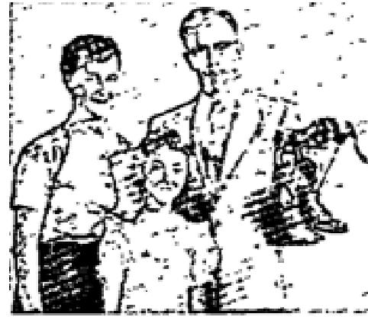

After Sister Nankivell prayed for her, I took her to the prayer room and removed the shoes and braces. Praise God, Lynda walked out on to the platform, in her bare feet, unaided, before all the people, in a full building, as a witness that God had wrought another miracle.
I had an appointment with the clinic which I was obliged to keep. So on Wednesday I took Lynda for her routine check-up. The nurse looked in astonishment, and said to me, "What have you been doing with her feet and legs? You must have worked on them a lot." I told her that I hadn't worked on them, but that I had her prayed for and that God had healed her. We are praising God for all that He has done.
Signed,
Lynda's mother, Mrs Benjamin Simpson, Haverhall Mass
Endorsed by Rev Clarence Temple, Pastor, Assembly of God, Haverhall, Mass
September 1954 p18
Eye Glasses Discarded - Growths Vanish
I was going to have surgery for growth on my female organs. I was healed in the Grant Revival, in Houston,
Texas. God also healed me of very bad eyes and I discarded my glasses. I could see faces plain for the
first time in two years.
Mrs R E Davis, Houston, Texas
Cancer Disappears From Face

THE VOICE OF HEALING 1954
There was a roaring in my head for three years. God gave me instant relief in the Grant Revival, in Houston, Texas. A skin cancer which had on my forehead for fifteen years dropped off.
Mrs Virgil Fry, Houston, Texas  Osteomyelitis Healed  I had osteomyelitis for 13 years according to the physicians. I still have the X-rays and  written statements from the doctors. There were seven openings in my leg at one time.  I used to preach and pray for the sick from a wheel chair. Then I used crutches.  The corruption soaked a hall bath tub full of towels once God healed me in Brother Grant's Revival, in Houston, Texas. I am now normal, the leg is like the other one, except for the scar.  Rev O N Petty, Houston, Texas | 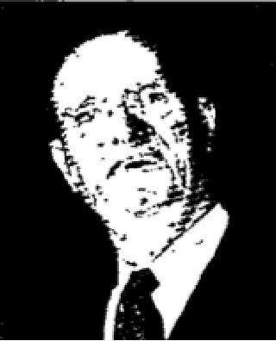

Ear Drum Replaced - Roaring Gone
I had no ear drum for 37 years. My head would ache and roar. I wore glasses for 14 years. I feel years
younger and can see and hear since I was healed in the Grant Revival, in Houston, Texas.
Mrs J O Chesney, Houston, Texas
Cancer Gone
God has healed me of female trouble and cancer of the breast, in the Grant Revival, in Houston, Texas. I am
now restored to normal health.
Mrs A J Hoffmaster, Houston, Texas
Cancer Disappears from Face  I had a cancer on the side of my nose for two years or more, which gnawed down into my cheekbone and affected my eye. It fell off instantly after being prayed for under the Big Tent, in the Grant Revival.  Mrs W L Stokey, Houston, Texas  Cancer on Face Healed  After I was prayed for by Evangelist W V Grant in the Big Tent Revival, in Houston, Texas,  I reached up to feel for the cancer and it was gone.  Robert A Gruff, Houston, Texas  Short Hip Lengthened  My right hip was shorter than the other. X-rays showed one leg to be three-quarters of an inch shorter than the other. The doctors said I should wear a built up shoe. God healed me in the Grant Revival, in Houston, Texas.  Mrs W A Perkins, Houston, Texan | 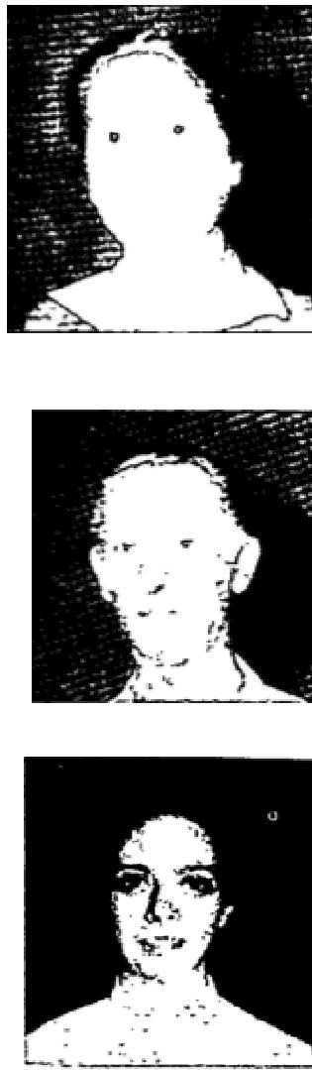

Useless Arm Normal - Paralysis Gone
In 1949, I had a stroke because of an operation. I lost complete control of my arm. The only way I could use
it was to take the other hand and pick it up. The doctors said nothing more could be done. I was instantly

THE VOICE OF HEALING 1954
healed in the Grant Revival, in Houston, Texas. I can use it in every way now.
B Battison, Houston, Texas
Growth Vanishes Instantly
I was booked for surgery for June 16, 1954, for a large growth under my ribs. I also had gall bladder trouble, heart trouble, and on ulcerated stomach. They all vanished instantly in the prayer line, in the Grant Revival, in Houston, Texas.
Mary Rains, Houston, Texas  September 1954 p23  Injured Back Healed  A chair slipped out from under me three years ago this caused severe injury to my back.  My doctor told me  the X-ray showed I had several joints in my back out of place. I had to have an  operation which would be very serious.  I had severe pains in my back and legs, especially at night or when I would lay down, so bad I could not rest. | 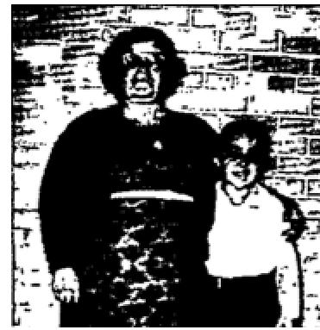

I also had an awful pain around my heart and had suffered several heart attacks. Brother Park layed his hands upon me and prayed, and Jesus healed me completely. Praise His holy name
Mrs Gunther E Miller, Sparta, Wisconsin
Large knot on Back Disappears Instantly  About ten years ago I was bitten on my back by a horse. This left a large knot bigger  than an egg, and it  bothered me all the time. Brother Russell B Park prayed for me and the knot left  instantly. It is gone completely.  I was also healed of sinus trouble and my lungs were hurting from a cold. This, too, was healed instantly.  Mary E Johnson, Spectra, Wisconsin | 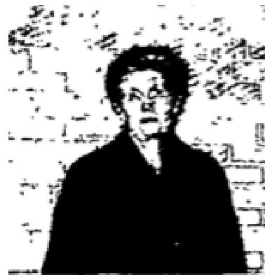

Healed of Sinus Trouble
I thank and praise my wonderful Lord for healing me of sinus trouble. I had suffered with this for seven years. I had three operations on my nose but it always came back. At times it was so bad I could hardly breathe and I had terrible headaches. When Brother Park prayed for me I was gloriously healed, not only of sinus trouble but of a stomach ailment I had had for years. I can't thank and praise my wonderful Lord enough. Truly He is the same yesterday, today and forever. Praise His name.
Royal Peters, Melrose, Wisconsin
Deaf Ear Unstopped
My grandson could not hear anything out of his right ear, and the left ear was just about gone, also. The doctors said this was caused by several licks on his head. Brother Park layed his hands on him and prayed, and he was instantly and completely healed by the power of Jesus.
Praise His name!

THE VOICE OF HEALING 1954

Mrs Gunther E Miller, Sparta, Wisconsin
Delivered from Hearing Aid
I want to thank the Lord for what He has done for me. I wore a hearing aid for nearly a
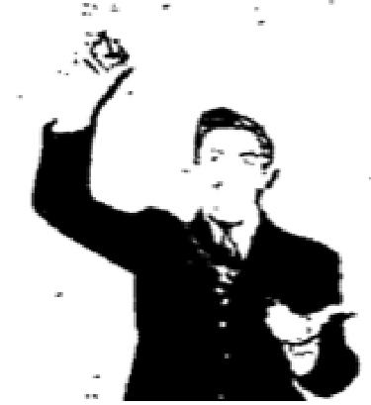
year before Brother Park prayed for me. I couldn't even hear a whisper before he
prayed for me, but now I can hear the faintest
whisper. Praise the Lord! I want to do all I can for Him. I just can't thank Him enough
for what He has done
done for me.
John Clemmerson (Age -17), Tomah, Wisconsin
November 1954 p9
Healed of Spinal and Intestinal Trouble
I have been suffering with several things the night that I was prayed for by you in Lake
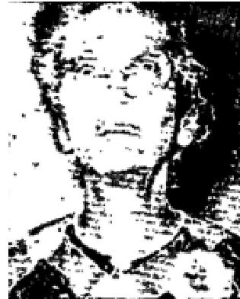
Wales, Fla including a failing eye, a severe spinal condition and intestinal trouble.
Praise the Lord, I can testify today of being healed by the great Physician. The eye has been strengthened, the spine with its naggin' pain, has been healed and the intestinal trouble gone by the mighty power of God.
God be with you in your good work.
Sincerely in Christ,
Mrs K S McGee, Hotel Lake Alfred, Lake Alfred, Fl.

Wheel Chair Deliverance
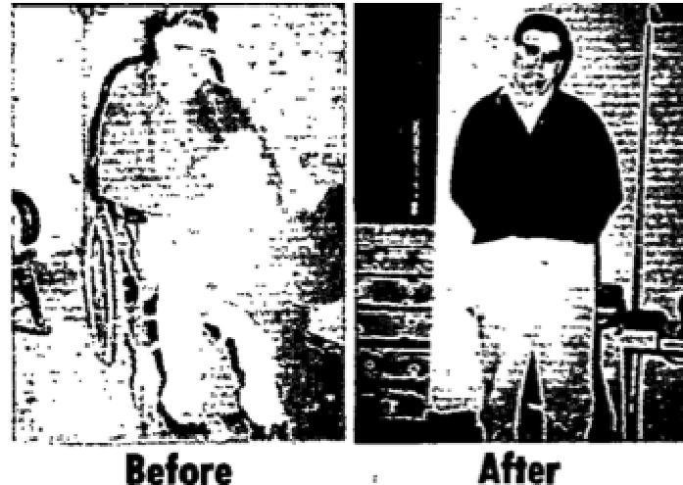
I can never cease thanking the Lord for the mighty deliverance that was wrought in my behalf during your revival in Elmira Heights, N Y. I had been sick for about two years and for the last 11 months had been confined to my bed and wheelchair. I had a severe rheumatic condition called “gouty arthritis,” a very severe stomach condition causing me to be on a special diet, and also suffered with a kidney condition. Satan had bound me with the cigarette habit, over which I was powerless. On the night of May 24th I came to your service in a wheel chair, an invalid and in desperate need of help from God. You called me out of the audience to the platform, laid your hands on me and commanded me to be made whole and to “arise and walk in the name of Jesus.” The next thing I knew I was walking back and forth. First I was helped by you but then entirely on my own. Today I am praising God, for I know He is the same yesterday, today and forever. I now am able to eat anything, and am walking and driving my car and also praising the Lord over my deliverance from the “smoke habit.” May God continue to use you to help others in need like myself.
Joseph Hackett, Elmira, N Y
I witness this testimony to be true having known of Bro Hackett's condition and can say “truly this was a miracle of God.”
Carl H. Leverenz, Pastor, Elixir Heights Glad Tidings Church

THE VOICE OF HEALING 1954
Perforated Ear Drum
For many years I had a perforated ear drum. The United States Army rejected me for service due to this condition in my body. The first night of the Salvation-Healing Revival in Lake Wales, Bro DeGrado called me out of the audience, the Lord having revealed to him of the presence of one with this "ear condition" and as he prayed for me God moved by His Healing power. God instantly touched me and I have had no trouble with the ear since. Praise the Lord who can do anything!
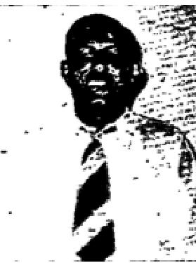
Malley Shelley, Salaam Park, Florida
Witnessed by Pastor E L Wine

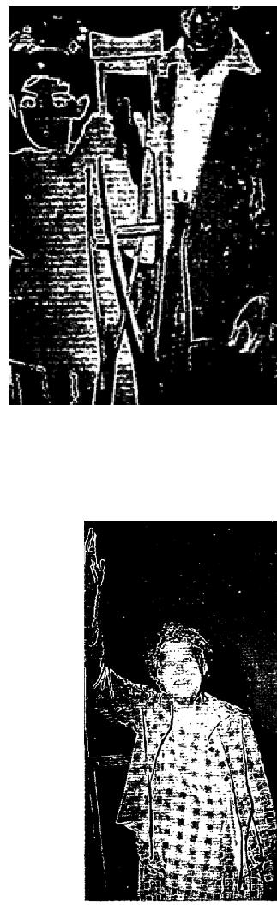
Testimony of Healing
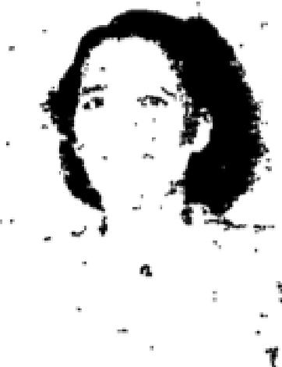
It was during the DeGrado Salvation-Healing Revival I attended in Lake Wales, Florida, that God so marvelously came on the scene and worked a Miracle in my body. I came to the service that night with a
tube which had been inserted there by the doctor following a liver operation several weeks before. The
doctor had said that I must wear this drainage tube for a period of six months, also informing me that the operation may not have been successful and that another operation might be necessary. The condition of the liver was very grave and the drainage continuous. However, after being prayed for in your campaign the drainage ceased. I returned to the doctor who took X-rays of my liver and found that the trouble had completely cleared up and I no longer would need an operation.
The tube was removed two days after prayer was made for my condition, and I am praising and thanking God for this truly has been a miracle in my body. May God bless you and help you to help others such as I,
throughout the land is my prayer. -
Beatrice Meadows, Lake Wales, Fl.
Witnessed by:
Pastor H L. Wine
November 1954 p12
This totally crippled boy of Tunas, Cobs, was made whole in a few seconds while out in the audience at least 200 ft from the platform during prayer for congregation by Bro Jeffery.
The Testimony of Ola Beggs
For nine months I had been unable to use my right arm, due to an arthritis condition.
During your campaign in Louisville, I attended the services beginning the very first night. On the third night, Thursday, I went forward and joined the prayer line. Immediately after your prayer for my healing, I was able to raise my arm high in the air, put it far behind my back, and reach around behind my neck to touch my left ear. Since that time I have had no pain whatsoever in my arm, and have needed no medicine.
I praise the Lord for healing me and for sending you to Louisville to preach the Divine Word of God.
Mrs Ola Beggs, Louisville, Kentucky

THE VOICE OF HEALING 1954
In May, 1951, while we were holding a service in Mexicali, a boy, Pablo Martinez, came for prayer. He was born with no ear on his right side, just a sort of nubbin with absolutely no opening of any kind and only 10% hearing in his other ear .After prayer he could hear perfectly with both ears July of this year. Bro E H Mellado of Reform 1805, Mexicali, B C, reports that the boy is still absolutely normal and can hear perfectly without any hole whatsoever in his head.  COMPLETE hearing was restored to this man who was totally deaf in one ear, because of a broken ear drum caused by a dynamite explosion. The doctor said it would be impossible for him to ever hear again. Shown with him is Bro Jeffery and Walter Haydus, the Superintendent of the Assemblies of God in Guatemala. | 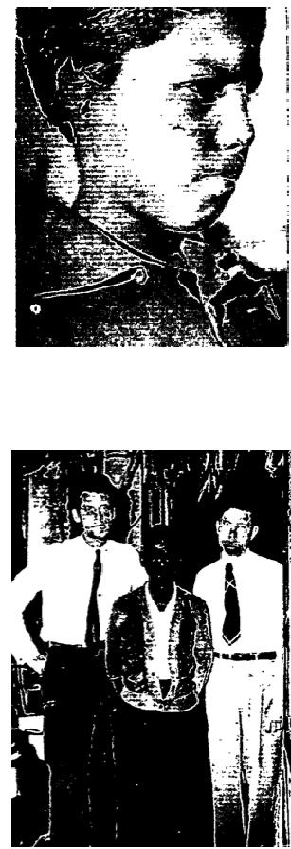
November 1954 p12
Healed of Carbuncles
I had 14 carbuncles at the time I was prayed for. Within two days they had all dried up and completely
disappeared. This was a real relief to me I want to praise the Lord for this wonderful healing.
Arthur W Miller, Binford, North Dakota
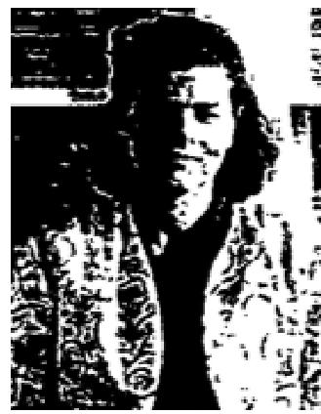
Deaf Ear Unstopped
I have been hard of hearing for 17 years. The doctors said there was nothing they could do until the last few years they have discovered an operation that has been a help to some people. This operation was performed on my right ear and since then it never ceased to run. The left ear remained deaf.
Exactly a year from the date I had this operation. Evangelist Marc Conley was holding a revival at the Assembly of God Church in Carom, Illinois. On the night of May 16, 1954, I went through the prayer line to be prayed for. The Lord miraculously opened the deaf ear and now I use it in talking over the telephone instead of the ear that was operated on. After the operation on my right ear it would drain terribly at night on my pillow. Since I was prayed for there has appeared no drainage.
All praise and glory be unto my wonderful Lord.
Helen McCord, Carom, Illinois
Delivered of Callouses on Feet  I had callouses that covered the soles of my feet. They hurt so badly that I could hardly walk. After Brother Conley prayed for me these callouses disappeared and I want to praise the Lord for healing me. I was also healed of many other ailments at that time. Thanks be to God.  Betty Szabo, South Bend, Indiana | 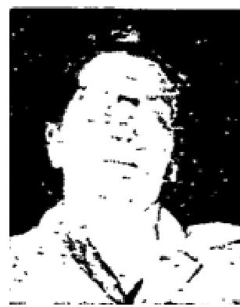

THE VOICE OF HEALING 1954  Delivered From Constant Pain  I want to thank Jesus for healing my whole body. I suffered all the time with pain in my body, and my feet would swell up and hurt so badly. After Brother Conley prayed for me Jesus healed my body and the pain is completely gone. Praise be unto God.  Mrs Ceclia Paszli, South Bend, Indiana | 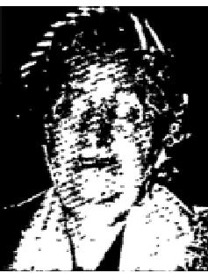

Child Healed of Eczema
My son had eczema in both ears for ten years. At times this eczema would become so severe he would scratch until boils would form and he would wake up trembling and screaming with pain. I brought him to the Marc Conley healing campaign in the Armo Theater in South Bend, Ind. Within one week after Brother Conley prayed for him the eczema was completely gone Praise the Lord.
Also I have a baby girl 9 months old and for several days she could net eat and she cried day and night and lost 3 lbs in three days. She fell asleep shortly after Brother Conley prayer for her. Upon awakening she immediately took her food and has been well ever since flow we thank God for His goodness and mercy.
Mrs George Kolar, South Bend, Ind
Healed of Heart Trouble  In Brother Conley's meeting in the Armo Theatre in South Bend, Indiana, the Lord saved me, filled me with the Holy Spirit and healed me of a severe heart ailment. My heart skipped beats and it would keep me at wake at night. Now I am healed and I thank the Lord for it.  Laura Burger, South Bend, Indiana | 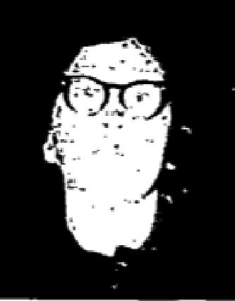

Spits Up Goiter
For many years I had a goiter in the right side of my throat. On Friday night, March 5, 1964, during the preaching, I felt the goiter slip from the right side of my throat around to the middle. After the prayer of faith by Brother Conley, I ran to the back of the building and spit up the goiter. Praise be to God for deliverance.
Twila Dent, South Bend, Indiana

Eyes Healed - Headaches Gone
I have never been without a headache and intense pain in my eyes since an operation in 1946. I could not stand bright overhead lights or sunshine without dark glasses. My reading glasses even had to be tinted.

I had never been to a healing service until Sunday, April 4, 1954. I attended the Marc Conley meeting at the American Legion Hall in Robinson, Illinois. The third night I was prayed for by Brother Conley and was amazed to find myself free from headache. Then the pain in my eyes lessened to the extent that now, on April 15, I have no headaches, no pain in my eyes and have no need for glasses even in bright sunlight.
My thanks to God for this wonderful work.
Mrs Juanita Lindow, Robinson, Illinois

THE VOICE OF HEALING 1954
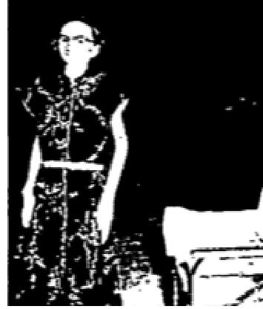
November 1954 p15
I have been a victim of incurable arthritis for 3" years. The past year and a half I have been totally helpless and confined to a wheel chair. I have been gradually becoming worse until I weighed only 74 pounds. Many blood transfusions have been given me to keep me alive.
In August 1954 I heard of the Clifton Enckson Healing Revival in Fresno, California, and my husband took me there. The second night I attended Bro Erickson prayed for me and a mighty miracle took place. I immediately arose from my wheel chair, and walked to the platform healed by God's power The next Sunday I went with my husband to our local Assembly of God Church. As I walked in the people all stood to their feet and praised God.
Since my healing I am able to do my housework, write letters, etc, which I could not do before because of my crippled condition. Praise God for healing me.
Mrs Madline Cummerfelt, Pastor Rev Ralph Goither, Was., California.
November 1954 p16, 17
TESTIMONIES TAPE RECORDED. JANUARY 24, 1954, GRANTS PASS, OREGON
I am so glad for what Jesus has done for me. I had a limb that was numb for the past two years. It has been
getting worse all of the time. Now, praise the Lord, it has all disappeared. Ida Entriken.
My tonsils swelled up, and they got in such bad condition that they burst in my mouth. I came here one night, and Brother Nunn prayed for me, and Hallelujah, the Lord delivered me. H. B. Scott.
For years I have had a running sore in my left ear. Brother Nunn prayed for me the other night, and praise the Lord, I am healed. My ear is all dried up. Ella Alderson.
I have had a stiff knee for three or four years. I couldn't get down to pray. After Brother Nunn prayed for me, I went home and got down on my knees, and I have been able to do it ever since. Mrs. Frank Parkins.
Healed of Goiter  The Lord healed me of a goiter. I had a goiter which I had carried for 33 years, and when  Brother Nunn prayed for me it immediately released all pressure.  Also a cancer mole on the back of my neck, was killed at the same time. This was the first time I have normally breathed, without gasping for breath in years. So I am praising the Lord and giving all the glory for His wonderful healing. I want to be found always trusting in His grace.  Mrs. Homer Ramsey, Van West, Iowa | 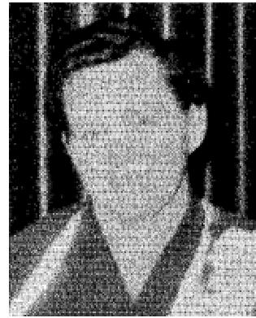

Healed of Deafness and Heart Trouble  For 23 years I have been deaf. It was caused from a blast from a gun. You prayed for me  and I can hear perfectly. Mr D.V. Cox  Eleven years ago I had a heart ailment. The doctor said it was arthritic heart. At times I was unable to move for such pain through my heart. You prayed for me and God healed me through His mighty power.  Praise His name forever.  Mrs. D. V. Cox, Van Wert, Iowa | 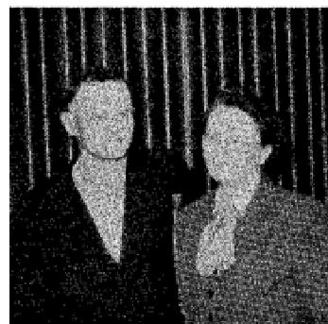

THE VOICE OF HEALING 1954
Goiter Dissolves
For thirty years I had an outside, very large Goiter on my neck. You prayed for me in February, 1952, in
Oxnard, California, and God healed me.
The goiter dissolved gradually and is now entirely gone. I praise God for His healing power.

Mrs. Clara Carter, Oxnard, California
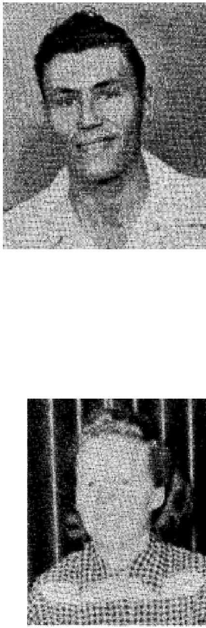
Acute Iritis
I am so happy over my healing. I had acute iritis and always before I had to spend weeks at a time in the Veteran Hospital in Amarillo. The doctors told me if the infection came back to get back to Amarillo as soon as possible, for if the pupil closed I would lose my eyesight.
When Bro. Nunn prayed for me my eye was at its worst. The pupil was closed and the sight was already gone. I couldn't even see a shadow or a movement. The eye had turned bloodred. After Bro. Nunn prayed my sight returned and the pain is all gone. I am so happy. I catch myself every once in a while covering up my other eye and praise God I can still see.
Robert L. Owens, Plainview, Texas.

Healed of Appendicitis
God healed my appendix. I had been bothered with this condition for about 3 years at
first the attacks were light and as time went by they became more severe.
They occurred at intervals of between 3 and 6 months apart. The very day previous to the service when I received my healing my appendix became sore and I ralised my healing must come for another attack was evident. But praise God, he reached down through his servant Brother Nunn and I was healed. God spoke to
Brother Nunn and directed a prayer from the pulpit; every person in the church who wanted healing could stand and repeat the prayer of faith. I did as I was directed, accepted God's word, believed and I was healed. Praise God the soreness left my body and I was made every wit whole by Jesus Christ.
Miss Lois Davenport, Van Wert, Iowa
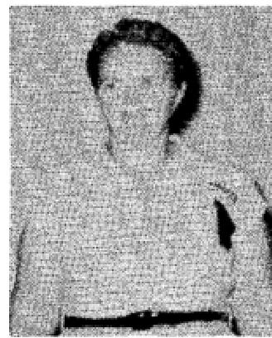
Sense of Smell Restored
I am writing my testimony because I want others to know God still heals, and answers prayers. I give God all the praise for healing my body. I had had no sense of smell since I was a child too small to remember;
but God healed me and and now I can smell food cooking which I had never smelled before.
Also I had sick headaches caused by sinus trouble since I was just a child but God healed me when you layed your hands on me and prayed for me on September 17, 1951. I give
God all the glory because He is our Great Healer. Since that time I have never had a sick headache again.
Mrs. H. C. McNatt, Cleburne. Texas

THE VOICE OF HEALING 1954
Deaf Fifty-five Years - Healed
I would like to give a public testimony to you and God for giving me back my hearing. I had been deaf in my left ear for fifty-fivc years. One night while you were conducting your Healing Campaign in Elmira, I went in the Healing Line and after you prayed for me, my hearing was restored. I could hear you speak to me many feet away. I was also healed of severe lameness in my left leg.
Mrs. Lula Van Cise, Elmira, New York
“I hereby certify that the foregoing testimony is true." Rev. John Bedsyk,, Elmira, N. Y.  Eyes Healed  Since a small child I have had a weakness of the eyes. After I would read so long my  vision would blur.  When Brother Nunn prayed for my eyes I felt a sudden pain. Then it left never to return  again. I thank God  fee healing my eyes.  Bette Cain, Van Wert, Iowa | 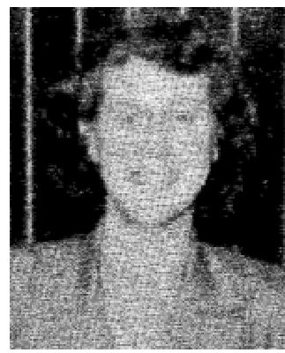

Blind from Childhood - Healed
From a child up, I had had very little sight in my right eye and what I did have was clouded and bleared. The eye had been thoroughly examined by Dr. Bert G. Voorhees of Elmira, N. Y. and he officially announced that the eye had never fully developed. Consequently, after thirty (30) years, I became almost completely blind in that eye, but Bless the Lord, while you were conducting your Salvation-Healing Campaign in Elmira, N Y, one night you prayed a mass prayer for the blind people in the audience and told the people to place their hands over their eyes if they were blind while you prayed. Praise the Good Lord, this I did and instantly my sight was restored.
Mrs Rose Patterson, Elmira, N Y
I hereby certify that the foregoing is true. Rev John Bedzyk, Elmira, N Y.
Right Ear Drum Created
I have had two mastoid operations on my right ear. For eight years I have not had a right ear drum. Behind my ear on the right side of my head there is a steel plate in place of the bone. This plate is about the size of a quarter.
During your Salvation-Healing Campaign in Oxnard, California, you prayed for me and God instantly healed me. Now I can hear a watch ticking and people whispering with my right ear.
Cleo Smith, Santa Paula, Calif.
November 1954 p20
Healed of Sores
While you were in Revival Center holding a revival I came for you to pray for me. I had runny sores all over my hands and my body. I could not do my work because they would break open and bleed and cause me much pain. After the night that you prayed for me. I was completely healed of this condition on my back first, and then my hands. Now my hands are completely healed and they look almost normal. I just want to praise and thank God for what he has done for me.
Juan R Vega, Kansas City, Me

THE VOICE OF HEALING 1954
Spits Up Cancer
I came to Revival Center during the second week of your meeting with Sister Mary Trinqual. I had been to three doctors and they told me that I had a cancer in my mouth. They also said that the only thing they could do would be to cut the cancer out. I told them that I did net feel that I wanted that done as I felt that God would undertake for me and help me.
When I came into the service that night. I went into the prayer line and when you prayed for me I immediately left the prayer line and went into the rest room and spit out the cancer. I can say that my mouth has been healing ever since and I feel God has delivered me completely.
Mr Lester C Miller, Kansas City. Mo

November 1954 p23
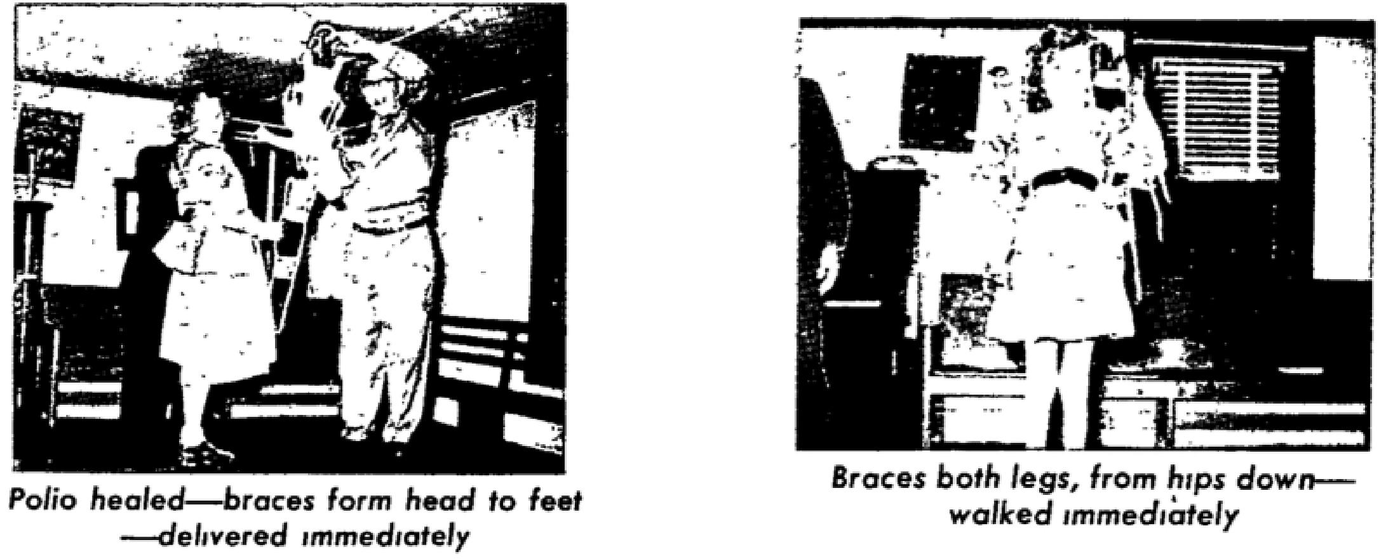
Child Healed of Heart Trouble
Our daughter Denise LaRae Scherod has had a critical heart murmur. This condition was found by the doctors when she was only 6 weeks old. In the space of 9 months' time, she was hospitalised 6 times. She has had pneumonia 4 times and has been unable to walk because of her weakened condition. At one time her left lung collapsed and her heart completely filled her chest. Her heart failed and the doctors gave no hope. Her last trip to the hospital was on March IS, 1954, at which time the doctors diagnosed her case as that of having a chronic heart murmur which she would not be able to outgrow. Wednesday night, July 21, 1954, Bro Erickson prayed for her. There was an immediate improvement in her heart beat. Her heart stopped palpitating and began beating normally and has ever since. Sunday morning, July 25, 1954, we took her back to the clinic. She was examined by several doctors, all of which could not hear the murmur. The doctors all pronounced her as having a perfect heart beat, normal so every way. She is now walking, growing and gaining strength and we are praising God.
Mr and Mrs Garry Scherod, Des Moines, Iowa
Child Healed of Serious Blood Condition
On August 23, 1954, we brought our granddaughter, Carol Martin, age six years, into the healing line in Fresno. She had a severe blood condition which caused her blood to clot from the slightest bruise or bump. Doctors had warned that a hump on the head could easily be fatal before we could get her to the hospital. She was on a very strict diet and would only eat sparingly. When Brother Erickson prayed for her she was instantly healed. When she came down from the platform, she said that she felt a warm hand placed on her

THE VOICE OF HEALING 1954
stomach, and when she looked to see who had done it, there was no one close by. She is perfectly healed and has a good appetite, eats three times a day, and between meals.
By Mrs C B Morris, Fresno, California
Was Blind 16 Years
Clifford Hall, Rockport, California, was blind in his left eye since 1938. Mr Halls eye was blinded by shattered glass in an automobile accident. When Brother Erickson prayed for him, he was instantly healed and could count fingers at the far end of the platform.
Goiter Vanishes
I entered the Fresno healing line August 21, 1954, with a goiter about the size of an egg. The goiter left instantly, and no trace of it could be found. My nervous condition also left me immediately and my hearing was healed. I thank and praise the Lord for his healing power.

Gertie Inabrut, Lemoore, Calif
November 1954 p28
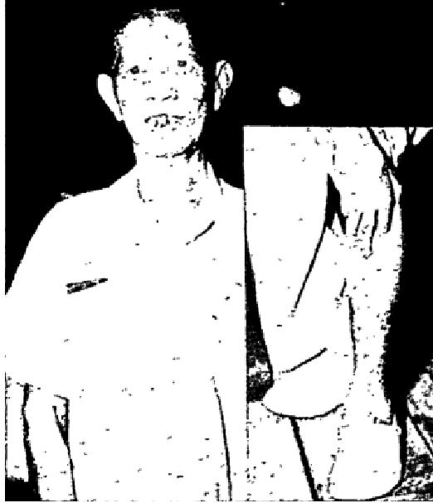
LIONG EK SlANG, Tangki 70, Djakarta, Java, a LEPER since 1936, lived separate from his family for past eight years. Was so bad when he attended the campaign that his flesh was swollen, his ears were twice their normal size, large swollen lumps were all over his face under the skin (this means the worst kind of leprosy) a large running sore was open on his leg, his fingers were running, lifeless, stiff and drawn closed, no feeling in his ears, nose, legs up to his knees or arms to his elbows. He was instantly healed and all feeling returned at once.
Within one week all symptoms were gone. Two weeks later he testified with his flesh so clean as mine. He accepted Christ, is going to Church, and is re-united with his wife at home.

ALL THREE EXTREMELY CROSS-EYED FROM BIRTH; COMPLETELY HEALED
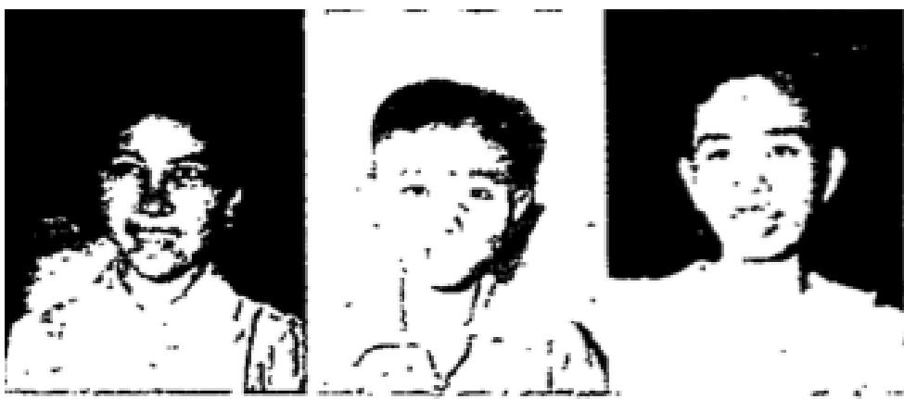
Left: Elizabeth Pattisalomui, Djl Abdul Rachmal Saleh, Djak , Java. Center: Name not recorded. Right: Lie Lien Nio, Tjuritan 8, Magelang, Java. Almost every night of the entire campaign, at least one or two cases of crossed eyes were healed.
INSANE! TOTALLY BLIND!  Left LIE TIAN ANN, Pasar, Baru, Cheribon, Java, INSANE FOUR YEARS. Perfectly restored (Only one of a few score insane who were healed). Right ANAH, Tundjugan 2, Surabaya, Java, TOTALLY BLIND FIVE YEARS. Was instantly healed so perfectly that she could read the Bible. (Almost every night, from one to a half dozen or more totally blind have received their sight. | 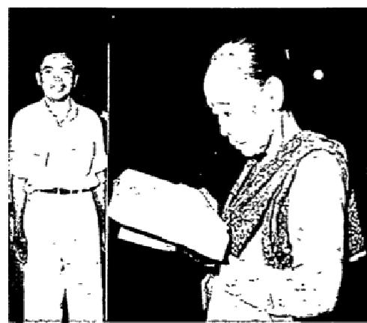

THE VOICE OF HEALING 1954
TWO FAMILIES OF THREE DEAF-MUTES EACH; ALL HEARING AND SPEAKING
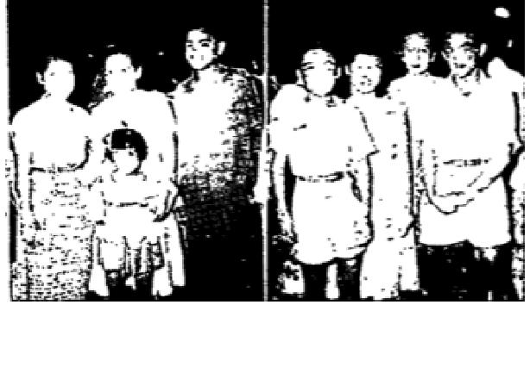 | Left Mother, Mrs T D Pieterez Sinjal , 6 Djalan Tjenteh, Bandung, Java. Her three children were born deaf-mutes.  Right Mother, Kwee Lang Tjien, Djalan Pintukise 20, Djakarta, Java. Her three children were deaf and dumb from fever they had when babies. All six of them healed on different nights. Many scores of deaf-mutes were healed and restored.
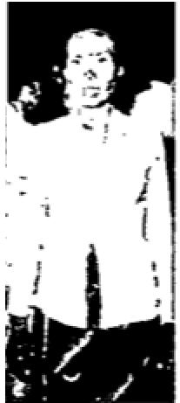 | LEPER 13 YRS - HEALED  KAISAH, Lantegalan #22, Djakarta, Java, a LEPER for 23 years. This lady had a slow creeping kind of leprosy in her feet and legs, both of which were dead up half way to her knees. The right foot had an open sore. She was immediately healed. She suddenly noted that she could feel her feet. The ulcer dried up and her feet were perfect. She accepted Christ and is going to Church. | 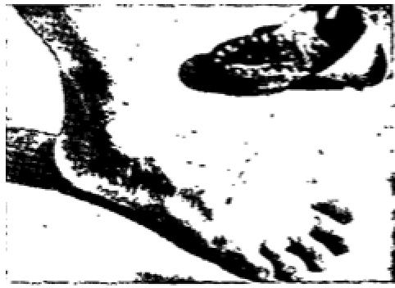

December 1954 p13  Case Discerned and Healed  I am so happy to give this testimony and to praise the Lord for the power in the Blood.  On the evening of May 20, 1954, as a sat in the audience I was called out and in an amazingly accurate manner my case was discerned, and I was informed of the many ailments in my body, which was correct. Among the ailments was a tumor, which Bro Hill said, “would pass from my body within four days.”  As you prayed for me and told me to claim my healing in Jesus Name, the power of God swept over my entire being - and I knew the work was done. | 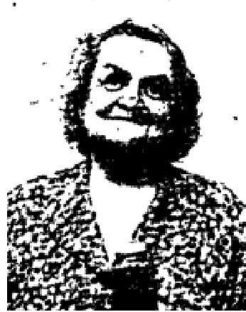

I am glad that I stood on His promise for my deliverance. At 1:45 am, May 25th, this tumor that you mentioned passed from me, and I had immediate relief.
This testimony is given of my own volition and for the glory of God, and to help others to place their faith in God pray that my testimony will increase the faith of all who hear it.
Signed,
Mr. Margaret Prong, 4223 North 26th St
Healed of Broken Neck
I want to praise the Laid for what he has done for me during the meetings conducted by Evangelist Roy Hill while at Faith Temple, Tacoma, Washington. On February 21, 1954, I was in an auto accident, and my neck was broken. The car went over a 100 foot embankment. I want to thank God for sparing my life.
I was taken to the hospital, and all x-ray photos showed that my neck was broken. I went to the meeting and was in line when Brother Hill suddenly realized that something was wrong with my neck and he took my head in his hand and rebuked the situation and commanded that my neck become normal. Suddenly there was a crack and for the first time since the accident I was able to move my head in any direction I desired. It is wonderful to feel well again, and to be able to move my head in any direction.

THE VOICE OF HEALING 1954
Many of my friends cautioned me against moving my head too much as I may bring on a relapse, but I have been moving it for weeks and it feels good, and I give all the praise to the Lord. During the meetings. I was also healed of a liver condition, and all the pain that had been in my body is gone.
Signed, M K Horton, 1714 South K St, Tacoma, Washington

THE VOICE OF HEALING 1955
April 1955 p12
HEALED OF ARTHRITIS OF FEET AND ANKLES - ONE YEAR AND THREE MONTHS When Brother Rudy Cerullo was in Hazleton, Pennsylvania, one of my friends took me from Easton, Pennsylvania, to hear him and be prayed for.
For over two years, at that time, I really suffered pain and agony in my feet and ankles due to arthritis. Also, I could not wear shoes during that same two-year period, but rather had to go everywhere with bedroom slippers.
Upon being played for, Brother Rudy Cerullo asked me to stand on my toes and produce action in my ankles. In the natural this would have been impossible for I hadn't been able to do this for two years, but Brother Cerullo's theme in Isaiah 10:27, "The yoke shall be destroyed because of the anointing," on him brought destruction to my yoke of arthritis and then and there I realized a further miracle. My shoe size was two sizes smaller than what I was wearing during my affliction. Arthritis had made them swell so severely that I had to have slippers that were several sizes larger than previously needed. All this was remedied because of God anointing.
It has been over one year and three months and I am still well, and I've been wearing shoes ever since. Praise God.
Mrs. Smith, East., Pennsylvania
TUMOR ON SPINE DISAPPEARS INSTANTLY - HEALED NINE MONTHS AGO
Over 13 years ago, I fell and hurt my back, not knowing that in a few months my spine would be affected with a tumor growing between two of the vertebrae of the spinal column. For these thirteen years, I suffered untold agonies and extreme pain, many times being packed in ice and sand packs as s method to help relieve the pain.
Some of my friends took me to the Rudy Cesullo Healing Campaign in Lebanon, Pennsylvania. This was the meeting that was to change my life and bring heaven sent relief, I hadn't had for over thirteen years.
When the prayer line was called, I went up and waited until my thirteen- year- old "yoke" would be destroyed by the "anointing." As Brother Cerullo prayed for me, I could feel the tumor melting, and the pain leaving my back. Oh praise God, I never felt anything like this is in my life. By the time I arrived home, every bit of pain was gone and also the tumor had completely vanished.
This has been over nine months ago and I can truthfully say I am still well and praising God. Catherine Wolf, Lititz, Pennsylvania
WATER ON KNEE HEALED - ONE YEAR, TWO MONTHS AGO
My daughter requested me to tell you how wonderfully God healed her after you prayed for her while in
your revival in Luzeme, Pennsylvania, December, 1953.
She injured her knee while doing some of her household duties, and a pocket of water formed which caused much discomfort as well as not being able to use her knee or even kneel. Her doctor drained it often, and thought an operation was necessary, for if it were prolonged it would go into a serious case of arthritis.
At that time, we brought her up to Luzeme, Pennsylvania, in December, 1953.

THE VOICE OF HEALING 1955
After you prayed for her, we took her downstairs where she wanted to test her knee, so that she bent her knee and it felt so much better that she knelt down it faith and to her good surprise found she was healed by God's anointing.
After she was home several weeks all the water was dried out and she s now able to do all her own floor scrubbing and household work. God has been so good to me and my daughter.
Mrs. Smith, Easton, Pennsylvania
April 1955 p13
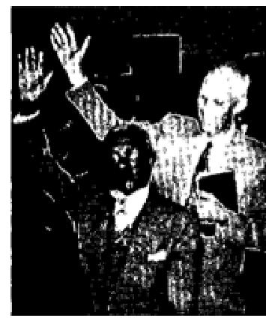
HEALED OF GLAUCOMA
For about six years I have been blind. I have been treated by the best eye specialists. They diagnosed my case as being glaucoma and that there was no known cure. Some kind friends invited me to attend a Bible Healing Crusade being conducted by Rev. H. E. Hardt in the Full Gospel Church, Coatesville, Pennsylvania, Being a colored man I accepted with considerable apprehension. My friends assured me I was entirely welcome. Rev. Hardt brought a very inspiring message on the healing of blind Bartimaeus. I responded in the healing line. When Rev, Hardt laid his hands on me and prayed the prayer of faith, life seemed to go through my entire body. At once light appeared and my eyes were immediately healed. I was lead into the church blind, but I walked out seeing.
Signed: Samuel F. Butler, Coatesvslle, Pennsylvania, November 23, 1954
Pastor's Note: Dear Brother Hardt: In response to your request I have checked on the man healed of glaucoma and found that he is getting along fine. In fact wife and I met him in a store doing shopping. He was all alone. Also, the woman whose picture was taken standing in front of the altar holding her Bible, is still praising God for healing her of eczema. She had suffered with it for twenty years.
Signed: Charles S. Strauser, Pastor
HEALED OF CANCER OF LIVER
When you were conducting a Bible Healing Crusade in The Lorian Gospel Tabernacle, [asked you to pray for a lady that was dying with cancer of the liver. You gave me a prayer cloth for her. She placed it on her body and in four days she stopped vomiting which she had done for a year. In a very short time she was home and doing her own work, also keeping three boarders as she is a widow and needs the financial help. Her name is Lourne Byrns. I, too, am much better since you prayed for me,
Mrs. H. Meredith Lorain, Ohio
HEALED OF MANY AFFLICTIONS
I have been a Christian for 57 years and have believed that one could be healed by faith, but the thing that happened when you laid your hands on me was beyond expression. I do not mean that I bed thunder and lightning experience when you rebuked Satan in Jesus' name, but the many afflictions that had tormented me for years immediately disappeared. I came to be healed of a virus infection, but received much more. The doctors said that I had a slipped disc that caused severe pain and caused me to be a victim of cysts and severe nervousness. He said only an operation would help me, but I am now happy and free. Your scripture presentation has blessed me tremendously spiritually and I am now a happy Christian.
Mrs. Mary Ban Phillips, Atlanta, Georgia

THE VOICE OF HEALING 1955  April 1955 p14  HEALED OF ARTHRITIS  For about seven years I suffered with arthritis in my arms and legs. My condition was so bad  that people could actually hear the grating of my knee joints as I walked.  About five years ago my stiffness and pain became so bad that I had to use crutches. My body was continually in pain. During these years was never without pain except when I used sedatives. | 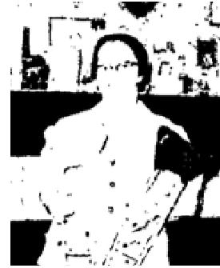

It looked as though my remaining years would be filled with suffering, but when I heard that Brother Caldwell was coming to Alpena, I began to believe that my prayers would be answered.
I began attending the meetings every night on my crutches. I listened to the preaching of the Word nightly. I saw the miracles and I believed that God would heal me, too. In the second week, before I ever came to the prayer line, the healing power of God came upon me and I felt my knees break loose as I was sitting in the congregation.
Although I was delivered from my crutches at that time, I still had the pain but when I came into the prayer line and Brother Caldwell prayed for me, immediately the pain left and for the first time in more than five years, I was able to kneel, right there on the platform.
I am so happy now, I want to give God all the glory for my marvelous deliverance.
Mrs. Wellington Eagle, Herron, Michigan
This is to certify that the above is a true testimony of my wife, Wellington Eagle, Herron, Michigan
HEALED OF SERIOUS STOMACH AILMENT
I had a very, very serious stomach ailment. I had been operated on but the condition returned, I vomited when I ate and I lost my appetite. I could sleep only 2 to 4 hours a night and suffered much pain. When I laid down it felt as if very hot water was inside and worms ware crawling around. I lost control of my bowels and lost much blood.
With some friends I began attending Brother Caldwell's meetings at Highway Tabernacle in Chester. One night as I stood at the head of the prayer line Brother Caldwell discerned my condition and prayed for me. I was healed that very minute! Two months have passed and I am still healed.
I had not known anything about the Holy Spirit before attending those services, but Brother Caldwell opened the Word to us and showed us the light, and on Holy Ghost night I, together with several of my friends, received the wonderful Baptism of the Holy Ghost. Praise the Lord!
Mrs. Ralph G. Hess, Wawa, Penna.
THE AMAZING TESTIMONY OF MRS. CHARLES HILDEBRANDT  For many years I suffered with arthritis, in my arms, legs, and spine, the condition being worst in my knees. I also had hardening of the arteries, poor circulation, and heart trouble so bad that I could not even lie down to sleep. For years I had to sleep in a chair. Even the slightest exertion, such as a short walk, would leave me in such a state that would fall over in pain and exhaustion.  When Brother Caldwell started his meetings in Memorial Hail in Alpena, I came in the prayer line the first night and immediately my arthritis, heart trouble, and other conditions | 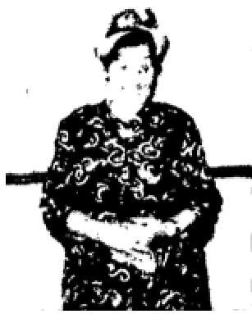

THE VOICE OF HEALING 1955
were healed. My joints became free and I had no more pain.
It is wonderful to be able to lie down in bed and sleep right through the night without suffering. My neighbors who knew my condition are marveling at my deliverance.
I also had been deaf in one ear for ten years because of a bursted ear drum. I came again in the prayer line and as Brother Caldwell prayed for me, God gave me a new eardrum. I used to sit up front in church because I could not hear, but now I like to sit all the way in the back, and I can hear perfectly with that ear.
But God has also done something else for me that was very wonderful. For five or six years I had a tumor on my leg about the size of a small walnut. It gave me some trouble and pain, and the doctor wanted to cut it out. However, one morning as I was dressing, I discovered that my leg was smooth and the lump was gone, and I had not even asked prayer for that condition,
I certainly am thankful to God for sending Brother Caldwell to our city. It really seems as though I feel a million times better.
Mrs. Charles Hildebrandt, Alpena, Michigan
This is to certify that I believe the above to be a true testimony of Sister Hildebrandt.
Rev. Gunnar Kars, Pastor, Gospel Tabernacle, Ninth and Cavanaugh Streets, Alpena, Michigan.
April 1955 p20
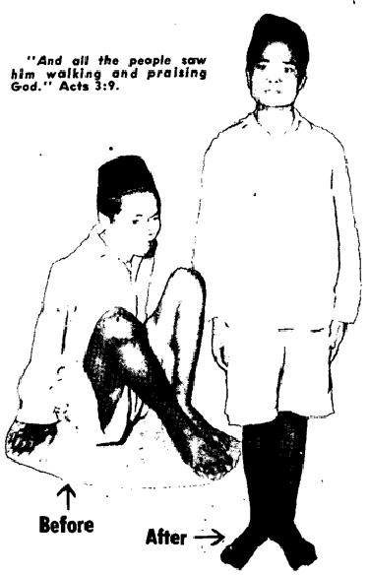 | Left; Kasmin. of Coampung Malang, Surabaja, a Muslim from birth, dragged his body on the ground  with his hand. From a high fever, which lasted four days he was left a cripple, with his legs drawn almost double. He accepted Christ in the Surabaja revival and was instantly and perfectly healed.  Right: Salina, of Djombang Tjinkia Village. also crippled from a severe oriental fever, was left unable to walk. She moved her body with her hands. The third night she attended the campaign she was saved and instantly healed. | 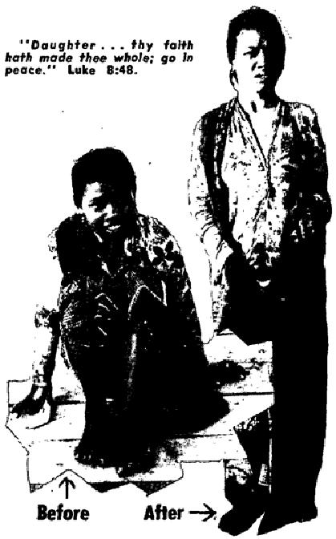
April 1955 p21
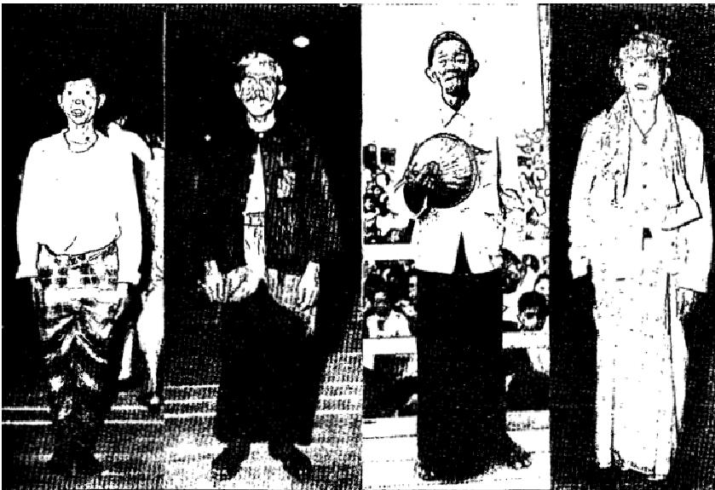 | LEFT TO RIGHT: 1) Piet Howia FOUR YEARS A LEPER, born a Moslem, accepts Christ,  instantly healed in Surabaja revival, 2) Pa Sumaryo, Madurese. CRIPPLED 15 MONTHS, accepts  Christ, forsakes witch doctors and was instantly healed. 3) M. Ng. Purboodiputra, TORMENTED  BY NERVOUS SPASMS SINCE FIVE MONTHS OLD so bad they would throw him on the ground as  he walked, Heard and believed the Gospel, received Christ, and was made perfectly whole. 4) Pa Ebing, Madurese, DUMB FOUR YEARS, perfectly restored after accepting Christ in Surabaja.

THE VOICE OF HEALING 1955
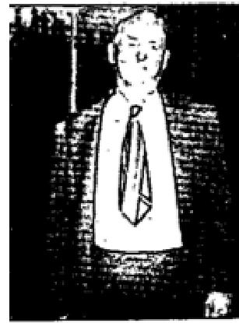
August 1955 p14
GROWTH VANISHES
I had a growth protruding under my right breast. It began about the size of a man's thumb tip. I had it about 3 months, and it had grown to be about the size of a tea cup. It pained and burned like fire. At times it felt as if I had thorns sticking me in that region.
I attended the Erickson meeting on the second night of the campaign. He said he would pray for everyone in the audience that was afflicted. I raised my hands and began to pray. I put my hand on the growth and it seemed to swell. Then it softened up and disappeared under my hand. I couldn't believe I had been beaten
even though I felt the thing go. I praise God for His healing power. All pain is completely gone and I have suffered no more. I am completely healed!

J, E, Benbry, Tallahassee, Florida
HEALED OF CANCER
I thank the Lord for what He has done for me. I was lost in sin although I had been a
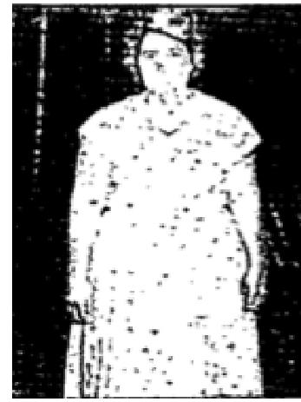
church member for eight years. But God saved me band healed me.
I had been in pain since 1938 when hit by a truck. Doctors said that from the awful bruise I received in the accident, it had turned to cancer. When Bro. Clifton Erickson prayed for me, God's power went through me and thank God I am healed. I am so thankful God sent Bro. Erickson to our city.
Mrs. A. E. Spies, Tallahassee. Florida
CANCER CURED
I had been sick for a long time with cancer. The doctors gave me dope to deaden the pain. I was in the hospital in Thomasville for many X-rays but the doctors could not help me. I went to the Clifton Erickson Campaign, as I was no longer able to eat my meals, for I was
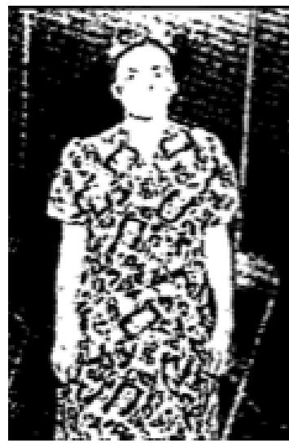
so sick. Brother Erickson prayed for me, end the Lord completely healed me. I cant thank God enough for His goodness to me.
Mrs. L. W. Adams
Quitman, Florida
This lady was brought to the Erickson tent in a dying condition. Rev. A. P. Warner
August 1955 p15
CHILD WHO NEVER TALKED - HEALED
My daughter, Virginia Gonzales, age 9, was declared to be beyond the aid of
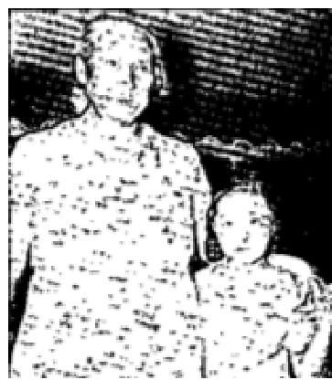
medical science by three doctors. She had never talked in her life. After Brother Todd
prayed for her in the Dallas Crusade she began
to talk and has been talking ever since.
Mrs. P. A. Gonzales, Shawnee, Oklahoma

DELIVERED FROM PARTIAL DEAFNESS
I came to the Sharon, Pa. Salvation Healing Campaign suffering from deafness. I could not hear a telephone
ring. Since Bro. Todd prayed for me I hear perfectly. God answers prayer.

THE VOICE OF HEALING 1955
Mrs. J. H. Russell, Sharon, Pa.
HEALED OF THYROID CONDITION
Dear Bro. Todd,
During the Sharon, Pa., Salvation Healing Campaign, I came to the prayer line suffering from thyroid condition of 14 years standing. My thyroid gland had not been active for 14 years. Due to this condition I had developed excessive weight. The excess is now leaving, praise God for His healing power.
Susie Sebassic, Sharpsville, Pa.  August 1955 p16  GETS COMPLETE OVERHAUL  I thank the Lord for healing my body from cancer, he trouble, arthritis and bursitis. Even  hemorrhoids I had  for 30 years are gone. My cup runneth over with joy.  Jesus is truly the same yesterday, today and forever, a Name be glorified.  Mrs. B. B. Turner  Portland, Oregon | 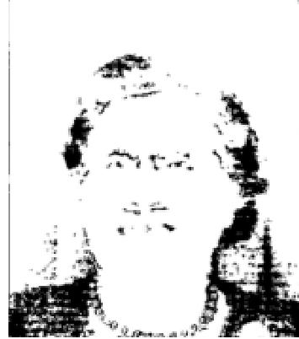

A MIRACLE WROUGHT BY GODS POWER
I was horn with my hips out of place and as a little girl my mother could not get my clothes to hang straight
on me.
When Brother Bob Herald prayed for me, one night, bravery bad headache, I did not know that right then a miracle was taking place in my body. I did not know that God had straightened my hips until two days later. I also had a very bad case of nerves which made me want to eat all the time.
And now, praise God, after 25 years my hips are straight and I no longer want to eat all the time. I thank God for this miracle.
Barbara Whitehead
Murphy,Oregon
SUFFERED SEVEN YEARS - HEALED
For about seven years. I had aches in the back of my head, and my leg would become numb. I had difficulty
in swallowing my food and also had pyorrhea of the gums.
Brother Bob Herald prayed for me and God's prayer moved on my body and was instantly healed. Gople L. Parker, Grants Pass, Oregon

THE VOICE OF HEALING 1955

Afte(wo(d
The past year has been a difficult one - nearly every Christian I know had been challenged by the Lord, as he prepares us to go into the Next Level.
All year the Lord has been pressing Raf that “the Next Wave is near - time is short” (Two articles about the Next Wave are posted on “Paul’s Page”).
The Holy Spirit is about to do something special in history, and much of the church is NOT ready. We have had a number of fantastic sermons in the Well of Healing meetings, that are all posted in “AW Video Messages” on the website: www.AncientWells.org.au.
- The Fast Track - how to get onto God’s Fast track to be ready in time.
- Faith Comes by Hearing - The Word is a person, not a book. Faith comes by hearing the NOW word from the Lord.
- Wise and Foolish Virgins - You either have it together in preparation or you will miss out. The short version is this:
- Praying in Tongues - Declares the mysteries of God over your life, Edifies you (builds you up in your Spirit-man). This most ordinary Spiritual Gift has been much-maligned and misunderstood over the years, but is the key for Spiritual growth., especially when combined with:
- Fasting - Puts the flesh to death - particularly the unbelief that keeps us from functioning in miracles (See Mark 9).
When you combine the two you are on the Fast Track, and you will have major battles as the Lord begins to reveal issues in your life that are preventing Him from using you in the way he wishes. Don’t give up. Let him deal with your flesh and get it out of the way. When your Spirit begins to rule your flesh under the headship of the Holy Spirit (ie. it’s no longer YOU who lives...), you will accelerate into usefulness as a Son/Daughter (Rom 8), and you will hear God clearly.
We are seeing the Lord do some incredible healings in Adelaide - people recovering from cancer, MS, etc. I recently had a Relief lesson torpedoed by a girl who announced to the class that her short leg had grown out overnight, and she now had two nearly normal legs. Suffice to say that was the last effective teaching for that lesson, and they all wanted to hear about Jesus.
Today’s youth are no longer going to swallow a message that lacks power. But they will fall over themselves to witness and hear about reality. 1 Cor 4:20 says: “The Kingdom of God is NOT a matter of talk but of POWER!” The church MUST wake up and hit the prayer closet, or we will lose many who have been entrusted to us (see: “There are not enough lifeboats” on “Paul’s Page”).
These testimonies are for us to see what the Holy Spirit did through obedient men who could hear in the past. They set a level for us to aspire to, and then go beyond. There has been much focus in Australia in the last year on the Wigglesworth Prophecy - that the last great revival before the Lord returns would begin in Australia/NZ, go up into SE Asia, and then out to the rest of the world. This was spoken in Goolwa (right next to Middleton where Raf is based). We believe we’re getting very close to another major revival.
Blessings to you all,

Paul Davies

